Install Cucumber Eclipse Plugin

It is easy to install ***Cucumber Eclipse Plugin***, as it comes as a plugin for ***Eclipse IDE***. Prerequisite for installing this plugin is your Internet connection should be up & running during installation of this plugin and Eclipse IDE should be installed in your computer. Please see [***Download and Install Eclipse***](http://toolsqa.wpengine.com/selenium-webdriver/download-and-start-eclipse/) to setup Eclipse to you system.

Steps to follow:

1) Launch the *Eclipse IDE* and from Help menu, click “***Install New Software***”.

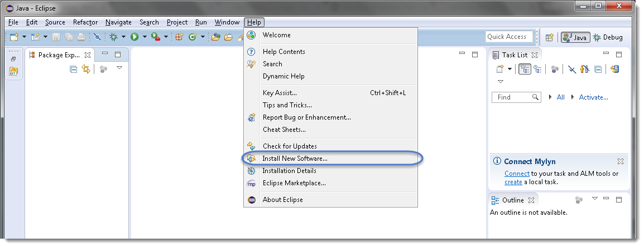

2) You will see a dialog window, click “***Add***” button.

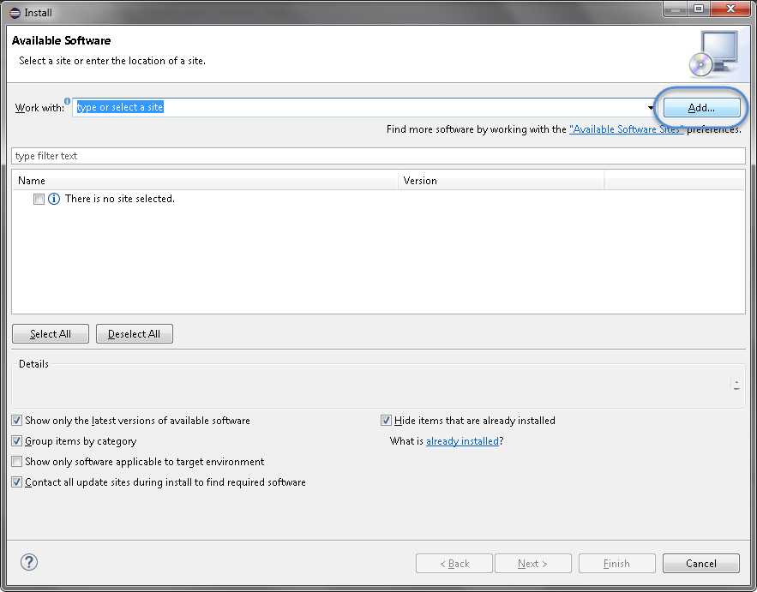

3) Type name as you wish, let’s take “***Cucumber***” and type “***http://cucumber.github.com/cucumber-eclipse/update-site***” as location. Click ***OK***.

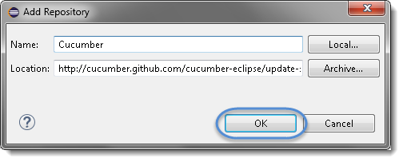

4) You come back to the previous window but this time you must see ***Cucumber Eclipse Plugin*** option in the available software list. Just ***Check*** the box and press “***Next***” button.

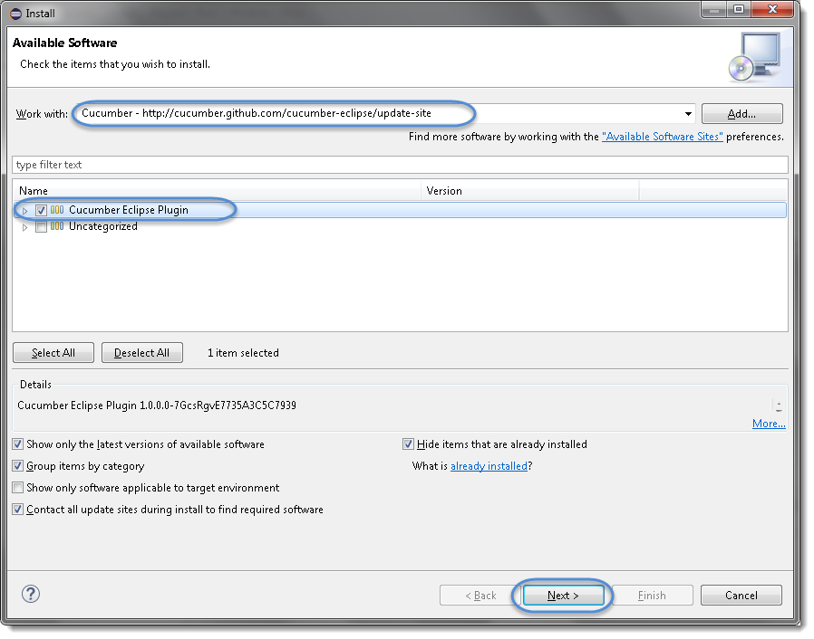

***Note:****If running behind a proxy server and you get a ‘HTTP Proxy Authentication Required’ error you may need to contact a system administrator to set up your proxy server settings.*

5) Click on ***Next***.

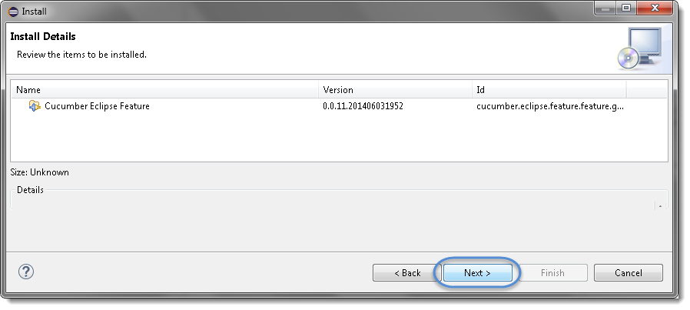

6) Click “***I accept the terms of the license agreement***” then click ***Finish***.

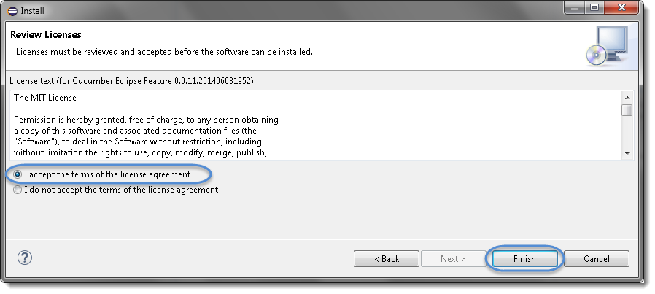

7) Let it install, it will take few seconds to complete.

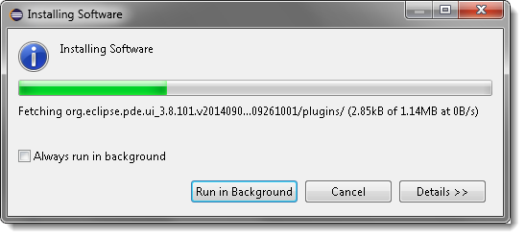

8) You may or may not encounter a Security warning, if in case you do just click***OK***.



9) You are all done now, just Click **Yes**.

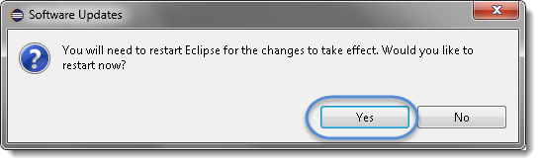

# Download Cucumber JVM for Eclipse

Cucumber functionality is abstracted out in jars and following Cucumber jars/modules are required to run a *Cucumber* test with *Java* in *Eclipse*.

1. ***cucumber-core***
2. ***cucumber-java***
3. ***cucumber-junit***
4. ***cucumber-jvm-deps***
5. ***cucumber-reporting***
6. ***gherkin***
7. ***junit***

*** Sending cucumber demo project with Feature, step definition and runner file