**Assignment 19**

Answer 1

class Thing:

pass

print(Thing)

l=Thing()

print(l)

They are different:

<class '__main__.Thing'>

<__main__.Thing object at 0x0000023CBBDD4160>

Answer 2

class Thing2:

letters="abc"

print(Thing2.letters)

Answer 3

class Thing3:

def __init__(self):

self.letters="xyz"

l=Thing3()

l.letters

Answer 4

class Element:

def __init__(self,name,symbol,number):

self.name=name

self.symbol=symbol

self.number=number

Answer 5

dic={'name':'Hydrogen','symbol':'H','number':1}

hydrogen=Element(dic['name'],dic['symbol'],dic['number'])

Answer 6

class Element:

def __init__(self,name,symbol,number):

self.name=name

self.symbol=symbol

self.number=number

def dump():

print(name,symbol,number)

hydrogen=Element(dic['name'],dic['symbol'],dic['number'])

hydrogen.dump()

Answer 7

print(hydrogen)

<__main__.Element object at 0x000002A0B925A580>

print(hydrogen)

Hydrogen H 1

Answer 8

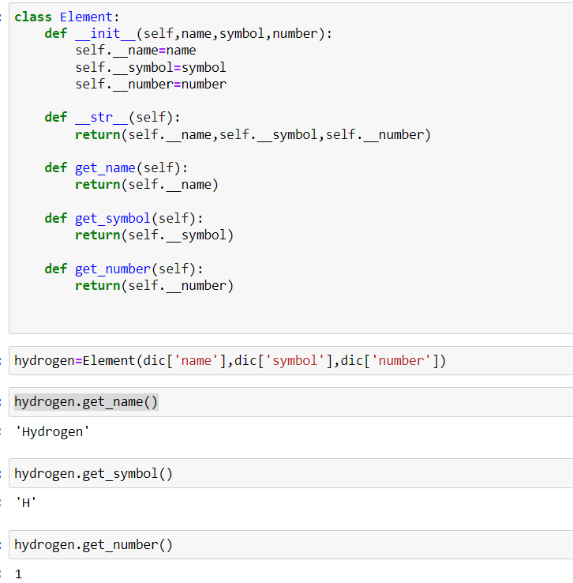

Answer 9

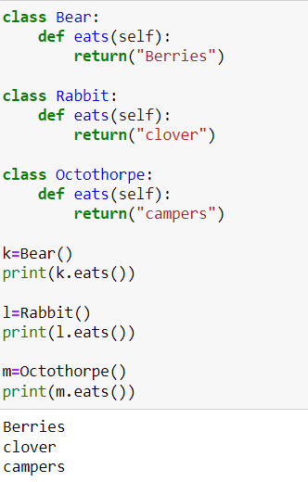

Answer 10

