**Assignment 20**

Answer 1

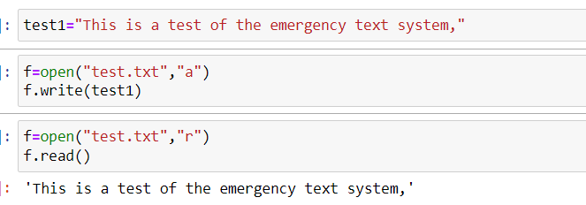

Answer 2

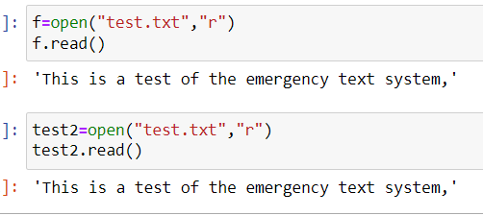

NO differenece

Answer 3

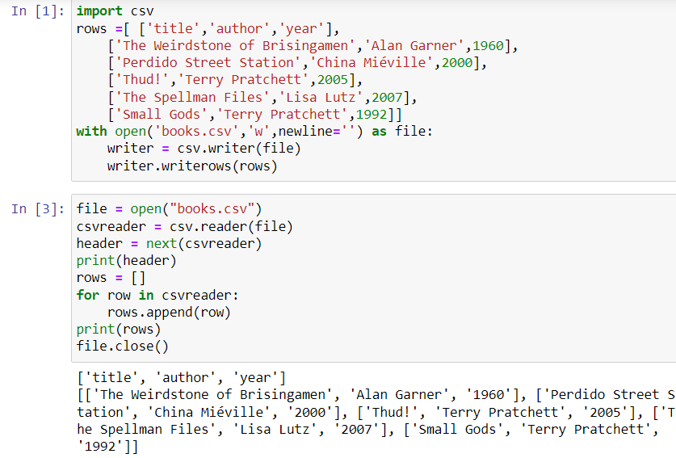

Answer 4

**import** sqlite3

conn **=** sqlite3**.**connect('books.db')

c **=** conn**.**cursor()

c**.**execute('create table books(title varchar(20),author varchar(20), year int)')

conn**.**commit()

Answer 5

import pandas as pd

read_books = pd.read_csv('books.csv',encoding='unicode_escape')read_books.to_sql('books', conn, if_exists='append', index = False)

Answer 6

c.execute('select title from books order by title asc')print(c.fetchall())

Answer 7

c.execute('select title, author,year from books order by year')

df = pd.DataFrame(c.fetchall(), columns=['title','author','year'])

Df

Answer 8

import sqlalchemy

engine = sqlalchemy.create_engine("sqlite:///books.db")

rows = engine.execute('select * from books')

for i in rows:

print(i)

Answer 9

import redis

conn = redis.Redis()conn.delete('test')

conn.hmset('test', {'count': 1, 'name': 'Fester Bestertester'})

conn.hgetall('test')

Answer 10

conn.hincrby('test','count', 3)