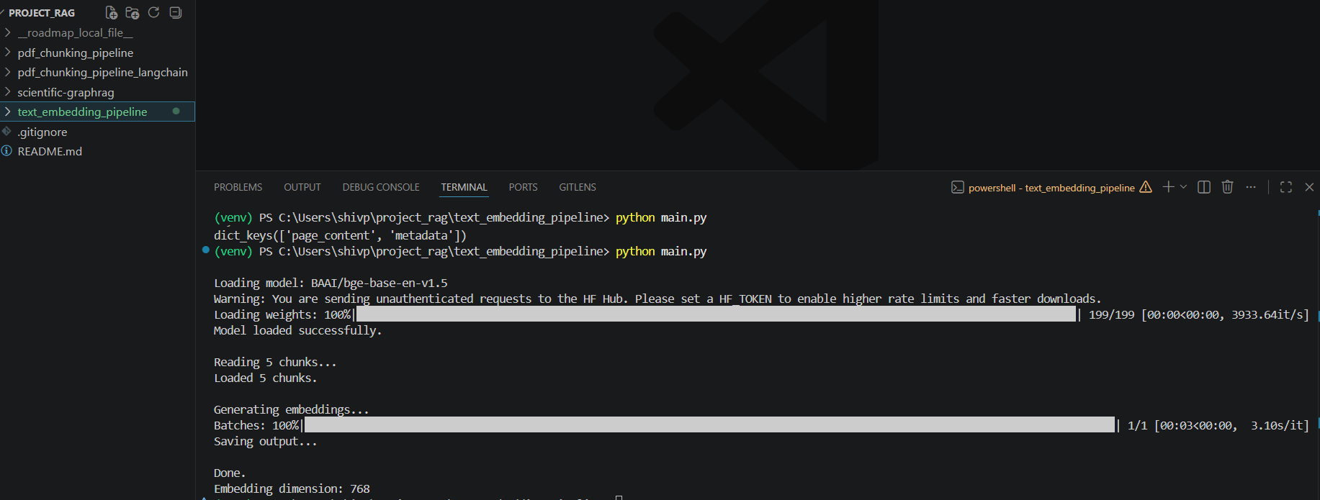

Embedding generation for first few chunks

Then I downloaded the model locally with this command:
hf download BAAI/bge-base-en-v1.5 --local-dir models\bge-base-en-v1.5

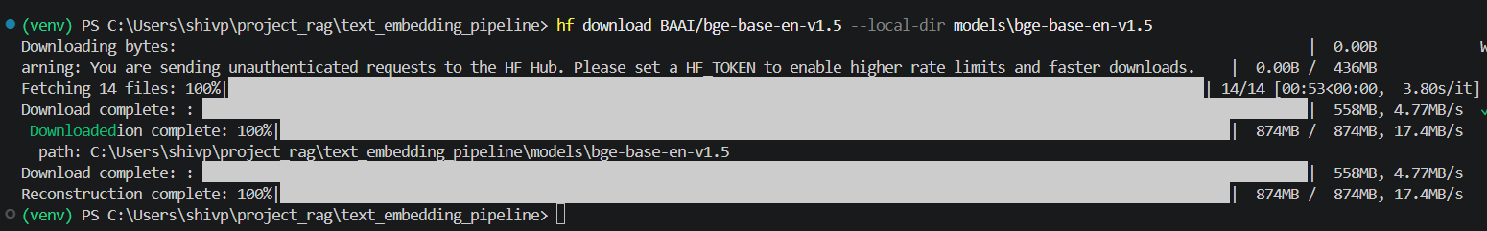

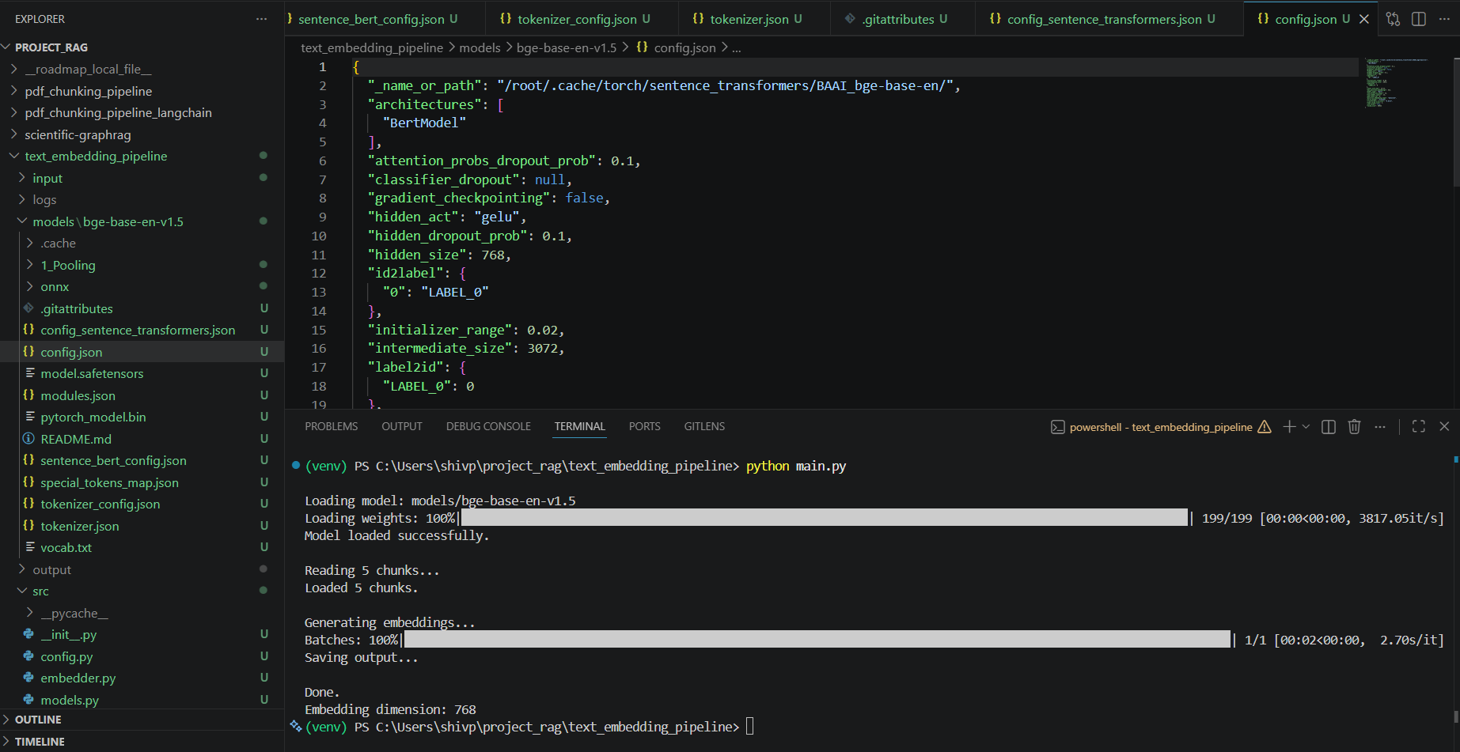
Having model locally, I avoided the warning which I was seeing earlier.

Sample embeddings:
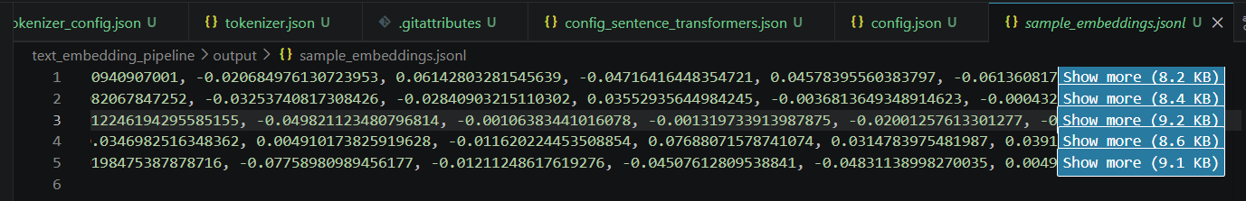

It appears embedding time per chunk is very large than expected

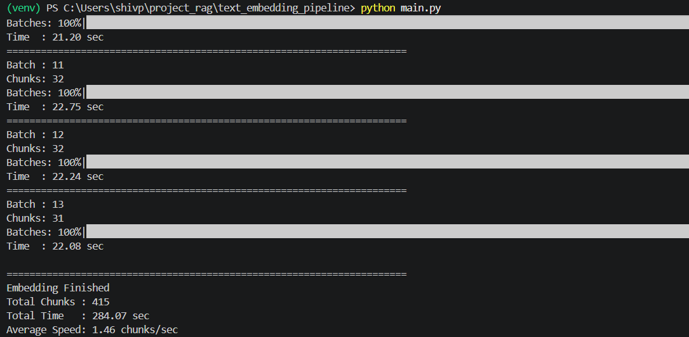

Benchmarked chunk size 32, 64, 128, 256 for embedding time
PS C:\Users\shivp\project_rag\text_embedding_pipeline> python main.py

Loading model: models/bge-base-en-v1.5
Loading weights: 100%|██████████████████████████████████████████████████████████████████████████████████████████████████████████████| 199/199 [00:00<00:00, 7190.38it/s]
Model loaded successfully.

======================================================================
Embedding Pipeline Benchmark
======================================================================
Batch Size : 64

======================================================================
Benchmarking Batch 1
Chunks : 64
Batches: 100%|████████████████████████████████████████████████████████████████████████████████████████████████████████████████████████████| 1/1 [00:27<00:00, 27.18s/it]

Embedding Time : 27.18 sec
Chunks/sec : 2.35

Benchmark complete.
Stopping after first batch.

(venv) PS C:\Users\shivp\project_rag\text_embedding_pipeline> python main.py

Loading model: models/bge-base-en-v1.5
Loading weights: 100%|██████████████████████████████████████████████████████████████████████████████████████████████████████████████| 199/199 [00:00<00:00, 7163.90it/s]
Model loaded successfully.

======================================================================
Embedding Pipeline Benchmark
======================================================================
Batch Size : 128

======================================================================
Benchmarking Batch 1
Chunks : 128
Batches: 100%|████████████████████████████████████████████████████████████████████████████████████████████████████████████████████████████| 1/1 [00:52<00:00, 52.12s/it]

Embedding Time : 52.13 sec
Chunks/sec : 2.46

Benchmark complete.
Stopping after first batch.

(venv) PS C:\Users\shivp\project_rag\text_embedding_pipeline> python main.py

Loading model: models/bge-base-en-v1.5
Loading weights: 100%|██████████████████████████████████████████████████████████████████████████████████████████████████████████████| 199/199 [00:00<00:00, 7029.24it/s]
Model loaded successfully.

======================================================================
Embedding Pipeline Benchmark
======================================================================
Batch Size : 256

======================================================================
Benchmarking Batch 1
Chunks : 256
Batches: 100%|███████████████████████████████████████████████████████████████████████████████████████████████████████████████████████████| 1/1 [01:44<00:00, 104.12s/it]

Embedding Time : 104.14 sec
Chunks/sec : 2.46

Benchmark complete.
Stopping after first batch.

(venv) PS C:\Users\shivp\project_rag\text_embedding_pipeline> python main.py

Loading model: models/bge-base-en-v1.5
Loading weights: 100%|██████████████████████████████████████████████████████████████████████████████████████████████████████████████| 199/199 [00:00<00:00, 7505.18it/s]
Model loaded successfully.

======================================================================
Embedding Pipeline Benchmark
======================================================================
Batch Size : 32

======================================================================
Benchmarking Batch 1
Chunks : 32
Batches: 100%|████████████████████████████████████████████████████████████████████████████████████████████████████████████████████████████| 1/1 [00:11<00:00, 11.66s/it]

Embedding Time : 11.67 sec
Chunks/sec : 2.74

Benchmark complete.
Stopping after first batch.

We can also add following features as well:

- Resume after interruption
- Logging framework
- Multi-processing
- Multi-GPU support
- Quantized embedding models
- Model versioning
- Storage abstraction
- Vector database integration

