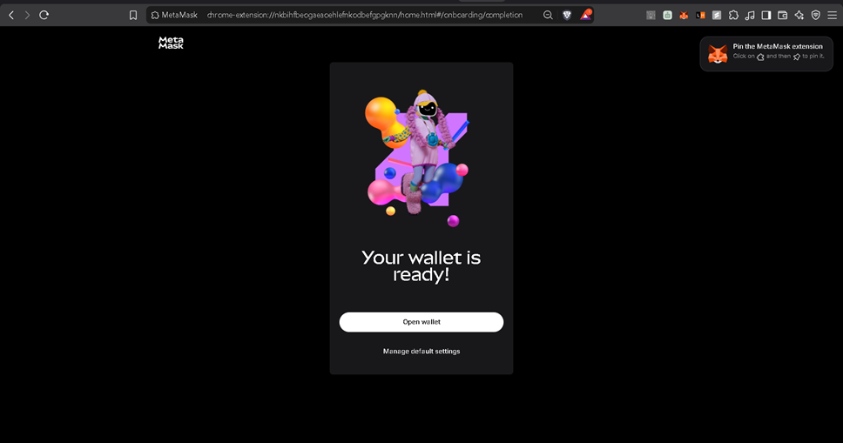
Step 1: Wallet Created (MetaMask Setup Complete)
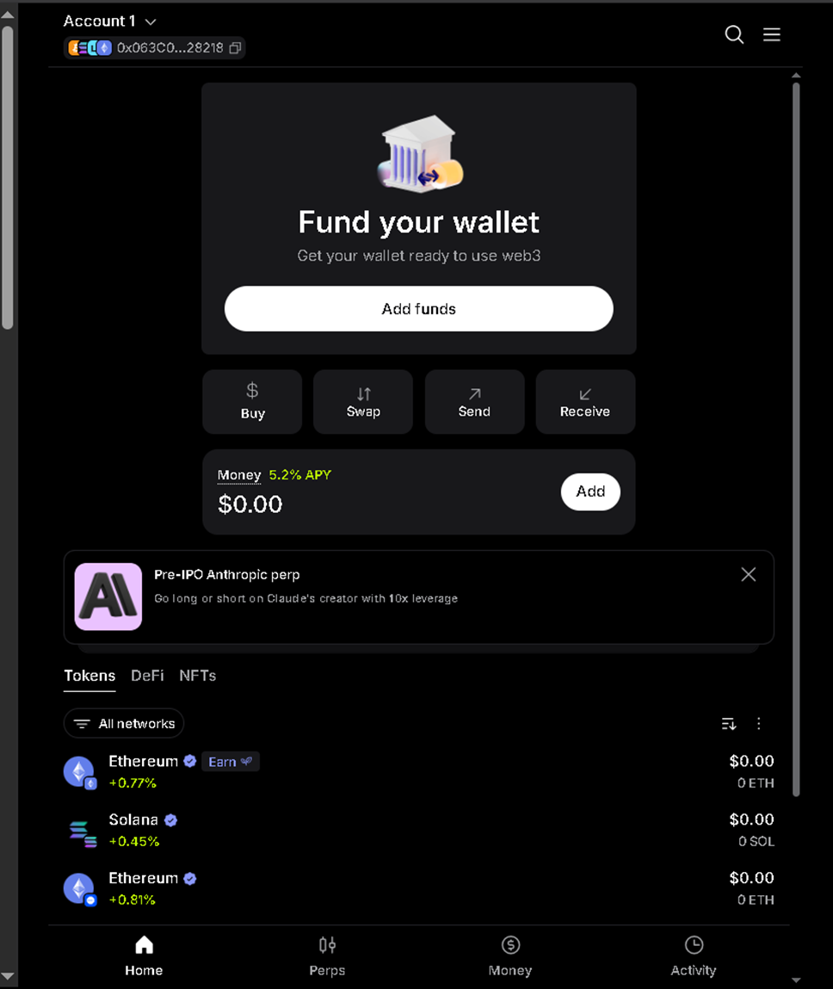
Step 2: Account 1 Wallet Home
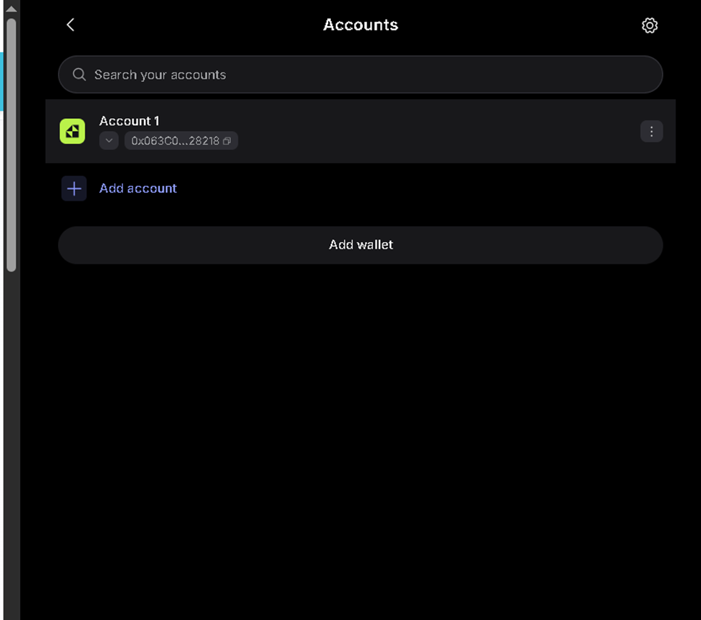
Step 3: Accounts List (Account 1 Address)
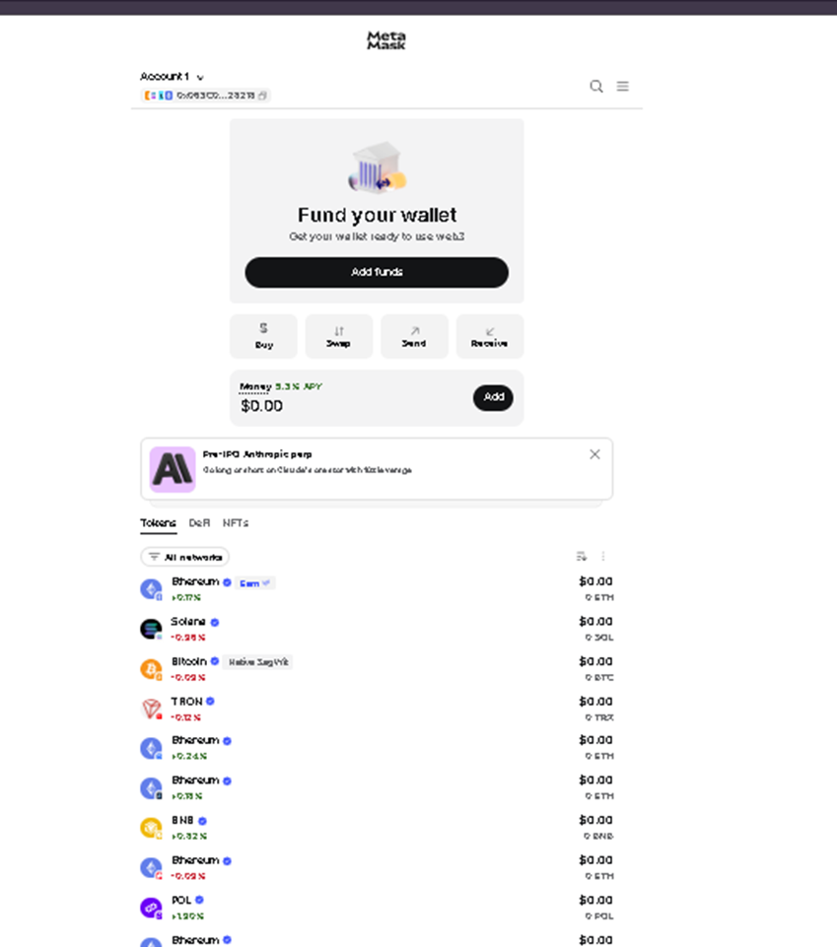
Step 4: Wallet Overview and Token List
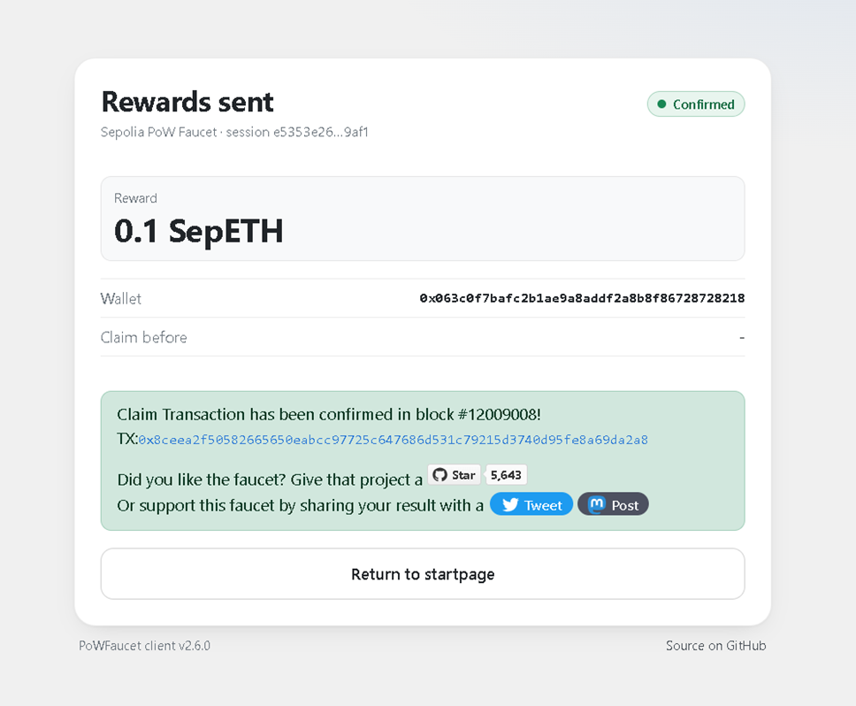
Step 5: Sepolia Faucet: 0.1 SepETH Reward Confirmed
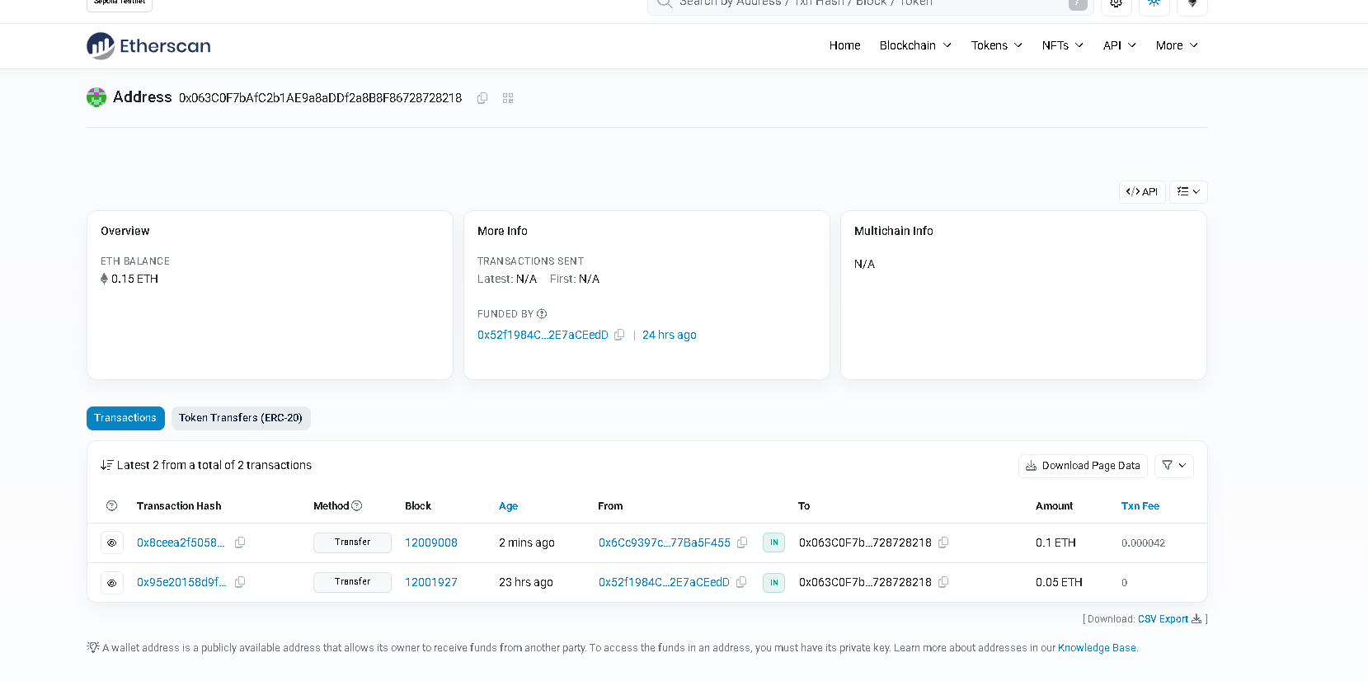
Step 6: Etherscan (Sepolia) Address Page: Balance and Transactions
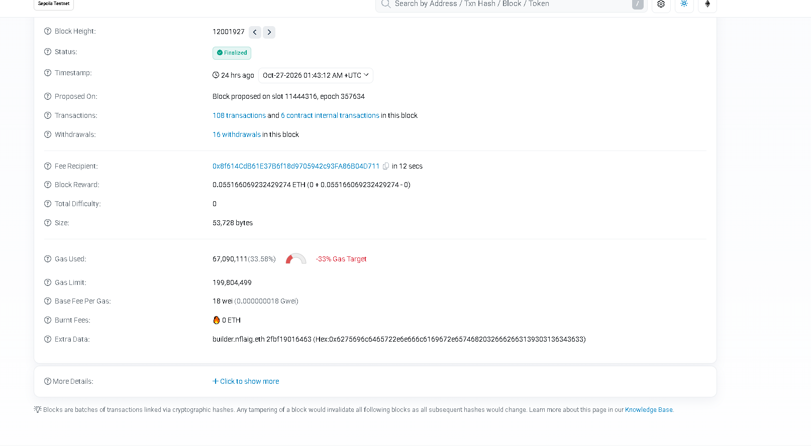
Step 7: Etherscan (Sepolia) Block Details: Block 12001927, Gas Used and Base Fee

