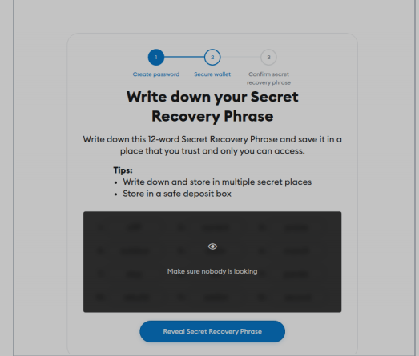
Step 1: Secure Wallet: Write Down Secret Recovery Phrase
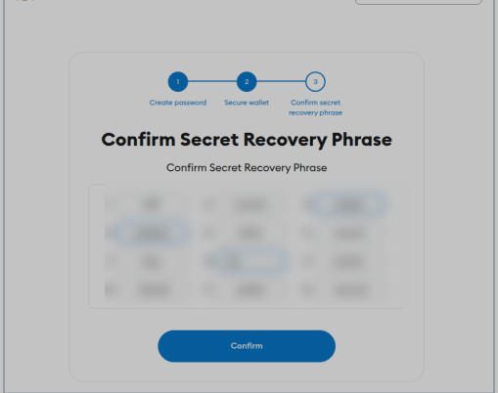
Step 2: Secure Wallet: Confirm Secret Recovery Phrase
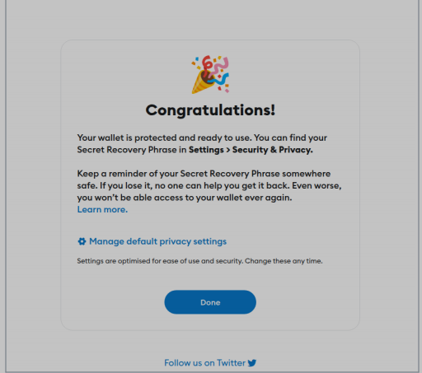
Step 3: Wallet Protected and Ready (Congratulations)
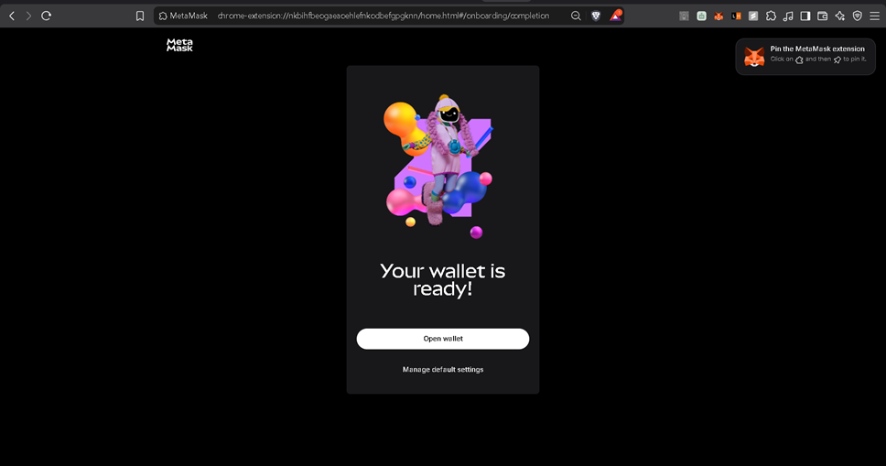
Step 4: Wallet Created (MetaMask Setup Complete)
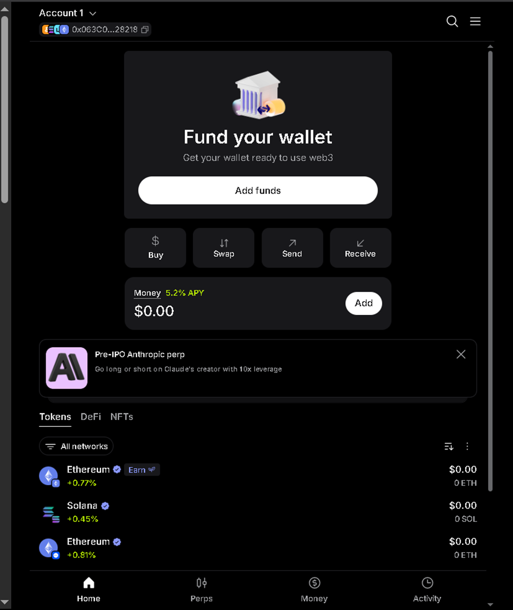
Step 5: View Wallet: Account 1 Home
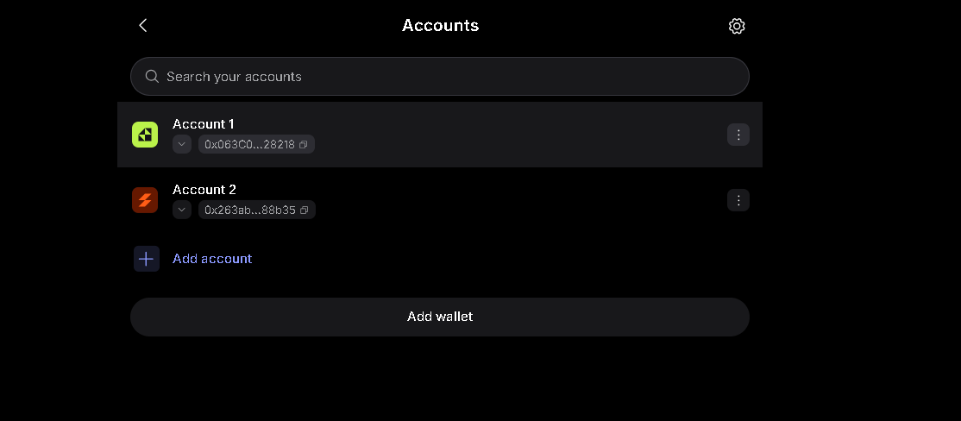
Step 6: View Wallet Address: Accounts List
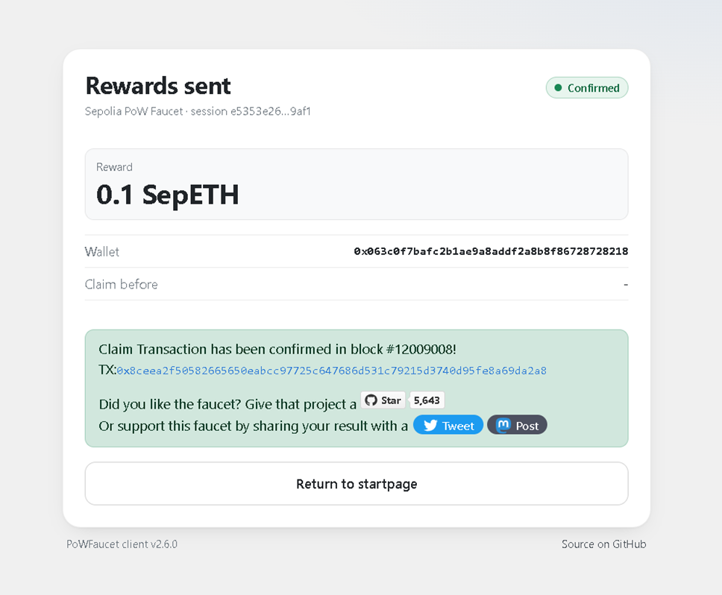
Step 7: Receive Ether: Sepolia Faucet 0.1 SepETH Confirmed
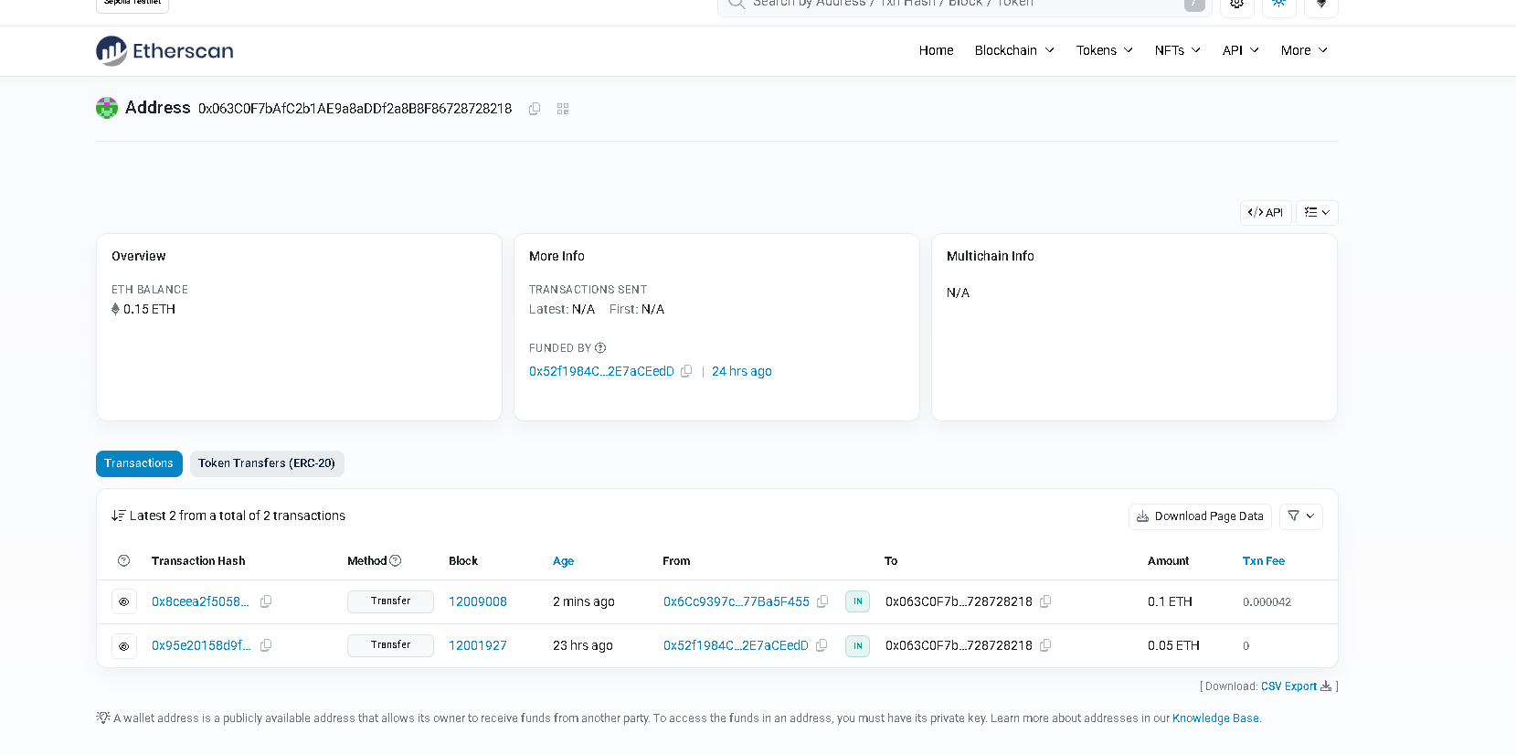
Step 8: Transaction History: Etherscan (Sepolia) Address Page

