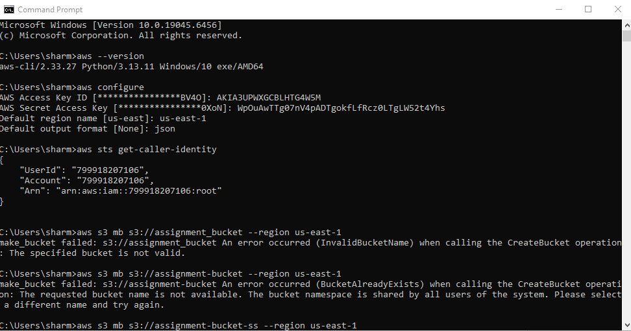

Local Set Up steps:

- Download and Install python(v3.13.12) in local from this link: https://www.python.org/downloads/ and make sure to select add python.exe to the path.
- Then install aws cli from this link to set up asw cli in local(pre requisite : before this aws free tier account is required and access key id and secret key from the account settings(I added them to the root user directly. WE can create a user and then add them to the user account)): https://awscli.amazonaws.com/AWSCLIV2.msi

- Then create a s3 bucket using following commands from aws cli

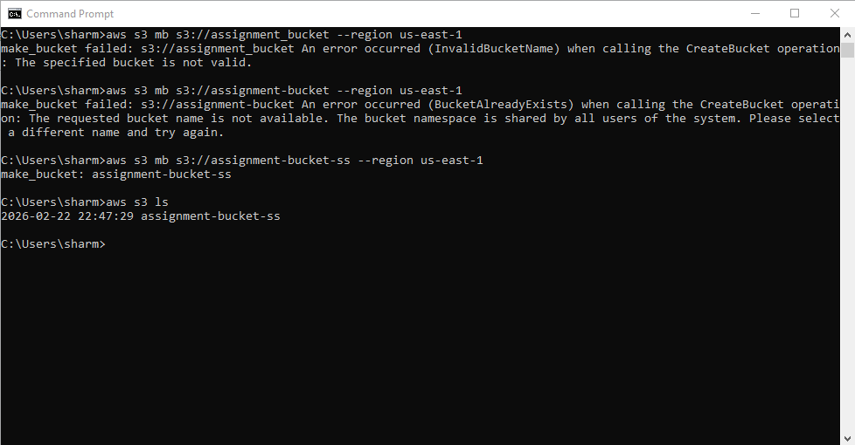

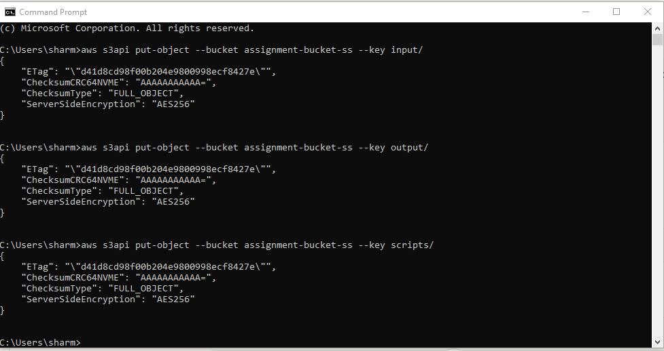

- Data Uploading to s3 bucket steps from aws cli::

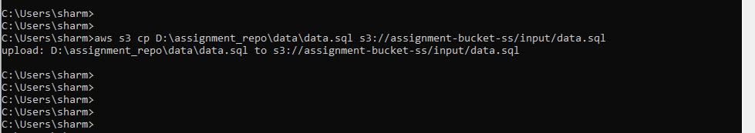

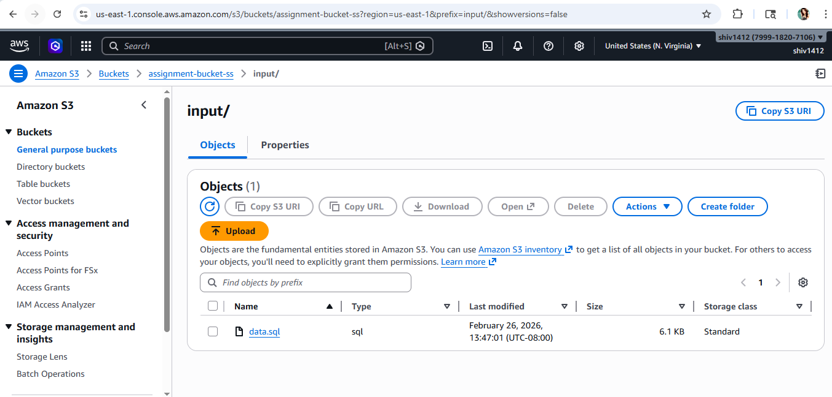

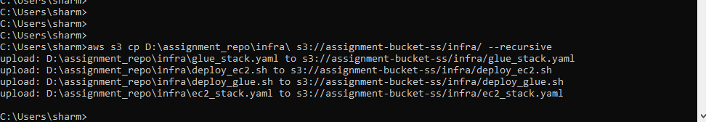

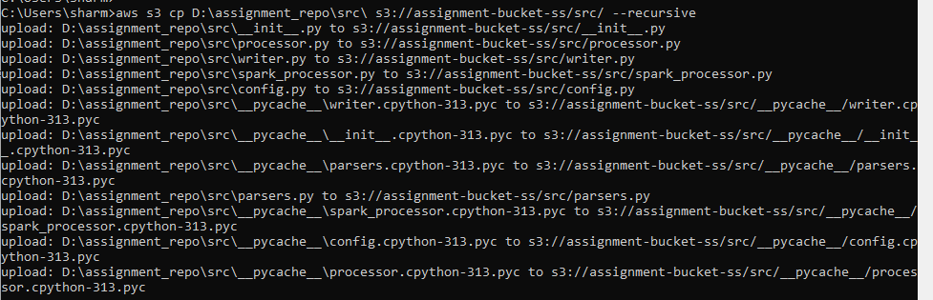

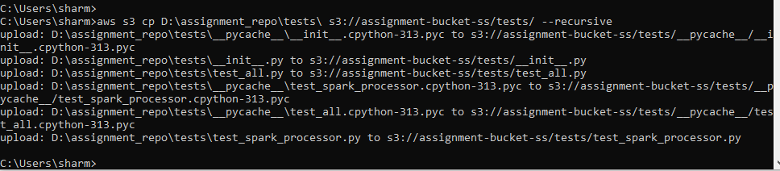

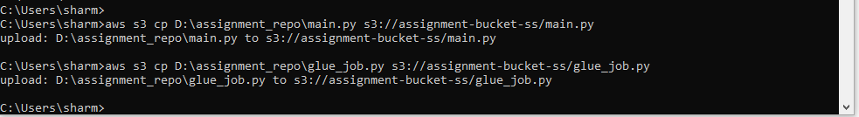

- Ec2 stack creation and code deployment and validation steps:

- Key value pair pem file creation :

aws ec2 create-key-pair --key-name assignment-key --region us-east-1 --query "KeyMaterial" --output text | Out-File -FilePath C:\Users\sharm\assignment-key.pem -Encoding ascii -NoNewline

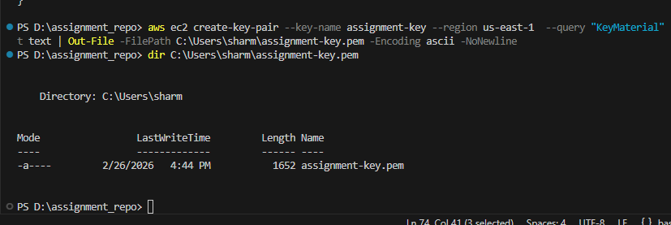

- Ec2 Stack deployment : aws cloudformation deploy --template-file D:\assignment_repo\infra\ec2_stack.yaml --stack-name assignment-ec2 --capabilities CAPABILITY_NAMED_IAM --region us-east-1 --parameter-overrides DataBucketName=assignment-bucket-ss KeyPairName=assignment-key
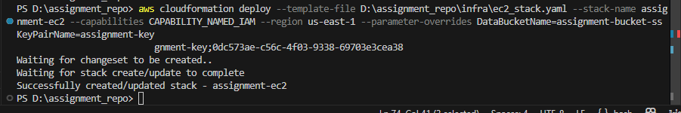

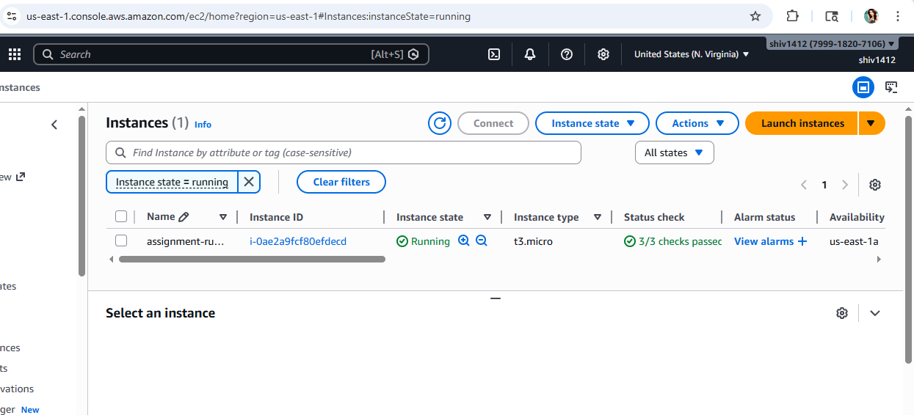

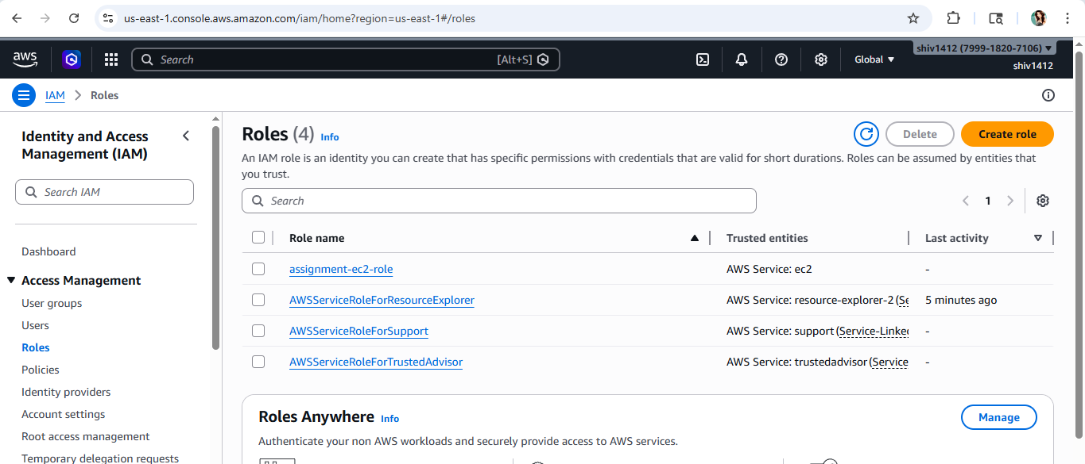

6. After ec2 stack is created we need to deploy the code to EC2 instance . This can be done in 2 ways either from local aws cli by doing a ssh connectivity or directly cloning the code from s3 bucket zipped file. Here are the steps by cloning the code from s3 bucket on ec2.

1. /bin/assignment_repo
2. aws s3 cp s3://assignment-bucket-ss/scripts/glue_job.py .
3 aws s3 cp s3://assignment-bucket-ss/scripts/src.zip .
4 aws s3 cp s3://assignment-bucket-ss/input/data.sql .

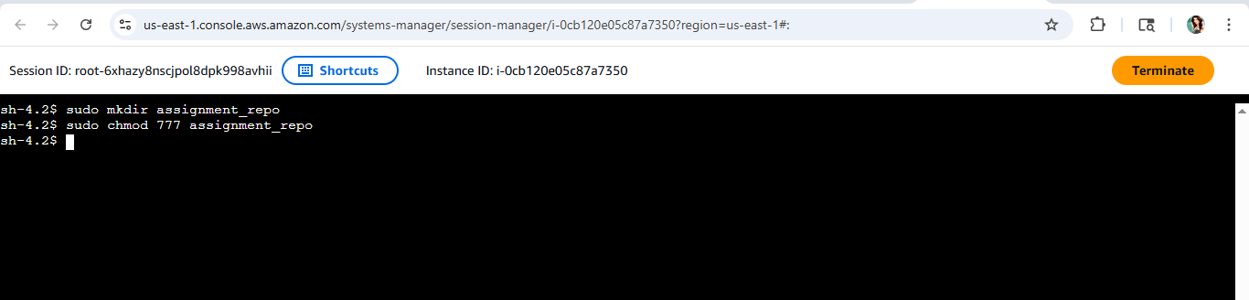

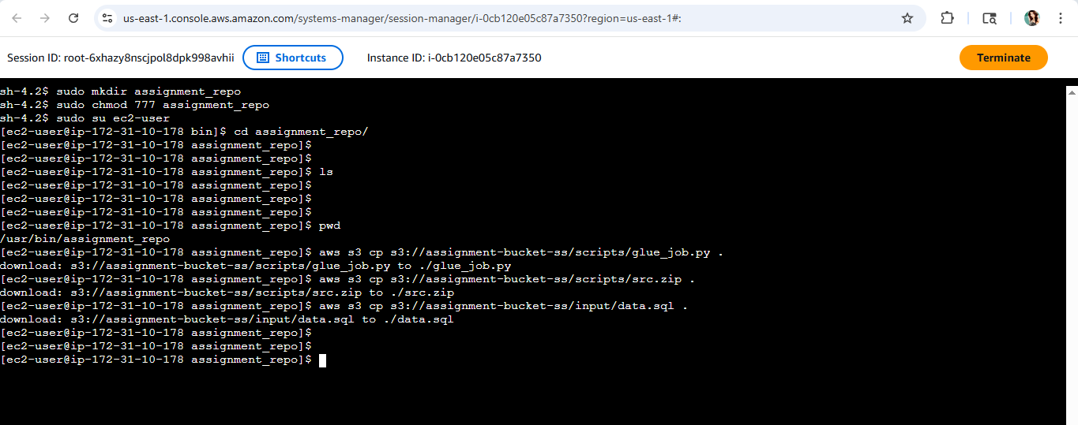

7. Then create a virtual environment using these commands one by one: python3 -m venv .venv and source .venv/bin/activate

8. Then unzip the src file and run the main.py file using this command python main.py data.sql

9. If we need to just deploy using a shell script then go to infra folder and simply run this shell script deploy_ec2.sh …. It will generate the output to the respective output folder.Below is the screenshot for execution of this shell script.

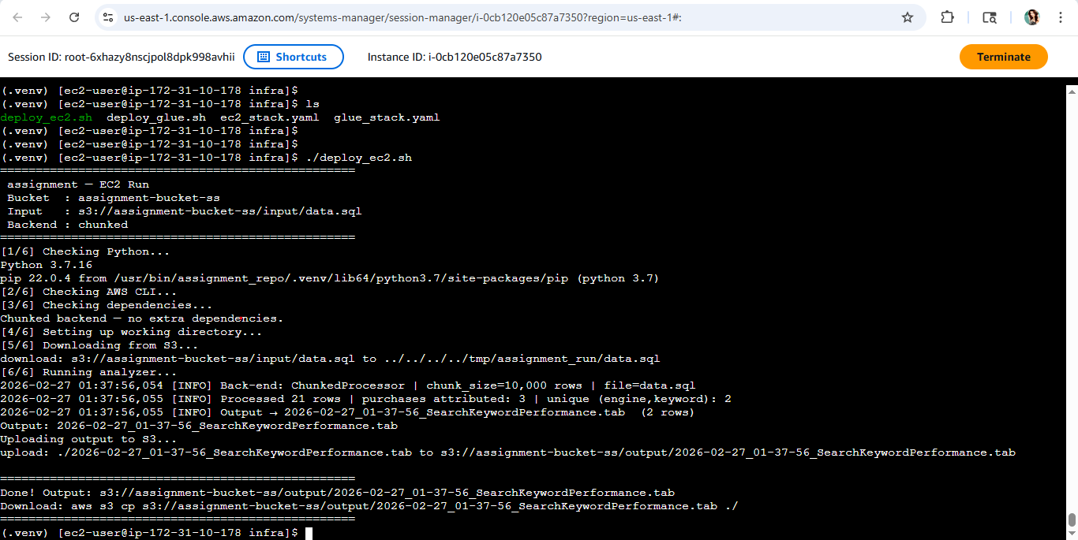

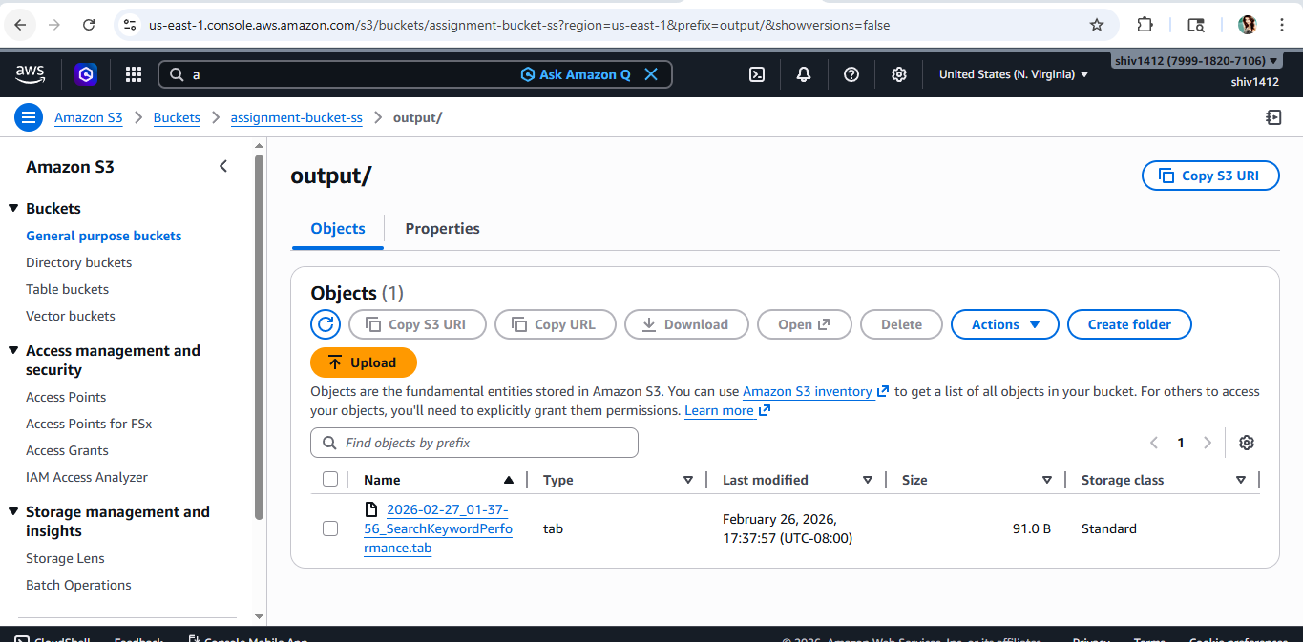

10. Now coming to the scaling part using spark and creating a glue job ,here are the Glue deployment steps to follow from local aws cli:

- Go to local path : cd D:\assignment_repo
- Then create a zip folder : Compress-Archive -Path src\ -DestinationPath src.zip -Force

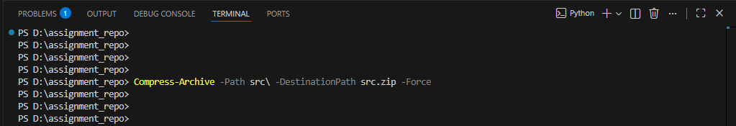

- Then copy glu_job.py script to s3 bucket using this command: C:\Users\sharm>aws s3 cp D:\assignment_repo\glue_job.py s3://assignment-bucket-ss/scripts/glue_job.py
upload: D:\assignment_repo\glue_job.py to s3://assignment-bucket-ss/scripts/glue_job.py

- Then copy the zipped src folder to s3 bucket : C:\Users\sharm>aws s3 cp D:\assignment_repo\src.zip s3://assignment-bucket-ss/scripts/src.zip
upload: D:\assignment_repo\src.zip to s3://assignment-bucket-ss/scripts/src.zip

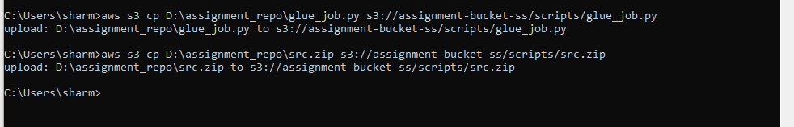

d. Then create the glue stack using this command from aws cli and wait for the message successfully created stack and go to aws glue and check the job appears in glue ETL jobs : aws cloudformation deploy --template-file D:\assignment_repo\infra\glue_stack.yaml --stack-name assignment-glue-stack --capabilities CAPABILITY_NAMED_IAM --region us-east-1 --parameter-overrides ProjectName=assignment-glue-stack DataBucketName=assignment-bucket-ss ScriptBucketName=assignment-bucket-ss

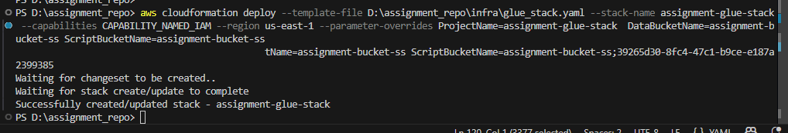

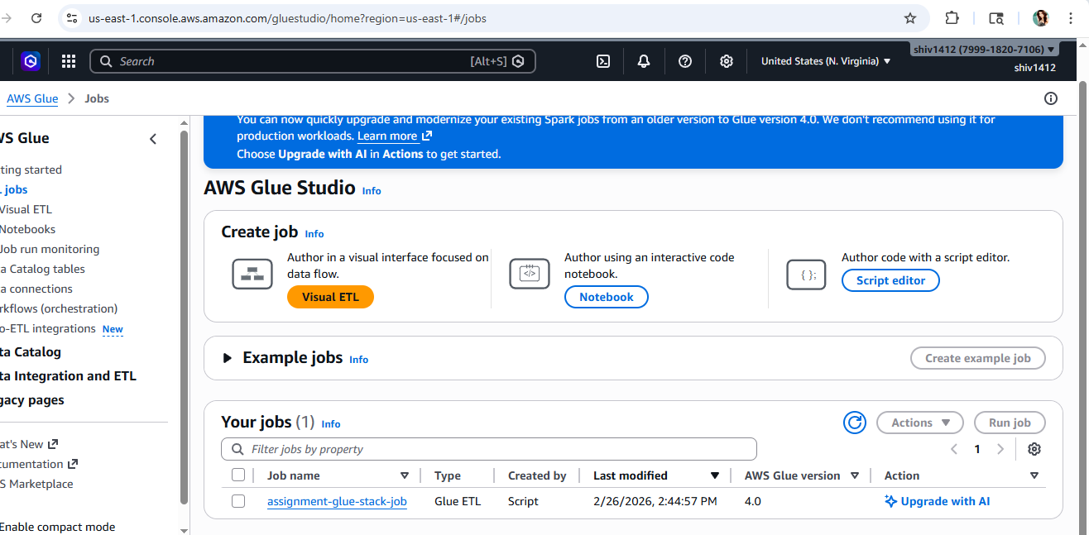

- THen run the glue job using this command from aws cli:
aws glue start-job-run --job-name assignment-glue-stack-job --region us-east-1
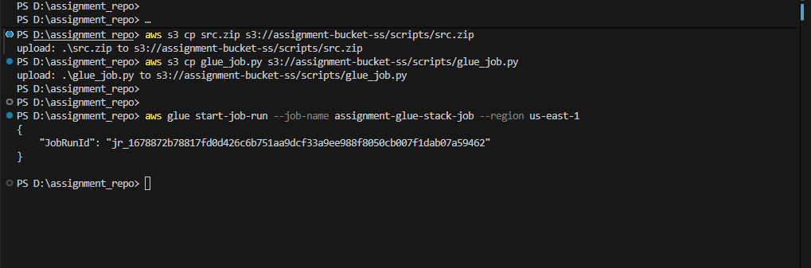

- THen go to aws glue and search for the job and go to the cloud watch logs to see the progress.

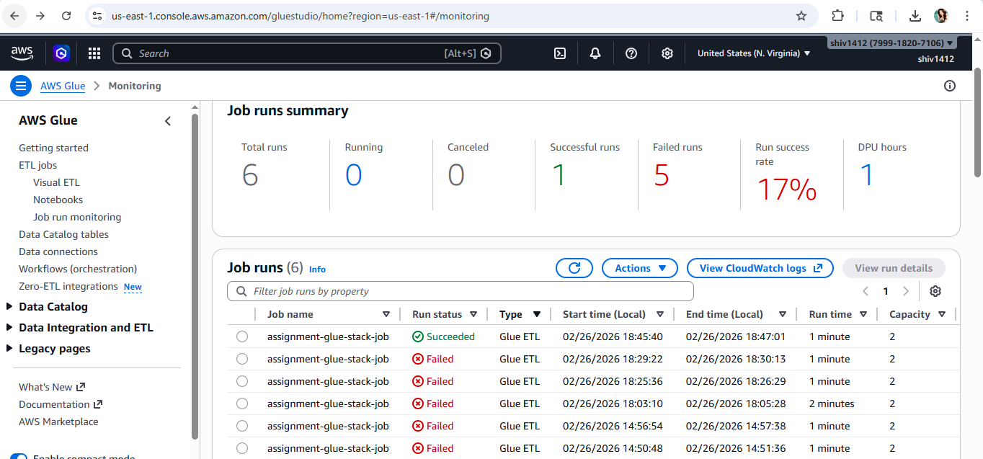

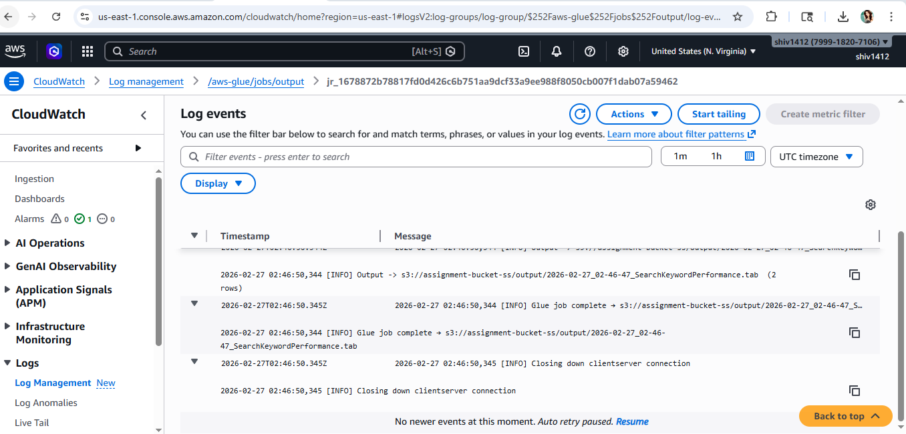

- Then once the job is succeeded then go to s3 bucket output path to validate if the file is created.

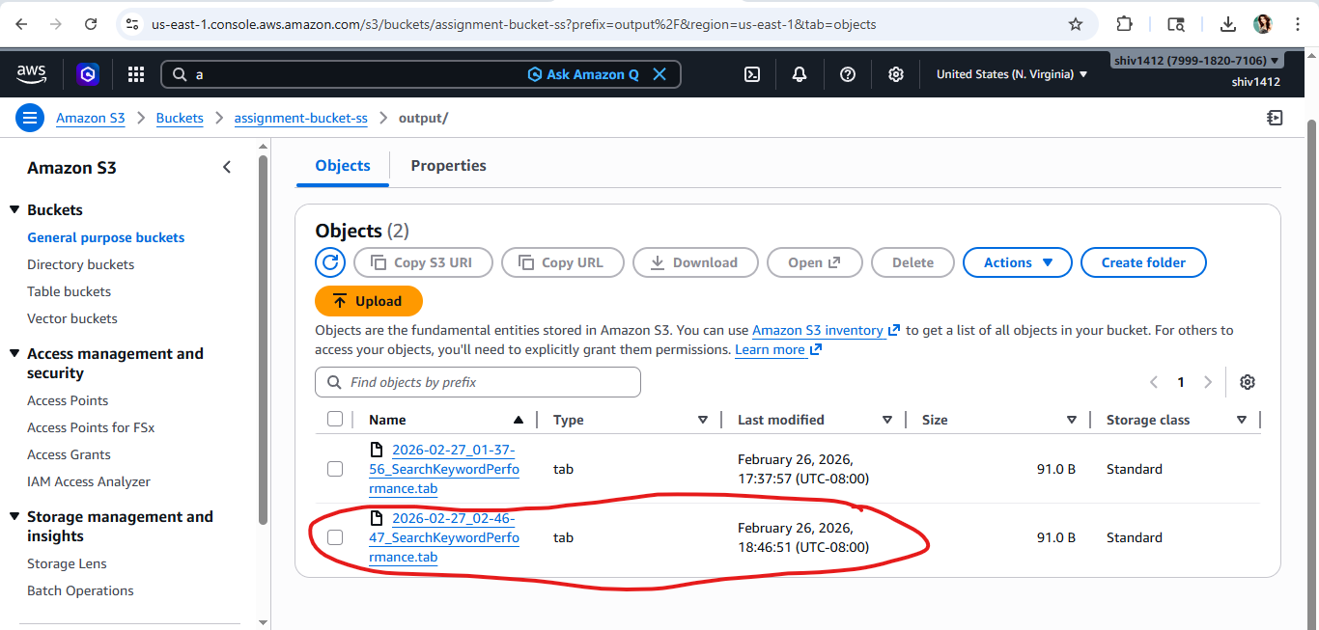

- Additionally if we want to see the aws glue job config we can simply trigger this command to see the config from aws cli locally : aws glue get-job --job-name assignment-glue-stack-job --region us-east-1

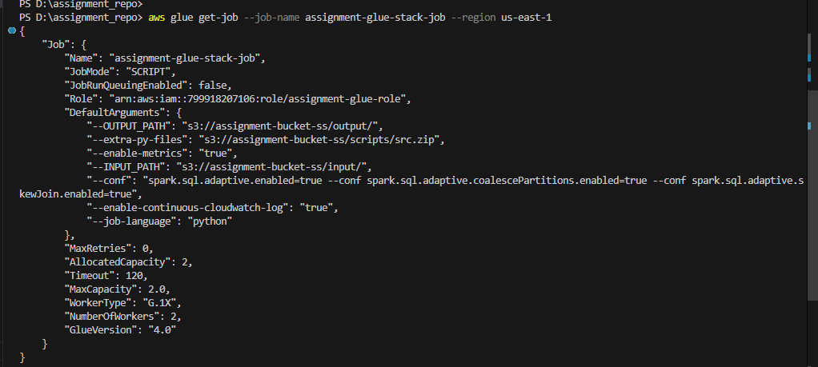

11. Here are the few unit test cases execution from local. Simply run this : python -m unittest tests/test_all.py -v

- Results from local:
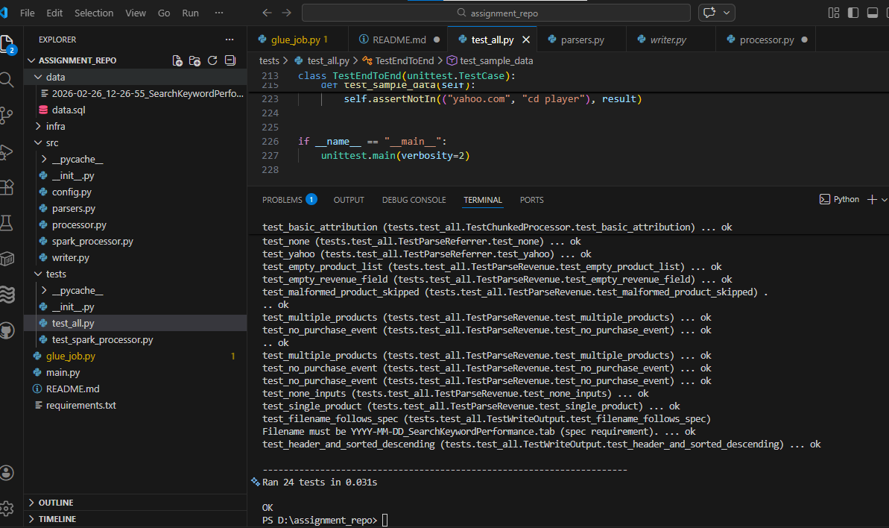

- Same command from ec2 instance
