Dsp-ap-nfs-space-monitoring

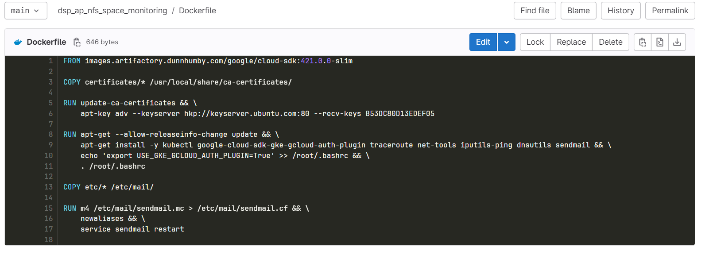

Daily Standup Bot

Daily-standup-bot.sh

#!/bin/bash

set -xeuo pipefail

TODAY=$(date +%Y-%m-%d)

POST_BODY='{title: "Standup '"$TODAY"'", text: "### *[This message was generated from Gitlab CI]('"${CI_JOB_URL-blank}"')* \n\n ## Current Focus \n\n - E.g., Incident, jira ticket, something else \n\n ## Blockers / Help / Something to share \n\n - E.g., Waiting for ServiceNow team to give me API access"}'

curl \

-H 'Content-Type: application/json' \

-d "$POST_BODY" "$WEBHOOK_URL"

Digicert expiring certs notification

Alert_expiring_certs.sh

#!/bin/bash

set -xuo pipefail

TODAY=$(date +%Y-%m-%d)

NINETY_DAYS_FROM_TODAY=$(date -d "90 days" +%Y-%m-%d)

FORTEEN_DAYS_AGO_FROM_TODAY=$(date -d "14 days ago" +%Y-%m-%d)

curl "https://www.digicert.com/services/v2/order/certificate?filters\[status\]=issued&filters\[valid_till\]=$TODAY...$NINETY_DAYS_FROM_TODAY" \

-H "Content-Type: application/json" \

-H "X-DC-DEVKEY: $DIGICERT_API_KEY" \

| jq -r '[.orders[]] | sort_by(.certificate.days_remaining) | .[] | ["- [\(.certificate.common_name)](https://www.digicert.com/secure/orders/\(.id)) expires on \(.order_valid_till) (in \(.certificate.days_remaining) days)"] | @tsv' > expiring_certs.tsv

curl "https://www.digicert.com/services/v2/order/certificate?filters\[status\]=issued&filters\[valid_till\]=$FORTEEN_DAYS_AGO_FROM_TODAY...$TODAY" \

-H "Content-Type: application/json" \

-H "X-DC-DEVKEY: $DIGICERT_API_KEY" \

| jq -r '[.orders[]] | sort_by(.certificate.days_remaining) | .[] | ["- [\(.certificate.common_name)](https://www.digicert.com/secure/orders/\(.id)) expired on \(.order_valid_till)"] | @tsv' > expired_in_past_14_days_certs.tsv

NUMBER_OF_CERTS=$( wc -l < expiring_certs.tsv )

NUMBER_OF_CERTS_EXPIRED_INPAST_14_DAYS=$( wc -l < expired_in_past_14_days_certs.tsv )

echo "Certs Expired in past 14 days" "$NUMBER_OF_CERTS_EXPIRED_INPAST_14_DAYS"

POST_BODY=$(jq -sR '{title: "'"$NUMBER_OF_CERTS"' Digicert certificates expiring before '"$NINETY_DAYS_FROM_TODAY"'", text: "### *[This message was generated from Gitlab CI]('"$CI_JOB_URL"')* \n\n \(.)"}' < expiring_certs.tsv )

curl \

-H 'Content-Type: application/json' \

-d "$POST_BODY" "$WEBHOOK_URL"

if [ -z "$NUMBER_OF_CERTS_EXPIRED_INPAST_14_DAYS"] || [ "$NUMBER_OF_CERTS_EXPIRED_INPAST_14_DAYS" == 0] ; then

POST_BODY_EXPIRED_CERTS='{title: "No Certs Expired in past 14 days"}'

else

POST_BODY_EXPIRED_CERTS=$(jq -sR '{title: "'"$NUMBER_OF_CERTS_EXPIRED_INPAST_14_DAYS"' Digicert certificates expired in past 14 days", text: "### *[This message was generated from Gitlab CI]('"$CI_JOB_URL"')* \n\n \(.)"}' < expired_in_past_14_days_certs.tsv)

fi

curl \

-H 'Content-Type: application/json' \

-d "$POST_BODY_EXPIRED_CERTS" "$WEBHOOK_URL"

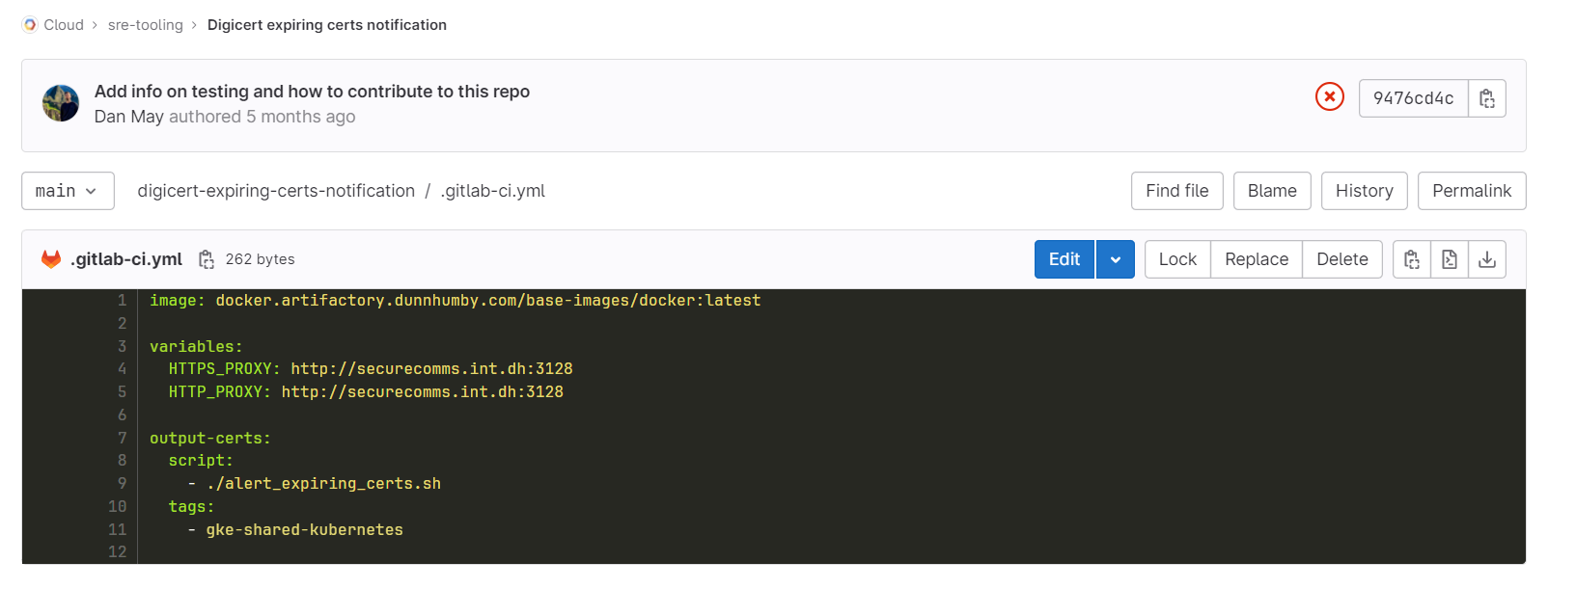

Internal cert renewal

Download_pem.sh

#!/bin/bash

set -xeuo pipefail

ORDER_ID=$1

curl -s "https://www.digicert.com/services/v2/certificate/download/order/$ORDER_ID/format/pem_noroot" \

-H 'Content-Type: application/json' \

-H "X-DC-DEVKEY: $DIGICERT_API_KEY"

Get_core_config.sh

#!/usr/bin/env bash

STACK_NAME=$1

if [ "$#" -lt 1 ]; then

echo "Please provide STACK NAME as the first argument"

exit 1

fi

echo "Copying config from gs://${STACK_NAME}-config"

gsutil -q cat "gs://${STACK_NAME}-config/core.json" | jq . > core.json

gsutil -q cat "gs://${STACK_NAME}-config/k8s.json" | jq . > k8s.json

export PROJECT=$(jq .project core.json -r)

export docker_repo=$(jq .docker_repo core.json -r)

export CLUSTER_DNS=$(jq .cluster_dns k8s.json -r)

export CLUSTER_NAME=$(jq .cluster_name k8s.json -r)

export REGION=$(jq .region core.json -r)

export ZONE=$(jq .zone core.json -r)

export WEBUSERPROXY_DOMAIN=$(jq .webuserproxy_domain core.json -r)

export DEPLOYMENT_PREFIX=$(jq .deployment_prefix core.json -r)

renew_cert.sh

#!/bin/bash

set -xeuo pipefail

ORDER_ID=$1

# Constants

ORG_ID=350086 # dunnhumby Ltd

CONTAINER_ID=394398 # CloudOperations

REPO_URL="https://dhgitlab.dunnhumby.co.uk/Cloud/sre-tooling/internal-cert-renewal"

APACHE_SERVER_PLATFORM_ID=2

EXPIRING_ORDER_DETAILS=$( curl -s "https://www.digicert.com/services/v2/order/certificate/$ORDER_ID" \

-H "Content-Type: application/json" \

-H "X-DC-DEVKEY: $DIGICERT_API_KEY" )

CSR=$( echo $EXPIRING_ORDER_DETAILS | jq '.certificate.csr' )

CN=$( echo $EXPIRING_ORDER_DETAILS | jq '.certificate.common_name' )

DNS=$( echo $EXPIRING_ORDER_DETAILS | jq '.certificate.dns_names' )

EXPIRES_AT=$( echo $EXPIRING_ORDER_DETAILS | jq '.certificate.valid_till' )

IS_RENEWED=$( echo $EXPIRING_ORDER_DETAILS | jq '.is_renewed' )

WAS_RENEWED_BY_ORDER_ID=$( echo $EXPIRING_ORDER_DETAILS | jq '.was_renewed_by_order_id' )

if [[ "$IS_RENEWED" == "true" ]]; then

echo "This order is not the latest one, maybe someone has already tried to renew this certificate???"

echo "Found a more recent order with id $WAS_RENEWED_BY_ORDER_ID. Please check if this certificate still requires renewal by looking at the new order."

echo "Aborting renewal process as a more recent order was found!"

exit 1

fi

RENEWED_ORDER_DETAILS=$( curl -s -X POST \

https://www.digicert.com/services/v2/order/certificate/ssl_securesite_flex \

-H "Content-Type: application/json" \

-H "X-DC-DEVKEY: $DIGICERT_API_KEY" \

-d '{

"certificate": {

"common_name": '"$CN"',

"dns_names": '"$DNS"',

"csr": '"$CSR"',

"signature_hash": "sha256",

"server_platform": {

"id": '$APACHE_SERVER_PLATFORM_ID'

}

},

"comments": "Renewed by '$REPO_URL'",

"container": {

"id": '$CONTAINER_ID'

},

"custom_renewal_message": "Renewed by '$REPO_URL'",

"organization": {

"id": '$ORG_ID'

},

"order_validity": {

"years": 1

},

"renewal_of_order_id": '$ORDER_ID'

}' )

RENEWED_ORDER_ID=$( echo $RENEWED_ORDER_DETAILS | jq '.id' )

export RENEWED_ORDER_ID=$RENEWED_ORDER_ID

export EXPIRES_AT=$EXPIRES_AT

revoke.sh

#!/bin/bash

set -xeuo pipefail

curl --request PUT "https://www.digicert.com/services/v2/order/certificate/$ORDER_ID/revoke" \

-H 'Content-Type: application/json' \

-H "X-DC-DEVKEY: $DIGICERT_API_KEY" \

--data-raw '{

"skip_approval": true

}'

#!/usr/bin/env bash

for i in "$@"

do

case $i in

--region=*)

REGION="${i#*=}"

shift # past argument=value

;;

--project=*)

PROJECT="${i#*=}"

shift # past argument=value

;;

--cluster_name=*)

CLUSTER_NAME="${i#*=}"

shift # past argument=value

;;

--master_custom_dns=*)

MASTER_CUSTOM_DNS="${i#*=}"

shift # past argument=value

;;

--default)

DEFAULT=YES

shift # past argument with no value

;;

*)

# unknown option

;;

esac

done

KUBECONFIG_CLUSTER=gke_"$PROJECT"_"$REGION"_"$CLUSTER_NAME"

echo "Manipulating kubeconfig entry using cluster: $KUBECONFIG_CLUSTER"

# We would like to communicate to the GKE API server, which is exposed on a public IP address.

# We can't do this because these public IP addresses are no whitelisted by the hybrid securecomms instance,

# But .dunnhumby.cloud *is* whitelisted (and securecomms can do DNS resolution)

# So, we create a Cloud DNS A record with the public address of the GKE API server

# We also need to skip TLS because the certificate that is presented by the GKE APi server is only valid for:

# kubernetes, kubernetes.default, kubernetes.default.svc, kubernetes.default.svc.cluster.local, <API_PUBLIC_IP>, <API_INTERNAL_IP>

gcloud config set component_manager/disable_update_check true

gcloud container clusters get-credentials --project="${PROJECT}" --region="${REGION}" "${CLUSTER_NAME}"

kubectl config set "clusters.$KUBECONFIG_CLUSTER.server" "https://$MASTER_CUSTOM_DNS"

kubectl config set "clusters.$KUBECONFIG_CLUSTER.insecure-skip-tls-verify" true

kubectl config set "clusters.$KUBECONFIG_CLUSTER.proxy-url" "http://securecomms.int.dh:3128"

kubectl config unset "clusters.$KUBECONFIG_CLUSTER.certificate-authority-data"

validate.sh

#!/bin/bash

set -xeuo pipefail

exit 0

gitlab.ci.yml

variables:

HTTPS_PROXY: http://securecomms.int.dh:3128

HTTP_PROXY: http://securecomms.int.dh:3128

ORDER_ID:

description: "The Digicert order id we want to renew"

STACK:

description: "`<stack_name>/config` file from Cloud > clients > client E.g., `cds-wfm-pre` for internal.pre.cds-wholefoods"

default:

image: docker.artifactory.dunnhumby.com/cs-core/ceng-deploy:master

tags:

- gke-shared-kubernetes

stages:

- renew

- rotate

- validate

- revoke

renew-cert:

stage: renew

rules:

- when: manual

script:

- source renew_cert.sh $ORDER_ID

- echo "RENEWED_ORDER_ID=$RENEWED_ORDER_ID" >> cert.env

- echo "EXPIRES_AT=$EXPIRES_AT" >> cert.env

artifacts:

reports:

dotenv: cert.env

publish-new-cert-pem:

stage: renew

script:

- ./download_pem.sh $RENEWED_ORDER_ID > cert.pem

- cp cert.pem cert.cer

- cp cert.pem cert.crt

needs: ["renew-cert"]

artifacts:

paths:

- cert.cer

- cert.crt

- cert.pem

rotate-istio-tls-secret:

stage: rotate

script:

- echo $GCP_APP_CREDS_JSON > ~/gcp-app-creds-key.json

- GOOGLE_APPLICATION_CREDENTIALS=~/gcp-app-creds-key.json

- GOOGLE_APPLICATION_CREDENTIALS_CONTENT=${GCP_APP_CREDS_JSON}

- gcloud auth activate-service-account --key-file=$GOOGLE_APPLICATION_CREDENTIALS

- source get_core_config.sh ${STACK}

- gcloud config set project ${PROJECT}

- gsutil cp gs://gcp-project-certs/internal.${WEBUSERPROXY_DOMAIN}/internal.${WEBUSERPROXY_DOMAIN}.key cert.key

- bash setup_kubeconfig.sh --region=${REGION} --cluster_name=${CLUSTER_NAME} --project=${PROJECT} --master_custom_dns=${CLUSTER_DNS}

- kubectl delete secret -n istio-system istio-ingressgateway-certs

- kubectl create secret -n istio-system tls istio-ingressgateway-certs --key cert.key --cert cert.crt

- kubectl delete pod -n istio-system -l app=istio-ingressgateway -l istio=ingressgateway

needs: ["publish-new-cert-pem"]

validate:

stage: validate

script:

- ./validate.sh

needs: ["renew-cert", "rotate-istio-tls-secret"]

revoke:

stage: revoke

script:

- ./revoke.sh

needs: ["validate"]