**Web Chat Application**

**PROJECT SYNOPSIS**

FOR THE FULLFILLMENT OF

**MASTER OF COMPUTER APPLICATIONS**

SUBMITTED BY

SHIVANSH SETHI ( 2101206 ) Sec A

&

HEMESH MAHRA ( 2101079 ) Sec B



**GRAPHIC ERA HILL UNIVERSITY, DEHRADUN**

**Title**

Web Chat Application - A Full-Stack Web Project

**Introduction**

Web Chat Application is a full-stack web project that aims to provide real-time chat functionality to its users. The application targets individuals who want to connect with their friends, family, or colleagues in real-time, regardless of their location.

The project uses HTML, CSS, JavaScript, MongoDB, React, and Node.js technologies to develop a user-friendly and secure platform.

**Requirement Analysis**

The Web Chat Application project aims to address the need for a secure and user-friendly platform that provides real-time chat functionality. The project requirements include user authentication and authorization, real-time messaging, data storage and retrieval, and a responsive and intuitive user interface.

**Methodology**

The methodology for the development of the web chat application project will be an agile methodology.

The agile methodology will allow for a flexible and iterative approach to software development, focusing on delivering a working product in small increments, while continuously improving and refining the application.

The agile methodology will be implemented using the following process:

1. **Planning**: In this stage, the project team will identify the project requirements, prioritize the features to be developed, and create a project plan.
2. **Design**: In this stage, the team will create wireframes, prototypes, and mockups of the user interface and design the software architecture.
3. **Development**: In this stage, the development team will start building the software application, including the front-end and back-end components.
4. **Testing**: In this stage, the testing team will conduct unit tests, integration tests, and acceptance tests to ensure that the application meets the requirements.
5. **Deployment**: In this stage, the application will be deployed to the production environment, and the project team will monitor the application to ensure that it is functioning correctly.
6. **Maintenance**: In this stage, the project team will fix any bugs or issues that arise after deployment, maintain the application, and make updates as needed.

The agile methodology will allow the project team to deliver a high-quality product that meets the project requirements, while also being flexible enough to adjust to changes in the requirements or project scope.

The methodology will also allow the team to incorporate feedback from stakeholders throughout the development process, ensuring that the final product meets the needs of the end-users.

Overall, the use of the agile methodology for the development of the web chat application project will enable the team to efficiently develop, test, and deploy the application while ensuring that it meets the needs of the end-users.

1. Data Flow Diagram:

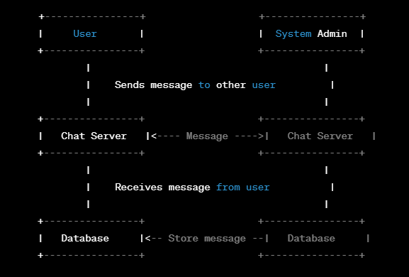

Figure : Data Flow Diagram

2.ER Diagram:

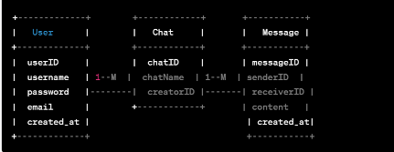

                                                          Figure : ER Diagram

3.Database, Table and Data Structure Design :

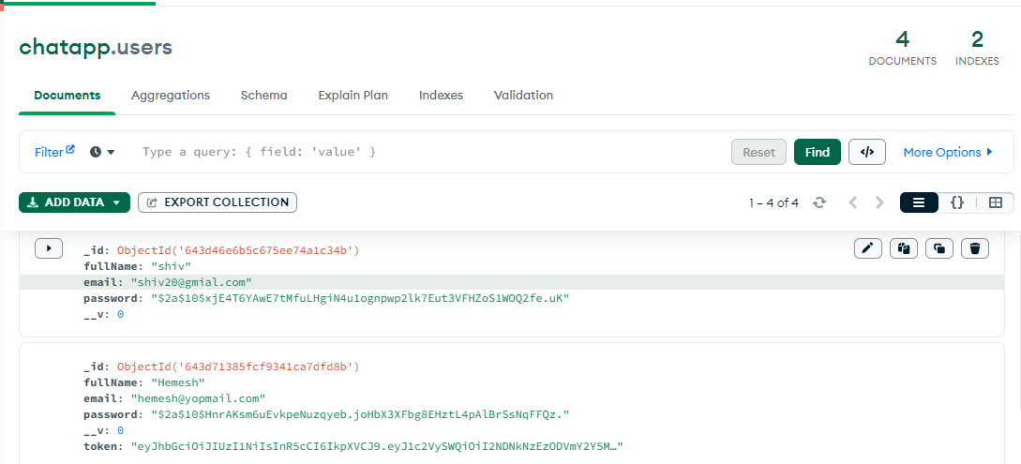

Figure 3: Database, Table & Data Structure Design

**Architecture**

The Web Chat Application will use a client-server architecture, where the front-end and back-end will communicate with each other through RESTful APIs. The front-end will be responsible for displaying the user interface and sending requests to the back-end, while the back-end will process requests and manage user data.

**Technical Requirements**

The Web Chat Application project will require the following technologies and tools:

* HTML, CSS, and JavaScript for front-end development
* Node.js and MongoDB for back-end development
* React for building user interfaces
* Bootstrap for making the website responsive

Bibliography

* <https://nodejs.org/en/>
* <https://www.mongodb.com/>
* <https://reactjs.org/>
* <https://getbootstrap.com/>
* <https://www.w3schools.com/>
* <https://developer.mozilla.org/>
* https://stackoverflow.com/Top of Form