**BUSINESS PROBLEM**

Build And Automate Machine Learning Model To Predict Used Car Price On Cloud.

**ARCHITECTURE**

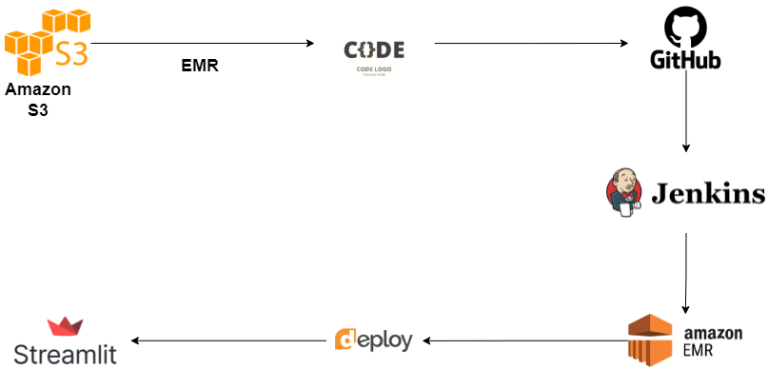

**DATASET**

<https://drive.google.com/drive/folders/1uGHbncdG-o09YYev4ihW8SSq-yjhbvsQ>

**POSSIBLE TOOLS AND TECHNOLOGIES**

* AWS EMR, S3
* GITHUB
* JENKINS
* JUPYTER NOTEBOOK ­
* PYTHON
* STREAMLIT