**Session 1, Assignment 1**

**Problem Statement**:

1. Install Node JS.

2. Check if node is installed on your machine or not through cmd.

3. Check node and npm version.

**Solutions** (Steps + Commands + Screenshots)

Solution 1:

Step 1: Go to https://nodejs.org/en/

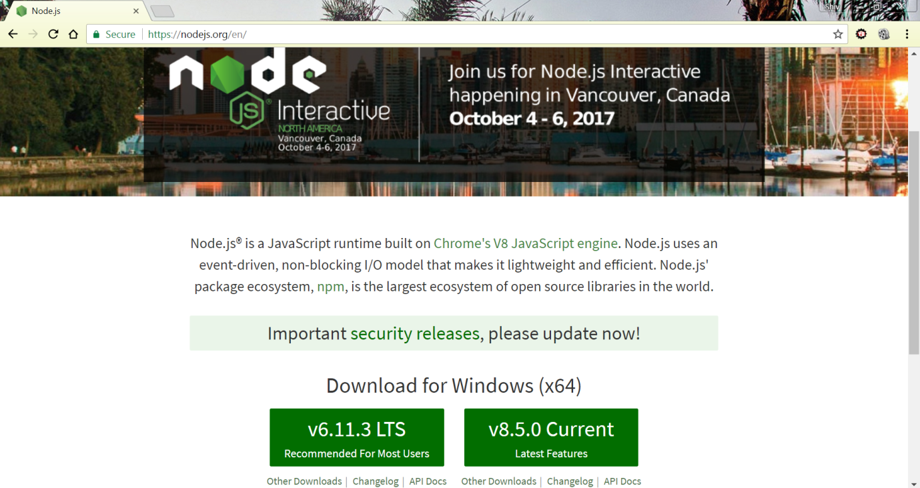

Step 2: Click on Download for Windows(x64), 8.5.0 Current (Latest Features). This downloads the installation file on the computer.

Step 3: Double click on the downloaded file. This opens up the installation window.

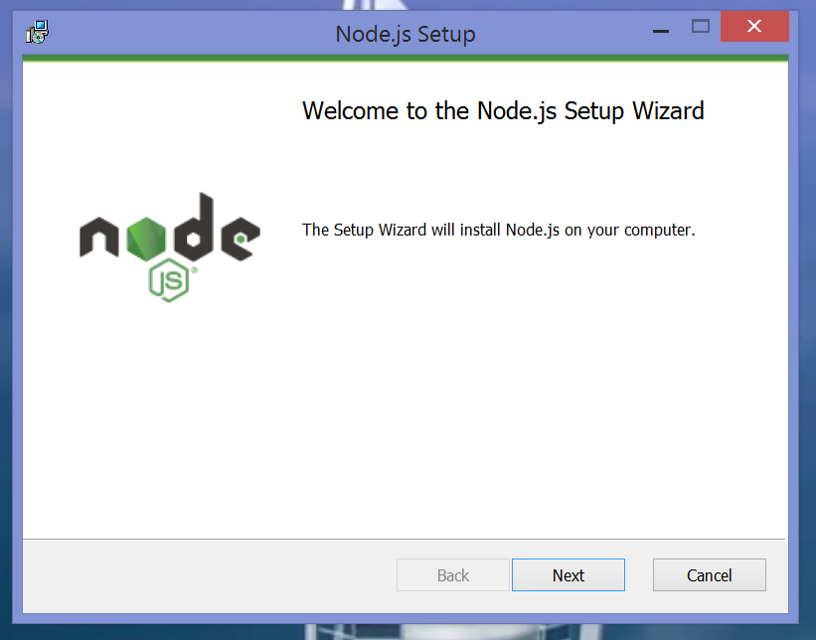

Step 4: Go through the installation process by clicking Next.

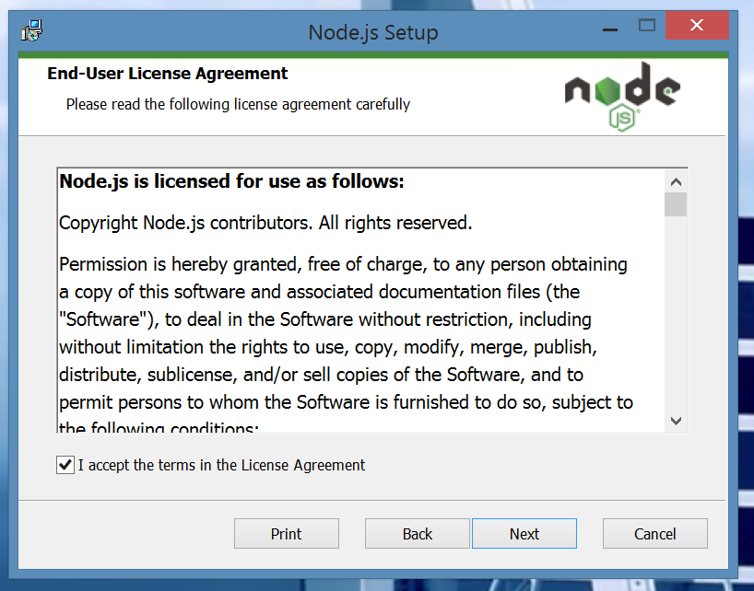

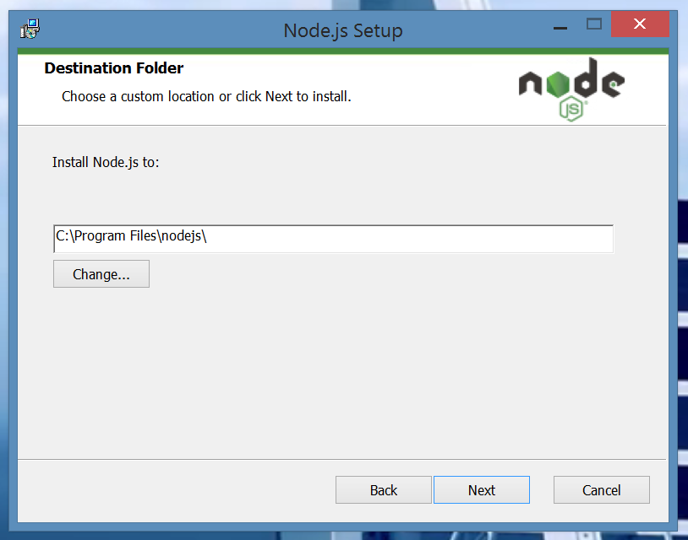

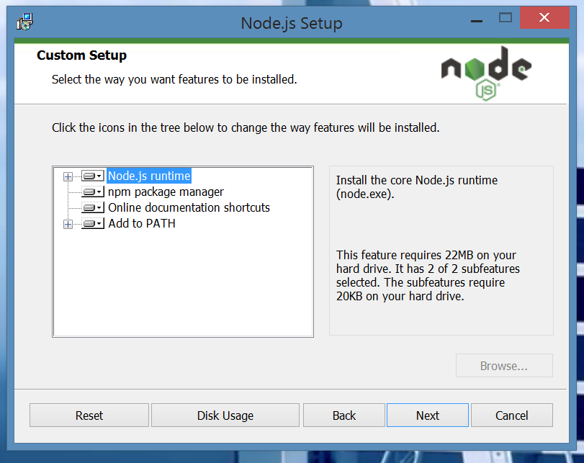

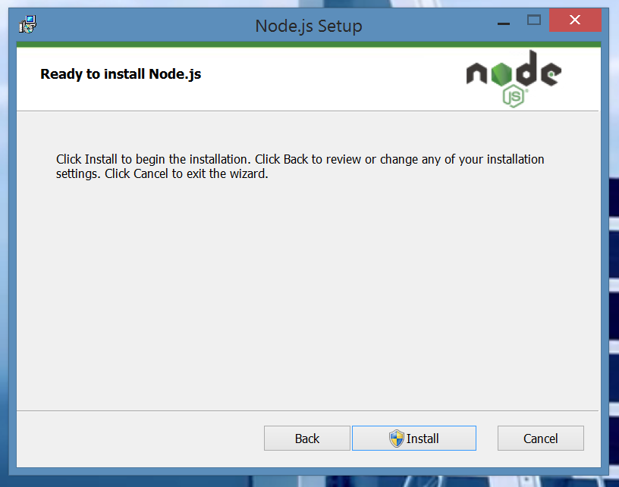

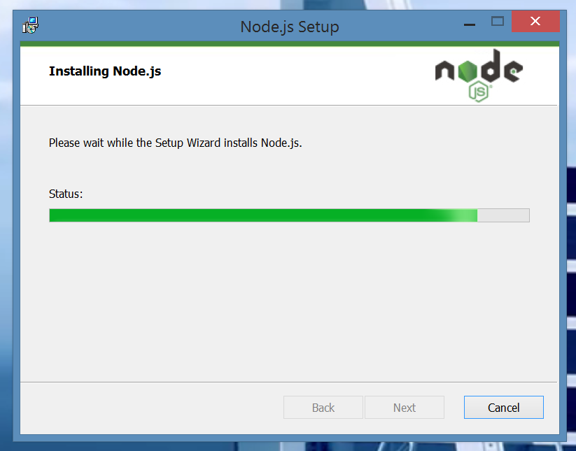

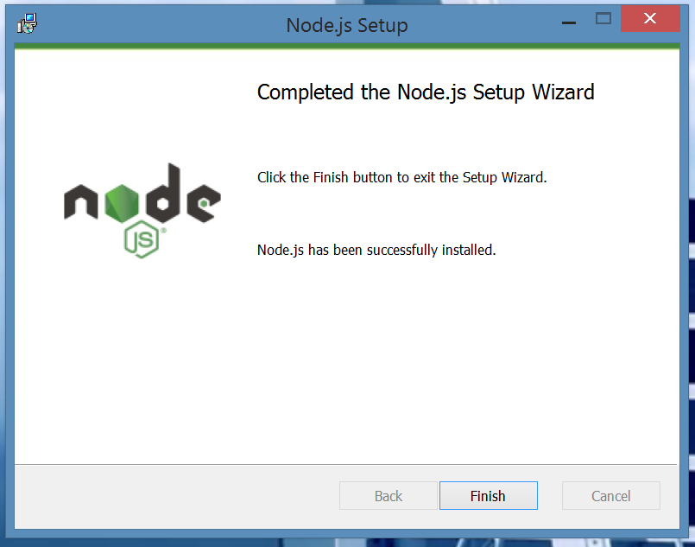

Step 5: Click on Finish. Now, the Node JS has been successfully installed on the computer.

Solution 2:

Step 1: Open Command Prompt.

Step 2: Type and run the command ***node --version***

Command: node --version

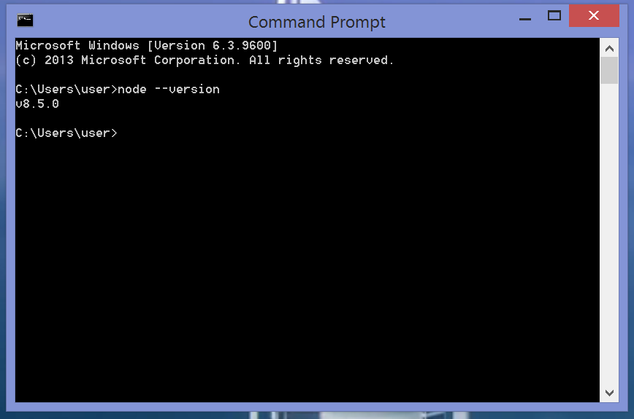

Step 3: Since the Command Prompt shows the version number of Node JS as v8.5.0, Node JS is successfully installed.

Solution 3:

Step 1: Open Command Prompt.

Step 2: Type and run the commands ***node --version*** and ***npm --version***

Commands: 1. node --version

2. npm --version

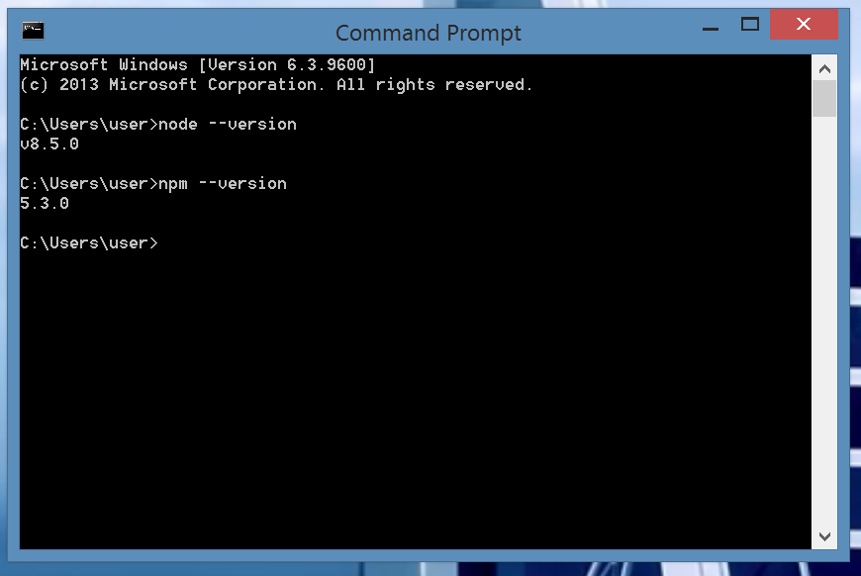

Step 3: The version numbers of Node JS and NPM are,

Node JS: 8.5.0

NPM: 5.3.0