**Assignment 1.2**

**Problem Statement**:

1. Install Angular cli through npm.

2. Check angular cli version.

3. Create new project with Angular CLI through cmd.

4. Run the project and navigate to the*http://localhost:4200/*

**Solutions** (Steps + Commands + Screenshots)

Solution 1:

Step 1: Open Command Prompt.

Step 2: Type and run the command ***npm install -g @angular/cli***

Command: npm install -g @angular/cli

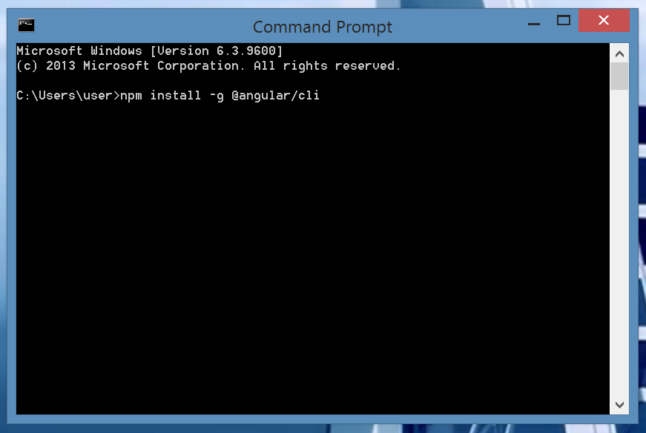

This starts the Angular CLI installation.

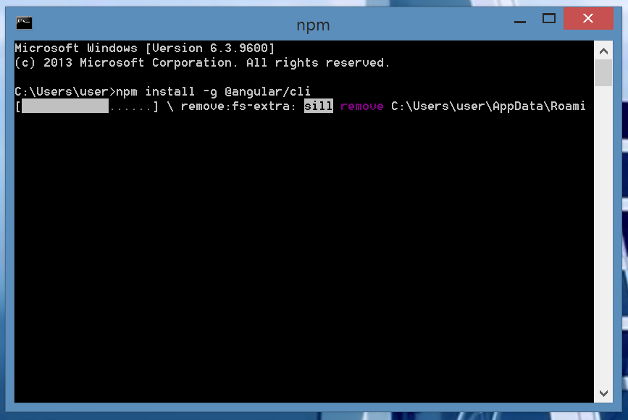

Step 3: Once the installation is complete we get the message ***@angular/cli@1.4.2***

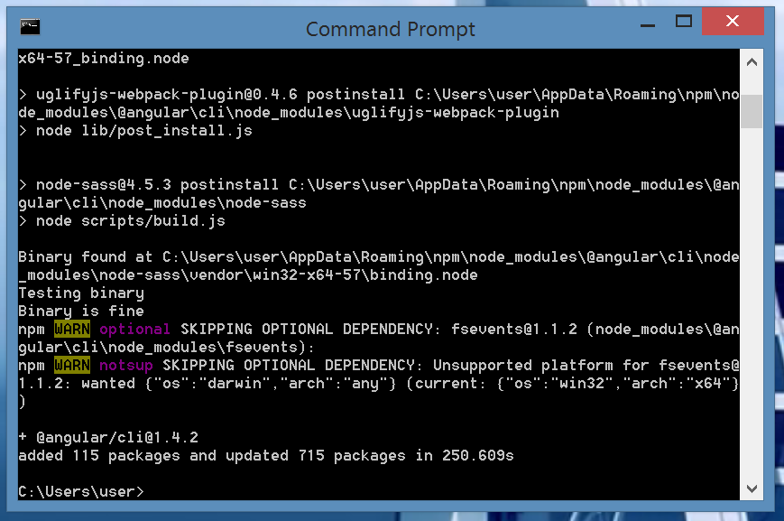

Now, the installation of Angular CLI through NPM is complete.

Solution 2:

Step 1: Open Command Prompt.

Step 2: Type and run the command ***ng --version***

Command: ng --version

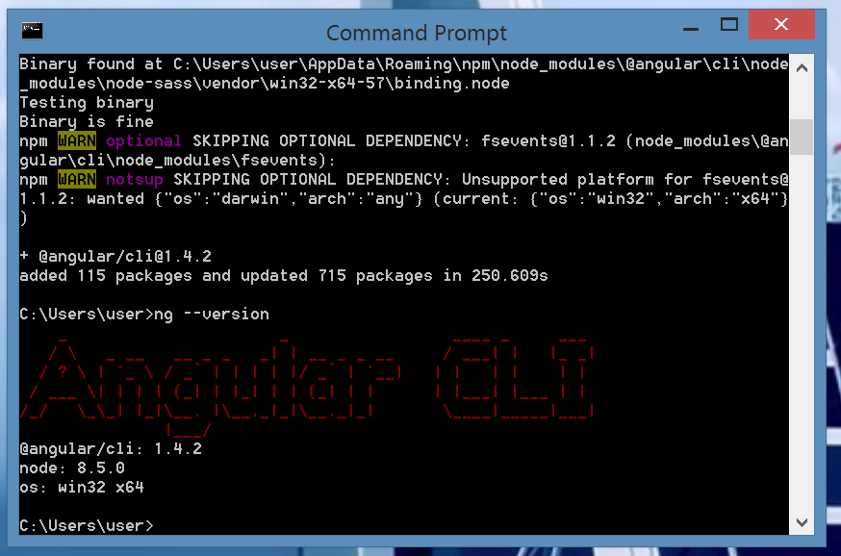

Step 3: The version number of Angular CLI is 1.4.2

Solution 3:

Step 1: Open Command Prompt and go to the folder in which the project needs to be created.

Step 2: Type and run the command ***ng new FirstProject.*** This command starts creating a new project.

Command: ng new FirstProject

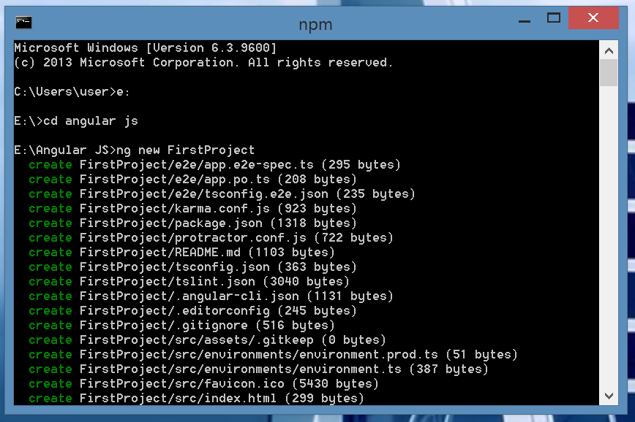

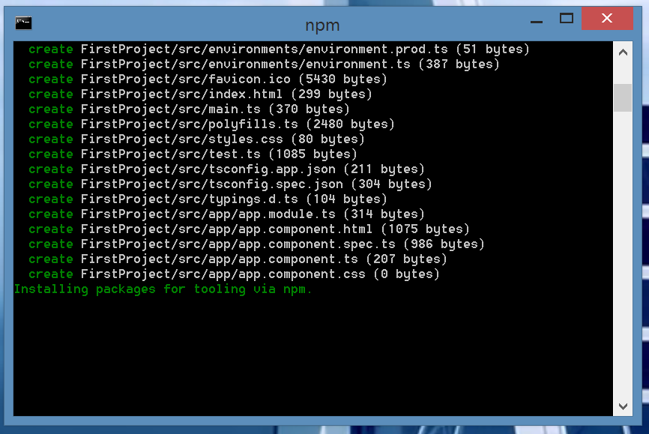

Step 3: Once the project is created we get the success message ***Project 'FirstProject' successfully created***.

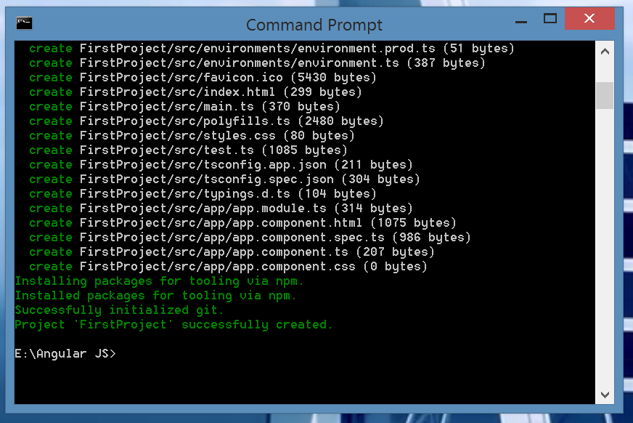

Now, the project has been successfully created.

Solution 4:

Step 1: To run the project go to the project folder through command line.

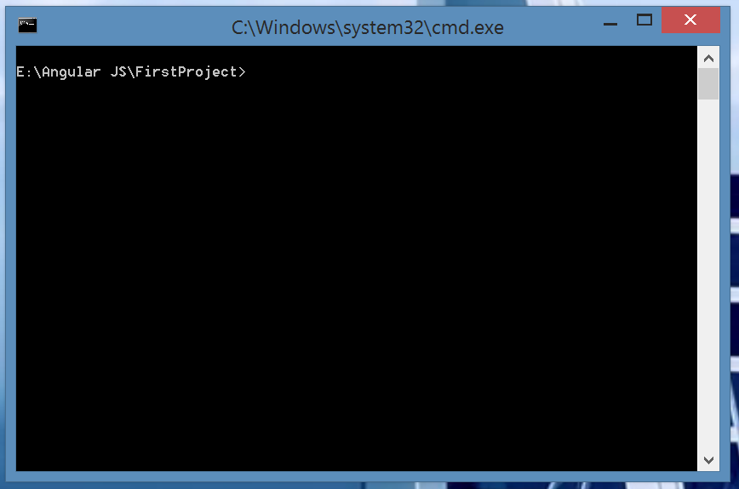

Step 2: Type and run the command ***ng serve***. This will start the compilation of the project.

Command: ng serve

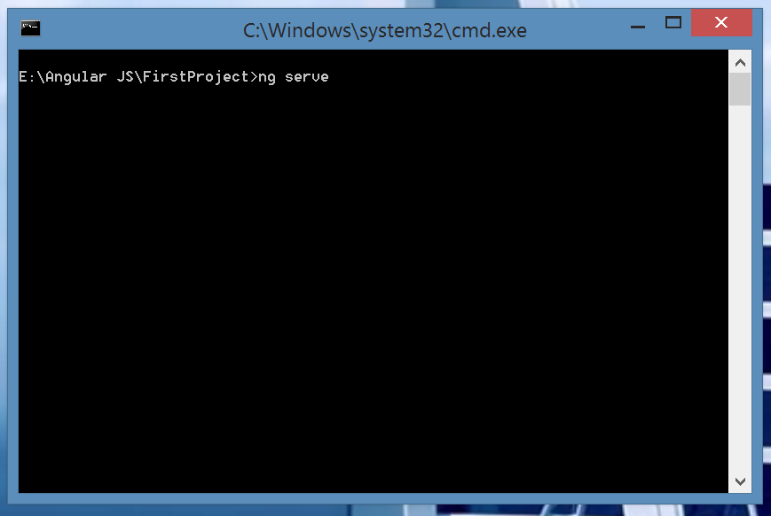

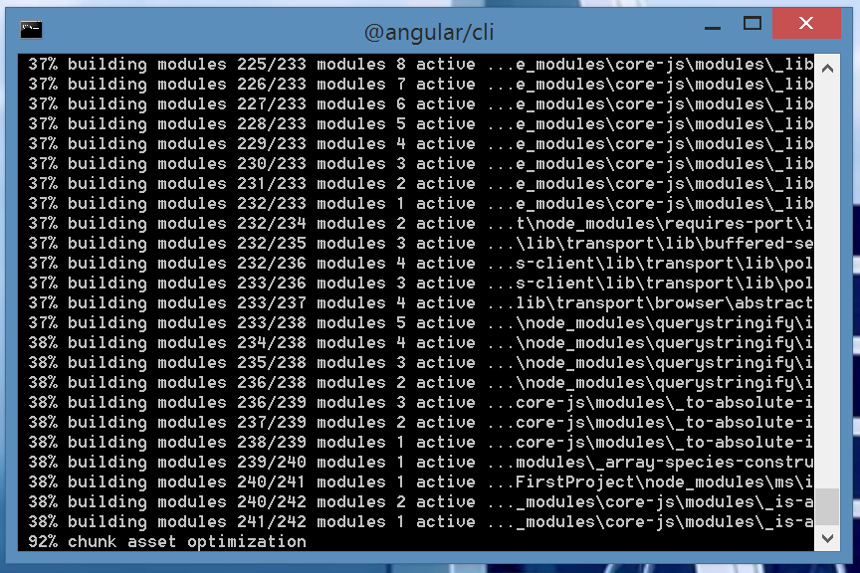

Step 3: Once the compilation is complete we get a success message ***webpack: Compiled Successfully***

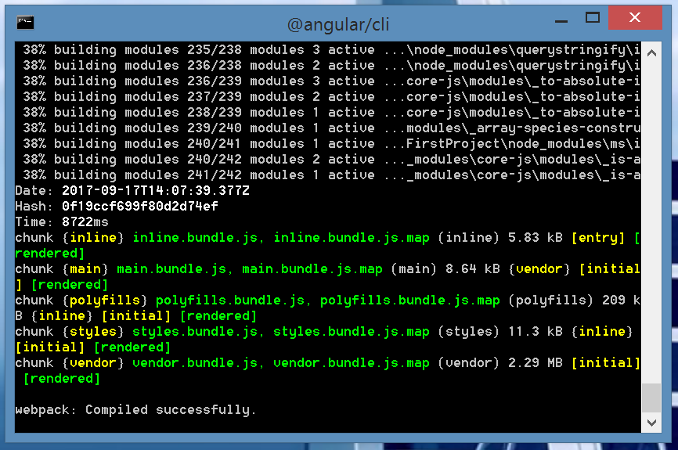

Step 4: To run the project go to web browser and type the URL ***http://localhost:4200***

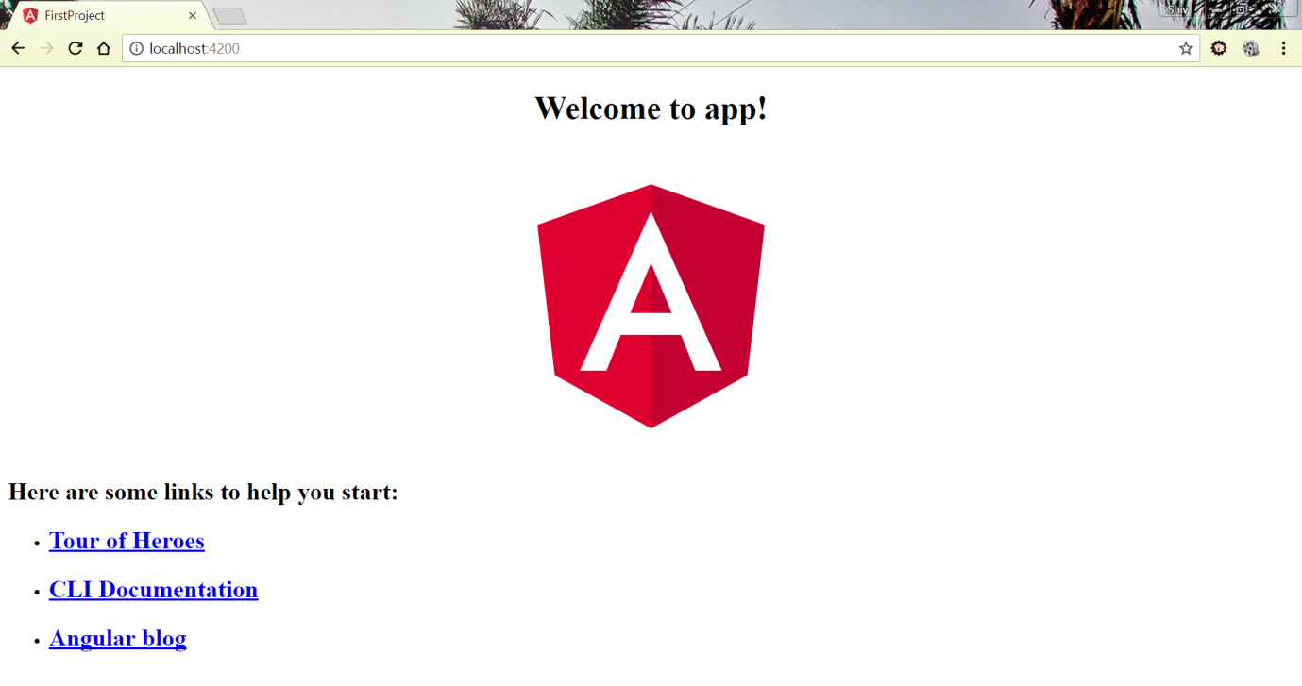

Since we see the message ***Welcome to app!*** we have successfully complied and run the project.