**Session 1, Assignment 3**

**Problem Statement**:

1. Clone the project from Angular Github seed.

2. Install all the packages in the project.

3. Start the project using npm start.

**Solutions** (Steps + Commands + Screenshots)

Solution 1:

Step 1: Open Visual Studio Code.

Step 2: Select ***Clone Git Repository...*** from the Welcome page.

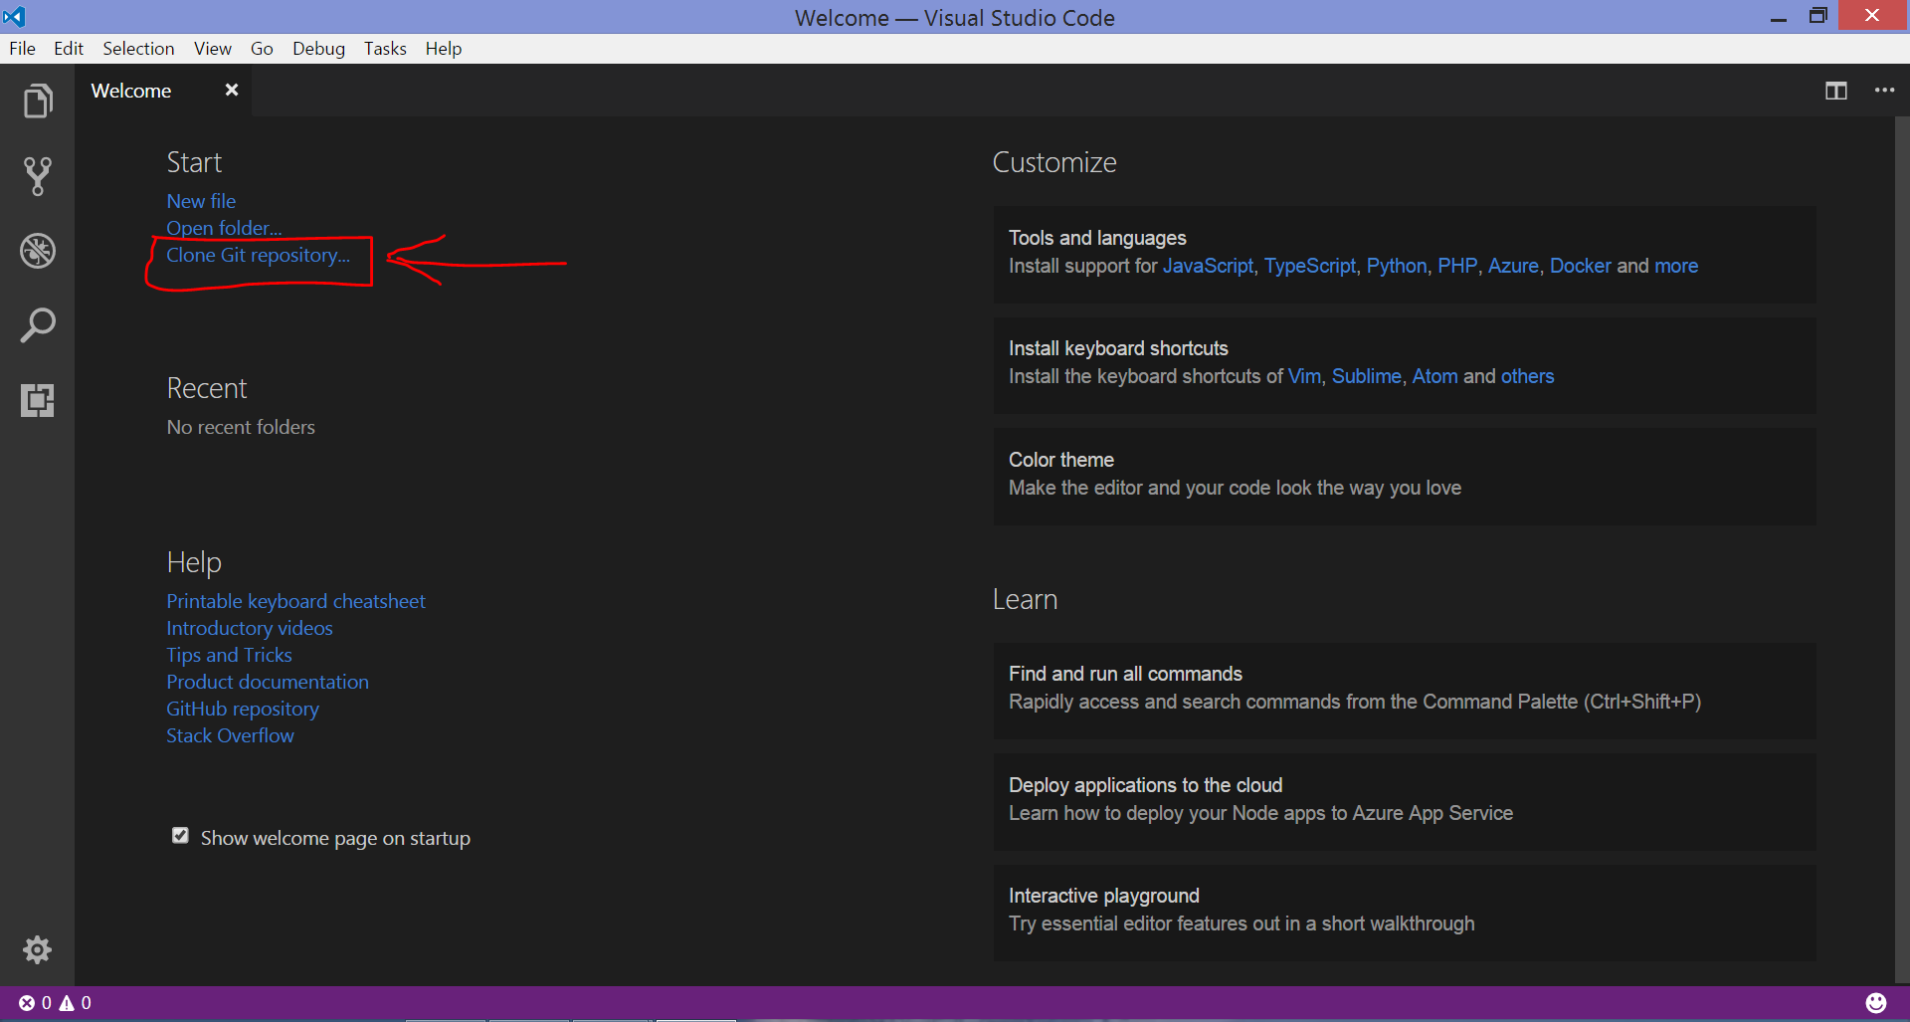

Step 3: This prompts an input field at the top. Here we have to enter the URL of the project on github.com that we want to clone.

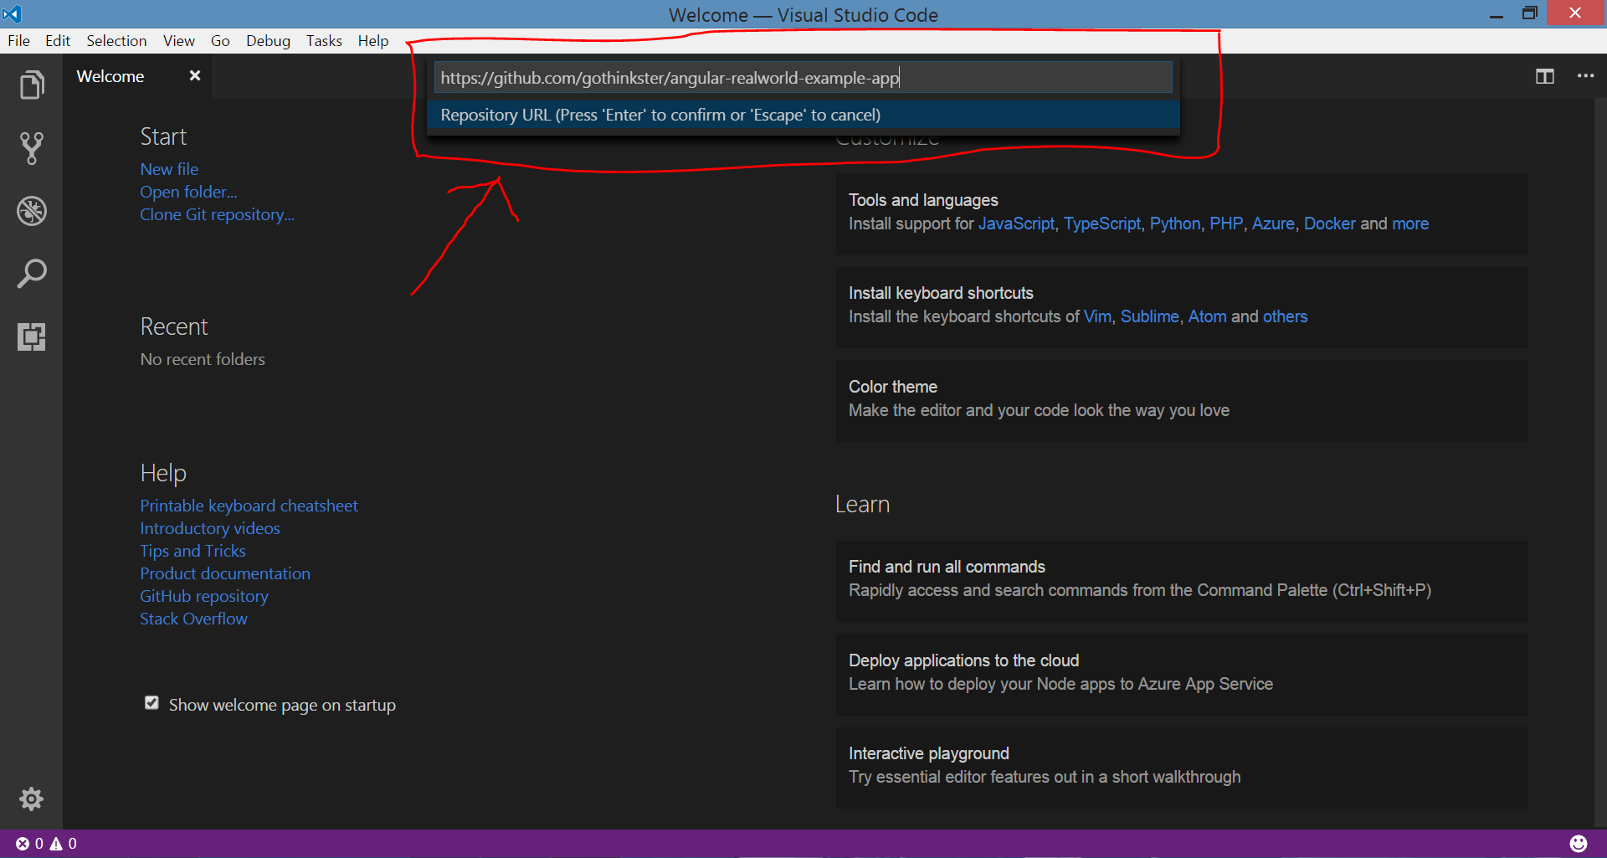

***Note***: In my case we are cloning the project with the URL ***https://github.com/gothinkster/angular-realworld-example-app***

Step 4: We have to give the path on the local computer in which we want the project to be cloned. We are giving the path as **E:\Angular JS.**

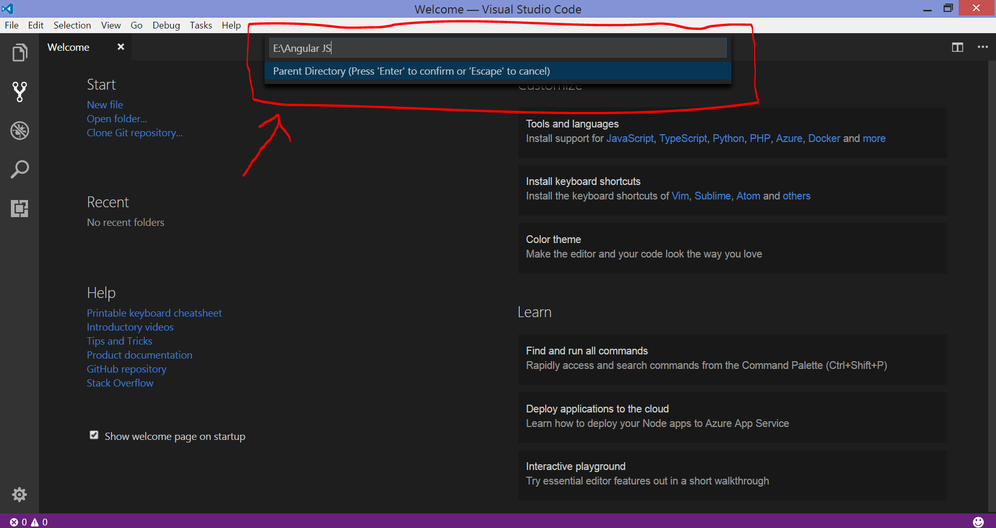

Step 5: After the project is downloaded in the local computer, we will get the prompt to open the repository. Click on ***Open Repository***.

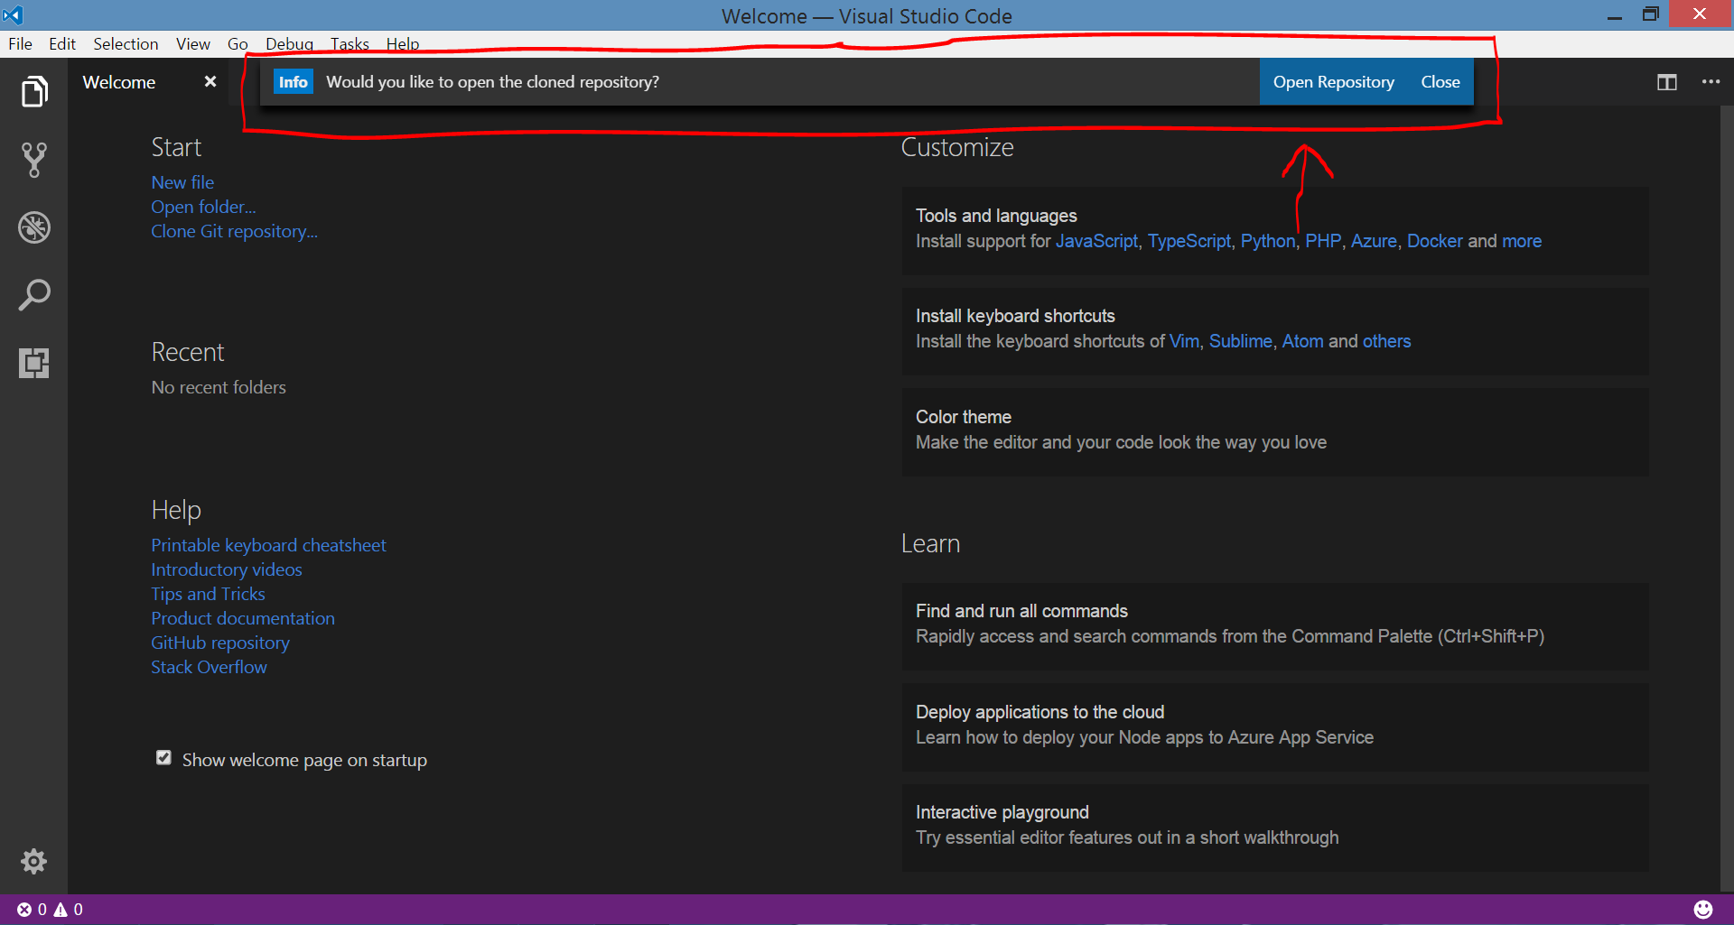

Step 5: Now the Github project is successfully cloned.

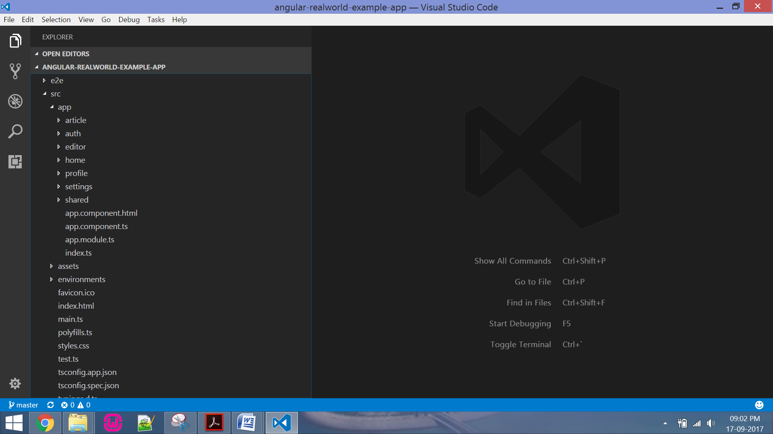

Solution 2:

Step 1: Open Command Prompt and go to the folder in which the project is cloned.

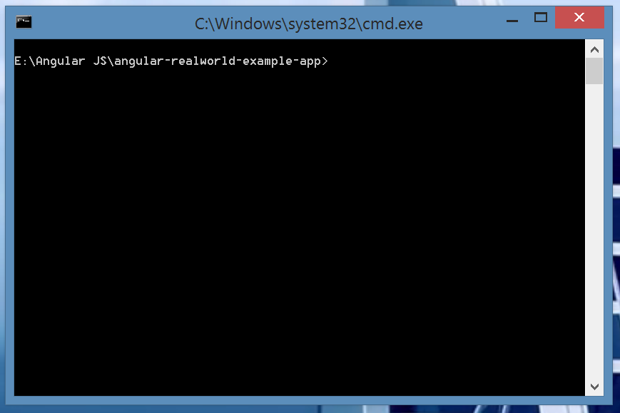

Step 2: Type and run the command ***npm install***.

Command: npm install

This command helps ***NPM*** to read the list of dependencies mentioned in ***package.json*** file and install them in ***node_modules*** folder.

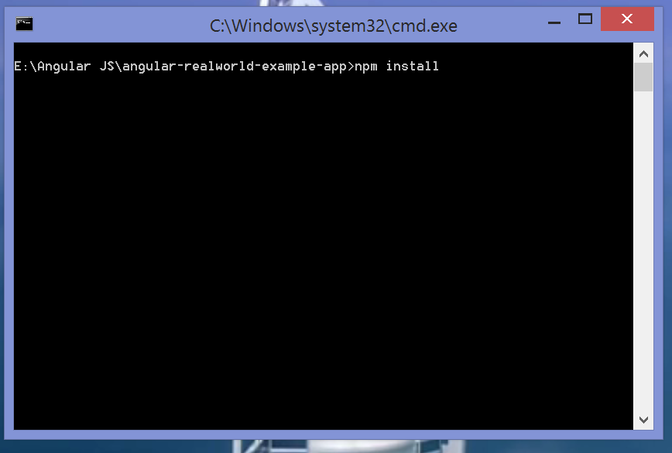

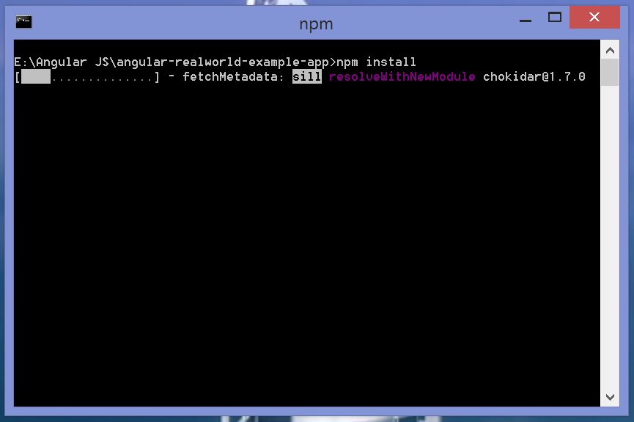

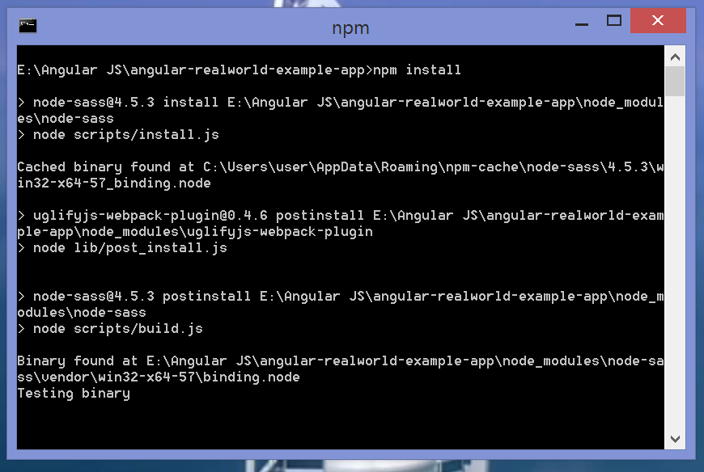

Step 3: Once all the dependencies are installed we get a success message saying ***added 1092 packages in 91.577s***. 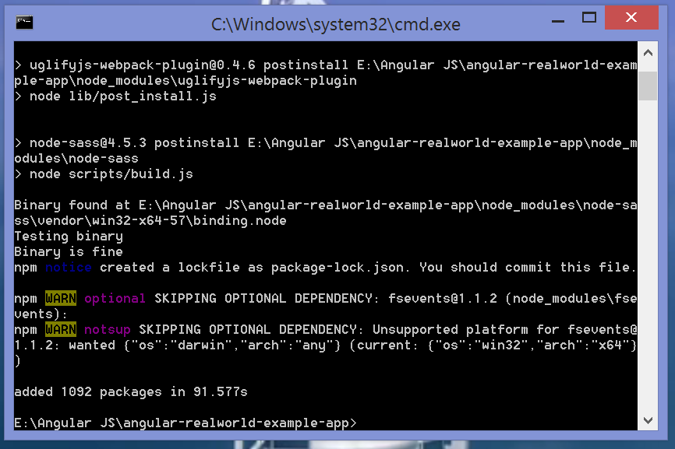

So, we have successfully installed all the packages.

Solution 3:

Step 1: Open Command Prompt and go to the folder in which the project is cloned.

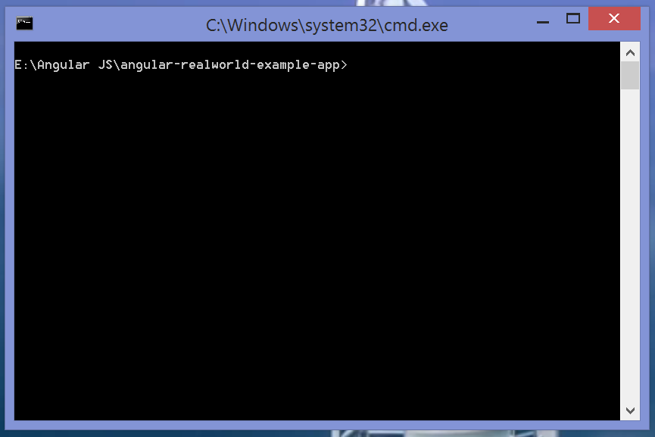

Step 2: Type and run the command ***npm start.***

Command: npm start

This command starts compiling the project.

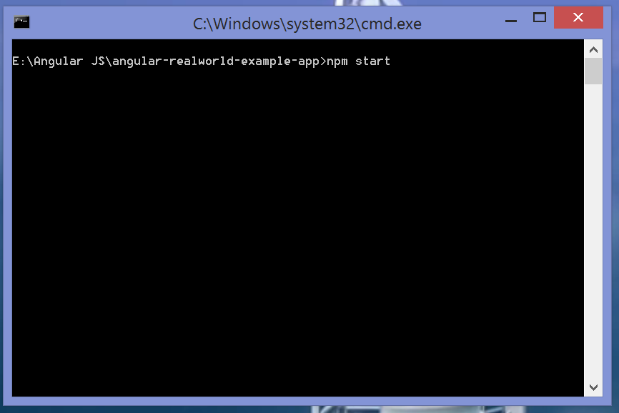

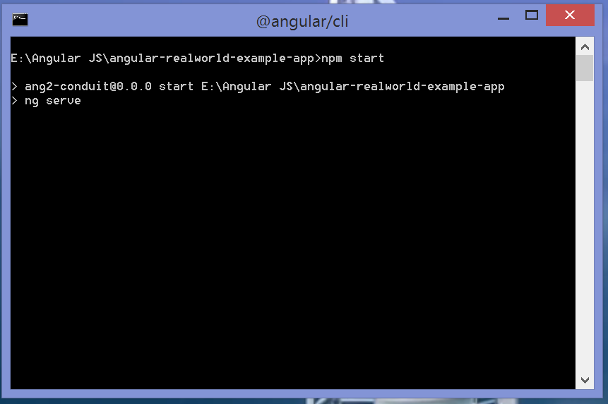

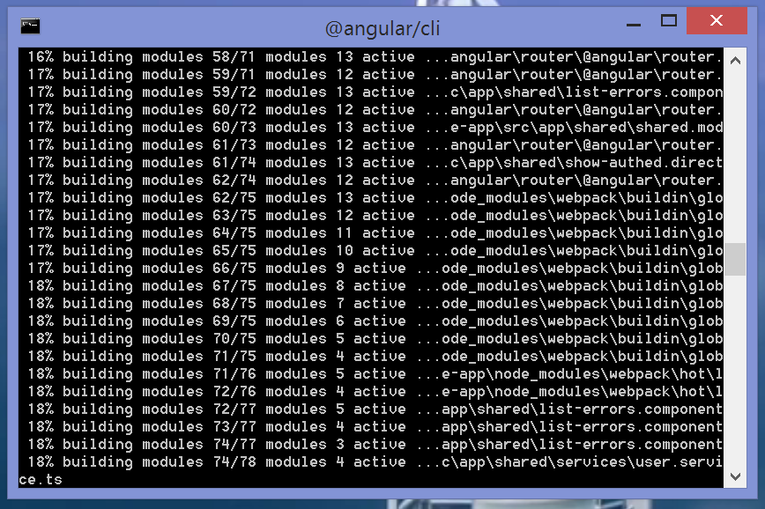

Step 3: Once the compilation is complete we get a success message ***webpack: Compiled Successfully.***

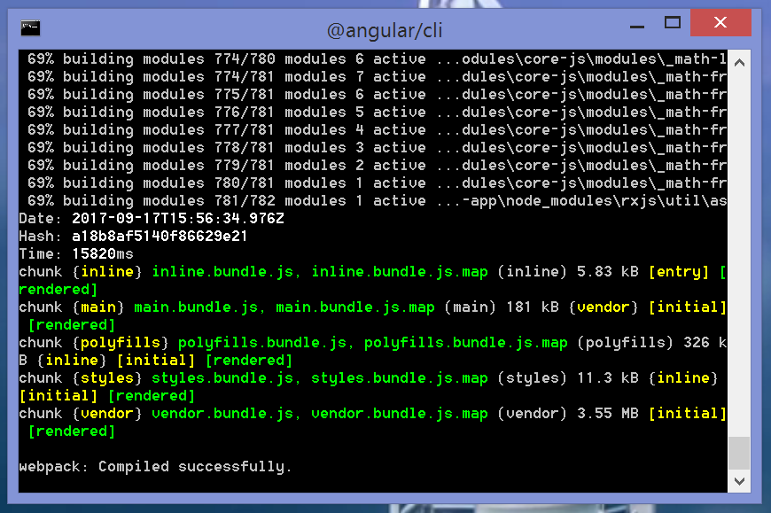

Step 4: To start the project go to web browser and type the URL ***http://localhost:4200***

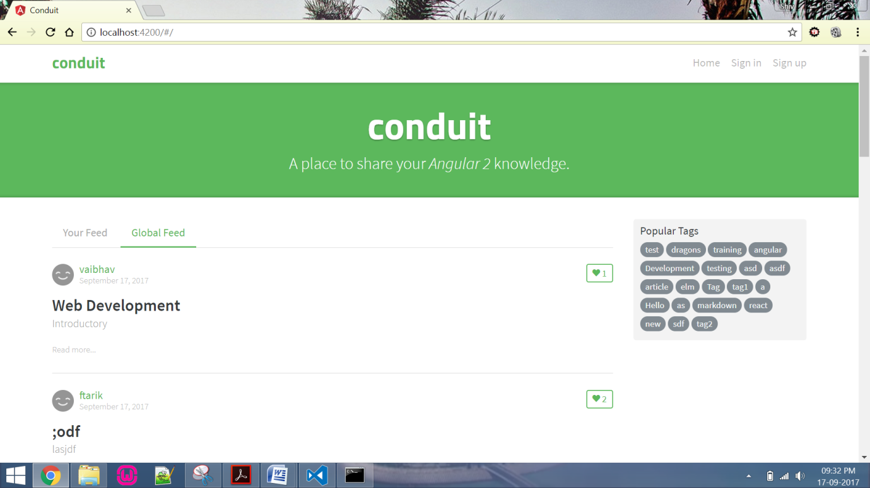

So, as we can see the project has been successfully cloned, compiled and run using npm start.