**Session 1, Assignment 4**

**Problem Statement**:

1. Install 3rd Party libraries (bootstrap).

2. Check if the Bootstrap is installed properly or not by adding this line of code:

*<button type="submit" class="btn btn-primary btn-lg btn-block" [disabled]="form.invalid">Submit</button>*

**Solutions** (Steps + Commands + Screenshots)

Solution 1:

Step 1: Open Command Prompt and go to the project folder in which the Bootstrap Library needs to be installed. In our case, we are installing ng2-bootstrap and bootstrap-sass libraries.

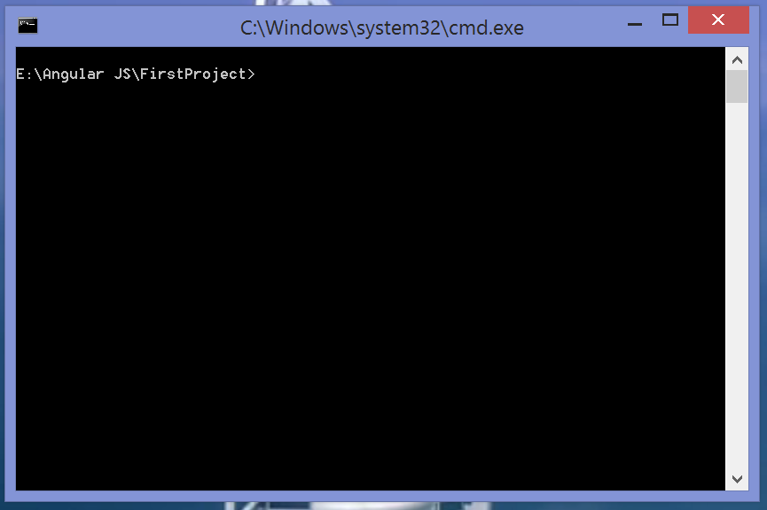

Step 2: Type and run the command ***npm install bootstrap-sass ng2-bootstrap --save***. This command helps NPM install the Bootstrap libraries in the project.

Command: npm install bootstrap-sass ng2-bootstrap --save

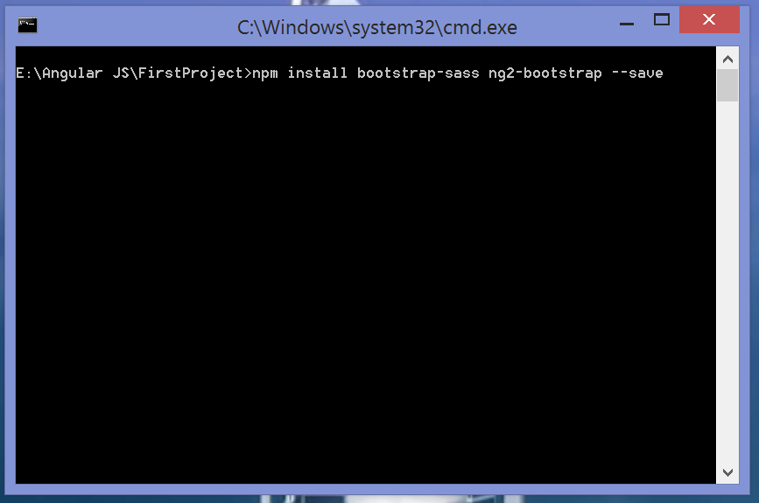

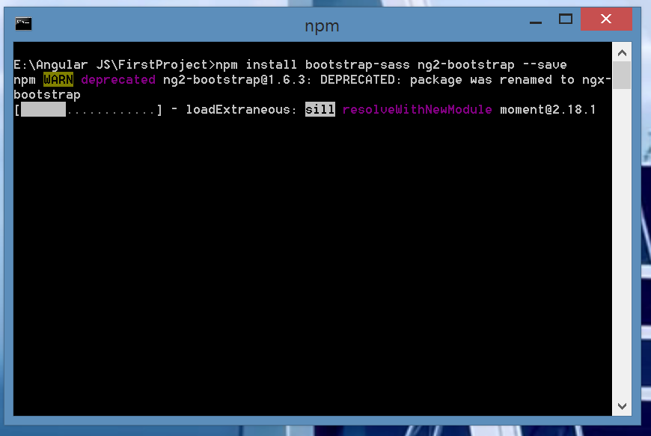

Step 2: Once the libraries are installed we get the success message

***+ bootstrap-sass@3.3.7***

***+ ng2-bootstrap@1.6.3***

***added 117 packages in 40.084s***

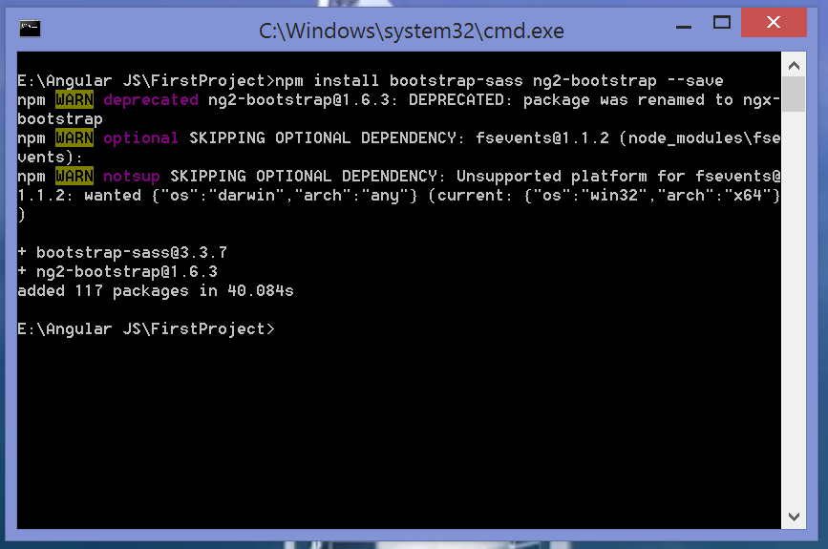

Now, the 3rd Party Bootstrap Library has been successfully installed in the project.

Solution 2:

Step 1: Updating the Angular CLI Configuraion**:** Open the project folder in Visual Studio Code. Open the ***angular-cli.json*** file.

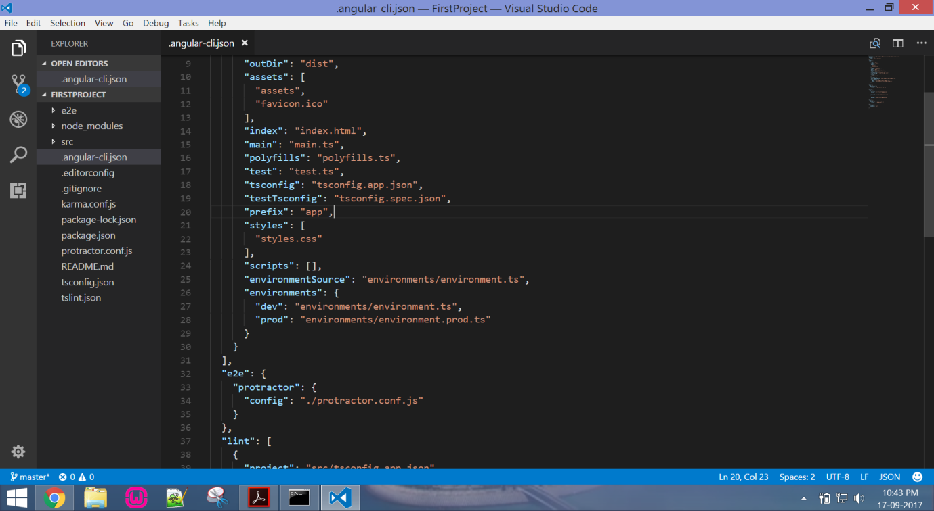

Step 2: Search for the styles node and add the bootstrap file,

***"styles": [***

***"styles.css",***

***"../node_modules/bootstrap-sass/assets/stylesheets/_bootstrap.scss"***

***],***

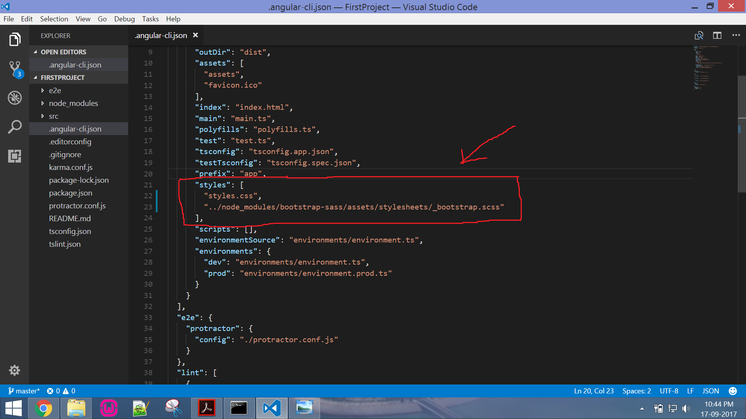

Step 3: Open the file ***src\app\app.component.html***

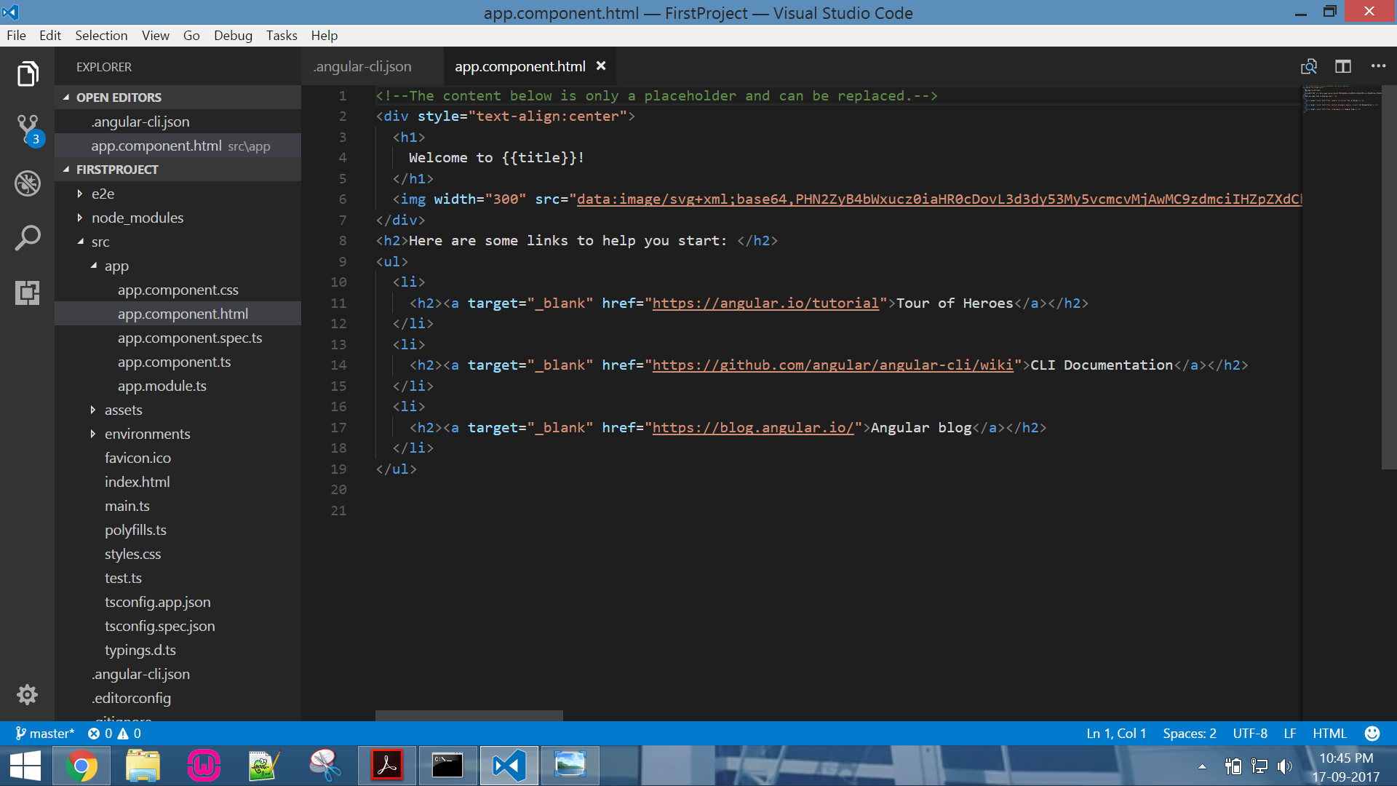

Step 4: Edit the file by adding the following HTML code,

***<button type="submit" class="btn btn-primary btn-lg btn-block" [disabled]="form.invalid">Submit</button>***

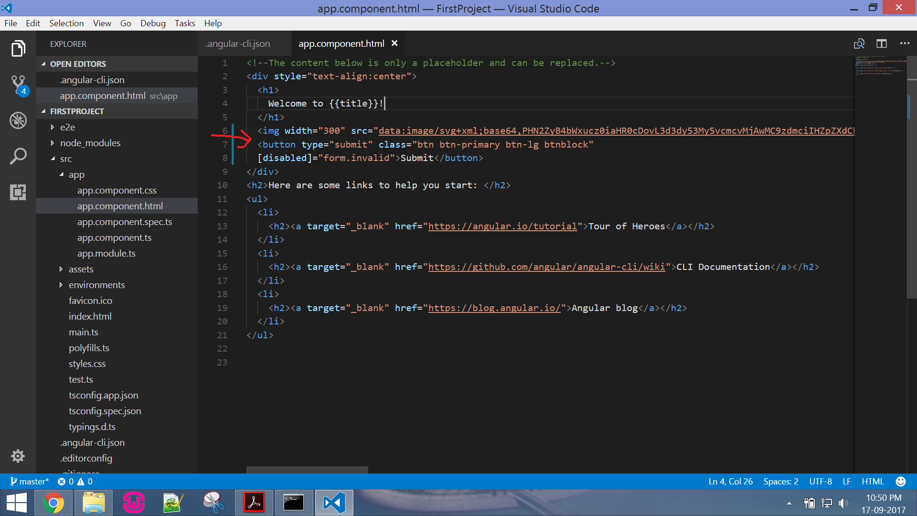

Step 5: Compile the project using the command ***ng serve***. When the compilation is complete we can run the project. Go to web browser and type the URL ***http://localhost:4200***

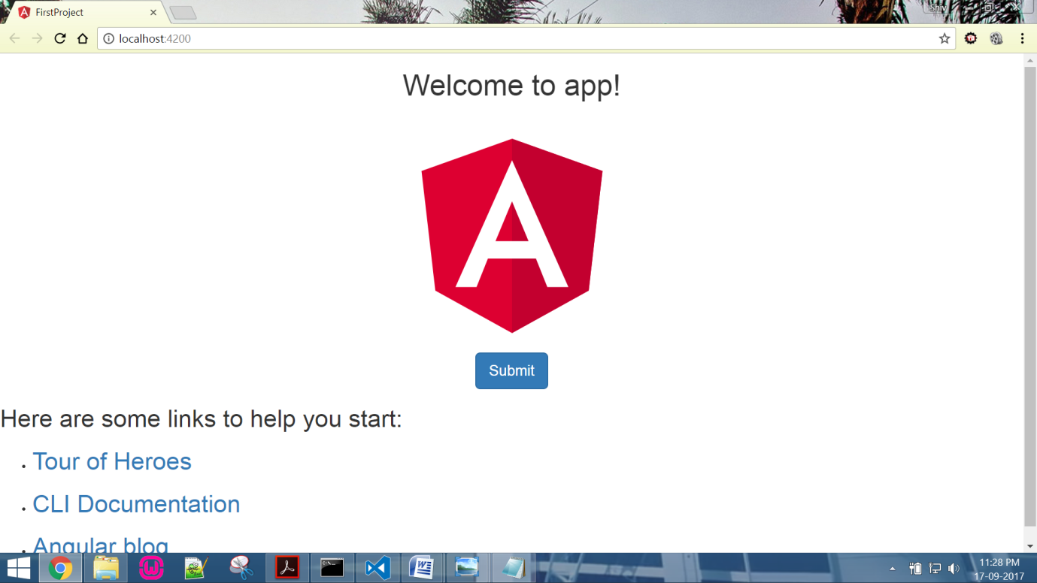

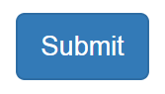

Since we are able to see the button, we have successfully installed the Bootstrap Libraries.