create folder(with anyname)

author

publish

author

aem-author-4502.jar

licence.properties

publish

aem-author-4503.jar

licence.properties

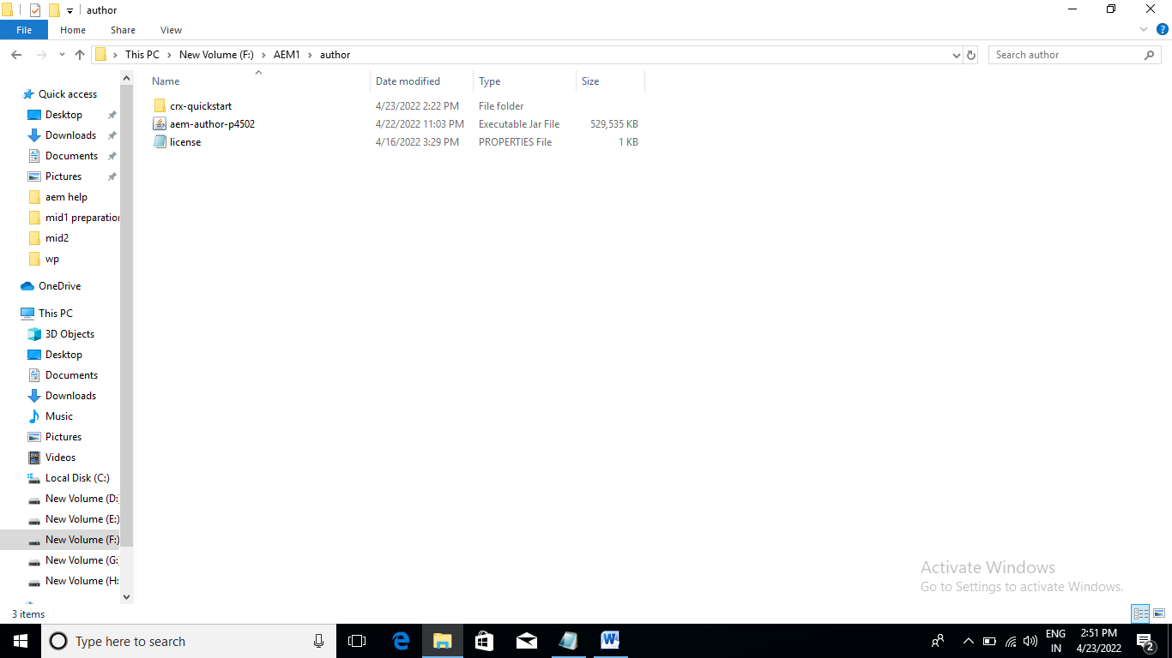

INSTALLATION STEPS:

double click on jar quick start will create

aem window will appear and server start

create aem new folder empty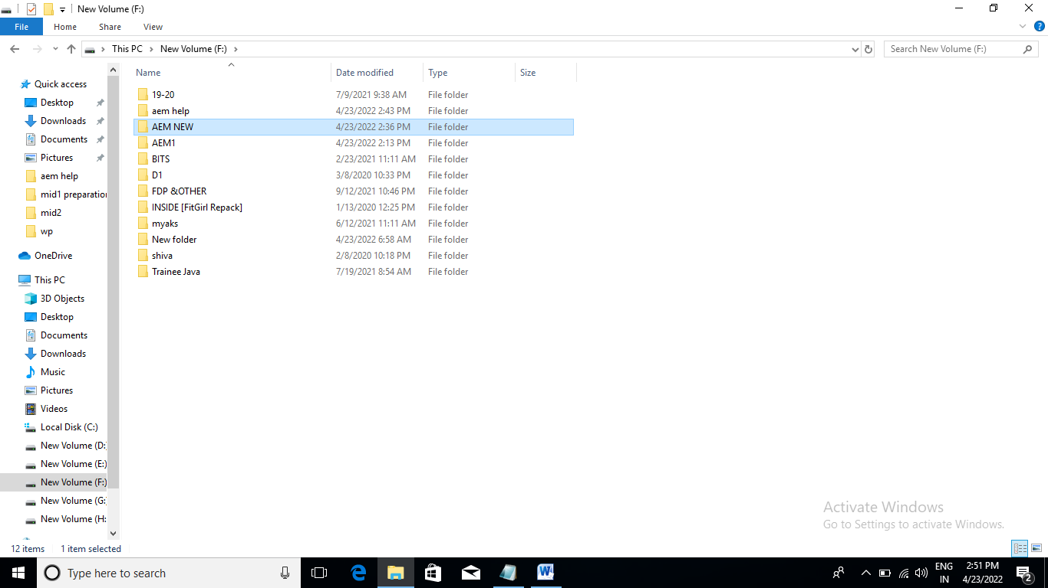

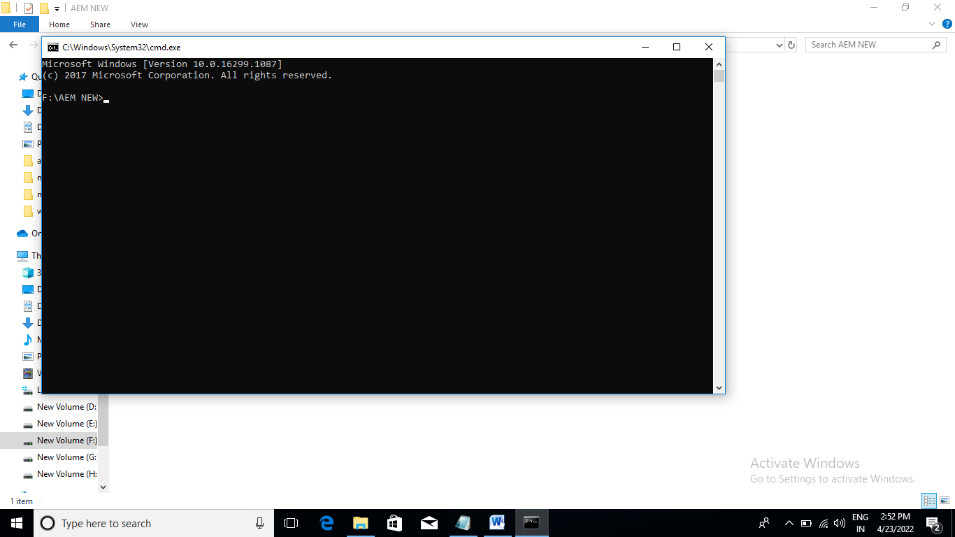

Copy paste

mvn -B org.apache.maven.plugins:maven-archetype-plugin:3.2.1:generate -DarchetypeGroupId=com.adobe.aem -DarchetypeArtifactId=aem-project-archetype -DarchetypeVersion=35 -DaemVersion=6.5.0 -DappTitle="aemfeb project" -DappId="aemfeb" -DgroupId="com.adobe.aem.aemfeb" -DfrontendModule=none -DincludeDispatcherConfig=none -DlanguageCountry="en_us" -DsingleCountry=y -DincludeExamples=none

**aemfeb project will build after build success**

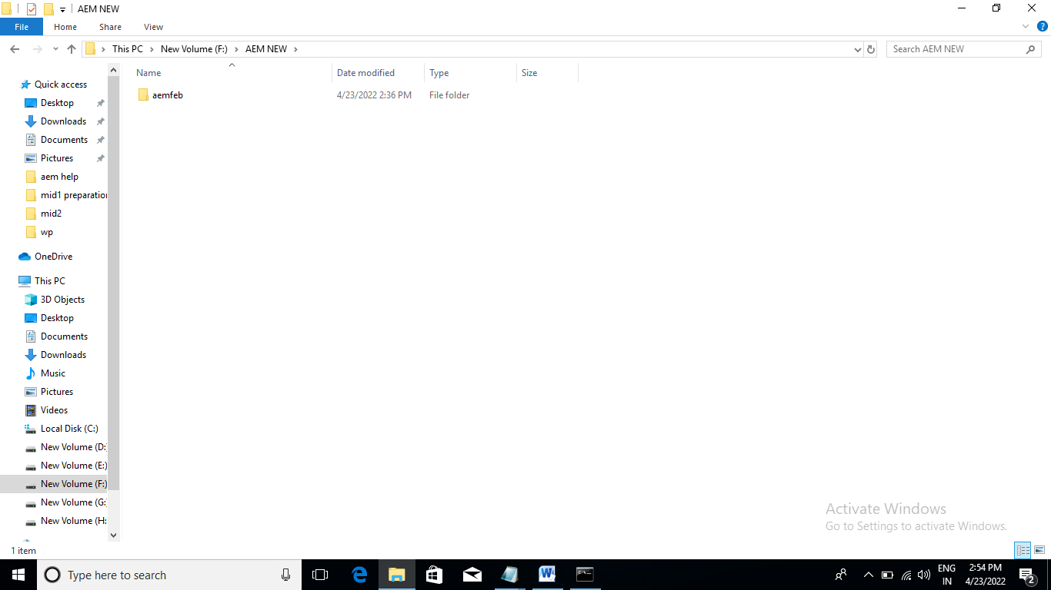

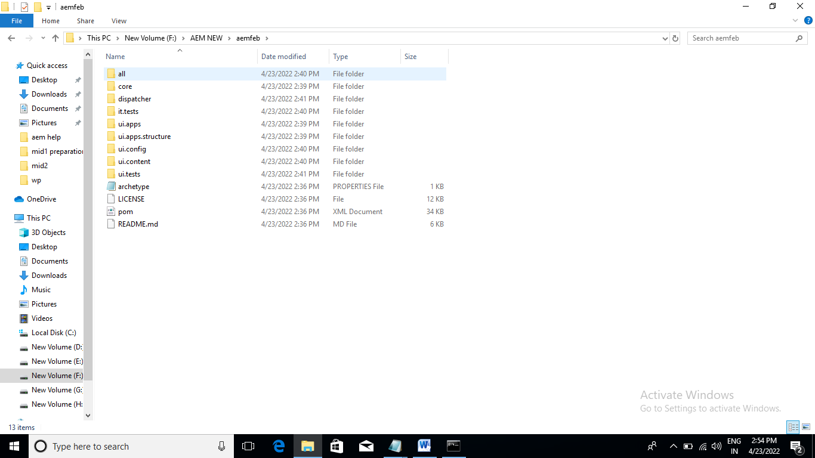

**Goto subfolder:**

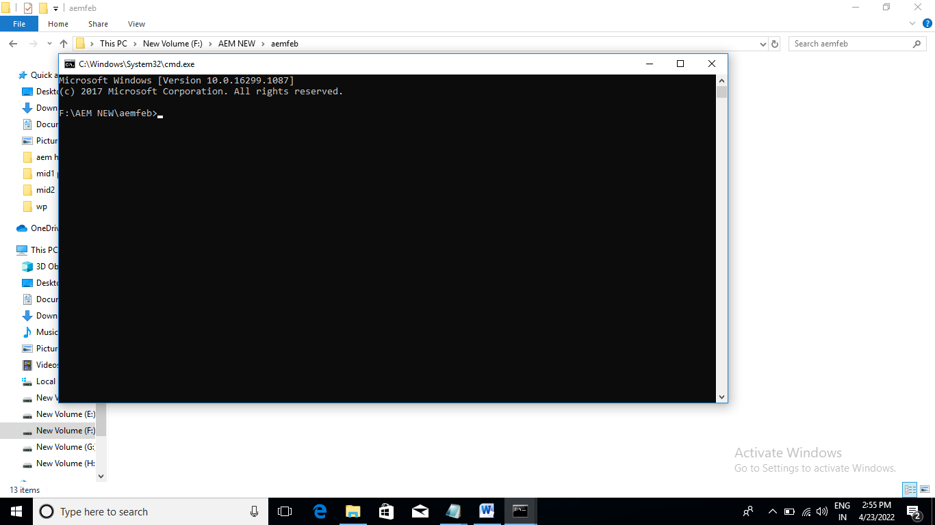

**mvn clean install**

**build success**

**upto here project local build**

**mvn clean install -PautoInstallPackage -Padobe-public**

**build success**

**upto here project in server build**

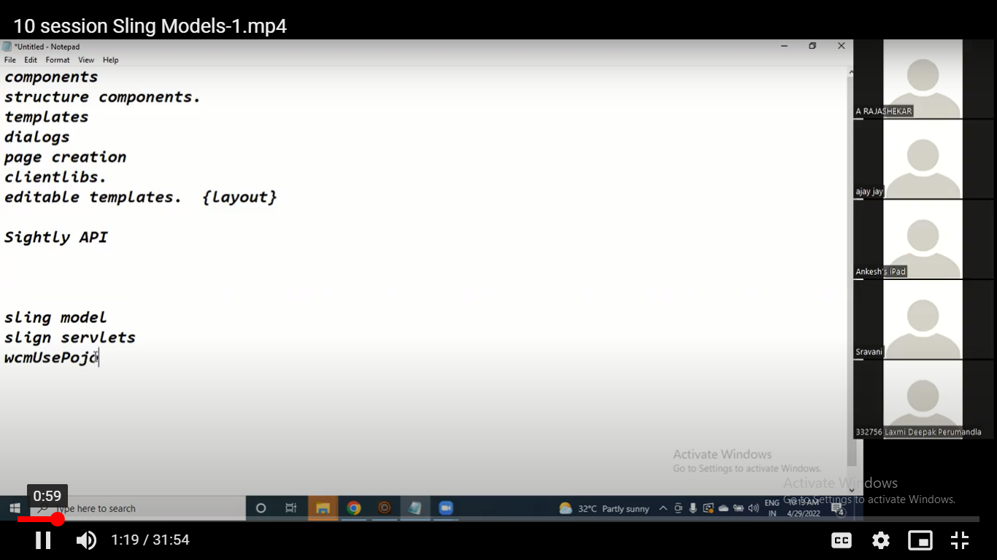

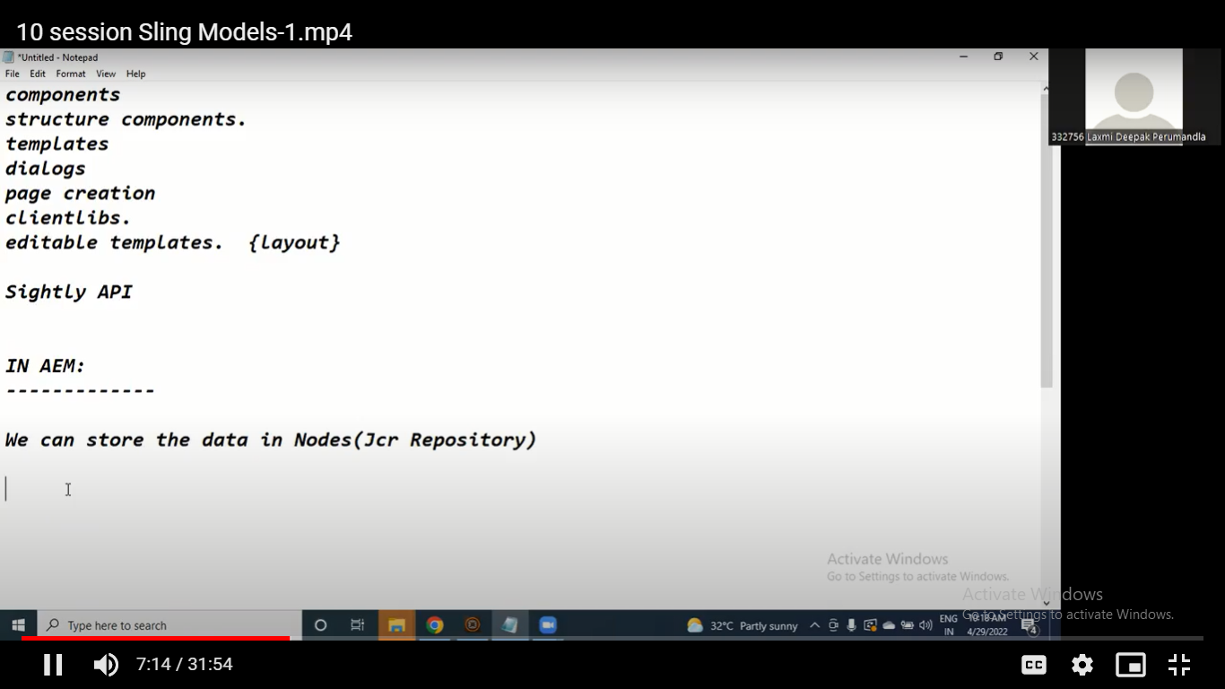

**Node and database for both for data manipulation**

**Node is better than databases**

