**Bootstrap 5**

1.Zero css (classes+component+grid system)

2.Custom Design (grid system)

Best Reference for bootstrap : Official bootstrap website

**Install bootstrap**

1. CDN

2. Download and include bootstrap 5 files

3.NPM package manager

*Note : there will be one file in head (bootstrap css file) and one file in body (bootstrap js file)

**Bootstrap Grid System**

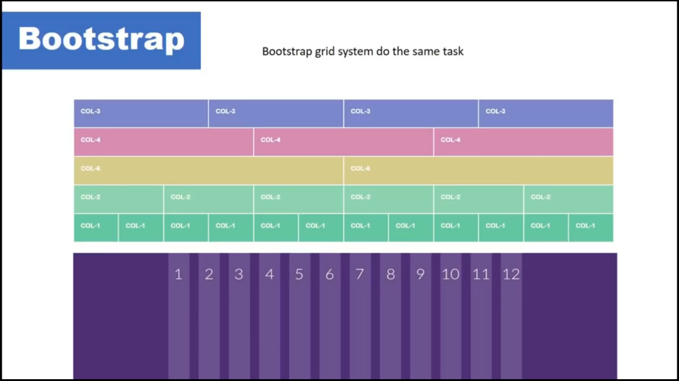

**Grid System**

1.Breakpoint  
2.Container  
3.Row  
4.Column

**Breakpoints**

**Col-12**

**Col-sm-12**

**Col-md-12**

**Col-lg-12**

**Col-xl-12**

**Col-xxl-12**

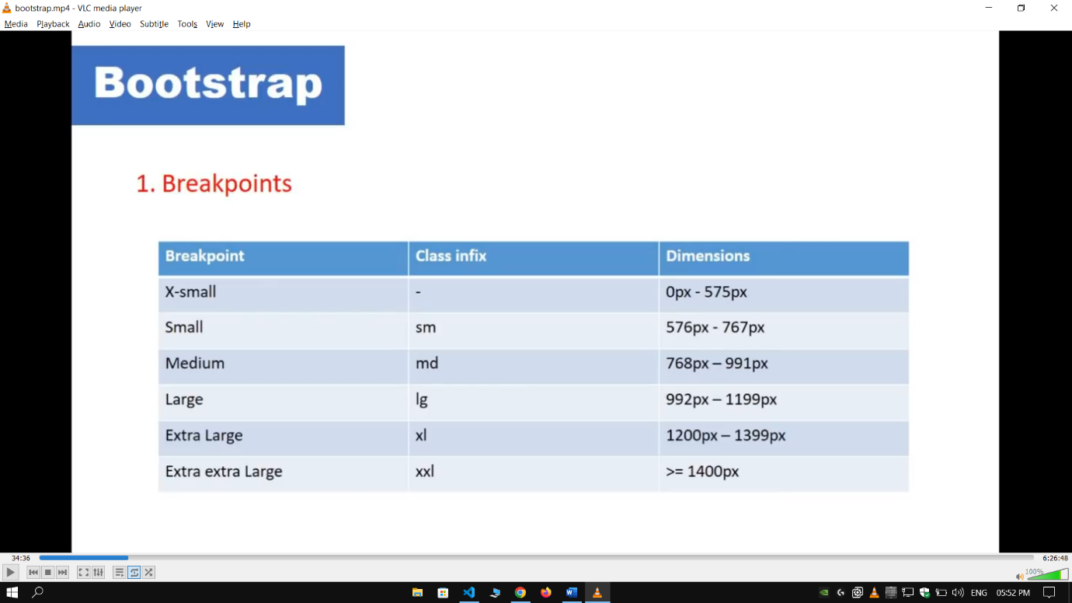

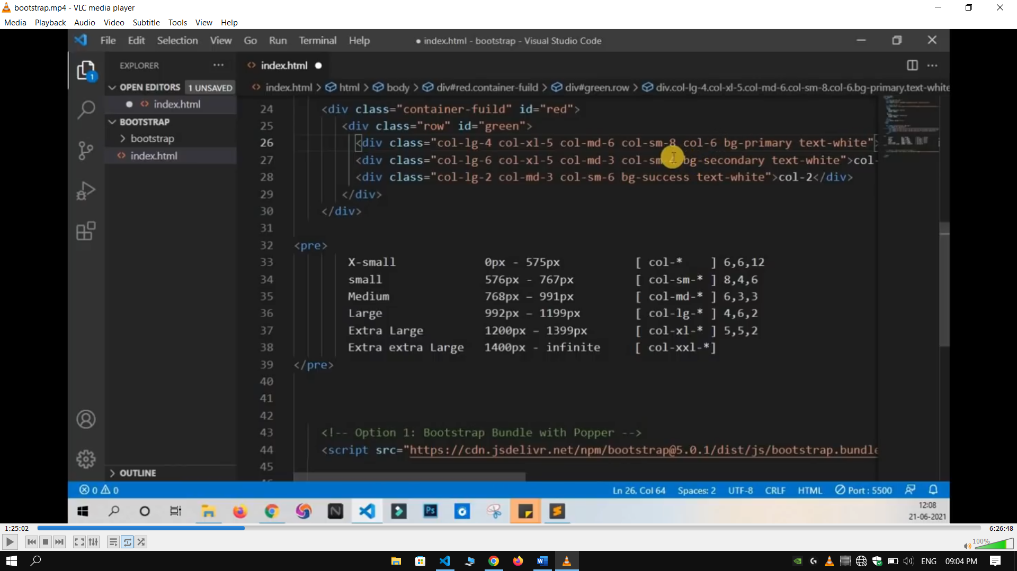

**Going on higher screen col-* will remain same  
going on smaller screen col-* will take 100% width**

**Agar break point doge to sab screen par work krega**

**Agar breakpoint doge to ja par diya hai use par same rhega and neeche pe nahi**

**Container**Wrapper that contain website   
website width depends on wrapper width

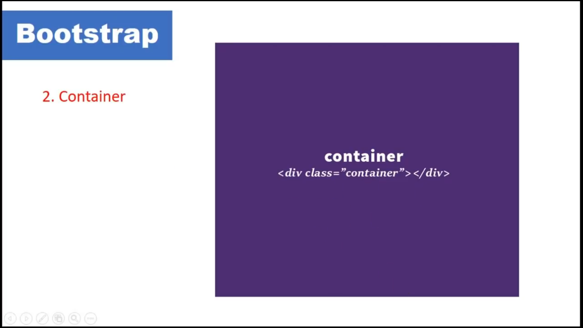

**Row**  
It divides 12 column

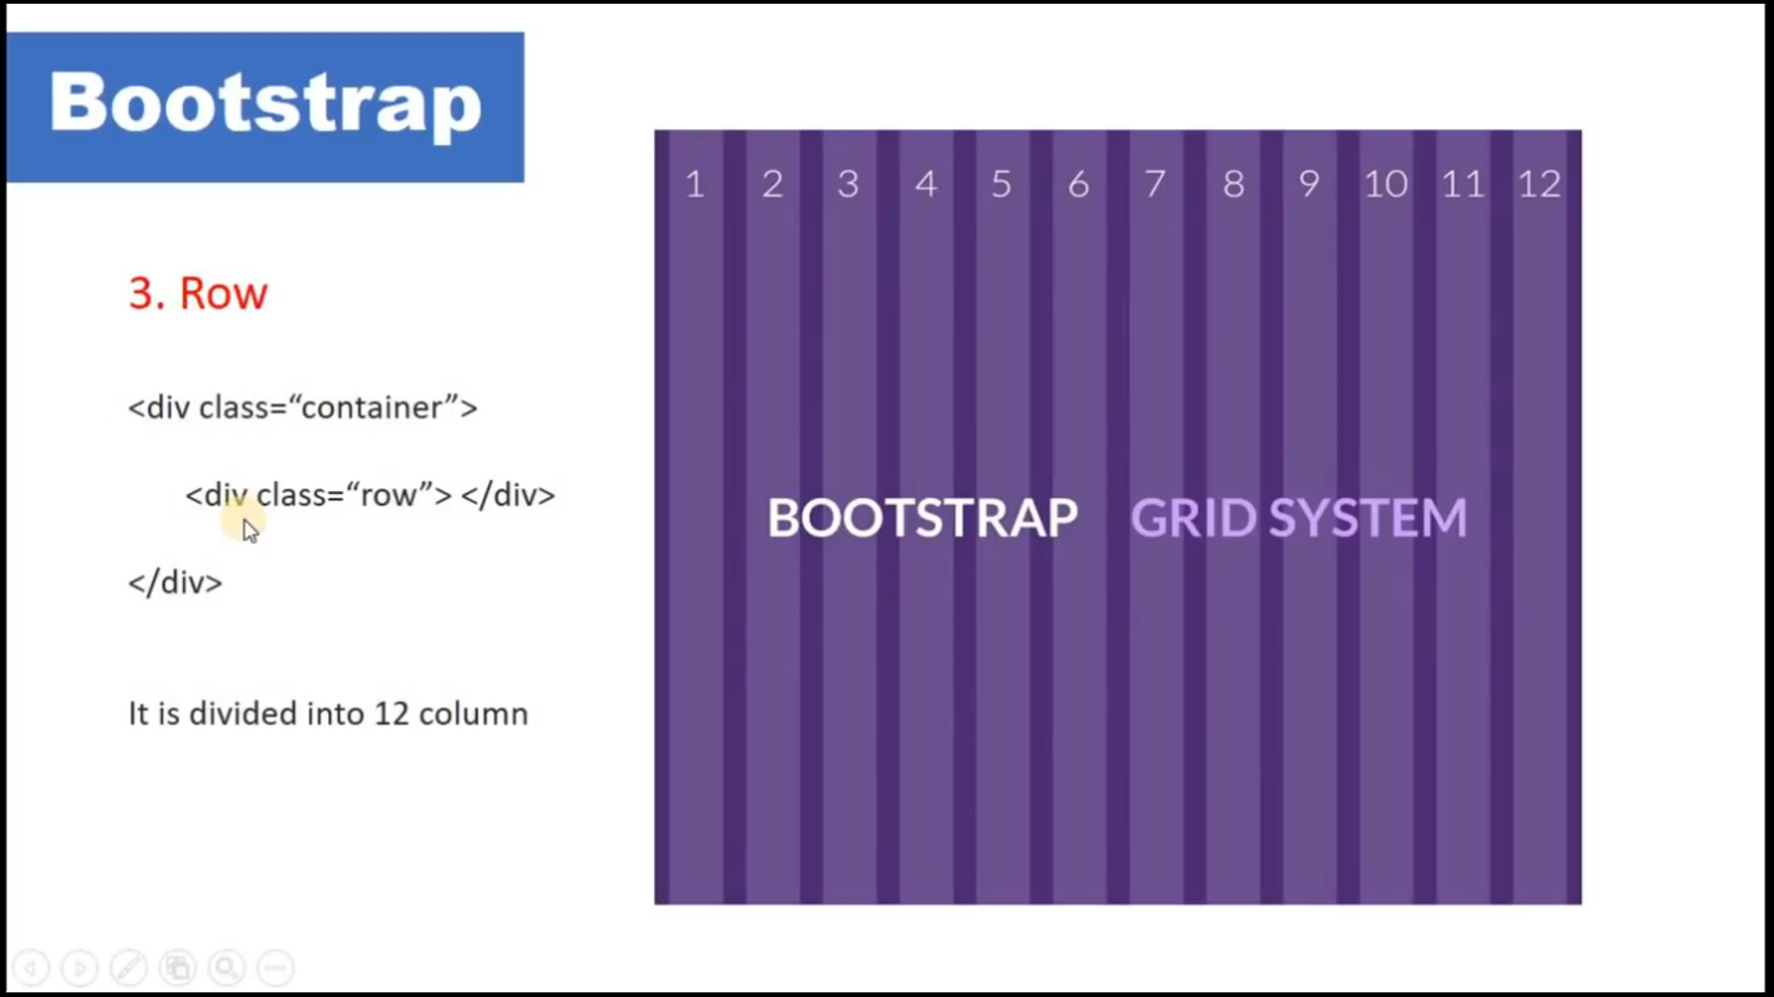

**Column**

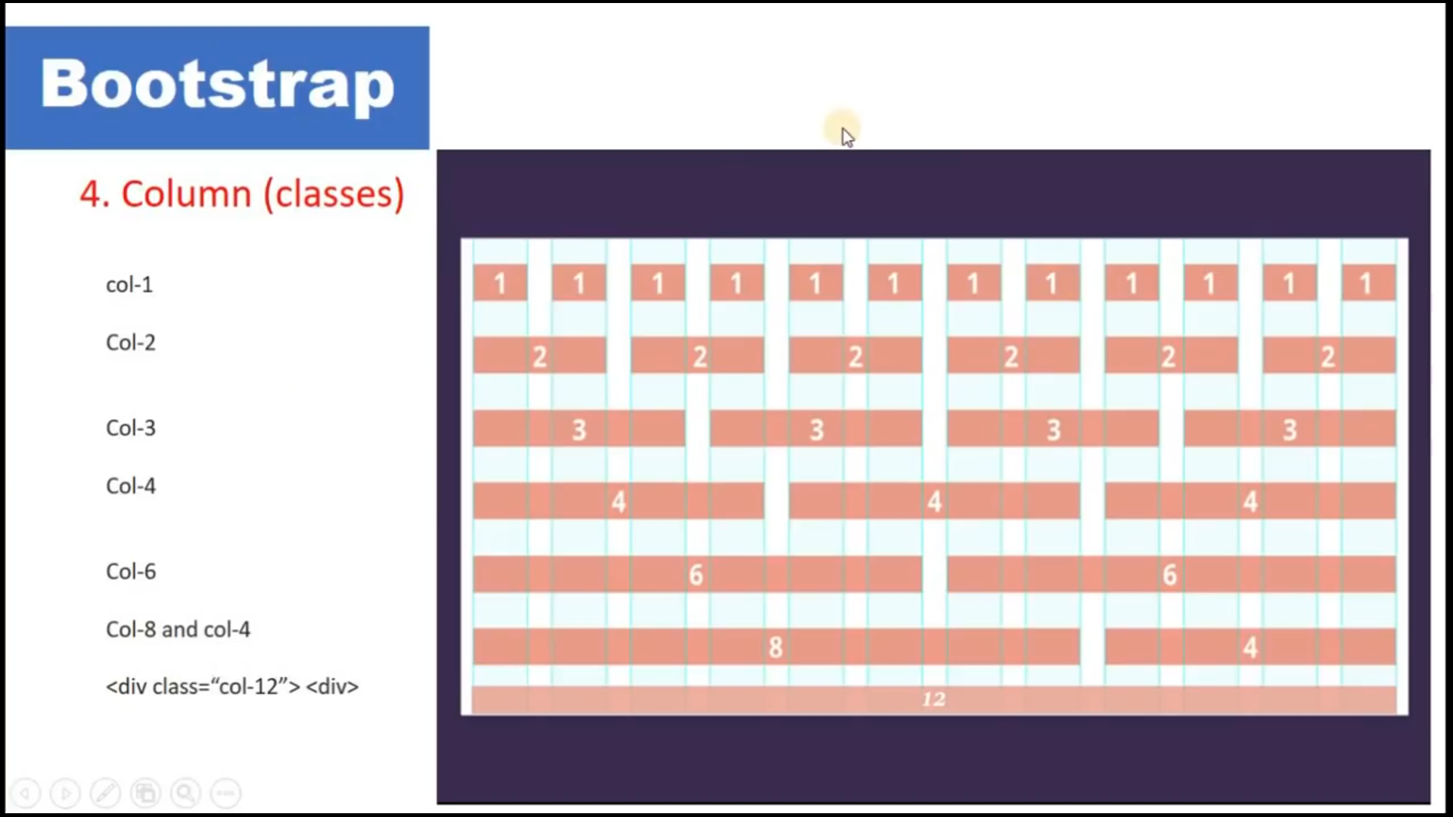

**Summarize**

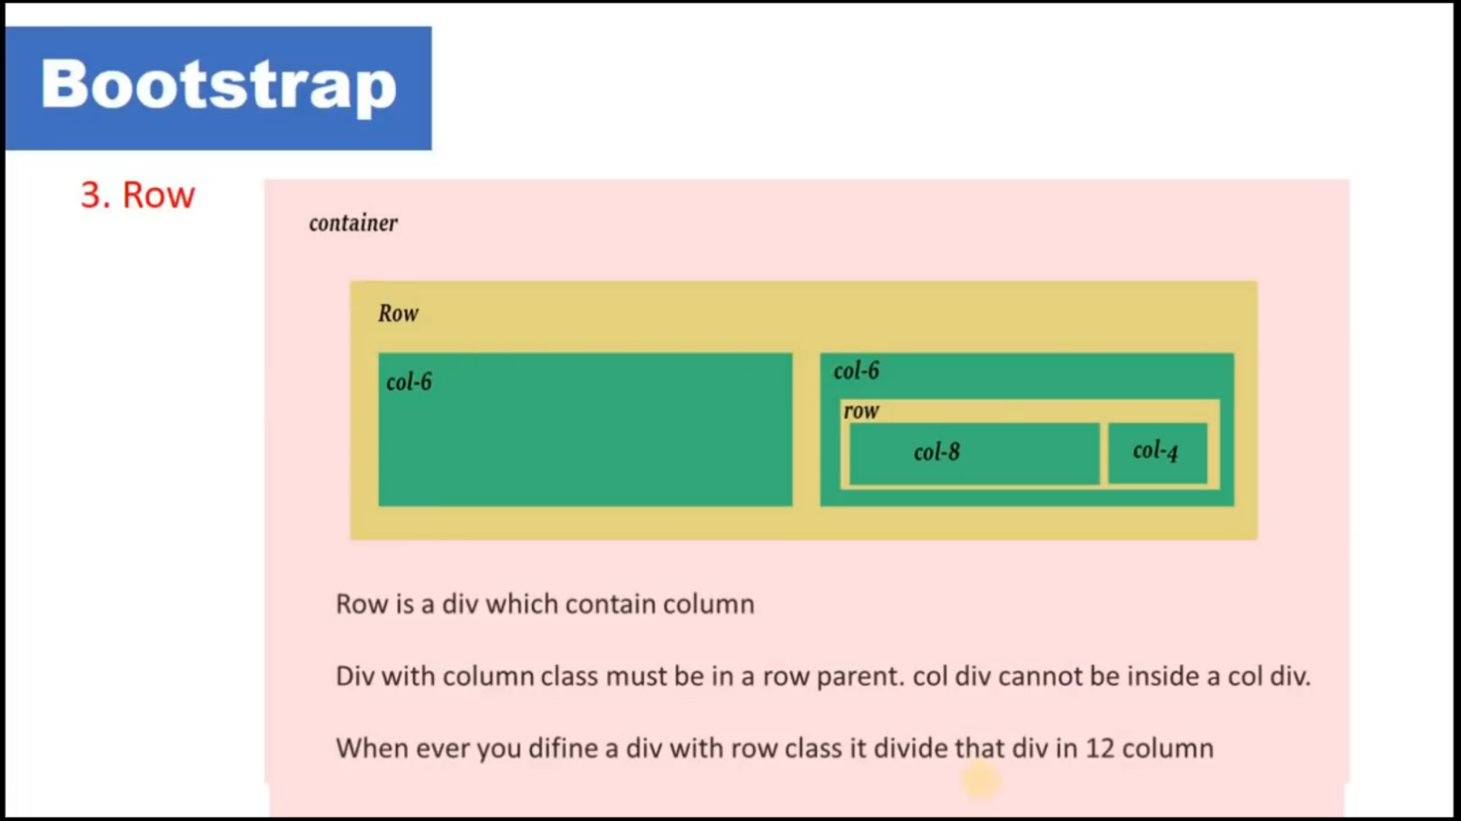

**3 types of containers**   
1.container-fluid  
2.container  
3.container-{breakpoint}

**Bootstrap Flow**

container -> row -> col -> content