NEXUS — Approach, Autonomy Boundary & Future Roadmap

Approach
NEXUS is a supervised-autonomy data migration agent designed to automate safe, deterministic migration tasks while escalating ambiguous or high-impact decisions to a human reviewer.
NEXUS uses a hybrid approach: deterministic rules handle validation, cleaning, duplicate detection, API operations, and retries, while Groq-based semantic inference is used primarily for field mapping. This keeps execution predictable and auditable while using the LLM where semantic interpretation adds value.

Autonomy Boundary
The core principle is:
Automate what is safe and reversible; escalate what requires judgment or has a high impact if wrong.
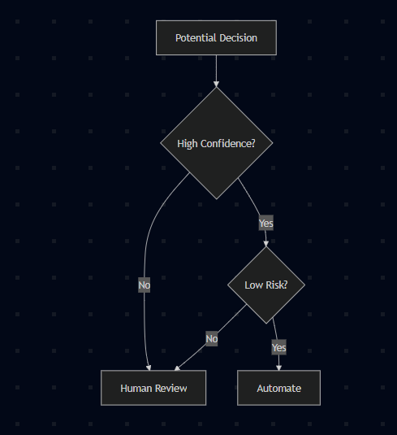
For field mapping, exact aliases are automatically accepted, while semantic mappings require ≥90% confidence and ≥8% margin over the next-best candidate. Ambiguous mappings such as Staff Ref are escalated rather than guessed.

Decision Boundary
Scenario | Action
Exact/high-confidence mapping | Automate
Email normalization / whitespace cleanup | Automate
Unambiguous date conversion | Automate
Schema and format validation | Automate
Transient API failure (500/timeout) | Retry automatically
Ambiguous mapping | Escalate
Missing/invalid required data | Escalate
Conflicting duplicate | Escalate
API conflict/business-rule rejection | Escalate + edit/retry
The boundary is deliberately conservative: a wrong mapping can affect many records, while conflicts and invalid data may require business context that the agent does not have.

Human-in-the-Loop & Auditability
Escalation is treated as a recovery workflow rather than a terminal failure. The reviewer receives the reason for escalation, the agent's proposed value where available, and the available actions—approve, correct, reject, or retry.
All important actions are recorded with the timestamp, record ID, action, reason, and before/after state. This provides traceability from:
Load → Map → Validate → Review → Push → Retry → Success

What I Would Build Next
The current prototype uses a mock target API. The first production step would be replacing it with real HR-system connectors such as Workday, BambooHR, or ADP, backed by PostgreSQL and asynchronous processing for larger migrations.
The next priorities would be:
- Production readiness: real connectors, PostgreSQL state, async jobs, authentication/RBAC, secure secrets, PII masking and observability.
- Intelligence: organization-specific mapping memory, anomaly detection, cross-file reconciliation and schema versioning.
- Feedback loop: learn from human approvals and continuously calibrate confidence thresholds.
- Metrics: mapping accuracy, escalation rate, correction rate, push success, retry rate and false auto-approval rate.
The key safety metric would be incorrect autonomous decisions, rather than simply maximizing the percentage of records automated.

Overall Design Position
NEXUS prioritizes trust, explainability, and safe autonomy over maximum automation.
Automate what the agent can confidently justify. Escalate what requires human judgment. Learn from feedback without compromising trust.

