A Mini Project Report on
PERSONAAI
An Adaptive AI Study Assistant with Retrieval-Augmented Generation and Weak-Topic Memory
Submitted in partial fulfilment of the requirements for the award of the degree of
BACHELOR OF TECHNOLOGY
in
[Branch, e.g. Artificial Intelligence]
Submitted by
[Student Name 1] ([Roll No.])
[Student Name 2] ([Roll No.])
[Student Name 3] ([Roll No.])
Under the guidance of
[Guide Name]
[Designation, Department]
[College logo]
DEPARTMENT OF [DEPARTMENT NAME]
[COLLEGE / UNIVERSITY NAME]
[City, State]
[Academic Year, e.g. 2026–2027]
[COLLEGE / UNIVERSITY NAME]
Department of [Department Name]
CERTIFICATE
This is to certify that the mini project report entitled “PersonaAI: An Adaptive AI Study Assistant with Retrieval-Augmented Generation and Weak-Topic Memory” is a bonafide record of work carried out by [Student Name 1 (Roll No.)], [Student Name 2 (Roll No.)] and [Student Name 3 (Roll No.)] in partial fulfilment of the requirements for the award of the degree of Bachelor of Technology in [Branch] during the academic year [Academic Year], under my supervision and guidance.
The results embodied in this report have not been submitted to any other university or institution for the award of any degree or diploma.

Project Guide Head of the Department
[Guide Name] [HoD Name]
[Designation] [Department]

External Examiner
DECLARATION
We hereby declare that the mini project report entitled “PersonaAI: An Adaptive AI Study Assistant with Retrieval-Augmented Generation and Weak-Topic Memory”, submitted to the Department of [Department Name], [College / University Name], in partial fulfilment of the requirements for the award of the degree of Bachelor of Technology in [Branch], is a record of original work done by us under the guidance of [Guide Name], [Designation].
The work presented in this report has not been submitted, in part or in full, to any other university or institution for the award of any degree or diploma. Third-party libraries, models and services used in the project are acknowledged in the report and listed in the references.

Place: [City]
Date: [Date]
[Student Name 1 (Roll No.)]
[Student Name 2 (Roll No.)]
[Student Name 3 (Roll No.)]
ACKNOWLEDGEMENT
We express our sincere gratitude to our project guide, [Guide Name], [Designation], Department of [Department Name], for the guidance, encouragement and constructive feedback given throughout the course of this mini project.
We thank [HoD Name], Head of the Department of [Department Name], and [Principal / Director Name], [Principal / Director], [College / University Name], for providing the facilities and an environment that made this work possible.
We are also thankful to the faculty members and staff of the department, and to our classmates who tried the application and shared their feedback. Finally, we thank our families for their constant support.

[Student Name 1]
[Student Name 2]
[Student Name 3]
ABSTRACT
Students revise from scattered notes and PDFs, and general-purpose AI chatbots answer from general knowledge rather than from the student’s own syllabus, do not remember what a student got wrong earlier, and give everyone the same advice. PersonaAI is a web-based study assistant that addresses these gaps for a single course. A student uploads course material (PDF, DOCX or TXT); the system extracts the text page by page, splits it into overlapping chunks, embeds them locally and stores them in a vector database. Questions are answered by Retrieval-Augmented Generation (RAG): a two-stage retriever (dense embedding search followed by a cross-encoder re-ranker) selects the five most relevant excerpts, and a large language model (Google Gemini, with a local Ollama model as an offline fallback) answers only from them, citing the file and page of every claim, or states that the answer is not in the notes.
The same material drives auto-generated multiple-choice quizzes. Every answer is stored per topic, and a weak-topic memory computes each topic’s accuracy over the student’s last ten answers, classifying topics as weak (below 60 %), learning or strong (80 % or more). An adaptive quiz mode directs about 60 % of questions to weak topics, and a rule-based study planner produces a day-by-day revision timetable up to the exam date that gives weak topics three times the time of strong ones, schedules spaced review sessions, and ends with a mock exam and a final revision day.
The system is implemented in Python with Streamlit, ChromaDB, SQLite, sentence-transformers and Plotly, and is covered by 101 automated tests. In an evaluation on 60 short exam questions from the course (split into development and held-out sets), the notes-grounded answers were never factually wrong but scored 85 % fully correct against 98 % for the plain model, because retrieval sometimes missed or truncated the relevant passage; a simulation of the adaptive quiz mode, using the application’s own allocation and scoring code, placed 55 % of questions on genuinely weak topics against 25 % for evenly spread quizzes. The report describes the design, implementation, testing and evaluation of the system, its limitations, and directions for future work. The project is aligned with UN Sustainable Development Goal 4 (Quality Education).
Keywords: Retrieval-Augmented Generation, large language models, adaptive learning, learner modelling, spaced repetition, vector database, Streamlit.
TABLE OF CONTENTS
Chapter 1: Introduction 1
1.1 Overview 1
1.2 Motivation 1
1.3 Problem Statement 1
1.4 Objectives 2
1.5 Scope 2
1.6 Relevance to SDG 4: Quality Education 2
1.7 Organisation of the Report 2
Chapter 2: Literature Survey 4
2.1 Large Language Models in Education 4
2.2 Retrieval-Augmented Generation 4
2.3 Dense Retrieval and Sentence Embeddings 4
2.4 Re-ranking with Cross-Encoders 4
2.5 Retrieval Practice and Spaced Repetition 5
2.6 Learner Modelling 5
2.7 Using an LLM as an Evaluator 5
2.8 Existing Tools 5
Chapter 3: System Analysis and Requirements 7
3.1 Existing System and its Limitations 7
3.2 Proposed System 7
3.3 Feasibility Study 7
3.4 Functional Requirements 7
3.5 Non-Functional Requirements 8
3.6 Hardware and Software Requirements 8
3.7 Tools and Technologies 9
Chapter 4: System Design 10
4.1 System Architecture 10
4.2 Module Design 10
4.3 Use Case Diagram 11
4.4 Data Flow Diagrams 12
4.5 Database Design 12
4.6 Question Answering Sequence 14
4.7 Document Ingestion Pipeline 14
4.8 Quiz Generation and Adaptive Allocation 14
4.9 User Interface Design 15
Chapter 5: Implementation 17
5.1 Development Methodology 17
5.2 Document Processing 17
5.3 Retrieval and Answer Generation 18
5.4 LLM Access, Fallback and Rate Limits 19
5.5 Quiz Generation 20
5.6 Weak-Topic Memory and Adaptive Quizzes 21
5.7 Study Planner 22
5.8 User Interface 23
Chapter 6: Testing 24
6.1 Testing Strategy 24
6.2 Sample Test Cases 24
6.3 Defects Found and Fixed 25
Chapter 7: Results and Discussion 26
7.1 Application Screens 26
7.2 Evaluation: Answers With and Without the Notes 34
7.3 Failure Analysis and a Retrieval Experiment 36
7.4 Evaluation: Adaptive versus Evenly Spread Quizzes 36
7.5 Performance Observations 37
7.6 Discussion 37
Chapter 8: Conclusion and Future Scope 39
8.1 Conclusion 39
8.2 Limitations 39
8.3 Future Scope 39
References 41
Appendix A: Installation and User Guide 43
A.1 Installation 43
A.2 Using PersonaAI 43
Appendix B: Project Structure 44

LIST OF FIGURES
Figure 1: Layered system architecture of PersonaAI 10
Figure 2: Use case diagram 11
Figure 3: Data flow diagram — level 0 (context) 12
Figure 4: Data flow diagram — level 1 12
Figure 5: Entity-relationship diagram of the SQLite database 13
Figure 6: Sequence diagram — answering a question from the notes 14
Figure 7: Document ingestion pipeline 14
Figure 8: Activity diagram — quiz generation, grading and topic memory update 15
Figure 9: Sign-in page 26
Figure 10: Home dashboard: welcome banner, statistics, today’s plan, topics to revise (sample quiz history) 27
Figure 11: Notes Q&A: a real answer from the notes with file and page citations 28
Figure 12: Notes Q&A: an off-syllabus question is refused instead of answered from general knowledge 29
Figure 13: Quiz setup: documents, topics, number of questions and mode 29
Figure 14: Taking a quiz: one question at a time with progress and question navigator (real generated question) 30
Figure 15: Quiz results with per-question review, explanations and sources 30
Figure 16: Progress dashboard: score trend, weak/strong topics and accuracy per topic (sample quiz history) 31
Figure 17: Creating a study plan 32
Figure 18: Study plan timeline with task chips and weak-topic priority flags (sample quiz history) 33
Figure 19: Responsive layout on a phone-sized screen 34
Figure 20: Held-out set: grading of answers with and without the notes 35
Figure 21: Simulated mastery of the genuinely weak topics per quiz 37

LIST OF TABLES
Table 1: Comparison of existing study tools with PersonaAI 5
Table 2: Functional requirements 7
Table 3: Non-functional requirements 8
Table 4: Hardware and software requirements 8
Table 5: Technologies used 9
Table 6: Modules and responsibilities 10
Table 7: Database tables 13
Table 8: Development phases 17
Table 9: Topic classification and key parameters 21
Table 10: Automated test suite (101 tests, all passing) 24
Table 11: Sample test cases 24
Table 12: Defects found during testing 25
Table 13: Answer accuracy with and without the notes 35
Table 14: Analysis of notes-grounded answers that were not fully correct 36
Table 15: Simulation results (200 simulated students per mode) 36
Table 16: Observed response times on the development machine 37

Chapter 1: Introduction

1.1 Overview
Large language models (LLMs) have made conversational AI assistants widely available to students. They explain concepts fluently, but they answer from their general training data, which may not match how a particular course defines or teaches a topic, and they occasionally state plausible but incorrect facts. They also have no memory of an individual learner’s performance: a student who repeatedly struggles with one topic receives the same generic help as everyone else.
PersonaAI is a study assistant built around the student’s own course material. It grounds every answer in the uploaded notes using Retrieval-Augmented Generation (RAG), turns the same notes into quizzes, remembers which topics each student answers incorrectly, and uses that memory to focus later quizzes and to build a personalised revision plan for an upcoming exam. The project was developed and tested with the material of a Big Data course (Units III and IV: Apache Pig, Flume, Hive and Sqoop).

1.2 Motivation
- Exam revision usually happens from several sources (lecture notes, unit PDFs, question banks). Finding the right page for a specific question takes time.
- Answers that do not match the syllabus can mislead students: an exam expects the points that were taught, not a generic textbook answer.
- Practice testing and spaced review are among the most effective study techniques reported in learning research, but organising them by hand for many topics is tedious.
- Students rarely know precisely which topics they are weak in until they lose marks in an exam.

1.3 Problem Statement
To design and build a web application that (i) answers a student’s questions using only that student’s uploaded course material, with verifiable citations; (ii) generates multiple-choice quizzes from the same material and grades them; (iii) maintains a per-student, per-topic model of strengths and weaknesses from quiz results; and (iv) uses that model to target later quizzes and to produce a day-by-day study plan for an exam date — while remaining usable when the online AI service is rate-limited or unavailable.

1.4 Objectives
- Ingest PDF, DOCX and TXT files, extract text page by page, and build a searchable vector index per student.
- Answer questions from the notes only, citing the source file and page, and reply “not found in your notes” for off-syllabus questions.
- Generate valid multiple-choice quizzes (5, 10 or 15 questions) with explanations, and save every answer with its topic.
- Track topic accuracy over recent answers and classify topics as weak, learning or strong.
- Provide an adaptive quiz mode that concentrates on weak topics.
- Generate a study plan that covers every topic, gives weak topics more time, and changes as performance improves.
- Evaluate answer accuracy with and without retrieval on real exam questions, and evaluate the adaptive quiz strategy.
- Provide a clean, responsive user interface usable on desktop and mobile browsers.

1.5 Scope
In scope: single- or multi-subject study material for a student; per-user memory; the four features above (Q&A, quizzes, weak-topic memory, study plan); an offline mode through a local model; an evaluation of the approach.
Out of scope: lecture recording and transcription, calendar and e-mail integration, a native mobile app, payments, password-based authentication and multi-institution deployment.

1.6 Relevance to SDG 4: Quality Education
United Nations Sustainable Development Goal 4 aims to ensure inclusive and equitable quality education. PersonaAI supports this by giving every student a free, personalised tutor that works from the student’s own syllabus, explains where each answer comes from, and directs practice to the topics the student finds difficult. The offline mode allows use without a continuous internet connection or a paid API.

1.7 Organisation of the Report
Chapter 2 surveys related work and existing tools. Chapter 3 analyses the requirements and feasibility. Chapter 4 presents the system design: architecture, module design, UML and data-flow diagrams, and the database schema. Chapter 5 describes the implementation of each module, including the key algorithms. Chapter 6 covers testing. Chapter 7 presents the application screens and the evaluation results. Chapter 8 concludes the report and outlines future work.

Chapter 2: Literature Survey

2.1 Large Language Models in Education
Instruction-tuned large language models can explain concepts, generate practice questions and give feedback in natural language, which makes them attractive as study aids. Two limitations matter for exam preparation: the model answers from its general training data rather than the course material, and it can produce fluent but incorrect statements (often called hallucinations). Both motivate grounding the model in the student’s own sources.

2.2 Retrieval-Augmented Generation
Lewis et al. [1] introduced Retrieval-Augmented Generation, in which a retriever first selects relevant passages from a document collection and a generator then conditions its answer on them. RAG lets a model use knowledge it was not trained on, makes answers traceable to sources, and can be updated by changing the document collection instead of retraining. PersonaAI applies this idea with the student’s notes as the collection, and additionally instructs the model to refuse when the retrieved passages do not contain the answer.

2.3 Dense Retrieval and Sentence Embeddings
Sentence-BERT [2] showed that siamese transformer networks produce sentence embeddings whose cosine similarity reflects semantic similarity, enabling fast semantic search. MiniLM [3] distils large transformers into small, fast models; the all-MiniLM-L6-v2 model used in this project produces 384-dimensional embeddings and runs on a laptop CPU. A known limitation, observed in this project, is that the model reads at most 256 word-pieces, so longer chunks are silently truncated.

2.4 Re-ranking with Cross-Encoders
Embedding search compares a question and a passage independently. A cross-encoder instead reads the question and passage together and is far more accurate at judging whether the passage answers the question, at higher cost. Nogueira and Cho [4] showed large gains from re-ranking retrieved passages with a BERT cross-encoder trained on the MS MARCO passage-ranking dataset [5]. PersonaAI uses the common two-stage design: embedding search for 20 candidates, then a MiniLM cross-encoder trained on MS MARCO to choose the best five. Keyword ranking functions such as BM25 [6] are another widely used first stage; this project tested adding BM25 (Section 7.3).

2.5 Retrieval Practice and Spaced Repetition
Roediger and Karpicke [7] showed that taking tests improves long-term retention more than restudying the same material (the testing effect). Cepeda et al. [8] reviewed hundreds of experiments and found that distributing practice over time (spacing) improves recall compared with massed practice. PersonaAI’s quizzes apply retrieval practice, and its study planner schedules a review session with a short quiz about two days after each topic is first studied.

2.6 Learner Modelling
Intelligent tutoring systems estimate what a learner knows in order to choose the next activity. Bayesian Knowledge Tracing [9] models the probability that a student has mastered each skill and updates it after every answer. PersonaAI uses a deliberately simple, explainable learner model: per-topic accuracy over the most recent ten answers, with fixed thresholds for weak and strong topics. The simplicity makes its behaviour easy to verify and to explain to students.

2.7 Using an LLM as an Evaluator
Grading free-text answers by hand is slow. Zheng et al. [10] studied using strong LLMs as judges and found good agreement with human preferences, together with biases such as favouring the first-shown answer. This project’s evaluation therefore shows the two candidate answers to the judge in random order and without labels, and provides columns for manual overrides.

2.8 Existing Tools
Table 1: Comparison of existing study tools with PersonaAI
Tool / approach | Answers from own notes | Citations | Quizzes | Tracks weak topics | Study plan
General AI chatbots | No (general knowledge) | No | On request | No | Generic
Notes-grounded assistants (e.g. NotebookLM) | Yes | Yes | Limited | No | No
Flashcard apps (e.g. Anki) | Cards written by the user | – | Flashcards | Per card | Review schedule
Quiz platforms (e.g. Quizlet) | From user’s sets | – | Yes | Limited | No
PersonaAI (this project) | Yes | File + page | Auto-generated MCQs | Per topic | Day-by-day, weighted

The comparison reflects the general design of each category at the time of writing; individual products change frequently. The gap PersonaAI addresses is the combination of notes-grounded answers, automatic quizzes, and a learner model that feeds back into both quizzes and planning, in one tool that also works offline.

Chapter 3: System Analysis and Requirements

3.1 Existing System and its Limitations
Without a dedicated tool, a student revises by reading PDFs, searching for keywords, asking a general chatbot, and occasionally attempting question-bank questions. The limitations are: answers are not tied to the syllabus; there is no record of which topics were answered wrongly; practice is not targeted; and planning revision across many topics before an exam is done by hand.

3.2 Proposed System
PersonaAI combines four features in one web application: (1) Notes Q&A with citations, (2) quiz generation and grading, (3) weak-topic memory with a progress dashboard and an adaptive quiz mode, and (4) a study plan for an exam date. All four share one per-student store of documents, topics and quiz results, so each feature benefits from the others.

3.3 Feasibility Study
Technical feasibility. All components are mature open-source libraries or documented APIs: Streamlit for the web UI, ChromaDB for vector search, sentence-transformers for local embeddings and re-ranking, SQLite for application data, the Google Gemini API for generation, and Ollama for local models. The embedding and re-ranking models run on a laptop CPU.
Economic feasibility. The project uses only free tools and the free tier of the Gemini API. The free tier is rate-limited (observed limits: 20 requests per day for gemini-3.8-flash and 15 requests per minute for gemini-3.5-flash-lite), which the system handles by retrying, falling back to a lighter model, and finally to a local Ollama model.
Operational feasibility. Students need only a browser. Sign-in is by username, uploads are drag-and-drop, and every page works on phones as well as laptops.

3.4 Functional Requirements
Table 2: Functional requirements
ID | Requirement
FR1 | The user signs in with a username; each username has a private space (documents, quizzes, plan).
FR2 | The user uploads one or more PDF, DOCX or TXT files with an optional subject.
FR3 | The system extracts text page by page, chunks it, embeds it and stores it in a vector index tagged with user, file and page.
FR4 | The system extracts 5–15 syllabus topics per document; the user can edit them.
FR5 | The user asks questions in a chat; answers come only from the notes and cite file and page; off-syllabus questions get “not found”.
FR6 | The user generates a quiz of 5, 10 or 15 MCQs from chosen documents/topics, in adaptive or even-mix mode.
FR7 | The system validates generated questions and regenerates missing ones; options are shuffled.
FR8 | The user answers one question at a time, submits, and sees the score, correct answers, explanations and sources.
FR9 | Every answer is saved with its topic; topic scores and weak/strong status are updated after each quiz.
FR10 | A progress page shows quiz history, per-topic accuracy and weak/strong topics.
FR11 | The user creates a study plan from an exam date, hours per day and documents; marks days done; regenerates it with the latest scores.
FR12 | If the online model fails, the system falls back to a lighter online model and then to a local model.

3.5 Non-Functional Requirements
Table 3: Non-functional requirements
Category | Requirement
Accuracy & honesty | Answers must be traceable to the notes; the assistant must say when the notes do not contain an answer.
Performance | A Q&A answer within a few seconds on the online model; a 10-question quiz within about 20 s.
Availability | Usable when the online API is rate-limited or offline (local model fallback).
Usability | Clean, consistent UI; works on desktop and phone widths; clear empty states and error messages.
Privacy | Each user’s documents and results are filtered by user id; API keys are kept in a git-ignored .env file.
Maintainability | Modular code (UI separate from logic), automated tests, one module per responsibility.
Portability | Runs with streamlit run app.py on Windows, Linux or macOS with Python 3.12.

3.6 Hardware and Software Requirements
Table 4: Hardware and software requirements
Item | Minimum | Development machine used
Processor | Intel Core i5 or equivalent | AMD Ryzen 7 7445HS
RAM | 8 GB (16 GB for offline mode) | 16 GB
GPU | Not required | NVIDIA GeForce RTX 4050 Laptop GPU (used by Ollama)
Operating system | Windows 10/11, Linux or macOS | Windows 11 Home
Software | Python 3.12+, a modern browser, Git | Python 3.12.10, Chrome, Git 2.52
Network | Needed for the Gemini API; not needed in offline mode | Broadband

3.7 Tools and Technologies
Table 5: Technologies used
Component | Technology | Version
Language | Python | 3.12.10
Web UI | Streamlit (custom theme, st.navigation) | 1.65.0
LLM (online) | Google Gemini API via google-genai (gemini-3.8-flash, gemini-3.5-flash-lite) | 2.28.0
LLM (offline) | Ollama with llama3.1:8b | ollama 0.6.3
Embeddings & re-ranking | sentence-transformers: all-MiniLM-L6-v2, cross-encoder/ms-marco-MiniLM-L-6-v2 | 6.1.0
Deep learning runtime | PyTorch | 2.14.1
Vector database | ChromaDB (persistent, cosine distance) | 1.5.9
Application database | SQLite (Python standard library) | –
Document parsing | pypdf, python-docx | 6.19.0, 1.2.0
Charts | Plotly | 7.1.0
Data handling | pandas | 3.0.6
Testing | pytest, Streamlit AppTest | 9.1.1
Version control | Git | 2.52

Chapter 4: System Design

4.1 System Architecture
PersonaAI follows a layered architecture (Figure 1). The presentation layer is a Streamlit application: app.py shows the sign-in card and routes between five pages in views/, using shared styling in ui/. The application layer (core/) contains the logic, with no user-interface code, so it can be tested directly. The data layer stores application data in SQLite and chunk embeddings in ChromaDB. The AI models layer has two small local models (embeddings and re-ranking) and the generative models, reached only through core/llm.py.
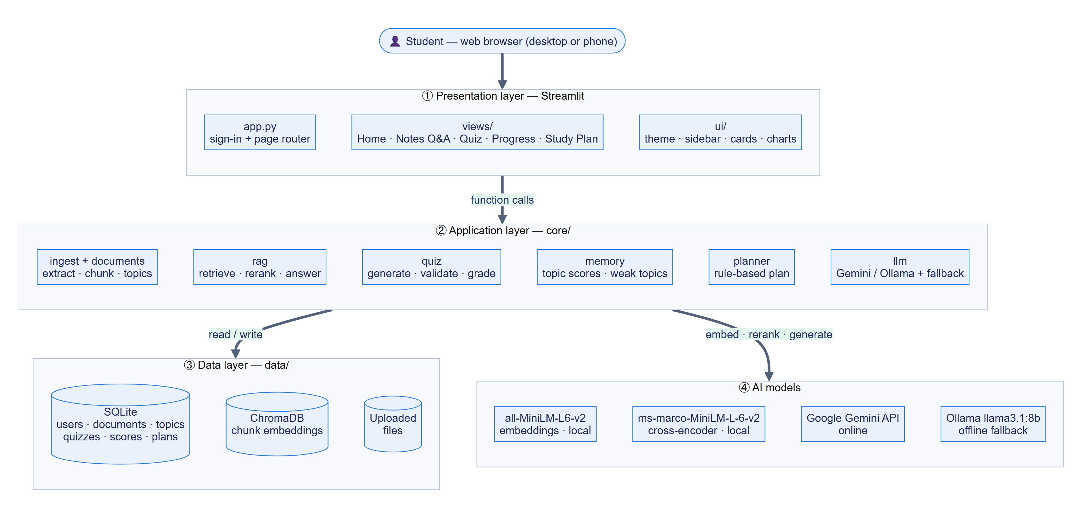
Figure 1: Layered system architecture of PersonaAI

4.2 Module Design
Table 6: Modules and responsibilities
Module | Responsibility | Lines
core/config.py | Loads settings from .env or Streamlit secrets; paths; logging | 63
core/documents.py | PDF/DOCX/TXT extraction, header/footer removal, page-bounded chunking | 175
core/vectorstore.py | Local embeddings and ChromaDB storage/search, filtered by user | 107
core/ingest.py | Upload pipeline: save, extract, chunk, embed, extract topics; re-upload keeps topics | 126
core/rag.py | Two-stage retrieval, grounded prompt, citation parsing, “not found” handling | 127
core/llm.py | One interface to Gemini and Ollama: retries, rate limits, quota cool-down, fallback | 206
core/quiz.py | Question allocation, MCQ generation, validation, shuffling, answer-key check, grading | 333
core/memory.py | Topic statistics, weak/strong classification, adaptive allocation, question→topic match | 138
core/planner.py | Rule-based study plan: weighted time, spaced reviews, final days; save/regenerate | 260
core/db.py | SQLite schema and queries; topic scores rebuilt after every quiz | 288
core/charts.py | Plotly charts for the Progress page | 75
app.py, ui/ | Sign-in card, router, sidebar navigation, theme and UI components | 437
views/ | Home, Notes Q&A, Quiz, Progress and Study Plan pages | 830
evaluation/ | Question set builder, RAG vs no-RAG runner, adaptive-quiz simulation | 641

4.3 Use Case Diagram
The primary actor is the student. The LLM service is a secondary actor used when documents are uploaded (topic extraction), questions are answered and quizzes are generated (Figure 2).
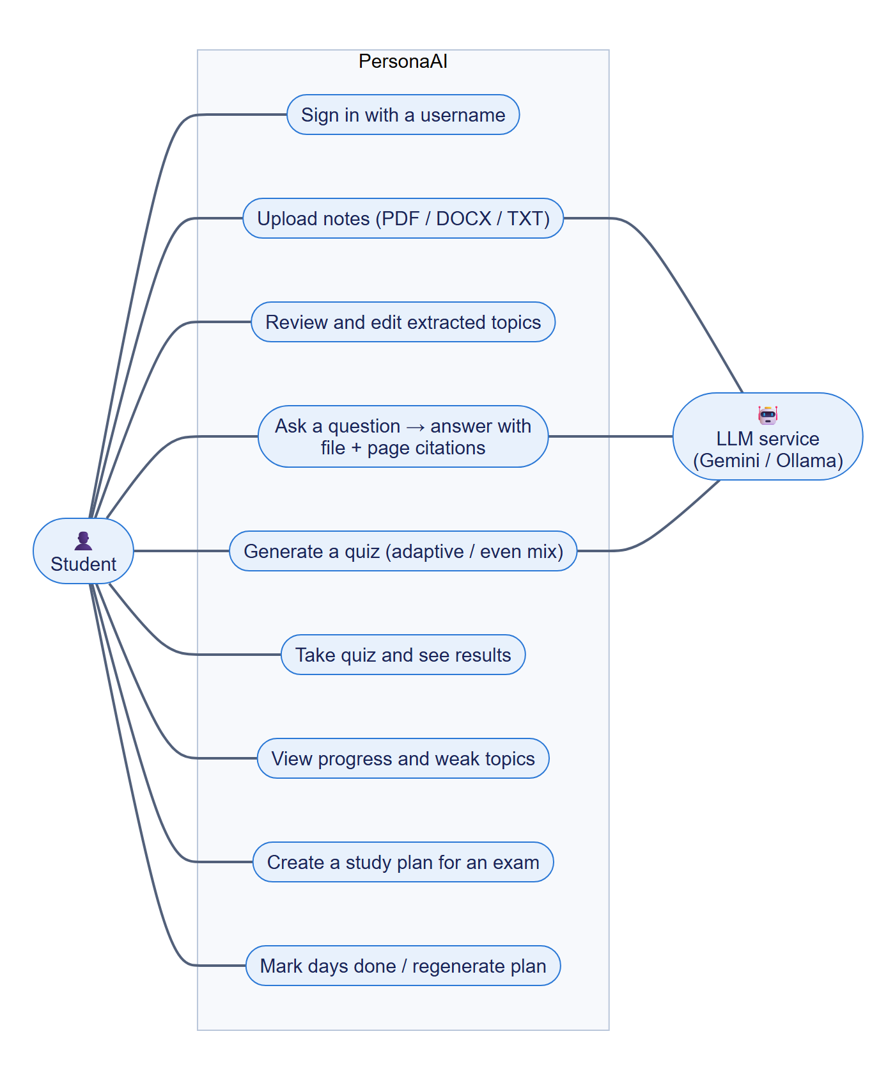
Figure 2: Use case diagram

4.4 Data Flow Diagrams
Figure 3 shows the context-level (level 0) data flow diagram, and Figure 4 decomposes the system into five processes and four data stores.
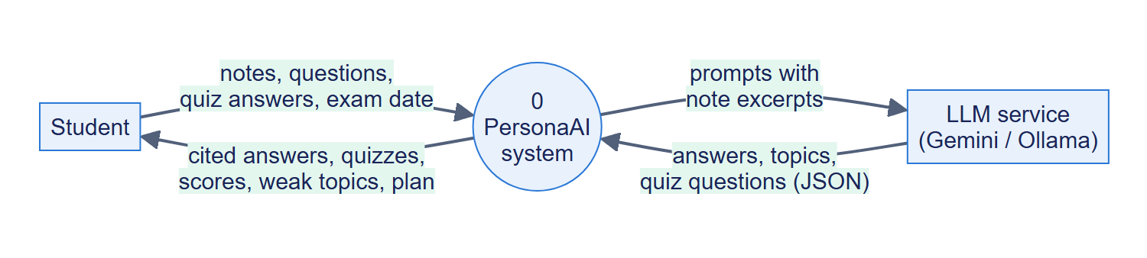
Figure 3: Data flow diagram — level 0 (context)
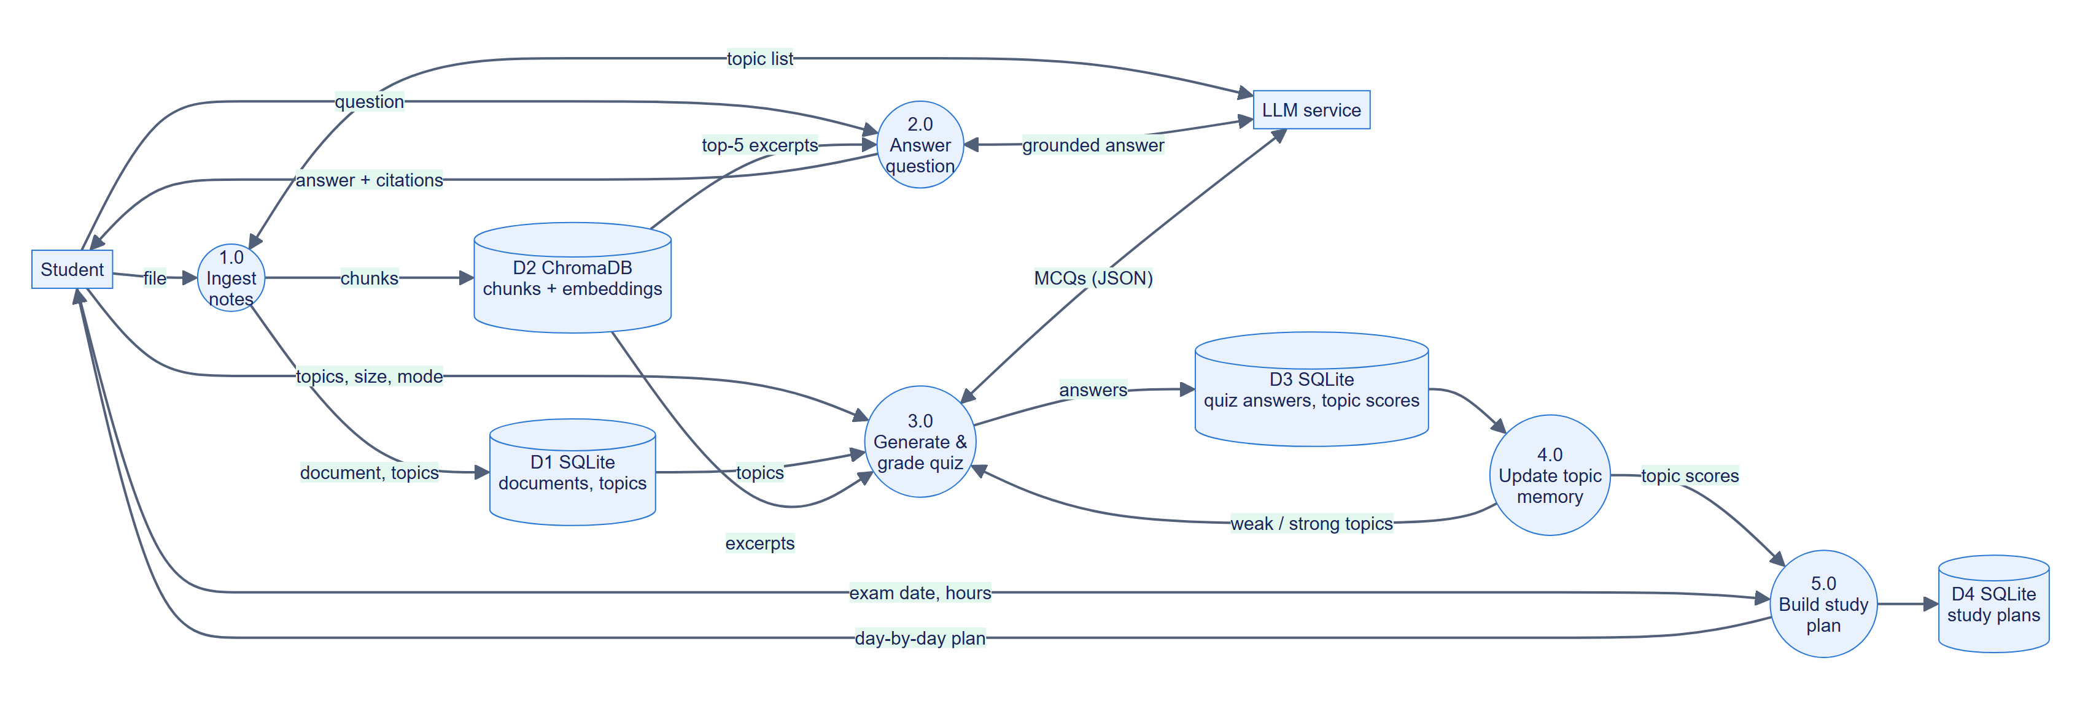
Figure 4: Data flow diagram — level 1

4.5 Database Design
Application data is stored in seven SQLite tables (Figure 5). Foreign keys cascade on delete, so removing a document removes its topics. Topic scores are not updated incrementally: after every quiz they are rebuilt from the saved answers in the same transaction, so they can never drift from the underlying data. Chunk text and embeddings live in ChromaDB, with metadata (user id, document id, file name, page) used for filtering and citations.
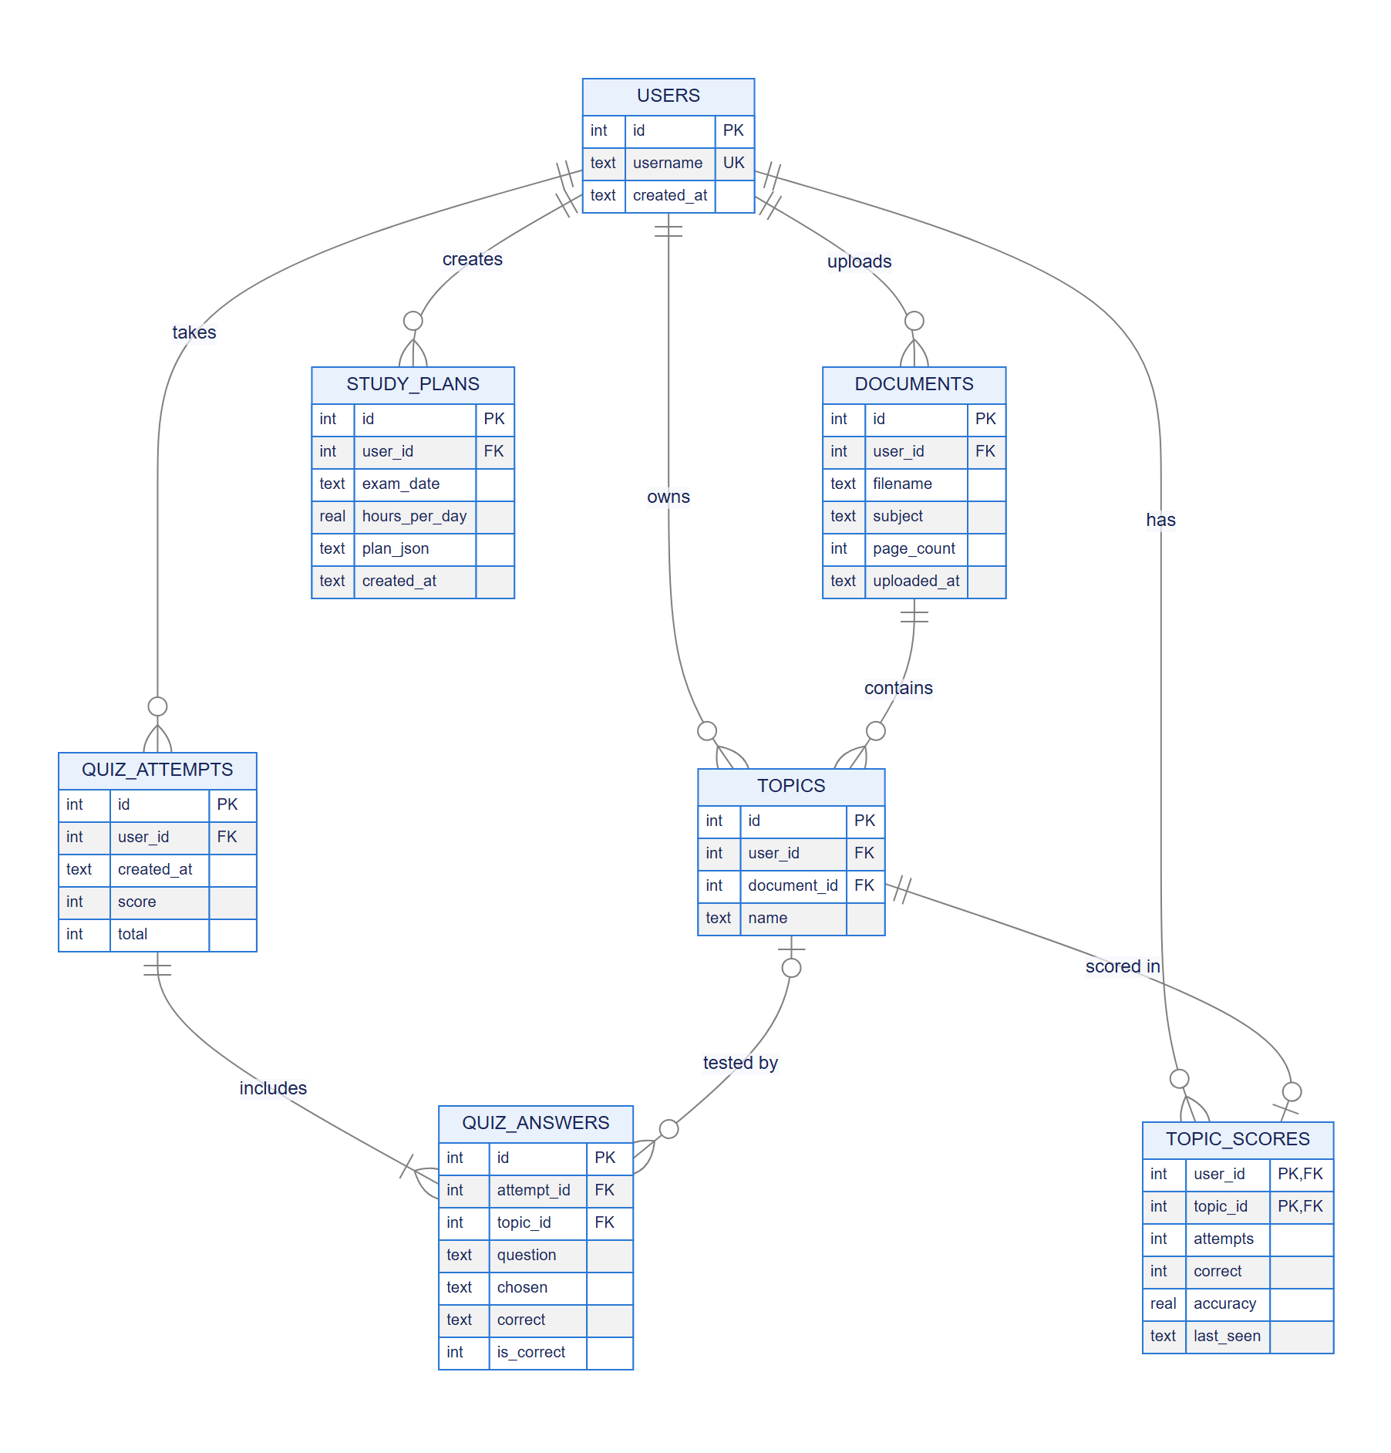
Figure 5: Entity-relationship diagram of the SQLite database
Table 7: Database tables
Table | Purpose | Key columns
users | One row per username | id, username (unique, case-insensitive)
documents | Uploaded files | id, user_id, filename, subject, page_count
topics | Syllabus topics per document (editable) | id, user_id, document_id, name
quiz_attempts | One row per submitted quiz | id, user_id, created_at, score, total
quiz_answers | Every answer with its topic | attempt_id, topic_id, question, chosen, correct, is_correct
topic_scores | Derived accuracy per topic | user_id, topic_id, attempts, correct, accuracy, last_seen
study_plans | Saved plans (JSON) and done flags | id, user_id, exam_date, hours_per_day, plan_json

4.6 Question Answering Sequence
Figure 6 shows the sequence of interactions when a student asks a question, including the “not found” branch and the model fallback chain.
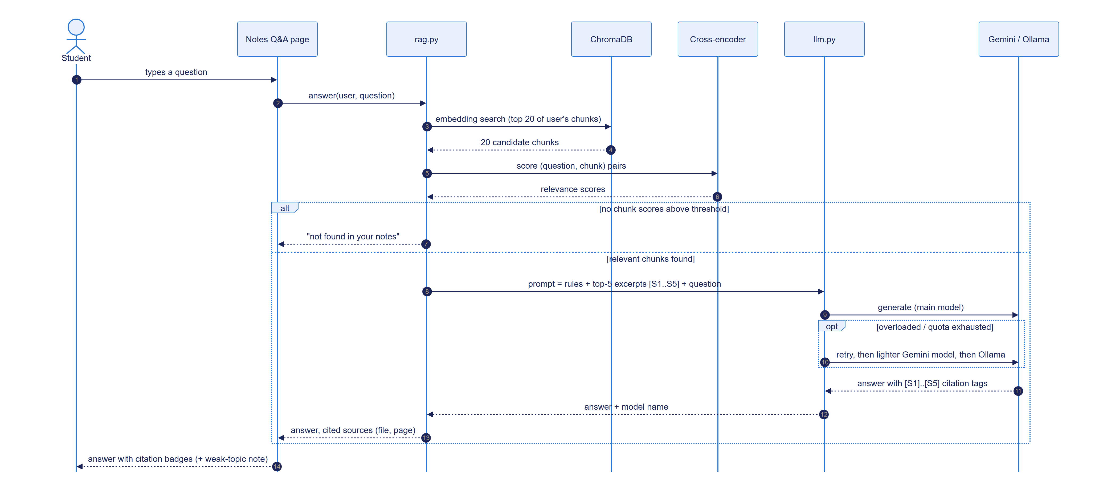
Figure 6: Sequence diagram — answering a question from the notes

4.7 Document Ingestion Pipeline
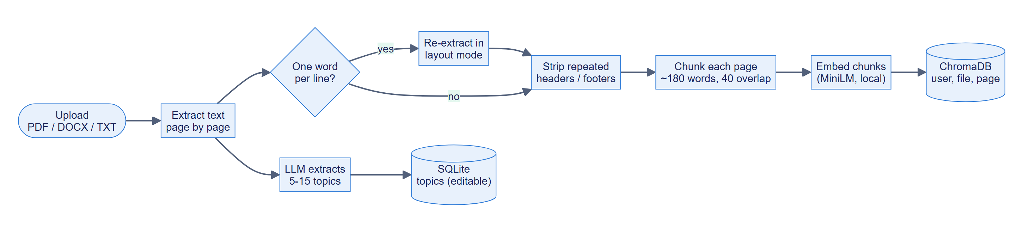
Figure 7: Document ingestion pipeline

4.8 Quiz Generation and Adaptive Allocation
Figure 8 shows how a quiz is produced. The only difference between adaptive and even-mix quizzes is the allocation of questions to topics; generation, validation and grading are shared.
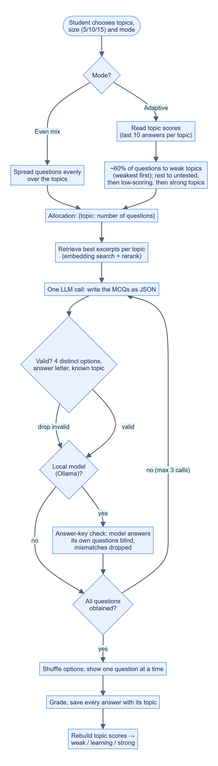
Figure 8: Activity diagram — quiz generation, grading and topic memory update

4.9 User Interface Design
The interface uses a light theme with a soft background (#F5F7FB), white rounded cards, the Inter typeface for text and Poppins for headings. One primary colour (blue #2A78D6) is used for actions and charts, with aqua, orange, violet and yellow as secondary accents, and green, amber and red reserved for status (correct / partial / wrong, strong / learning / weak). Status is always shown with an icon or text label as well as colour. The sidebar contains the logo, icon navigation with the current page highlighted, and a profile card; there is no sidebar before sign-in. All styling lives in one module (ui/styles.py), and layouts reflow to a single column on phones.

Chapter 5: Implementation

5.1 Development Methodology
The project was built incrementally in phases, each ending with a working application, automated tests and a Git commit (Table 8). Every design choice that deviated from the initial plan was made in response to a measured problem, which the following sections describe.
Table 8: Development phases
Phase | Deliverable
0. Setup | Virtual environment, configuration, LLM wrapper with fallback, SQLite schema, username sign-in
1. Notes Q&A | Extraction, chunking, embeddings, ChromaDB, cross-encoder re-ranking, cited answers, topic extraction
2. Quiz | Topic-based MCQ generation, validation, shuffling, answer-key check for local models, grading, saving answers
3. Weak-topic memory | Topic scores over recent answers, weak/strong classification, adaptive mode, progress dashboard
4. Study plan | Rule-based weighted plan with spaced reviews, mock exam and revision days, regeneration
5. Evaluation | RAG vs no-RAG on 60 exam questions with a blind LLM judge; adaptive-quiz simulation
UI redesign | Custom theme, navigation, dashboard components, one-question-at-a-time quiz, timeline plan

5.2 Document Processing
Text is extracted page by page with pypdf (DOCX and TXT are split into ~400-word sections). Two problems found in the real course PDFs were handled:
- One word per line. One PDF extracted with every word on its own line. When the average line has fewer than 1.5 words, the page is re-extracted in pypdf’s layout mode, which restores normal lines.
- Repeated headers. Every page of two PDFs began with “Prepared by … Page N”, which polluted search results. Lines in the top or bottom three lines of a page that repeat on at least half of the pages (ignoring digits) are removed. Limiting this to the page edges was necessary: a first version also removed the labels “Answer:” and “Example:”, which repeat in the body of a question-bank PDF.
Pages are split into chunks of 180 words with a 40-word overlap, never crossing a page boundary so that every chunk has exactly one page to cite. The size was chosen because the embedding model reads only 256 word-pieces (about 190 words); the originally planned 500-token chunks would have been silently truncated.
Listing 1: Page-bounded chunking (core/documents.py)
def chunk_pages(
pages: list[Page], size: int = CHUNK_WORDS, overlap: int = CHUNK_OVERLAP
) -> list[Chunk]:
"""Split each page into overlapping word windows. Chunks never span pages,
so every chunk has exactly one page to cite."""
if overlap >= size:
raise ValueError("overlap must be smaller than size")
chunks: list[Chunk] = []
for page in pages:
words = page.text.split()
if not words:
continue
start = 0
while True:
end = min(start + size, len(words))
# Fold a short tail into this chunk instead of making a tiny one.
if len(words) - end < MIN_CHUNK_WORDS:
end = len(words)
chunks.append(Chunk(" ".join(words[start:end]), page.number, len(chunks)))
if end == len(words):
break
start = end - overlap
return chunks

5.3 Retrieval and Answer Generation
Retrieval has two stages. Embedding search returns the 20 chunks closest to the question (filtered by the student’s user id); a cross-encoder then scores each (question, chunk) pair and the best five with a score of at least −5 are kept. The re-ranker was added after testing on the real notes: for “What is Apache Pig?”, embedding search ranked the defining chunk 8th because almost every chunk was “about Pig”; the cross-encoder ranked it 1st (score 7.4 against 1.9 for the next).
Listing 2: Two-stage retrieval (core/rag.py)
def retrieve(
user_id: int, question: str, document_ids: list[int] | None = None, k: int = TOP_K
) -> list[vectorstore.Hit]:
"""Best k relevant chunks for the question, best first (empty if none are relevant)."""
candidates = vectorstore.search(user_id, question, k=CANDIDATES, document_ids=document_ids)
if not candidates:
return []
scores = _cross_encoder().predict([(question, h.text) for h in candidates])
for hit, score in zip(candidates, scores):
hit.score = float(score)
ranked = sorted(candidates, key=lambda h: h.score, reverse=True)
return [h for h in ranked if h.score >= MIN_SCORE][:k]

The excerpts are numbered [S1]…[S5] with their file and page, and the model is instructed to answer only from them, cite them inline and reply with the token NOT_FOUND otherwise. Tags were changed from [1] to [S1] after the model confused a question number in the notes (“22. What is bucketing?”) with an excerpt number.
Listing 3: Grounding instructions given to the model (core/rag.py)
SYSTEM_PROMPT = f"""You are PersonaAI, a study assistant for a university student.
Answer the question using ONLY the numbered excerpts from the student's own notes.

Rules:
- Use only facts stated in the excerpts. Do not add outside knowledge.
- Cite the excerpts you used inline with their tags, like [S1] or [S2][S4], right after the
sentence they support. Only use these [S#] tags for citations, never the notes' own numbering.
- If the excerpts do not contain the answer, reply with exactly {NOT_FOUND} and nothing else.
- Write the way a good exam answer reads: a one-line definition or direct answer first,
then key points as bullets. Include a short example or syntax if the excerpts give one.
- Keep it concise."""

Unanswerable questions are handled in two layers: if no chunk passes the re-ranker threshold the system answers “not found” without calling the LLM (saving quota), and otherwise the LLM’s NOT_FOUND reply is detected. The threshold was calibrated on the course notes: on-syllabus questions scored between −2.3 and 8.6 for their best chunk, unrelated questions between −9.4 and −4.7.

5.4 LLM Access, Fallback and Rate Limits
All generation goes through core/llm.py. It tries the configured Gemini model, then a lighter Gemini model, then the local Ollama model. During development the free tier returned three kinds of failures, each handled differently:
- Overload (HTTP 503/504): retried once after a short back-off, then the next model is tried.
- Per-minute rate limit (HTTP 429 with a short retry delay, e.g. 6 s): the system waits and retries the same model. An earlier version treated this as an outage and fell back to the much slower local model.
- Daily quota (HTTP 429 with a retry delay of hours): the model is skipped for that period, so later calls do not waste attempts on it.
Listing 4: Retry policy for transient errors and rate limits (core/llm.py)
def _with_retries(fn, *args, attempts: int = 2):
"""Retry with exponential backoff (1s, 2s, ...) for transient errors like overload.

Rate limits (HTTP 429) depend on how long Google says to wait: a per-minute limit
(retry in ~6s) is waited out on the same model, which is far faster than falling
back to a local model; a daily quota (retry in hours) is raised so the caller can
skip the model."""
failures = rate_waits = 0
while True:
try:
return fn(*args)
except LLMError:
raise
except Exception as exc:
cooldown = _quota_cooldown(exc)
if cooldown is not None:
if cooldown > MAX_RATE_LIMIT_WAIT_S or rate_waits >= MAX_RATE_LIMIT_WAITS:
raise
rate_waits += 1
log.info("Rate limited; waiting %.0fs and retrying", cooldown + 1)
time.sleep(cooldown + 1)
continue
failures += 1
if failures >= attempts:
raise
wait = 2 ** (failures - 1)
log.warning("LLM call failed (%s); retrying in %ss", exc, wait)
time.sleep(wait)

5.5 Quiz Generation
A quiz is described by an allocation {topic: number of questions}. The best excerpts for each topic are retrieved, and one LLM call asks for exactly the allocated number of questions per topic as JSON (question, four options, answer letter, explanation, topic tag, source tag). Each question is validated: exactly four distinct options, no “all/none of the above”, an answer given as a letter or the exact option text (numeric answers are rejected because models mix 0- and 1-based indices), and a known topic. Missing questions are requested again (at most three calls). Options are then shuffled, because LLMs tend to place the correct answer early; over 4,000 shuffles each position held the answer 24–26 % of the time.
Quality differed by model. In manual checks, Gemini produced 15 of 15 questions with correct answer keys, but the local llama3.1:8b model produced wrong keys in 2 of 5. For local-model quizzes, PersonaAI therefore adds an answer-key check: the model answers its own questions without seeing the key, and questions where its answer disagrees are discarded and regenerated.
Listing 5: Answer-key check for local-model quizzes (core/quiz.py)
def verify(questions: list[Question], hits) -> list[Question]:
"""Have the model answer its own questions without seeing the key; keep only the
questions where its answer matches. Catches wrong keys and ambiguous questions."""
listing = "\n\n".join(
f"{i}. {q.question}\n" + "\n".join(f"{LETTERS[j]}. {o}" for j, o in enumerate(q.options))
for i, q in enumerate(questions, 1)
)
reply = llm.generate(
VERIFY_PROMPT.format(excerpts=_excerpts(hits), questions=listing),
json_mode=True,
temperature=0,
)
try:
data = json.loads(re.sub(r"^```(?:json)?|```$", "", reply.strip(), flags=re.M).strip())
answers = {int(a["n"]): str(a["answer"]).strip().upper()[:1] for a in data["answers"]}
except (ValueError, KeyError, TypeError):
log.warning("Quiz verification reply unreadable; keeping no questions: %r", reply[:200])
return []
kept = [q for i, q in enumerate(questions, 1) if answers.get(i) == LETTERS[q.answer]]
log.info("Quiz verification kept %d of %d questions", len(kept), len(questions))
return kept

5.6 Weak-Topic Memory and Adaptive Quizzes
After every quiz, topic scores are rebuilt from the saved answers by a single SQL statement. A topic’s accuracy is computed over its last ten answers, not all-time: with all-time accuracy, a student who answered a topic wrong ten times and then right nine times would still be at 47 % and labelled weak; over the last ten answers the topic is at 90 % and labelled strong.
Listing 6: Rebuilding topic scores from recent answers (core/db.py)
_REFRESH_SCORES = """
INSERT INTO topic_scores (user_id, topic_id, attempts, correct, accuracy, last_seen)
SELECT q.user_id, a.topic_id, COUNT(*), SUM(a.is_correct),
(SELECT AVG(r.is_correct) FROM (
SELECT a2.is_correct FROM quiz_answers a2
JOIN quiz_attempts q2 ON q2.id = a2.attempt_id
WHERE a2.topic_id = a.topic_id AND q2.user_id = q.user_id
ORDER BY a2.id DESC LIMIT {recent}) r),
MAX(q.created_at)
FROM quiz_answers a JOIN quiz_attempts q ON q.id = a.attempt_id
WHERE q.user_id = ? AND a.topic_id IS NOT NULL
GROUP BY a.topic_id
""".format(recent=RECENT_ANSWERS)

Table 9: Topic classification and key parameters
Parameter | Value | Meaning
Minimum answers | 3 | A topic is not judged on fewer answers
Weak | accuracy < 60 % | Target of adaptive quizzes; 3× time in plans
Strong | accuracy ≥ 80 % | 1× time in plans
Learning / untested | otherwise | 2× time in plans
Adaptive weak share | ≈ 60 % of questions | Rest: untested, then lowest-scoring, then strong topics seen longest ago
Chunk size / overlap | 180 / 40 words | Fits the embedding model’s 256-token limit
Retrieval | 20 candidates → top 5 | Re-ranker threshold −5

Listing 7: Adaptive allocation of questions to topics (core/memory.py)
def adaptive_allocation(stats: list[TopicStat], n: int) -> dict[int, int]:
"""Spread n questions with ~60% on weak topics (weakest first). The rest go to
untested topics first (to discover new weak spots), then the lowest-scoring ones,
then strong topics seen longest ago (a light spaced-repetition touch)."""
weak = sorted((s for s in stats if s.status == "weak"), key=lambda s: s.accuracy)
others = sorted(
(s for s in stats if s.status != "weak"),
key=lambda s: (
{"new": 0, "learning": 1, "strong": 2}[s.status],
s.accuracy if s.accuracy is not None else 0,
s.last_seen or "",
),
)
if not weak and not others:
return {}
if weak and others:
weak_n = round(n * ADAPTIVE_WEAK_SHARE)
else:
weak_n = n if weak else 0

allocation: dict[int, int] = {}
for i in range(weak_n):
tid = weak[i % len(weak)].topic_id
allocation[tid] = allocation.get(tid, 0) + 1
for i in range(n - weak_n):
tid = others[i % len(others)].topic_id
allocation[tid] = allocation.get(tid, 0) + 1
return allocation

The Q&A page also tells the student when a question is about one of their weak topics. The topic is found by embedding similarity between the question and every topic name. A fixed similarity cut-off failed calibration (correct pairs scored as low as 0.27 while sibling topics scored up to 0.70), but the single closest topic was correct for all nine test questions, so the closest topic is used with only a low floor (0.22) for unrelated questions.

5.7 Study Planner
The planner is rule-based rather than LLM-generated so that its guarantees always hold and it uses no API quota. Study time (study days × hours per day) is divided into 30-minute slots. Every topic receives one slot; the remaining slots are divided in proportion to the weights (weak 3, untested/learning 2, strong 1) using the largest-remainder method. Each topic’s time is split into a study session (~60 %) and a review session with a five-question quiz (~40 %) at least two days later. Days are filled greedily: due reviews first, then new topics in syllabus order. For exams more than six days away, the last two days are a mock exam and a final revision of the weakest topics. Regenerating re-runs the rules from today with the latest topic scores and lists how each topic’s time changed.
Listing 8: Weighted allocation of study slots (core/planner.py)
def _allocate_slots(
topics: list[TopicStat], total: int, study_days: int, hours_per_day: float
) -> dict[int, int]:
"""Split `total` slots by weight (largest remainder), at least one per topic."""
if total < len(topics):
needed = math.ceil(len(topics) * SLOT_HOURS / max(study_days, 1) / SLOT_HOURS) * SLOT_HOURS
raise PlanError(
f"Not enough time to cover all {len(topics)} topics at {hours_per_day} h/day. "
f"Plan at least {needed} h/day, or pick fewer documents."
)
slots = {t.topic_id: 1 for t in topics}
remaining = total - len(topics)
weights = {t.topic_id: WEIGHTS[t.status] for t in topics}
weight_sum = sum(weights.values())
shares = {tid: remaining * w / weight_sum for tid, w in weights.items()}
for tid, share in shares.items():
slots[tid] += int(share)
leftover = total - sum(slots.values())
# Ties go to the heavier (weaker) topic.
by_remainder = sorted(shares, key=lambda tid: (-(shares[tid] % 1), -weights[tid]))
for tid in by_remainder[:leftover]:
slots[tid] += 1
return slots

5.8 User Interface
app.py uses st.navigation with the page list hidden, and ui/shell.py draws a custom sidebar. Shared styling is injected once per run from ui/styles.py; selectors target Streamlit’s data-testid attributes and the classes Streamlit adds to keyed containers rather than generated class names. All user-provided text (file and topic names) is HTML-escaped before being inserted into custom components. The quiz shows one question at a time; answers are recorded through widget callbacks, because Streamlit discards the state of widgets that are not displayed, and an early version lost navigation clicks for that reason.

Chapter 6: Testing

6.1 Testing Strategy
- Unit tests for pure logic: chunking, header removal, answer and citation parsing, quiz validation, allocation, classification, plan rules and the LLM retry/fallback policy (with stubbed models).
- Integration tests that use the real embedding and re-ranking models with a temporary ChromaDB and SQLite database, and a stubbed LLM.
- User-interface tests with Streamlit’s AppTest, which runs each page headlessly and drives its widgets (sign-in, quiz flow, adaptive targeting, progress, study plan).
- Live tests against the real models on the course PDFs, checked manually (answer quality, quiz quality, “not found” behaviour), and visual checks of every page at desktop and phone widths using headless Chrome screenshots.
Table 10: Automated test suite (101 tests, all passing)
Test file | Tests | What is covered
test_documents.py | 8 | Chunk sizes, overlap, page boundaries, header removal, DOCX/TXT extraction, bad files
test_rag.py | 5 | NOT_FOUND handling, [S#] citation parsing, prompt format, topic JSON parsing
test_ingest.py | 4 | Ingest → search → answer → delete with real embeddings; re-upload; user isolation
test_llm.py | 9 | Fallback order, retries, daily quota cool-down, per-minute rate-limit waits
test_quiz.py | 14 | Validation rules, answer formats, retries for missing questions, answer-key check
test_memory.py | 9 | Classification, recent-answer window, backfill, adaptive allocation, topic matching
test_planner.py | 10 | Coverage of all topics, weighting, spacing, final days, errors, regeneration
test_db.py | 5 | Schema, users, topic editing keeps ids, cascading deletes
test_eval.py | 6 | Blind judging order, abstentions, quota stop, summaries, simulation
test_app.py | 10 | Sign-in, pages, one-question quiz flow, adaptive targeting, progress, study plan

6.2 Sample Test Cases
Table 11: Sample test cases
ID | Test case | Input / action | Expected result | Result
TC1 | Sign in | Enter “Vivek”, click Continue | Home page with “Welcome back, Vivek” | Pass
TC2 | Empty username | Click Continue with no name | Error “Please enter a username.” | Pass
TC3 | Unsupported file | Upload a .pptx / empty .txt | Clear error, nothing stored | Pass
TC4 | Cited answer | “What is bucketing in Hive?” | Answer with file + page badges | Pass
TC5 | Off-syllabus question | “Who won the 2018 FIFA World Cup?” | “Not found in your notes”, no LLM call | Pass
TC6 | Invalid MCQ | Model returns 3 options / “All of the above” | Question dropped and regenerated | Pass
TC7 | Incomplete quiz | Submit with unanswered questions | Warning listing missing numbers | Pass
TC8 | Answer kept | Answer Q1, Next, Previous | Q1 still shows the chosen option | Pass
TC9 | Weak topic | 3 answers on a topic, 1 correct | Topic flagged weak (33 %) | Pass
TC10 | Improvement | 10 wrong then 9 right | Topic becomes strong (90 % recent) | Pass
TC11 | Adaptive quiz | 10 questions, one weak topic | 6 questions on the weak topic | Pass
TC12 | Plan coverage | 14-day plan, 10 topics | Every topic studied; weak > untested > strong | Pass
TC13 | Plan update | Improve a topic, regenerate | That topic’s planned hours decrease | Pass
TC14 | Rate limit | 429 with retryDelay 6 s | Wait and retry the same model | Pass

6.3 Defects Found and Fixed
Testing against the real course material and real model outputs found several defects that unit tests alone would not have shown:
Table 12: Defects found during testing
Defect | How it was found | Fix
“What is Apache Pig?” answered “not found” | Live Q&A on course PDFs | Cross-encoder re-ranking of 20 candidates
Header removal deleted “Answer:”/“Example:” | Inspecting extracted text | Only remove repeats at page edges
Model cited “[22]” (a question number) | Live Q&A | Excerpt tags changed to [S1]…[S5]
Local model quizzes had wrong answer keys | Manual quiz review | Answer-key self-check for Ollama
Quiz page crashed (form key = state key) | AppTest UI test | Renamed session-state key
Quiz navigator lost clicks after answering | AppTest trace | Widget callbacks update state first
Per-minute limit triggered slow local fallback | Evaluation run stopped at question 16 | Wait out short 429 delays on same model
Re-upload deleted topics and quiz history | Design review in Phase 3 | Re-upload updates the document in place

Chapter 7: Results and Discussion

7.1 Application Screens
The screenshots below were captured from the running application. The Notes Q&A answers and quiz questions are real outputs generated from the Big Data course notes. Screens that depend on quiz history (Home, Progress and the Study Plan timeline) use a sample quiz history in a demonstration copy of the database, because the student account had only one quiz at the time of capture.
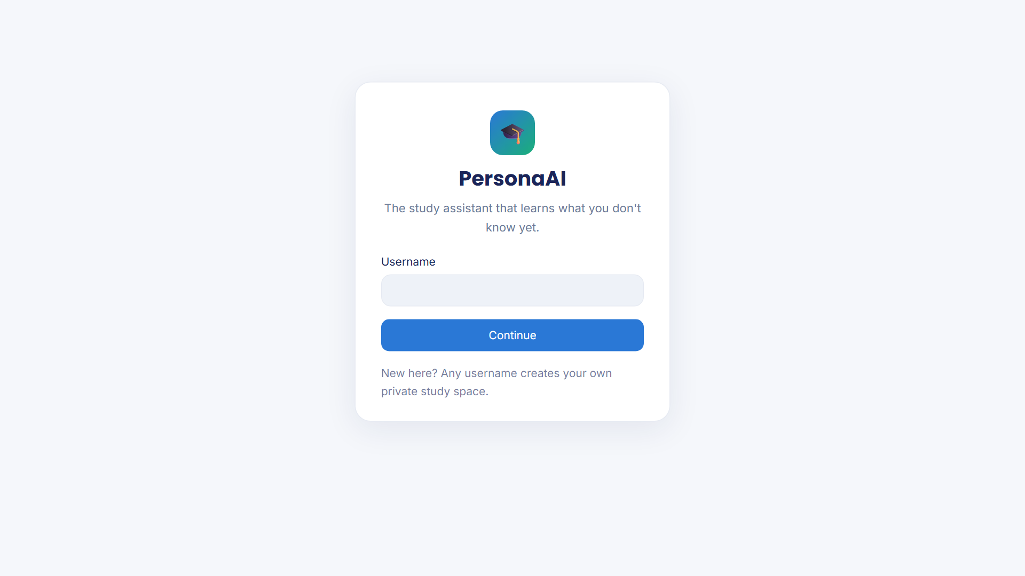
Figure 9: Sign-in page
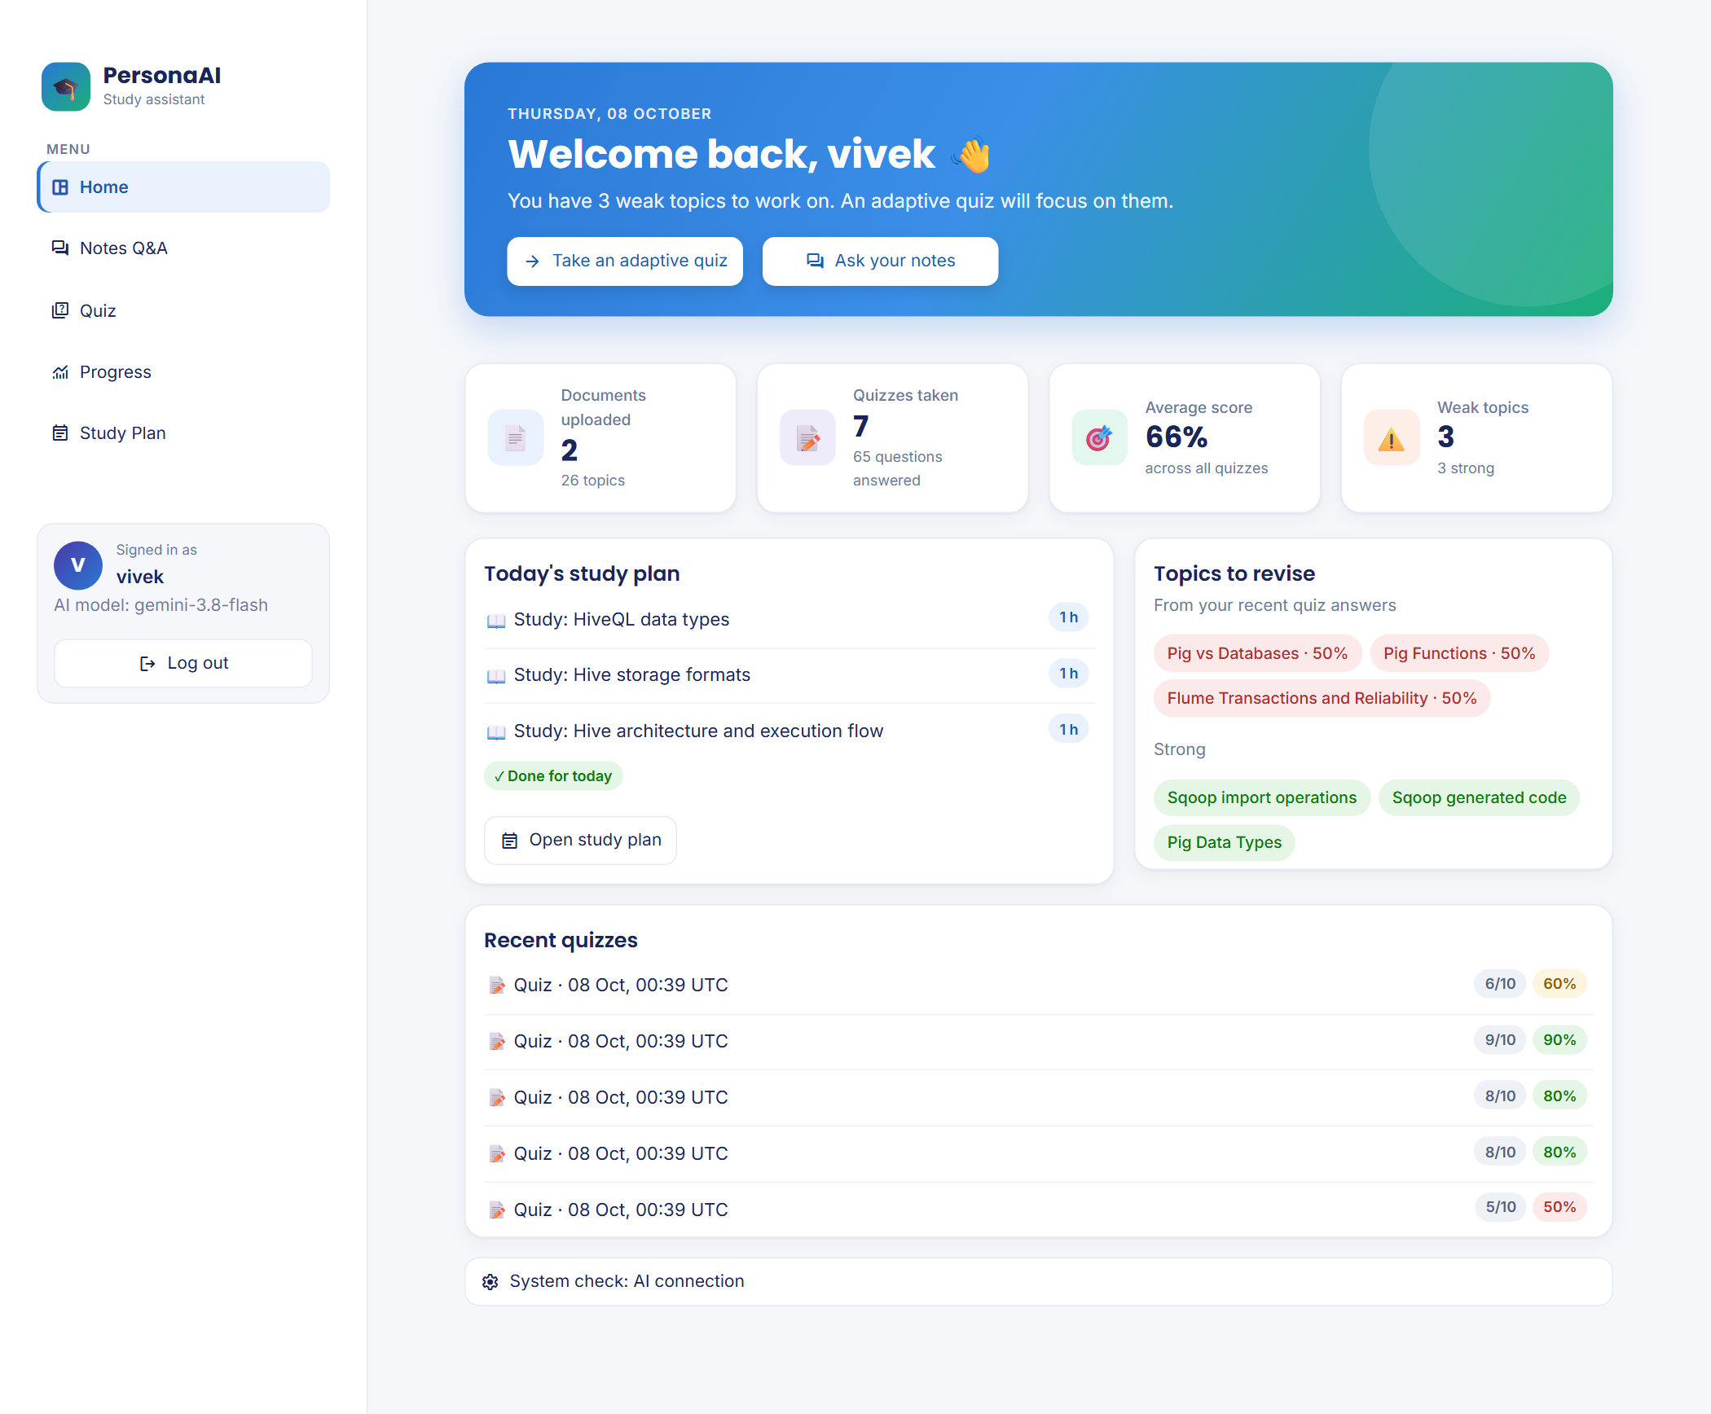
Figure 10: Home dashboard: welcome banner, statistics, today’s plan, topics to revise (sample quiz history)
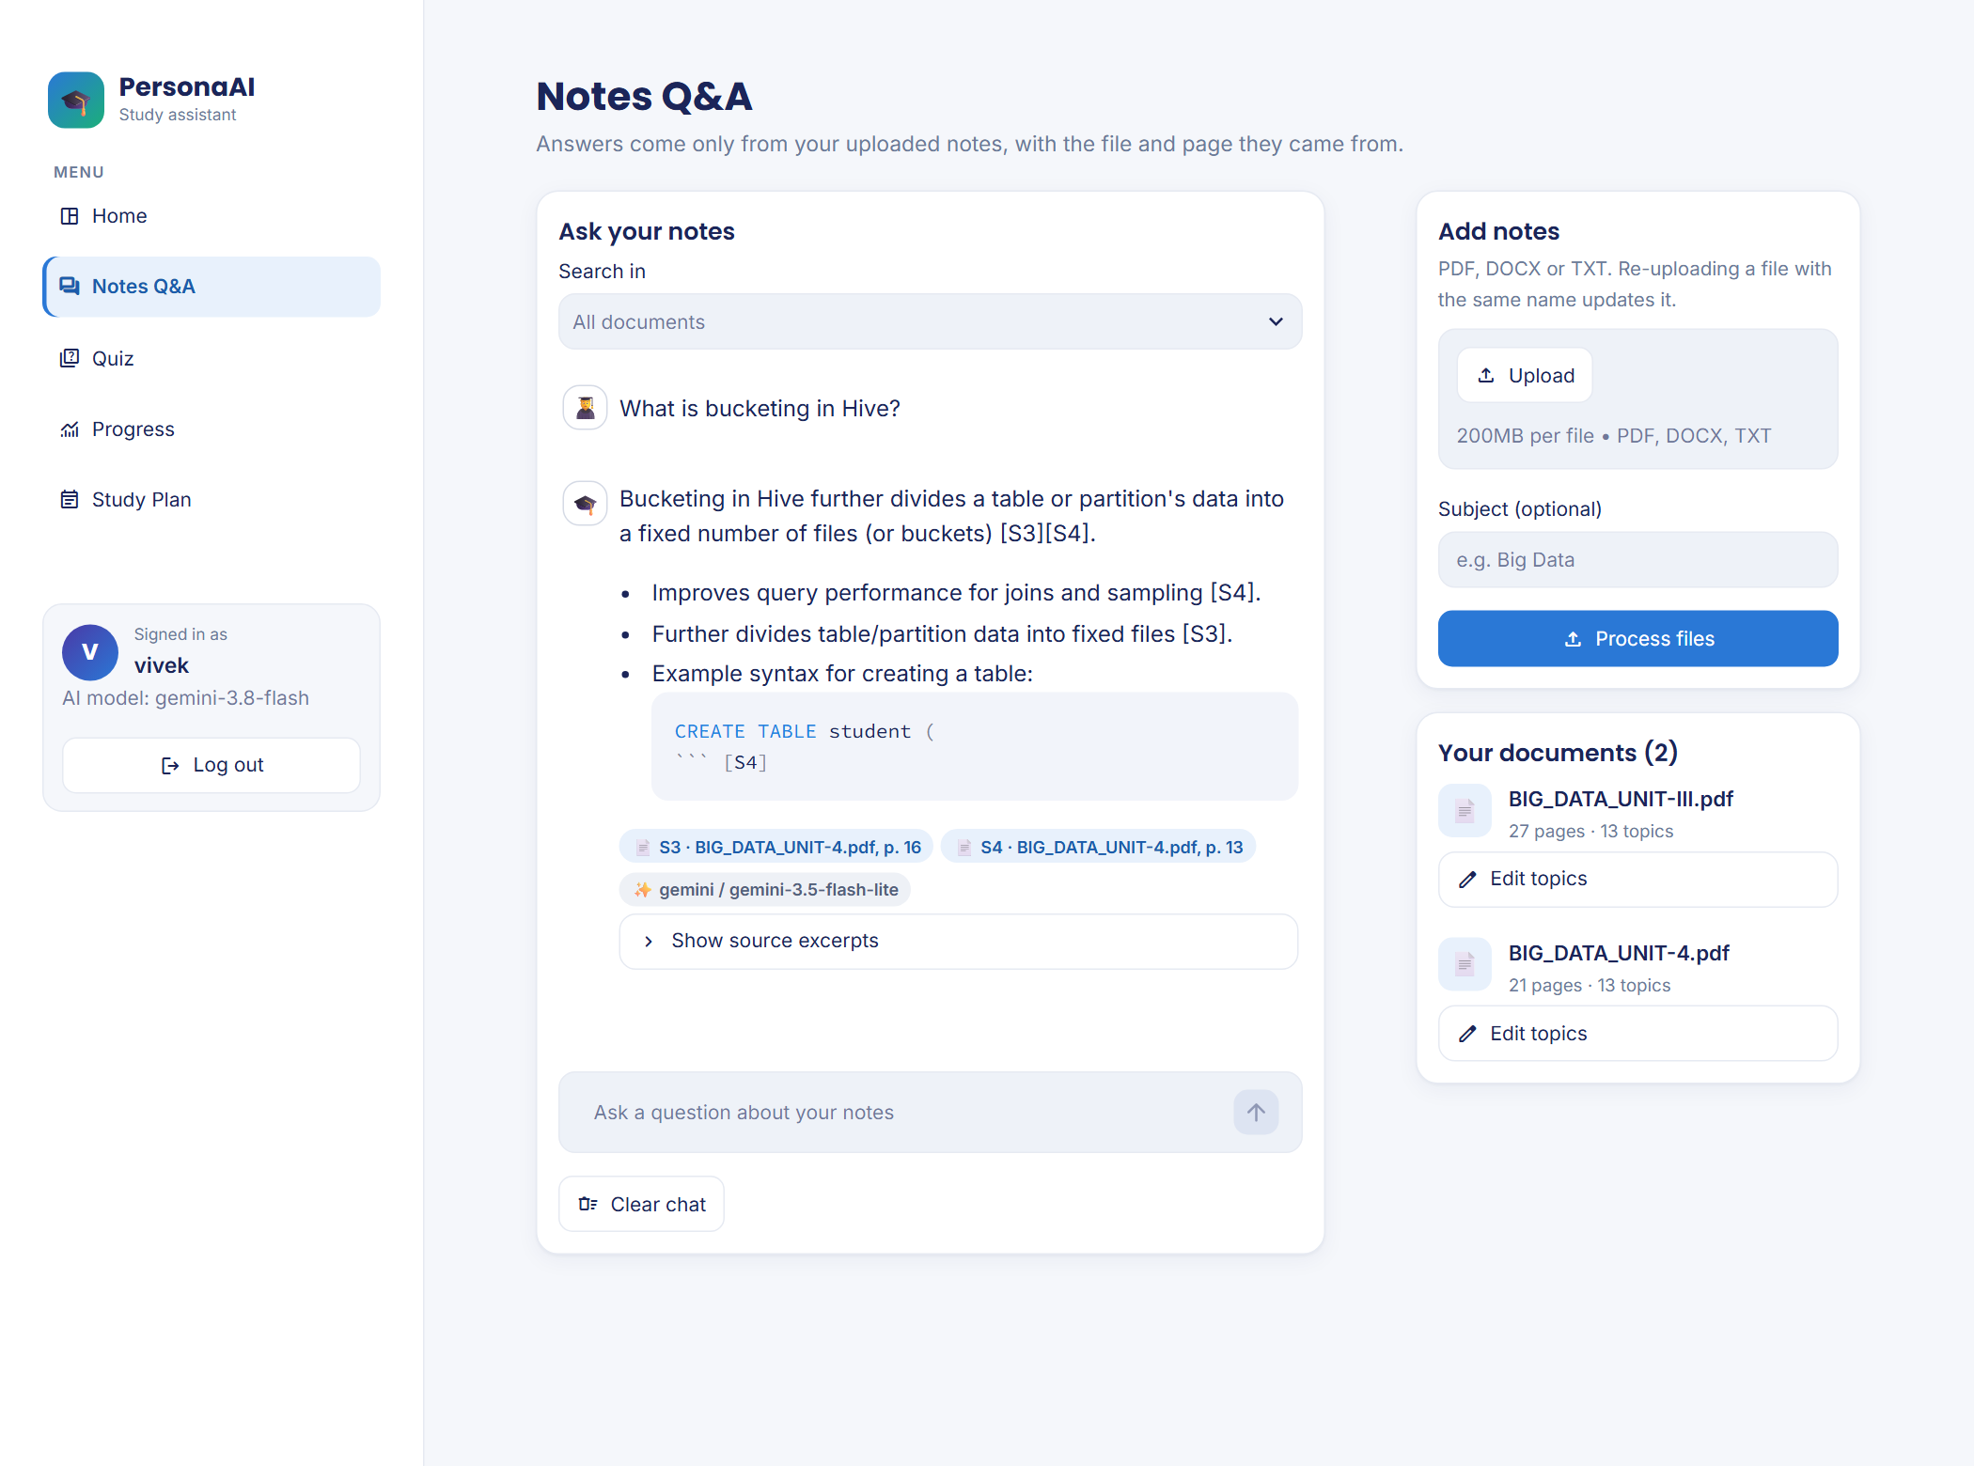
Figure 11: Notes Q&A: a real answer from the notes with file and page citations
Figure 11 also shows a known limitation: the SQL example in the answer is cut off after CREATE TABLE student (, because the chunk containing the example ends at that point (see Section 7.3).
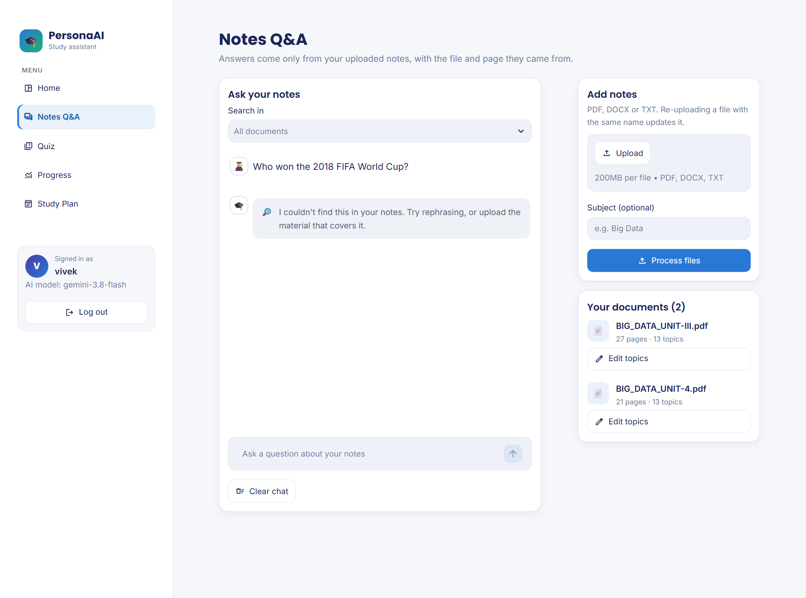
Figure 12: Notes Q&A: an off-syllabus question is refused instead of answered from general knowledge
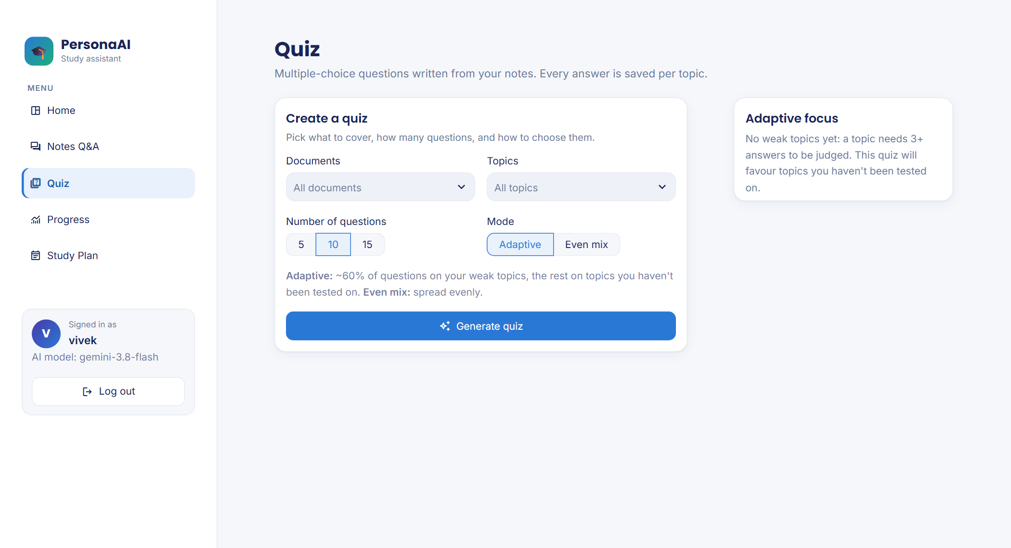
Figure 13: Quiz setup: documents, topics, number of questions and mode
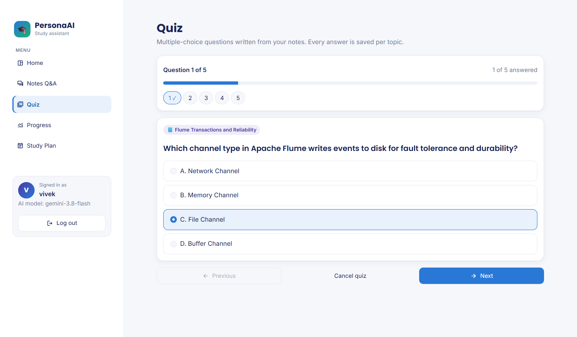
Figure 14: Taking a quiz: one question at a time with progress and question navigator (real generated question)
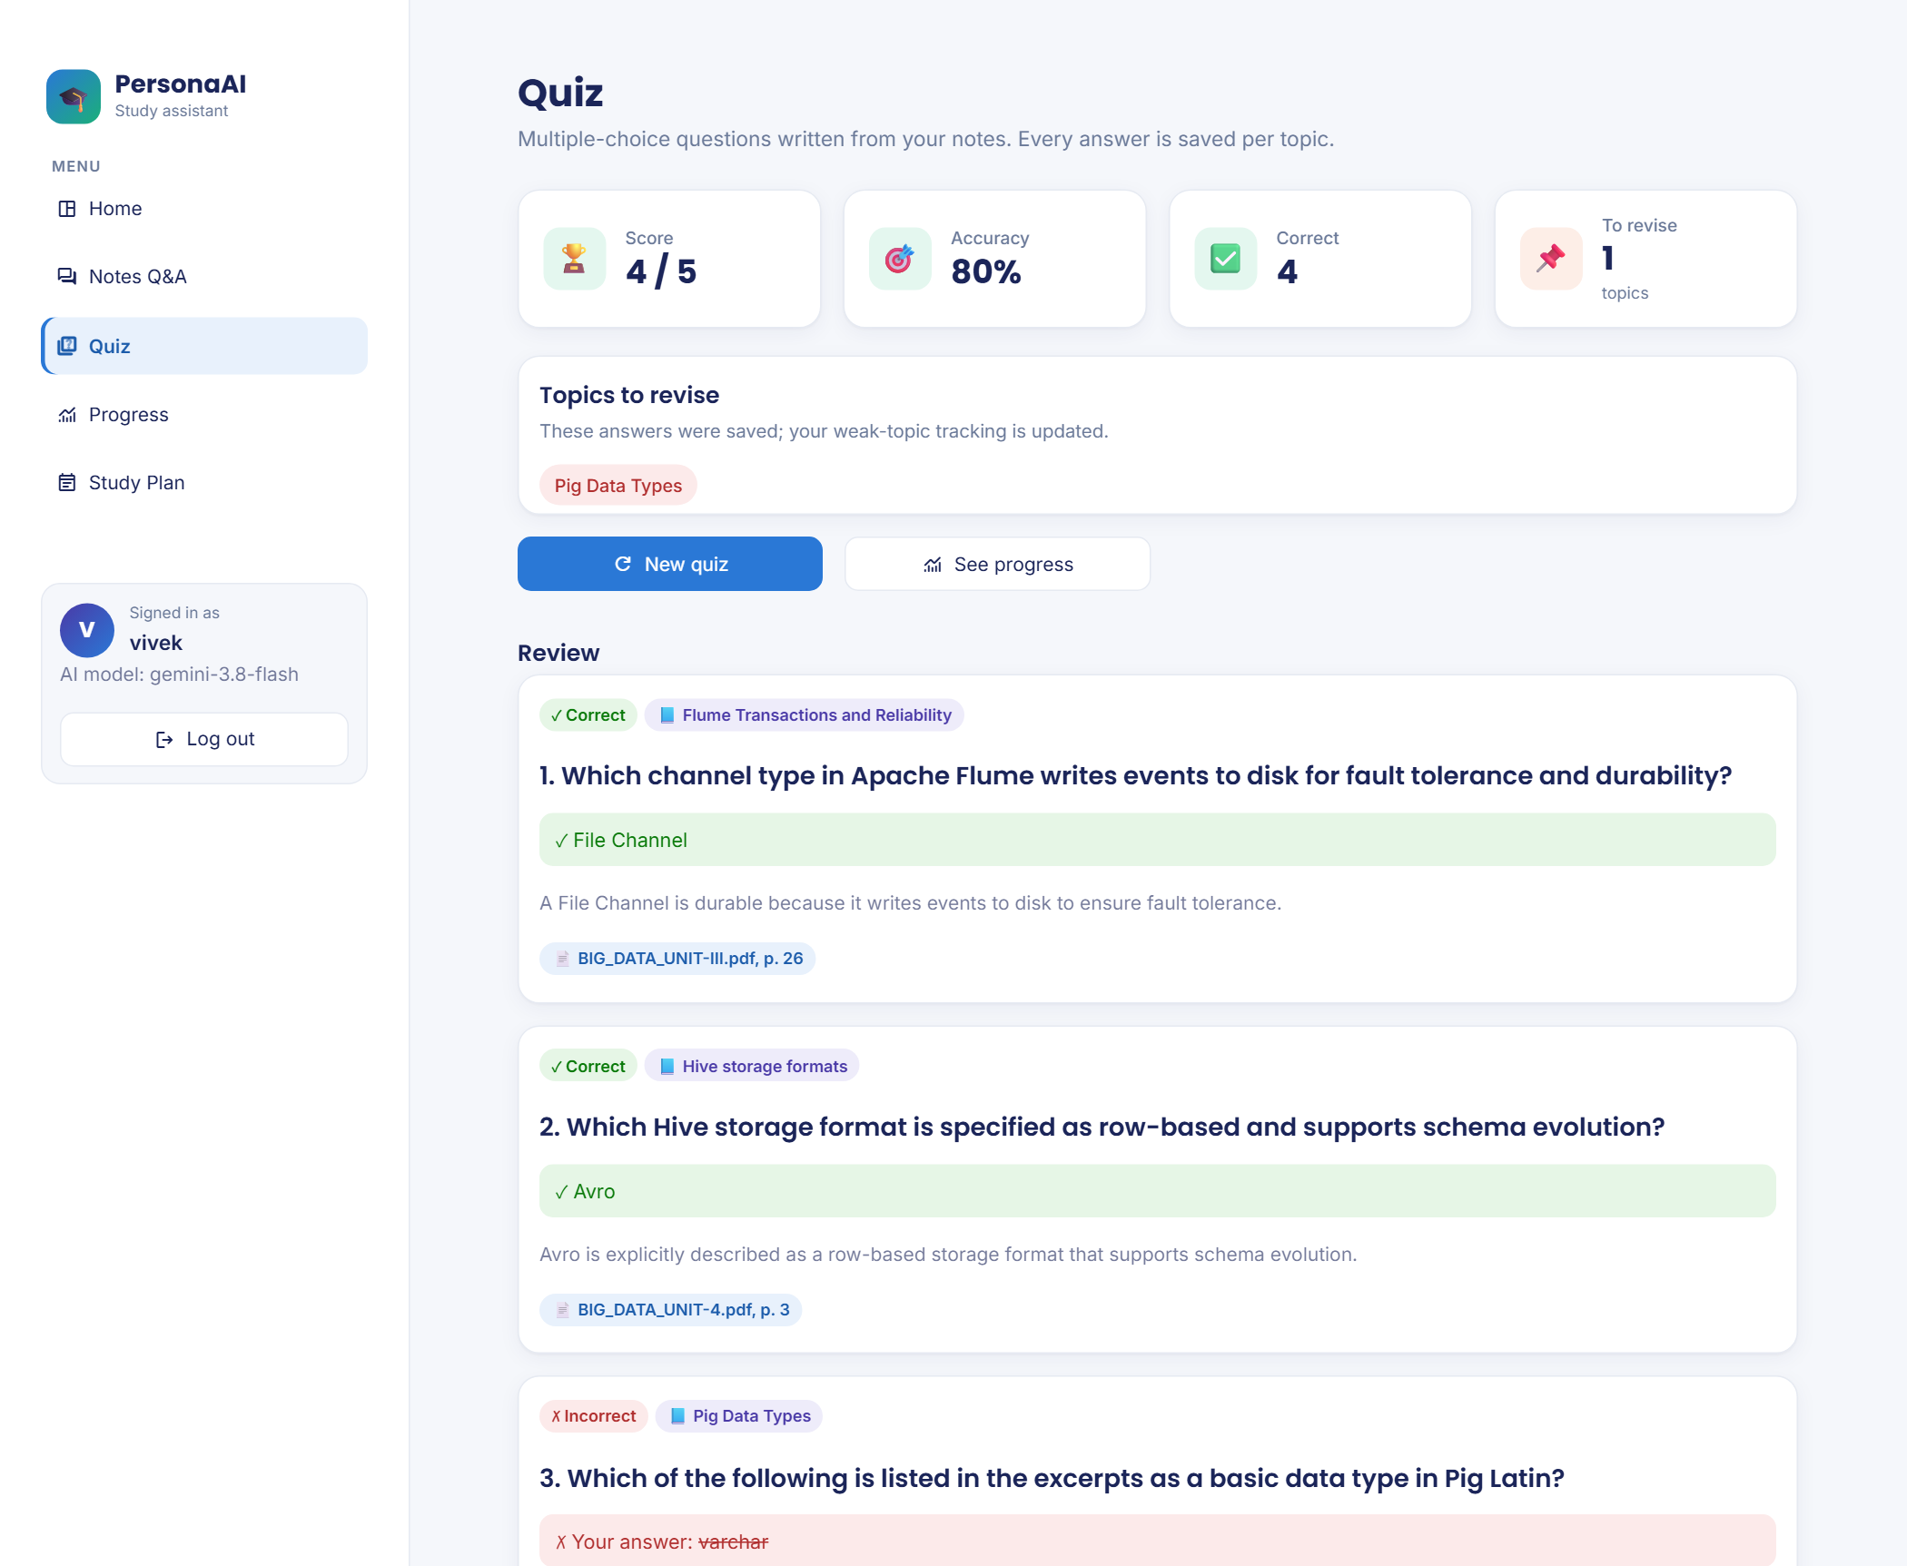
Figure 15: Quiz results with per-question review, explanations and sources
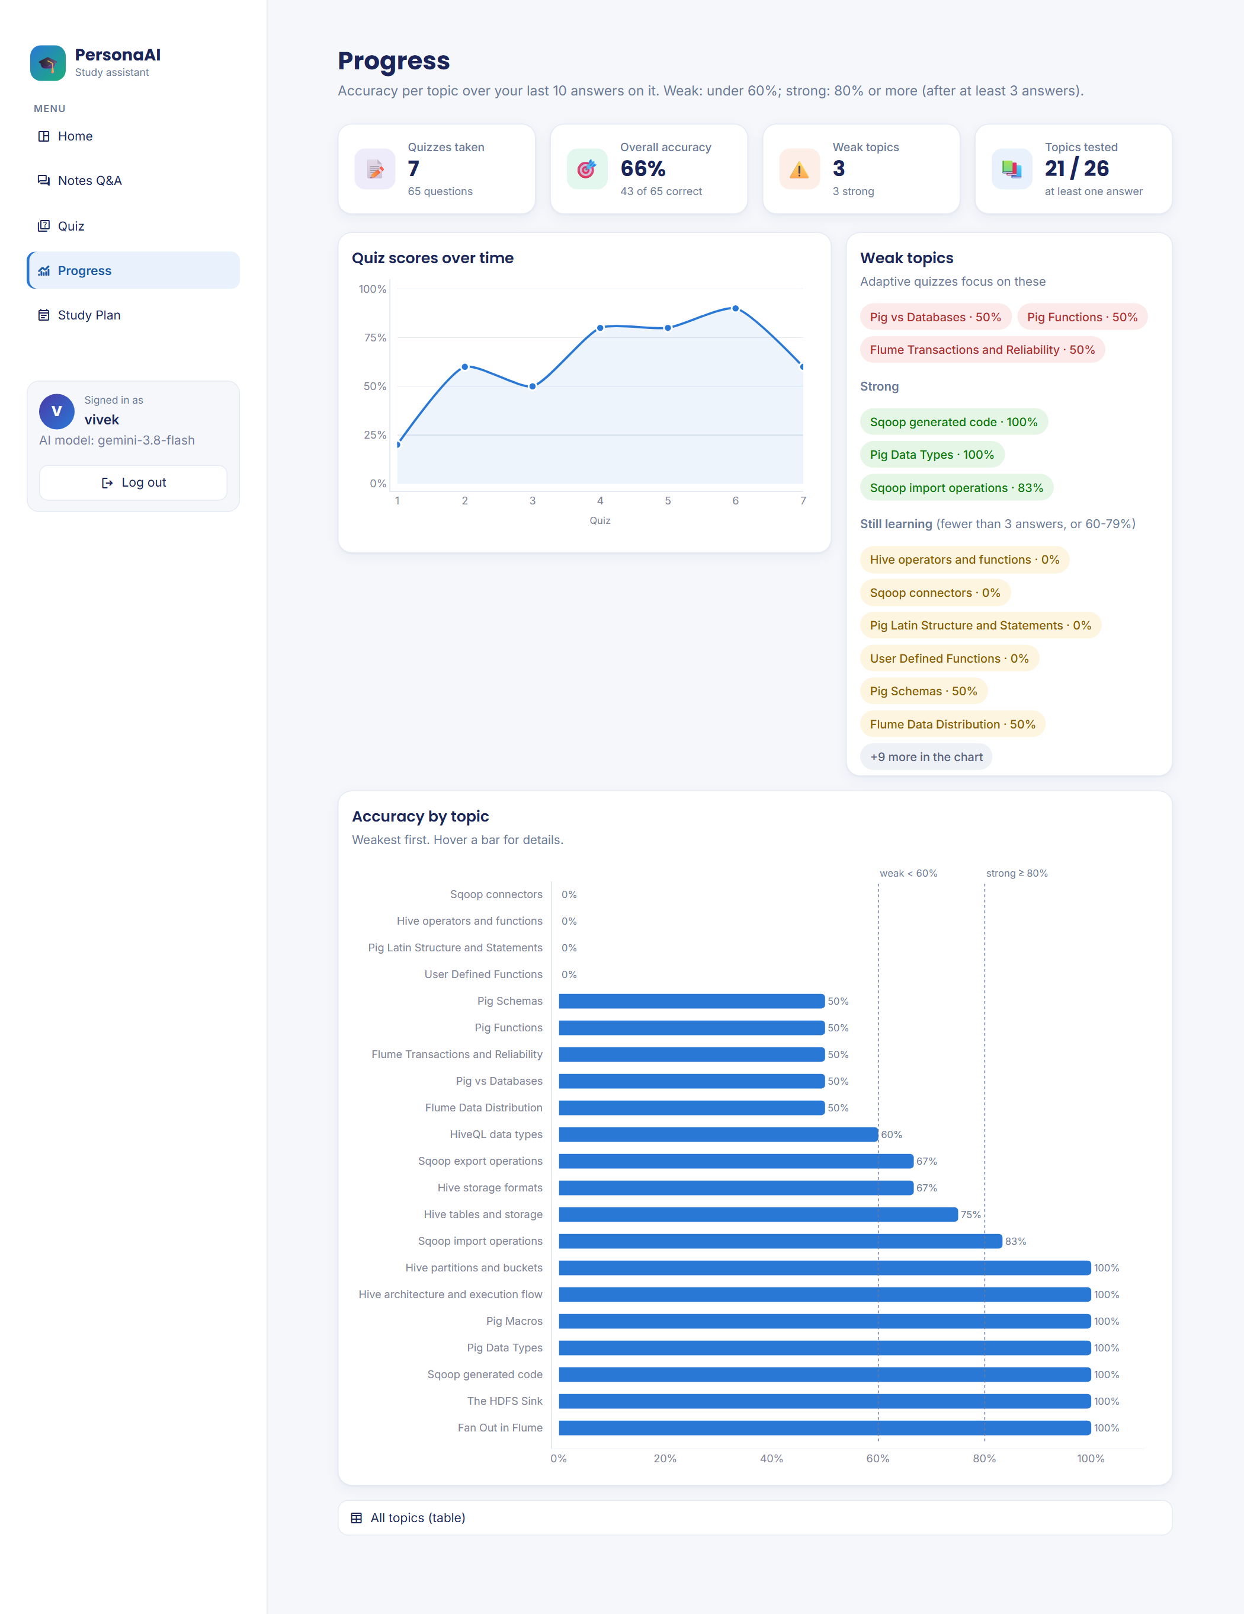
Figure 16: Progress dashboard: score trend, weak/strong topics and accuracy per topic (sample quiz history)
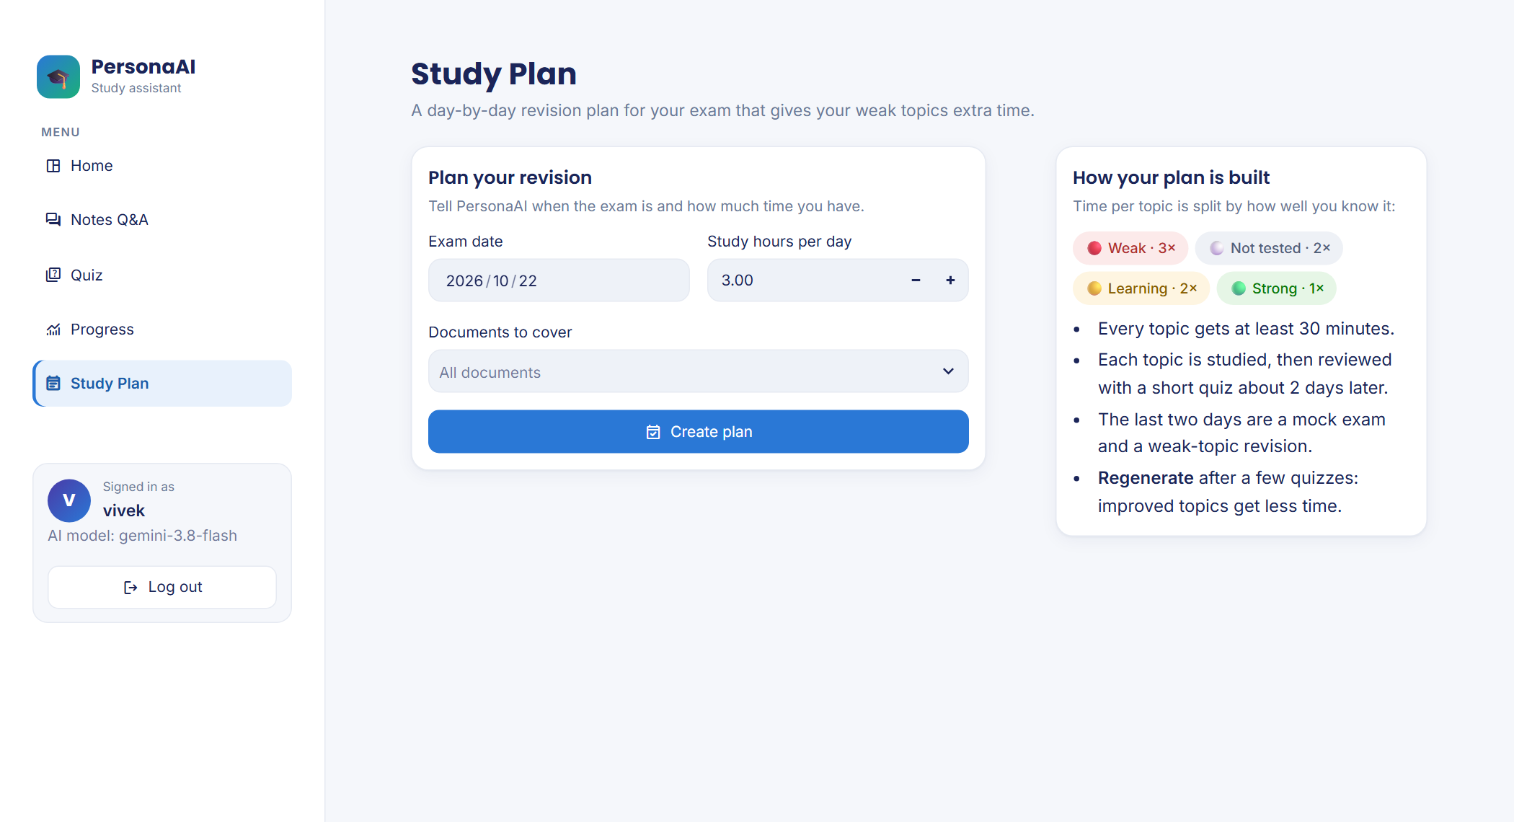
Figure 17: Creating a study plan
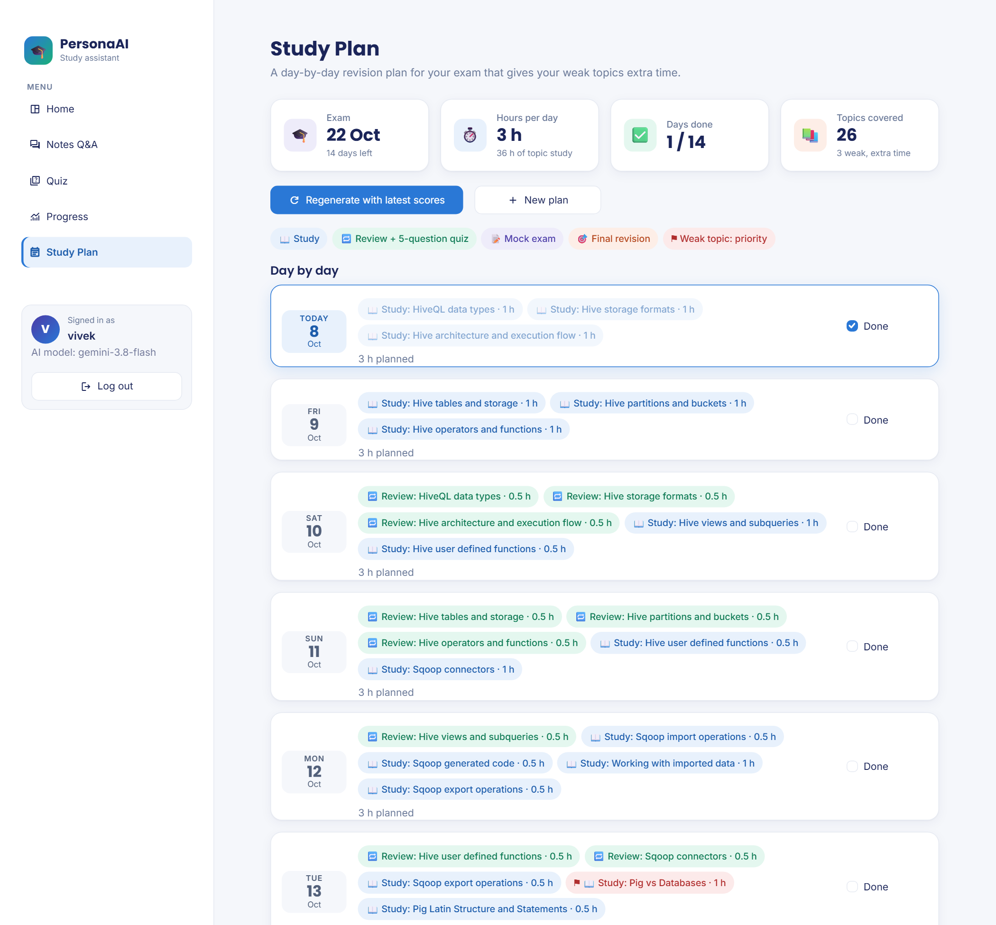
Figure 18: Study plan timeline with task chips and weak-topic priority flags (sample quiz history)
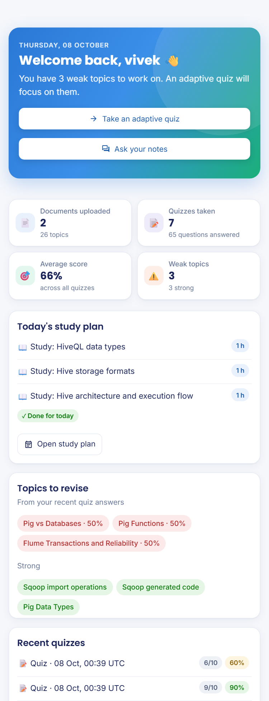
Figure 19: Responsive layout on a phone-sized screen

7.2 Evaluation: Answers With and Without the Notes
Method. Sixty short exam questions with model answers were extracted from the course’s question-bank PDF (30 per unit) and split into a development set (odd-numbered questions) and a held-out set (even-numbered). Only the two unit PDFs were indexed for retrieval, so the system could not copy the reference answers. Each question was answered by the full RAG pipeline and by the same model without notes (gemini-3.5-flash-lite, fixed for the whole run). An LLM judge graded both answers against the reference as correct, partial or wrong, seeing them in random order without labels. The development set was used to look for problems; the held-out set was run once on the final pipeline.
Table 13: Answer accuracy with and without the notes
Set | Condition | Correct | Partial | Wrong | Accuracy
Development (30) | With notes (RAG) | 26 | 1 | 3 | 87 %
 | Without notes | 29 | 1 | 0 | 97 %
Held-out (30) | With notes (RAG) | 25 | 5 | 0 | 83 %
 | Without notes | 30 | 0 | 0 | 100 %
All 60 | With notes (RAG) | 51 | 6 | 3 | 85 %
 | Without notes | 59 | 1 | 0 | 98 %

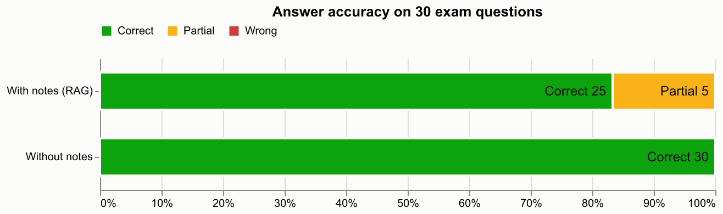
Figure 20: Held-out set: grading of answers with and without the notes
On these questions the plain model was more accurate than the notes-grounded answers. This is the opposite of the expected result, and the reasons are important:
- The notes-grounded answers were never factually wrong. All three “wrong” verdicts were cases where the system replied “not found in your notes”; when it answered, 96 % (development) and 83 % (held-out) of answers were fully correct and the rest were partial.
- The questions are general knowledge for the model. Questions such as “What is Apache Hive?” are well covered in the model’s training data, so the plain answers are complete, whereas RAG can only use what the retrieved excerpts contain.
- Where the course has specific points, RAG did better: for “What are the benefits of using schemas?”, the RAG answer gave the course’s points (fields referenced by name) and was graded correct, while the plain answer gave generic database benefits and was graded partial.
This evaluation does not measure two benefits of grounding: answers that follow the course’s own terminology and emphasis, and the ability to verify every claim against a cited page.

7.3 Failure Analysis and a Retrieval Experiment
Table 14: Analysis of notes-grounded answers that were not fully correct
Question | Verdict | Cause
What is a Map in Pig? | Not found | The defining bullet never mentions “Pig”; “Map” matched MapReduce chunks (ranked 16th)
What are conditional functions in Hive? | Not found | The IF/CASE chunk was not among the 20 embedding candidates
What is a Subquery in Hive? | Not found | A chunk only mentioning subqueries ranked above the defining summary table
How can data be imported into Hive? | Partial | “Import” retrieved the Sqoop import pages instead of Hive’s LOAD DATA section
What is Bucketing in Hive? | Partial | The chunk boundary cut the CREATE TABLE … CLUSTERED BY example in half
UDFs / relational operators in Hive | Partial | Retrieved excerpts listed fewer items than the reference answer

The common cause is chunks that lose their context: a 180-word chunk from the middle of a section does not contain the section heading that would connect it to the question. Because exact terms such as “Map” were confused with “MapReduce”, keyword search (BM25) was tested as an additional first stage on the development set. It brought the missing chunks into the candidate list, but the re-ranker still ranked them low, and end-to-end accuracy did not improve (25 vs 26 correct), so the change was reverted to keep the pipeline simple. A re-grading check also showed that the judge itself varies by about ±2 questions out of 30; the 8-question gap between the conditions over 60 questions is larger than this.

7.4 Evaluation: Adaptive versus Evenly Spread Quizzes
A real comparison would require many students over several weeks, so the adaptive strategy was evaluated by simulation, using the application’s own allocation and scoring code. Each of 200 simulated students per mode had 20 topics, 5 of them genuinely weak (probability of a correct answer 25–45 %; others 70–95 %), and took ten 10-question quizzes. The stated assumption is that answering a question on a topic, with its explanation, closes 8 % of the gap to full mastery of that topic.
Table 15: Simulation results (200 simulated students per mode)
Measure | Adaptive | Even mix
Questions on genuinely weak topics (quizzes 4–10) | 55 % | 25 %
Weak topics flagged as weak at least once in 10 quizzes | 73 % | 70 %
Mean mastery of weak topics after 10 quizzes (start ≈ 35 %) | 68 % | 55 %

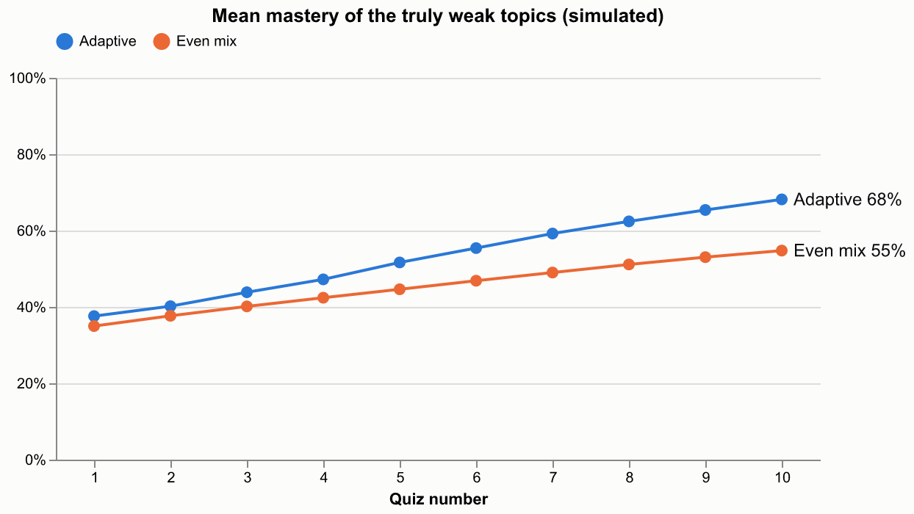
Figure 21: Simulated mastery of the genuinely weak topics per quiz
Adaptive mode spent more than twice as much practice on the weak topics once they were identified, and under the stated assumption raised their mastery by about 13 points more than an even mix. It did not identify weak topics faster: with only three answers needed to judge a topic, a weak topic still scores 2 out of 3 by chance about a third of the time.

7.5 Performance Observations
Table 16: Observed response times on the development machine
Operation | Observed time
Answer a question (Gemini Flash-Lite) | about 2–7 s
Generate a 10-question quiz (Gemini) | about 15–16 s
Generate a 5-question quiz (local llama3.1:8b, with answer-key check) | about 97–100 s
First local-model reply after start-up (model loading) | about 60 s
Load embedding + re-ranking models (first use after server start) | about 30 s
Embed and index the three course PDFs (67 chunks) | about 26 s

7.6 Discussion
The system meets its functional objectives: answers are grounded and cited, off-syllabus questions are refused, quizzes are valid and saved per topic, weak topics are detected and targeted, and study plans adapt to performance. The evaluation shows that grounding trades some completeness for verifiability on general-knowledge questions, and identifies retrieval — specifically, chunks that lose their section context — as the main area for improvement. The free-tier API limits shaped several engineering decisions (lighter-model fallback, rate-limit handling, rule-based planning, skipping the LLM for clearly unrelated questions).

Chapter 8: Conclusion and Future Scope

8.1 Conclusion
PersonaAI demonstrates that a study assistant can be grounded in a student’s own course material, remember each student’s weak topics, and use that memory to direct both practice and planning. The application provides cited answers from uploaded notes, automatically generated and validated quizzes, a per-topic learner model with an adaptive quiz mode, and a weighted, spaced study plan, in a responsive web interface that keeps working when the online AI service is limited or unavailable. The work was developed incrementally with 101 automated tests and evaluated honestly: grounded answers were never factually wrong but were less complete than a general model on general-knowledge questions, and simulation showed that adaptive quizzes concentrate practice on weak topics.

8.2 Limitations
- Retrieval misses or truncates some answers because fixed-size chunks lose their section headings.
- The free-tier API is rate-limited; the local model is slower and writes lower-quality quiz questions.
- Sign-in is by username only, without passwords; suitable for a classroom demonstration, not for public deployment.
- Weak-topic detection after three answers is noisy, and the adaptive-quiz benefit was measured by simulation rather than with real students.
- Scanned (image-only) PDFs are not supported, as no OCR is performed.

8.3 Future Scope
- Prefix each chunk with its section heading and split on section boundaries (the main fix suggested by the evaluation).
- A stronger re-ranker, if deployment memory allows.
- An optional, clearly labelled “notes first, then general knowledge” answer mode.
- A probabilistic learner model (e.g. Bayesian Knowledge Tracing) and a study with real students over a semester.
- Password or institutional sign-in, a hosted database, and a teacher view of class-wide weak topics.
- OCR for scanned notes, and support for lecture slides and handwritten notes.
- Let each student use their own API key in the deployed version.

References
[1] P. Lewis, E. Perez, A. Piktus, F. Petroni, V. Karpukhin, N. Goyal, H. Küttler, M. Lewis, W. Yih, T. Rocktäschel, S. Riedel and D. Kiela, “Retrieval-Augmented Generation for Knowledge-Intensive NLP Tasks,” in Advances in Neural Information Processing Systems (NeurIPS), 2020.
[2] N. Reimers and I. Gurevych, “Sentence-BERT: Sentence Embeddings using Siamese BERT-Networks,” in Proc. EMNLP-IJCNLP, 2019.
[3] W. Wang, F. Wei, L. Dong, H. Bao, N. Yang and M. Zhou, “MiniLM: Deep Self-Attention Distillation for Task-Agnostic Compression of Pre-Trained Transformers,” in Advances in Neural Information Processing Systems (NeurIPS), 2020.
[4] R. Nogueira and K. Cho, “Passage Re-ranking with BERT,” arXiv:1901.04085, 2019.
[5] P. Bajaj et al., “MS MARCO: A Human Generated MAchine Reading COmprehension Dataset,” arXiv:1611.09268, 2016.
[6] S. Robertson and H. Zaragoza, “The Probabilistic Relevance Framework: BM25 and Beyond,” Foundations and Trends in Information Retrieval, vol. 3, no. 4, pp. 333–389, 2009.
[7] H. L. Roediger and J. D. Karpicke, “Test-Enhanced Learning: Taking Memory Tests Improves Long-Term Retention,” Psychological Science, vol. 17, no. 3, pp. 249–255, 2006.
[8] N. J. Cepeda, H. Pashler, E. Vul, J. T. Wixted and D. Rohrer, “Distributed Practice in Verbal Recall Tasks: A Review and Quantitative Synthesis,” Psychological Bulletin, vol. 132, no. 3, pp. 354–380, 2006.
[9] A. T. Corbett and J. R. Anderson, “Knowledge Tracing: Modeling the Acquisition of Procedural Knowledge,” User Modeling and User-Adapted Interaction, vol. 4, no. 4, pp. 253–278, 1994.
[10] L. Zheng et al., “Judging LLM-as-a-Judge with MT-Bench and Chatbot Arena,” in Advances in Neural Information Processing Systems (NeurIPS), Datasets and Benchmarks Track, 2023.
[11] Streamlit documentation, https://docs.streamlit.io
[12] ChromaDB documentation, https://docs.trychroma.com
[13] Sentence-Transformers documentation, https://www.sbert.net
[14] Google Gemini API documentation, https://ai.google.dev/gemini-api/docs
[15] Ollama, https://ollama.com
[16] Plotly Python documentation, https://plotly.com/python
[17] United Nations, “Goal 4: Quality Education,” Sustainable Development Goals, https://sdgs.un.org/goals/goal4

Appendix A: Installation and User Guide

A.1 Installation
git clone <repository URL>
cd PersonaAI
py -3.12 -m venv .venv
.venv\Scripts\activate # Linux/macOS: source .venv/bin/activate
pip install -r requirements.txt
# create .env with: GEMINI_API_KEY=..., LLM_PROVIDER=gemini, OLLAMA_MODEL=llama3.1:8b
streamlit run app.py

Optional offline mode: install Ollama, run ollama pull llama3.1:8b, and set LLM_PROVIDER=ollama in .env. Run the tests with pytest; run the evaluation with python -m evaluation.run_eval.

A.2 Using PersonaAI
- Sign in with any username; it creates a private study space.
- Open Notes Q&A, upload the course PDFs, and check the extracted topics (edit them if needed).
- Ask questions in the chat; open “Show source excerpts” to read the cited passages.
- Open Quiz, choose topics, the number of questions and the mode, and answer one question at a time. Review the explanations after submitting.
- After a few quizzes, open Progress to see weak and strong topics, and use the Adaptive quiz mode to practise the weak ones.
- Open Study Plan, enter the exam date and hours per day, tick days as you finish them, and press Regenerate after more quizzes.

Appendix B: Project Structure
PersonaAI/
├── app.py # Entry point: sign-in card + page router
├── views/ # home, notes_qa, quiz, progress, study_plan
├── ui/ # styles.py (theme, components), shell.py (sidebar, login guard)
├── core/ # config, documents, vectorstore, ingest, rag, llm,
│ # quiz, memory, planner, db, charts
├── evaluation/ # build_questions, run_eval, simulate_adaptive, REPORT.md, results/
├── tests/ # 101 automated tests (pytest + Streamlit AppTest)
├── .streamlit/config.toml # theme: colours, fonts, radius
├── data/ # uploads, ChromaDB, SQLite, logs (git-ignored)
├── requirements.txt / requirements-dev.txt
├── README.md
└── IMPLEMENTATION.md

