SMS Spam Detection using Recurrent Neural Networks (RNN)
Deep Learning
Study Project Report
By
B.Tech IV Year - I Semester
Name of the Student
23EG110XXX
CSE(DS)
Under Guidance of
Dr P Rajeshwari

Department of Computer Science Engineering (Data Science)
ANURAG UNIVERSITY
VENKATAPUR (V), GHATKESAR (M),
MEDCHAL- MALKAJGIRI (D), TELANGANA-500088.
www.anurag.edu.in

INDEX
SNO | Topic | Page No
1 | Abstract | 3
2 | Introduction | 4
3 | Objectives | 5
4 | Dataset Description | 6
5 | Model Used | 7
6 | Framework and Tools used | 8
7 | Methodology | 9
8 | Model Performance | 10
9 | Analysis & Results | 15
10 | Graphs | 13
11 | Conclusion | 16

SMS SPAM DETECTION USING RECURRENT NEURAL NETWORKS (RNN)
ABSTRACT
Unwanted SMS spam such as fake prize offers, premium-rate numbers and phishing links is a daily nuisance and a security risk for mobile users. This project presents an “RNN-based SMS Spam Detection System” developed in Python using TensorFlow/Keras. Messages from the UCI SMS Spam Collection (5,574 real SMS messages, 13.4% spam) are lowercased, cleaned, tokenized and padded to 50 words, and then classified by a Recurrent Neural Network built as Embedding → recurrent layer → Dense → Sigmoid. Class weights handle the imbalance between ham and spam, and dropout with early stopping controls overfitting. Six configurations (SimpleRNN, LSTM and GRU) were trained and the best one was chosen on the validation set. The final GRU-based model achieved 99.04% accuracy, 0.9906 precision, 0.9375 recall and an F1-score of 0.9633 for the spam class on 837 unseen test messages, and a prediction script labels any new SMS as spam or ham instantly.

INTRODUCTION
SMS is still one of the most widely used ways to communicate, which also makes it an easy target for spammers. Spam messages advertise fake prizes, push premium-rate numbers or carry phishing links that steal personal and banking details, so detecting them automatically is an important and practical problem.
Traditional rule-based filters depend on fixed keyword lists and are easy to bypass when spammers change their wording. This project addresses that gap by using a Recurrent Neural Network (RNN), which reads a message word by word and learns from the order and context of the words instead of isolated keywords.
The system is designed to help mobile users and service providers separate spam from legitimate (ham) messages automatically, by learning directly from thousands of real, labelled SMS messages rather than from hand-written rules.

OBJECTIVES
- To build a deep learning model using a Recurrent Neural Network that classifies SMS messages as spam or ham with high accuracy.
- To preprocess raw SMS text (cleaning, tokenization and padding) into a form a neural network can learn from.
- To handle the imbalance between ham and spam messages with class weights, and to control overfitting with dropout and early stopping.
- To evaluate the model on unseen data using accuracy, precision, recall, F1-score and a confusion matrix.
- To provide a simple prediction script that labels any custom SMS as spam or ham.

DATASET DESCRIPTION

The project uses the SMS Spam Collection dataset from the UCI Machine Learning Repository: a public set of real English SMS messages, each tagged as ham (legitimate) or spam.
- Total Records: 5,574 SMS messages.
- Classes: ham (legitimate) – 4,827 messages (86.6%); spam – 747 messages (13.4%). The dataset is imbalanced.
- Source: UCI Machine Learning Repository, SMS Spam Collection v.1 (Almeida, Gómez Hidalgo and Yamakami, 2011), downloaded automatically by the project.
- Features: one raw text field (the SMS) and one label (ham/spam). After cleaning, a message has 16.5 words on average (median 13), and 98.7% have 50 words or fewer.
- Sample text: spam – “Free entry in 2 a wkly comp to win FA Cup final tkts 21st May 2005. Text FA to 87121 to receive entry question…”; ham – “Ok lar... Joking wif u oni...”
- Data Split: stratified 70/15/15 – 3,901 training, 836 validation and 837 test messages, each keeping about 13.4% spam.
The tokenizer was fitted on the training messages only, so no information from the validation or test messages leaked into training.

MODEL DESCRIPTION
1. Architecture
The final model is a Recurrent Neural Network built with TensorFlow/Keras as a simple stack: Embedding → GRU (recurrent layer) → Dense (ReLU) → Dropout → Dense (Sigmoid). Six variants were trained (SimpleRNN, LSTM and GRU), and the GRU variant was selected because it gave the best validation performance.
Layer | Output Shape | Parameters
Input (word indices) | (50) | 0
Embedding (5,000 words × 64) | (50, 64) | 320,000
GRU (64 units, padding masked) | (64) | 24,960
Dense (32, ReLU) | (32) | 2,080
Dropout (0.3) | (32) | 0
Dense (1, Sigmoid) – output | (1) | 33
Total trainable parameters |  | 347,073

The Embedding layer turns each word index into a 64-value vector. The GRU reads the 50 word vectors in order and keeps a 64-value hidden state that summarises the message so far; its update and reset gates decide what to keep and what to forget, which makes it more stable than a plain SimpleRNN. The Dense layer combines these features and the final Sigmoid neuron outputs the probability that the message is spam (0.5 or more is labelled spam).
2. Training Process
The model was trained with the Adam optimizer and binary cross-entropy loss in mini-batches of 32 messages. Class weights (ham 0.577, spam 1.865) make each spam example count more, compensating for the small number of spam messages. Early stopping watched the validation loss with a patience of 5 epochs and restored the best weights: training ran for 9 epochs and the weights from epoch 4 were kept.
3. Hyperparameters
Hyperparameter | Value | Reason
Vocabulary size | 5,000 words | Most frequent training words
Sequence length | 50 tokens | Covers 98.7% of messages
Embedding dimension | 64 | Learned word vectors
Recurrent layer | GRU, 64 units | Best of 6 attempts (validation)
Dense layer | 32 units, ReLU | Combines the GRU features
Dropout | 0.3 | Reduces overfitting
Optimizer | Adam, lr 0.001, clipnorm 1.0 | Stable gradient updates
Loss function | Binary cross-entropy | Two classes (spam / ham)
Batch size | 32 | Standard mini-batch size
Epochs | Max 40, early stopping (patience 5) | Stops when val. loss stops improving
Class weights | ham 0.577, spam 1.865 | Balanced, spam weight halved
Decision threshold | 0.5 | Probability ≥ 0.5 → SPAM
FRAMEWORK AND TOOLS USED
- Python 3
Core programming language for data processing, model building and scripts.
- TensorFlow / Keras 2.21
Deep learning framework used to build, train and save the RNN model.
- scikit-learn
Used for the stratified data split, class weights and evaluation metrics.
- pandas & NumPy
Used to load the dataset and handle the padded sequences as arrays.
- Matplotlib
Used to plot the accuracy graph, loss graph and confusion matrix.
- Docker
Provides a reproducible Linux environment with TensorFlow for training.
- UCI SMS Spam Collection
The dataset of 5,574 labelled SMS messages.

METHODOLOGY
1. Data Collection and Cleaning
The dataset was downloaded automatically from the UCI repository. Every message was converted to lowercase; web links, e-mail addresses, currency symbols and numbers were replaced by placeholder words (urltoken, emailtoken, currencytoken, numtoken) because they are strong spam signals, and all remaining punctuation was removed.
2. Tokenization and Padding
A word-level tokenizer was built from the training messages, keeping the 5,000 most frequent words (unknown words map to a special out-of-vocabulary index). Each message was converted into a sequence of word indices and padded with zeros at the front, or truncated, to exactly 50 tokens.
3. Data Splitting and Class Imbalance
The data was split with stratification into 70% training, 15% validation and 15% test sets, so every set keeps the same spam ratio. Because only 13.4% of the messages are spam, class weights were applied during training so that missing a spam message costs more than misclassifying a ham message.
4. Model Training and Selection
A SimpleRNN baseline was trained first and then improved over five further attempts (dropout, early stopping, a smaller learning rate with gradient clipping, LSTM, GRU and softer class weights). The model with the best validation F1-score was kept, and only then was it evaluated once on the test set.
5. Evaluation and Prediction
Accuracy, precision, recall, F1-score and the confusion matrix were computed on the 837 test messages. A prediction script applies the same cleaning and tokenization to any new SMS and prints SPAM or HAM with its probability.

MODEL PERFORMANCE

1. DATA PREPARATION & CLEANING
“Convert raw SMS text into fixed-length sequences of numbers.”
Raw messages contain capital letters, punctuation, links and phone numbers. The cleaning function normalises them, the tokenizer maps every word to an index and the sequences are padded to the same length:
- Lowercasing and punctuation removal
- Links, e-mails, currency symbols and numbers → placeholder words
- 5,000 most frequent training words kept; other words → OOV index
- Pre-padding / truncation to 50 tokens
Program:
src/data_prep.py (excerpt)
def clean_text(text):
text = text.lower()
text = URL.sub(" urltoken ", text)
text = EMAIL.sub(" emailtoken ", text)
text = CURRENCY.sub(" currencytoken ", text)
text = NUMBER.sub(" numtoken ", text)
text = NON_ALNUM.sub(" ", text)
return SPACES.sub(" ", text).strip()

tokenizer = SimpleTokenizer(vocab_size=5000).fit(train_df["clean"])
X_train = pad(tokenizer.texts_to_sequences(train_df["clean"])) # 50 tokens

- THE RECURRENT NEURAL NETWORK (RNN)
“Train the RNN to learn the patterns of spam messages.”
The model reads each message word by word. At every step the recurrent layer updates its hidden state, so after the last word it holds a summary of the whole message, which the Dense and Sigmoid layers turn into a spam probability. Six configurations were trained in the self-evaluation loop and compared on the validation set:
No. | Model and key changes | Val F1 | Test Acc. | Test F1
1 | SimpleRNN baseline (no dropout, 15 epochs) | 0.9554 | 98.57% | 0.9444
2 | SimpleRNN + dropout 0.3 + early stopping (patience 3) | 0.9129 | 96.18% | 0.8667
3 | Smaller SimpleRNN, lr 0.0005, gradient clipping, patience 5 | 0.9351 | 98.57% | 0.9455
4 | LSTM, dropout 0.3, early stopping | 0.9520 | 98.92% | 0.9585
5 | GRU, dropout 0.3, early stopping | 0.9692 | 99.16% | 0.9680
6 | GRU + softer spam class weight (selected) | 0.9732 | 99.04% | 0.9633
The baseline already reached the targets but overfitted (100% training accuracy while its validation loss rose), so regularisation was added. The final model was chosen by validation F1-score, not by test score.
Program:
src/model.py and src/train.py (excerpt)
model = tf.keras.Sequential([
layers.Input(shape=(50,), dtype="int32"),
layers.Embedding(5000, 64, mask_zero=True),
layers.GRU(64, dropout=0.3),
layers.Dense(32, activation="relu"),
layers.Dropout(0.3),
layers.Dense(1, activation="sigmoid")])
model.compile(optimizer=Adam(0.001, clipnorm=1.0),
loss="binary_crossentropy", metrics=["accuracy"])

w = compute_class_weight("balanced", classes=[0, 1], y=y_train)
class_weight = {0: w[0], 1: w[1] * 0.5}
early_stop = EarlyStopping(monitor="val_loss", patience=5,
restore_best_weights=True)
history = model.fit(X_train, y_train, validation_data=(X_val, y_val),
epochs=40, batch_size=32, class_weight=class_weight,
callbacks=[early_stop])
model.save("models/best_model.keras")

- PREDICTION ON NEW MESSAGES
“Classify any custom SMS as SPAM or HAM.”
The prediction script loads the saved model and tokenizer, applies the same cleaning and padding, and prints the label with the spam probability. It was tested on eight new messages written for this check (none are from the dataset):
Program:
src/predict.py (usage)
python src/predict.py "WINNER!! Claim your free prize now, call 09061701461"
python src/predict.py # interactive mode

Output:
Message | Expected | Prediction (spam probability)
Congratulations! You have won a GBP 1000 cash prize. Call 09061234567 now to claim, T&C apply | SPAM | SPAM (1.0000)
URGENT: your mobile number has been selected for a free iPhone. Reply YES to 80085 to claim | SPAM | SPAM (0.9999)
FREE entry into our weekly draw! Text WIN to 85233 for a chance to win a holiday worth 500 pounds | SPAM | SPAM (0.9999)
Your account has been suspended, click http://bit.ly/secure-login to verify your details | SPAM | SPAM (0.9806)
Hey, are we still meeting for lunch tomorrow at 1? | HAM | HAM (0.0000)
Can you pick up some milk on your way home please | HAM | HAM (0.0000)
Sorry I missed your call, I was in a meeting. Will call you back tonight | HAM | HAM (0.0001)
Happy birthday bro! Have a great day, see you at the party | HAM | HAM (0.0000)

All 8 of 8 messages were classified correctly, including a phishing message that contains a link but no “prize” words.

GRAPHS

“To verify training, the accuracy and loss on the training and validation sets are plotted for every epoch, and the test predictions are summarised in a confusion matrix.”

The graphs are produced from the saved training history and test predictions of the final model (GRU, attempt 6):

- The blue line shows the training set and the orange line the validation set.
- Validation accuracy reaches 99.28% at epoch 4, the epoch whose weights were restored (dashed line).
- After epoch 4 the training loss keeps falling towards zero while the validation loss rises from 0.0251 to 0.0423 – the start of overfitting, which early stopping prevents.
- The confusion matrix shows only 1 false positive and 7 false negatives among 837 test messages.

Figure 1: Training vs Validation Accuracy
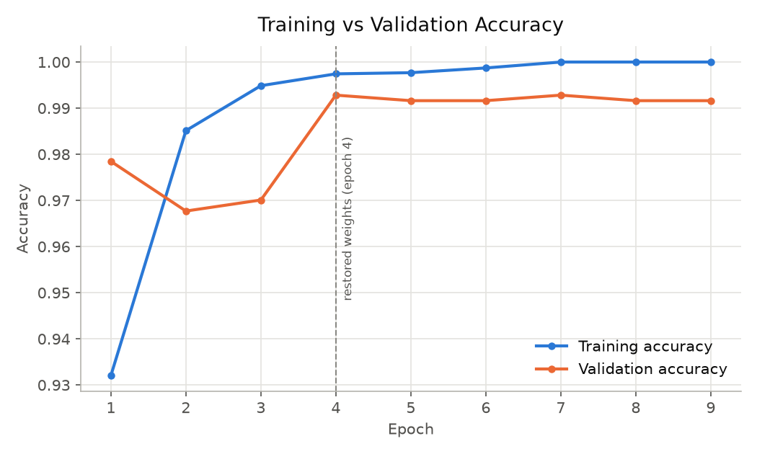

Figure 2: Training vs Validation Loss
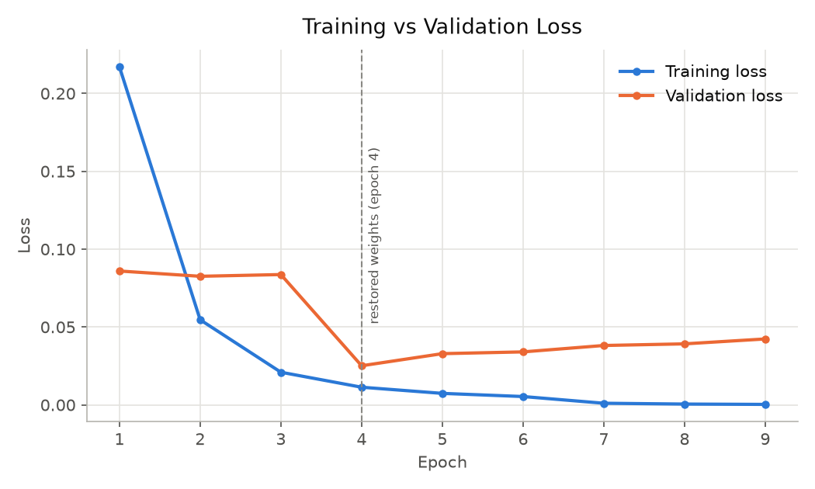

Figure 3: Confusion Matrix on the Test Set
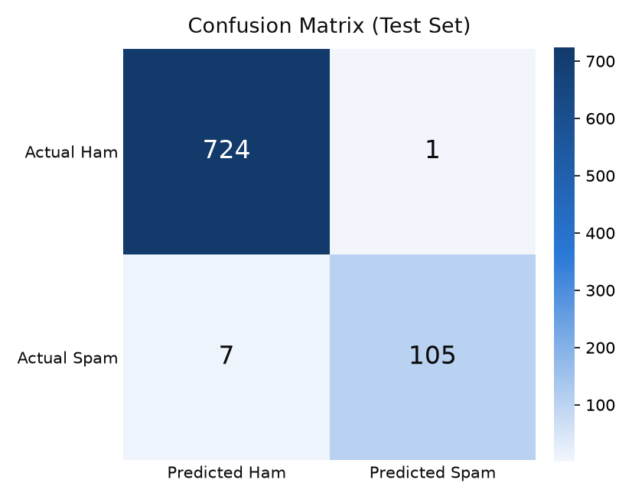

ANALYSIS & RESULTS

The “RNN SMS Spam Detection” model was evaluated on 837 test messages (725 ham, 112 spam) that were never used for training or for choosing the model.

Metric | Value | Meaning
Accuracy | 99.04% | 829 of 837 messages correct
Precision (spam) | 0.9906 | Share of flagged messages that are really spam
Recall (spam) | 0.9375 | Share of spam messages that were caught
F1-score (spam) | 0.9633 | Balance of precision and recall
Confusion matrix | TN 724, FP 1, FN 7, TP 105 | Ham/spam counts, actual vs predicted

The analysis revealed:

- Accuracy: The final GRU model classified 99.04% of the test messages correctly, above the 95% target.
- Precision: 0.9906 – of the 106 messages flagged as spam, 105 really were spam; only 1 legitimate message was wrongly flagged.
- Recall: 0.9375 – 105 of the 112 spam messages were caught and 7 were missed.
- F1-score: 0.9633 for the spam class, above the 0.90 target.
- Model Comparison: after tuning, the SimpleRNN reached 98.57% accuracy (F1 0.9455), the LSTM 98.92% (F1 0.9585) and the GRU 99.04–99.16% (F1 0.9633–0.9680); the gated cells trained more stably.
- Overfitting Control: without regularisation the baseline reached 100% training accuracy while its validation loss rose; dropout and early stopping (best weights from epoch 4) closed this gap.
- Custom Messages: the prediction script labelled all 8 new test messages correctly (4 spam, 4 ham).
These findings show that a compact recurrent neural network can filter SMS spam very accurately, catching most spam while blocking almost no legitimate messages.

CONCLUSION

The RNN SMS Spam Detection project successfully demonstrates how deep learning can automatically separate spam from legitimate text messages. Using the real UCI SMS Spam Collection, a simple pipeline of text cleaning, tokenization, padding and a recurrent neural network (Embedding → GRU → Dense → Sigmoid) achieved 99.04% accuracy and a spam F1-score of 0.9633 on unseen test messages, with only 1 legitimate message misclassified.
The study confirms that handling class imbalance and controlling overfitting matter as much as the choice of model: class weights, dropout and early stopping turned an overfitting baseline into a stable model that was selected purely on validation data. In future, the system can be extended with a larger and more recent multilingual SMS dataset, pre-trained word embeddings or attention-based models, and deployed as a mobile or web service for real-time filtering.

