SALES PERFORMANCE EXECUTIVE SUMMARY
Period: 2014-2017

Executive Overview
This report provides a comprehensive analysis of sales performance across a four-year period (2014-2017), covering 9,993 transactions from 793 unique customers across multiple product categories and geographic locations. The analysis reveals consistent year-over-year growth with strong performance in the Technology category and significant geographic concentration in California and New York.

Key Financial Metrics
Metric | Value
Total Sales Revenue | $2,296,919.70
Total Profit | $286,409.85
Overall Profit Margin | 12.47%
Total Transactions | 9,993
Unique Customers | 793
Average Order Value | $229.85

Year-over-Year Performance
The business demonstrates strong growth trajectory with sales increasing by 51.5% from 2014 to 2017. Both revenue and profit show consistent upward trends, indicating healthy business expansion and improved operational efficiency.
Year | Sales | Profit | Customers
2014 | $483,966 | $49,556 | 595
2015 | $470,532 | $61,619 | 573
2016 | $609,206 | $81,795 | 638
2017 | $733,215 | $93,440 | 693

Performance by Category
Technology leads in both sales and profitability with a strong 17.4% profit margin. While Furniture generates substantial revenue, its profit margin of only 2.5% indicates opportunities for pricing optimization or cost management. Office Supplies maintains a healthy 17.0% margin.
Category | Sales | Profit (Margin)
Technology | $836,154 | $145,456 (17.4%)
Furniture | $741,719 | $18,463 (2.5%)
Office Supplies | $719,047 | $122,491 (17.0%)

Top Product Sub-Categories
Phones and Chairs are the leading sub-categories by sales volume, each generating over $328,000. Storage products and Tables also show strong performance, rounding out the top four revenue generators.
Rank | Sub-Category (Sales)
1 | Phones - $330,007
2 | Chairs - $328,168
3 | Storage - $223,844
4 | Tables - $206,966
5 | Binders - $203,413

Geographic Performance
California dominates sales performance with $457,688 in revenue, representing nearly 20% of total sales. New York ranks second with $310,876. The top 10 states account for approximately 64% of total sales, indicating significant geographic concentration.
Rank | State (Sales)
1 | California - $457,688
2 | New York - $310,876
3 | Texas - $170,188
4 | Washington - $138,641
5 | Pennsylvania - $116,512

Customer Analysis
The customer base has grown from 595 customers in 2014 to 693 in 2017, representing a 16.5% increase. The top 5 customers by profitability account for significant value, with Tamara Chand leading at $8,981 in profit contribution.
Rank | Customer (Profit)
1 | Tamara Chand - $8,981
2 | Raymond Buch - $6,976
3 | Sanjit Chand - $5,757
4 | Hunter Lopez - $5,622
5 | Adrian Barton - $5,445

Sales Dashboard Overview
The comprehensive sales dashboard below visualizes key performance indicators across multiple dimensions, including sales by category, profit trends over time, geographic distribution, top customers, and monthly sales patterns.
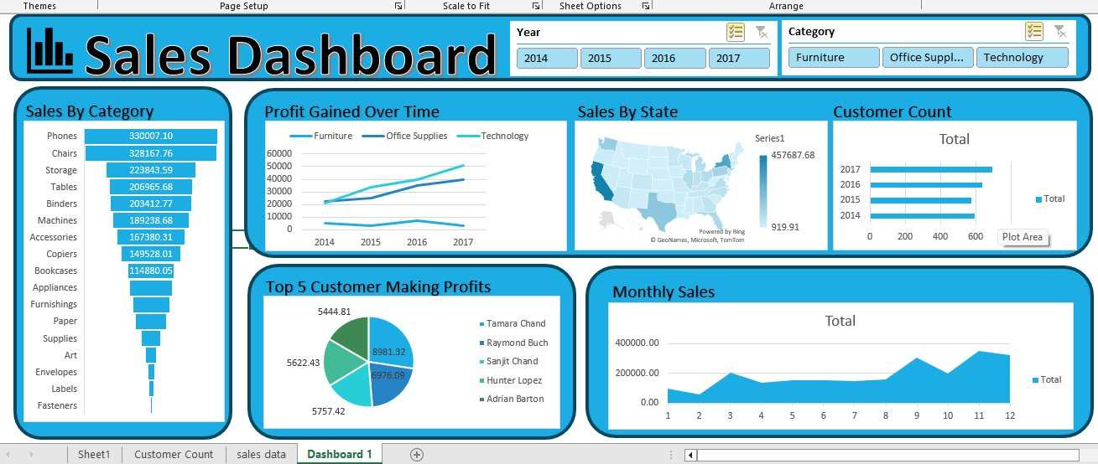

Key Insights and Recommendations
Strengths:
Strong year-over-year growth momentum with 51.5% sales increase from 2014 to 2017. Technology and Office Supplies categories maintain healthy profit margins above 17%. Customer base expansion shows positive trajectory with 16.5% growth.
Areas for Improvement:
Furniture category shows concerning profit margin of only 2.5% despite high sales volume, suggesting need for pricing strategy review or cost optimization. Geographic concentration in California and New York presents both opportunity and risk, indicating potential for market expansion in underperforming regions.
Recommendations:
Conduct detailed profitability analysis of Furniture category to identify specific products or processes driving low margins. Develop customer retention programs targeting high-value customers to protect the significant profit contribution from top accounts. Explore expansion opportunities in underrepresented geographic markets, particularly in the southern and midwestern states. Investigate the strong Q4 performance pattern to potentially replicate success factors throughout the year.

Conclusion
The business demonstrates solid fundamentals with consistent growth and improving profitability. The strategic focus should be on optimizing the Furniture category margins, maintaining Technology and Office Supplies performance, and expanding geographic reach while strengthening relationships with key customer accounts. With targeted improvements in identified areas, the business is well-positioned for continued growth and enhanced profitability.

