# **MEDICAL DATA HISTORY**

**Project Team’s ID:**   PTID-CDA-FEB-25-358

**Project code:** PRSQL-02

**Team**

1.Shiva Kumar Vangapally

2.Ajay Kumar Pudi

# **ABOUT DATA SET**

# **Medical data history data set contains four tables patients, admissions, doctors and province name in patients include patient_id, patients names, height, weight,gender,birth data, city ,province id , allergies this all about patients details and admission table contains patients when they had admitted columns like admission date discharge date ,patient id and coming to the doctors table having information about doctors like their name , speciality ,doctors id and the last table province name in this table columns like province name ,province id**

**This is tells us particular places of patients from where they are coming .**

# 

# **Queries:**

# **1. Show first name, last name, and gender of patients who's gender is 'M'**

# Query: select first_name, last_name, gender from patients

# where gender = 'M' limit 10;

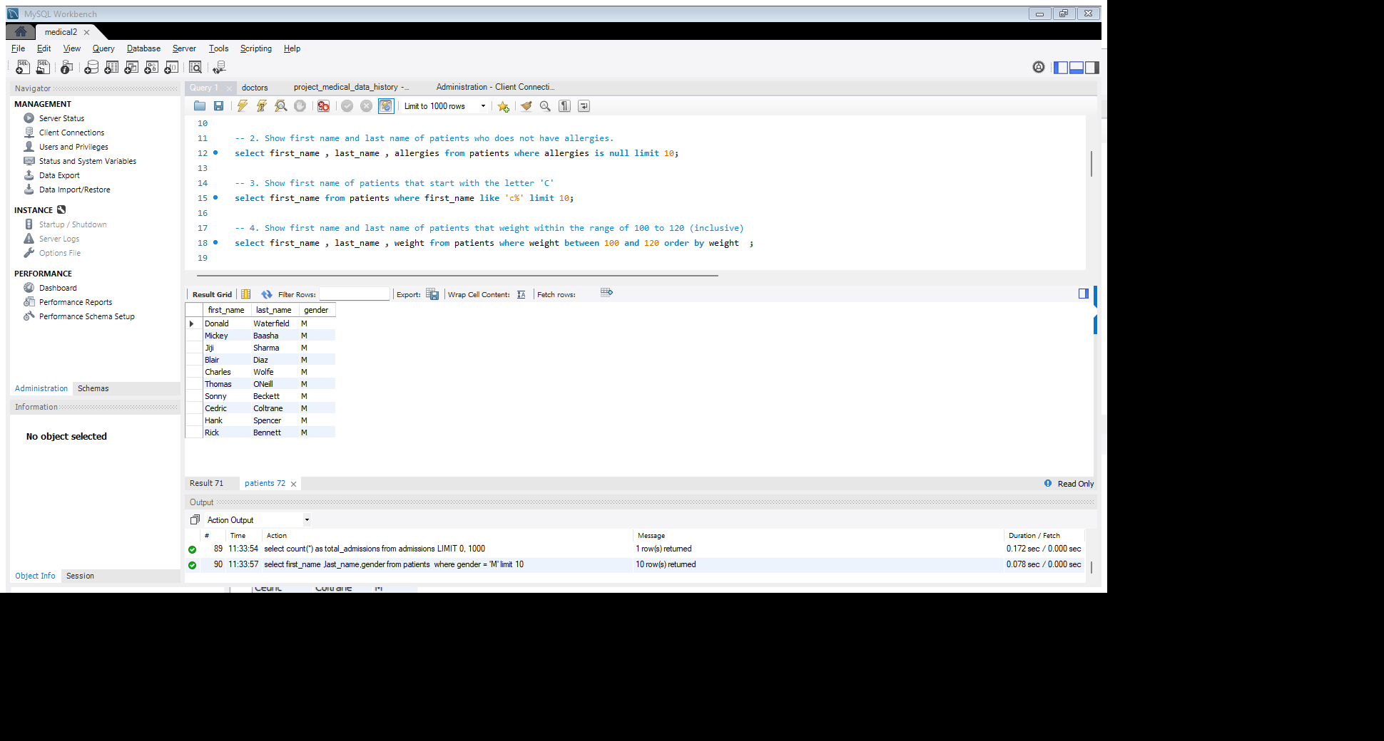

**2. Show first name and last name of patients who does not have allergies.**

# Query:

# select first_name, last_name, allergies from patients where allergies is null limit 10;

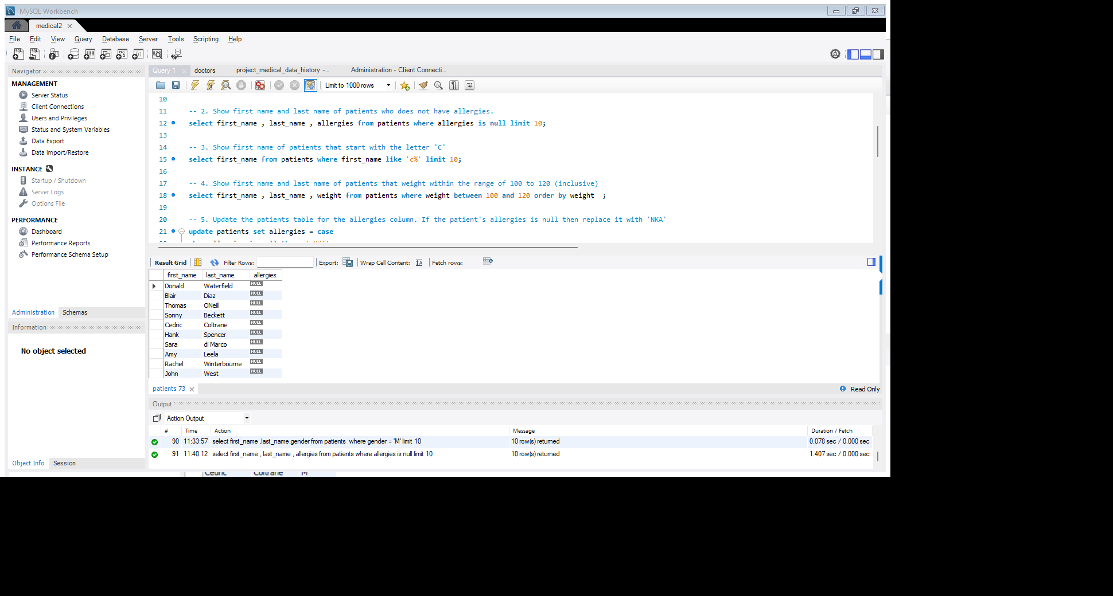

**3. Show first name of patients that start with the letter 'C'**

# Query: select first_name from patients where first_name like 'c%' limit 10;

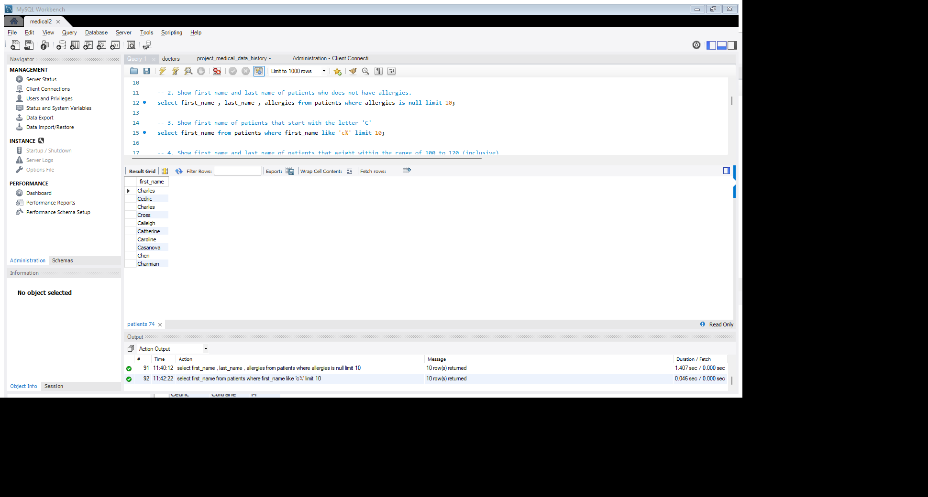

**4.Show first name and last name of patients that weight within the range of 100 to 120 (inclusive)**

# Query: select first_name, last_name, weight from patients where weight between 100 and 120 order by weight;

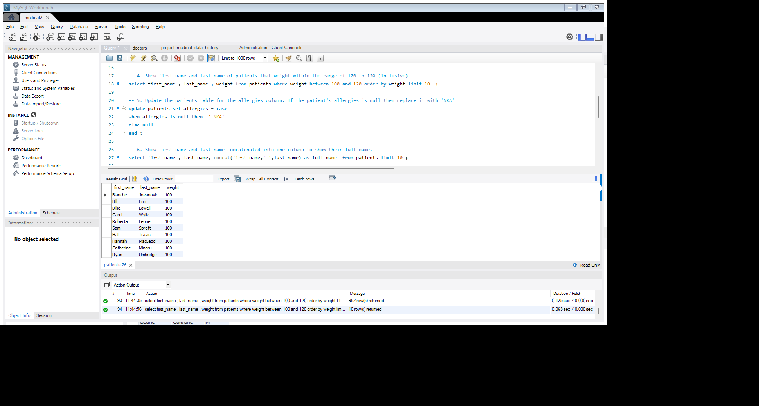

5. Update the patients table for the allergies column. If the patient's allergies is null then replace it with 'NKA'

# Query: update patients set allergies = case

# when allergies is null then ‘NKA'

# else null

# end;

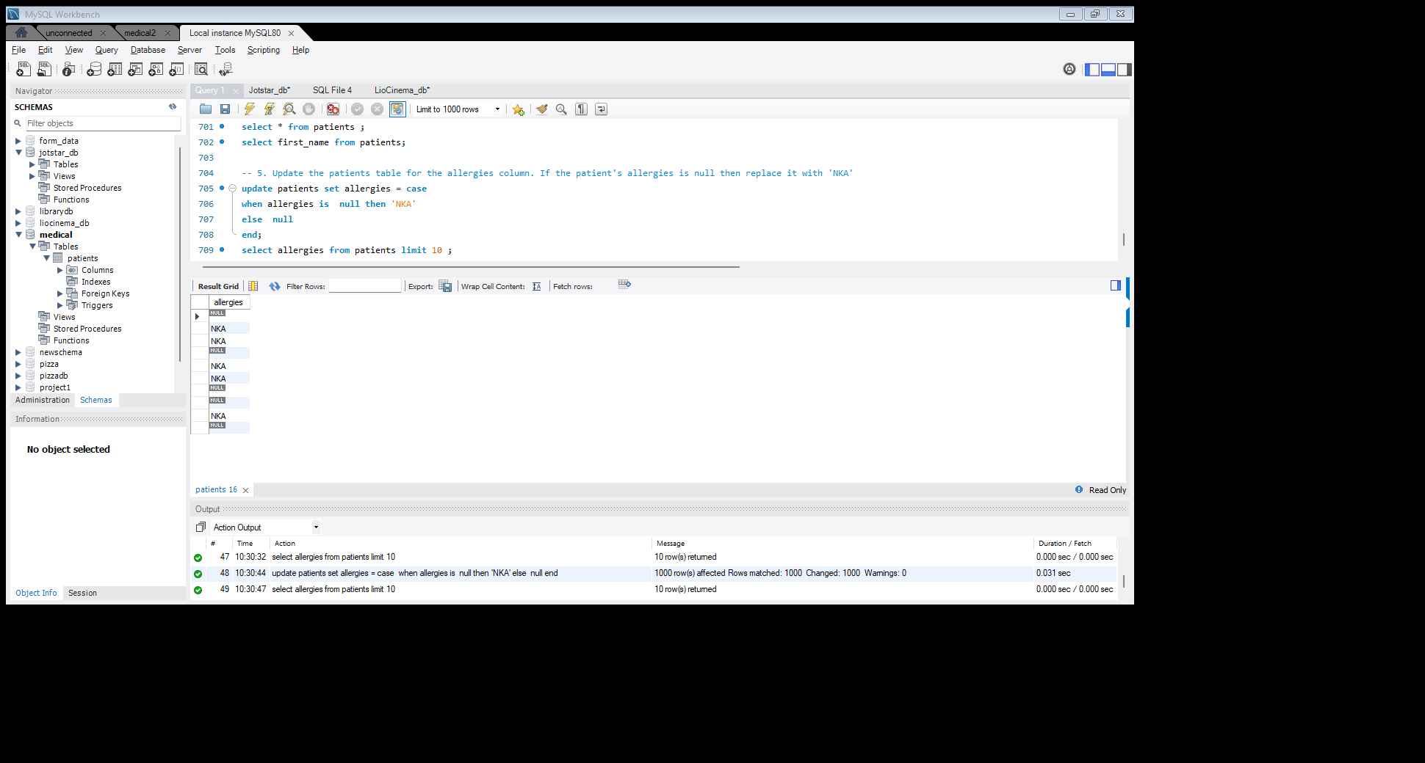

**6. Show first name and last name concatenated into one column to show their full name.**

# Query:

# select first_name, last_name, concat (first_name,' ‘, last_name) as full_name from patients limit 10;

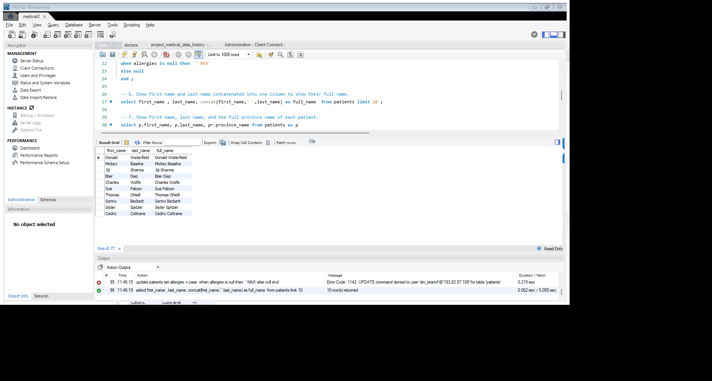

**7. Show first name, last name, and the full province name of each patient.**

# Query: select p. first_name, p. last_name, pr. province_name from patients as p

# join

# province_names as pr on pr. province_id = p.province_id order by province_name limit 10;

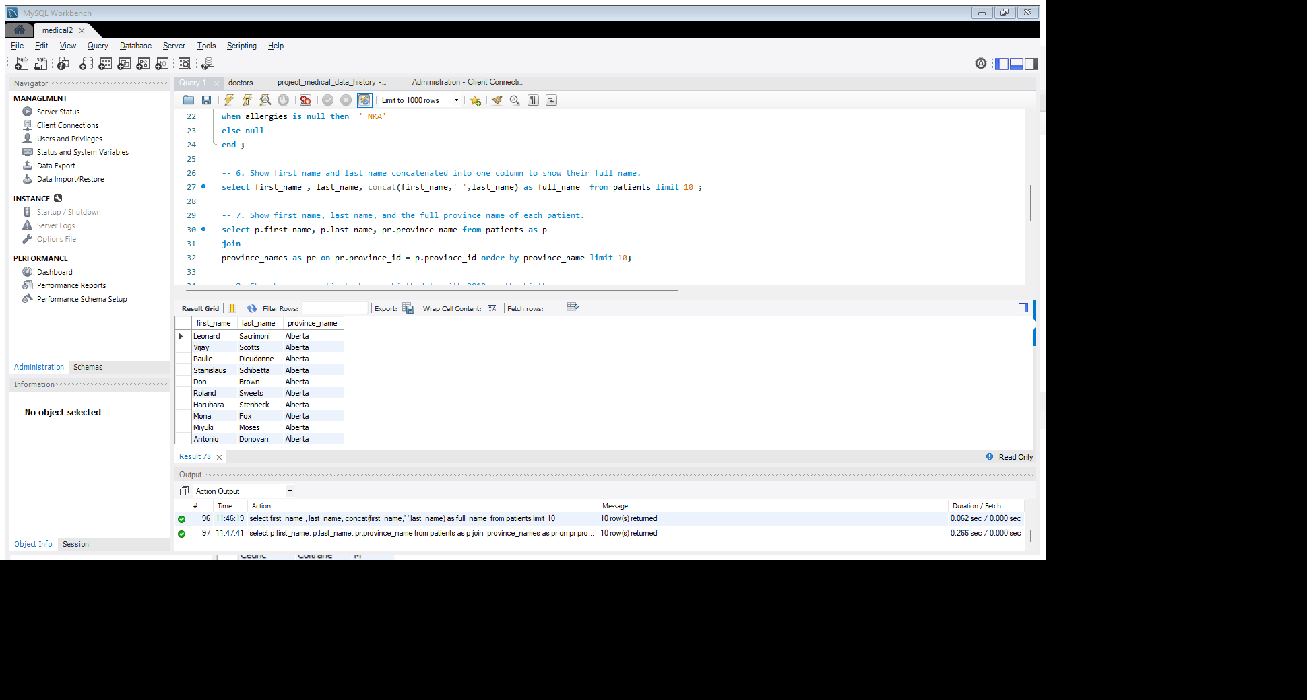

**8. Show how many patients have a birth_date with 2010 as the birth year.**

# Query: select year(birth_date) as birth_year, count (*) as no_patients from patients

# where year(birth_date) = '2010' group by birth_year;

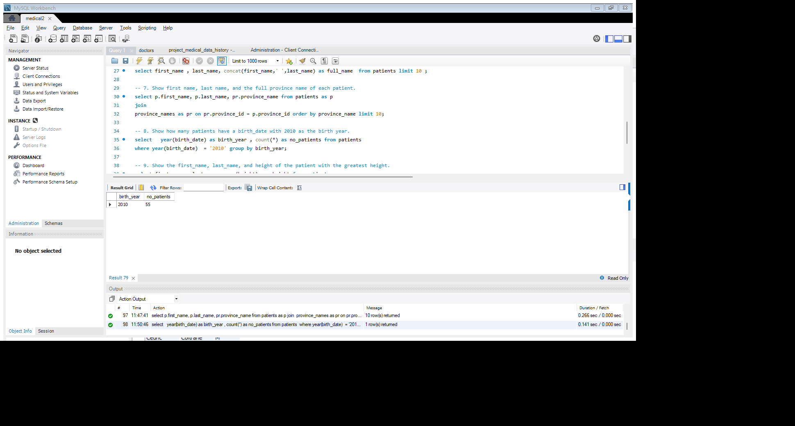

**9. Show the first_name, last_name, and height of the patient with the greatest height.**

# Query:

# select first_name, last_name, max(height) as height from patients

# group by first_name ,last_name order by height desc limit 10;

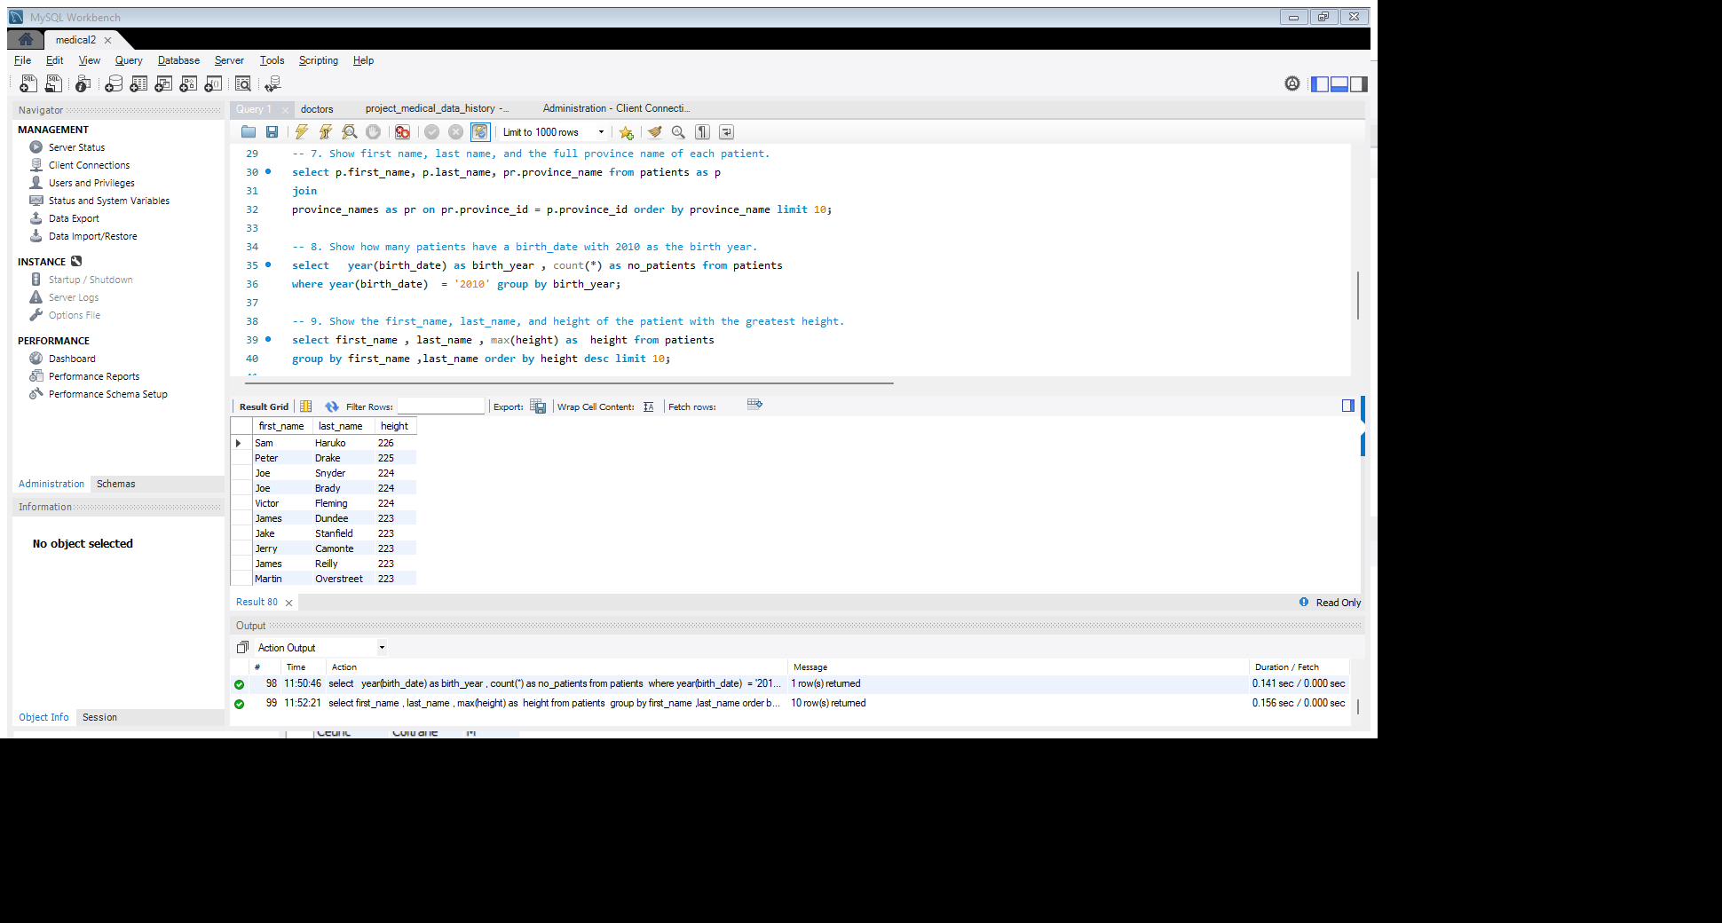

**10. Show all columns for patients who have one of the following patient_ids: 1,45,534,879,1000.**

# Query:

# select * from patients where patient_id in (1,45,534,879,1000)

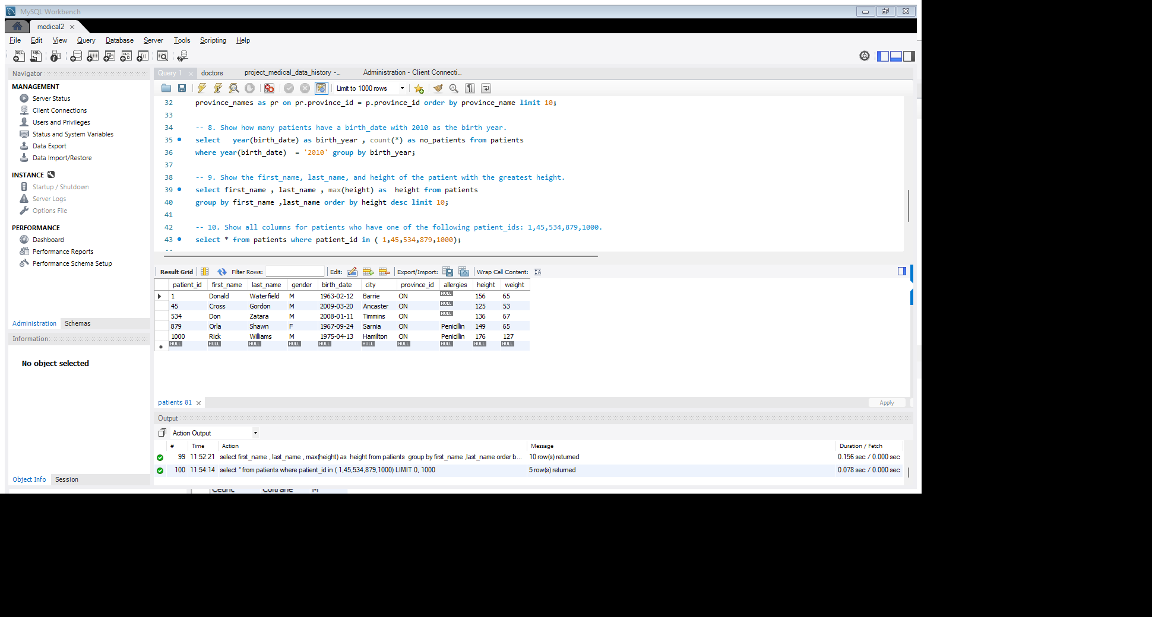

**11. Show the total number of admissions.**

# Query:

# select count (*) as total_admissions from admissions;

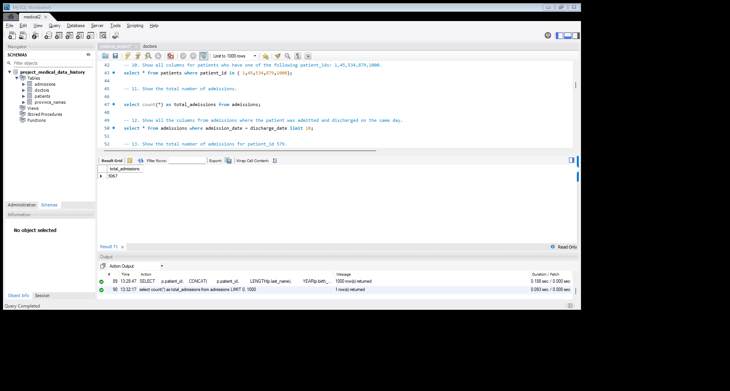

**12. Show all the columns from admissions where the patient was admitted and discharged on the same day.**

# Query: select * from admissions where admission_date = discharge date limit 10;

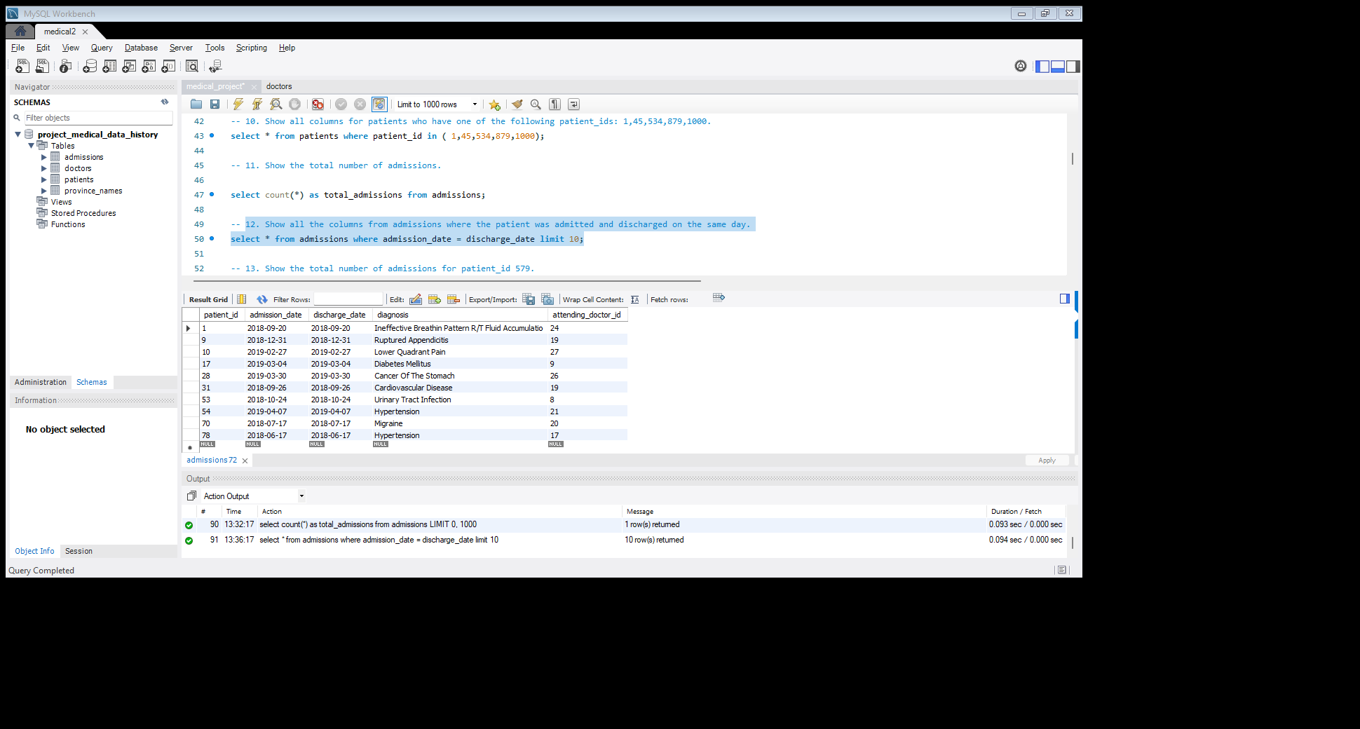

**13. Show the total number of admissions for patient_id 579.**

# Query:

# select count (*) as total_admissions, patient_id from admissions where patient_id = 579;

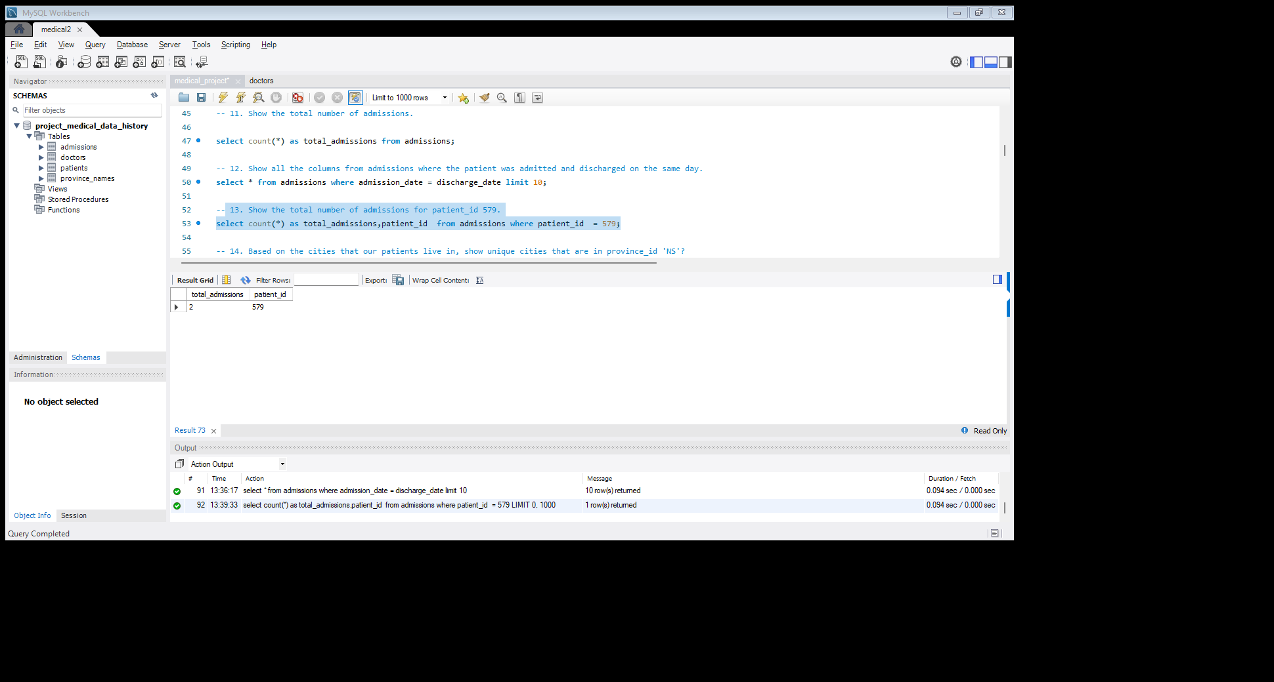

# 14. Based on the cities that our patients live in, show unique cities that are in province_id 'NS'?

# Query: select distinct (p. city), p. province_id from patients as p

# join

# admissions as a on a. patient_id = p. patient_id

# where province_id = 'NS’;

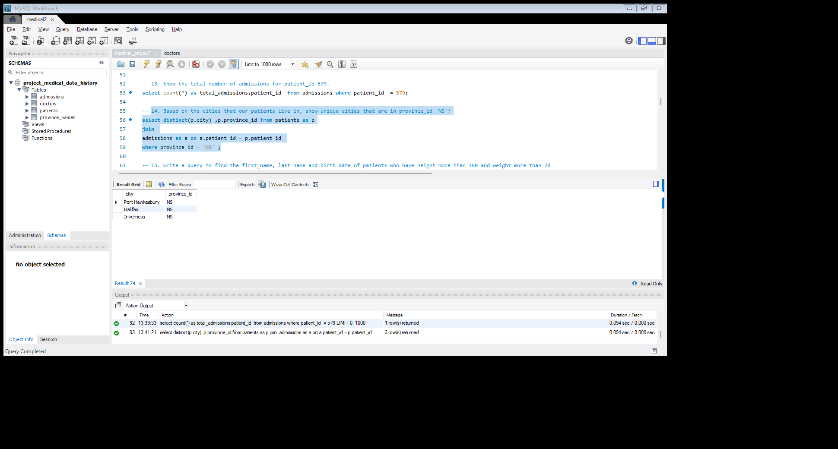

**15. Write a query to find the first_name, last name and birth date of patients**

**who have height more than 160 and weight more than 70**

# Query: select first_name, last_name, birth_date,height,weight from patients

# where height > 160 and weight > 70 limit 10;

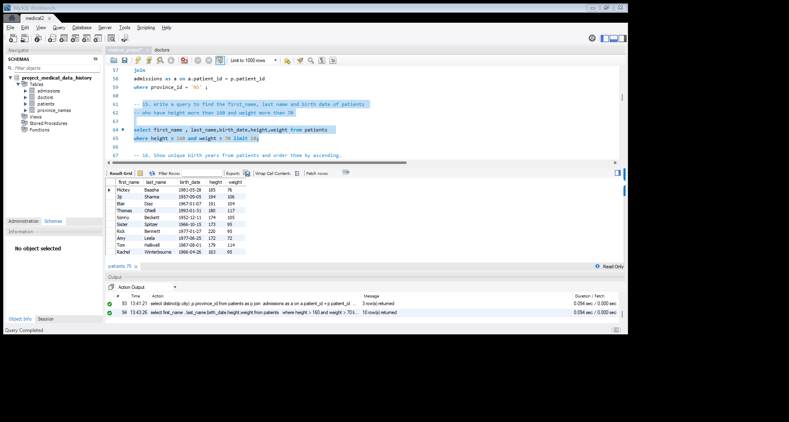

**16. Show unique birth years from patients and order them by ascending.**

# Query: select distinct(year(birth_date)) as birth_year from patients

# order by year(birth_date) asc limit 10;

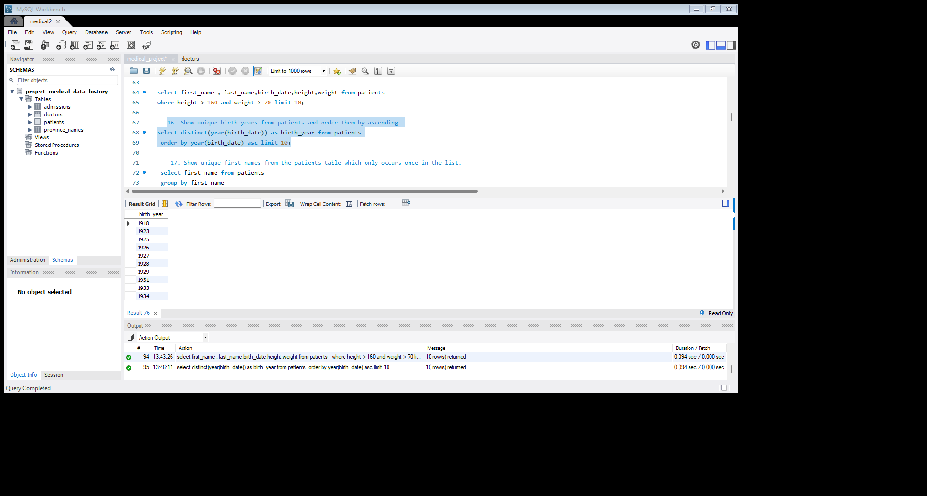

**17. Show unique first names from the patients table which only occurs once in the list.**

# Query: select first_name from patients

# group by first_name

# having count(first_name) = 1 limit 10;

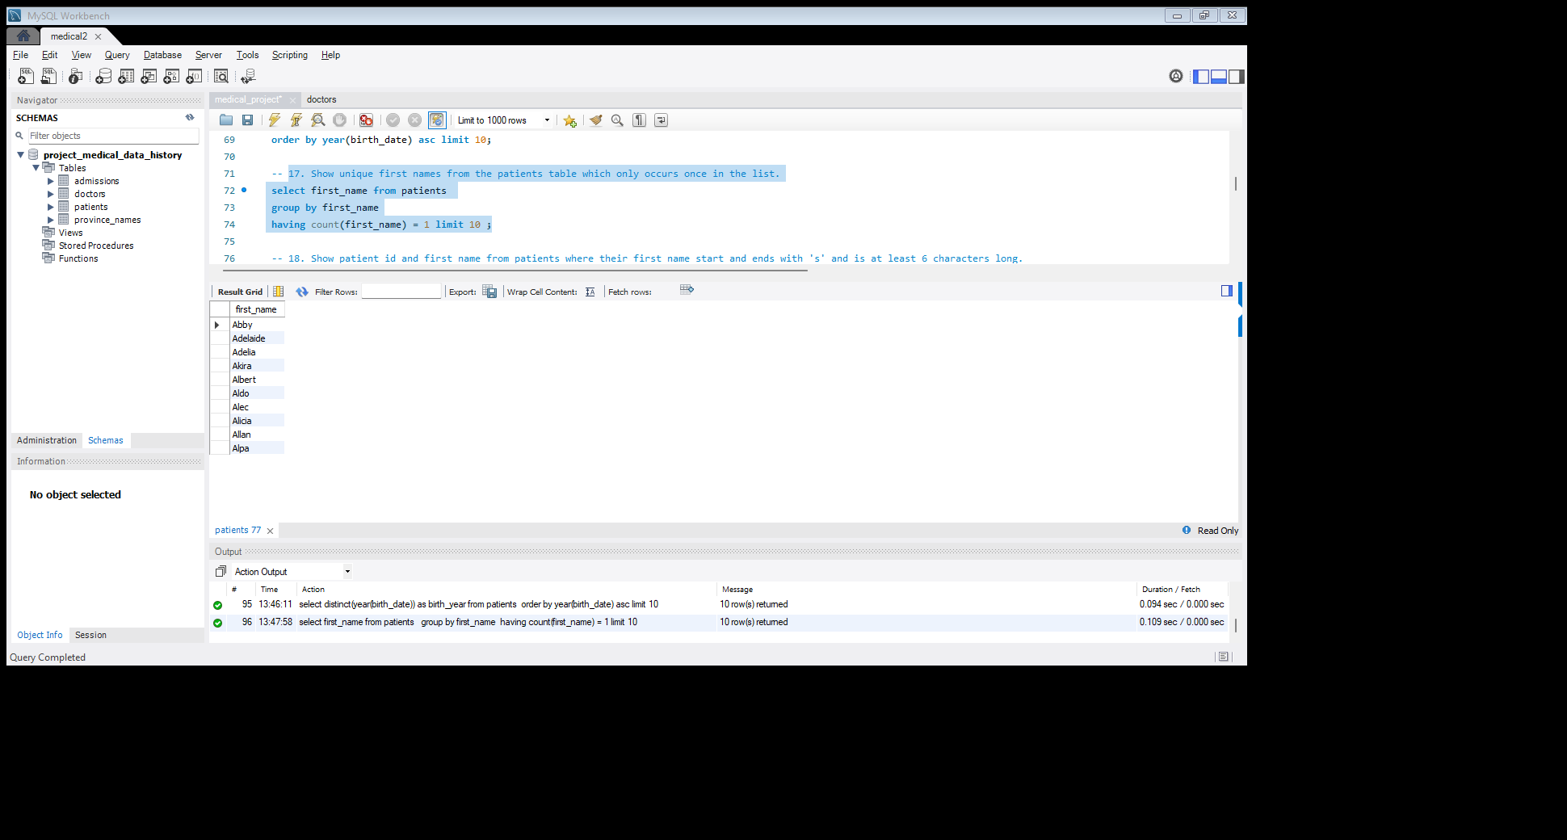

**18. Show patient_id and first_name from patients where their first_name start and ends with 's' and is at least 6 characters long**.

# Query: select patient_id, first_name from patients

# where first_name like 's%s'

# and length(first_name) >= 6 limit 10;

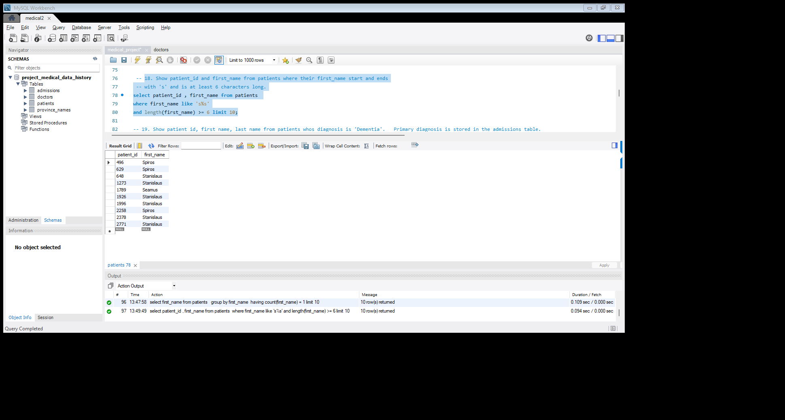

**19. Show patient_id, first_name, last_name from patients whos diagnosis is 'Dementia'. Primary diagnosis is stored in the admissions table.**

# Query: select p. patient_id, p. first_name,p.last_name,a.diagnosis from patients as p

# join

# admissions as a on a.patient_id = p.patient_id

# where diagnosis = 'Dementia'limit 10;

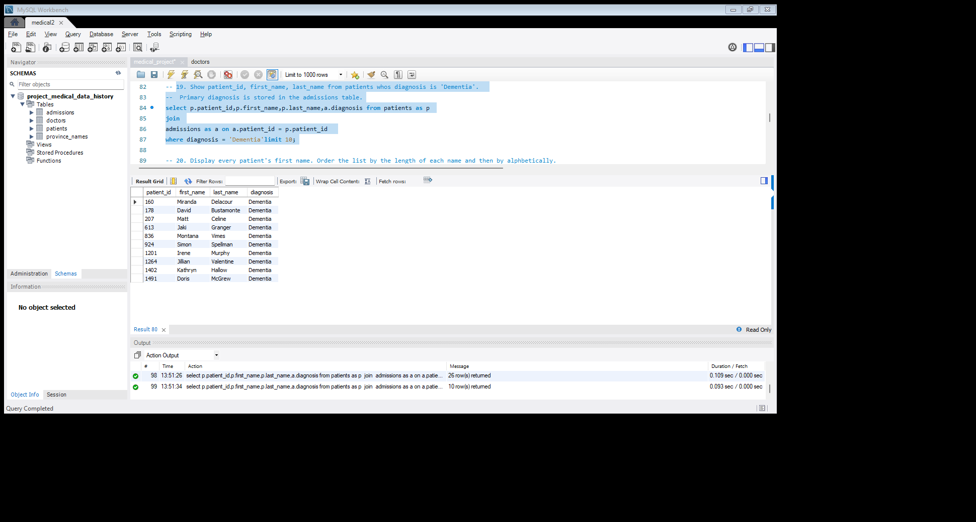

**20. Display every patient's first_name. Order the list by the length of each name and then by alphabetically.**

# Query: select first_name from patients

# order by length(first_name), first_name limit 10;

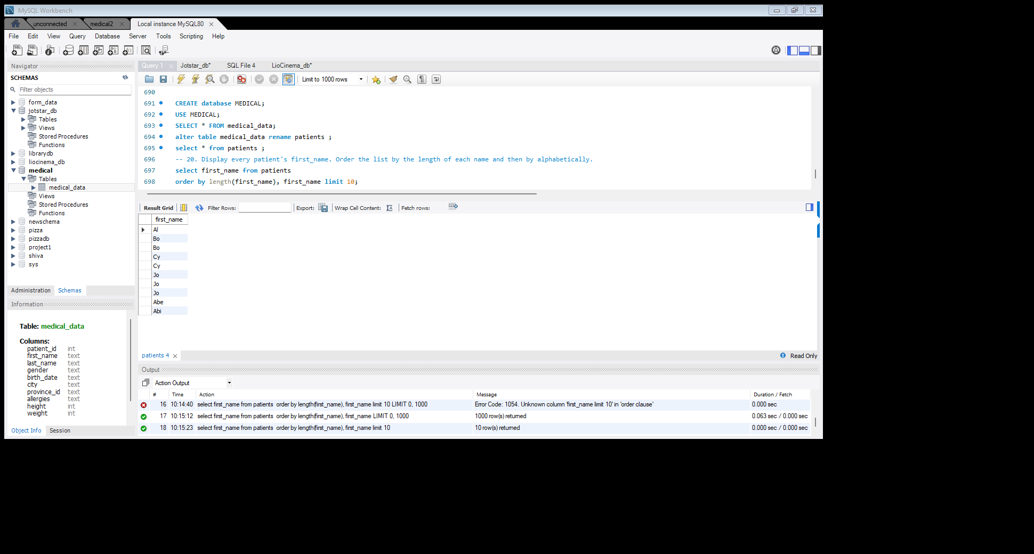

**21. Show the total amount of male patients and the total amount of female select patients in the patients table. Display the two results in the same row.**

# Query:

# sum (case when gender = "M" then 1 else 0 end) as male_patients,

# sum (case when gender = "F" then 1 else 0 end) as female_patients

# from patients;

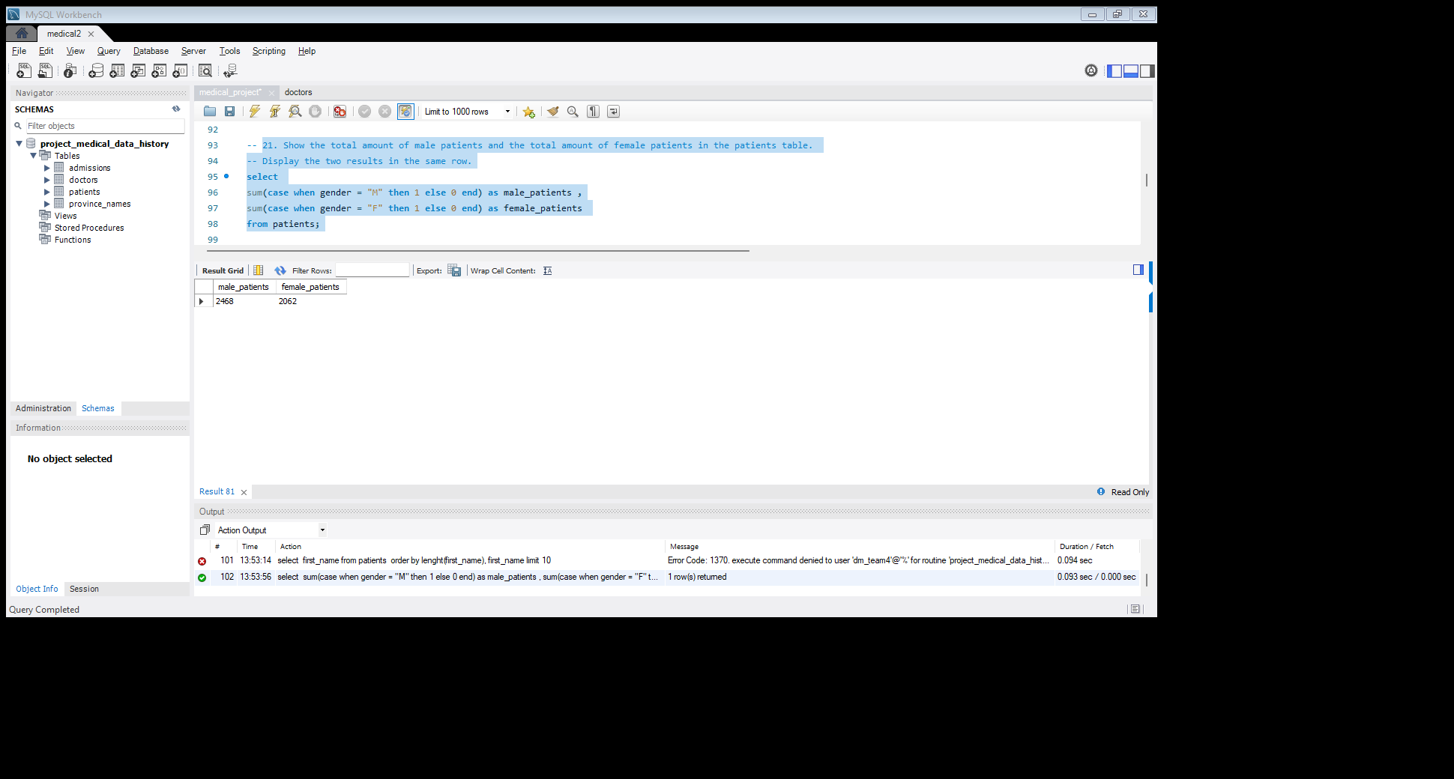

**23. Show patient_id, diagnosis from admissions. Find patients admitted multiple times for the same diagnosis.**

# Query: select patient_id , diagnosis from admissions

# group by patient_id, diagnosis

# having count (*) > 1;

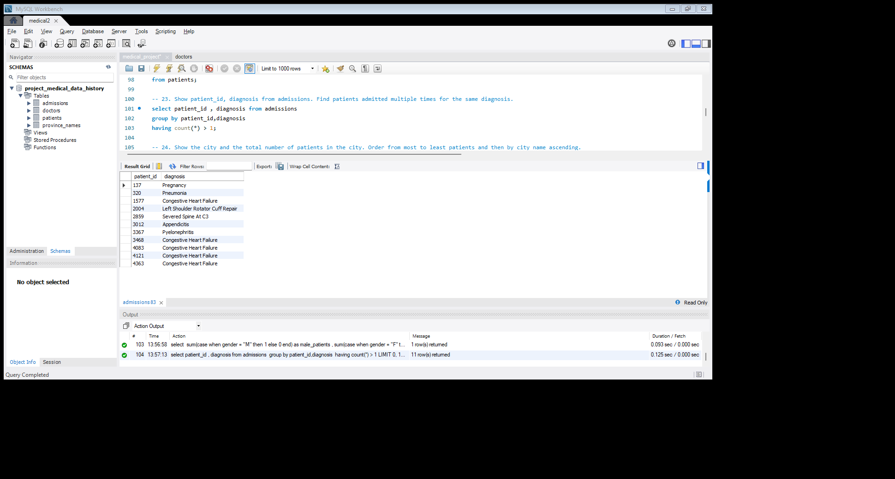

**24. Show the city and the total number of patients in the city. Order from most to least patients and then by city name ascending.**

# Query: select city, count(patient_id) as no_of_patients from patients

# group by city

# order by no_of_patients desc, city asc limit 10;

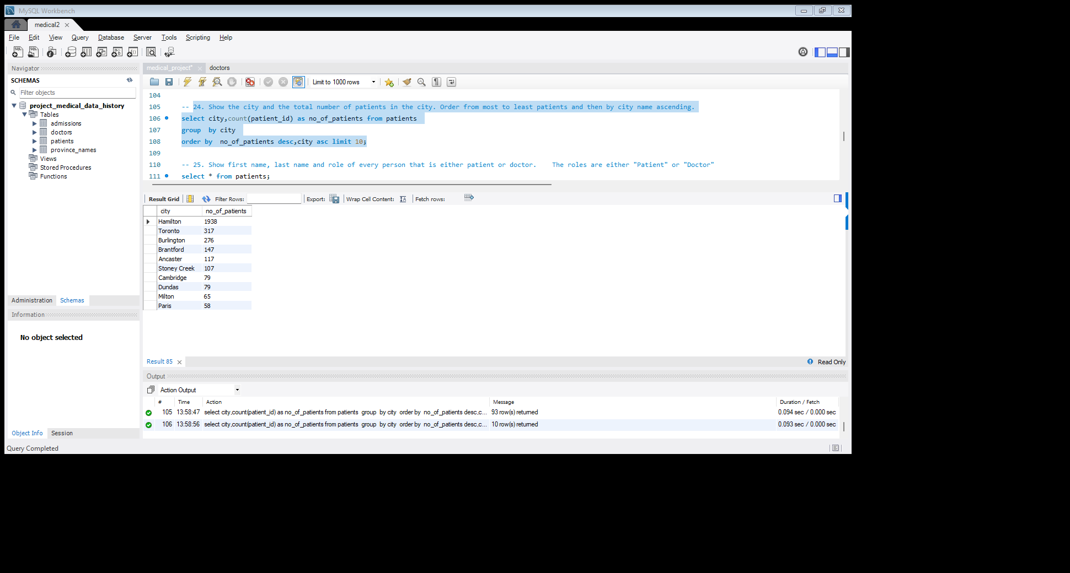

**25. Show first name, last name and role of every person that is either patient or doctor. The roles are either "Patient" or "Doctor"**

# Query:

# select first_name, last_name, “patient" as role from patients

# union all

# select first_name, last_name, “Doctor" as role from doctors limit 10;

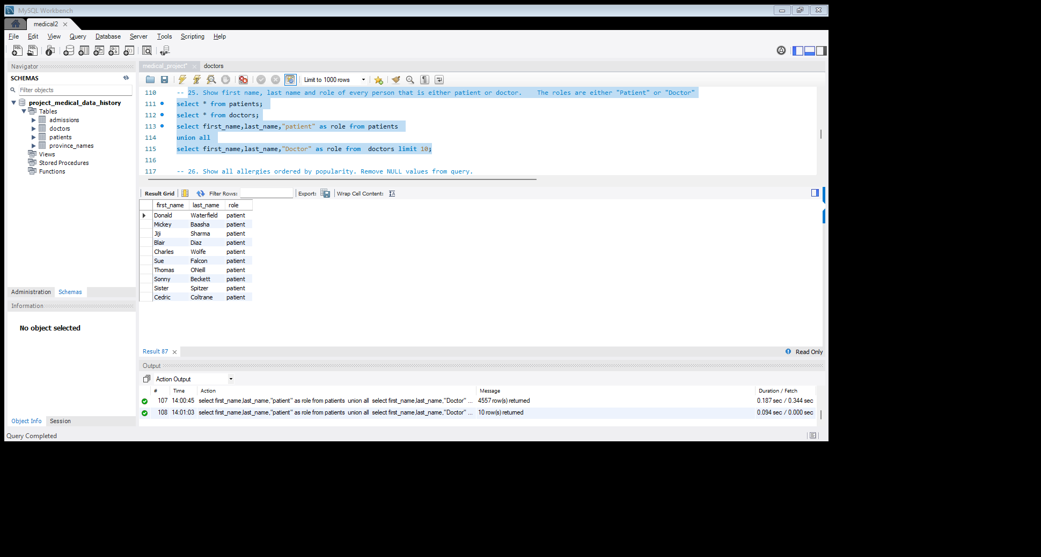

**26. Show all allergies ordered by popularity. Remove NULL values from query.**

# Query:

# select allergies, count (*) as popularity from patients where allergies is not null

# group by allergies

# order by popularity desc limit 10;

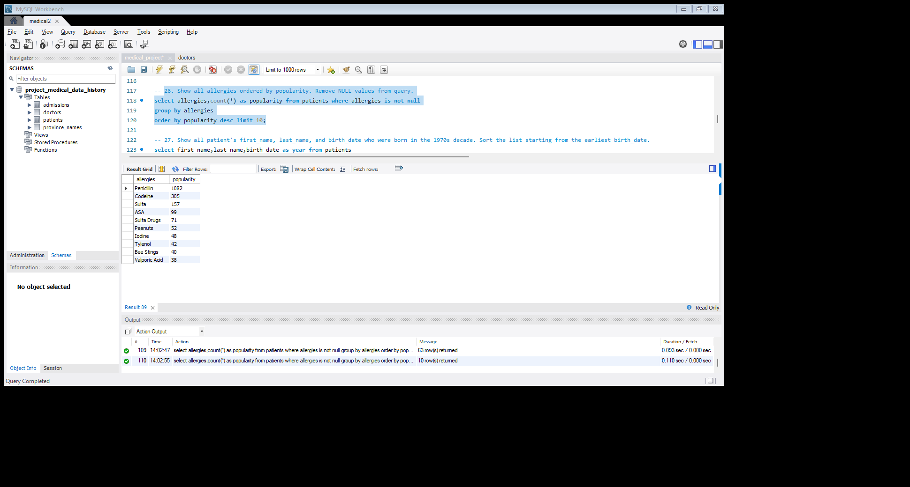

**27. Show all patient's first_name, last_name, and birth_date who were born in the 1970s decade. Sort the list starting from the earliest birth_date.**

# Query:

# select first_name, last_name, birth_date as year from patients

# where birth_date between ‘1970-01-01’ and '1979-12-31'

# order by year limit 10;

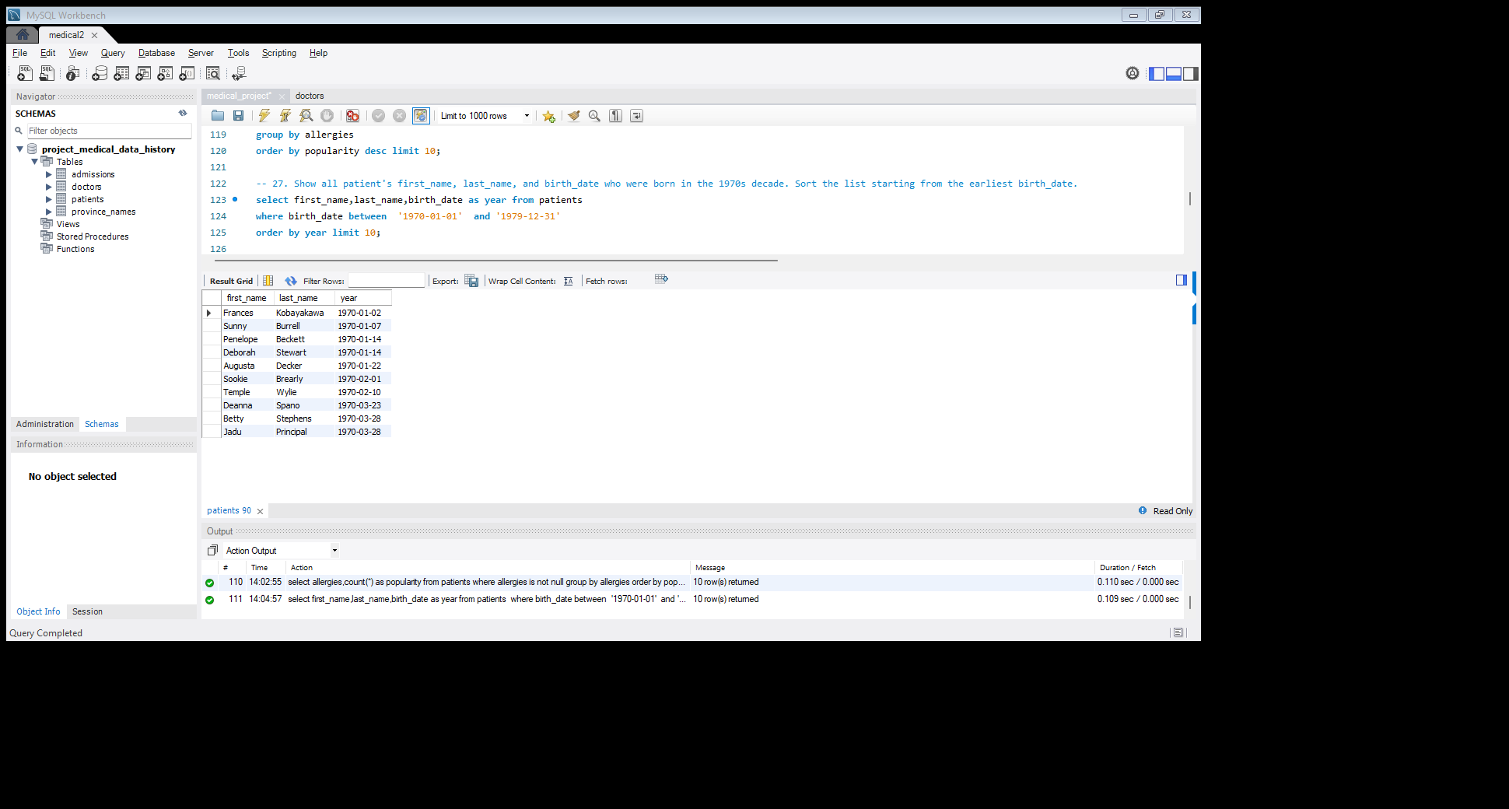

**28. We want to display each patient's full name in a single column. Their last_name in all upper letters must appear first, then first_name in all lower-case letters. Separate the last_name and first_name with a comma. Order the list by the first_name in descending order EX: SMITH, Jane**

# Query:

# select concat(upper(last_name),',’, lower(first_name)) as Full_Name from patients

# order by upper(last_name) desc limit 10;

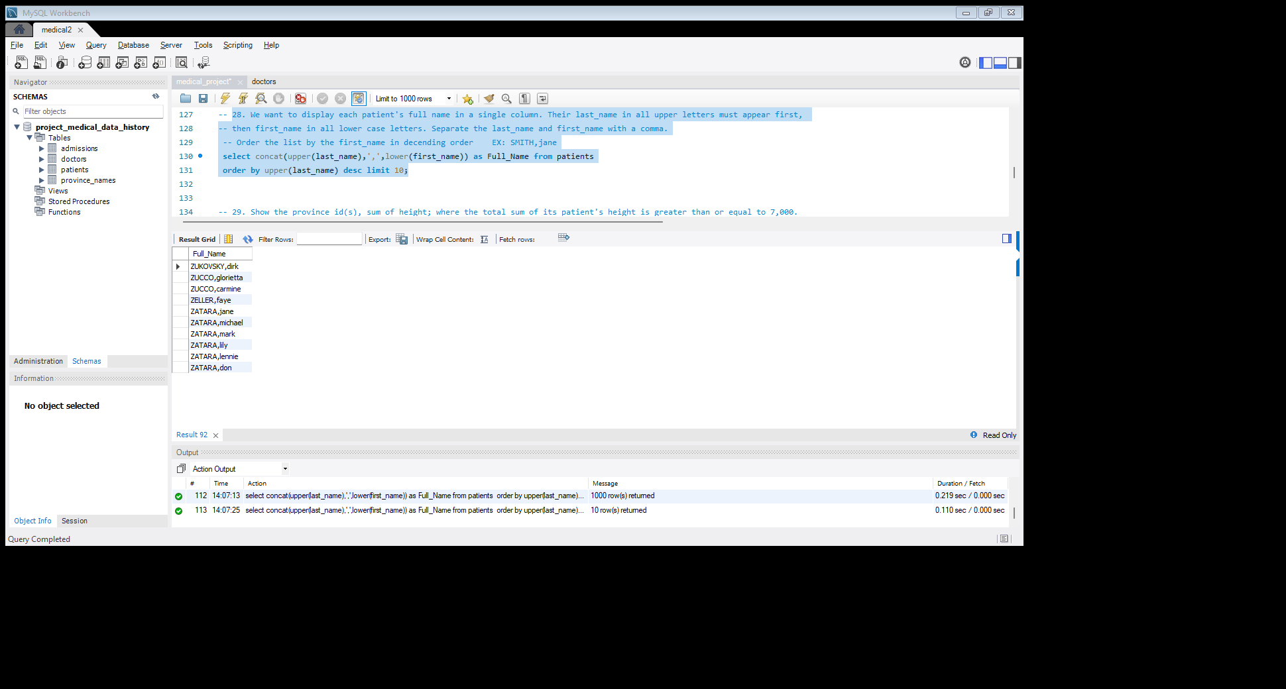

**29. Show the province_id(s), sum of height; where the total sum of its patient's height is greater than or equal to 7,000.**

# Query:

# select province_id, sum(height) as total_height from patients

# group by province_id

# having total_height >= 7000;

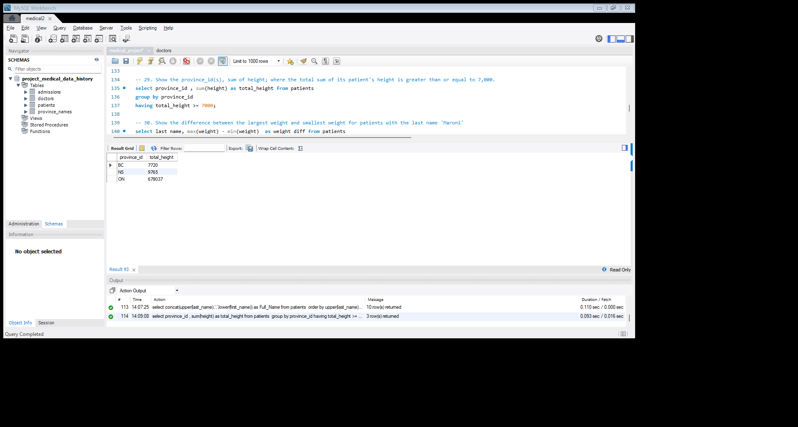

**30. Show the difference between the largest weight and smallest weight for patients with the last name 'Maroni'**

# Query:

# select last_name, max(weight) - min(weight) as weight_diff from patients

# where last_name = "Maroni" ;

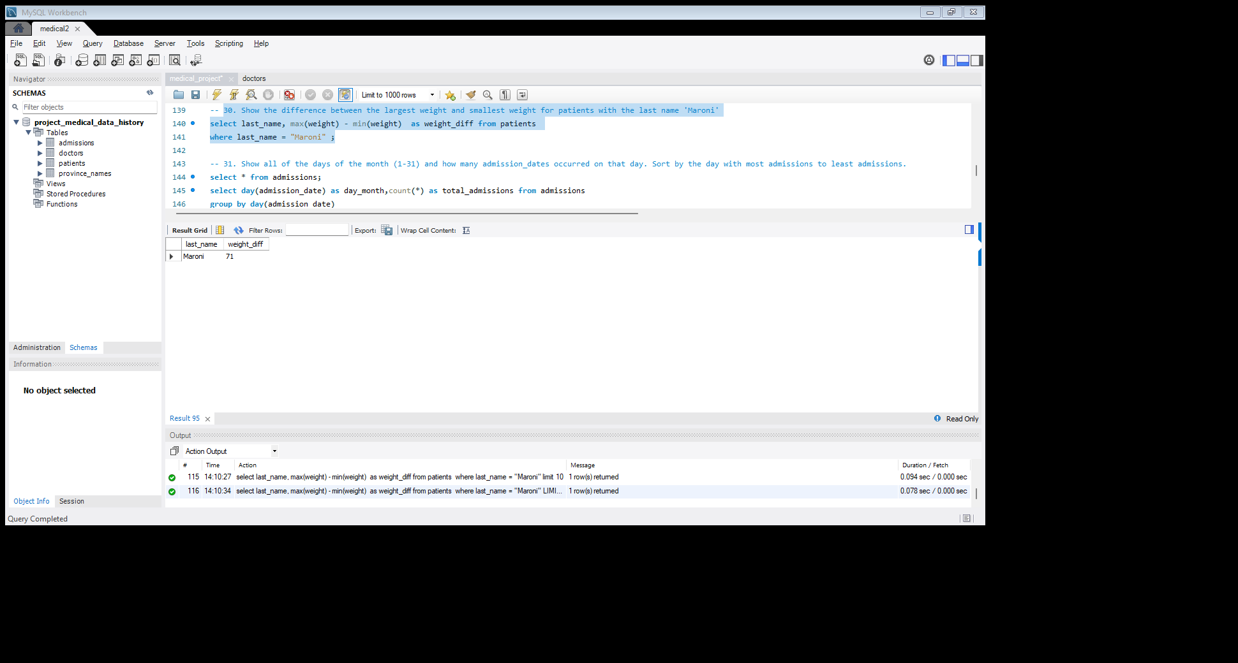

**31. Show all of the days of the month (1-31) and how many admission_dates occurred on that day. Sort by the day with most admissions to least admissions.**

# Query:

# select day(admission_date) as day_month, count (*) as total_admissions from admissions

# group by day(admission_date)

# having count (*) > 1

# order by day_month desc limit 10;

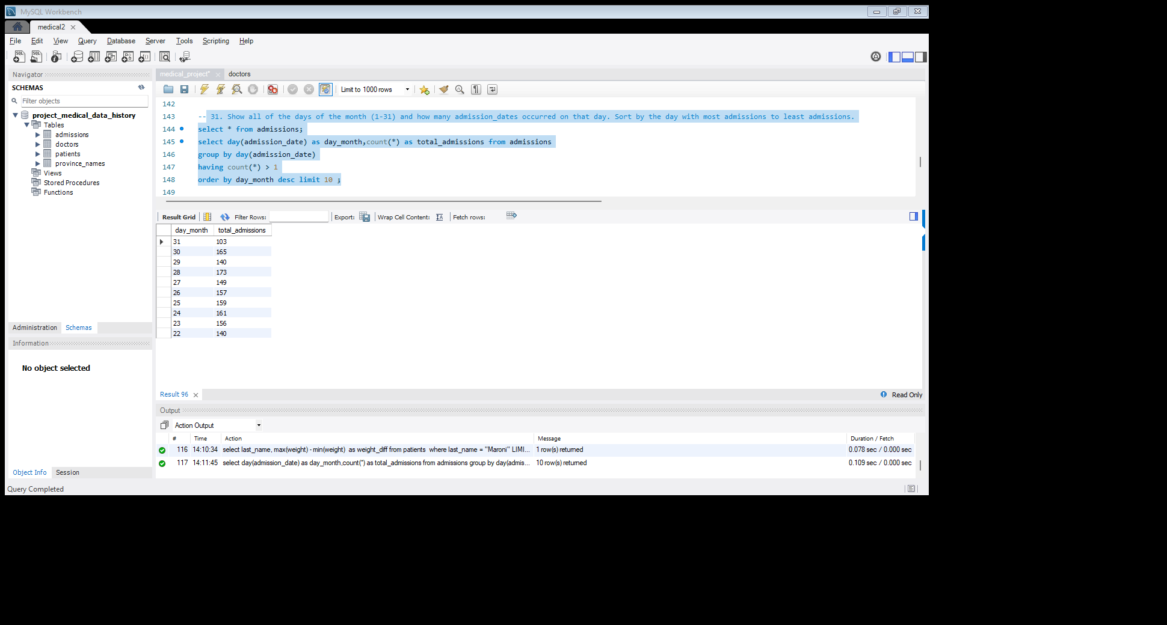

**32. Show all of the patients grouped into weight groups. Show the total amount of patients in each weight group. Order the list by the weight group descending. e.g. if they weight 100 to 109 they are placed in the 100-weight group, 110-119 = 110 weight group, etc.**

# Query:

# select floor(weight/10) *10 as weight_group, count (*) as total_patiens from patients

# group by weight_group

# order by weight_group desc limit 10;

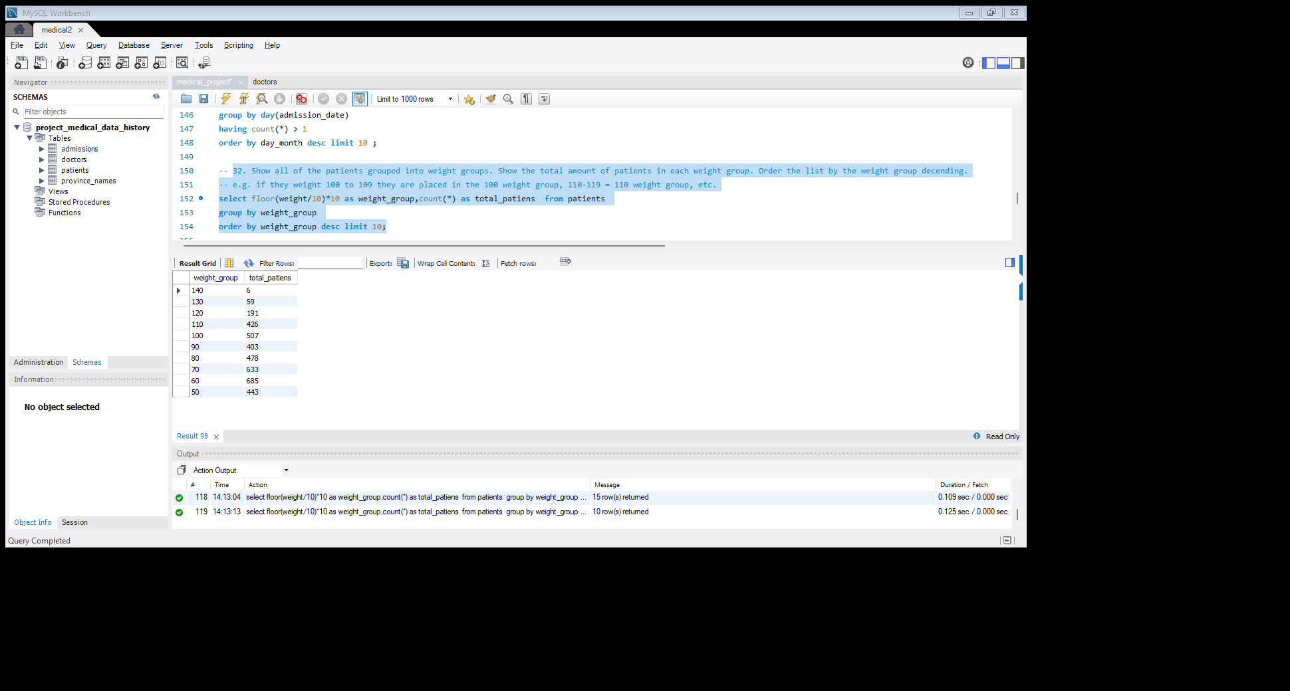

**33. Show patient_id, weight, height, isObese from the patients table. Display isObese as a Boolean 0 or 1. Obese is defined as weight(kg)/(height(m). Weight is in units kg. Height is in units cm.**

# Query:

# select patient_id, weight, height,

# case

# when weight (power (height /100.0,2)) > 30 then 1 else 0

# end as isobese from patients;

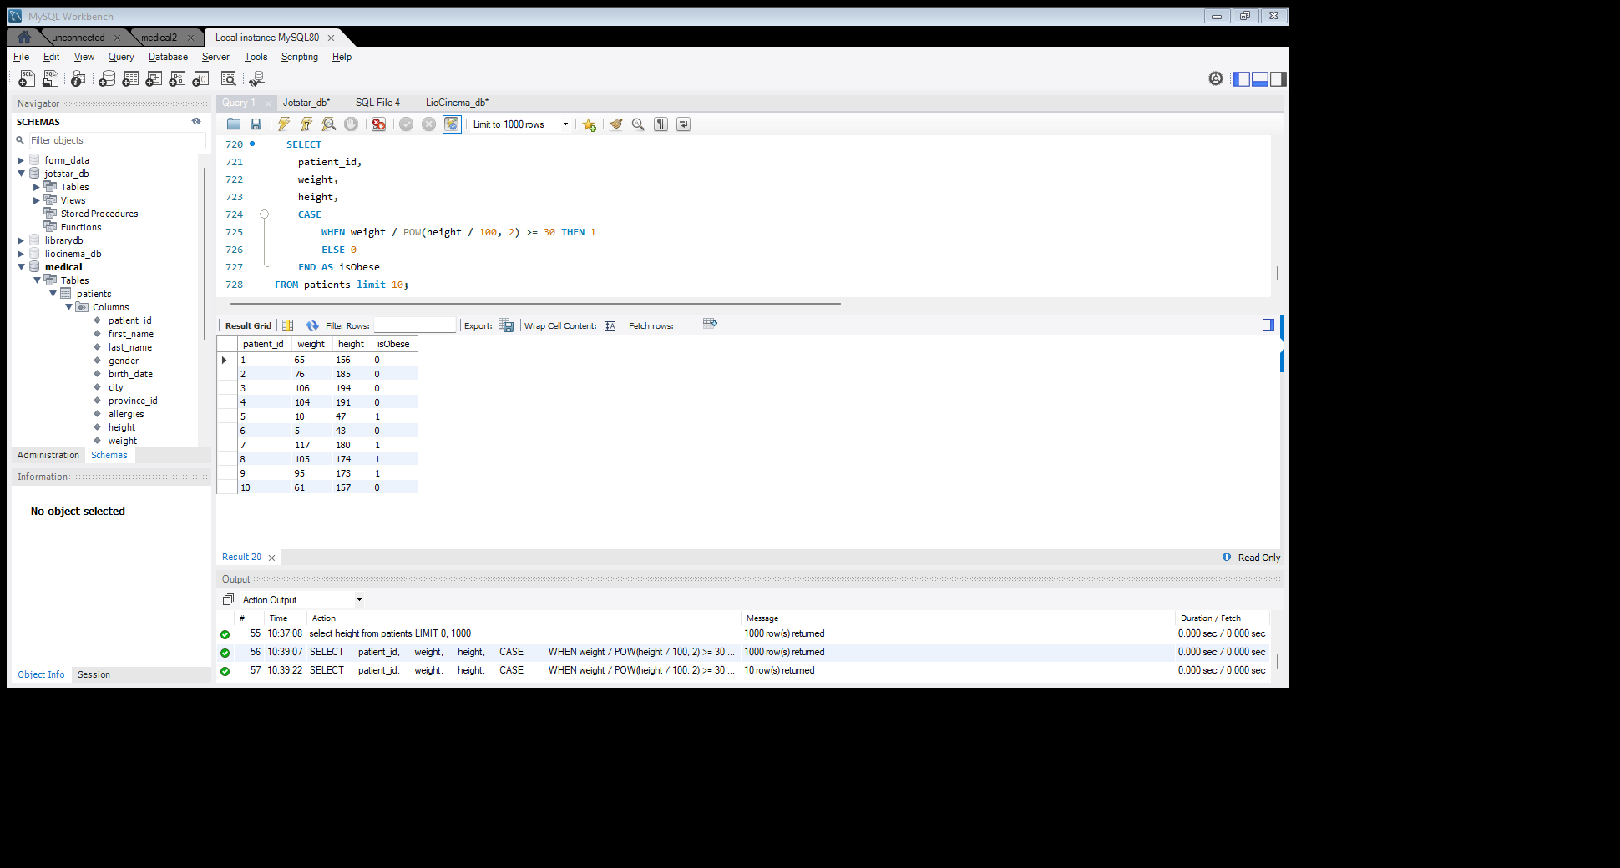

**34. Show patient_id, first_name, last_name, and attending doctor's specialty. Show only the patients who has a diagnosis as 'Epilepsy' and the doctor’s first name is 'Lisa'. Check patients, admissions, and doctors’ tables for required information.**

# Query:

# select p. patient_id, d.first_name,d.last_name,d.specialty,a.diagnosis from patients as p

# join

# admissions as a on a. patient_id = p. patient_id

# join

# doctors as d on d. doctor_id = a. attending_doctor_id

# where diagnosis = 'Epilepsy' and d.first_name = 'Lisa';

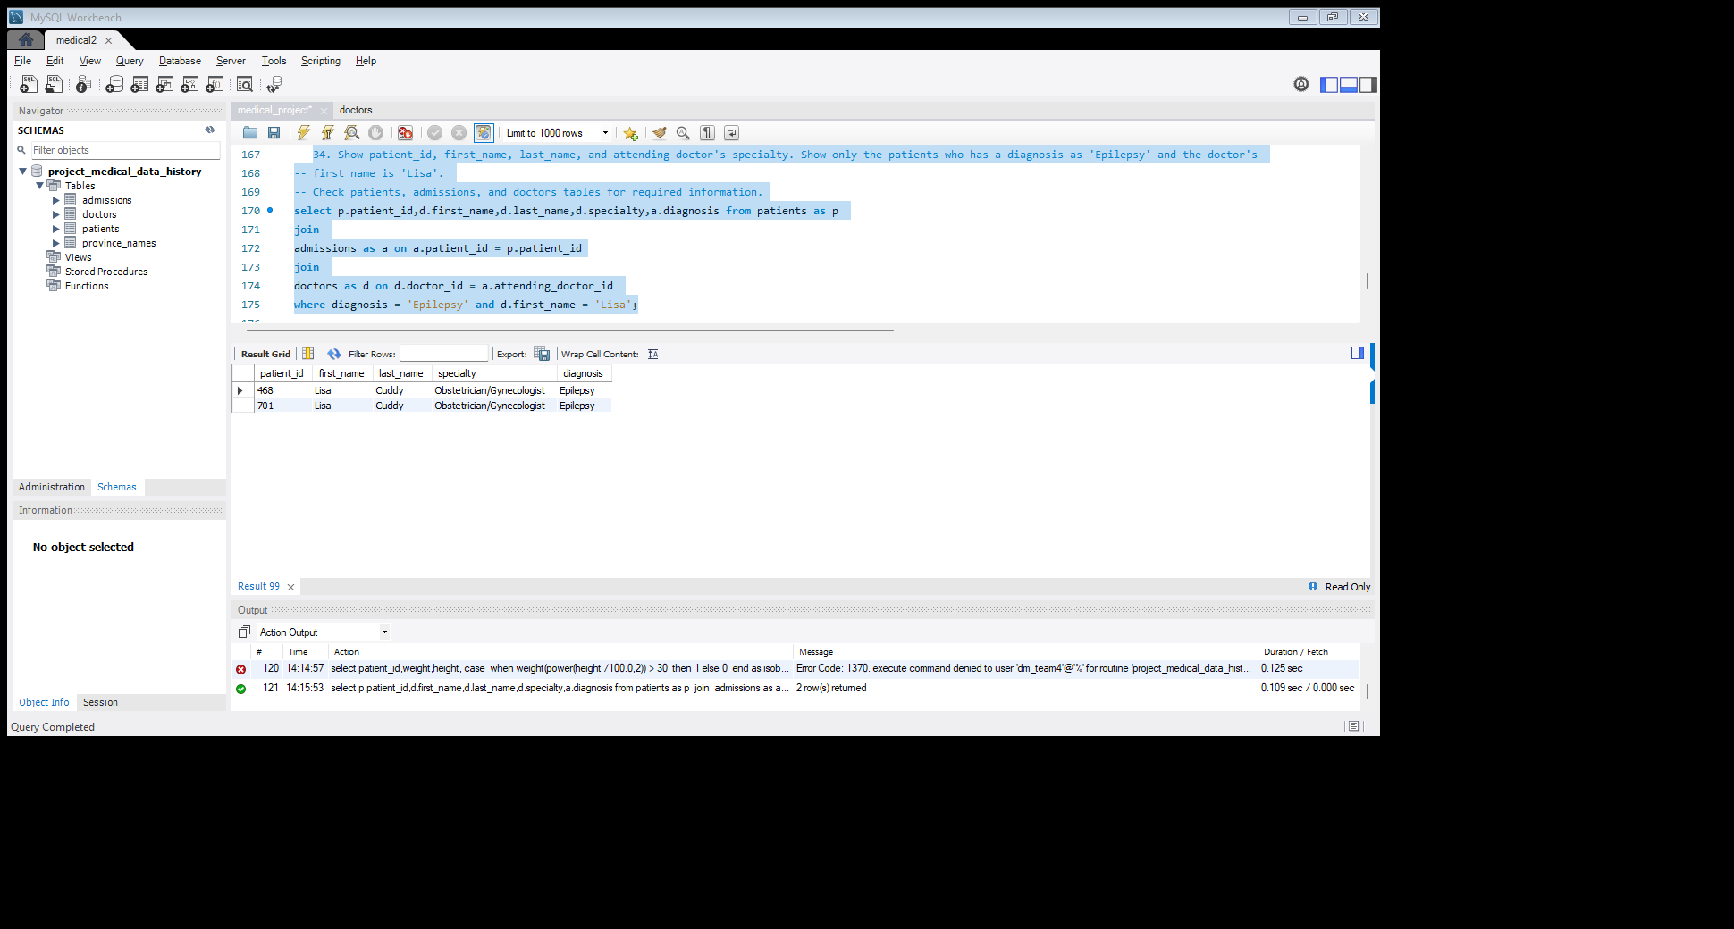

35. All patients who have gone through admissions, can see their medical documents on our site. Those patients are given a temporary password after their first admission. Show the patient_id and temp_password.The password must be the following, in order patient_id the numerical length of patient's last_name year of patient's birth_date

Query:

# SELECT

# P. PATIENT_id,

# CONCAT (P. PATIENT_id, LENGTH (P. LAST_name), YEAR (p. birth_date)

# ) AS temp_password

# FROM patients p

# WHERE EXISTS (

# SELECT 2

# FROM admissions a

# WHERE a. patient_id = p. patient_id

# ) LIMIT 10;

