Performing Eda on the data:

1.finding the 0’s and 1;s in the values

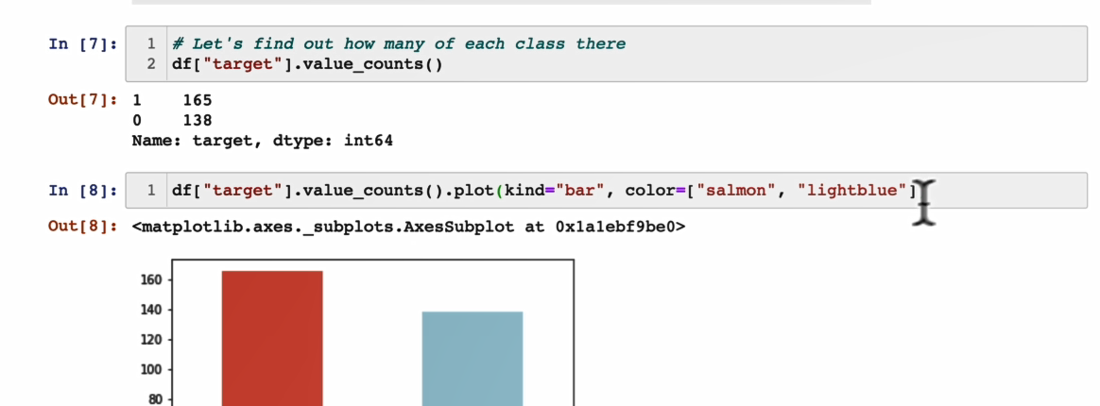

Comparing age coloumn and sex coloumn

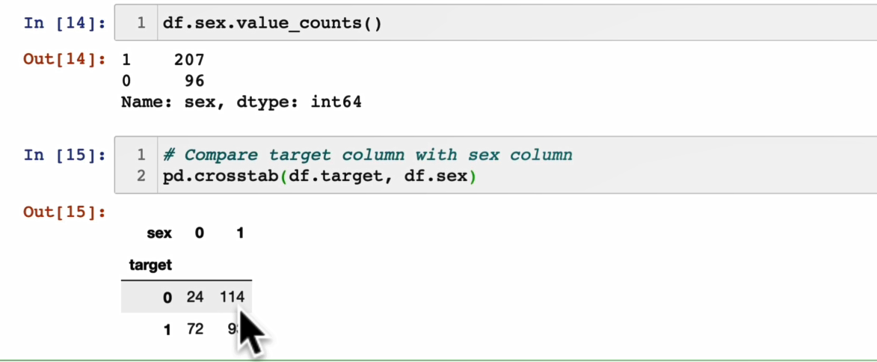

Daigram for the same:

Other plt tags for the graphs:

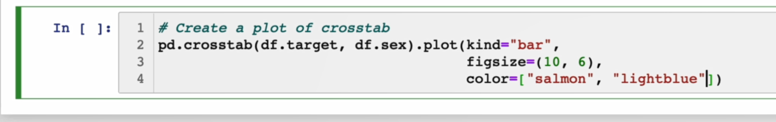

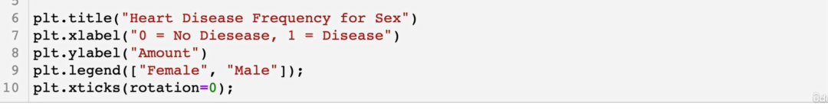

Counted different values :

SO I got more then 3,4 decided to take scatter plot

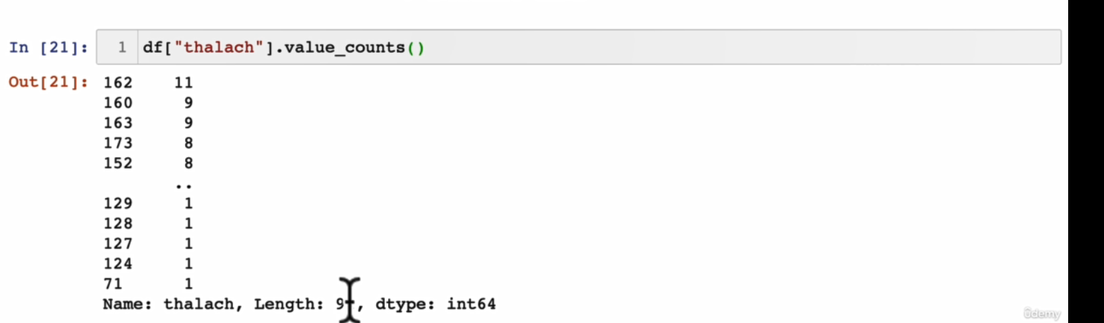

Code:

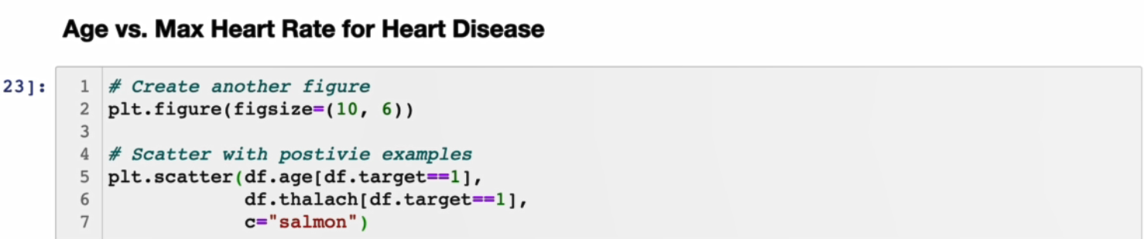

Graph:

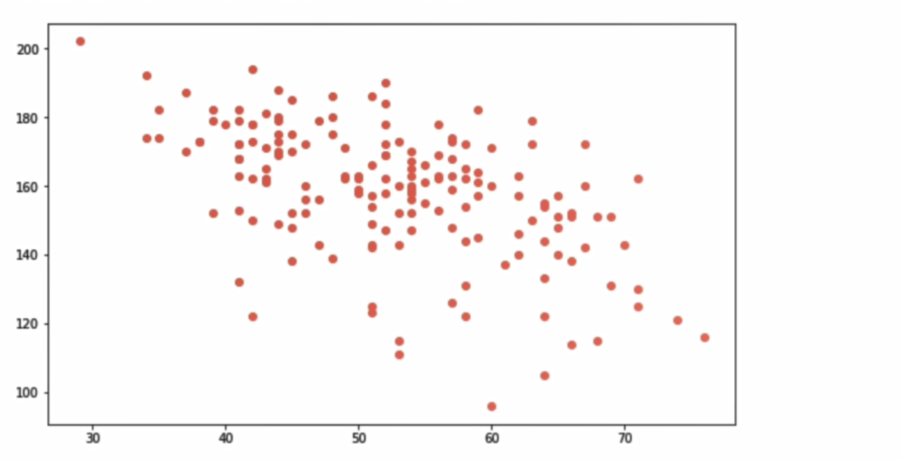

For plotting both the values 0’s and 1’s:

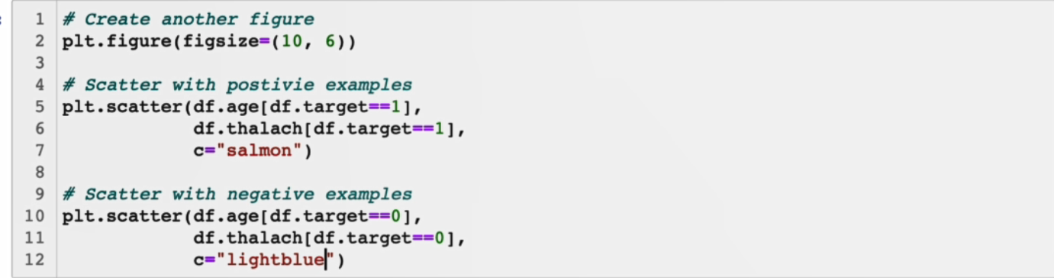

Defining relation between each and every features:

Using correlation matrix:

If the values is positive then it means when the one variable is increasing then another variable is also increasing vice versa for the negative.

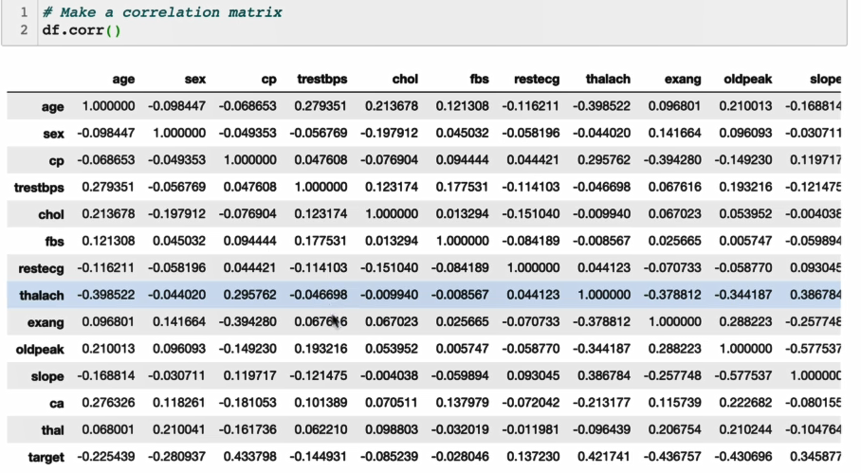

Code for plotting the heatmap:

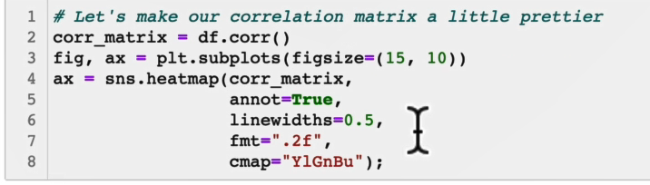

Tunning of models:

Tunning of knn:

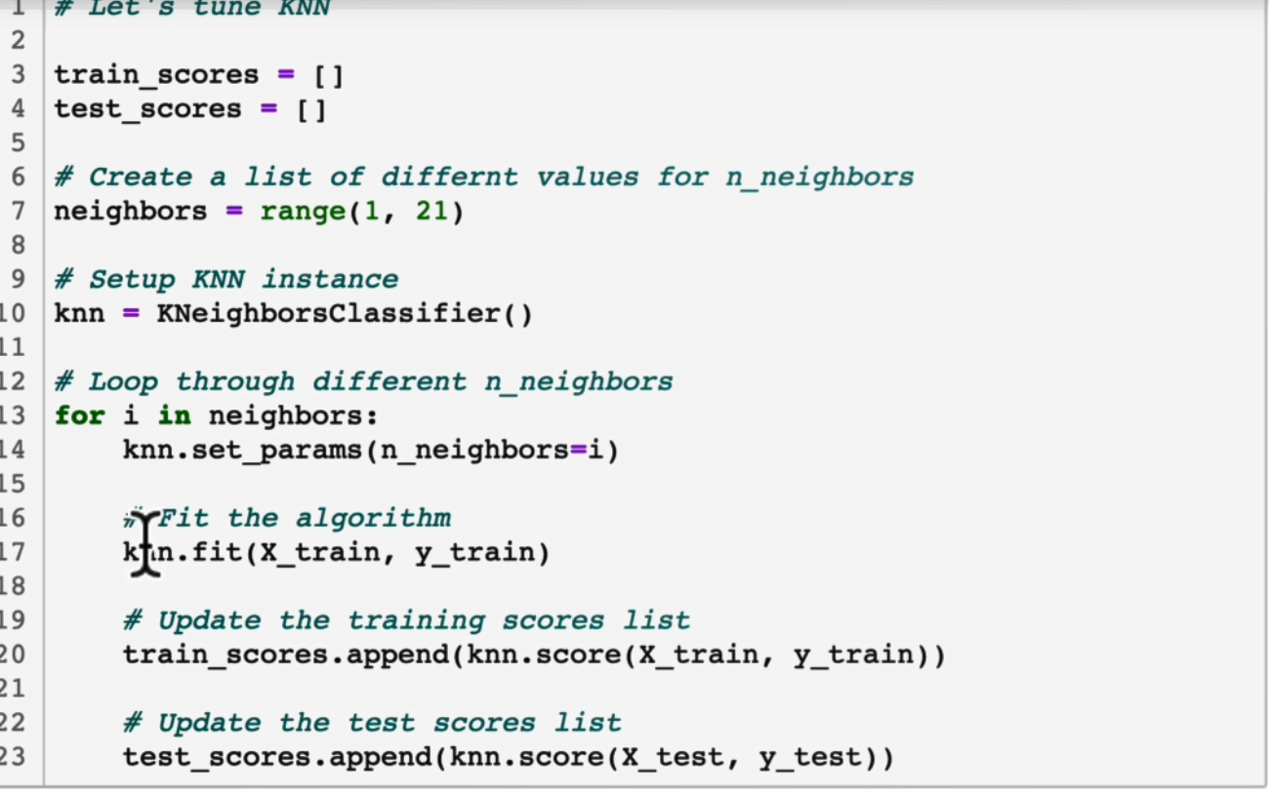

Code for plotting it:

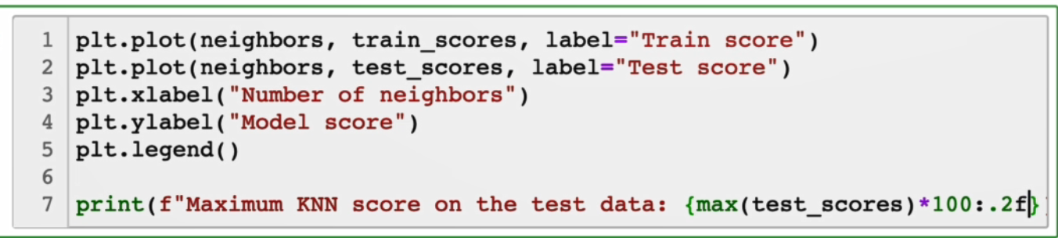

Coef tells the correlation directly we can reduce labels using this:

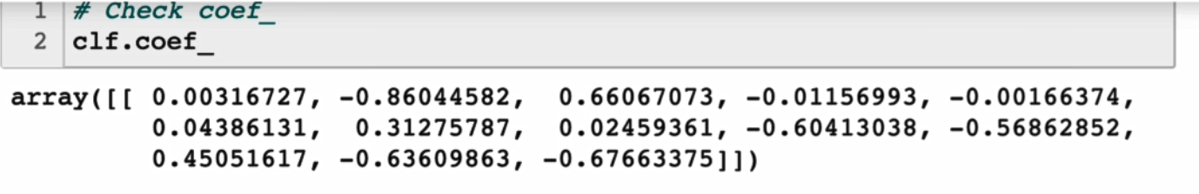

Attribute information:

