**Heart Disease Prediction Project**

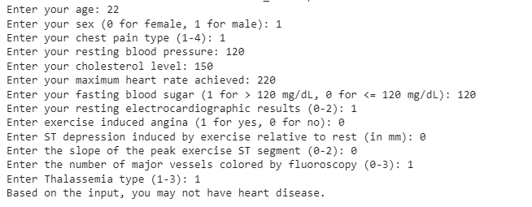

**Overview**

This project is aimed at developing a machine learning model to predict heart disease based on a set of input features. It utilizes a dataset containing various medical parameters and outcomes to build and evaluate the predictive model.

**Table of Contents**

* [Project Description](https://chat.openai.com/c/24fa6aa4-b996-491d-805d-5c791968f041#project-description)
* [Dataset](https://chat.openai.com/c/24fa6aa4-b996-491d-805d-5c791968f041#dataset)
* [Installation](https://chat.openai.com/c/24fa6aa4-b996-491d-805d-5c791968f041#installation)
* [Usage](https://chat.openai.com/c/24fa6aa4-b996-491d-805d-5c791968f041#usage)
* [Contributing](https://chat.openai.com/c/24fa6aa4-b996-491d-805d-5c791968f041#contributing)
* [License](https://chat.openai.com/c/24fa6aa4-b996-491d-805d-5c791968f041#license)

**Project Description**

In this project, we have developed a predictive model for heart disease using machine learning techniques. The model is trained on a dataset consisting of various attributes such as age, sex, cholesterol levels, and more. It aims to predict the likelihood of a patient having heart disease based on these parameters.

**Dataset**

We used the following dataset for this project:

* [Dataset Name](link to dataset if available)

Please make sure to download the dataset and place it in the appropriate directory before running the Jupyter Notebook.

**Installation**

To run this project locally, follow these steps:

1. Clone the repository to your local machine:

git clone https://github.com/ediction.gitgithub.com/yourusername/heart-disease-prediction.git

1. Navigate to the project directory:
2. Install the required dependencies:

ents.txt

**Usage**

To use this project, open the Jupyter Notebook file provided (**project.ipynb**) and follow the instructions within the notebook. It contains code for data preprocessing, model training, and evaluation.

1: Download ipynb file

2 : Download the heart disease data set

3: Replace the file link with your system

4: Run it

Give input according to provided images:

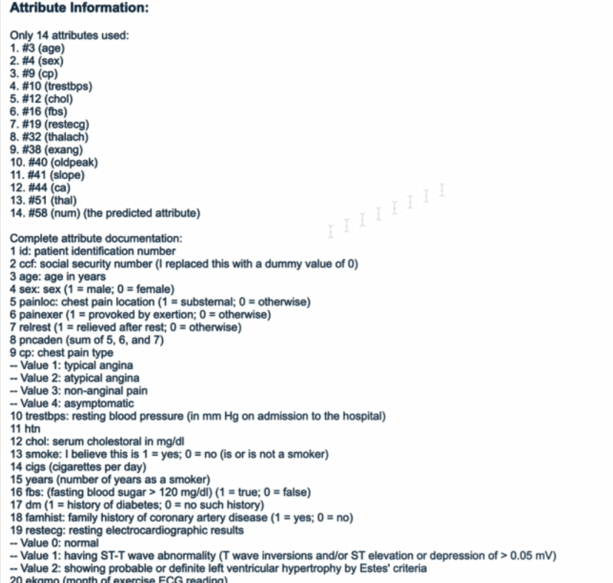

**Logo**



**Contributing**

If you want to contribute to this project, please fork the repository and create a pull request with your changes.

**License**

This project is licensed under the [MIT License](https://chat.openai.com/c/LICENSE).