TASK-5

* 1. **Print odd numbers in an array**

**Code:**

let arr = [1,2,3,4,5,6,7,8,9,10,11,12]

let odds = arr.filter(n => n%2)

console.log(odds)

Output:

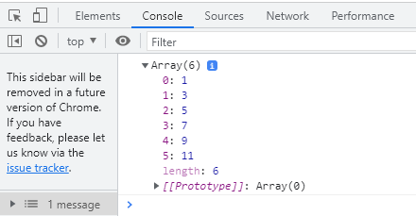

* 1. **Convert all the strings to title caps in a string array**

Code:

function gm() {

const arr = ["my", "name", "is", "panugothushiva"];

for (var i = 0; i <= arr.length; i++) {

const my=arr[i][0].toUpperCase() + arr[i].substr(1);

console.log(my)

}

} gm();

Output:

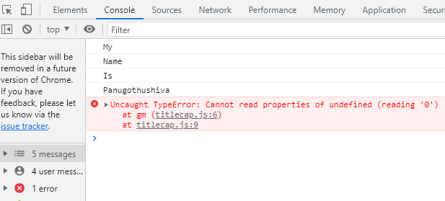

* 1. **Sum of all numbers in an array**

***Code;***

function allsum() {

let arr=[10,201,1010]

console.log(arr.reduce((current,sum)=>sum+current,0)

)}

allsum();

**Output:**

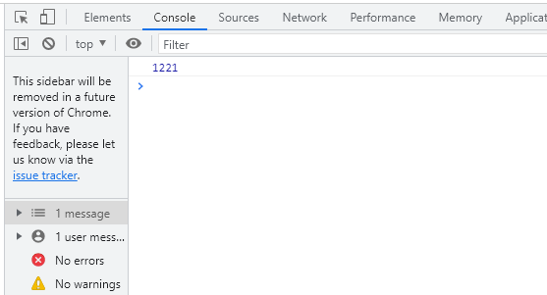

**d.Return all the prime numbers in an array**

**Code:**

function prime(){

let numbers=[10,79,90,7808,90]

for(var val of numbers){

if(val%2===0){

console.log("prime number:",val)

}

}

}

prime();

Output:

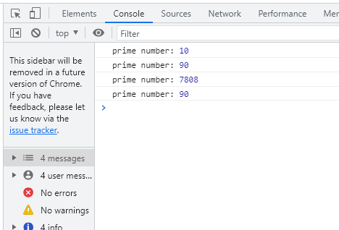

**e.Return all the palindromes in an array**

**CODE:**

let palindromes = function (arr)

{ let arr1 = [];

for (let i in arr) {

if (arr[i].split("").reverse().join("") === arr[i].split("").join(""))

{ arr1.push(arr[i]); } } return arr1; };

console.log(palindromes(["palap", "malam", "lavish", "nayan", "aya"]));

**OUTPUT:**

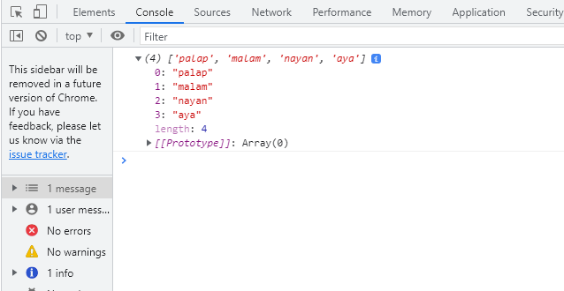

**F.Return median of two sorted arrays of same size**

**Code:**

function sum(){

var a1=[1,3,5,7]

var a2=[2,4,6,8]

let sum=a1.concat(a2)

var sum1=sum.sort()

if(sum1.length%2===0){

const first=[sum1.length/2-1]

const second=[sum1.length/2]

console.log((first+second)/2)

}

}

sum();

**Output**

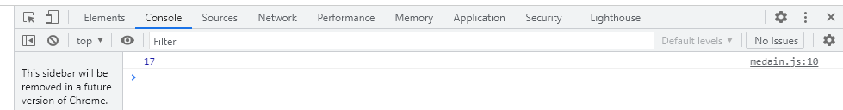

* 1. Remove duplicates from an array

**Code:**

let city = [

1,2,3,4,4,2,5,6,7

]

let unique_city = [new Set(city)];

console.log(unique_city);

**Output**

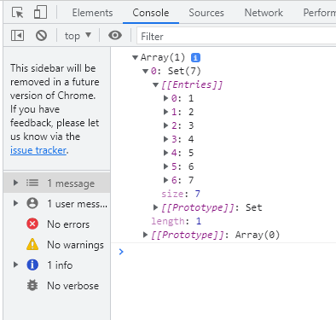

* 1. Rotate an array by k times

**Code:**

function rotate(){

var arr=[1,3,4,5,6,8]

let k=4;

k=k%arr.length;

for(i=0;i<arr.length;i++){

if(i<k){

console.log(arr[arr.length+i-k]+" ");

}

else{

console.log((arr[i-k])+" ")

}

}}

rotate();

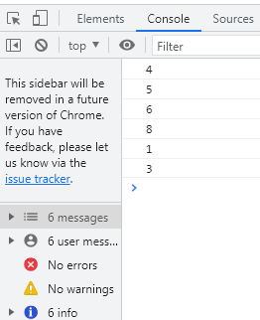

3.

* 1. **Print odd numbers in an array**

**Code:**

let arr=[13,45,67,43,2,8]

let prime=arr.filter((n) => {

for( var i=0;i<=arr.length;i++ ){

if(n%2 === 0)return false;

}

return true;

});

console.log(prime)

**Output:**

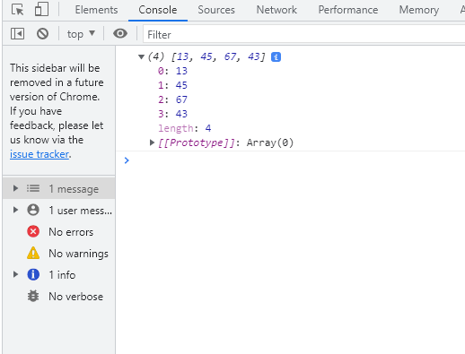

**b.Convert all the strings to title caps in a string array**

Code:

function titleCase(str) {

return str.toLowerCase().replace(/\b(\w)/g, s => s.toUpperCase());

}

console.log(titleCase('iron man')

console.log(titleCase('iNcrEdible hulK'));

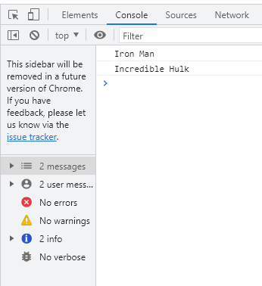

c.Sum of all numbers in an array

let arr=[3,5,6,700]

let sum=arr.reduce((curr,sum) => curr+sum,0)

console.log(sum)

Output:

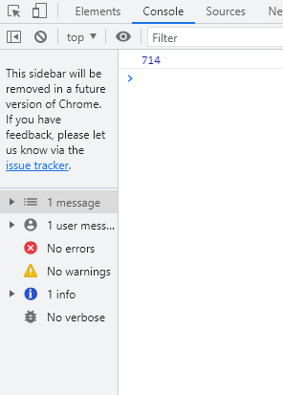

**d,Return all the prime numbers in an array**

let arr=[13,45,67,43,2,8]

let prime=arr.filter((n) => {

for( var i=0;i<=arr.length;i++ ){

if(n%2 === 0)return false;

}

return true;

});

console.log(prime)

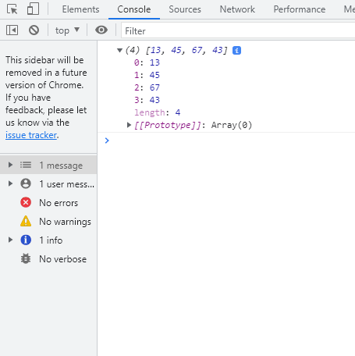

* 1. Return all the palindromes in an array

**Code**

let palindromes = function (arr)

{ let arr1 = [];

for (let i in arr) {

if (arr[i].split("").reverse().join("") === arr[i].split("").join(""))

{ arr1.push(arr[i]); } } return arr1; };

console.log(palindromes(["mam", "vafaf", "dad", "hdgdg", "aya"]));

output: