Correlation Power Analysis (CPA) Attack
Recovering the 128-bit AES Master Key from Power Traces
Side-Channel Analysis • CTF Walkthrough & Submission
Recovered Key Flag{2b7e151628aed2a6abf7158809cf4f3c}
Team: ____________________ Date: ____________

1. Objective
We are given 30,000 power traces captured from a hardware AES-128 engine running with an unknown 128-bit key K. Each trace records 150 sample points of instantaneous power consumption, together with the plaintext fed in and the ciphertext produced. The goal is to recover all 16 bytes of K using a Correlation Power Analysis (CPA) attack.
CPA is the modern, correlation-based refinement of Paul Kocher’s original power-analysis attacks (DPA, 1999). Where Kocher’s Differential Power Analysis partitions traces by a single predicted bit, CPA models the full instantaneous leakage with a continuous power model (Hamming weight / Hamming distance) and ranks every key hypothesis by its Pearson correlation against the measured traces. It is the method used here.

2. Dataset
- Column 0 — Plaintext (32 hex chars / 16 bytes).
- Column 1 — Ciphertext (32 hex chars / 16 bytes).
- Columns 2…151 — 150 power-trace samples (integers).
Rows: 30,000. Note that the plaintext of each row equals the ciphertext of the previous row (the cipher is chained), which is irrelevant to the attack — CPA only needs the known plaintext/ciphertext of each individual encryption.

3. Attack Principle
CPA exploits the fact that the power a CMOS circuit draws at an instant correlates with the number of bits flipping in a register (its Hamming distance), or with the Hamming weight of the value being processed. The attack proceeds byte-by-byte against a value that depends on (i) a known plaintext/ciphertext byte and (ii) one unknown key byte — only 256 possibilities.
- For a target key byte, compute a hypothetical intermediate value for all 256 key guesses and every trace.
- Map each value to a predicted power figure with a leakage model (Hamming weight or Hamming distance).
- Compute the Pearson correlation between the 256 prediction columns and each of the 150 trace columns.
- The guess whose prediction shows the single highest |correlation| at any sample is the correct key byte.
Pearson correlation (vectorised over all 256 guesses g and 150 samples t):
r(g, t) = Σ (H_g - mean H_g)(T_t - mean T_t)
———————————————————————————————————————
√[ Σ(H_g - mean H_g)² · Σ(T_t - mean T_t)² ]
H = hypothetical power (model) T = measured trace samples

4. Choosing the Leakage Model (the key step)
The textbook first attempt models the first-round S-box output, HW(Sbox(PT ⊕ k)). On these traces that model produces only noise — the best correlation (≈ 0.022) is no higher than that of random hypotheses. The implementation is clearly a hardware round-based core, so the register leaks the Hamming distance of the state as it updates, and the most observable transition is the final one that produces the ciphertext.
Last-round model. AES’s final round has no MixColumns: C = AddRoundKey(ShiftRows(SubBytes(state₉))). Inverting one byte gives the round-9 state byte InvSbox(C[i] ⊕ K10[i]). The register cell at that position transitions to a ciphertext byte, so the leakage is a Hamming distance between the two.
The ShiftRows subtlety. Modelling that distance as HW(InvSbox(C[i]⊕k) ⊕ C[i]) only worked for the four row-0 bytes (0, 4, 8, 12), because ShiftRows leaves row 0 in place. For the other rows the cell that holds InvSbox(C[i]⊕k) ends up paired with a different ciphertext byte after ShiftRows. Pairing each byte with its ShiftRows partner g(i) makes all 16 bytes leak strongly at the same clock cycle:
leakage(i) = HW( InvSbox(C[i] ⊕ k) ⊕ C[g(i)] )
where g(i) = row + 4·((col + row) mod 4), row = i mod 4, col = i div 4
g = [0,5,10,15, 4,9,14,3, 8,13,2,7, 12,1,6,11]
With this model every key byte’s correct guess is a clear outlier, and all 16 peaks land on the same sample (≈ 60–61) — the signature of one parallel hardware round.
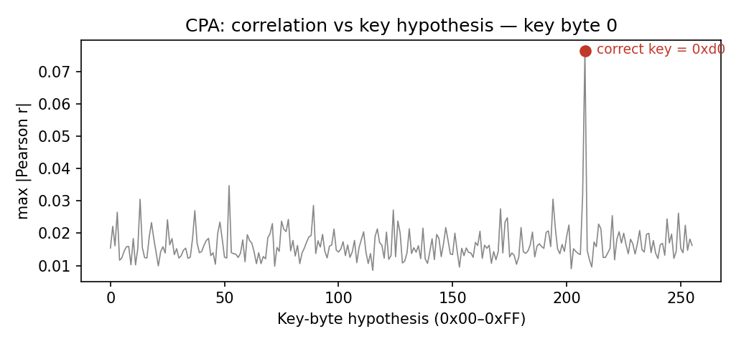
Figure 1. Key byte 0: maximum |correlation| for each of the 256 hypotheses. The correct value 0xD0 stands clearly above all others.
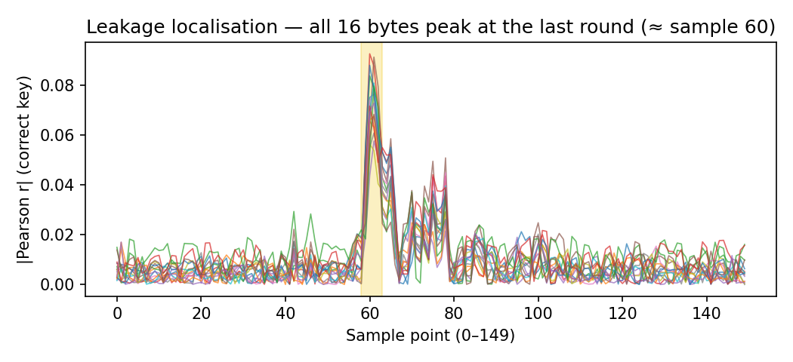
Figure 2. Correlation of the correct guess versus sample index for all 16 bytes. Every byte peaks inside the highlighted last-round window (≈ sample 60).

5. Per-Byte Recovery Results
Running the CPA across all 30,000 traces recovers the round-10 key one byte at a time. The table lists, for each byte, the winning key value, its peak absolute correlation, the sample at which it peaks, and the margin over the second-best guess (a clear positive margin confirms a unique, unambiguous winner).
Byte | Key (hex) | Peak |r| | Leak sample | Margin
0 | D0 | 0.0763 | 61 | 0.0416
1 | 14 | 0.0655 | 60 | 0.0384
2 | F9 | 0.0836 | 60 | 0.0607
3 | A8 | 0.0925 | 60 | 0.0676
4 | C9 | 0.0575 | 61 | 0.0297
5 | EE | 0.0911 | 61 | 0.0683
6 | 25 | 0.0774 | 61 | 0.0548
7 | 89 | 0.0607 | 61 | 0.0343
8 | E1 | 0.0563 | 60 | 0.0324
9 | 3F | 0.0808 | 61 | 0.0518
10 | 0C | 0.0879 | 60 | 0.0652
11 | C8 | 0.0675 | 61 | 0.0440
12 | B6 | 0.0796 | 61 | 0.0515
13 | 63 | 0.0715 | 60 | 0.0479
14 | 0C | 0.0728 | 61 | 0.0489
15 | A6 | 0.0682 | 61 | 0.0445
Round-10 key D0 14 F9 A8 C9 EE 25 89 E1 3F 0C C8 B6 63 0C A6

6. From Round-10 Key to Master Key
CPA recovers the last round key (K10), not K directly. Because the AES-128 key schedule is fully invertible, we run it backwards to obtain the round-0 key, which is the master key. For each word index i from 43 down to 4:
W[i-4] = W[i] ⊕ ( (i mod 4 == 0) ? SubWord(RotWord(W[i-1])) ⊕ Rcon[i/4-1]
: W[i-1] )
master key K = W[0] || W[1] || W[2] || W[3]
Master key K = 2b7e151628aed2a6abf7158809cf4f3c

7. Verification
The recovered key is confirmed independently of the side channel: encrypting each captured plaintext under K with a reference AES-128 reproduces the captured ciphertext exactly.
- 2000 / 2000 plaintext → ciphertext pairs matched (100%).
- AES(00…00, K) = 7df76b0c1ab899b33e42f047b91b546f — matches row 1 of the dataset.
Final flag: Flag{2b7e151628aed2a6abf7158809cf4f3c}

8. Reproducing the Attack
The complete attack is implemented in cpa_attack.py (included). It loads the CSV, runs the last-round Hamming-distance CPA for all 16 bytes, inverts the key schedule, and verifies the result. Requires only Python 3 and NumPy.
$ python3 cpa_attack.py traces_AES_2026.csv
...
Round-10 key : d014f9a8c9ee2589e13f0cc8b6630ca6
Master key K : 2b7e151628aed2a6abf7158809cf4f3c
Verification : 2000/2000 plaintext->ciphertext pairs match
FLAG: Flag{2b7e151628aed2a6abf7158809cf4f3c}

