CAMPUSFIX
A Role-Based College Complaint and
Maintenance Management System
Final Project Report
Fourth-Year CSE Mini Project
Student Name: [Student Name]
Roll Number: [Roll Number]
Guide Name: [Faculty Guide Name]
Academic Session: 2026-27
Department of Computer Science and Engineering

Certificate and Declaration
This page is intentionally provided for institution-approved certificate and declaration text.
Certified that the project titled CampusFix: A Role-Based College Complaint and Maintenance Management System is the original work of [Student Name], Roll Number [Roll Number], completed under the guidance of [Faculty Guide Name] during the academic session 2026-27.
Student signature: ____________________ Guide signature: ____________________

Acknowledgement
I express my sincere gratitude to [Faculty Guide Name], the Department of Computer Science and Engineering, and all faculty members who supported this mini project. I also thank the students and maintenance personnel whose practical needs informed the role and workflow design. Any remaining errors are my responsibility.

Abstract
CampusFix is a local web application for registering, assigning, tracking, resolving, and reviewing college maintenance complaints. It replaces informal reporting through verbal messages or disconnected channels with a role-based workflow for Students, Maintenance Staff, and Administrators. The completed Django application provides secure authentication, complaint tickets, validated image evidence, controlled status transitions, permanent history, notifications, feedback, priority scoring, analytics, filtered reporting, CSV exports, and print views. The implementation uses Python, Django 6.1.1, SQLite, Bootstrap, Chart.js, and Pillow. Verification at the end of Batch 6 comprised 84 passing automated tests, a clean Django system check, no missing migrations, static-file collection, and live HTTP role checks. The project demonstrates how a small, maintainable monolithic architecture can provide accountability and operational visibility without requiring cloud services.

Table of Contents
1.1 Background 6
1.2 Problem Statement 7
1.3 Need for the System 7
1.4 Objectives 7
1.5 Scope 7
1.6 Limitations 7
2.1 Related Concepts 8
2.2 Comparative Review 8
2.3 Literature Review Findings 8
3.1 Functional Requirements 8
3.2 Non-functional Requirements 9
3.3 User Roles and Permissions 9
3.4 Use Cases 10
4.1 Overall Architecture 10
4.2 Role and Workflow Design 11
4.3 Database Design 11
4.4 Priority Scoring 12
4.5 Security and Privacy 12
5.1 Technology Stack 13
5.2 Authentication and Authorisation 13
5.3 Complaint Submission and Images 13
5.4 Workflow and Timeline 14
5.5 Notifications and Feedback 15
5.6 Analytics and Reporting 15
6.1 Testing Approach 18
6.2 Automated Evidence 18
6.3 Working Demonstration Evidence 19
6.4 Key Results 23
7.1 Conclusion 23
7.2 Future Scope 23

List of Figures
Figure 1. CampusFix architecture
Figure 2. Role-based permissions
Figure 3. Complaint lifecycle
Figure 4. Entity relationship overview
Figure 5. Priority scoring method
Figure 6. Public landing page
Figure 7. Student dashboard
Figure 8. Complaint submission form
Figure 9. Student ticket timeline
Figure 10. Maintenance Staff queue
Figure 11. Administrator workflow controls
Figure 12. Analytics dashboard
Figure 13. Reports and exports
Figure 14. Permission-denied page

List of Tables
Table 1. Project objectives
Table 2. Literature comparison
Table 3. Functional requirements
Table 4. Role permissions
Table 5. Data entities
Table 6. Technology stack
Table 7. Test evidence
Table 8. Important routes
Table 9. Priority scoring table

Chapter 1 Introduction

1.1 Background
College maintenance requests often begin as conversations, calls, or messages. These channels are easy to start but difficult to audit: reports may lack a location or evidence, assignments are unclear, and students cannot see whether work has progressed. CampusFix models the full maintenance request as a permanent ticket shared through controlled role-specific views.

1.2 Problem Statement
The problem is the absence of one accountable process connecting the person who reports an issue, the administrator who reviews it, and the staff member who performs the work. A useful solution must preserve the ticket history, prevent unauthorised actions, communicate updates, and give administrators evidence for workload and service review.

1.3 Need for the System
- A unique ticket prevents a complaint from disappearing in informal communication.
- Role-specific queues clarify responsibility and reduce accidental disclosure.
- A permanent timeline records what changed, when, and by whom.
- Priority scoring makes urgency visible while keeping the rule understandable.
- Analytics, feedback, and reports turn operational records into review evidence.

1.4 Objectives
Objective | Implemented evidence
Central complaint record | Ticket number, category, location, description, urgency, optional evidence
Controlled responsibilities | Student, Maintenance Staff, and Administrator permissions
Traceable workflow | Seven statuses and permanent ComplaintHistory events
Timely awareness | Private in-app notifications and unread counts
Decision support | Priority score, analytics, reports, CSV and print output
Quality assurance | 84 automated tests plus live HTTP checks

1.5 Scope
The accepted scope is a local, responsive college maintenance application. Public registration creates Students only. Administrators manage workflow and reports; Maintenance Staff act only on assigned work; Students see only their own complaints. The system is designed for demonstration and academic evaluation, not public production deployment.

1.6 Limitations
- SQLite and local media storage suit a single-machine demonstration, not a highly concurrent deployment.
- Notifications are in-app only; email and SMS are future work.
- Priority is deterministic and rule-based, not predictive machine learning.
- The project has no mobile application, multilingual interface, cloud hosting, or production monitoring.
- The print view intentionally limits browser rendering to 500 complaints; CSV exports include all matching records.

Chapter 2 Literature Review

2.1 Related Concepts
The design was informed by established ideas rather than copied from one product. NIST role-based access control associates permissions with roles instead of assigning each permission separately to each user [1]. Django provides authentication, authorisation, password handling, CSRF protection, parameterised ORM queries, and clickjacking middleware [2][3]. Jira describes work tracking through defined statuses and one-direction transitions [4]. SQLite provides a self-contained, serverless transactional database appropriate for a compact local application [5]. Chart.js renders browser charts but requires accessible names or text alternatives, which CampusFix supplements with tables [6]. OWASP documents formula injection when untrusted CSV cells begin with formula characters [7].

2.2 Comparative Review
Source / approach | Useful idea | CampusFix adaptation
NIST RBAC [1] | Permissions through assigned roles | Three explicit application roles with server-side checks
Django authentication [2] | Integrated users, sessions, passwords | Custom user model and role-specific dashboard router
Django security [3] | CSRF, query parameterisation, clickjacking defence | Middleware plus CSRF on every state-changing form
Jira workflows [4] | Statuses, transitions, assignee, auditability | Restricted complaint lifecycle and permanent history
SQLite [5] | Zero-configuration embedded SQL | Single local database for academic deployment
Chart.js [6] | Responsive canvas charts | Administrator charts with adjacent data tables
OWASP CSV Injection [7] | Spreadsheet formulas can execute untrusted text | Prefix formula-leading exported cells with an apostrophe
Bootstrap [8] | Responsive grid and accessible components | Consistent mobile-friendly interface

2.3 Literature Review Findings
The review suggests that a complaint system needs more than a submission form. Accountability depends on explicit roles, constrained transitions, a durable audit trail, and evidence that users can understand. CampusFix therefore combines a helpdesk-style ticket with role gates, a lifecycle service, private notifications, and reports. It remains intentionally smaller than enterprise service-management tools and is tailored to one college demonstration.

Chapter 3 Requirements and Analysis

3.1 Functional Requirements
ID | Requirement | Result
FR-01 | Student registration, login, logout, profile and password change | Implemented
FR-02 | Submit complaint with category, location, urgency and optional image | Implemented
FR-03 | Student-only ownership view with search and filters | Implemented
FR-04 | Administrator review, assignment, reassignment, rejection and closure | Implemented
FR-05 | Assigned Staff start and resolve workflow | Implemented
FR-06 | Permanent timeline and private notifications | Implemented
FR-07 | One feedback response for a resolved or closed complaint | Implemented
FR-08 | Priority, analytics, reports, CSV and print views | Implemented

3.2 Non-functional Requirements
- Security: server-side role and ownership enforcement, CSRF protection, safe local redirects, password validation, and validated image content.
- Usability: responsive layout, readable status and priority indicators, clear empty states, keyboard focus visibility, and branded errors.
- Integrity: workflow transitions are centralised and history entries are permanent.
- Performance: paginated lists and related-object loading limit page size and database queries.
- Maintainability: one Django project with separate core, accounts, and complaints applications.
- Portability: pinned Python dependencies, SQLite, local media, and repeatable demo commands.

3.3 User Roles and Permissions
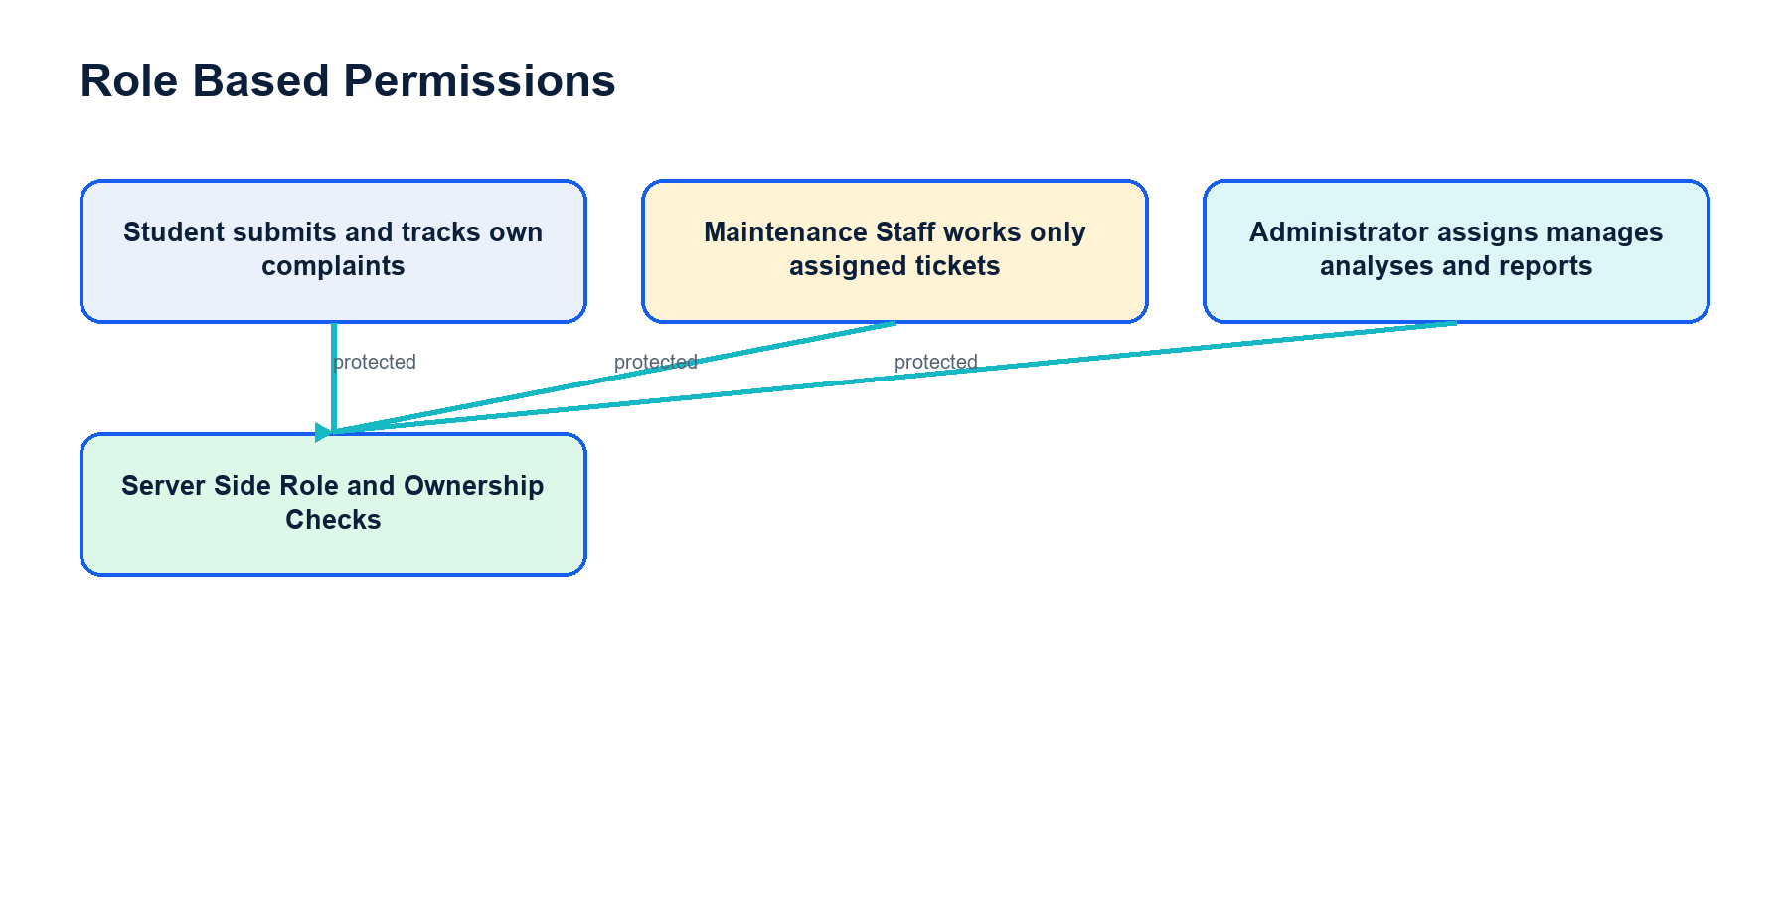
Figure 2. Role-based permissions
Capability | Student | Maintenance Staff | Administrator
Register publicly | Yes | No | No
Create complaint | Yes | No | No
View complaint | Own only | Assigned only | All
Change workflow | No | Start / resolve assigned | Review / assign / reject / close
Submit feedback | Own completed ticket | No | No
Analytics and reports | No | No | Yes

3.4 Use Cases
Primary use cases are: create a Student account; submit and track a complaint; review and assign a complaint; begin and resolve assigned work; close or reject a complaint; receive a private notification; submit feedback; filter analytics and reports; export filtered CSV files; and print a filtered report.

Chapter 4 System Design

4.1 Overall Architecture
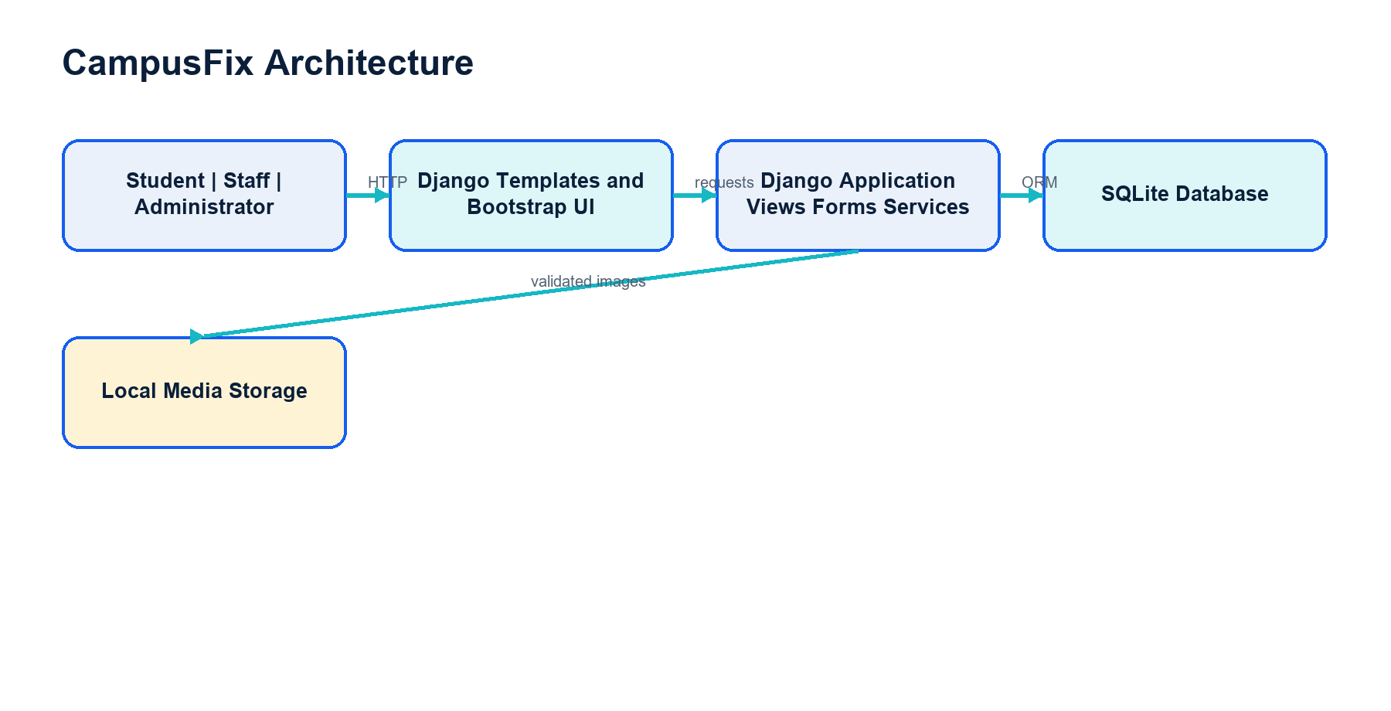
Figure 1. CampusFix architecture
The browser communicates with Django views rendered through templates. Forms validate input, decorators and service functions enforce access, the ORM stores structured records in SQLite, and validated evidence files are stored under the local media directory.

4.2 Role and Workflow Design
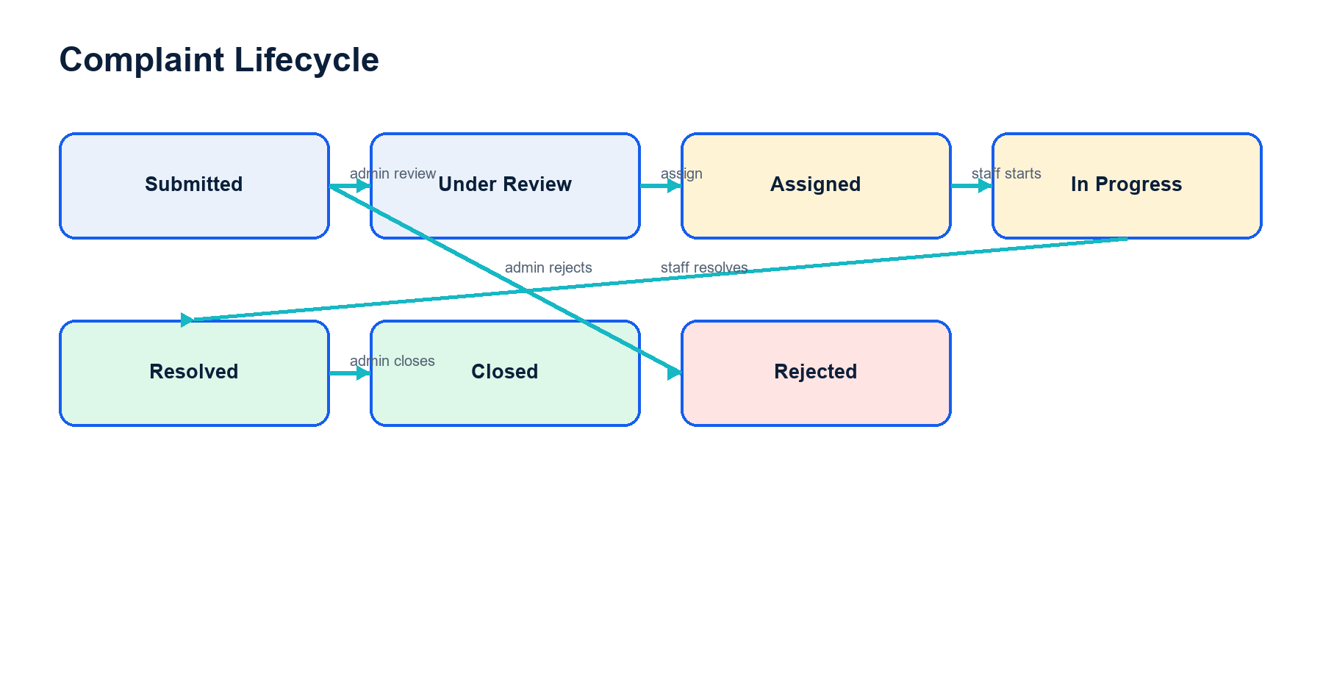
Figure 3. Complaint lifecycle
The normal path is Submitted to Under Review to Assigned to In Progress to Resolved to Closed. Administrators may assign directly from Submitted and may reject Submitted or Under Review complaints. Maintenance Staff cannot act on another staff member's assignment.

4.3 Database Design
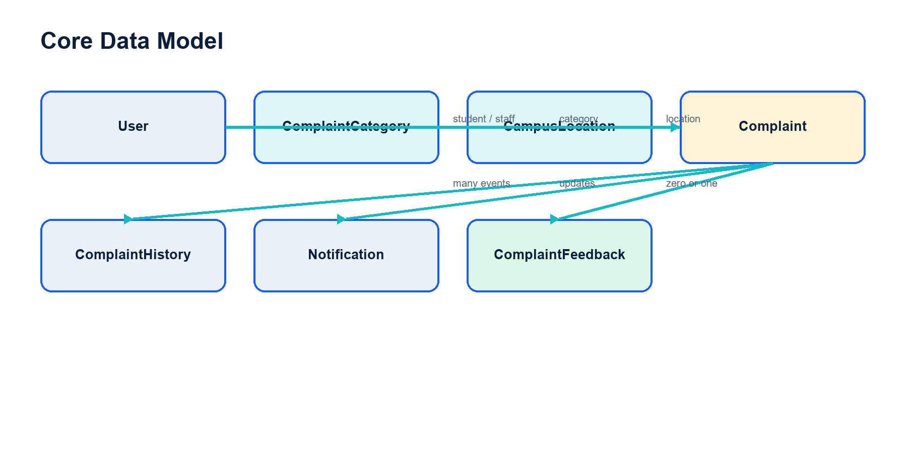
Figure 4. Entity relationship overview
Entity | Purpose | Key relationships
User | Authentication profile and role | Creates complaints; receives assignments and notifications
ComplaintCategory | Classification reference data | One category to many complaints
CampusLocation | Campus place reference data | One location to many complaints
Complaint | Central ticket and workflow state | Student, category, location, optional assigned Staff
ComplaintHistory | Permanent workflow event | Many events per complaint; optional actor
Notification | Private account update | Recipient and optional complaint destination
ComplaintFeedback | Student rating and comment | One-to-one with completed complaint

4.4 Priority Scoring
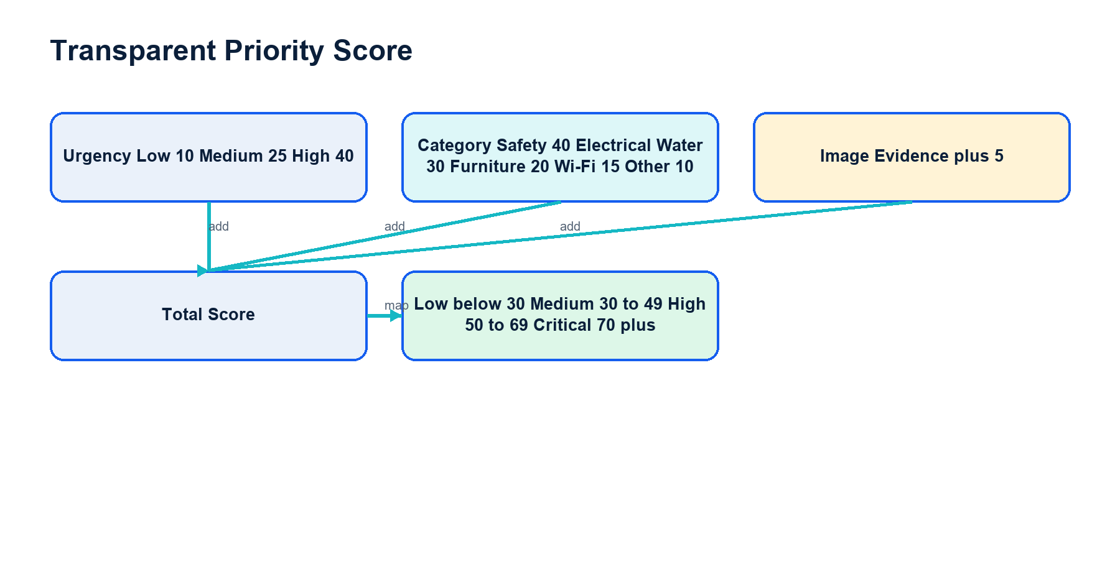
Figure 5. Priority scoring method
The exact score is urgency weight plus category weight plus five points when evidence is present. The explanation is saved with the complaint, making the decision inspectable instead of opaque.

4.5 Security and Privacy
- Every protected page checks authentication and the required CampusFix role on the server.
- Student ticket views verify ownership; Staff ticket views verify assignment.
- All state-changing forms use POST and Django CSRF tokens.
- Uploaded files are limited to 5 MB, decoded with Pillow, restricted to JPEG, PNG, or WebP, and renamed with random safe names.
- Reports do not export passwords, email addresses, phone numbers, or authentication data.
- CSV cells beginning with =, +, -, or @ are prefixed with an apostrophe before export.

Chapter 5 Implementation

5.1 Technology Stack
Technology | Version / use | Reason
Python | Application language | Readable ecosystem and strong Django support
Django | 6.1.1 | Authentication, ORM, forms, templates, testing and admin
SQLite | Local database | Zero-configuration single-file academic deployment
Bootstrap | 5.3.8 via CDN | Responsive navigation, forms and grid
Chart.js | 4.4.7 via CDN | Administrator analytics charts
Pillow | 11.3.0 | Decode and validate uploaded images

5.2 Authentication and Authorisation
CampusFix extends Django's AbstractUser with a STUDENT, STAFF, or ADMIN role and institutional profile fields. Public registration always assigns STUDENT regardless of submitted extra fields. A dashboard router sends authenticated users to the correct dashboard. A reusable role_required decorator returns a branded HTTP 403 page for cross-role access.

5.3 Complaint Submission and Images
The ComplaintForm exposes only student-controlled fields. The view assigns the logged-in Student and Submitted status. The model creates ticket numbers in the form CF-year-sequence. Image validation checks size, content, and detected format rather than trusting only the file extension.
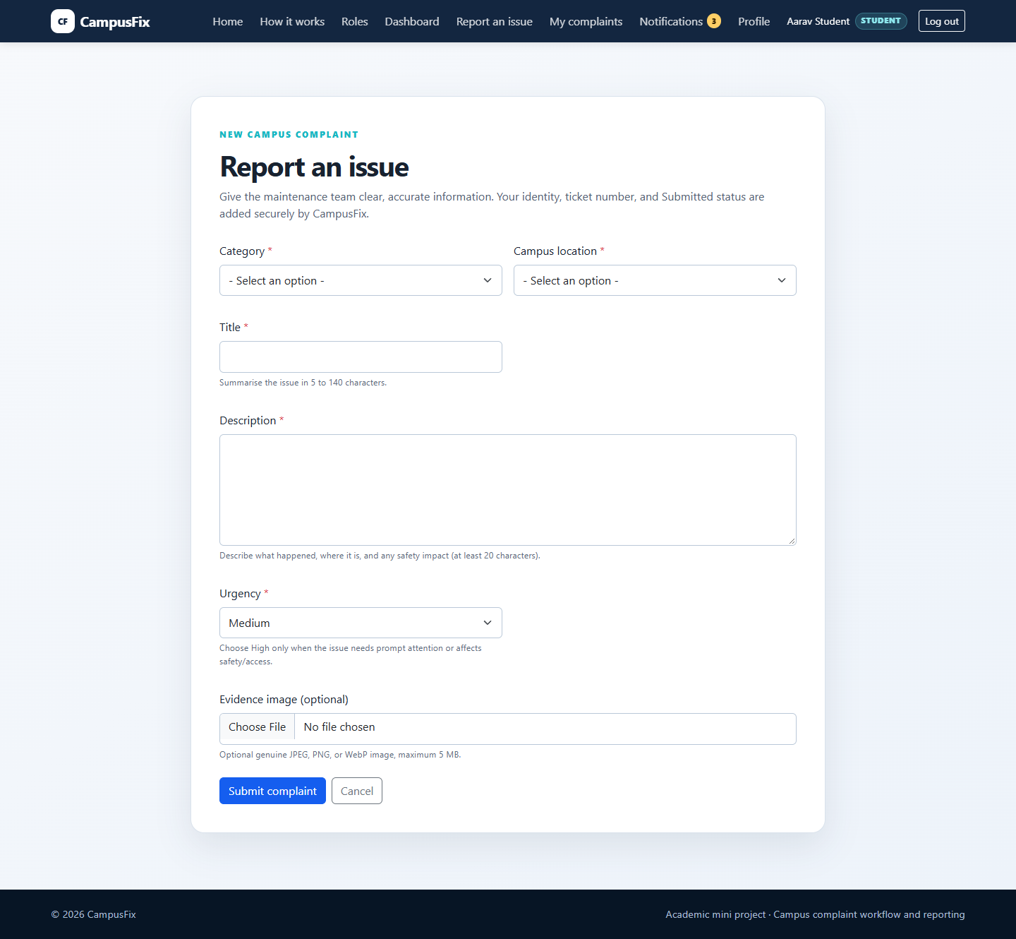
Figure 8. Student complaint submission form

5.4 Workflow and Timeline
Workflow rules are centralised in service functions using database transactions. Administrators and assigned Staff can perform only transitions valid for the current state. Each successful transition appends ComplaintHistory with previous status, new status, actor, note, and timestamp.
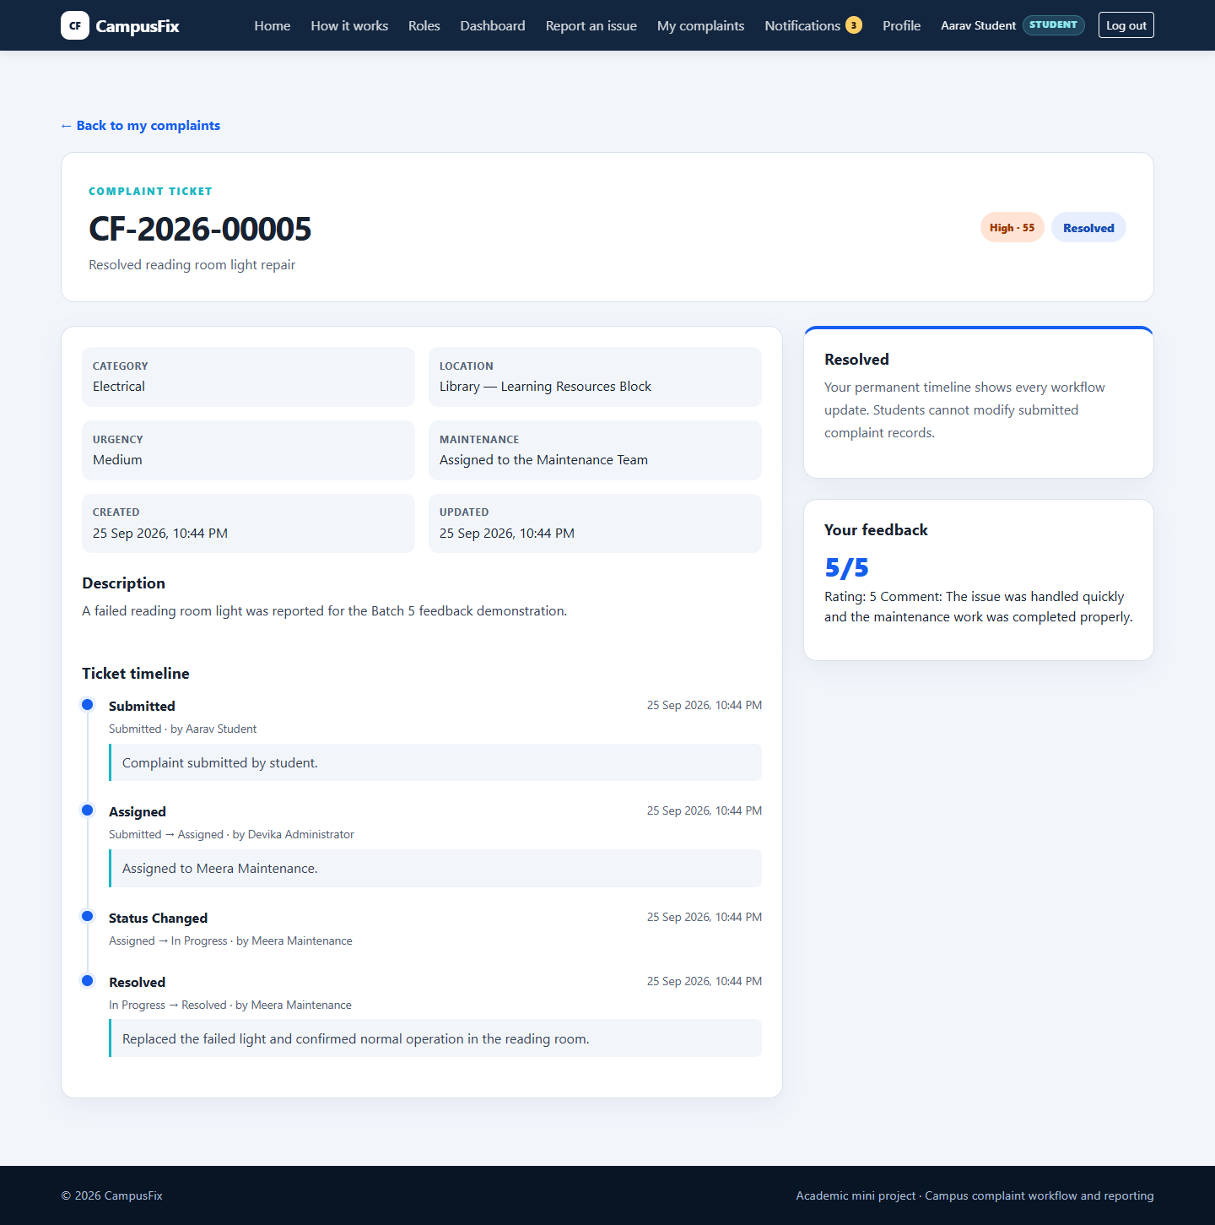
Figure 9. Student ticket detail with priority, feedback, and timeline

5.5 Notifications and Feedback
Notifications are written to specific recipients with deduplication keys. Users see unread counts, can open individual notifications, and can mark all as read through a CSRF-protected POST. A Student may submit one rating from 1 to 5 and an optional comment only after the complaint is Resolved or Closed.

5.6 Analytics and Reporting
Administrator analytics aggregate complaints by status, category, priority, urgency, and period. Reports add custom dates, staff and search filters, live totals, a workload table, feedback rows, pagination, three UTF-8 CSV downloads, and a print view. Related records are selected in the main query to avoid repeated per-row lookups.
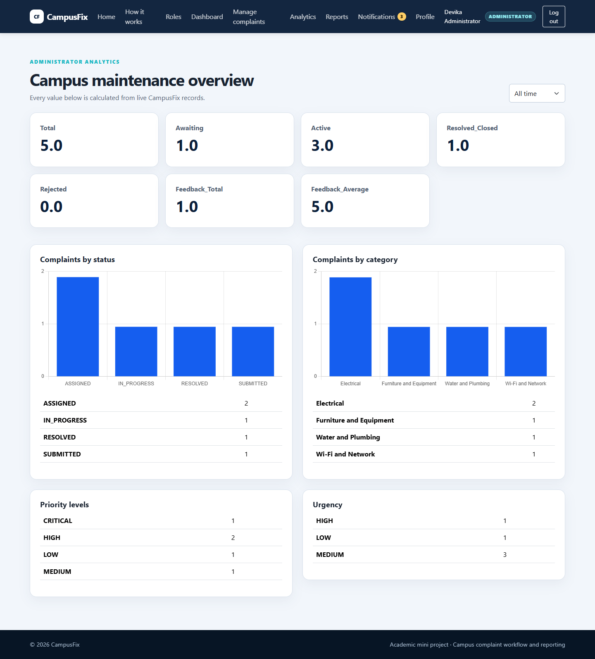
Figure 12. Administrator analytics with live charts
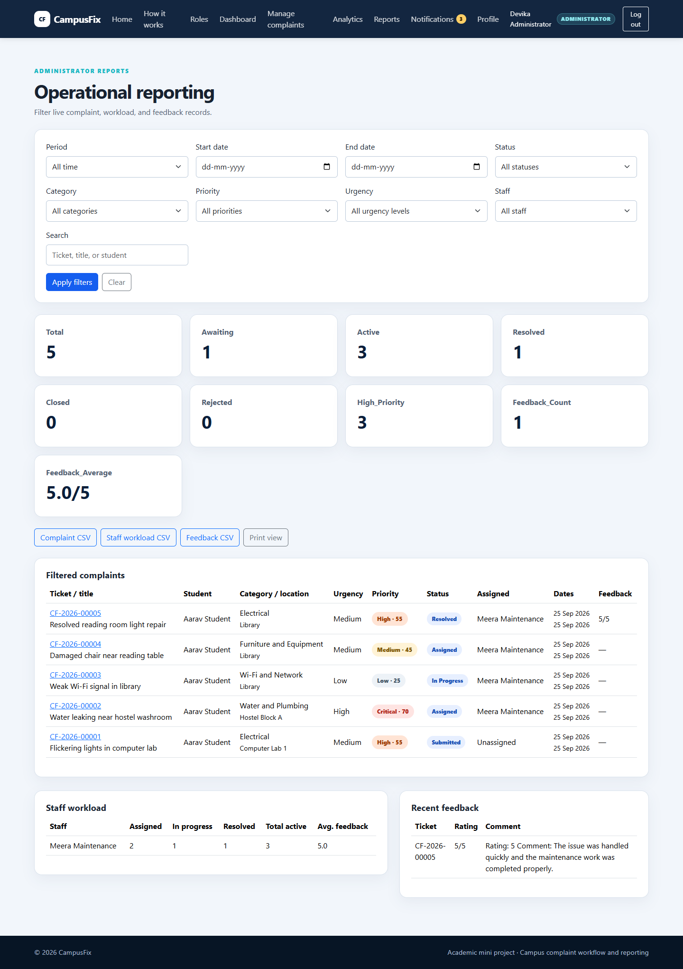
Figure 13. Administrator filtered reports and exports

Chapter 6 Testing and Results

6.1 Testing Approach
Testing combines unit tests for models and forms, permission tests for all roles, workflow service tests, page and ownership checks, demo-command idempotence tests, export-security tests, Django configuration checks, migration checks, static collection, and live HTTP smoke checks. Test data is created in an isolated temporary database.

6.2 Automated Evidence
Verification | Result
Django system check | 0 issues
Missing migration check | No changes detected
Database migration | No pending migrations
Static collection | Successful
Full automated suite | 84 tests passed in 131.552 seconds
Live report checks | Administrator 200; Student and Staff 403
CSV response checks | 200 with text/csv; charset=utf-8

6.3 Working Demonstration Evidence
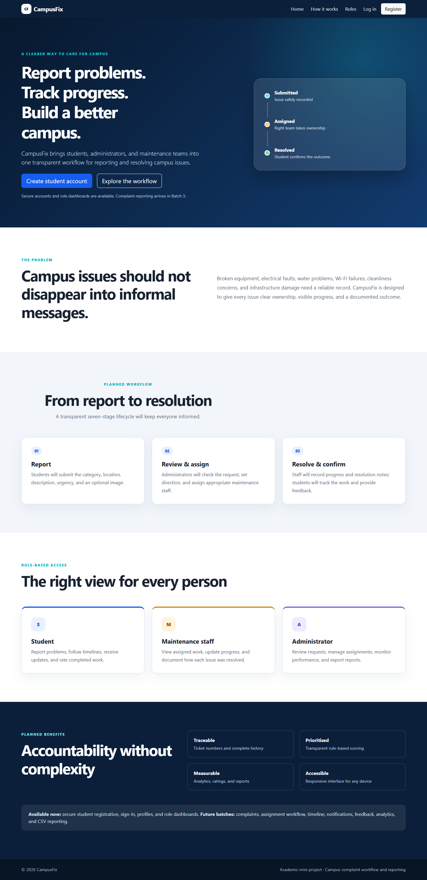
Figure 6. Public CampusFix landing page
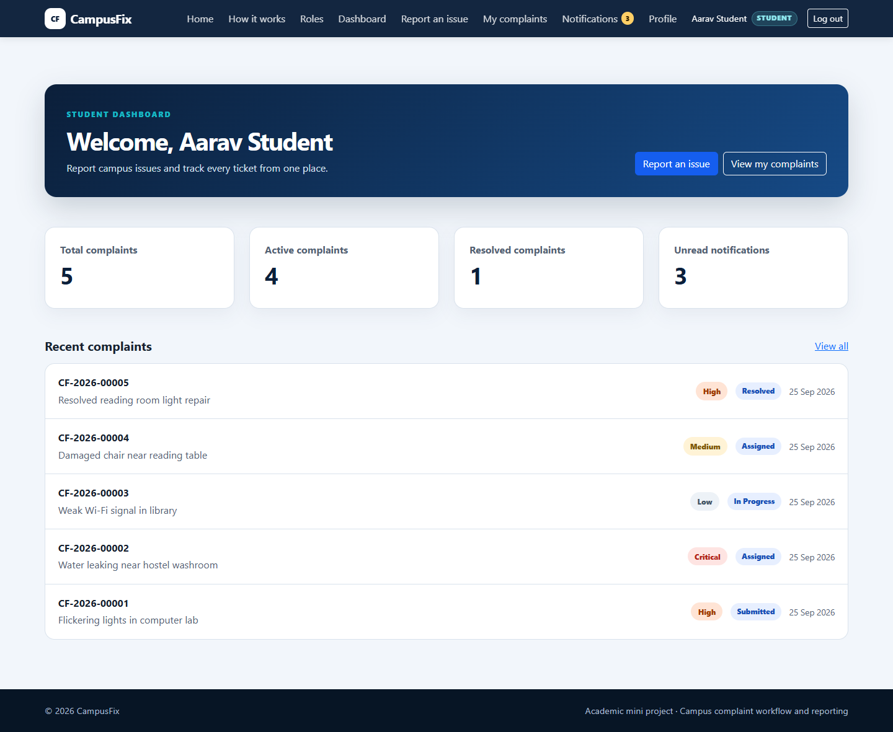
Figure 7. Student dashboard with live ticket counts
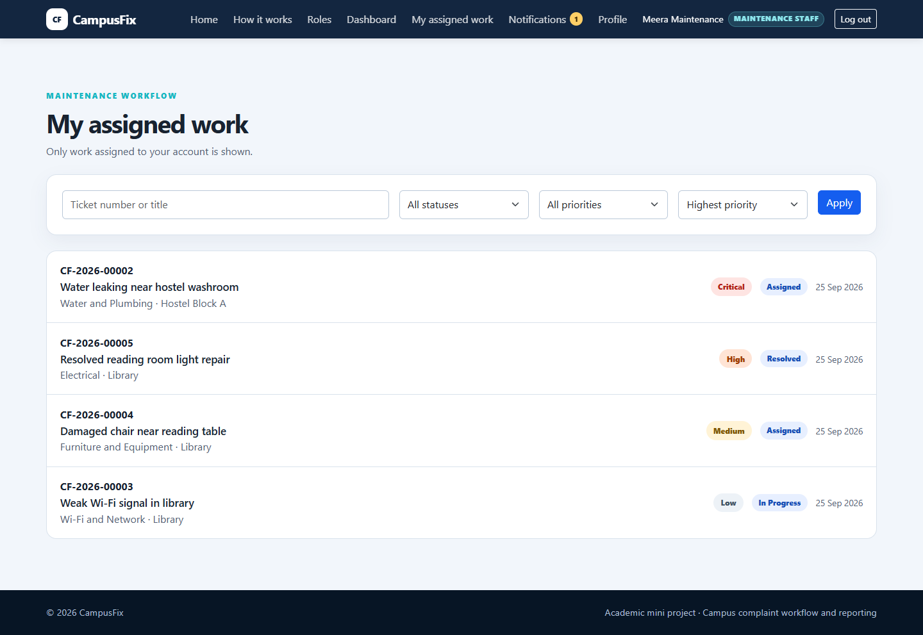
Figure 10. Maintenance Staff assigned-work queue
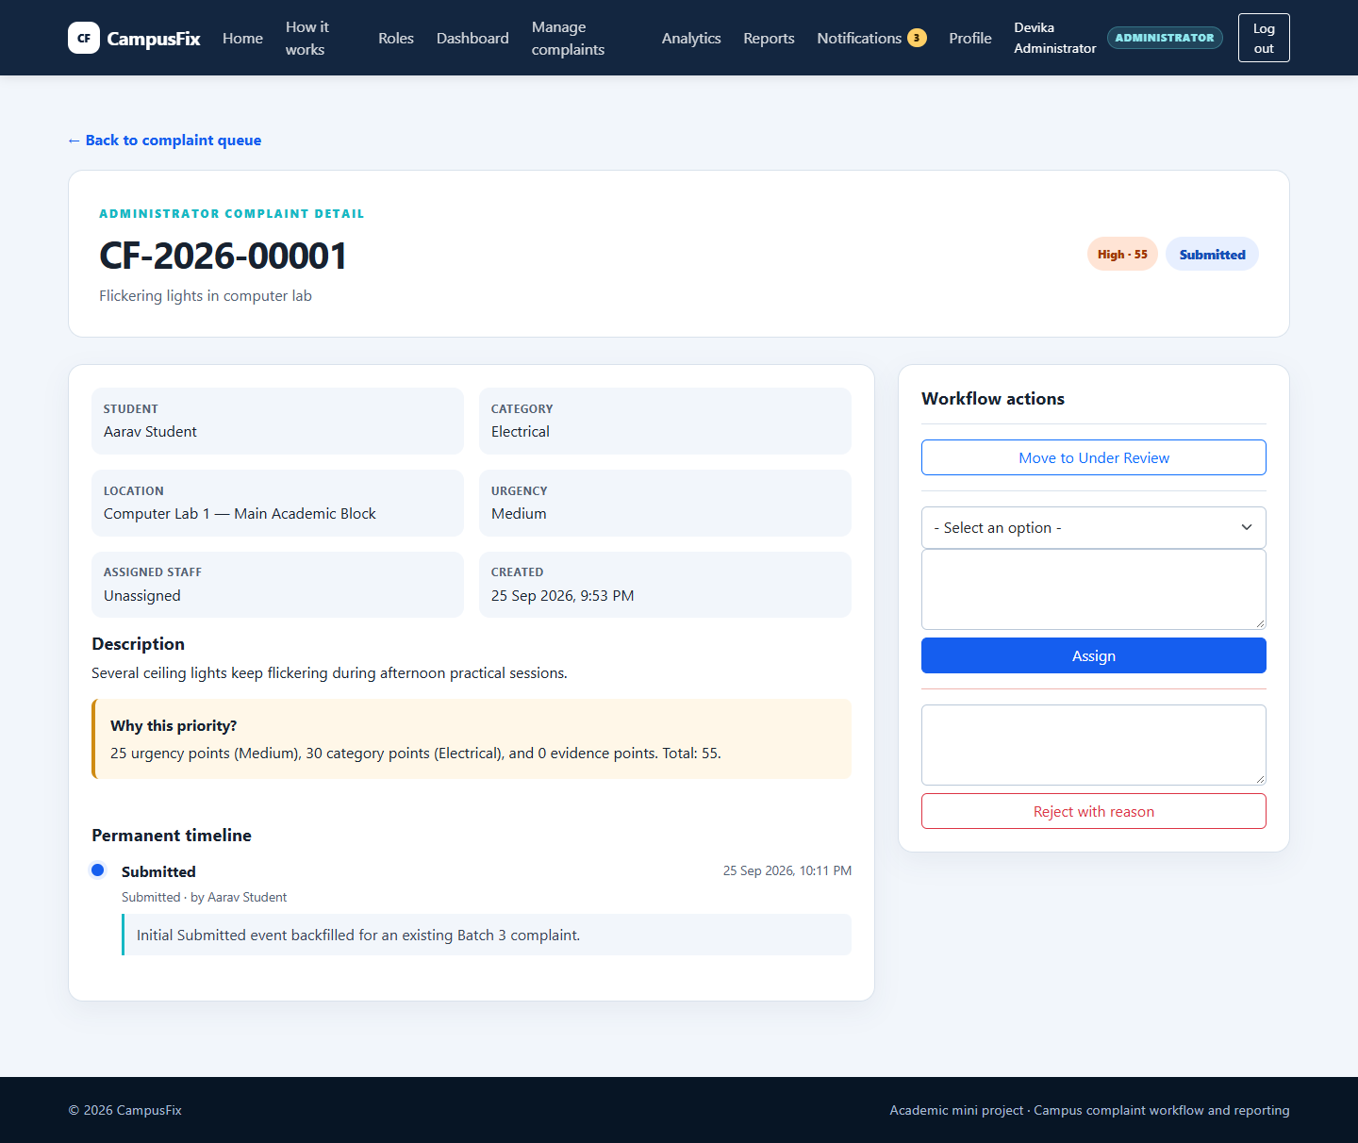
Figure 11. Administrator complaint detail and assignment controls
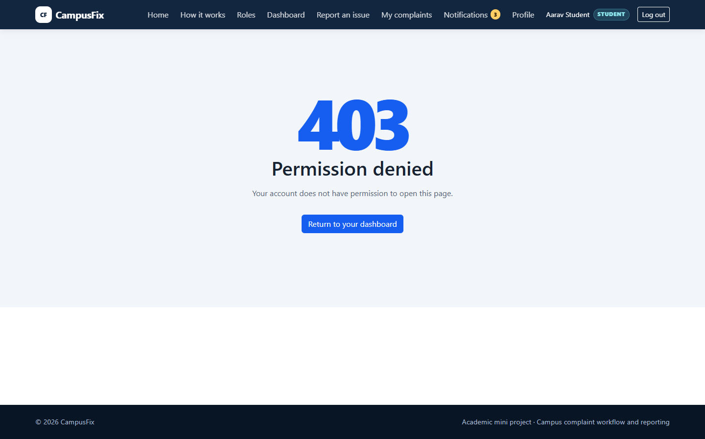
Figure 14. Branded server-side permission denial

6.4 Key Results
- A complaint remains traceable from submission through resolution and closure.
- Students cannot read another Student's ticket; Staff cannot act on unassigned work.
- Administrators can see live workload, priority, feedback, analytics, and filtered exports.
- Demo data commands can be rerun without duplicating their reference records.
- All accepted Batches 1 through 6 remain covered by the passing regression suite.

Chapter 7 Conclusion and Future Scope

7.1 Conclusion
CampusFix meets the project objective of replacing fragmented campus maintenance reporting with a controlled and transparent workflow. Its strongest result is the connection between role-based permissions, explicit status transitions, a permanent timeline, and evidence-based administrator reporting. The completed application is suitable for a fourth-year mini-project demonstration and provides clear opportunities for deployment-oriented extension.

7.2 Future Scope
- Email and SMS delivery for important status changes.
- A native or progressive mobile application.
- Production deployment with PostgreSQL, managed media storage, HTTPS, monitoring, and backups.
- Predictive maintenance using historical recurrence and resolution-time data.
- Richer service-level and response-time analytics.
- A multilingual interface and accessibility testing with assistive technologies.

References
[1] R. Sandhu, D. Ferraiolo, and D. R. Kuhn, The NIST Model for Role-Based Access Control: Towards a Unified Standard, ACM RBAC 2000. https://doi.org/10.1145/344287.344301
[2] Django Software Foundation, Using the Django authentication system, Django 6.1 documentation. https://docs.djangoproject.com/en/6.1/topics/auth/default/
[3] Django Software Foundation, Security in Django, Django 6.1 documentation. https://docs.djangoproject.com/en/6.1/topics/security/
[4] Atlassian, What are Jira workflows? https://www.atlassian.com/software/jira/guides/workflows/overview
[5] SQLite Consortium, About SQLite. https://www.sqlite.org/about.html
[6] Chart.js, Accessibility. https://www.chartjs.org/docs/latest/general/accessibility.html
[7] OWASP Foundation, CSV Injection. https://community.owasp.org/attacks/CSV_Injection
[8] Bootstrap Team, Bootstrap 5.3 Documentation. https://getbootstrap.com/docs/5.3/
[9] Django Software Foundation, File uploads, Django 6.1 documentation. https://docs.djangoproject.com/en/6.1/topics/http/file-uploads/
[10] Pillow Contributors, Pillow Documentation. https://pillow.readthedocs.io/en/stable/

Appendix A Important Routes
Route | Purpose
/ | Public landing page
/register/ and /login/ | Student registration and authentication
/dashboard/ | Role dashboard router
/complaints/new/ | Student complaint submission
/complaints/ | Student ticket list
/work/ | Maintenance Staff queue
/management/complaints/ | Administrator complaint queue
/analytics/ | Administrator analytics
/reports/ | Administrator reports
/admin/ | Django Admin for authorised superusers

Appendix B Local Demo Accounts
LOCAL DEMO ONLY. These credentials are created only by the DEBUG-only demo command and must never be used in production.
Role | Username | Password
Student | student_demo | CampusFixStudent@2026
Maintenance Staff | staff_demo | CampusFixStaff@2026
Administrator | admin_demo | CampusFixAdmin@2026

Appendix C Priority Scoring
Component | Points
Urgency: Low / Medium / High | 10 / 25 / 40
Safety | 40
Electrical or Water | 30
Furniture | 20
Wi-Fi | 15
Cleanliness or Other | 10
Valid image evidence | +5
Level thresholds | Low <30; Medium 30-49; High 50-69; Critical >=70

Appendix D CSV Safety Note
Spreadsheet software may interpret cells beginning with =, +, -, or @ as formulas. CampusFix converts nulls to blank text and prefixes those leading characters with an apostrophe before writing CSV rows. The files also begin with a UTF-8 byte-order mark for practical spreadsheet compatibility. No universal CSV strategy is safe for every spreadsheet and downstream import, so exports should still be treated as data files from a trusted local administrator workflow.

