AMSPRD/DC1/NODE_2/10.102.117.12:

--------------------------------------------------

In AMSPRD, we observed the database instances were down at “2024-02-24” both the nodes 10.102.117.11/12.

We checked alert log file on node to find out the root cause of the issue. Here is an ORA error.

* **ORA-29740: evicted by instance number 1, group incarnation 38**

Then,

We raised an SR to oracle support team, and we were communicating with them about this issue. The team asked required log files like database alert log and cluster log files.

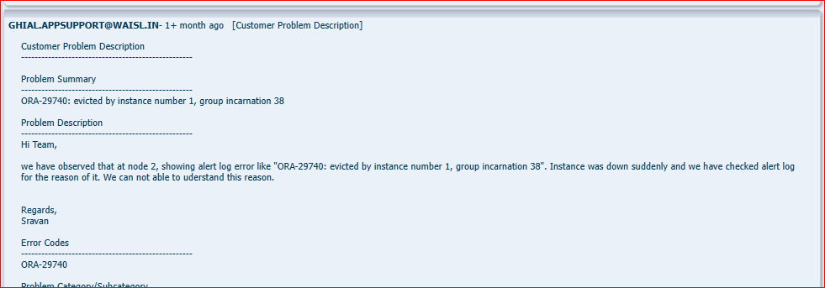

After a prolonged communication with SR team, they said the value of rp_filter is not configured correctly as per Kernal Linux norms and at that point IO wait time was more than 42%.

The value of rp_filter private interconnect is our environment as shown below.

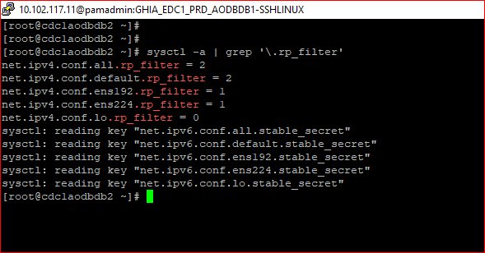

So, we need to change rp_filter of Private Interconnect value is 0 or 2.

* net.ipv4.conf.ens224.rp_filter = 1

This action plan will do OS team because of it Linux related issue and we confirmed with SR team.



