**PATCHING ACTIVITY ON STANDALONE DATABASE**

**AMSTEST DATABASE (10.102.117.21)**

Here’s a step-by-step guide on how to patch a standalone Oracle database using the OPatch utility:

Here are the headings for patching a standalone Oracle database using the OPatch utility:

1. **Check OPatch Version**

2. **Download the Latest Patch Version from Oracle Support Site**

3. **Make a Directory to Unzip the Patch File**

4. **Run Pre-Request Checks for Patch Eligibility**

5. **Upgrade OPatch Tool**

6. **Unzip the Patch File in the Dedicated Location (ORACLE_HOME)**

7. **Check the Patch Version Again**

8. **Check Patch Status Before Applying**

9. **Shutdown Database and Listener**

10. **Take Backup of ORACLE_HOME and Database (Rollback Plan)**

11. **Backup the Database Including Archive Logs**

12. **Shutdown the Database**

13. **Apply RU Patch on ORACLE_HOME 19c**

14. **Check if Patch Applied Successfully**

15. **Apply Patch to the Database**

16. **Start the Listener**

17. **Verify the Data Patch at Database Level**

1. **Check opatch version.**

First, we must check the opatch version by using the command below.

cd $ORACLE_HOME/OPatch/

./opatch version

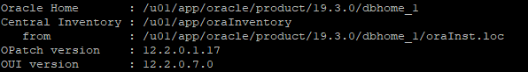

1. **Download the latest patch version from Oracle Support site**

If opatch is not upto date download optach from oraclesupport and replace with existing. Then here,The patch version is 12.2.0.1.17. It is not supported to apply the patch. So, in this scenario we must download the latest patch version and update the OPatch utility.

We can download the latest patch version file from Oracle Support site. And scp that file from windows server linux server by using winscp.

* **Download the Patch**: Log into My Oracle Support, find the required patch for your database version, and download it to your server.
* **Verify OPatch Version**: Make sure your OPatch utility is up-to-date. Run the following to check:

$ORACLE_HOME/OPatch/opatch version

If outdated, download the latest version (patch ID 6880880) from My Oracle Support.

1) Review readme file on Patch 31771877 – Database Release Update 19.9.0.0.201020  
2) Download patch p31771877_190000_Linux-x86-64.zip  
3) Make sure the opatch version is minimum 12.2.0.1.19

**Download the Patch from oracle support :-**

p31771877_190000_Linux-x86-64.zip  
p6880880_200000_Linux-x86-64.zip

[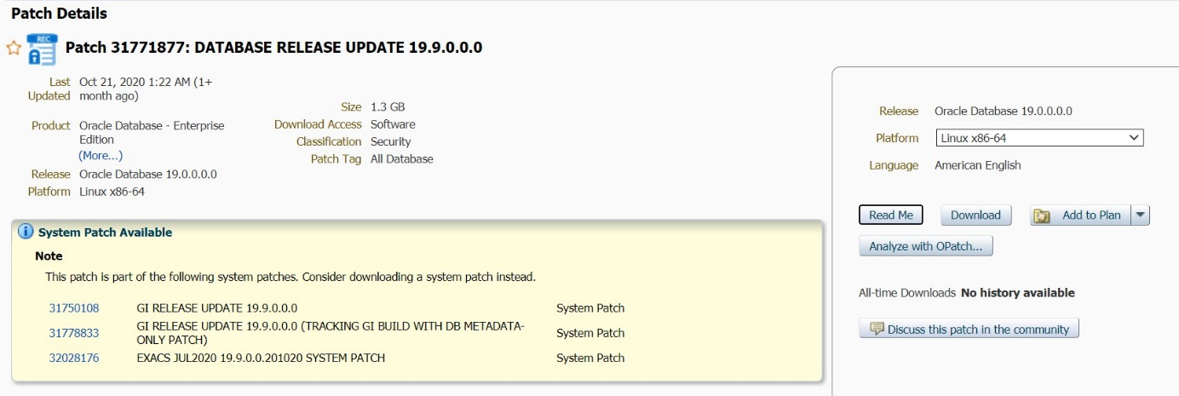](https://oracledbwr.com/wp-content/uploads/2020/11/1.jpg)

Download from My Oracle Support patch [**6880880**](https://updates.oracle.com/ARULink/PatchDetails/process_form?patch_num=6880880)

[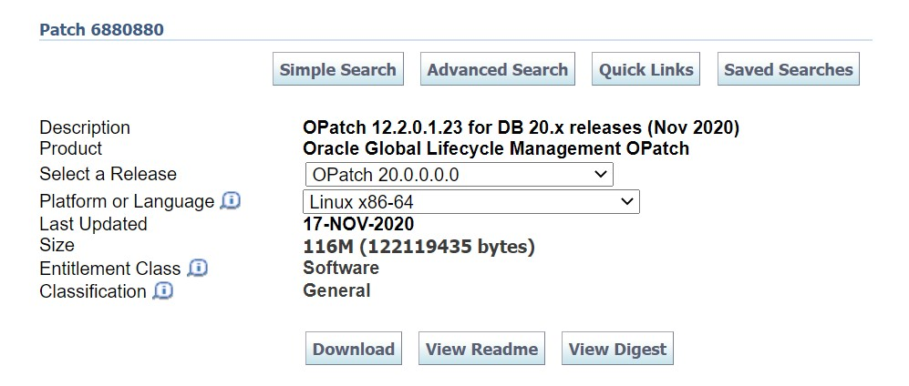](https://oracledbwr.com/wp-content/uploads/2020/11/2.jpg)

1. **Make a directory to unzip the patch file.**

Create a directory on selected file system location for unzip the patch file and scp the patch file to this location.

mkdir -p /u03/patch

pwd

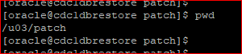



1. **Run the pre-request checks for the eligibility of patch version.**

Run the pre-request checks for the eligibility of patch version by using the command below.

$ORACLE_HOME/OPatch/opatch prereq CheckConflictAgainstOHWithDetail -ph ./

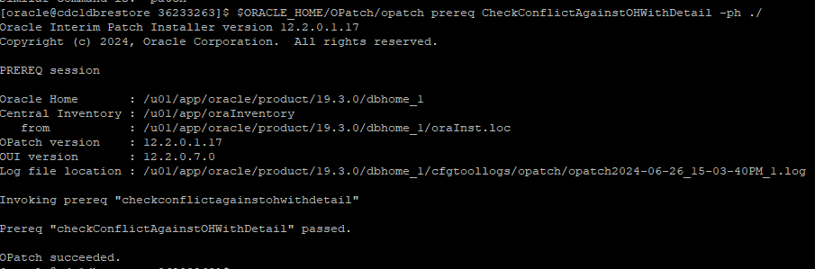

1. **Upgrade Opatch Tool from 12.2.0.1.17 to 12.2.0.1.44**

Now, the patch version is 12.2.0.1.17, it is not supported to OPatch apply. So, we need to update the patch version by applying the latest patch version.

[oracle@cdc1dbrestore dbhome_1]$ pwd/u01/app/oracle/product/19.3.0/dbhome_1

[oracle@cdc1dbrestore dbhome_1]$ mv OPatch/ OPatch_BKP

1. **Unzip the patch file in the dedicated location (ORACLE_HOME)**

i.e unzip the latest patch file from ORACLE_HOME location.

unzip p6880880_230000_Linux-x86-64.zip -d $ORACLE_HOME

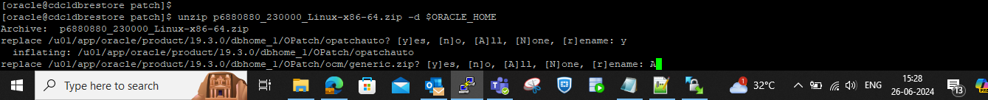

After unzipped here is a directory has generated, it is in numerical format (36233263). Go to the location and check files.

When we will apply the patch, go to this location (/u03/patch/36912597 and apply the patch.

1. **Again, check the patch version**

We have unzip the latest patch version and check once again OPatch version.

cd $ORACLE_HOME/OPatch

./opatch version

Now it is updated to the latest version. We can apply patch.

1. **Check Patches status before apply using below query**

SET LINESIZE 500

SET PAGESIZE 1000

SET SERVEROUT ON

SET LONG 2000000

COLUMN action_time FORMAT A12

COLUMN action FORMAT A10

COLUMN comments FORMAT A30

COLUMN description FORMAT A60

COLUMN namespace FORMAT A20

COLUMN status FORMAT A10

SELECT TO_CHAR(action_time, 'YYYY-MM-DD') AS action_time,action,status,description,patch_id FROM sys.dba_registry_sqlpatch ORDER by action_time;

](https://oracledbwr.com/wp-content/uploads/2020/11/3.jpg)

col comp_id for a10

col version for a11

col status for a10

col comp_name for a37

select comp_id,comp_name,version,status from dba_registry;

](https://oracledbwr.com/wp-content/uploads/2020/11/4.jpg)

Identifying Invalid Objects before patching

COLUMN object_name FORMAT A30

SELECT owner,

object_type,

object_name,

status

FROM dba_objects

WHERE status = 'INVALID'

ORDER BY owner, object_type, object_name;

1. **Shutdown Database and Listener**

Before applying the patch we should down the listener.

lsnrctl status

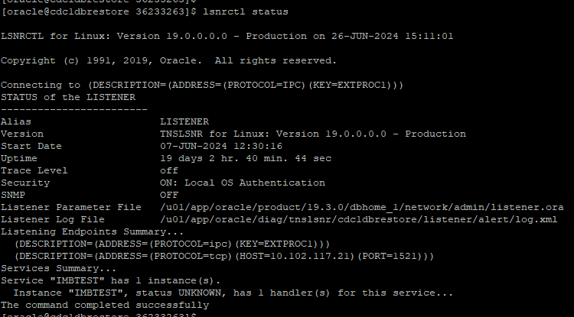

lsnrctl stop

1. **Take backup of ORACLE_HOME and Database (Rollback plan)**

Take the backup of entire ORACLE_HOME by using “tar” command.

tar -cvf /u03/oracle_home_06_11_bkp.tar $ORACLE_HOME

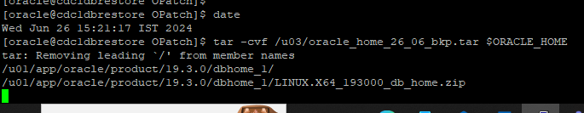

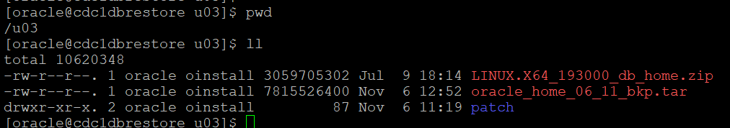

1. **Backup the database including archive logs.**

And take backup of database including archive logs by using RMAN.

rman target /

backup database plus archivelog all;

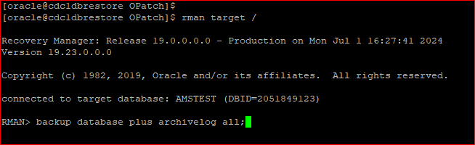

1. **Down the database.**

Then after down the database.

shutdown immediate;

1. **Apply RU patch on ORACLE_HOME 19c:**

Apply the patch from “/u03/patch/36912597” this location

cd 36912597

export ORACLE_HOME= /u01/app/oracle/product/19.3.0/dbhome_1

export PATH=/u01/app/oracle/product/19.3.0/dbhome_1/OPatch:$PATH

./opatch version

[oracle@cdc1dbrestore 36912597]$ opatch apply

**(OR)**

$ORACLE_HOME/OPatch/ opatch apply

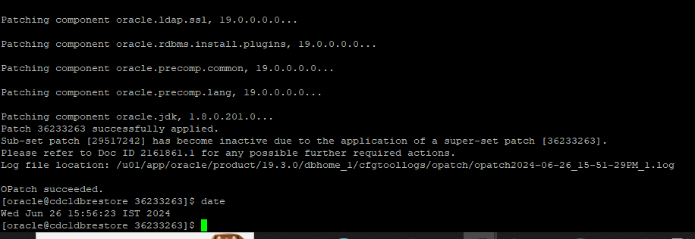

1. **Check whether patch applied or not.**

Now, check whether patch has applied or not by the command below.

$ORACLE_HOME/OPatch/opatch lsinventory |grep applied



1. **Apply patch to the database (database should be up and running).**

We have successfully applied the patch to the instance, now we will apply to the database.

Startup the database.

startup;

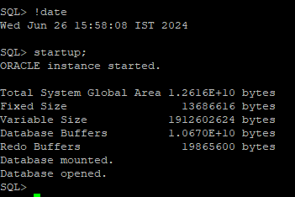

Now, apply the patch to the database.

./datapatch -verbose

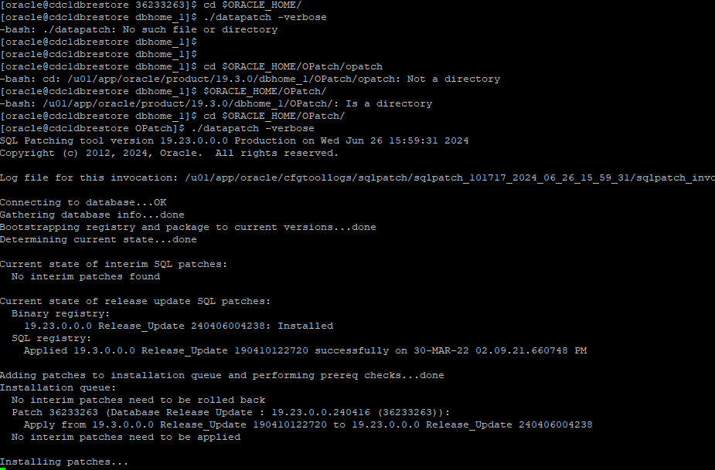

1. **Start the listener**

* Now, startup the listener
  + - lsnrctl start

1. **Verify the data patch at database level**

By using the command below, we can check the database patch version.

set lines 200 pages 200

col BANNER for a20

col BANNER_FULL for a20

select * from v$version;

Now, connected latest patch version sql.