|  |  |
| --- | --- |
| **Switchover Activity** | |
| Document No. | WAISL_GHIAL_SOP_ORCL-003 |
| Revision | 1.0 |
| Issue Date | ---- |
| File Name | WAISL_GHIAL_SOP_ORCL-002.docx |

|  |  |  |  |
| --- | --- | --- | --- |
| **Document No.** | WAISL_GHIAL_SOP_ORCL-002 | | |
| **File Name** | WAISL_GHIAL_SOP_ORCL-002.docx | | |
| **Document Description** | Switchover Activity (LIBERTYDB DATABASE) | | |
| **Revision** | 1.0 | | |
| **Date (DD-MM-YYYY)** | --- | | |
|  | **Prepared by** | **Checked by** | **Approved by** |
| **Name** | Sravan | Pavan.P | Pavan.P |
| **Issue Document Control Verification with Document** | | |  |

|  |
| --- |
| Security Notice:  The information contained in this document is CONFIDENTIAL. Employees should not disclose any confidential Company, client, or third-party information To anyone outside the Company, except as authorized. Failure To comply with Company policies regarding security and protection of confidential information will be reported and disciplinary action will be taken. Such action may include, but is not limited To, reprimand, financial penalties, termination of employment, and/or legal action. |

Guidelines for distribution

The Retention period is as defined in the retention policy.

Data access is limited To access list.

Use strong authentication / EFS Encryption / Lock in a Drawer.

Log access details in a register.

Version HisTory

| Version | Approved Date | Author | Reviewer | Approver for Change | Description |
| --- | --- | --- | --- | --- | --- |
| 1.0 | ---- | Sravan | Pavan.P | Pavan.P | Switchover Activity |

Access list

| Sr. No. | Role | Read | Modify | Delete |
| --- | --- | --- | --- | --- |
| 1 | Process Owner | Yes | Yes | Yes |
| 2 | Q & A | Yes | Yes | No |
| 3 | Personnel listed in the Target Group section | Yes | No | No |

Table of Contents

1.0 Purpose: 4

2.0 Scope: 4

3.0 Responsibilities: 4

4.0 Prerequisites 4

4.1 Primary Database (AMSPRD - 10.102.117.11) 4

4.2 Issue Resolution: 12

5.0 Switching process : 14

5.1 Primary (DC1) to Standby 14

5.2 Standby (DC2) to Primary: 16

6.0 Post-Switchover Activity: 21

1. Purpose:

This SOP provides detail procedure for performing a Manual switchover between the primary and

standby databases in an Oracle environment. This process Ensures the continuity of database operations

with minimal downtime.

1. Scope:

This SOP applies To all database Administrators (DBAs) responsible for managing Oracle databases that

are configured with Data Guard.

1. Responsibilities:

**Database Administrator (DBA):** Execute the procedure, ensure prerequisites are met, and verify the success of the switchover.

**System Administrator:** Approve the switchover plan and notify the stakeholders of planned downtime.

1. Prerequisites
   1. Primary Database (LIBERTYDB - 10.102.123.11)

Step 1: Backup

Perform export and RMAN backup before the switchover.

Run the backup script:

**Script:** sh /dbbkp/scripts/backupliberty.sh LIBERTYD1 full > /tmp/full_libbackup.log

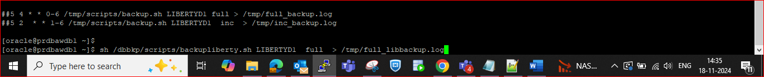

Take and Check the export backup status in SQL:

Script: /dbbkp/expdp_full_liberty.sh

Check the status of export backup:

set lines 200 pages 200

col JOB_NAME for a20

col STATE for a20

select JOB_NAME, STATE from dba_datapump_jobs;

Step 2: Pre-requisite Checks

Verify the status of database services, listener, and ASM using the following commands:

srvctl status database -d libertydb

srvctl status service -d libertydb

srvctl status listener

srvctl status asm

lsnrctl status

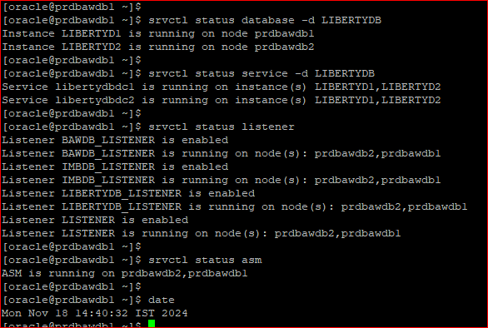

Check the cluster resources:

crsctl check crs

crsctl check cluster -all

crsctl stat res -t

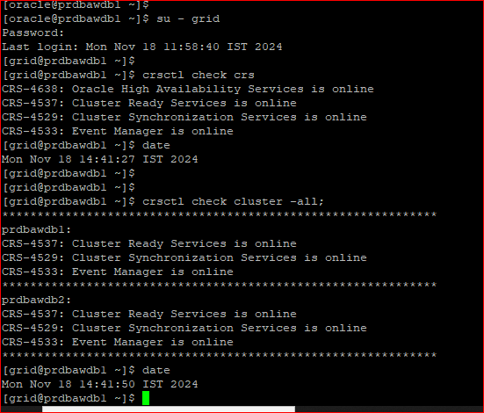

Verify the OCR backup:

**Script:** ocrconfig -showbackup

Step 3: Synchronization Check

Ensure DC1 and DC2 are synchronized:

cd/tmp

connect sqlplus "/ as sysdba"

@sync.sql

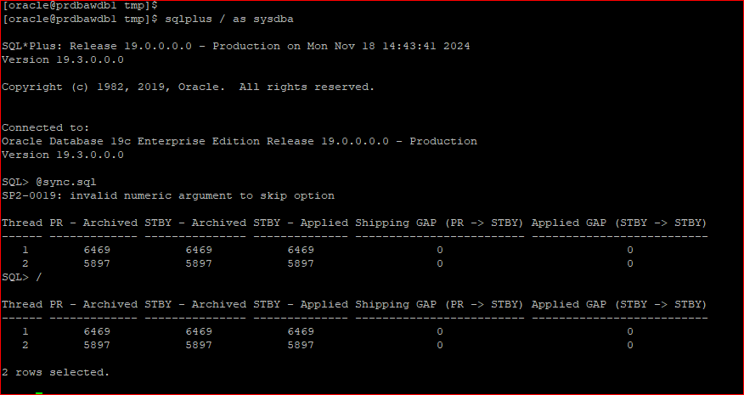

Step 4: Parameter Checks

Confirm the following parameters and reset them post-switchover:

archive log list; -- Ensure this is enabled.

show parameter log_archive_max_process; -- Reset to original value post-activity.

show parameter job_queue_processes; -- Set to "0" before activity and reset post-activity.

show parameter standby_file_management; -- Reset post-activity.

Step 5: Gap Status Check

Check the gap between DC1 and DC2:

**Script:** select status,gap_status from v$archive_dest_status where dest_id=2;

show parameter job_queue_processes >>>>

**Before activity we need set as “0”, then after reset as it before value.**

alter system set job_queue_processes=0 scope=both sid=’*’;

show parameter job_queue_processes

Step 6: Session Count

Check the active and inactive sessions:

**Script:** select count(*),status,inst_id from gv$session group by inst_id,status;

Step 7: Verify Backups

Ensure physical and logical backups are completed:

df -h

cd /dbbkp/backup/libertydb

ls -lrt

cd ..

cd /dbbkp/data_pump/libertydb

ls -lrt

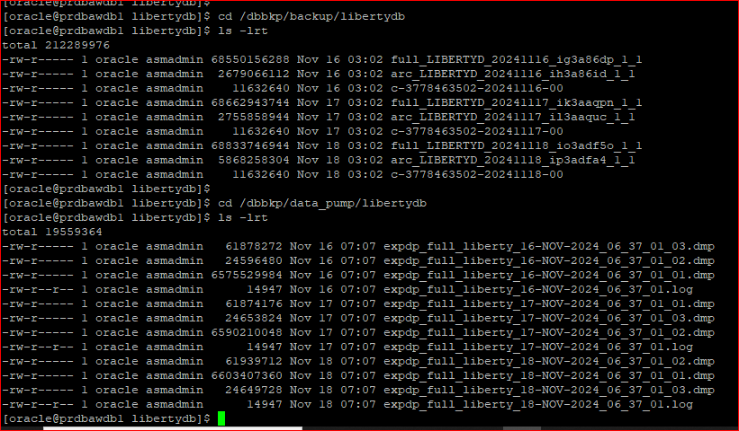

Step 8: Log and Error Check

Review the alert log for any errors.

Sqlplus / as sysdba

Select value from v$diag_info;

* /u02/app/oracle/diag/rdbms/libertydb/LIBERTYD1/trace
* cd /u02/app/oracle/diag/rdbms/libertydb/LIBERTYD1/trace
* tail -500f alert_LIBERTYD1.log

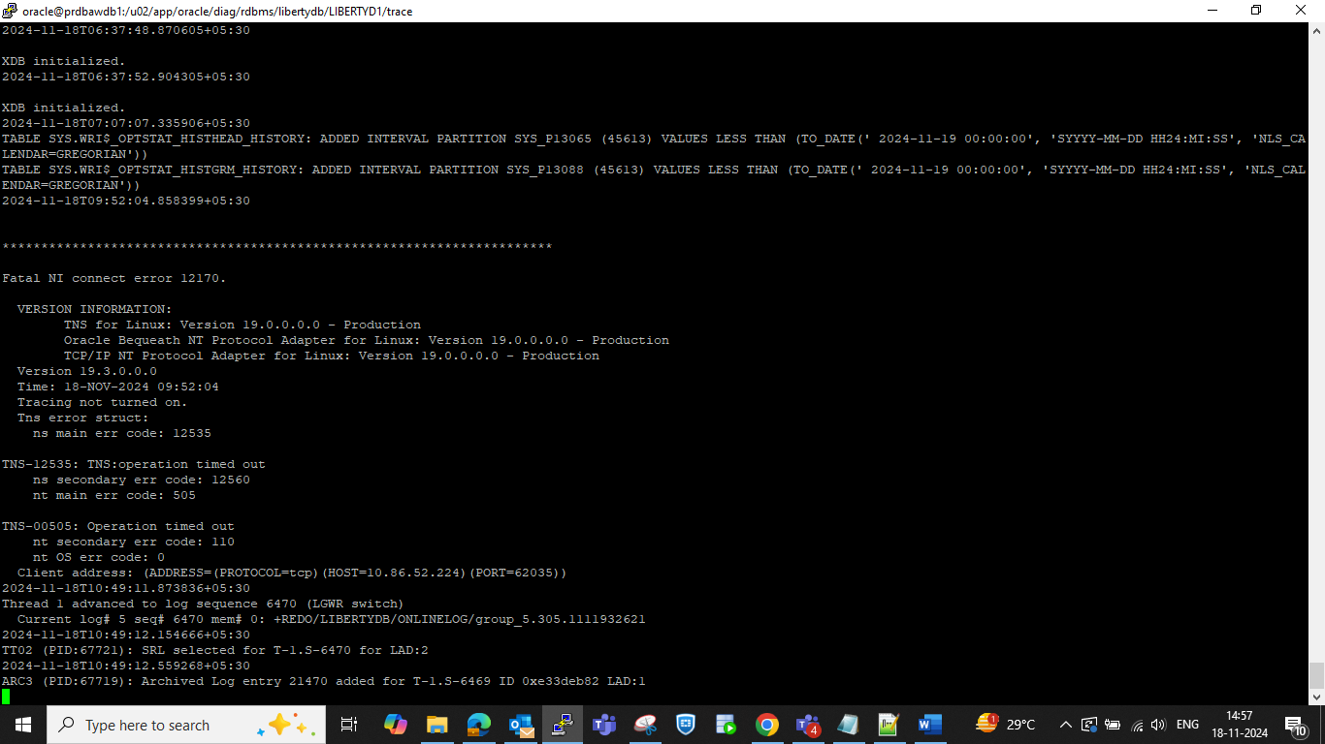

* 1. Issue Resolution:

If synchronization issues occur, perform a manual sync between DC1 and DC2 before proceeding with the switchover.

On Standby:

alter database recover managed standby database cancel;

On primary:

alter system set log_archive_dest_state_2=defer scope=both sid=’*’;

On standby:

alter database recover managed standby database disconnect from session;

On primary:

alter system set log_archive_dest_state_2=enable scope=both sid=’*’;

Now, check status switchover status, if it “TO STANDBY” to proceed.

1. Switching process :

Switching over a database in Oracle typically involves transitioning the primary database To a standby

role and the standby database to a primary role. This process is commonly used in disaster recovery and

high availability configurations and is often part of Oracle Data Guard.

* 1. Primary (DC1) to Standby

Step1: Shutdown Secondary Nodes (DC1 and DC2 - 10.102.123.12/10.102.223.12)

Connect to SQL and shutdown:

connect sqlplus "/ as sysdba"

shutdown immediate;

Step 2: Switchover Execution

Convert the primary database to a standby database:

alter database switchover to IMBDBSTBY verify;

alter database commit to switchover to physical standby with session shutdown;

Here, primary database (DC1) converted into physical standby database.

* 1. Standby (DC2) to Primary:

Step 1: Parameter Checks

Active and inactive sessions on old standby database.

Verify parameters on the new primary (DC2):

show parameter log_archive_max_process;

Archive log list;

show parameter job_queue_processes;

show parameter standby_file_management;

Verify status of old standby database 10.102.223.11:

show parameter log_archive_max_process;

Archive log list;

show parameter job_queue_processes;

show parameter standby_file_management

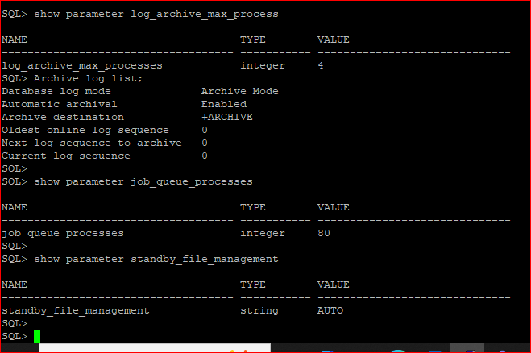

Step 2: Switchover Status Check

Ensure the switchover status is "TO PRIMARY":

**Command:** select name, open_mode, switchover_status from v$database;

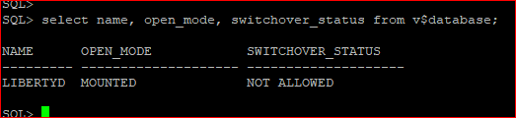

Step 3: Execute Switchover

Convert the standby database (DC2) to the primary (DC1):

**Command:** alter database commit to switchover to primary with session shutdown;

Check for alert logs files.

* + select value from v$diag_info;
  + /u02/app/oracle/diag/rdbms/libertydbstby/LIBERTYDSTBY1/trace
  + cd /u02/app/oracle/diag/rdbms/libertydbstby/LIBERTYDSTBY1/trace
  + tail -500f alert_LIBERTYDSTBY1.log

Once the switchover process completes, check the status of new standby and primary databases.

New Standby database:

-------------------------------

Connect to new standby database 10.102.123.11

ps -ef|grep pmon

export ORACLE_SID= LIBERTYDSTBY1

connect “sqlplus / as sysdba”

select name,open_mode,switchover_status from v$database;

New Primary Database:

--------------------------------

Connect new primary database 10.102.223.11:-

Crosscheck the below parameter at new primary database (DC1):

show parameter log_archive_max_process >>>>> value must be 4 as per old primary

show parameter job_queue_processes >>>> value must be 160 as per old primary

show parameter standby_file_management >>>> value must be “AUTO” as per old primary

1. Post-Switchover Activity:

Step 1: Start Secondary Nodes

Start secondary nodes on both servers:

LIBERTYDSTBY2:- (10.102.223.12)

LIBERTYD2:- (10.102.123.12)

Step 2: Resource Status Check

Verify sync status from DC1 and DC2.

* + cd /tmp
  + export ORACEL_SID=LIBERTYDSTBY1
  + sqlplus / as sysdba
  + @sync.sql

Verify the status of services and resources on the new primary(10.102.223.11):

srvctl status database -d LIBERTYDSTBY

srvctl status service -d LIBERTYDSTBY

srvctl status listener

srvctl status asm

srvctl status scan

srvctl status scan_listener

Step 3: Cluster Resources Check

Ensure cluster resources are online:

su - grid

crsctl check crs

crsctl check cluster -all

crsctl stat res -t

Step 4: Session Status

Check switchover status.

select name,open_mode,switchover_status from v$database;

Check the count of active and inactive sessions:

select status, count(*) from gv$session group by status;

Step 5: Log Synchronization Check

Confirm that archive logs are shipping correctly between DC1 and DC2.

Verify there is no log gap between the new primary and standby.

Finally, check the sync status of DC1 and DC2.

Here, there is no logs gap between new primary database (10.102.223.11) and new standby database (10.102.123.11) are observed.