SGA and PGA Calculation Document
Document No.
Revision | 1.0
Issue Date | 19-Nov-2024
File Name

Document No.
File Name
Document Description | SGA and PGA Calculation Document
Revision | 1.0
Date (DD-MM-YYYY) | 19-11-2024
 | Prepared by | Checked by | Approved by
Name
Issue Document Control Verification with Document

Security Notice:
The information contained in this document is CONFIDENTIAL. Employees should not disclose any confidential Company, client, or third-party information to anyone outside the Company, except as authorized. Failure to comply with Company policies regarding security and protection of confidential information will be reported and disciplinary action will be taken. Such action may include, but is not limited to, reprimand, financial penalties, termination of employment, and/or legal action.
Guidelines for distribution
The Retention period is as defined in the retention policy.
Data access is limited to access list.
Use strong authentication / EFS Encryption / Lock in a Drawer.
Log access details in a register.
Version History
Version | Approved Date | Author | Reviewer | Approver for Change | Description
1.0 | 19-11-24 |  |  | WAISL SD Head | SGA and PGA Calculation Document

Access list
Sr. No. | Role | Read | Modify | Delete
1 | Process Owner | Yes | Yes | Yes
2 | Q & A | Yes | Yes | No
3 | Personnel listed in the Target Group section | Yes | No | No

Table of Contents
1.0 PURPOSE 4
2.0 Assumptions 4
3.0 Prerequisites 4
4.0 Memory Allocation 4
5.0 Example Allocation Summary 4
6.0 Configuration Parameters 4
7.0 Memory STructures 5
8.0 Steps to Modify SGA and PGA 6
9.0 Alter SGA and PGA 10
10.0 Post-Check Activities 15
11.0 Monitoring 16

- PURPOSE
This document outlines the calculation and allocation of SGA (System Global Area) and PGA (Program
Global Area) for a server with 60 GB RAM, ensuring optimal database performance.
- Assumptions
- Total System RAM: 60 GB
- Operating System Usage: 20% of total RAM
- Calculation: 60 x 0.2 = 12 GB
- Memory Available for Oracle: 60 GB − 12 GB = 48 GB
- Prerequisites
- User Access: Ensure you have DBA privileges to make changes.
- Backup: Take a full backup of your database to avoid any issues.
- Understand Workload: Analyze the database workload and application needs.
- Memory Allocation
- SGA Calculation
- Recommended Allocation: 75% of available memory.
- Calculation: 48 x 0.75 = 36 GB
- Total SGA allocation for three databases: 36 GB.
- SGA per database: 36 GB/3= 12 GB per database.

- PGA Calculation
- Recommended Allocation: 25% of available memory.
- Calculation: 48 x 0.25=12 GB
- Total PGA allocation for three databases: 12 GB.
- PGA per database: 12 GB/2= 4 GB per database.

- Example Allocation Summary

Component | Total Memory Allocation | Per Database Allocation
Total RAM | 60 GB | N/A
Operating System | 12 GB | N/A
Available for Oracle | 48 GB | N/A
Total SGA | 36 GB | 12 GB
Total PGA | 12 GB | 4 GB

- Configuration Parameters
Set the following parameters in init.ora or spfile.ora for each database:

- SGA Target: ALTER SYSTEM SET SGA_TARGET = 12G SCOPE=SPFILE;

- PGA Aggregate Target: ALTER SYSTEM SET PGA_AGGREGATE_TARGET = 4G SCOPE=SPFILE;

Note: The above allocations are based on standard recommendations and can vary depending on the workload.
- Memory STructures
In the context of Oracle RAC (Real Application Clusters) databases, SGA, PGA, and MGA refer to
different memory structures that are essential for Oracle database operations. Here's what they mean in
this context:

- SGA (System Global Area):
- The SGA is a shared memory region that contains data and control information for one Oracle
database instance. It includes elements like:

- Database Buffer Cache: Holds copies of data blocks read from disk.
- Shared Pool: Caches SQL queries, PL/SQL code, and data dictionary information.
- Redo Log Buffer: Stores redo entries, which are used to recover the database after a failure.
- Java Pool, Large Pool, and others.

- In Oracle RAC, the SGA is instance-specific, meaning each node in the cluster has its own SGA, but these instances coordinate with each other to form a cohesive database system.

- PGA (Program Global Area):
- The PGA is a memory region specific to each Oracle server process or background process. Unlike the SGA, the PGA is not shared between processes. It contains data and control information for a server process, like:

- Sort areas
- Session information
- Cursor state
- Stack space for processing.

- The PGA is crucial for tasks like sorting operations and is tied to user sessions.

- MGA (Managed Global Area):
- The MGA is not a commonly referenced term in Oracle RAC databases. However, it can sometimes refer to Memory Guard Areas or Memory Granule Area, but this is less standard in Oracle's documentation. More commonly, people use SGA and PGA when referring to memory management in Oracle RAC.

In Oracle RAC environments, efficient management of SGA and PGA is critical to ensure
that the cluster nodes work smoothly together, avoiding memory contention issues and
ensuring data consistency across nodes.

Here’s a general guideline for memory allocation:

- SGA and PGA Allocation Guidelines:

- SGA + PGA ≈ 75-80% of total RAM
- A common recommendation is to allocate around 75-80% of the total RAM for the Oracle instance memory, leaving the remaining 20 -25% for the operating system and other processes.

- Divide the 75-80% between SGA and PGA:

- The distribution between SGA and PGA depends on the workload:
    - OLTP (Online Transaction Processing) systems usually require more SGA for caching, as they frequently access the same data.
    - DSS (Decision Support Systems) or data warehouses require more PGA because of intensive sorting, grouping, and aggregation operations.
- Key Parameters:
- SGA_TARGET: Sets the target size of the SGA.
- PGA_AGGREGATE_TARGET: Sets the target size of the PGA for all server processes.
- MEMORY_TARGET: If Oracle Automatic Memory Management (AMM) is used, you can set this to 39.2 GB to allow Oracle to automatically manage the memory distribution between the SGA and PGA dynamically.

- Important Considerations:
- Operating System Memory: Ensure that you leave at least 20-25% of the RAM for the operating system to avoid system performance issues.
- Workload Characteristics: Fine-tune the SGA and PGA settings based on your workload's performance needs, especially after monitoring system behavior over time.

- Steps to Modify SGA and PGA

Step1: Pre-Check Activities
- Run these queries to capture the current settings and utilization:
- Current Memory Settings:

Sql>

SELECT component, current_size/1024/1024 AS current_size_mb

FROM v$sga_dynamic_components

WHERE current_size > 0;

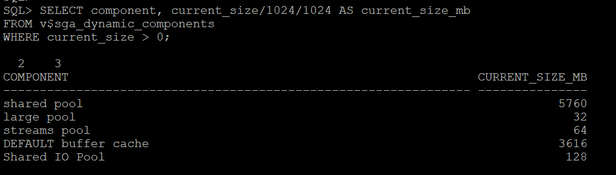
Figure 1:

Sql>

SELECT name, value/1024/1024 AS value_mb

FROM v$parameter

WHERE name IN ('sga_target', 'sga_max_size', 'pga_aggregate_target');

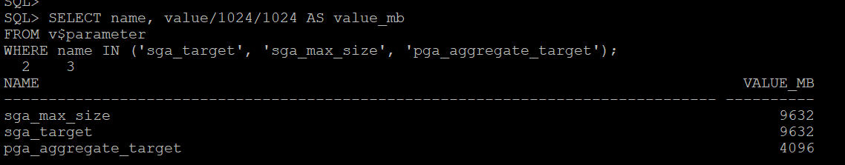
Figure 2:

- Current Usage:

Sql>

SELECT pool, name, bytes/1024/1024 AS size_mb FROM v$sgastat;

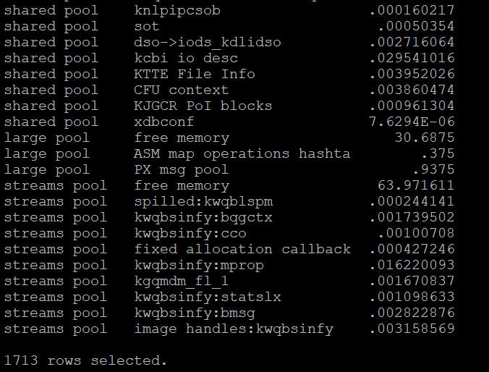
Figure 3:

Sql>

SELECT ROUND(SUM(pga_used_mem)/1024/1024, 2) AS pga_used_mb,

ROUND(SUM(pga_alloc_mem)/1024/1024, 2) AS pga_alloc_mb,

ROUND(SUM(pga_max_mem)/1024/1024, 2) AS pga_max_mb FROM v$process;

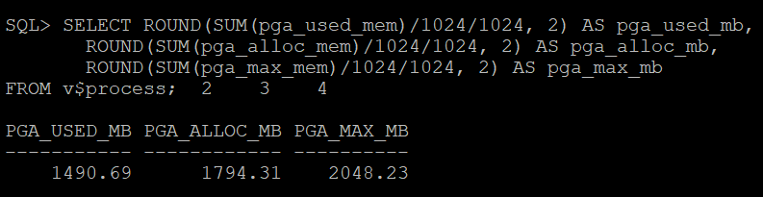
Figure 4:

Step 2: Advisory Views
- Check advisory views for optimal memory settings:

Sql>

SELECT * FROM v$sga_target_advice;

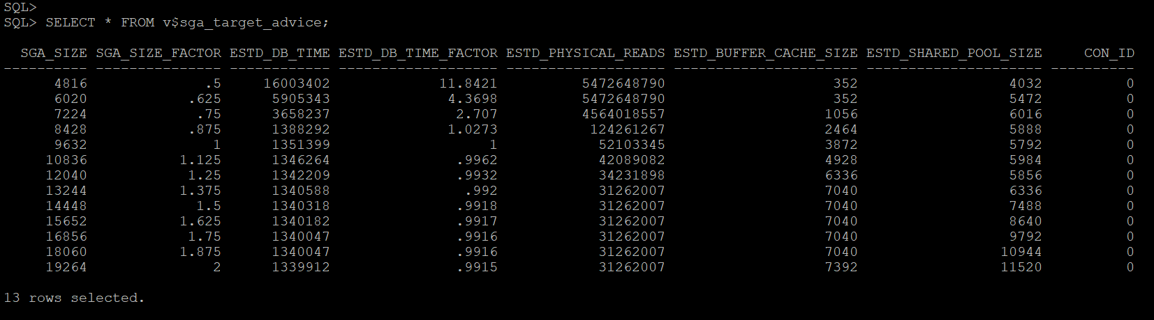
Figure 5:

Sql>

SELECT * FROM v$pga_target_advice;

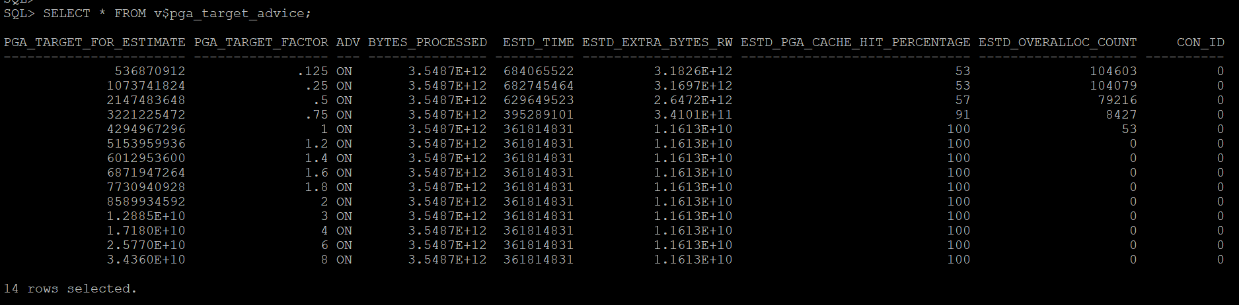
Figure 6:

Step 3: A rule of thumb is as follows:

- PGA_AGGREGATE_LIMIT =(original PGA_AGGREGATE_LIMIT value) + ((maximum number of connected processes) * 5M)
- The "original PGA_AGGREGATE_LIMIT value" is the PGA_AGGREGATE_LIMIT prior to upgrading to 18c or 19c, and "maximum number of connected processes" is the upper limit of processes that could be connected to the database at any one time (ostensibly equal to the value of the PROCESSES parameter). This also could be determined for any given instance lifetime as follows:

Sql>

select max_utilization from v$resource_limit where resource_name='processes';

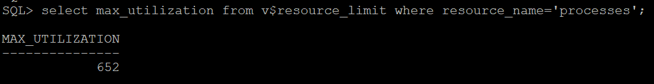
Figure 7:

- However, there is a more 'scientific' method of determining this value based on values currently retrievable in the database. The generic equation is:
- ((maximum aggregate PGA in use for the life of the instance) + ((maximum number of attached processes for the life the instance) * 5M)) * 1.1
- The following query can be used to determine the new recommended PGA aggregate limit:

Sql>

WITH
MAX_PGA as
(select round(value/1024/1024,1) max_pga from v$pgastat where
name='maximum PGA allocated'),
MGA_CURR as
(select round(value/1024/1024,1) mga_curr from v$pgastat where name='MGA allocated (under PGA)'),
MAX_UTIL as
(select max_utilization as max_util from v$resource_limit where resource_name='processes')
SELECT
a.max_pga "Max PGA (MB)",
b.mga_curr "Current MGA (MB)",
c.max_util "Max # of processes",
round(((a.max_pga - b.mga_curr) + (c.max_util * 5)) * 1.1, 1) "New PGA_AGGREGATE_LIMIT (MB)"
FROM MAX_PGA a, MGA_CURR b, MAX_UTIL c
WHERE 1 = 1;

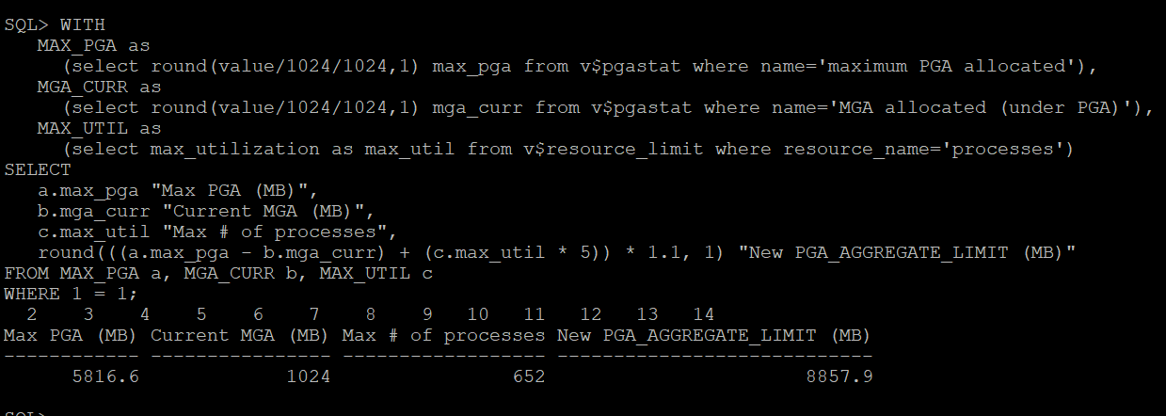
Figure 8:

Step 4: Plan SGA and PGA Allocation
- For 60 GB of total RAM:
- Allocate 75-80% to Oracle processes. E.g., ~48 GB.
- Divide between SGA and PGA based on workload (e.g., 70% SGA, 30% PGA).

Component | Size (Example)
SGA Target | 34 GB
SGA Max Size | 34 GB
PGA Target | 14 GB

- Alter SGA and PGA

Update sga_target, sga_max_size, and pga_aggregate_target:

To alter or change the values of SGA and PGA in an Oracle RAC database, use the following methods,
depending on whether you have Automatic Memory Management (AMM), Automatic Shared
Memory Management (ASMM), or manual memory management configured.

Step-by-Step: Altering SGA and PGA Values:

Step 1: Check Current Memory Settings
- Before making any changes, you should check the current memory settings for SGA and PGA.
sql

SHOW PARAMETER sga_target;

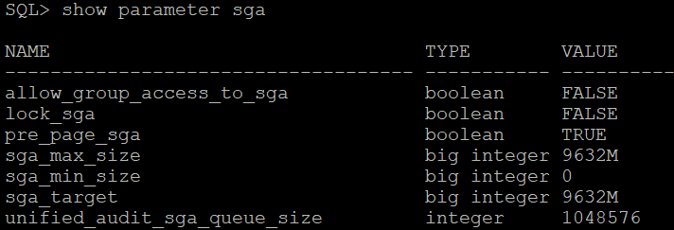
Figure 9:

SHOW PARAMETER pga_aggregate_target;

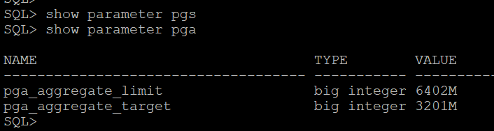
Figure 10:
SHOW PARAMETER memory_target; -- For AMM (if enabled)

SHOW PARAMETER memory_max_target; -- For AMM (if enabled)

Step 2: Using Automatic Memory Management (AMM)
- AMM allows Oracle to manage both SGA and PGA dynamically by using the MEMORY_TARGET and MEMORY_MAX_TARGET parameters.
- To enable or modify AMM (if not already in use):

- Set the MEMORY_TARGET and MEMORY_MAX_TARGET parameters:
sql

ALTER SYSTEM SET memory_target = 39G SCOPE=SPFILE;

ALTER SYSTEM SET memory_max_target = 39G SCOPE=SPFILE;

Explanation:
- MEMORY_TARGET: Defines the total memory Oracle can dynamically manage for both SGA and PGA.
- MEMORY_MAX_TARGET: The upper limit for MEMORY_TARGET.
- Restart the database to apply the changes:
sql

SHUTDOWN IMMEDIATE;

STARTUP;

Oracle will now manage the memory dynamically within the specified target.

Step 3: Using Automatic Shared Memory Management (ASMM)
- If ASMM is in use, user needs to adjust SGA_TARGET and PGA_AGGREGATE_TARGET individually. This method allows Oracle to manage individual SGA components (like buffer cache, shared pool, etc.) automatically, but SGA and PGA are manually managed.
- To alter SGA and PGA settings with ASMM:

- Based upon memory allocation plan set SGA_TARGET and PGA_AGGREGATE_TARGET
For an OLTP workload (assuming 13 GB for SGA and 8 GB for PGA as per the earlier example):
sql

ALTER SYSTEM SET sga_target = 13G SCOPE=SPFILE;

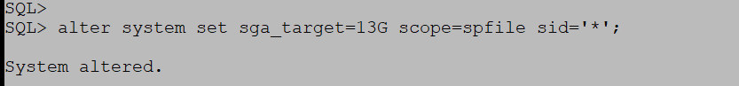
Figure 11:

ALTER SYSTEM SET pga_aggregate_target = 8G SCOPE=SPFILE;

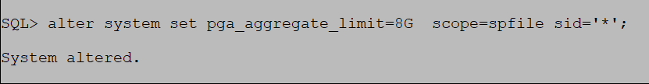
Figure 12:
Explanation:
- SGA_TARGET: The total size of the System Global Area.
- PGA_AGGREGATE_TARGET: The total amount of memory available for all PGAs across all sessions.

- Restart the database to apply the changes:
sql
SHUTDOWN IMMEDIATE;

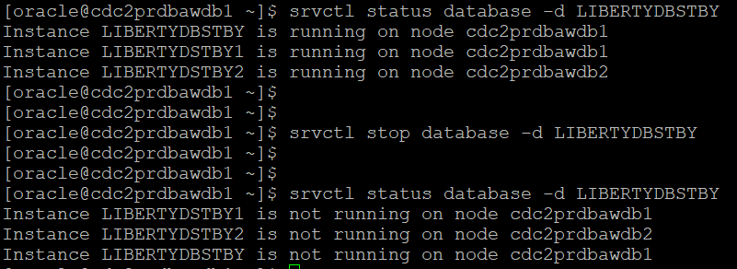
Figure 13:
STARTUP;

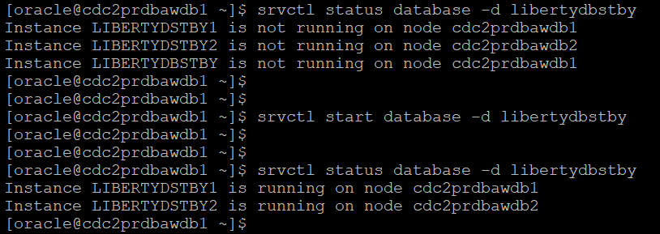
Figure 14:

Step4: Manual Memory Management (if not using AMM or ASMM)
- In manual memory management, user needs to set individual components of the SGA like DB_CACHE_SIZE, SHARED_POOL_SIZE, etc., as well as the PGA_AGGREGATE_TARGET.
- For example, to manually set different SGA components:

sql

ALTER SYSTEM SET db_cache_size = 15G SCOPE=SPFILE;

ALTER SYSTEM SET shared_pool_size = 6G SCOPE=SPFILE;

ALTER SYSTEM SET large_pool_size = 1G SCOPE=SPFILE;

ALTER SYSTEM SET pga_aggregate_target = 12G SCOPE=SPFILE;

- After setting these parameters, restart the database for changes to take effect:

sql

SHUTDOWN IMMEDIATE;
Figure 15:
STARTUP;

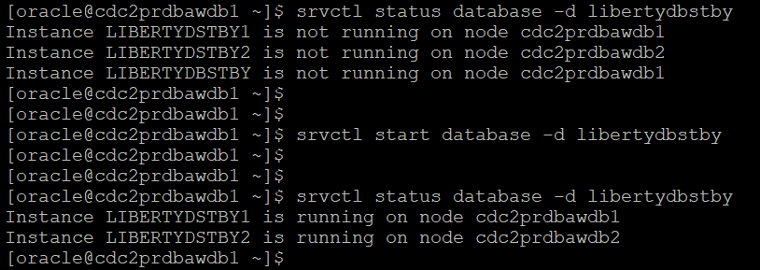
Figure 16:

Step 5: Monitor Memory Usage
- After adjusting SGA and PGA values, it's crucial to monitor memory usage and performance over time to ensure that your allocations are optimal.
- To check the current usage of PGA:

sql

SELECT * FROM v$pgastat;
- To check the SGA usage:

sql

SELECT * FROM v$sga;

- These queries will help you assess whether the memory allocations need further adjustments based on workload performance.

Conclusion:
- Use AMM for automatic memory management by adjusting MEMORY_TARGET.
- Use ASMM to control SGA and PGA independently by setting SGA_TARGET and PGA_AGGREGATE_TARGET.
- For manual control, set individual SGA components like DB_CACHE_SIZE, SHARED_POOL_SIZE, and adjust PGA_AGGREGATE_TARGET.

- Post-Check Activities
- Verify New Memory Settings:
sql
SELECT name, value/1024/1024 AS value_mb
FROM v$parameter
WHERE name IN ('sga_target', 'sga_max_size', 'pga_aggregate_target');

- Validate SGA Allocation:
sql
SELECT component, current_size/1024/1024 AS current_size_mb
FROM v$sga_dynamic_components
WHERE current_size > 0;

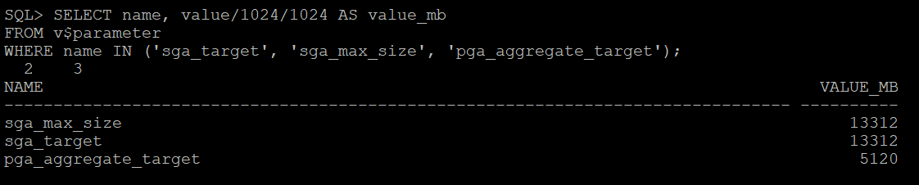
Figure 17:

- Validate PGA Allocation:
sql

SELECT ROUND(SUM(pga_used_mem)/1024/1024, 2) AS pga_used_mb,
ROUND(SUM(pga_alloc_mem)/1024/1024, 2) AS pga_alloc_mb,
ROUND(SUM(pga_max_mem)/1024/1024, 2) AS pga_max_mb
FROM v$process;

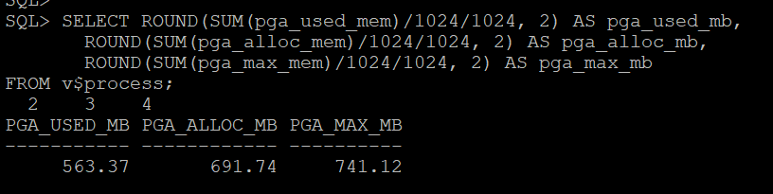
Figure 18:

Check Performance: Monitor advisory views and OS resource utilization to confirm stability.

- Monitoring
Set up continuous monitoring:
- AWR Reports: Analyse memory usage trends.
- Dynamic Views: Use v$memory_dynamic_components and v$pgastat.

Points to Consider:
- Allocate memory proportionally to SGA and PGA based on the database’s workload characteristics.
- Adjust memory_target and memory_max_target if AMM (Automatic Memory Management) is enabled.
- Perform regular performance testing post-implementation to validate the changes.

