2)

**Deploy Jenkins as Pod on Kubernetes using Service Type ClusterIP. Capture Pod & Service Yamls created at this step. Capture the results and logs.**

Please observe the Service Type ClusterIP

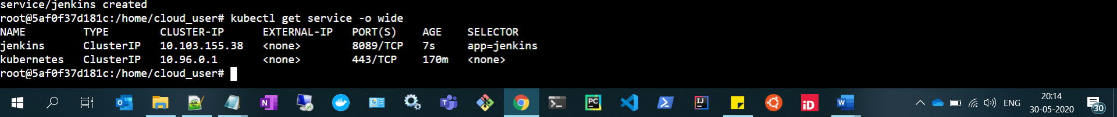

Created 2 replicas, Hence two Jenkins pods

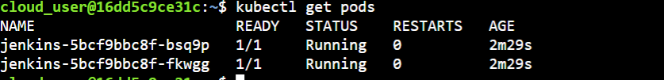

**3) Try communicating to it from outside of cluster. Capture the results.**



