**4) Try changing the Service Type to NodePort. Capture latest Yaml of Service**

Please observe the service type as NodePort

Created two replicas and they are in the running status

**PODS:**



Accessing the Jenkins on the port 32766

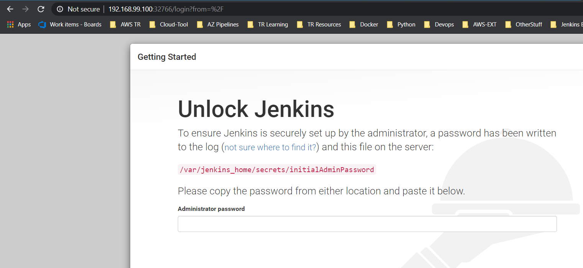

**5. Try communicating to Jenkins service from outside of cluster. Capture the result**

Assigning the external IP to the typeNodePort

