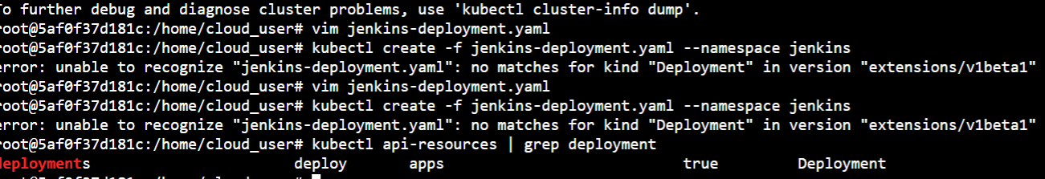



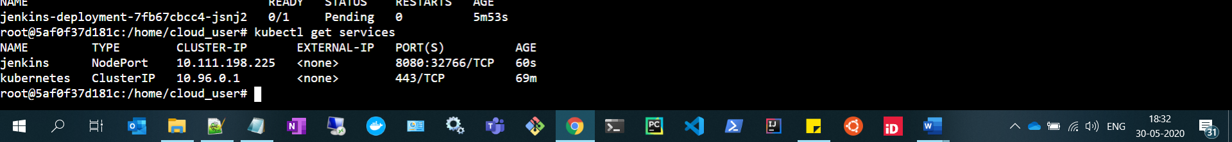

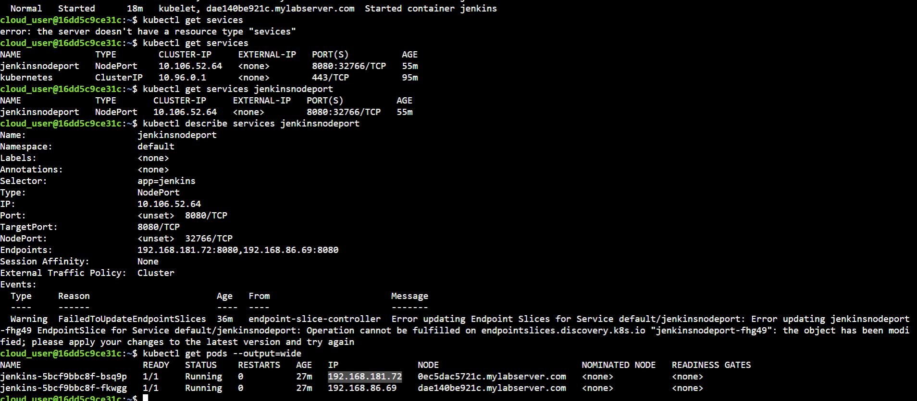



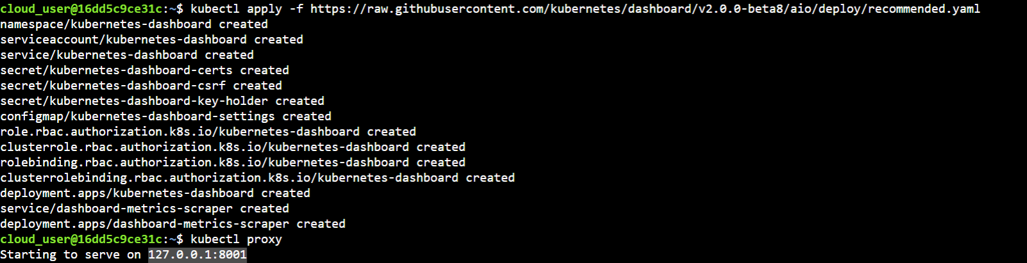

<http://localhost:8001/api/v1/namespaces/kube-system/services/https:kubernetes-dashboard:/proxy/>

