**Student Name: Shiva**

**Student ID: 11716427**

**Email Address: shivavangari36@gmail.com**

**GitHub Link:**

# QUESTION NO 18:

Ten students (a,b,c,d,e,f,g,h,i,j) are going to attend an event. There are lots of gift shops, they all are going to the gift shops and randomly picking the gifts. After picking the gifts they are randomly arriving in the billing counter. The accountant gives the preference to that student who has maximum number of gifts. Create a C or Java program to define order of billed students?

**DESCRIPTION:**

We can consider N no of students and they will be collected random no of gifts. The student

Will be given more preference who has max no of gifts among all students by accountant in the shop. There is no limit to take particular no of gifts from the shop. There will be random arrival(positions of students )by the students to the counter .

**ALGORITHM:**

1. N no. of students has choosen to take gifts
2. Students have given positions and gifts
3. If the no of gifts are equal then the compiler compares the position of the students and display it
4. The students who has more no of gifts while compare to the other students then he will compile first
5. Name of the student and no of gifts will be printed by more to less gifts one by one.

**Entire Code:**

#include<stdio.h>

#include<pthread.h>

#include<semaphore.h>

#include<string.h>

pthread_t t1;

pthread_mutex_t counter;

typedef struct

{

char name[10];

int pos;

int ngift;

}billing;

void *bill()

{

pthread_mutex_lock(&counter);

printf("is getting billed\n");

printf("Wait billing is going on\n");

sleep(2);

pthread_mutex_unlock(&counter);

printf("\n\nNext person\n");

}

int main()

{

int n;

billing d[100],t;

printf("enter no of students for billing\n");

scanf("%d",&n);

printf("enter the students for billing with their positions in a queue\n");

printf("Also enter the no of gifts an individual has for billing\n");

for(int i=0;i<n;i++)

{

scanf("%s",d[i].name);

scanf("%d",&d[i].pos);

scanf("%d",&d[i].ngift);

}

printf("\nsort them on the basis of no of gifts they have for billing\n");

printf("if any of them has equal no of gifts then sort w.r.t position\n");

for(int i=0;i<n;i++)

{

for(int j=0;j<n-i;j++)

{

if(d[j].ngift<d[j+1].ngift)

{

t=d[j];

d[j]=d[j+1];

d[j+1]=t;

}

else if(d[j].ngift==d[j+1].ngift)

{

if(d[j].pos>d[j+1].pos)

{

t=d[j];

d[j]=d[j+1];

d[j+1]=t;

}

}

}

}

for(int i=0;i<n;i++)

{

printf("%s with %d gifts ",d[i].name,d[i].ngift);

}

pthread_exit(NULL);

}

**Complete Solution: -**

**ANSWER:**

enter no of students for billing  
10  
enter the students for billing with their positions in a queue  
Also enter the no of gifts an individual has for billing  
a  
1  
10  
b  
2  
10  
c  
3  
5  
d  
4  
6  
e  
5  
11  
f  
6  
8  
g  
7  
7  
h  
8  
13  
i  
9  
15  
j  
10  
12  
  
sort them on the basis of no of gifts they have for billing  
if any of them has equal no of gifts then sort w.r.t position  
i with 15 gifts   
h with 13 gifts   
j with 12 gifts   
e with 11 gifts   
a with 10 gifts   
b with 10 gifts   
f with 8 gifts   
g with 7 gifts   
d with 6 gifts   
c with 5 gifts

**Test Cases: -**

Test Case1: -

|  |  |  |
| --- | --- | --- |
| Student | gift | position |
| tarun | 6 | 3 |
| viswa | 6 | 2 |
| siva | 5 | 4 |

Sort them on the basis on the basis of no of gifts they have for billing if any of them has equal no of gifts then sort w.r.t position.

Viswa with 6 gifts

Tarun with 6 gifts

Siva with 5 gifts

Reference:-

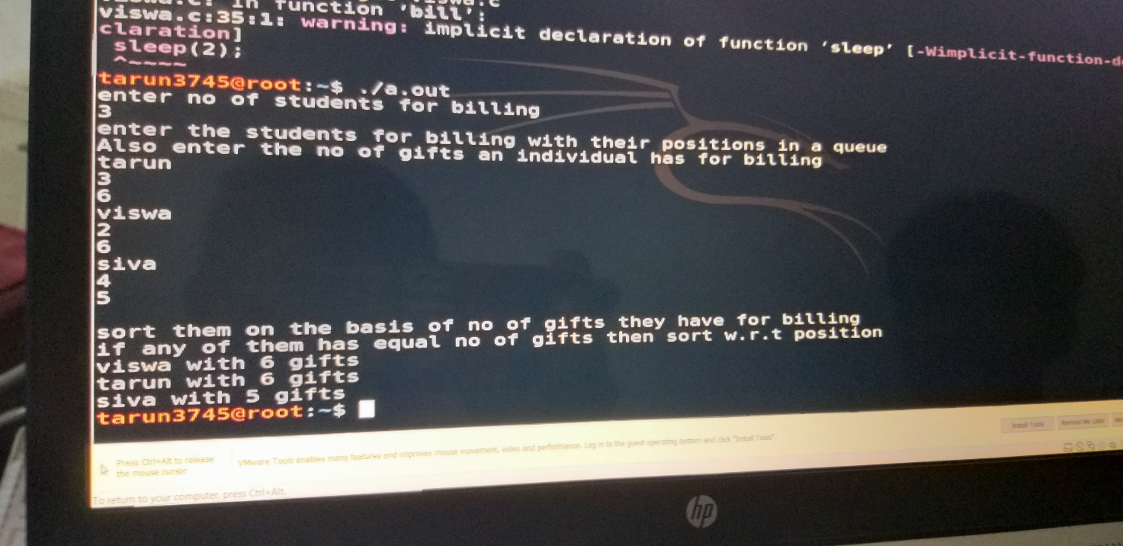

Test Case2: -

|  |  |  |
| --- | --- | --- |
| student | gifts | position |
| kiran | 10 | 0 |
| priya | 15 | 2 |
| nancy | 15 | 1 |
| princy | 5 | 5 |
| fancy | 3 | 4 |

Sort them on the basis on the basis of no of gifts they have for billing if any of them has equal no of gifts then sort w.r.t position.

Fancy with 32617 gifts

Nancy with 15 gifts

Priya with 15 gifts

Kiran with 10 gifts

Princy with 5 gifts

Test Case 3:-

|  |  |  |
| --- | --- | --- |
| student | position | gifts |
| Kedar | 0 | 6 |
| Dhoni | 15 | 20 |
| rayudu | 5 | 2 |
| watson | 6 | 8 |
| bravo | 8 | 10 |
| imran | 12 | 12 |

Sort them on the basis on the basis of no of gifts they have for billing if any of them has equal no of gifts then sort w.r.t position.

In the place of Rayudu there is a presence of some symbols .q.&

.q.& with 1179036 gifts

Dhoni with 20 gifts

Imran with 12 gifts

Bravo with 10 gifts

Watson with 8 gifts

Kedar with 6 gifts

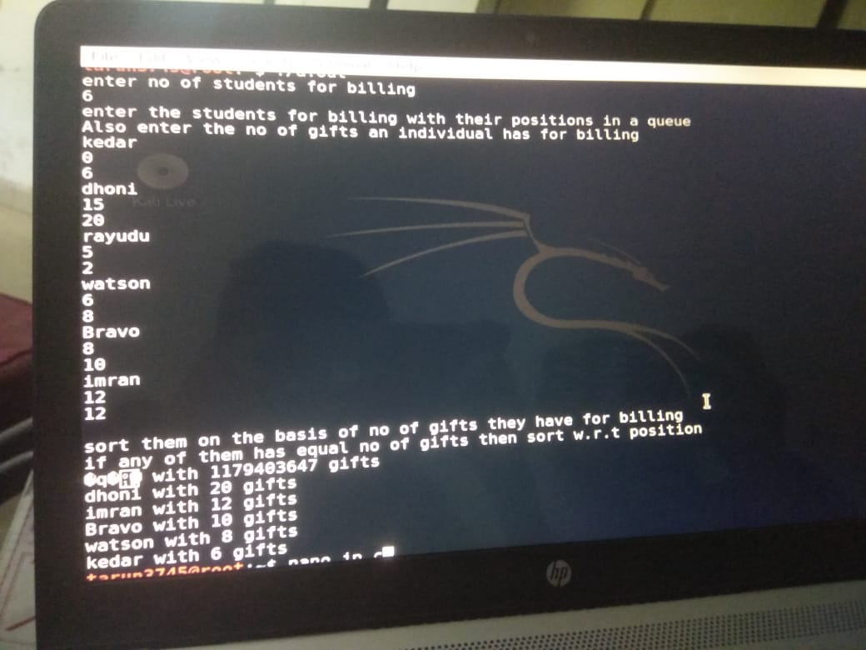

**Constraints: -**

Some Constraints used in my scheduling program are :

* Here, I have declared n no of students as per question, we can assign 10 no of students also

int n;

printf("enter no of students for billing\n");

scanf("%d",&n);

* In this constraint the student name, position and no of gifts has been taken by the compiler

printf("enter the students for billing with their positions in a queue\n");

printf("Also enter the no of gifts an individual has for billing\n");

for(int i=0;i<n;i++)

{

scanf("%s",d[i].name);

scanf("%d",&d[i].pos);

scanf("%d",&d[i].ngift);

}

* Here is the constraint of the given question to sort the gifts in the order of high to low**.**

for(int i=0;i<n;i++)

{

for(int j=0;j<n-i;j++)

{

if(d[j].ngift<d[j+1].ngift)

{

t=d[j];

d[j]=d[j+1];

d[j+1]=t;

}

else if(d[j].ngift==d[j+1].ngift)

* The compiler will give the n no of students list with no of gifts by giving the below constraint (using for loop)

for(int i=0;i<n;i++)

{

printf("%s with %d gifts ",d[i].name,d[i].ngift);

}

pthread_exit(NULL);

}

**Boundary Condition: -**

Here the main boundary condition is to execute the 10 people information after holding the data of 10 students who has maximum no gifts compiler executes his/her data first. who has least no of gifts will be executed last. when the program exceeds a particular limit value put by the compiler or user then the program will get error