MAJOR PROJECT REPORT
Current-State Packaging Data and Digital Readiness Assessment for PPWR Compliance Reporting

Submitted by: ______________________________
Roll No.: _________________________________
Department: ______________________________
College / University: ______________________
Guide: ___________________________________
Academic Year: 2026-2027

Academic prototype using simulated packaging data

Certificate
This is to certify that the project entitled “Current-State Packaging Data and Digital Readiness Assessment for PPWR Compliance Reporting” is a bona fide work carried out by __________________________ under my supervision and guidance in partial fulfilment of the requirements of the academic program.
Project Guide Signature: ____________________
Head of Department: ________________________
Date: _______________

Declaration
I declare that this project report is submitted for academic purposes and that the implementation, analysis and conclusions presented here are based on a simulated case study and publicly available regulatory information. No confidential company data has been used.

Abstract
The European Union Packaging and Packaging Waste Regulation (PPWR), Regulation (EU) 2025/40, introduces a harmonised regulatory framework for packaging and packaging waste. Organisations that place packaging on the EU market need reliable information about packaging composition, weight, recyclability, recycled content, labelling and related evidence. This project develops an academic prototype that evaluates the current state of packaging data and estimates digital readiness for future PPWR compliance activities. The solution centralises packaging records in a lightweight web application, evaluates record completeness through rule-based checks, identifies gaps, calculates readiness indicators and produces a management-oriented report and CSV export. A simulated dataset is used to demonstrate the approach without representing any real organisation. The project shows how data governance, traceability and digital reporting capabilities can be assessed before implementing a production-grade regulatory compliance platform.

Keywords
PPWR, packaging data, compliance reporting, digital readiness, recyclability, recycled content, data governance, Flask, SQLite, sustainability reporting.

Table of Contents
1. Introduction
2. Regulatory and Domain Background
3. Problem Statement
4. Objectives and Scope
5. Existing-State Assessment
6. Proposed System
7. System Requirements
8. Architecture and Data Model
9. Readiness Assessment Methodology
10. Implementation
11. Testing and Results
12. Findings and Recommendations
13. Limitations and Future Scope
14. Conclusion
15. Viva Questions and Answers
References
Appendix A - Sample Data Fields
Appendix B - Installation and Demo Steps

1. Introduction
Packaging compliance increasingly depends on the quality and traceability of product and material data. The challenge is not only whether an organisation intends to comply with regulation, but whether it can reliably identify the packaging placed on the market, quantify its material composition, obtain evidence from suppliers, and transform those facts into structured information for internal and external reporting.
This project focuses on the data-readiness layer. Instead of attempting to implement every legal requirement in PPWR, it asks a practical question: “Is the packaging information currently available, complete, traceable and digitally structured enough to support compliance work?” The prototype provides a repeatable assessment that can be demonstrated with simulated products and packaging records.

2. Regulatory and Domain Background
Regulation (EU) 2025/40 on packaging and packaging waste entered into force on 11 February 2025 and applies from 12 August 2026. The Regulation covers the full life cycle of packaging and includes requirements related to substances in packaging, recyclability, recycled content in plastic packaging, packaging minimisation, labelling, reuse and waste management. The exact applicability and dates vary by provision, packaging category and implementing or delegated acts.

2.1 Examples of PPWR-relevant data domains
- Packaging identity and type: primary, secondary or transport packaging.
- Material composition and component information.
- Packaging mass or weight.
- Recyclability-related design and evidence.
- Post-consumer recycled content for relevant plastic packaging.
- Supplier declarations, certificates and technical evidence.
- Labelling or material-composition information readiness.
- Data lineage, verification date and source system.
The prototype uses these domains as a practical readiness checklist. It does not claim that passing the checklist proves legal compliance. Legal compliance requires product-specific analysis against the Regulation, applicable delegated and implementing acts, harmonised standards and guidance.

3. Problem Statement
In many organisations packaging information is distributed across ERP systems, product lifecycle management tools, spreadsheets, supplier documents, emails and local files. Data may use inconsistent naming conventions, different units of measure and different levels of evidence. This creates four major problems: incomplete information, weak traceability, manual reporting effort and difficulty identifying which records need remediation first.

3.1 Research question
How can a lightweight digital solution assess packaging-data completeness and traceability, identify gaps and provide a simple readiness view that supports PPWR compliance preparation?

4. Objectives and Scope

4.1 Objectives
- Create a structured packaging-data repository for a simulated organisation.
- Define a transparent set of data-readiness checks.
- Calculate record-level and portfolio-level readiness scores.
- Identify missing evidence and weak digital traceability.
- Provide a dashboard, gap analysis and management summary.
- Allow data capture and CSV export for further analysis.
- Document the limitations between academic readiness scoring and legal compliance determination.

4.2 In scope
- Packaging master-data assessment
- Digital readiness scoring
- Simulated packaging dataset
- Browser-based dashboard
- SQLite database
- CSV export
- Management report view

4.3 Out of scope
- Legal certification
- Automated submission to EU or Member State authorities
- Full life-cycle assessment
- Supplier portal integration
- Production cybersecurity and identity management
- Automatic interpretation of every PPWR provision

5. Existing-State Assessment
The current-state model assumes a typical organisation where packaging information exists in multiple systems. The assessment first maps data sources and then evaluates whether core fields are available and governed.
Source | Typical information | Readiness issue
ERP | SKU, product, supplier, market | Packaging attributes may be limited
PLM | Material specification, components | May not contain regulatory evidence
Supplier documents | Declarations and certificates | Often unstructured PDF/email
Spreadsheets | Local packaging trackers | Version control and ownership risk
Email | Ad hoc supplier confirmations | Weak traceability and searchability

5.1 Main current-state risks
- Missing material or weight information
- Unknown recyclability status
- Missing recycled-content values for plastic packaging
- Evidence not linked to the packaging record
- Labelling readiness not assessed
- No verification date
- Inconsistent source-system ownership

6. Proposed System
The proposed solution is a small web application named “PPWR Packaging Compliance Readiness System”. It is designed for demonstration, education and early-stage assessment. Users can review packaging records, add a new record, inspect readiness checks, view gap counts, assess digital readiness and export the dataset.
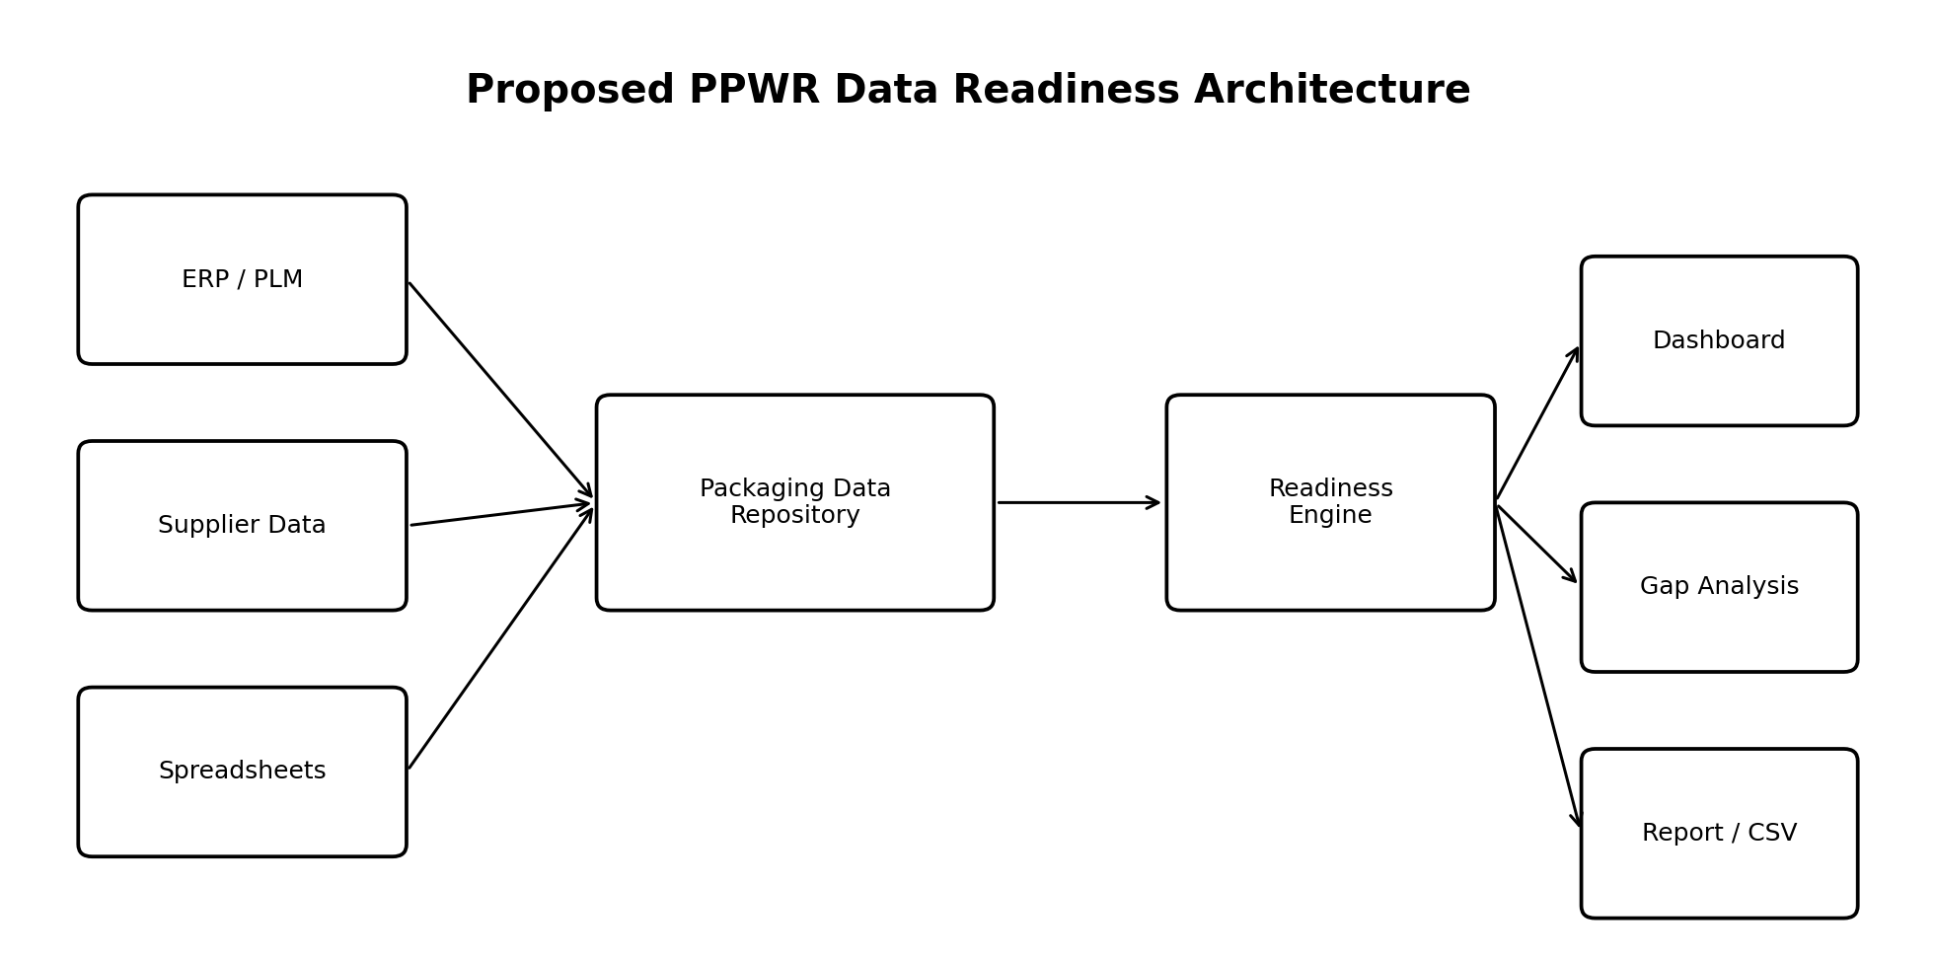
Figure 1. Proposed PPWR data-readiness architecture

7. System Requirements

7.1 Functional requirements
ID | Requirement
FR-01 | Display portfolio-level packaging readiness metrics.
FR-02 | List packaging records with score and status.
FR-03 | Allow a user to add a packaging record.
FR-04 | Assess a record using defined readiness checks.
FR-05 | Identify missing data and evidence.
FR-06 | Calculate digital-readiness dimensions.
FR-07 | Generate a management summary page.
FR-08 | Export packaging data to CSV.

7.2 Non-functional requirements
ID | Requirement
NFR-01 | Simple interface suitable for a college demonstration.
NFR-02 | Low-cost and open-source technology stack.
NFR-03 | Local SQLite database for easy setup.
NFR-04 | Transparent scoring logic that can be explained in a viva.
NFR-05 | No dependency on confidential company data.

8. Architecture and Data Model
The application follows a simple three-layer structure: presentation layer (HTML/CSS), application layer (Flask routes and scoring logic) and data layer (SQLite). The architecture is intentionally lightweight so that the project can be installed on a student laptop and demonstrated locally.

8.1 Core packaging table
Field | Type / example | Purpose
sku | Text | Unique product identifier
product_name | Text | Product description
packaging_level | Primary / Secondary / Transport | Packaging hierarchy
packaging_type | Bottle / Carton / Film | Physical format
material | PET / Glass / Paperboard | Material identity
weight_g | Numeric | Packaging mass
recycled_content_pct | Numeric | Recorded recycled-content percentage
recyclable | Yes / No / Unknown | Current recyclability status
supplier | Text | Packaging supplier
supplier_evidence | Yes / No | Evidence availability
label_ready | Yes / No | Labelling-readiness flag
data_source | ERP / PLM / Spreadsheet etc. | Traceability
last_verified | Date | Evidence freshness / verification
notes | Text | Assessment notes

9. Readiness Assessment Methodology
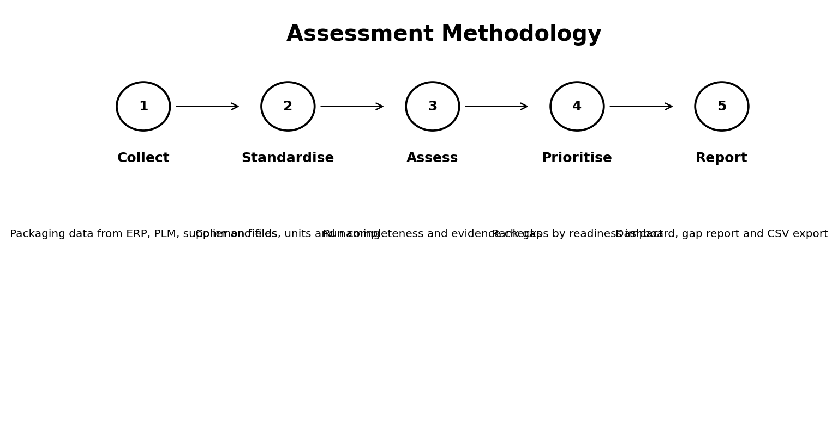
Figure 2. Five-step assessment methodology

9.1 Record-level scoring
Each packaging record is checked against eight readiness criteria. A satisfied criterion contributes one point. The record score is calculated as:
Readiness Score = (Number of Passed Checks / 8) x 100
Check | Pass condition
Material identified | Material value is present and not “Unknown”.
Packaging weight available | Weight is present.
Recycled content recorded | A value is recorded, including 0 where appropriate for the dataset.
Recyclability status recorded | Status is present and not “Unknown”.
Supplier evidence available | Supplier evidence = Yes.
Labelling readiness assessed | Label ready = Yes.
Data source traceable | Source field is present.
Verification date available | Last verified date is present.

9.2 Status bands
Score | Academic status
80-100% | High
60-79% | Medium
0-59% | Low

These bands are project-defined indicators for prioritising data remediation. They are not legal PPWR thresholds.

9.3 Digital-readiness dimensions
- Data completeness
- Evidence availability
- Labelling readiness
- Digital traceability
- Verification freshness

10. Implementation

10.1 Technology stack
Technology | Use
Python | Application logic
Flask | Web framework
SQLite | Local relational database
HTML | User interface structure
CSS | Dashboard styling
CSV | Portable export format

10.2 Main modules
Module | Function
Dashboard | Shows total records, readiness score, status distribution and gap counts.
Packaging Register | Lists all records with material, weight and readiness status.
Add Record | Captures packaging attributes through a form.
Record Assessment | Displays PASS/GAP result for each check.
Gap Analysis | Aggregates missing fields and lists affected records.
Digital Readiness | Calculates five portfolio dimensions.
Compliance Report | Creates a printable management summary.
CSV Export | Exports records with readiness score and status.

10.3 Important source files
File / folder | Purpose
app.py | Flask routes, database initialisation and scoring logic
templates/ | HTML pages
static/style.css | Visual design
data/ppwr.db | SQLite database created on first run
data/sample_packaging_data.csv | Reference sample dataset
README.md | Installation and demo instructions

11. Testing and Results
The project uses a 12-record simulated dataset containing PET, HDPE, PP, glass, paperboard, flexible plastic and multi-layer formats. Some records are intentionally complete while others contain missing evidence, unknown recyclability, missing recycled-content information or missing verification dates. This supports positive and negative test cases.

11.1 Test cases
Test | Input / action | Expected result
T1 | Open dashboard | Metrics and gap counts are displayed.
T2 | Open a complete record | Most or all checks show PASS; readiness is High.
T3 | Open incomplete record | Missing fields show GAP.
T4 | Add a new record | Record is stored and visible in register.
T5 | Open Gap Analysis | Records with missing criteria are listed.
T6 | Open Digital Readiness | Five dimension scores and overall index are displayed.
T7 | Export CSV | Browser downloads a CSV with score and status.
T8 | Print report | Browser print dialog can save the management report as PDF.

11.2 Expected outcome
The prototype converts dispersed packaging attributes into a single structured register and makes missing information visible. The main value is prioritisation: instead of reviewing every product manually, the dashboard identifies which records and data domains need attention first.

12. Findings and Recommendations

12.1 Example findings from the simulated dataset
- Supplier evidence is a frequent weakness in records sourced from spreadsheets or email.
- Labelling-readiness information is not consistently maintained.
- Unknown recyclability creates a direct data gap for assessment.
- Verification dates are useful for distinguishing current evidence from stale records.
- Centralised ERP/PLM or supplier-portal sources provide stronger traceability than uncontrolled spreadsheets and email.

12.2 Recommended target-state actions
- Create an enterprise packaging-data dictionary with agreed units and definitions.
- Assign data owners for packaging specifications and regulatory evidence.
- Link supplier declarations to packaging or component records.
- Add mandatory validation for material, weight, evidence source and verification date.
- Integrate packaging attributes into ERP, PLM or a governed master-data repository.
- Maintain a regulation-to-data mapping showing which PPWR obligations depend on each field.
- Introduce periodic quality checks and change-control processes.
- Design machine-readable exports or APIs once official reporting formats and implementation requirements are confirmed.

13. Limitations and Future Scope
The prototype is intentionally limited. It does not determine legal compliance, calculate all category-specific recycled-content obligations, evaluate design-for-recycling grades, validate restricted substances, manage EPR registrations, or submit official reports. The sample data is simulated and the readiness scoring weights all eight record checks equally.

13.1 Future enhancements
- User login and role-based access
- Document upload and supplier-evidence repository
- API integration with ERP/PLM systems
- Component-level packaging bill of materials
- Country-specific EPR reporting mappings
- Version history and audit trail
- Rules engine for category-specific PPWR obligations
- Automated reminders for evidence expiry
- Interactive charts and trend analysis
- Cloud deployment and secure database

14. Conclusion
The project demonstrates that PPWR preparation is not only a legal interpretation problem; it is also a data-management problem. A company cannot efficiently assess packaging obligations or prepare credible reporting if basic packaging attributes and supplier evidence are missing or scattered. The developed prototype provides a practical way to inventory packaging data, measure completeness, highlight traceability issues and prioritise remediation. Although the application is not a legal-compliance engine, it provides a clear foundation for understanding how digital readiness supports regulatory compliance reporting.

15. Viva Questions and Answers
Q: What is PPWR?
A: PPWR is Regulation (EU) 2025/40 on packaging and packaging waste. It establishes EU-wide requirements covering the life cycle of packaging.
Q: What is the main aim of your project?
A: To assess whether packaging data is complete, traceable and digitally structured enough to support PPWR compliance preparation.
Q: Why did you not call the score a compliance score?
A: Because legal compliance depends on detailed legal and technical requirements. My score measures data readiness only.
Q: Why use SQLite?
A: It is lightweight, requires no separate database server and is suitable for a college demonstration.
Q: Why use Flask?
A: Flask is a simple Python web framework that makes it easy to connect forms, routes, scoring logic and a database.
Q: How is the readiness score calculated?
A: Each record has eight checks. The percentage of passed checks becomes the readiness score.
Q: What is digital traceability?
A: It means knowing where the data came from and being able to connect a packaging record to a governed source rather than relying only on informal files or email.
Q: What is the biggest limitation?
A: The prototype does not make a legal compliance determination and does not implement every PPWR provision or future implementing act.
Q: How can this become an industry project?
A: Integrate it with ERP/PLM, add supplier evidence workflows, implement a regulatory rules engine, audit trails and official reporting interfaces.
Q: What data is simulated?
A: All product, supplier and packaging records in the prototype are fictional or illustrative for academic demonstration.
Q: What happens if evidence is missing?
A: The corresponding readiness check fails, the record score decreases and the gap appears in the gap-analysis page.
Q: How does the project help management?
A: It summarises the portfolio into KPIs and highlights where remediation effort should be focused.

References
- European Union. Regulation (EU) 2025/40 of the European Parliament and of the Council of 19 December 2024 on packaging and packaging waste. Official Journal of the European Union, 22 January 2025. EUR-Lex: https://eur-lex.europa.eu/eli/reg/2025/40/oj/eng
- European Commission. Guidance document for Regulation (EU) 2025/40 on packaging and packaging waste, Commission Notice C/2026/3084, 10 June 2026. EUR-Lex: https://eur-lex.europa.eu/legal-content/EN/TXT/?uri=CELEX:52026XC03084
- European Commission. Packaging and Packaging Waste policy information and related implementing material. Environment Directorate-General / EUR-Lex.
- Python Software Foundation. Python documentation. https://docs.python.org/
- Pallets Projects. Flask documentation. https://flask.palletsprojects.com/
- SQLite Consortium. SQLite documentation. https://www.sqlite.org/docs.html

Appendix A - Sample Data Fields
Category | Example fields
Identity | SKU, product name, packaging level, packaging type
Material | Material, weight, recycled content
Circularity | Recyclable status
Evidence | Supplier, supplier evidence
Reporting readiness | Label readiness, market
Governance | Data source, last verified, notes

Appendix B - Installation and Demo Steps
- Install Python 3.10 or newer.
- Open a terminal in the project folder.
- Create and activate a virtual environment.
- Run: pip install -r requirements.txt
- Run: python app.py
- Open http://127.0.0.1:5000 in a browser.
- Use the demo flow in README.md.

Suggested 5-minute demonstration
- Explain the project problem and PPWR context (45 seconds).
- Show dashboard KPIs and the meaning of readiness (45 seconds).
- Open one high-readiness and one low-readiness record (60 seconds).
- Show Gap Analysis and Digital Readiness pages (60 seconds).
- Add a sample record and export CSV (60 seconds).
- Finish with limitations and future scope (30 seconds).

