**Shiva Kumar Peddapuram**

**811235874**

**Information visualisation Midterm**

1. **Information visualization is the science that unveils the underlying structure of data sets using visual representations.**

Correct Answer: True

Explanation: Information Visualization is the science that unveils the underlying structure of data sets using the visual representation this is the basic definition of information visualisation.

1. **Letters appeared before visual symbols in the history of written languages.**

Correct Answer: True

Explanation:

1. **Which of the following choices uses images, graphs or movies to convey visual information or explanation of data acquired from the real world?**

**Correct Answer: Visualisation**

Explanation: Visualisation is a process where we collect the data and represent the data in different forms like images graphs or movies to convey and explain the information iin the foem of visual of the real time data that is present in the world.

1. ____ is the process through which we can transform continuous variables, models or functions into a discrete form.

**Answer: Discretization.**

Explanation: Discretization is a process through which we can transform continuous variables models or functions into a discrete form.

1. Human cognitive capacity is increasing in direct proportion to the amount of data in the world.

Correct Answer: False

Explanation: Human cognitive capacity is not increasing in direct proportion to the amount of the data in the world.

Human brain can store a data of 2.5 million gigabytes but the real world data is increasing day by day.

1. **The type of visualization created by Dr. Snow to pinpoint the origins of the Cholera epidemic could best be described as a:**

**Correct Answer: Heat Map**

Explanation: Dr.snow used heatmaps I am also attaching the visualisation which was collected from internet

reference: <https://www.theguardian.com/news/datablog/2013/mar/15/john-snow-cholera-map>

1. Human eyes respond to all color in the same amount of time.

Correct Answer: False

Explanation: Human eye can identify one million different colors. Generally a healthy human eye has three types of cone cells, each of which can register about 100 different color shades, amounting to around a million combinations.

I am attaching a image below The curve peaks at 555 nanometres that means under normal lighting conditions, the eye is most sensitive to a yellowish-green color.

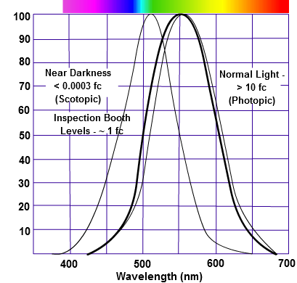

1. Which of the following visualization techniques maps values to colors in a table?

Correct answer: Heat Maps

Explanation:

23.) Visual Cues for user interaction are an important part of dimension manipulation.

Correct Answer: True

Explanation: visual cues,

Explanation: Successful data visualization will be achieved when these four elements are present: information, story, goal and visual inform.

24.) Which of the following are an important way to justify the effectiveness of a visualization?

Artistic Value, Color Scales, Visual Cues

25.) Categorical data has an inherent order to it.

Correct answer: False

Explanation: -

1. Even if the categories can be placed in a natural order, they have no magnitude or units.
2. Categorical variables are those that provide groupings that may have no logical order, or a logical order with inconsistent differences between groups (e.g., the difference between 1st place and 2 second place in a race is not equivalent to the difference between 3rd place and 4th place) differences between groups.