**Applied Statistics Homework-03**

**Name: - Shiva Kumar Peddapuram**

**KSU id: - 811235874**

**Ft. Collins temperature data (Data file: ft Collins temp) The data file gives the mean temperature in the fall of each year, defined as September 1 to November 30, and the mean temperature in the following winter, defined as December 1 to the end of February in the following calendar year, in degrees Fahrenheit, for Ft. Collins, CO (Colorado Climate Center, 2012). These data cover the time from 1900 to 2010. The question of interest is: Does the average fall temperature predict the average winter temperature**

**2.6.1 Draw a scatterplot of the response versus the predictor and describe any pattern you might see in the plot**.

**Explanation: -**

To predict the average winter temperature using average fall temperature, the response (Y) variable will be winter, and the predictor (X) variable will be fall.

The scatter plot of the response versus the predictor using r is as follows: -

**Code:**

**Plot:**

**Explanation:** The above scatter plot shows the plot between the temperature of winter and fall. We can also observe there is no correlation between the response and the predictor variables.

**Conclusion:** - From the above data as we can see the data is scattered all over. Therefore, no pattern is seen in this plot.

**2.6.2 Use statistical software to fit the regression of the response on the predictor. Add the fitted line to your graph. Test the slope to be 0 against a two-sided alternative and summarize your results.**

**Code:**

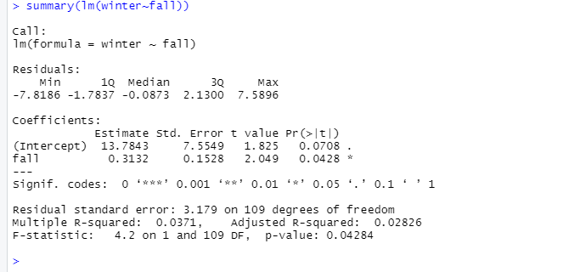

Plot:-

**Explanation:**

|  |
| --- |
| **The filled regression model is Winter (Y) = 13.7843 + 0.3132*fall(X).** |

The "*t* values" test the hypotheses for intercept and slope. i.e. intercept (α) is 0 (H0) Vs α ≠ 0 (H1) and

Slope (β) is 0 (H0) Vs β ≠ 0 (H1). We can conclude slope is 0 or not based on p value.

Here, p value for the slope is 0.0428 which is less than significance level 0.05 and greater than 0.01. i.e., we reject H0(slope is equal to 0) at 5% l.o.s. and accept H0at 1% l.o.s.

Therefore, we can say that slope is equal to 0 at 1% l.o.s. (99% confidence) and slope is not equal to 0 at 5% l.o.s. (95% confidence)

**Conclusion:** We can conclude that fall temperature significantly fits to the model.

**2.6.3 Compute or obtain from your computer output the value of the variability in winter explained by fall and explain what this means.**

**Code: -**

**Explanation:**

To check the variability, variability in winter explained by fall

Let, H0: There is no variability

H1: There is variability

Since the p value is greater than 0.01 and less than 0.05. Therefore, we accept H0 at 1% l.o.s. and reject H0 at 5% l.o.s. Thus, we can say that there is no variability at 1% l.o.s. (99% confidence)

**2.13) Heights of mothers and daughters (Data file: Heights)**

**2.13.1) Compute the regression of dheight on mheight, and report the estimates, their standard errors, the value of the coefficient of determination, and the estimate of variance. Write a sentence or two that summarizes the results of these computations**.

**Answer:**

We need to predict the height of the daughter using the mother height.

Code for the above question:

**Explanation for the above code:**

From the above results we can observe that the slope is 0.54175, Intercept 29.91744, standard error for slope is 0.02596 and intercept is 1.62247 and the coefficient of determination R2 as 0.2408.

To calculate the estimate of variance we use formula square of residual standard error.

Estimate of Variance= (Residual standard error) ^2=(2.266)^2=5.1348  
The value for estimate of variance is 5.1348.

Col Means (Heights)

|  |
| --- |
| mheight Dheight |
| 62.45 63.75 |

var (Heights)

|  |  |  |
| --- | --- | --- |
|  | mheight | Dheight |
| Mheight | 5.547 | 3.005 |
| Dheight | 3.005 | 6.760 |

2.13.2 Obtain a 99% confidence interval for β1 from the data.

Explanation: - To achieve 99% confidence interval we need to use the formula of conflict mentioning 99% as value