I'll analyze your Java microservices project to explain the flow, setup, and configuration. Let me examine the key configuration files.
Perfect! Now I have a clear picture. Let me create a comprehensive explanation of your project's architecture and flow.
Project Overview: Banking Microservices Application
This is a distributed microservices banking system built with Spring Cloud. Here's the complete flow:

🏗️ Architecture Overview
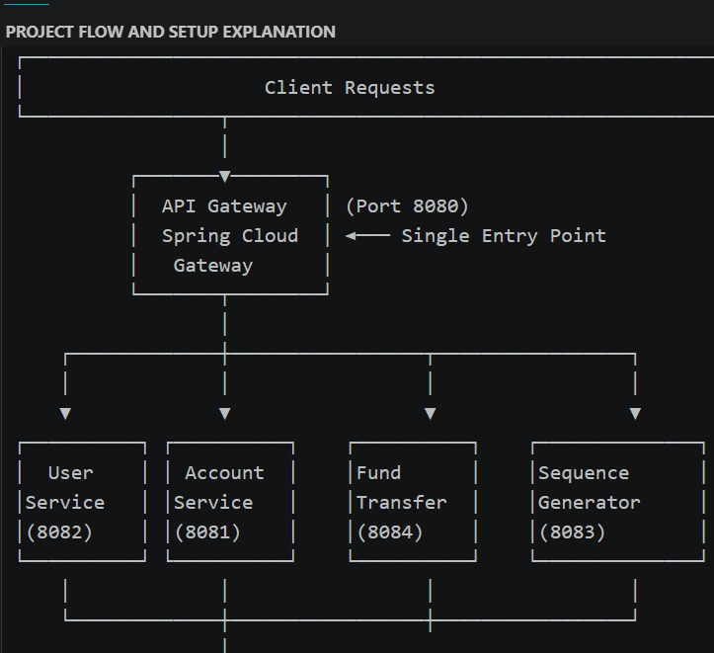
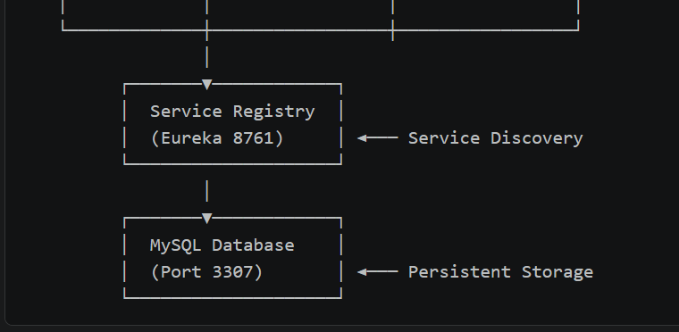

📌 Startup Flow
1️⃣ Database Initialization (MySQL)
- Starts first (port 3307)
- Runs init.SQL automatically
- Creates 5 databases:
  - user_service
  - account_service
  - fund_transfer_service
  - transaction_service
  - sequence_db
2️⃣ Service Registry (Eureka)
- Starts on port 8761
- Configuration: application.properties
- eureka.client.register-with-eureka=false (doesn't register itself)
- Waits for healthy status before other services start
3️⃣ Microservices Registration
Each service connects to Eureka registry. Services and their ports:
- User Service → Port 8082
- Account Service → Port 8081
- Transaction Service → Port 8080 (check docker-compose for actual)
- Fund Transfer → Port 8084
- Sequence Generator → Port 8083 (generates unique IDs)
4️⃣ API Gateway
- Starts last on port 8080
- Waits for Eureka to be healthy
- Becomes the single entry point

🔗 Request Flow Example
When a client makes a request to http://localhost:8080/user-service/users:
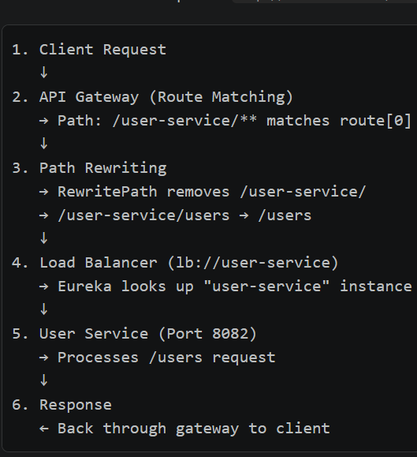

⚙️ Configuration Details

API Gateway Routes (application.properties)
spring.cloud.gateway.routes[0].id=user-service
spring.cloud.gateway.routes[0].uri=lb://user-service
spring.cloud.gateway.routes[0].predicates[0]=Path=/user-service/**
spring.cloud.gateway.routes[0].filters[0]=RewritePath=/user-service/(?<remaining>.*), /${remaining}
- Routes /user-service/** to User Service
- Same pattern for Account, Fund Transfer, Transaction, Sequence Generator
Service Registration (Each service's application.properties)
eureka.client.service-url.defaultZone=http://service-registry:8761/eureka/
eureka.instance.prefer-ip-address=true
spring.application.name=user-service
Database Connection (Each service)
spring.datasource.url=jdbc:mysql://mysql:3306/user_service
spring.datasource.username=root
spring.datasource.password=root
spring.jpa.hibernate.ddl-auto=update

📊 Service Responsibilities
Service | Purpose | Database | Port
User Service | User profiles & authentication | user_service | 8082
Account Service | Bank accounts & balances | account_service | 8081
Transaction Service | Transaction history & records | transaction_service | (varies)
Fund Transfer | Inter-account transfers | fund_transfer_service | 8084
Sequence Generator | Generates unique IDs for transactions | sequence_db | 8083

🚀 How to Start
- docker-compose up
Startup Order (automatically managed):
- MySQL (waits for healthcheck)
- Service Registry (waits for healthcheck)
- All microservices (depends on MySQL & Eureka healthy)
- API Gateway (depends on Eureka healthy)
Access Points:
- API Gateway: http://localhost:8080
- Eureka Dashboard: http://localhost:8761
- Swagger UI: http://localhost:8080/swagger-ui.html
This architecture enables loose coupling, independent scaling, and easy maintenance of individual services! 🏗️

