**SURVEY ASSIGNMENT**

**ON**

**RUMOUR DETECTION**



|  |  |
| --- | --- |
| Supervisor: | Submitted by: |
| Dr. Anupam Bishwas  Assistant Professor  Department Of Computer  Science and Engineering  NIT Silchar (Assam) | Shiva Agarwal  M.Tech Scholar  Reg. No.- 2022111  Department Of Computer Science and Engineering  NIT Silchar (Assam) |

DEPARTMENT OF COMPUTER SCIENCE & ENGG.

NIT SILCHAR

CACHAR – 788010 (ASSAM)

2020

**INTRODUCTION**

Fake or False news is a neologism. Fake information, or fake news sites, have no basis in fact, yet are introduced as being factually accurate.[6] Media scholar Nolan Higdon has argued that the meaning of fake news has been applied also narrowly to choose mediums and political ideologies.[7] Fake news also alludes to stories that are fabricated that obtain next to zero verifiable facts.[8]

Michael Radutzky, a maker of CBS an hour, said his show believes fake news to be "stories that are probably false, have tremendous traction in the way of life, and are devoured by a large number of individuals." These accounts are found in legislative issues, yet in addition in areas like vaccination, stock values and nutrition.[9] He did exclude news that is "summoned by politicians against the media for stories that they don't care for or for remarks that they don't care for" as fake news. Fellow Campanile, also an hour maker said, "What we are talking about are stories that are fabricated out of nowhere. By most measures, deliberately, and by any definition, that's a lie."

The expectation and motivation behind fake news is important. Sometimes, what appears to be fake news may be news satire, which utilizes exaggeration and presents non-factual components that are expected to amuse or make a point, rather than to bamboozle. Propaganda can also be fake news.[6][30] Some researchers have featured that "fake news" may be separated by the falsity of its substance, yet additionally the "character of its online circulation and reception".[31] We see the problem nowadays. The person Talk is "a fanciful story of clarifications of occasions coursing from one individual to another and relating to an article, occasion, or issue in open concern."[1]

In sociologies, gossip includes a type of an explanation whose veracity isn't rapidly or at any point affirmed. Moreover, a few researchers have distinguished talk as a subset of purposeful publicity. Humanism, brain science, and correspondence consider having generally shifting meanings of rumour.[2]

Tales are additionally regularly examined concerning "deception" and "disinformation" (the previous frequently seen as basically bogus and the last seen as intentionally fake, however as a rule from an administration source given to the media or an unfamiliar government). Rumours accordingly have frequently been seen as specific types of other correspondence ideas.

French and German sociology research on talk finds the cutting-edge insightful meaning of it to the German William Stern's spearheading work in 1902.[3] Stern probed gossip, including a "chain of subjects" who passed a story from "mouth to ear" without the option to rehash or clarify it. He tracked down that the story was abbreviated and changed when it arrived at the finish of the chain. His understudy was another pioneer in the field, Gordon Allport.

The trial is like the Chinese Wisper game.

Tales can spread rapidly through social media, and malicious ones can achieve significant economic and social impact. Motivated by this, our paper centres around the task of gossip location; particularly, we are interested in understanding how early we can recognize them. Although there are focused on talk discovery, few are concerned with the circumstance of the location. A effectively recognized malicious talk can still cause significant damage in the event that it isn't find in an ideal manner, and so timing is crucial. To address this, we present a novel philosophy for early talk location. Our model treats social media posts (for example tweets) as a data stream and integrates support learning to learn the number least number of posts needed before we classify an occasion as gossip. Examinations on Twitter and Weibo demonstrate that our model distinguishes bits of hearsay earlier than state-of-the-art frameworks while maintaining accuracy.

**Literature Survey**

**1994 Study on rumour:** "A Psychology of Rumour" was distributed by Robert H. Knapp in 1944. He gives an account of his analysis of more than 1,000 reports during World War II that were imprinted in the Boston Herald's "Rumour Clinic" Column. He characterizes gossip as a suggestion for conviction of topical reference disseminated without official verification. So formidably characterized, talk is nevertheless a special case of informal social communications, including fantasy, legend, and current humour. From fantasy and legend, it is recognized by its emphasis on the topical. Where humour is intended to incite laughter, talk asks for belief. Knapp distinguished three basic characteristics that apply to gossip: they're transmitted by listening in on others' conversations; they give "information" about a "individual, happening, or condition"; and they communicate and gratify "the emotional requirements of the local area."

To define and emphasise on transmission (verbal, which at that point was heard and announced in the newspaper); on content ("topical" means that it can by one way or another be recognized from trivial and private subjects—its domain is public issues); and on gathering ("emotional necessities of the local area" recommend that however, an individual gets it from an individual, it isn't grasped in the individual yet local area or social terms).

Based on his investigation of the newspaper section.

Unrealistic fantasy bits of gossip: reflect public cravings and wanted for results (for example, Japan's oil saves were low, and in this way, World War II would before the long end).

Bogie or fear tales reflect feared results (for example, A foe shock attack is approaching).

Wedge-driving tales plan to subvert bunch loyalty or interpersonal.

Knapp also tracked down that adverse reports were bound to be disseminated than positive bits of gossip. These sorts also differentiate between specific (unrealistic fantasy) and negative (bogie and wedge-driving) tales.

**In 1974 study**: In the 1947 examination, Psychology of Rumour, Gordon Allport and Leo Postman presumed that, "as talk travels it [...] becomes more limited, more succinct, all the more easily grasped and told."[4] This determination was based on a trial of message dispersion between people, which tracked down that 70% of knowledge in a Text were not found in the starting of 5-6 mouth-to-mouth saying.[4]

In the test, a guinea pig was shown an illustration and offered time to look it over. They were then informed to find the scene from memory to a subsequent guinea pig. This subsequent guinea pig was then asked to portray the scene to a third, and so forward and so on. Each individual's propagation was recorded. This cycle was repeated with various illustrations with altogether different settings and substance.

Allport and Postman utilized three terms to portray the development of gossip. They are: levelling, sharpening, and assimilation. Levelling alludes to the deficiency of detail during the transmission cycle; sharpening to the determination of certain details of which to transmit; and assimilation to a twisting in the transmission of information because of subliminal motivations.

Assimilation was seen when guineas pigs depicted the illustrations as they should be nevertheless not as they actually were. For example, in an illustration portraying a battle-scene, guineas pigs often erroneously explained an ambulance in the background of the deceived as taking "medical things," where in fact, it was seen that carrying cases marked "TNT (102)."

**2004 Study on Rumour:** In 2004, Prashant Bordia and Nicholas DiFonzo distributed their Problem answering in their Social Interactions with all on the network: Rumour as Social Cognition and found that gossip transmission is probably intelligent of a "aggregate explanation process."[5] This end was based on an analysis of archived message board conversations in which the statements were coded and analysed. It was tracked down that 29% (the majority) of statements inside these conversations could be coded as "sense-making" statements, which included, "[...] attempts at settling a problem."[5]

**2017 Study of different type of fake news or rumour:**

Claire Wardle identifies seven types of fake or false news:[10]

1. satire (" having no intention to cause harm but mend to fool")
2. false or fake connection ("when headlines, visuals or captions don't seem to match with the content")
3. misleading content ("misleading use of knowledge to frame a point or an individual")
4. false context ("when True content is shared with some fake contextual knowledge")
5. impostor content ("when true information is impersonated" with false, make-up sources)
6. manipulated content ("when True knowledge or imagery is manipulated to deceive", as with a photo)
7. fabricated content ("new content is false, designed or make to do harm")

IFLA distributed a summary in diagram structure (imagined at option) to assist individuals in perceiving fake news.[11] Its main focuses are:

1. Think about the source (to understand its main goal and reason)
2. Read past the headline (to understand the entire story)
3. Check the authors (to check whether they are real and dependable)
4. Assess the supporting sources (to guarantee they support the claims)
5. Check the date of publication (to check whether the story is relevant and exceptional)
6. Ask on the off chance that it is a joke (to decide whether it is meant to be satire)
7. Audit your own biases (to check whether they are affecting your judgment)
8. Ask specialists (to get confirmation from free individuals with knowledge).[12]

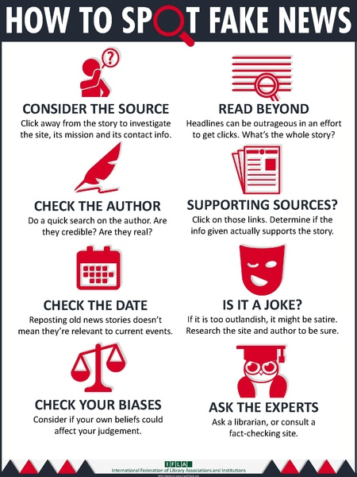

The International Fact-Checking Network (IFCN), launched in 2015, upholds international collaborative endeavours in fact-checking, gives training, and has distributed a code of principles.[13] In 2017 it presented an application and confirming cycle for journalistic organisations.[14] One of IFCN's confirmed signatories, the free, not-for-profit media journal The Conversation, created a short animation explaining its fact checking measure, which includes "extra balanced governance, including blind friend audit by a second academic master, additional examination and editorial oversight".[15]

Starting in the 2017 school year, kids in Taiwan study another educational plan intended to teach critical studying of propaganda and the evaluation of sources. Called "media literacy", the course gives training in journalism in the new information society.[16]

**Methodology**

We are working on different machine learning models and find their accuracy and define various other aspects of that methods.

Problem we are working on nowadays.

The authenticity of the Information has become issue affecting organizations and society, both for printed and digital media [17]. On social organizations, the reach and impacts of information spread happen at such a fast pace and so amplified that mutilated, inaccurate, or false information acquires a colossal potential to cause real-world impacts, in practically no time, for a great many clients. As of late, several public worries about this issue and a few approaches to mitigate the issue were communicated.

The sensationalism of not-so-accurate eye-catching and charming headlines aimed at retaining the attention of audiences to sell information has persevered all since the commencement of all sorts of information broadcast. On social systems administration sites, the reach and impacts of information spread are anyway significantly amplified and happen at a fast pace, that mutilated, inaccurate, or false information acquires a colossal potential to cause real impacts, in practically no time, for a great many clients.

1. Install all the software required, download from internet and run them and install on your machine. List of software is given Below.

* Python
* Jupyter Notebook
* Google Chrome

1. There are all the library that can be install on your machine by using command prompt. For example you want to install Tensorflow just type pip install tensorflow. Same for rest do it.

* Tensorflow
* Sklearn
* Pandas
* Numpy
* Seaborn
* Matplotlib
* Plotly
* Nkld
* Re
* String

1. Download the data set form the link provided above.
2. Now create a folder and paste true.csv and false.csv in that folder.

**Dataset Details**

This has 2 CSV files where one dataset contains fake news and other true news has nearly about **23481 fake news and 21417 true news.**

**Description of columns in the both dataset file:**

* title- contains the headlines of news
* text- contains content or article of the news
* subject- which says about the type of news
* date- the date on which the news was published in the paper

**Pre-processing and Cleaning the dataset**

We have to perform the on the pre-processing steps on the data before performing Data Analysis and giving the data to the different model. Let’s begin with making the output column on the dataset.

**Making the target column**

Make the target column for both fake or false and true news. Here we are going to make the target value as ‘0’ for case of fake or false news and ‘1’ for case of true news.

**Concatenating title and text of information**

News has to be distinguished based on the tile and text mutually. Treating the title and substance of information separately doesn't reap any advantage. Thus, we should concatenate both the segments in both datasets.

Changing the date segments over to datetime format

We can utilize pd.datetime to change our date segments over to date format we want. However, there was an issue, especially in fake_news date section. We should check the value_counts() to perceive what lies inside.

we had connections and news headlines inside the date segment which can give us inconvenience when changing over to datetime format. So how about we eliminate those records from the section.

**Appending two datasets**

At the point when we are giving a dataset to the model, we have to give it as a solitary document. So it's smarter to append both valid and fake news data and preprocess it further and perform EDA.

**Text Processing**

**fake news classification text preparing**

This is an important phase for any content analysis application. There will be a lot of un-helpful substance in the news which can be an obstacle when taking care of to a machine learning model. Except if we eliminate them the machine learning model doesn't work proficiently. How about we go bit by bit.

Just the fake news dataset had an issue with the date segment. Presently we should continue with changing the date section over to datetime format.

**News-Punctuation Cleaning**

How about we start our content preparing by eliminating the punctuations.

**News-Stop words**

A stop word is a normally utilized word, (for example, "the", "a", "an", "in") that a search motor has been programmed to overlook, both when ordering passages for searching and while recovering them as the aftereffect of a search inquiry. We would not like these words to make up space in our database or dataset, or taking up our valuable preparing time. For this, we can eliminate them easily, by putting away a rundown of words that you consider to stop words. Natural Language Toolkit(NLTK) in python language has a come down with the stop words put away in 16 distinct languages.

For our task, we are thinking about the English stop words and eliminating those words

**Story Making and Visualization from news**

In this segment, we will finish do exploratory data analysis on news, for example, ngram analysis and understand which are all the words, setting which is undoubtedly found in fake news.

**Tally of the news subject**

We should start by taking a simple at the include of information types in our dataset.

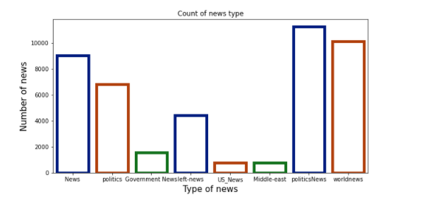

**Bits of knowledge:**

Our dataset has more political news than any other news followed by world news

1. We have some repeated class names which express the same meaning like news, legislative issues, government news, and so on which is similar to the alternative
2. Tally of information subject based on evident or fake
3. How about we take a simple at the tally based on the fake/genuine result.

**Let’s see the graph and see what is same and what is difference on the fake and true news.**

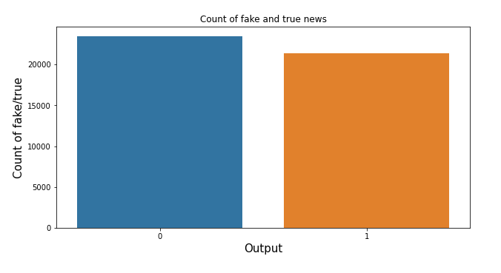

**We are using 5 models and checking there accuracy And** **finding most optimal method for rumour detection.**

1. **Logistic Regression**
2. **Decision Tree Classification**
3. **Gradient Boosting Classifier**
4. **Random Forest Classifier**
5. **Long Short Term Memory (LSTM)**
6. **Bidirectional Long Short Term Memory (Bi-LSTM)**

**Logistic Regression**

Arrangement strategies are a fundamental piece of AI and information mining applications. Roughly 70% of issues in Data Science are grouping issues. There are bunches of grouping issues that are accessible, however the coordination’s relapse is normal and is a helpful relapse technique for taking care of the paired order issue. Another classification of order is Multinomial grouping, which handles the issues where various classes are available in the objective variable. For instance, IRIS dataset an exceptionally acclaimed illustration of multi-class arrangement. Different models are arranging article/blog/archive classification [20].

Calculated Regression can be utilized for different order issues, for example, spam location, rumour detection. Diabetes forecast, if a given client will buy a specific item or will they agitate another contender, regardless of whether the client will tap on a given promotion interface or not, and a lot more models are in the pail.

Calculated Regression is perhaps the most straightforward and ordinarily utilized Machine Learning calculations for two-class characterization. It is not difficult to carry out and can be utilized as the pattern for any parallel arrangement issue. Its essential thing ideas are likewise valuable in profound learning. Calculated relapse depicts and appraises the connection between one ward twofold factor and autonomous factors.

**How do Logistic Regression function in python?**

Model structure in Scikit-learn

Model Evaluation utilizing Confusion Matrix.

**Benefits and Disadvantages of Logistic Regression**

1. Calculated Regression

Calculated relapse is a measurable strategy for anticipating paired classes. The result or target variable is dichotomous in nature. Dichotomous methods there are just two potential classes. For instance, it tends to be utilized for disease identification issues. It figures the likelihood of an occasion event.

It is a unique instance of direct relapse where the objective variable is straight out in nature. It utilizes a log of chances as the reliant variable. Strategic Regression predicts the likelihood of event of a parallel occasion using a logit work.

**Linear Regression Equation:**



Where, y is dependent variable and x1, x2 ... and Xn are explanatory variables.

**Sigmoid Function:**



Apply Sigmoid function on linear regression [21]:



**Properties of Logistic Regression:**

* The reliant variable in strategic relapse follows Bernoulli Distribution.
* Assessment is done through most extreme probability.
* No R Square, Model wellness is determined through Concordance, KS-Statistics.

**Accuracy score and classification Report of logistic Regression**

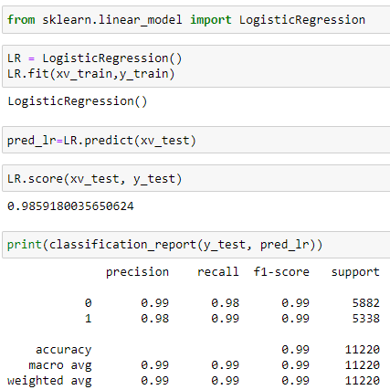

**Decision Tree Classification**

Decision tree assembles order or relapse models as a tree structure. It separates a dataset into more modest and more modest subsets while simultaneously a related choice tree is steadily evolved. The end-product is a tree with choice hubs and leaf hubs[22]. A choice hub (e.g., Outlook) has at least two branches (e.g., Sunny, Overcast and Rainy). Leaf node (e.g., Play) addresses an order or choice. The highest choice hub in a tree which compares to the best indicator called root hub. This tree can deal with both straight out and mathematical information.

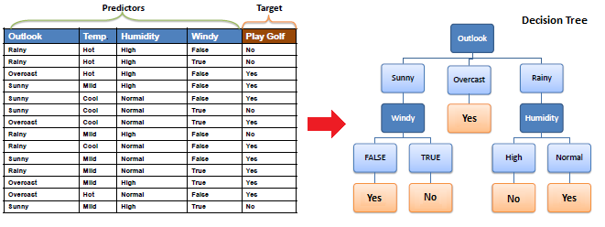

Calculation

The centre calculation for building choice trees called ID3 by J. R. Quinlan which utilizes a top-down, ravenous pursuit through the space of potential branches with no backtracking. ID3 utilizes Entropy and Information Gain to build a choice tree. In ZeroR model [24] there is no indicator, in OneR model we attempt to track down the absolute best indicator, credulous Bayesian incorporates all indicators utilizing Bayes' standard and the autonomy presumptions between indicators however choice tree incorporates all indicators with the reliance suppositions between indicators.

**Accuracy score and classification Report of Decision Tree Classifier**

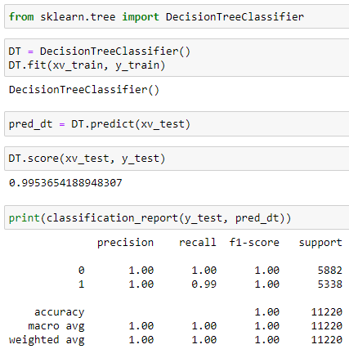

**Gradient boosting classifier**

Inclination boosting is an AI procedure for relapse and arrangement issues, which creates a forecast model as a gathering of frail expectation models, commonly choice trees.[26][27] When a choice tree is the feeble student, the subsequent calculation is called slope helped trees, which as a rule beats irregular forest.[26][27][28] It assembles the model in a phase shrewd style like other boosting techniques do, and it sums them up by permitting streamlining of a self-assertive differentiable misfortune work.

The possibility of angle boosting began in the perception by Leo Breiman that boosting can be deciphered as a streamlining calculation on an appropriate expense function.[31] Explicit relapse slope boosting calculations were in this manner created by Jerome H. Friedman,[29][30] at the same time with the more broad utilitarian angle boosting viewpoint of Llew Mason, Jonathan Baxter, Peter Bartlett and Marcus Frean.[32][33] The last two papers presented the perspective on boosting calculations as iterative practical inclination plunge calculations. That is, calculations that improve an expense work over work space by iteratively picking a capacity (frail theory) that focuses in the negative slope bearing. This useful inclination perspective on boosting has prompted the improvement of boosting calculations in numerous spaces of AI and insights past relapse and grouping.

**Algorithm For Gradient Boosting Classifier**

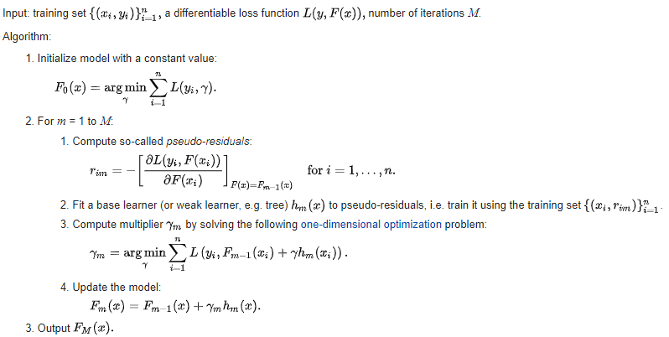

**Accuracy score and classification Report of Gradient boosting classifier**

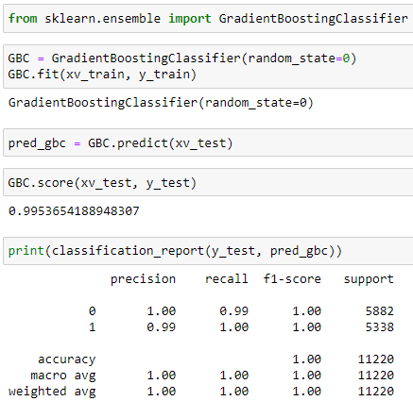

**Random Forest classifier**

Random forests or random choice forests are a troupe learning strategy for order, relapse and different assignments of the work which is developing a large number of choice trees at preparing time and yielding the class that is the Type of the classes (arrangement) or mean/normal expectation (relapse) of the individual trees.[34][35] Random choice forests right for choice trees' propensity for overfitting to their preparation set.[36]:587–588 Random forests for the most part beat choice trees, yet their precision is lower than slope helped trees. Notwithstanding, information attributes can influence their performance.[37][38]

The principal calculation for random choice forests was made by Tin Kam Ho[34] utilizing the random subspace method,[35] which, in Ho's plan, is an approach to execute the "stochastic segregation" way to deal with order proposed by Eugene Kleinberg.[39][40][41]

An augmentation of the calculation was created by Leo Breiman[42] and Adele Cutler,[43] who registered "Random Forests" as a brand name (starting at 2019, possessed by Minitab, Inc.). The expansion joins Breiman's "stowing" thought and random determination of highlights, presented first by Ho[34] and later autonomously by Amit and Geman[44] to develop an assortment of choice trees with controlled fluctuation.

Random forests are often utilized as "blackbox" models in organizations, as they create sensible forecasts across a wide scope of information while requiring little setup in bundles, for example, scikit-learn.

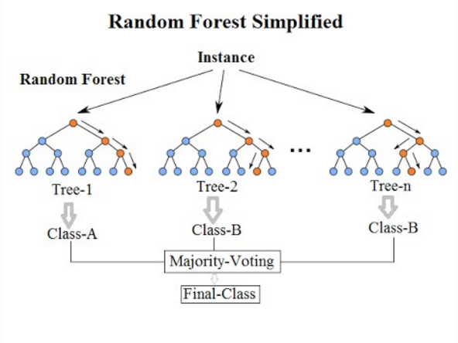

**Accuracy score and classification Report of Random Forest classifier**

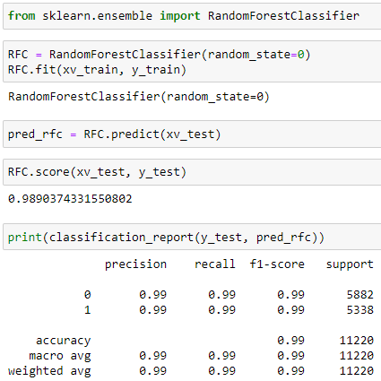

**LSTM (Long Short Term Memory)**

The Long Short Term Memory architecture (LSTM) was inspired by an analysis of blunder stream in existing RNNs, which figured out that long delays were inaccessible to existing architectures, because backpropagated mistake either explodes or decays exponentially[18].

A LSTM layer comprises of a bunch of intermittently associated blocks, known as memory blocks. These squares can be considered as a differentiable adaptation of the memory contributes a digital PC. Each one contains at least one repetitively associated memory cells and three multiplicative units—the info, yield and neglect gates—that give constant analogy of compose, read and reset operations for the cells. All the more accurately, the contribution to the cells is duplicated by the activation of the info gate, the yield to the net is increased by that of the yield gate, and the past cell values are duplicated by the neglect gate. The net can just interact with the cells via the gates.

As of late, we have concentrated on applying LSTM to real world succession handling issues. In particular, we have contemplated isolated word acknowledgment and constant discourse acknowledgment.

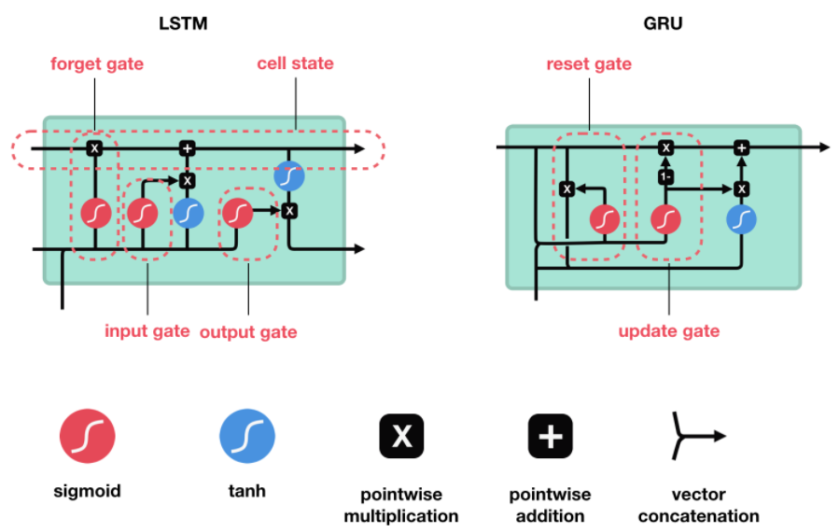

From the beginning, we will build up the base model and gather it. The main layer will be the installing layer which has the contribution of vocabulary size, vector features, and sentence length. Later we add a 30% dropout layer to forestall overfitting and the LSTM layer which has 100 neurons in the layer. In the final layer, we utilize the sigmoid activation work. Later we order the model utilizing ADAM analyser and binary cross-entropy as misfortune work since we have just two yields.

To understand how LSTM functions please check this connection. To give a small outline of how LSTM functions, it recollects just the important succession of words and fails to remember the insignificant words which don't add value to the forecast.

**Checking for accuracy of LSTM model**



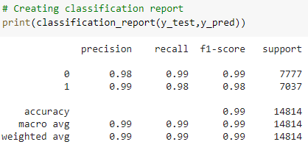

**BIDIRECTIONAL LSTM**

Bi-LSTM is an augmentation of normal LSTM with two autonomous RNN's together. The normal LSTM is unidirectional where it cannot have the foggiest idea about the future words whereas in Bi-LSTM we can foresee the future utilization of words as there is backward information passed on from the other RNN layer backward.

There is just one change made in the code compared to the LSTM, here we utilize Bidirectional() capacity and call LSTM inside[24].

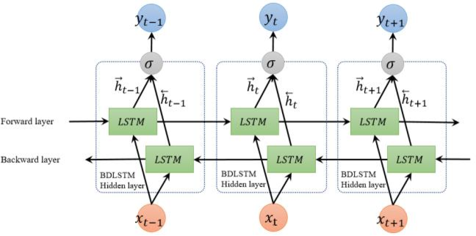

Bidirectional Recurrent Neural Networks

Recurrent neural networks (RNNs) are statistical modelling of serial data. An RNN allows to model the ith component in the sequence based on the past – the components x1: i up to and include it too. The RNN model provides a modelling for ruling on the entire past x1: i without getting back to the Markov assumption, which was used for modelling sequences. RNNs were capable of exploring to count, as well as to model line lengths and complex phenomena such as bracketing and code indentation. Our proposed feature extractors are based on a bidirectional recurrent neural network (BiRNN) which is an extension of RNNs that consider both the past x1: i and the future x i : n.[25] We use a specific flavour of RNN known an extended short-term memory network (LSTM). For brevity, we treat RNN as an abstraction without getting into the mathematical details of the implementation of the RNNs and LSTMs. For more information about RNNs and LSTM. The recurrent neural network (RNN) abstraction is a parameterized function RNN θ ( x1: n ) mapping a sequence of n input vectors x1: n , x i ∈ R din to a series of n output vectors h1:n, hi ∈ Rdout . Each output vector h i is conditioned on all the input vectors x1:i , and can be think of as a summary of the prefix x1: i of x1: n. In our notation, we ignore the intermediate vectors h1: n − 1 and take the output of RNN θ (x1: n) to be the vector hn [24][25].

A bidirectional RNN comprises two

1. RNNs, RNN F
2. RNN R,

one studying the sequence in its regular order and the other studying it in reverse. Concretely, given a series of vectors x1: n and the desired index i, the function B I RNN θ ( x1: n, i ) is defined as:

BIRNNθ(x1:n, i) = RNNF (x1:i) ◦ RNNR(xn:i)

The vector vi = B I RNN ( x1: n, i) is then a representation of the ith thing in x1:n, taking into account both the entire past x1: i and the entire future x i: n by concatenating the matching RNNs. We can view the BiRNN encoding of thing i as representing thing i together with a context of an infinite window around it [19].

Computational Complexity Computing the BiRNN vectors encoding the ith component of a sequence x1: n requires O(n) time to computing the two RNNs and concatenating their outputs. A past approach of adding the bidirectional representation of all n components results in O (n2) computation. However, it is trivial to add the BiRNN encoding of all sequence things in linear time by pre-computing RNN F (x1: n) and RNN R (x n:1), taking the intermediate representations, and concatenating the required components as needed.

**Checking the accuracy of Bidirectional LSTM**

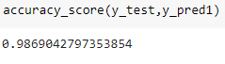

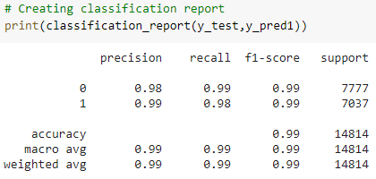

**Conclusion**

We study Different Algorithm and analyse that which algorithm is giving better result with better accuracy.

finding most optimal method for rumour detection.

1. Logistic Regression
2. Decision Tree Classification
3. Gradient Boosting Classifier
4. Random Forest Classifier
5. Long Short Term Memory (LSTM)
6. Bidirectional Long Short Term Memory (Bi-LSTM)

We can see with the above method implementation that LSTM and Bi LSTM is far better in accuracy. Though these algorithms are hard to implement and also the training time on this algorithm is very high. We see that they are complex but give results with better accuracy. Lots of thing are yet to explore in this topic. We can’t say this is best or this is not because you see human are also confused same way machine also.

We have accomplished standard work on preparing the information and building the model. We might have enjoyed changing the n grams while vectorizing the content information. We took 2 words and vectorized them. You can check on the equivalent dataset where we improved outcomes by considering both 1 and 2 words and further more way better outcomes with the assistance of LSTM and Bi-LSTM organization. How about we examine the overall bits of knowledge from the dataset.

A large portion of the phony news is encircled by Election news and about Trump. Considering the US decisions 2020. There are opportunities to get out counterfeit word and the utilization of this innovation will be intensely required.

Counterfeit news is as of now established during this pandemic circumstance to wade into controversy and to startle individuals and power them to purchase merchandise

The majority of the news is from Reuters. We don't know whether this news media is politically affected. So, we ought to consistently think about the wellspring of information to discover if the news is phony or valid.

**References**

1. Peterson, Warren; Gist, Noel (September 1951). "Rumour and Public Opinion." *The American Journal of Sociology*. 57 (2): 159–167. [doi](https://en.wikipedia.org/wiki/Doi_(identifier)):[10.1086/220916](https://doi.org/10.1086%2F220916). [JSTOR](https://en.wikipedia.org/wiki/JSTOR_(identifier)) [2772077](https://www.jstor.org/stable/2772077)
2. Pendleton, S.c. (1998), 'Rumour research revisited and expanded,' *Language & Communication*, vol. 1. no. 18, pp. 69-86
3. L. William Stern, at all. Experimentelle Untersuchungen uber Erinnerungstreue. "Zeitschrift fur die gesamte Strafechtswissuenschaft". Vol. XXII, cahier 2/3, 1902.
4. [Allport, Gordon](https://en.wikipedia.org/wiki/Gordon_Allport); Leo Postman (1951). *Psychology of Rumor*. Russell and Russell. p. 75.
5. Bordia, Prashant and Nicolas DiFonzo ( In March 2004). "Problem Solving in Social media Interactions on the Network: Rumour As Social Cognition". *Social Psychology Quarterly*. **67**(1):33–49. [doi](https://en.wikipedia.org/wiki/Doi_(identifier)):[10.1177/019027250406700105](https://doi.org/10.1177%2F019027250406700105). [JSTOR](https://en.wikipedia.org/wiki/JSTOR_(identifier)) [3649102](https://www.jstor.org/stable/3649102)
6. H. Allcott; M.Gentzkow (2017). ["Social Media and Fake News in the 2016 election"](https://web.stanford.edu/~gentzkow/research/fakenews.pdf) (PDF). *Journal of Economic Perspectives*. **31** (2): 211–236. [doi](https://en.wikipedia.org/wiki/Doi_(identifier)):[10.1257/jep.31.2.211](https://doi.org/10.1257%2Fjep.31.2.211). [S2CID](https://en.wikipedia.org/wiki/S2CID_(identifier)) [32730475](https://api.semanticscholar.org/CorpusID:32730475). Retrieved May 3, 2017.
7. Higdon, Nolan (August 15, 2020). ["The Anatomy of Fake News: A Critical News Literacy Education"](https://www.ucpress.edu/book/9780520347878/the-anatomy-of-fake-news). *University of California Press*. Retrieved September 12, 2020.
8. Desai, Shevon. ["Research Guides: "Fake News," Lies and Propaganda: How to Sort Fact from Fiction: What is "Fake News"?"](https://guides.lib.umich.edu/c.php?g=637508&p=4462356). *guides.lib.umich.edu*. Retrieved November 15, 2020.
9. Lazer, David M. J.; Baum, Matthew A.; Benkler, Yochai; Berinsky, Adam J.; Greenhill, Kelly M.; Menczer, Filippo; Metzger, Miriam J.; Nyhan, Brendan; Pennycook, Gordon; Rothschild, David; Schudson, Michael; Sloman, Steven A.; Sunstein, Cass R.; Thorson, Emily A.; Watts, Duncan J.; Zittrain, Jonathan L. (March 9, 2018). "The science of fake news". *Science*. **359** (6380): 1094-1096.
10. Wardle, Claire (February 16, 2017). ["Fake news. It's complicated"](https://firstdraftnews.org/fake-news-complicated/). firstdraftnews.org. Retrieved April 22, 2017.
11. ["How to Spot Fake News"](http://blogs.ifla.org/lpa/files/2017/01/How-to-Spot-Fake-News-1.jpg). IFLA blogs. January 27, 2017. Retrieved February 16, 2017.
12. Kiely, Eugene; Robertson, Lori (November 18, 2016). ["How to Spot Fake News"](https://www.factcheck.org/2016/11/how-to-spot-fake-news/). *FactCheck.org*. [University of Pennsylvania](https://en.wikipedia.org/wiki/University_of_Pennsylvania) – Annenberg Public Policy Center. Retrieved August 11, 2020.
13. ["International Fact-Checking Network fact-checkers' code of principles"](http://www.poynter.org/fact-checkers-code-of-principles/). Poynter. September 15, 2016. Retrieved March 25, 2017.
14. ["About the International Fact-Checking Network"](http://www.poynter.org/about-the-international-fact-checking-network/). Poynter. December 8, 2016. Retrieved March 25, 2017.
15. Creagh, Sunanda; Mountain, Wes (February 17, 2017). ["How we do Fact Checks at The Conversation"](https://theconversation.com/how-we-do-factchecks-at-the-conversation-73134). *The Conversation*. Retrieved March 2, 2017.
16. Smith, Nicola (on April 6, 2017). ["Schoolkids Will Now Be Taught about How to Identify False News"](http://time.com/4730440/taiwan-fake-news-education/). [*Time*](https://en.wikipedia.org/wiki/Time_(magazine)). Retrieved on April 17, 2017.
17. Álvaro Figueira, Luciana Oliveira, The current state of fake news: challenges and opportunities, Procedia Computer Science, Volume 121,2017, Pages 817-825, ISSN 1877-0509.
18. Alex Graves, Jürgen Schmidhuber, Framewise phoneme classification with bidirectional LSTM and other neural network architectures, Neural Networks, Volume 18, Issues 5–6, 2005,Pages 602-610,ISSN 0893-6080.
19. Kiperwasser, E. and Goldberg, Y., 2016. Simple and accurate methods dependency of the parsing using bidirectional LSTM with feature representations, *4*, pp.313-327.
20. Kleinbaum, David G., K. Dietz, M. Gail, Mitchel Klein, and Mitchell Klein. *Logistic regression*. New York: Springer-Verlag, 2002.
21. Hosmer Jr, David W., Stanley Lemeshow, and Rodney X. Sturdivant. *Applied logistic regression*. Vol. 398. John Wiley & Sons, 2013.
22. Ma, J., Gao, W. and Wong, K.F., 2018. Rumor detection on twitter with tree-structured recursive neural networks. Association for Computational Linguistics.
23. Habib, A., Akbar, S., Asghar, M.Z., Khattak, A.M., Ali, R. and Batool, U., 2018, November. Rumor detection in business reviews using supervised machine learning. *2018 5th International Conference (IC) on the Behavioral, Economic and Socio-Cultural Computing (BESC)* (pp. 233-237). By IEEE.
24. Huang, Z., Xu, W. and Yu, K., 2015. Bidirectional LSTM-CRF models for sequence tagging. *arXiv preprint arXiv:1508.01991*.
25. Ma, Xuezhe, and Eduard Hovy. "End-to-end sequence labeling via bi-directional lstm-cnns-crf." *arXiv preprint arXiv:1603.01354* (2016).
26. Piryonesi, S. Madeh; El-Diraby, Tamer E. (2020-03-01). ["Data Analytics of the Asset Management: and the Way of Cost-Effective Prediction of the Pavement Condition Index"](https://ascelibrary.org/doi/abs/10.1061/%28ASCE%29IS.1943-555X.0000512). *Journal of Infrastructure Systems*. **26** (1): 04019036. [doi](https://en.wikipedia.org/wiki/Doi_(identifier)):[10.1061/(ASCE)IS.1943-555X.0000512](https://doi.org/10.1061%2F%28ASCE%29IS.1943-555X.0000512). [ISSN](https://en.wikipedia.org/wiki/ISSN_(identifier)) [1943-555X](https://www.worldcat.org/issn/1943-555X).
27. Hastie, T.; Tibshirani, R.; Friedman, J. H. (2009). ["10. Boosting and Additive Trees"](https://web.archive.org/web/20091110212529/http:/www-stat.stanford.edu/~tibs/ElemStatLearn/). *The Elements of Statistical Learning* (2nd ed.). New York: Springer. pp. 337–384. [ISBN](https://en.wikipedia.org/wiki/ISBN_(identifier)) [978-0-387-84857-0](https://en.wikipedia.org/wiki/Special:BookSources/978-0-387-84857-0). Archived from [the original](http://www-stat.stanford.edu/~tibs/ElemStatLearn/) on 2009-11-10.
28. Piryonesi, S. Madeh; El-Diraby, Tamer E. (2021-02-01). ["Using Machine Learning to See the Impact of Type of Performance Indicator (PI) on Flexible Pavement Deterioration Modelling (FPDM)"](http://ascelibrary.org/doi/10.1061/%28ASCE%29IS.1943-555X.0000602). *Journal of Infrastructure Systems*. **27** (2): 04021005. [doi](https://en.wikipedia.org/wiki/Doi_(identifier)):[10.1061/(ASCE)IS.1943-555X.0000602](https://doi.org/10.1061%2F%28ASCE%29IS.1943-555X.0000602). [ISSN](https://en.wikipedia.org/wiki/ISSN_(identifier)) [1076-0342](https://www.worldcat.org/issn/1076-0342).
29. Friedman, J. H. (February 1999). ["Greedy Function Approximation: A Gradient Boosting Machine"](https://statweb.stanford.edu/~jhf/ftp/trebst.pdf) (PDF).
30. Friedman, J. H. (March 1999). ["Stochastic Gradient Boosting"](https://statweb.stanford.edu/~jhf/ftp/stobst.pdf) (PDF).
31. Breiman, L. (June 1997). ["Arcing The Edge"](https://statistics.berkeley.edu/sites/default/files/tech-reports/486.pdf) (PDF). *Technical Report 486*. Statistics Department, University of California, Berkeley.
32. Mason, L.; Baxter, J.; Bartlett, P. L.; Frean, Marcus (1999). ["Boosting Algorithms as Gradient Descent"](http://papers.nips.cc/paper/1766-boosting-algorithms-as-gradient-descent.pdf) (PDF). In S.A. Solla and T.K. Leen and K. Müller (ed.). *Advances Done in Neural Information Processing Systems (NIPS) 12*. MIT Press. pp. 512–518.
33. Mason, L.; Baxter, J.; Bartlett, P. L.; Frean, Marcus (May 1999). ["Boosting Algorithms (BA) as Gradient Descent in Function Space"](https://web.archive.org/web/20181222170928/https:/www.maths.dur.ac.uk/~dma6kp/pdf/face_recognition/Boosting/Mason99AnyboostLong.pdf) . Archived from [the original](https://www.maths.dur.ac.uk/~dma6kp/pdf/face_recognition/Boosting/Mason99AnyboostLong.pdf) on 2018-12-22.
34. Ho, Tin Kam (1995). [*Random Decision Forests*](https://web.archive.org/web/20160417030218/http:/ect.bell-labs.com/who/tkh/publications/papers/odt.pdf) (RDF). Proceedings of the 3rd International Conference (IC) on Document Analysis and the Recognition in Montreal, QC, 14–16 August 1995. pp. 278–282. Which Retrieved 5 June 2016.
35. Ho TK (1998). ["The Random Subspace implementation for Constructing the Decision Forests"](http://ect.bell-labs.com/who/tkh/publications/papers/df.pdf) (PDF). *IEEE Transactions on Pattern Judging and Machine or Artificial Intelligence*. **20** (8): 832–844. [doi](https://en.wikipedia.org/wiki/Doi_(identifier)):[10.1109/34.709601](https://doi.org/10.1109%2F34.709601).
36. [Hastie, Trevor](https://en.wikipedia.org/wiki/Trevor_Hastie); [Tibshirani, Robert](https://en.wikipedia.org/wiki/Robert_Tibshirani" \o "Robert Tibshirani); [Friedman, Jerome](https://en.wikipedia.org/wiki/Jerome_H._Friedman) (2008). [*The Components of Statistical Learning*](http://www-stat.stanford.edu/~tibs/ElemStatLearn/) in the book (2nd ed.). Springer. [ISBN](https://en.wikipedia.org/wiki/ISBN_(identifier)) [0-387-95284-5](https://en.wikipedia.org/wiki/Special:BookSources/0-387-95284-5)
37. Piryonesi S. Madeh; El-Diraby Tamer E. (2020-06-01). "Role of the Data Analytics in the Asset Management: Overcoming Data Size problem and Quality Problems". *Journal of the Transportation Engineering, Part B: Pavements*. **146** (2): 04020022. [doi](https://en.wikipedia.org/wiki/Doi_(identifier)):[10.1061/JPEODX.0000175](https://doi.org/10.1061%2FJPEODX.0000175).
38. Piryonesi, S. Madeh; El-Diraby, Tamer E. (2021-02-01). ["Using Machine Learning (ML) to Examine Impact of Type of Performance Indicator (PI) on Flexible Pavement Deterioration modelling (FPDM)"](http://ascelibrary.org/doi/10.1061/%28ASCE%29IS.1943-555X.0000602). *Journal of Infrastructure Systems*. **27** (2): 04021005. [doi](https://en.wikipedia.org/wiki/Doi_(identifier)):[10.1061/(ASCE)IS.1943-555X.0000602](https://doi.org/10.1061%2F%28ASCE%29IS.1943-555X.0000602). [ISSN](https://en.wikipedia.org/wiki/ISSN_(identifier)) [1076-0342](https://www.worldcat.org/issn/1076-0342).
39. Kleinberg E (1990). ["Stochastic that Discrimination"](https://pdfs.semanticscholar.org/faa4/c502a824a9d64bf3dc26eb90a2c32367921f.pdf) (PDF). [*Annals of Mathematics and Artificial Intelligence*](https://en.wikipedia.org/w/index.php?title=Annals_of_Mathematics_and_Artificial_Intelligence&action=edit&redlink=1) *(AI)*. **1** (1–4): 207–239. [CiteSeerX](https://en.wikipedia.org/wiki/CiteSeerX_(identifier)" \o "CiteSeerX (identifier)) [10.1.1.25.6750](https://citeseerx.ist.psu.edu/viewdoc/summary?doi=10.1.1.25.6750). [doi](https://en.wikipedia.org/wiki/Doi_(identifier)):[10.1007/BF01531079](https://doi.org/10.1007%2FBF01531079).
40. Kleinberg E (1996). ["An Overtraining-Resistant Stochastic that is Modeling the Method for Pattern Recognition"](https://doi.org/10.1214%2Faos%2F1032181157).   
    [*Annals of Statistics*](https://en.wikipedia.org/wiki/Annals_of_Statistics). **24** (6): 2319–2349.  [doi](https://en.wikipedia.org/wiki/Doi_(identifier)):[10.1214/aos/1032181157](https://doi.org/10.1214%2Faos%2F1032181157). [MR](https://en.wikipedia.org/wiki/MR_(identifier)) [1425956](https://www.ams.org/mathscinet-getitem?mr=1425956).
41. Kleinberg E (2000). ["On the Algorithmic that gives the Implementation of Stochastic Discrimination"](https://pdfs.semanticscholar.org/8956/845b0701ec57094c7a8b4ab1f41386899aea.pdf)  
     (PDF).  
     *IEEE Transactions on the PAMI*. **22** (5): 473 490. [CiteSeerX](https://en.wikipedia.org/wiki/CiteSeerX_(identifier)" \o "CiteSeerX (identifier)) [10.1.1.33.4131](https://citeseerx.ist.psu.edu/viewdoc/summary?doi=10.1.1.33.4131). [doi](https://en.wikipedia.org/wiki/Doi_(identifier)):[10.1109/34.857004](https://doi.org/10.1109%2F34.857004).
42. [Breiman L](https://en.wikipedia.org/wiki/Leo_Breiman) (in2001). ["Random-Forests"](https://doi.org/10.1023%2FA%3A1010933404324).  [*Machine Learning*](https://en.wikipedia.org/wiki/Machine_Learning_(journal)) *technique study*. **45** (1):5–32.

[doi](https://en.wikipedia.org/wiki/Doi_(identifier)):[10.1023/A:1010933404324](https://doi.org/10.1023%2FA%3A1010933404324).

1. Liaw A (on 16 October 2012). ["Documentation for the R package random-Forest"](https://cran.r-project.org/web/packages/randomForest/randomForest.pdf) (PDF). Retrieved 15 March 2013.
2. Amit Y, [Geman D](https://en.wikipedia.org/wiki/Donald_Geman" \o "Donald Geman) (1997). ["Shape of the quantization and recognition with randomized trees"](http://www.cis.jhu.edu/publications/papers_in_database/GEMAN/shape.pdf) (PDF).  
    [*Neural-Computation*](https://en.wikipedia.org/wiki/Neural_Computation_(journal)). **9** (7):1545-1588. . [doi](https://en.wikipedia.org/wiki/Doi_(identifier)):[10.1162/neco.1997.9.7.1545](https://doi.org/10.1162%2Fneco.1997.9.7.1545).