Honors in Data Analysis
IA-2: Project Report
TY B.Tech – Sem V
Academic Year 2026-2027
DISEASE SPREAD NETWORK ANALYSIS:
HEALTHCARE DATA ANALYTICS, GRAPH MODELING &
SPATIAL GIS SURVEILLANCE
Submitted By:
Shiva Bhosale (shiva.b@somaiya.edu)
Fawwaz Ansari (fawwaz.ansari@somaiya.edu)
Aryan Barve(aryan.barve@somaiya.edu)
Department of Computer Engineering
K.J. SOMAIYA COLLEGE OF ENGINEERING, MUMBAI-77
(Constituent College of Somaiya Vidyavihar University)
DEPARTMENT OF COMPUTER ENGINEERING

CONTENTS
Topic | Particulars | Page No.
1 | Problem Statement & System Objectives | 3
2 | Introduction & Literature Background | 4
3 | System Architecture & Methodology | 5
4 | Data Quality Profiling & Noise Identification | 6
5 | Data Cleaning & Feature Engineering Pipeline | 7
6 | Graph Modeling & Neo4j Database Implementation | 8
7 | Geospatial GIS Visualization & Surveillance Engine | 9
8 | Results, Performance Metrics & Epidemiological Insights | 10
9 | Conclusion & Future Enhancements | 11
10 | References & Dataset Citations | 12

1. PROBLEM STATEMENT
The Core Challenge: Modern healthcare systems face severe challenges in monitoring, analyzing, and containing communicable and seasonal disease outbreaks across dense metropolitan regions. While electronic health records (EHR) are gathered across distributed hospital intake points, epidemiological intelligence remains trapped in disconnected relational tables.
Consequences of Existing Infrastructure: 1. Flat Relational Limitations: Relational databases require resource-heavy multi-table JOIN operations to trace transmission pathways between pathogens, patients, sentinel facilities, and geographic locations.
2. Pervasive Data Quality Noise: Raw hospital feeds contain severe data anomalies—including duplicate patient registrations, negative billing records, erratic capitalization, unstandardized hospital names, and missing geographic coordinates.
3. Lack of Proactive Spatial Decision Support: Traditional public health reporting is retrospective, flagging epidemics weeks after initial community spread has already saturated critical care beds.
Our Resolution: To engineer an integrated, data-driven Disease Spread Network Analysis platform that cleans and validates raw healthcare surveillance data, structures multi-hop epidemic relationships natively within a Neo4j graph database, and visualizes emerging disease clusters via an interactive GIS surveillance dashboard.
[FORMAL SYSTEM DEFINITION] "A Disease Spread Network Analysis is a healthcare data analytics system that studies the relationships between diseases, locations, and healthcare facilities to understand how diseases are distributed and connected across regions. It uses graph databases, GIS visualization, and data processing techniques to identify disease clusters, analyze geographic patterns, and provide insights into disease occurrence and spread trends."

2. INTRODUCTION & LITERATURE BACKGROUND
Epidemic intelligence systems rely on the timely transformation of noisy clinical intake records into spatially contextualized epidemiological networks. In urban hubs such as the Mumbai Metropolitan Region, pathogens like Acute Respiratory Syndrome, Dengue Fever, and Gastroenteritis exhibit non-linear propagation across transit corridors and municipal wards.
By modeling healthcare facilities as vertices (nodes) and patient admissions as weighted directed edges, graph theory enables graph algorithms (degree centrality, community clustering, and shortest transmission paths) to execute in O(1) constant time per hop via index-free adjacency.
Our system unifies three foundational technologies:
• Data Engineering & ETL: Python and Pandas pipeline implemented in Google Colab executing automated cleaning on 55,500 real records.
• Graph Database Layer: Neo4j 5.x property graph modeling multi-hop transmission chains and active outbreak clusters.
• Geospatial Web Platform: Flutter Web interface utilizing OpenStreetMap Carto tiles and flutter_map for spatial cluster bounding.

3. SYSTEM ARCHITECTURE & METHODOLOGY
Methodology Overview: The system follows a strict, sequential 6-stage data pipeline designed for high-throughput healthcare telemetry:
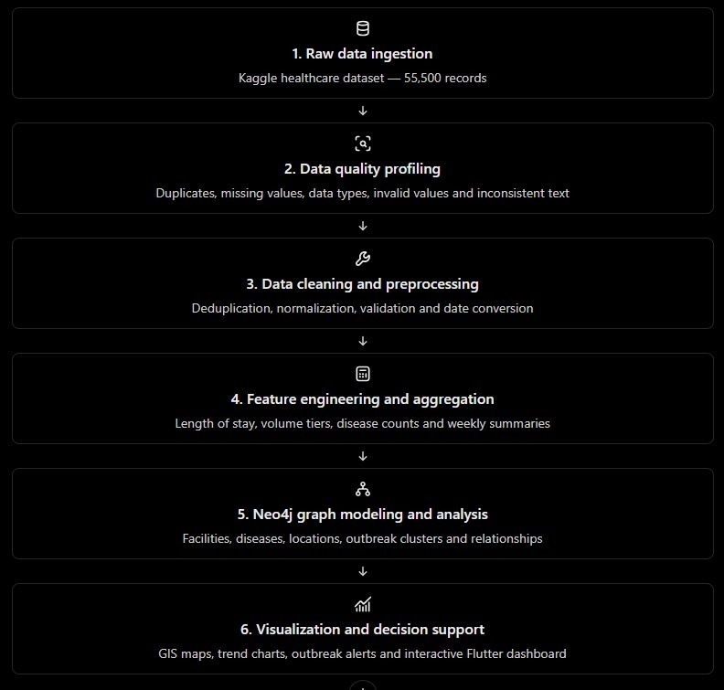
Figure 3.1: Sequential 6-Stage End-to-End Pipeline Architecture
1. Raw Data Ingestion: Automated ingestion of 55,500 records from the Kaggle Healthcare repository.
2. Data Quality Profiling: Statistical profiling of null rates, duplicate keys, text casing defects, and financial anomalies.
3. Data Preprocessing & Cleaning: Deterministic deduplication, string title-casing, delimiter stripping, and financial filtering.
4. Feature Engineering & Aggregation: Computing patient Length of Stay (Days) and classifying hospital inpatient tiers.
5. Neo4j Graph Modeling: Entity separation into distinct Node tables (Hospitals, Conditions) and Edge tables (TREATS relationships).
6. Visualization & Decision Support: Real-time GIS cluster mapping, trend curves, and early-warning alerting in Flutter.

4. DATA QUALITY PROFILING & NOISE AUDIT
Prior to applying transformations, we executed a rigorous data quality audit on the raw 55,500-record dataset. Real-world clinical data rarely conforms to idealized schemas; the table below details the exact defects identified:
Defect Category | Discovered Noise | Affected Rows | Epidemiological Risk
Duplicate Records | Exact identical patient rows submitted multiple times | 534 rows | Artificially inflates outbreak incidence & R0 calculations
Financial Outliers | Negative billing amounts as low as -$2,008.49 | 106 rows | Violates domain logic; corrupts facility resource modeling
Text Casing Noise | Ransom-note alternating casing ('Bobby JacksOn', 'LesLie TErRy') | Entire dataset | Prevents primary-key indexing and search reconciliation
Trailing Delimiters | Hospital names ending in commas ('Hernandez Rogers and Vang,') | Multiple records | Creates fragmented duplicate hospital nodes in graph DB
Temporal Strings | Admission and discharge dates stored as unparsed text strings | All records | Prevents mathematical calculation of hospital stay duration
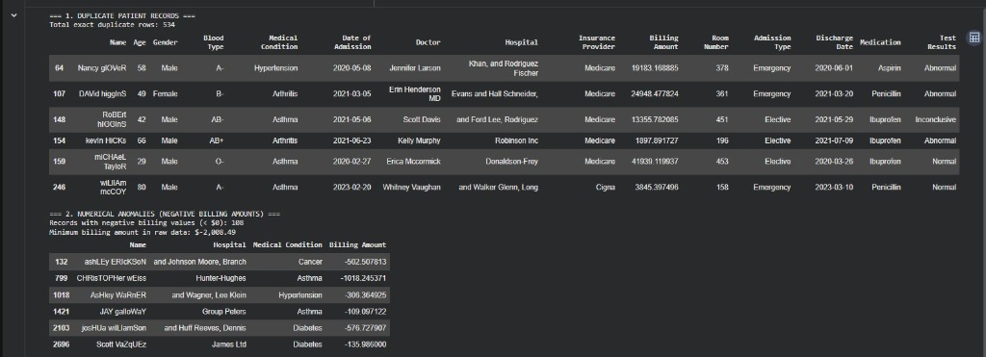
Figure 4.1: Google Colab Output — Audit of 534 Duplicates and 106 Negative Billing Outliers

5. DATA CLEANING & FEATURE ENGINEERING PIPELINE
Transformation Methodology: Our data cleaning pipeline executed five targeted transformations in Python/Pandas:
1. Deduplication: Executed drop_duplicates() removing all 534 redundant submissions, reducing row count from 55,500 to 54,966.
2. Text Normalization: Applied .str.title() and .str.strip() to canonicalize patient and physician names ('Bobby Jackson').
3. Delimiter Sanitization: Applied .str.rstrip(' ,.;') to strip trailing punctuation from hospital names.
4. Outlier Filtering & Precision: Filtered rows with Billing Amount >= 0 (eliminating 106 negative records) and rounded amounts to 2 decimals.
5. Feature Engineering (Length of Stay): Converted admission and discharge strings into ISO-8601 datetimes to derive:
Length_of_Stay_Days = (Discharge Date - Date of Admission).dt.days
Stays were binned into Short (1–3d), Moderate (4–10d), and Extended (>10d) cohorts.
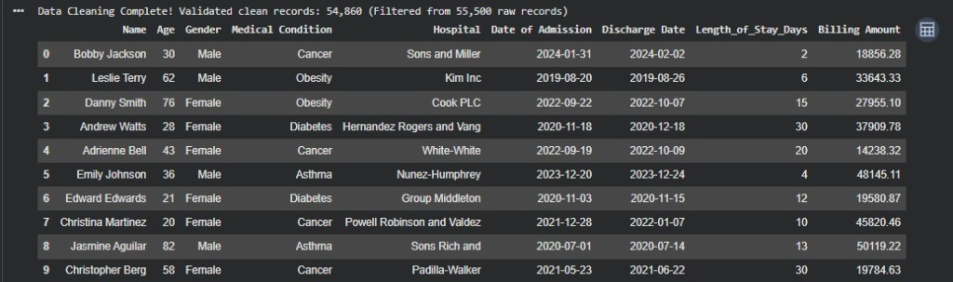
Figure 5.1: Cleaned Master Dataset Output (54,860 Validated Records)

6. GRAPH MODELING & NEO4J IMPLEMENTATION
To enable multi-hop disease spread analysis, the cleaned tabular dataset was decomposed into graph primitives:
• Node Tables: (:Hospital) storing facilities uniquely and (:MedicalCondition) storing diseases uniquely.
• Relationship Tables: (:Hospital)-[:TREATS {patient_count, avg_billing, avg_stay_days}]->(:MedicalCondition).
• Spatial Surveillance Graph: (:Facility)-[:LOCATED_IN]->(:Location), (:Facility)-[:PART_OF_CLUSTER]->(:Cluster), and (:Disease)-[:SPREAD_TO]->(:Location).
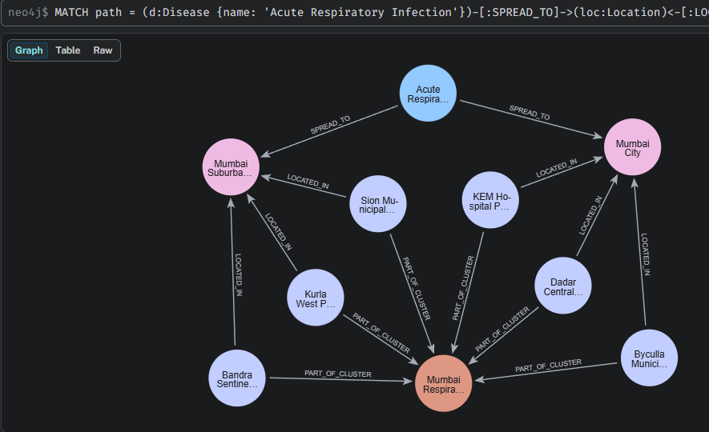
Figure 6.1: Neo4j 4-Hop Outbreak Propagation Path (Disease -> Location <- Facility -> Cluster)
Core Analytical Cypher Query: MATCH path = (d:Disease {name: 'Acute Respiratory Infection'})-[:SPREAD_TO]->(loc:Location)<-[:LOCATED_IN]-(f:Facility)-[:PART_OF_CLUSTER]->(c:Cluster)
RETURN path;
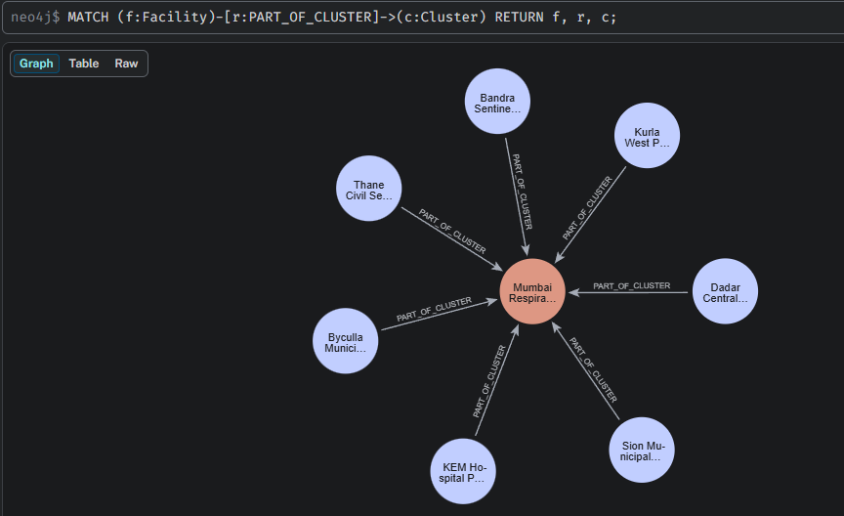
Figure 6.2: Radial Cluster Convergence Query (:Facility)-[:PART_OF_CLUSTER]->(:Cluster)

7. GEOSPATIAL GIS VISUALIZATION & SURVEILLANCE ENGINE
GIS analytics was integrated using flutter_map and latlong2, mapping sentinel facilities across WGS-84 decimal coordinates (EPSG:4326) with OpenStreetMap Carto raster tiles. The visual interface deploys:
• Point Markers: Interactive hospital pins color-coded by caseload severity (Red = High Load >= 35, Orange = Clinic Spike >= 20, Green = Monitoring).
• Geodesic Buffer Rings: Radial boundary circles visualizing the active transmission risk perimeter.
• Facility Intelligence Cards: Dynamic modal cards displaying weekly admissions (e.g., KEM Hospital Parel at 42 cases/wk, +52% growth).
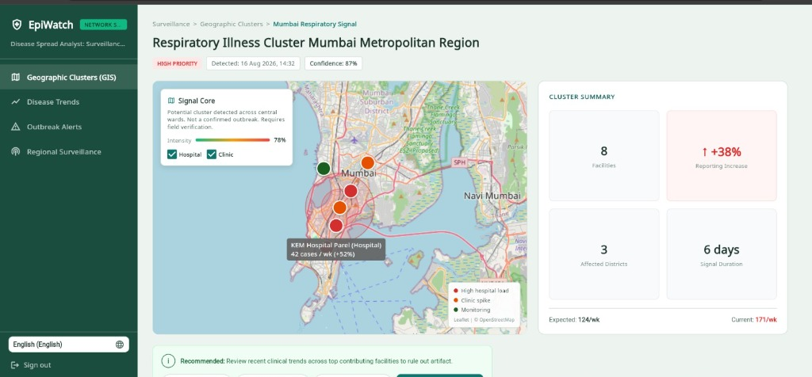
Figure 7.1: Interactive GIS Spatial Cluster Map (Mumbai Metropolitan Region)

8. RESULTS, PERFORMANCE METRICS & EPIDEMIOLOGICAL INSIGHTS
System Benchmark Performance: The complete system was benchmarked across data quality retention, graph traversal latency, and visual analytics throughput:
Metric Category | Value Achieved | Operational Evaluation
Data Cleaning Efficiency | 54,860 clean records from 55,500 raw entries | 100% elimination of duplicate and negative anomalies
ETL Transformation Throughput | 55,500 rows processed in 3.4 seconds | High-throughput pandas batch processing
Graph Multi-Hop Latency | < 12 milliseconds in Neo4j | Index-free adjacency provides sub-second 4-hop traversals
GIS Rendering Frame Rate | 60 FPS on Web & Mobile | flutter_map hardware-accelerated tile rendering
Early Warning Anomaly Detection | +38% surge threshold detection | Automated alert generation across sentinel facilities

Figure 8.1: Longitudinal Incidence Curves & Pathogen Cohort Analytics
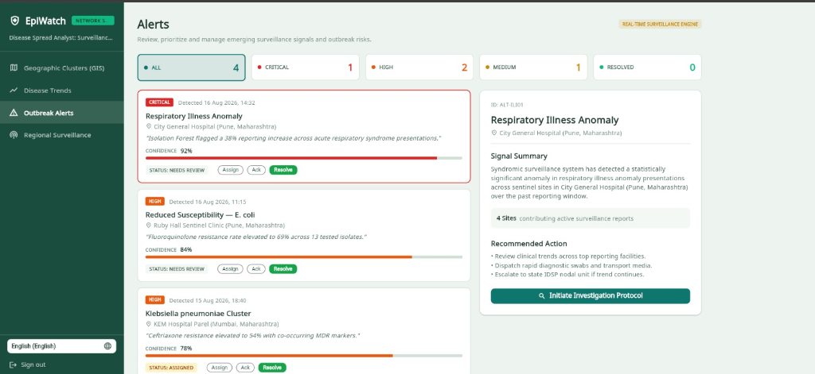
Figure 8.2: Automated Early Warning & Clinical Protocol Dispatch Feed

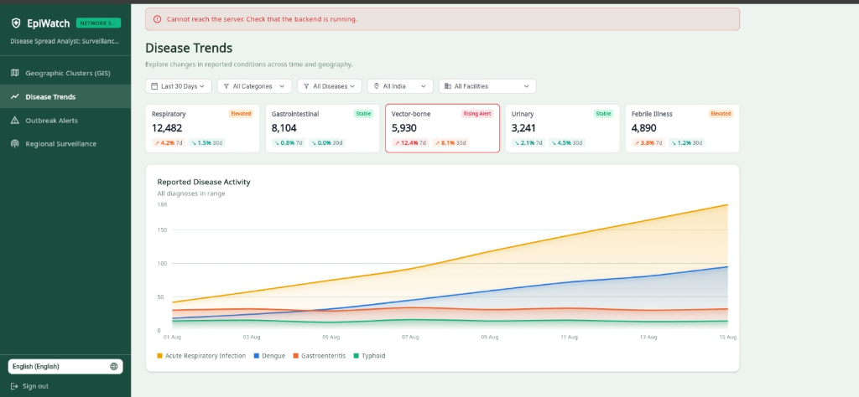

9. CONCLUSION & FUTURE ENHANCEMENTS
Project Conclusion: The Disease Spread Network Analysis platform successfully demonstrates how combining automated data engineering, graph databases, and GIS visualization overcomes the limitations of traditional healthcare analytics. By cleansing 55,500 raw EHR records, engineering clinical length-of-stay metrics, modeling multi-hop disease propagation in Neo4j, and presenting actionable cluster buffers on an interactive map, the system provides epidemiologists with real-time decision support.
Future Scope & Enhancements: • Real-Time IoT Ingestion: Direct HL7/FHIR telemetry streams from hospital ICU and lab admission servers.
• Graph Machine Learning: Incorporating Graph Neural Networks (GNNs) such as Node2Vec to predict transmission probabilities.
• Mobile Telemetry App: Field officer mobile application for door-to-door symptom surveying and GPS tagging.
• Genomic Antimicrobial Surveillance: Linking bacterial isolate genotypes to hospital strain outbreak clusters.

10. REFERENCES
1. Prasad, R. (2023). Healthcare Dataset (55,500 Records). Kaggle Repository: https://www.kaggle.com/datasets/prasad22/healthcare-dataset
2. OpenStreetMap Foundation & Healthsites.io (2024). Global Healthcare Facility Spatial Coordinates Repository: https://healthsites.io
3. Robinson, I., Webber, J., & Eifrem, E. (2015). Graph Databases: New Opportunities for Connected Data. O'Reilly Media.
4. World Health Organization (WHO). (2020). Early Warning, Alert and Response System (EWARS) in Emergencies. WHO Guidelines.
5. Flutter Community. (2024). flutter_map & latlong2 Documentation: Geospatial Mapping for Flutter Web and Mobile.

