**1.Exception Handling**

import java.io.*;

import java.util.*;

class Ageexcp extends Exception {

public Ageexcp(String m) {

super(m);

}

}

class Stringexcp extends Exception {

public Stringexcp(String m) {

super(m);

}

}

class Pinexcp extends Exception {

public Pinexcp(String m) {

super(m);

}

}

public class Election {

public void valid(int age) throws Ageexcp {

if (age < 18) {

throw new Ageexcp("You are not eligible to Vote ");

}

else {

System.out.println("You are eligible to Vote ");

}

}

public void strvalid(String name) throws Stringexcp {

if (!name.matches("[a-zA-Z]+")) {

throw new Stringexcp("Please enter only Alphabets");

}

}

public void pinvalid(int pin) throws Pinexcp {

String pinstring = String.valueOf(pin);

if (!pinstring.matches("\\d{6}")) {

throw new Pinexcp("Pin number should be strictly 6 digits");

}

}

public static void main(String[] args) {

Scanner sc = new Scanner(System.in);

Election e = new Election();

try {

System.out.println("Enter Elector's Name : ");

String name = sc.nextLine();

e.strvalid(name);

System.out.println("Enter Elector's Age : ");

int userage = sc.nextInt();

e.valid(userage);

sc.nextLine();

System.out.println("Enter Father's name :");

String fname = sc.nextLine();

e.strvalid(fname);

System.out.println("Enter Address : ");

String addr = sc.nextLine();

System.out.println("Enter PINCODE :");

int pincode = sc.nextInt();

e.pinvalid(pincode);

sc.nextLine();

System.out.println("Enter Taluk : ");

String taluk = sc.nextLine();

System.out.println("==== Voter Id ==== \nElector's Name :"+name+"\nElector's Father's name :" + fname + "\nAge :" + userage + "\nAddress :" + addr + "\nPincode :" + pincode + "\nTaluk :" + taluk);

} catch (Ageexcp exp) {

System.out.println("Exception Caught : "+exp.getMessage()+"\nWait until 18 to Vote...");

} catch (Stringexcp exp) {

System.out.println("Exception Caught : "+exp.getMessage());

} catch (Pinexcp exp) {

System.out.println("Exception Caught : "+exp.getMessage());

}

}

}

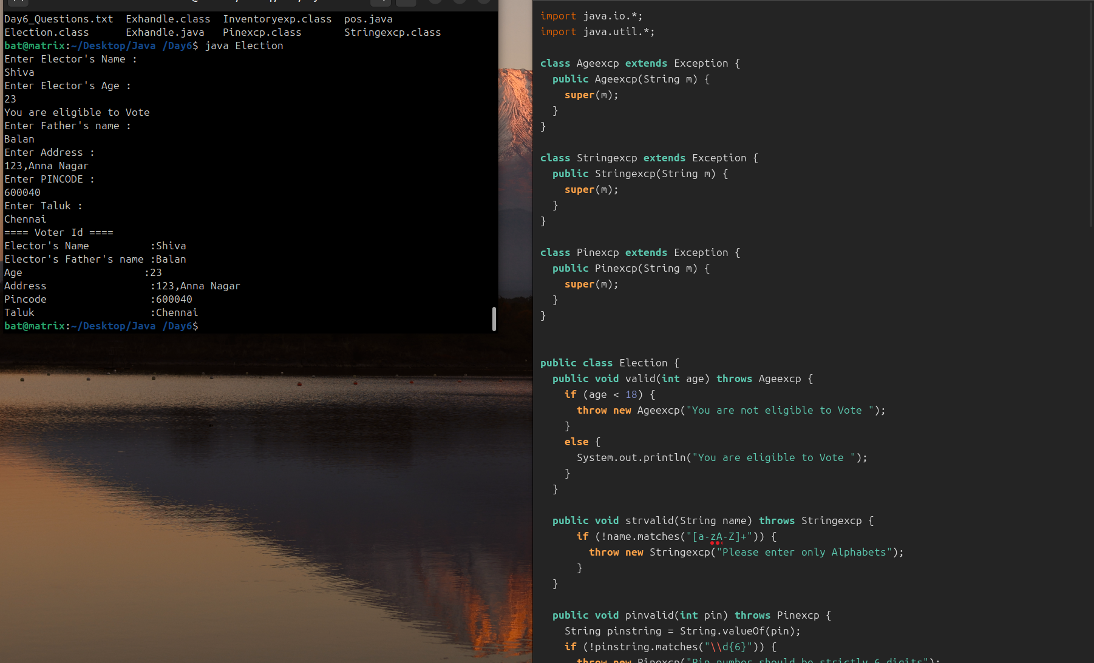

**Output :**

Enter Elector's Name :

Shiva

Enter Elector's Age :

23

You are eligible to Vote

Enter Father's name :

Balan

Enter Address :

123,Anna Nagar

Enter PINCODE :

600040

Enter Taluk :

Chennai

==== Voter Id ====

Elector's Name :Shiva

Elector's Father's name :Balan

Age :23

Address :123,Anna Nagar

Pincode :600040

Taluk :Chennai

**2.pos - basic with exception**

import java.util.*;

class Invalidexp extends Exception {

public Invalidexp(String m) {

super(m);

}

}

public class pos {

static String[] items = {"Apple","Banana","Carrot","Drumstick","Egg plant"};

static void display() {

System.out.println("Available Items are : ");

for (int i = 0; i<items.length;i++) {

System.out.println(i+" "+items[i]);

}

}

static void valid(int qty, double mrp,double sp) throws Invalidexp {

if (qty <= 0) throw new Invalidexp("Quantity must be greater than zero");

if (sp > mrp) throw new Invalidexp("Selling Price cant be greater than the MRP");

if (mrp <=0 || sp <=0) throw new Invalidexp("Price must be greater than zero");

}

public static void main (String[] args) {

Scanner sc = new Scanner(System.in);

double grandtotalmrp = 0;

double grandtotalsp = 0;

try {

System.out.println("Welcome to SHIVA SUPERMARKET");

boolean addItem = true;

while(addItem) {

display();

System.out.print("\nEnter item Number : ");

int choice = sc.nextInt();

String item = items[choice];

System.out.println("\nEnter quantity :");

int qty = sc.nextInt();

System.out.println("\nEnter MRP per Unit :");

double mrp = sc.nextDouble();

System.out.println("\nEnter SP per Unit :");

double sp = sc.nextDouble();

valid(qty,mrp,sp);

double totalmrp = qty * mrp;

double totalsp = qty * sp;

double savings = totalmrp - totalsp;

grandtotalmrp += totalmrp;

grandtotalsp += totalsp;

System.out.println("------------------------------");

System.out.println("Item : "+item);

System.out.println("Quantity : "+qty);

System.out.println("MRP/unit : "+mrp);

System.out.println("SP/unit : "+sp);

System.out.println("Total MRP : "+totalmrp);

System.out.println("Total SP : "+totalsp);

System.out.println("Savings : "+savings);

System.out.println("------------------------------");

System.out.println("Do you want to add items : ");

int addon = sc.nextInt();

if(addon == 0)

addItem = false;

}

System.out.println("\n==== Grand Total ====");

System.out.println("Total MRP :"+grandtotalmrp);

System.out.println("Amount Paid :"+grandtotalsp);

System.out.println("Total Savings :"+(grandtotalmrp-grandtotalsp));

}catch (ArrayIndexOutOfBoundsException e) {

System.out.println("Exception : Item doesnot Exist");

}catch (NumberFormatException e) {

System.out.println("Exception : Enter only valid Input");

}catch (Invalidexp e) {

System.out.println("Exception : "+e.getMessage());

}catch (Exception e) {

System.out.println("Exception : "+e.getMessage());

} finally {System.out.println("***Thanking You***");}

}

}

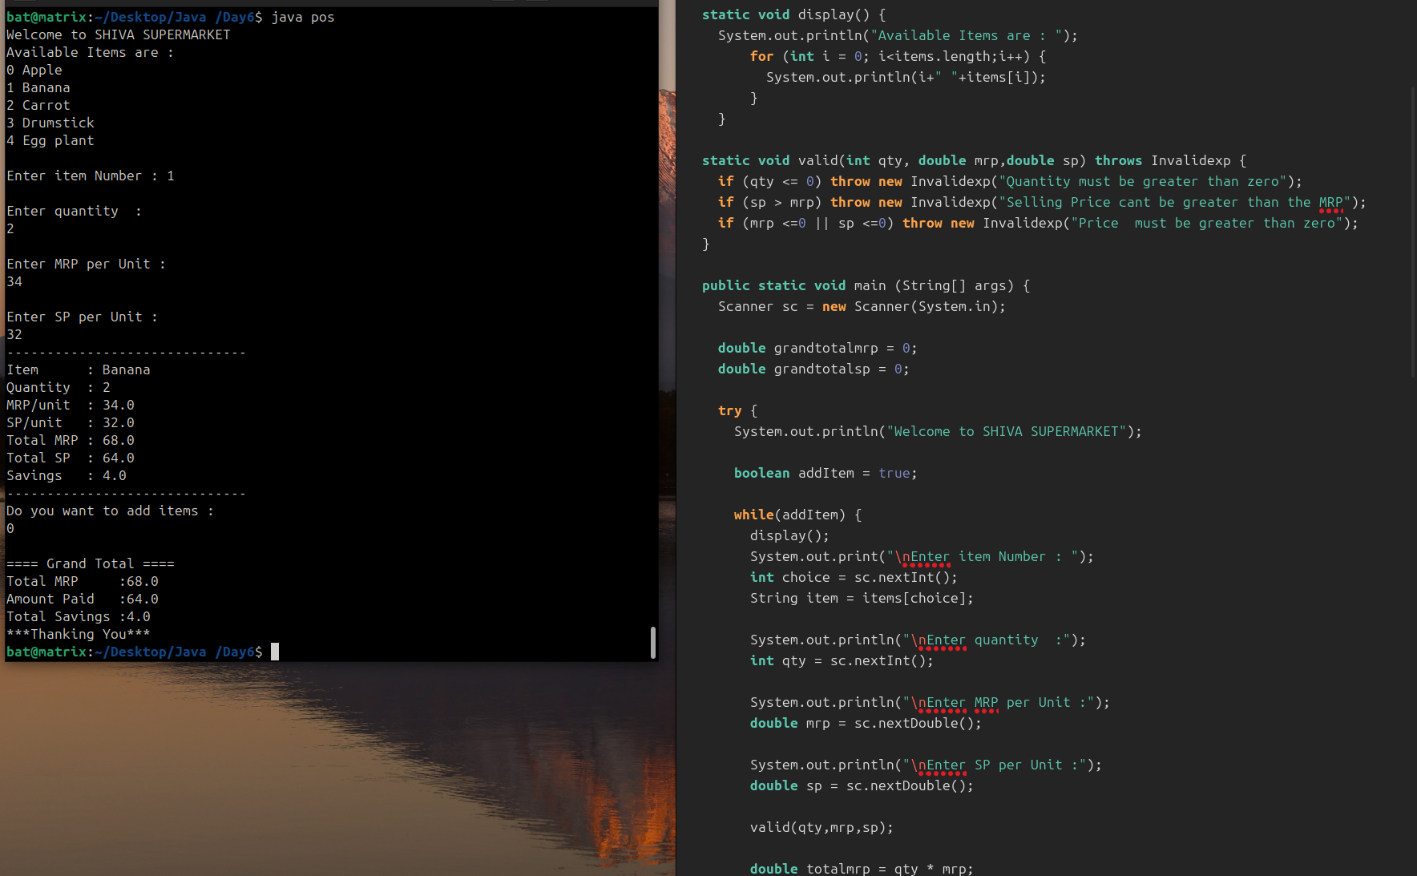

**Output:**

Welcome to SHIVA SUPERMARKET

Available Items are :

0 Apple

1 Banana

2 Carrot

3 Drumstick

4 Egg plant

Enter item Number : 1

Enter quantity :

2

Enter MRP per Unit :

34

Enter SP per Unit :

32

------------------------------

Item : Banana

Quantity : 2

MRP/unit : 34.0

SP/unit : 32.0

Total MRP : 68.0

Total SP : 64.0

Savings : 4.0

------------------------------

Do you want to add items :

0

==== Grand Total ====

Total MRP :68.0

Amount Paid :64.0

Total Savings :4.0

***Thanking You***