**1. write a java program to reverse a string using string builder**

public class String_Builder

{

public static void main(String[] args)

{

StringBuilder str = new StringBuilder("Shiva Balan K");

System.out.println(str.reverse());

}

}

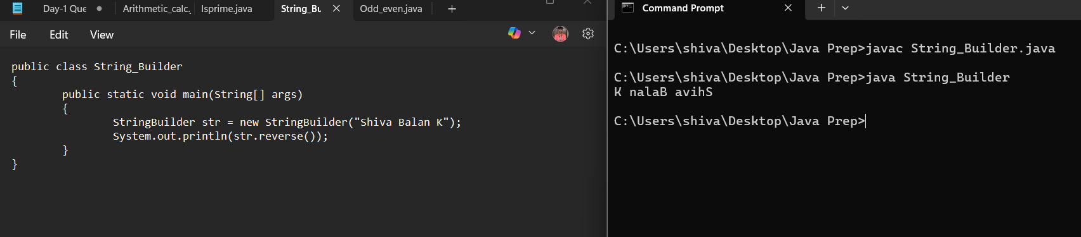

**2. write a java program to find whether given number is prime or not**

import java.util.Scanner;

public class Isprime {

public static boolean prime(int num) {

if (num <= 1) {

return false;

}

for (int i = 2; i * i <= num; i++) {

if (num % i == 0) {

return false;

}

}

return true;

}

public static void main(String[] args) {

Scanner sc = new Scanner(System.in);

System.out.print("Enter a number to check : ");

int n = sc.nextInt ();

if (prime(n)) {

System.out.println(n + " is a prime number.");

} else {

System.out.println(n + " is not a prime number.");

}

}

}

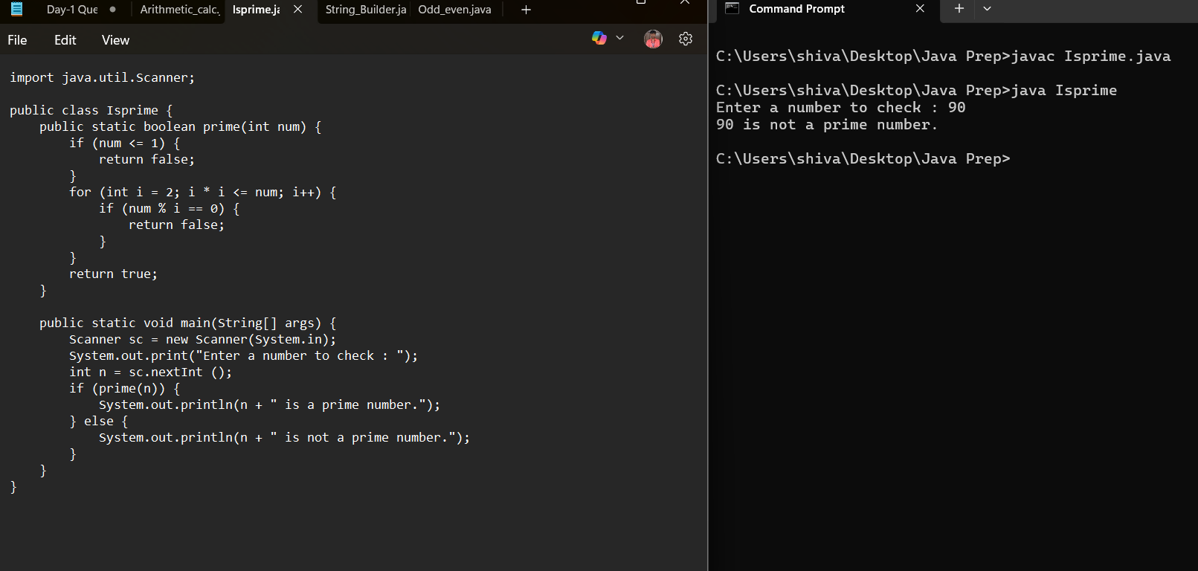

**3. write a java program to perform arithmetic calculator,**

import java.util.Scanner;

public class Arithmetic_calc {

public static void main(String[] args) {

Scanner sc = new Scanner(System.in);

System.out.print("Enter the first number: ");

int a = sc.nextInt();

System.out.print("Enter the second number: ");

int b = sc.nextInt();

System.out.println("Choose Operation");

System.out.println("Enter 1 for Addition (+)");

System.out.println("Enter 2 for Subtraction (-)");

System.out.println("Enter 3 for Multiplication (*)");

System.out.println("Enter 4 for Division (/)");

System.out.print("Enter your choice: ");

int c = sc.nextInt();

if (c >= 1 && c <= 4) {

int result = switch (c) {

case 1 -> a + b;

case 2 -> a - b;

case 3 -> a * b;

case 4 -> {

if (b != 0) yield a / b;

else {

System.out.println("Error: Division by zero.");

yield 0;

}

}

default -> 0;

};

System.out.println("Result: " + result);

} else {

System.out.println("Enter only between 1 - 4");

}

sc.close();

}

}

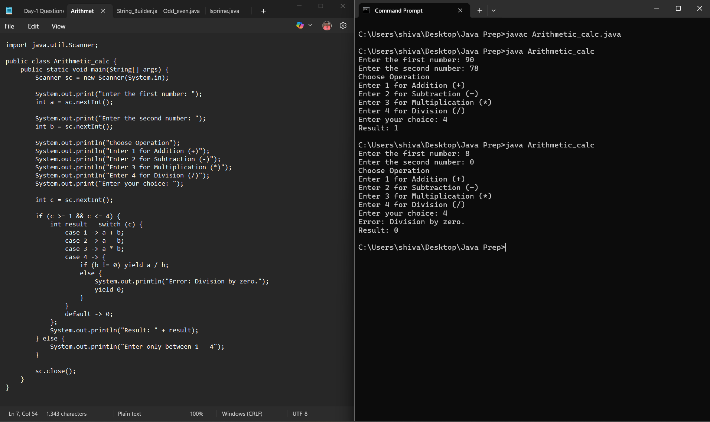

**4. write a java program to print even numbers 1-100,**

public class Odd_even

{

public static void main(String[] args)

{

for(int i=0;i<=100;i++)

{

if(i%2==0)

System.out.print(i + " ");

}

};

}

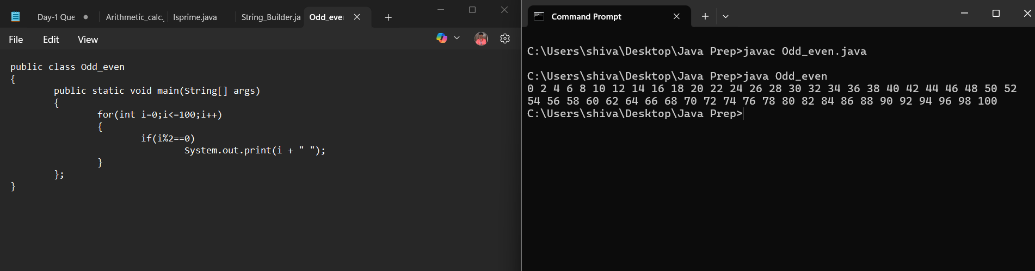

**5. write a java program to perform bank transaction - creation of account, transaction.**

import java.util.*;

public class Banking {

static class Account {

String accno;

String accname;

double balance;

public Account(String accno, String accname, double balance) {

this.accno = accno;

this.accname = accname;

this.balance = balance;

}

public void deposit(double amount) {

if (amount > 0) {

balance += amount;

System.out.println("Deposited Rs." + amount);

System.out.println("Current Balance: Rs." + balance);

} else {

System.out.println("Deposit Failed. Amount must be positive.");

}

}

public void withdraw(double amt) {

if (amt > 0 && balance >= amt) {

balance -= amt;

System.out.println("Withdrawal of Rs." + amt + " success.");

System.out.println("Current Balance: " + balance);

} else if (amt <= 0) {

System.out.println("Enter only positive values.");

} else {

System.out.println("Insufficient Balance.");

}

}

public double getBal() {

return balance;

}

public String getAccinfo() {

return "Account Number: " + accno + ", Account Holder Name: " + accname + ", Balance: " + balance;

}

public String getAccno() {

return accno;

}

}

static class Bank {

public List<Account> accounts;

public Bank() {

this.accounts = new ArrayList<>();

}

public void addAccount(Account account) {

accounts.add(account);

System.out.println("Account Created Successfully");

}

public Account findAccount(String accno) {

for (Account account : accounts) {

if (account.getAccno().equals(accno)) {

return account;

}

}

return null;

}

}

public static void main(String[] args) {

Scanner sc = new Scanner(System.in);

Bank bank = new Bank();

int choice;

do {

System.out.println("\n====== Bank ====== \n 1. Create Account \n 2. Deposit \n 3. Withdraw \n 4. View Account \n 5. Exit \n Enter your Choice : ");

choice = sc.nextInt();

sc.nextLine();

switch (choice) {

case 1:

System.out.print("Enter Account Number: ");

String accNo = sc.nextLine();

System.out.print("Enter Account Holder Name: ");

String accName = sc.nextLine();

System.out.print("Enter Initial Balance: ");

double initBal = sc.nextDouble();

sc.nextLine();

Account acc = new Account(accNo, accName, initBal);

bank.addAccount(acc);

break;

case 2:

System.out.print("Enter Account Number: ");

String depAccNo = sc.nextLine();

Account depAcc = bank.findAccount(depAccNo);

if (depAcc != null) {

System.out.print("Enter amount to deposit: ");

double amount = sc.nextDouble();

sc.nextLine();

depAcc.deposit(amount);

} else {

System.out.println("Account not found.");

}

break;

case 3:

System.out.print("Enter Account Number: ");

String withAccNo = sc.nextLine();

Account withdrawAcc = bank.findAccount(withAccNo);

if (withdrawAcc != null) {

System.out.print("Enter amount to withdraw: ");

double amt = sc.nextDouble();

sc.nextLine();

withdrawAcc.withdraw(amt);

} else {

System.out.println("Account not found.");

}

break;

case 4:

System.out.print("Enter Account Number: ");

String infoAccNo = sc.nextLine();

Account infoAcc = bank.findAccount(infoAccNo);

if (infoAcc != null) {

System.out.println("Account Found!");

System.out.println(infoAcc.getAccinfo());

} else {

System.out.println("Account not found.");

}

break;

case 5:

System.out.println("*** Thanking you! ***");

break;

default:

System.out.println("Enter a valid option only ...");

}

} while (choice != 5);

sc.close();

}

}

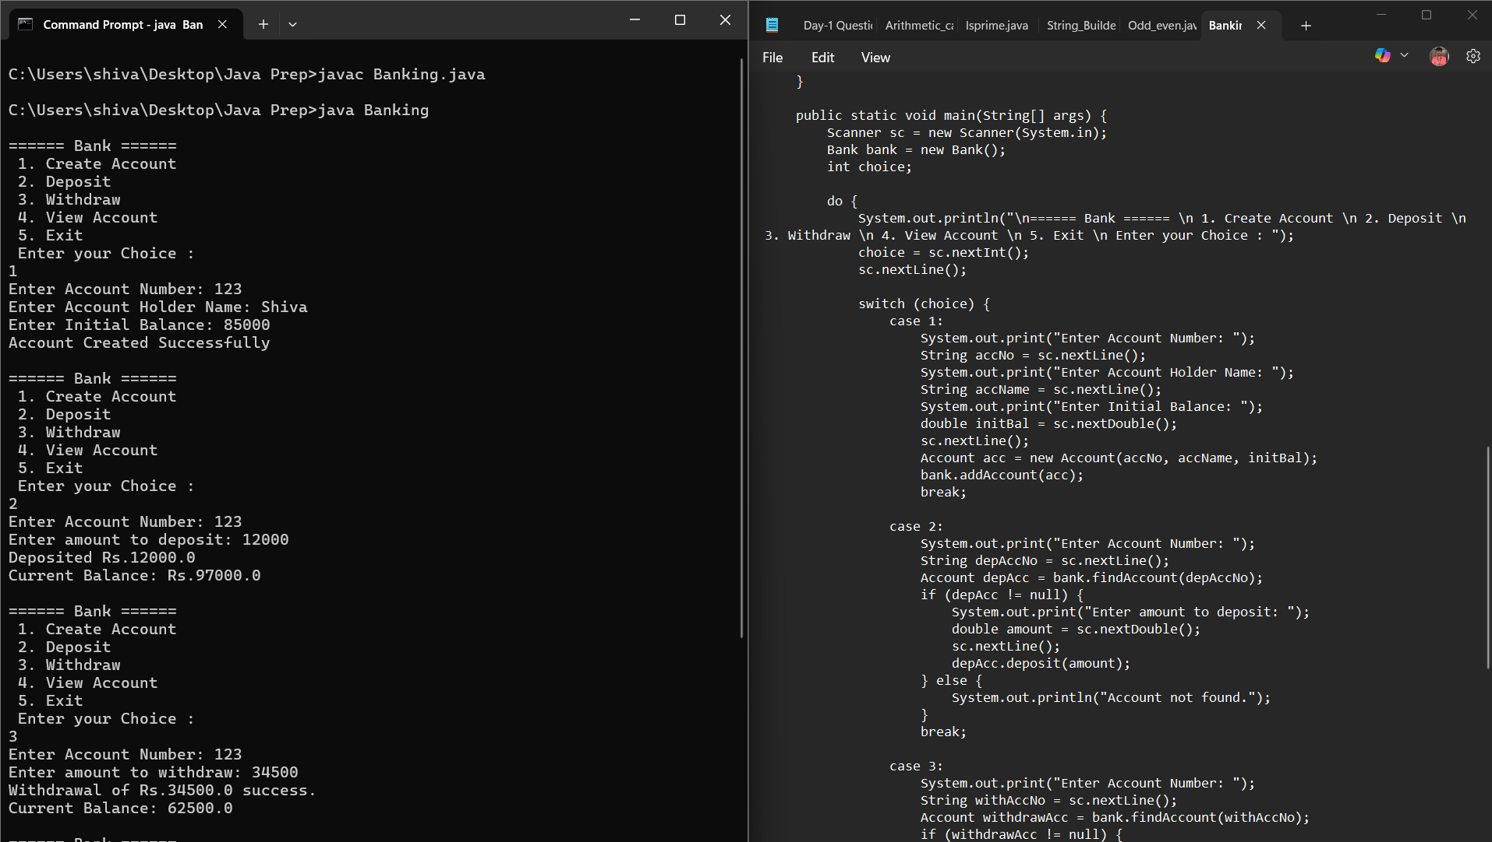

Output

====== Bank ======

1. Create Account

2. Deposit

3. Withdraw

4. View Account

5. Exit

Enter your Choice :

1

Enter Account Number: 123

Enter Account Holder Name: Shiva

Enter Initial Balance: 85000

Account Created Successfully

====== Bank ======

1. Create Account

2. Deposit

3. Withdraw

4. View Account

5. Exit

Enter your Choice :

2

Enter Account Number: 123

Enter amount to deposit: 12000

Deposited Rs.12000.0

Current Balance: Rs.97000.0

====== Bank ======

1. Create Account

2. Deposit

3. Withdraw

4. View Account

5. Exit

Enter your Choice :

3

Enter Account Number: 123

Enter amount to withdraw: 34500

Withdrawal of Rs.34500.0 success.

Current Balance: 62500.0

====== Bank ======

1. Create Account

2. Deposit

3. Withdraw

4. View Account

5. Exit

Enter your Choice :

4

Enter Account Number: 123

Account Found!

Account Number: 123, Account Holder Name: Shiva, Balance: 62500.0

====== Bank ======

1. Create Account

2. Deposit

3. Withdraw

4. View Account

5. Exit

Enter your Choice :

1

Enter Account Number: 345

Enter Account Holder Name: balan

Enter Initial Balance: 30908

Account Created Successfully

====== Bank ======

1. Create Account

2. Deposit

3. Withdraw

4. View Account

5. Exit

Enter your Choice :

2

Enter Account Number: 809

Account not found.

====== Bank ======

1. Create Account

2. Deposit

3. Withdraw

4. View Account

5. Exit

Enter your Choice :

5

*** Thanking you! ***