STUDENT PERFORMANCE ANALYTICS SYSTEM
EWB Courses — Python with AI Internship
Student Name: Gattu Shiva chandra
College Name: Balaji Institute of Technology and Science
Project Title: Student Performance Analytics System
Technologies: Python, NumPy and Pandas
Submission Deadline: 26 October 2026

1. Project Title
Student Performance Analytics System
2. Objective
The objective of this project is to develop a Python-based system that analyzes student academic performance using student marks and attendance data.
The system processes student records, calculates total and average marks, assigns grades, identifies pass/fail status and generates meaningful information about individual students and overall class performance.
The project demonstrates the practical application of Python programming, NumPy numerical calculations and Pandas data analysis.
3. Technologies Used
Python: Used to implement program logic, functions, loops and conditional statements.
NumPy: Used to perform numerical calculations, including the total and average marks of students.
Pandas: Used to read CSV data, organize records in a DataFrame, process student information and calculate summary statistics.
CSV: Used to store the student dataset in a structured tabular format.
Visual Studio Code: Used to write, edit and execute the Python program.
4. Dataset Description
The project uses a sample dataset containing 20 student records. The dataset is stored in a file named students.csv.
The dataset contains eight columns:
- Student_ID
- Name
- Department
- Python
- Mathematics
- Statistics
- Computer_Fundamentals
- Attendance
The four subject columns contain marks out of 100, while Attendance contains attendance percentages.
The sample data includes different marks and attendance values to support analysis of student performance.
Pandas reads the CSV file and stores the data in a DataFrame, which is used for subsequent calculations and analysis.
5. Implementation
Step 1: Load Student Data
The program uses Pandas to read the students.csv file. The loaded DataFrame contains the student records required for analysis.
The program also handles the situation in which the CSV file cannot be found.
Step 2: Display Dataset Information
The system displays the student records, number of students, number of columns and column names.
It uses Pandas functions to inspect data types, non-null values and numerical summary statistics.
Step 3: Calculate Total and Average Marks
The program selects the four subject columns and converts their values into a NumPy array.
NumPy calculates total marks and average marks for each student. The resulting values are stored in the Total_Marks and Average_Marks columns.
Step 4: Assign Grades
The system assigns grades according to the student's average marks using conditional statements.
The grading rules used in this project are:
Average Marks | Grade
90–100 | A
80–89.99 | B
70–79.99 | C
60–69.99 | D
50–59.99 | E
Below 50 | F
These thresholds are defined for this project.
Step 5: Identify Pass/Fail Status
The system checks each student's marks in all four subjects.
A student passes if every subject mark is at least 40. If a student's mark is below 40 in any subject, the student is classified as Fail.
This rule is used consistently throughout the project.
Step 6: Analyze Class Performance
The program identifies the students with the highest and lowest average marks.
It also calculates the overall class average using the average marks of all students.
Step 7: Analyze Subject-Wise Performance
The system calculates the average marks for Python, Mathematics, Statistics and Computer Fundamentals.
It identifies the subject with the highest class average and the subject with the lowest class average.
Step 8: Identify Top Performers
The system sorts students by average marks in descending order and displays the top three performing students.
Step 9: Calculate Pass/Fail Statistics
The program counts the number of students who passed and failed.
It calculates the pass percentage and fail percentage to summarize class results.
6. Key Features
The main features of the system are:
- CSV dataset loading using Pandas.
- Dataset inspection and numerical summary.
- Total and average marks calculation using NumPy.
- Automatic grade assignment.
- Pass/fail identification using conditions and loops.
- Highest and lowest student performance analysis.
- Overall class average calculation.
- Subject-wise average analysis.
- Identification of the top three students.
- Pass/fail counts and percentages.
7. Output and Screenshots
The program displays the student records and the calculated results in the terminal.
The output includes individual student totals and averages, grades, pass/fail status, highest and lowest performers, overall class average, subject-wise averages, top-performing students and pass/fail statistics.
Screenshots to include:
- Screenshot 1: Student Performance Result.
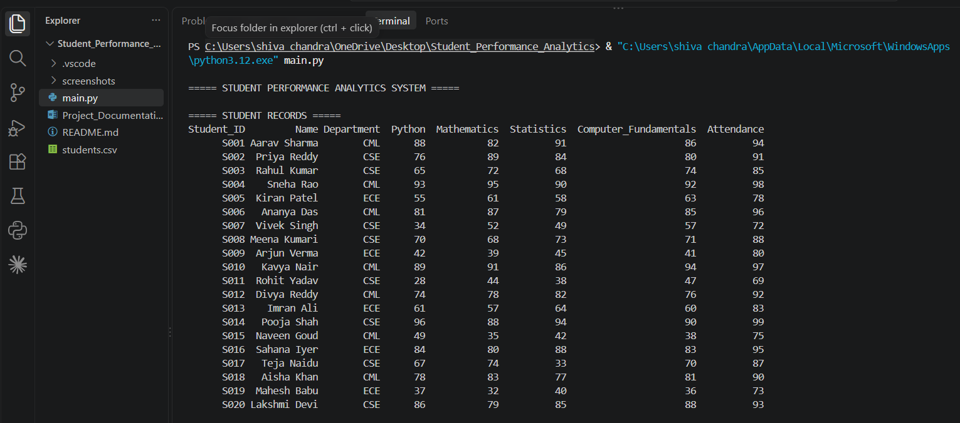
- Screenshot 2: Overall Class Performance and Subject-Wise Performance.
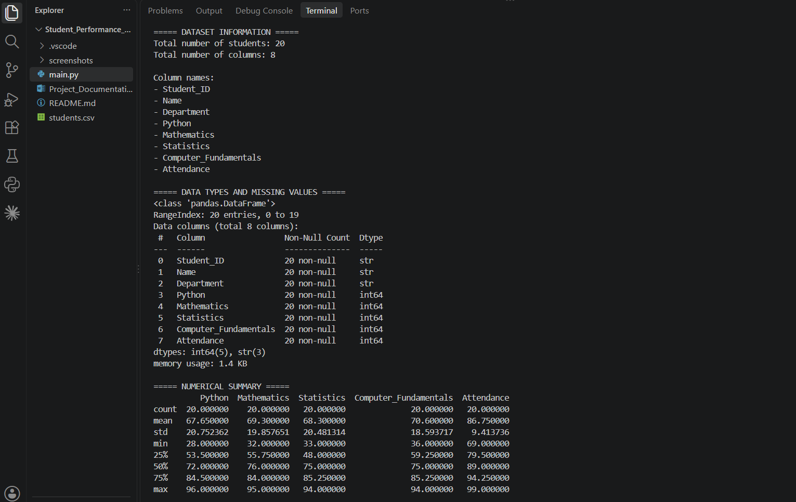
- Screenshot 3 & 4: Top Three Students and Pass/Fail Statistics.
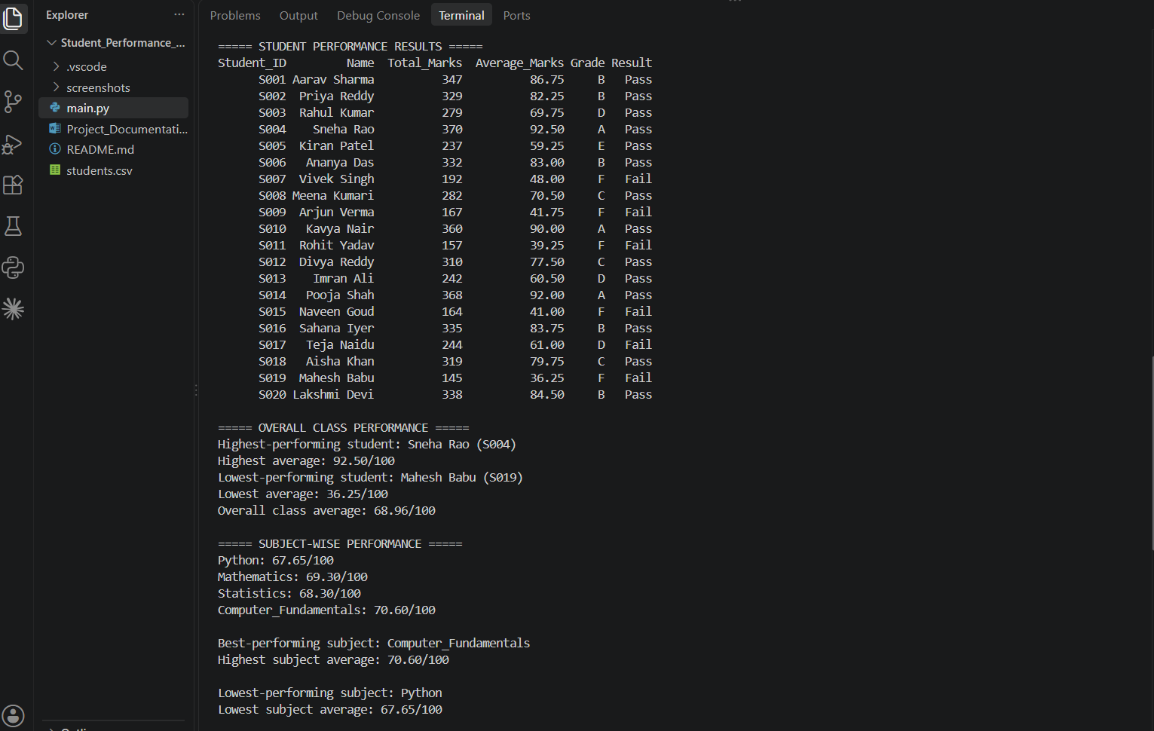
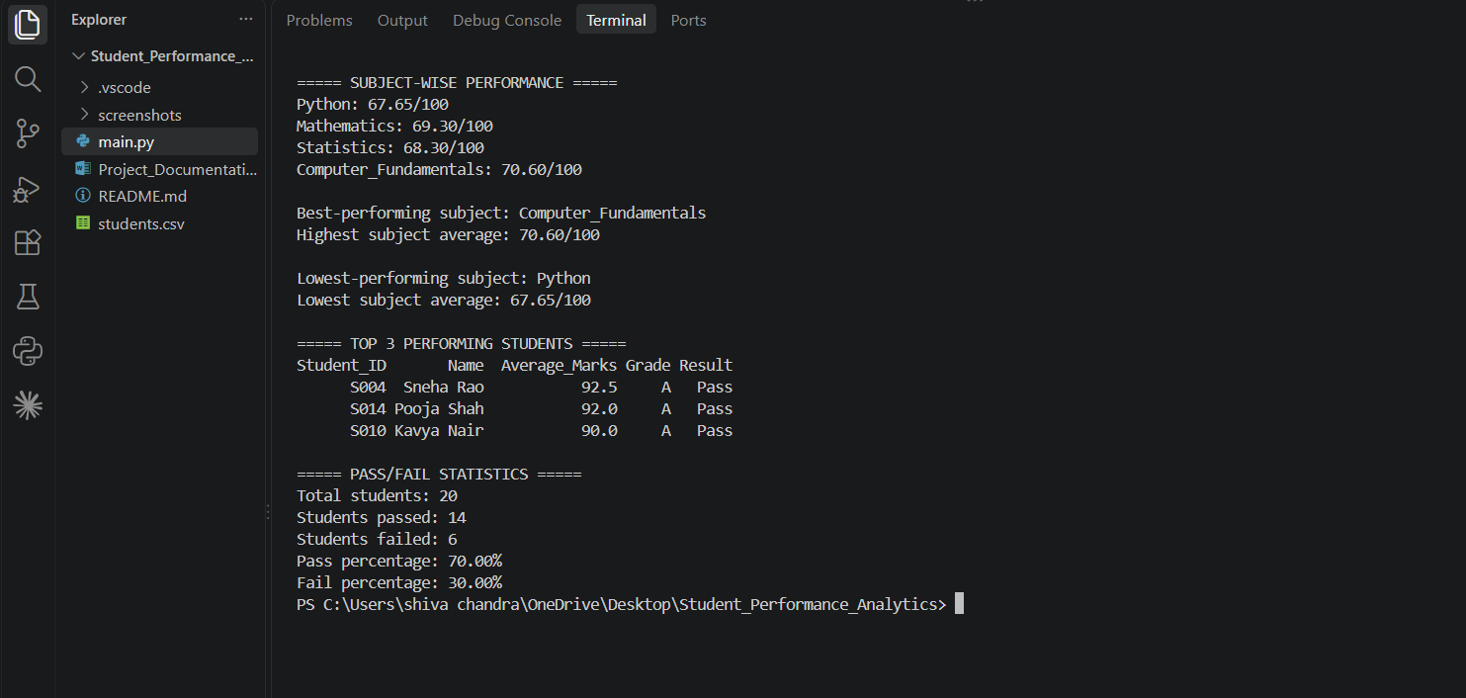
8. Final Outcome
The project successfully demonstrates how Python, NumPy and Pandas can be used to analyze a student dataset.
It calculates marks and averages, assigns grades, identifies pass/fail status, analyzes subject performance and produces class-level statistics.
The system makes student performance information easier to understand through organized tables and summary results.
For the current sample dataset and the grading rules defined for this project, the expected results include:
Metric | Result
Total students | 20
Original dataset columns | 8
Highest-performing student | Sneha Rao
Highest average | 92.50
Lowest-performing student | Mahesh Babu
Lowest average | 36.25
Overall class average | 68.96
Best-performing subject | Computer Fundamentals
Best subject average | 70.60
Lowest-performing subject | Python
Lowest subject average | 67.65
Students passed | 14
Students failed | 6
Pass percentage | 70.00%
These results correspond to the sample dataset used in the project.
9. Challenges and Learning
One challenge encountered during development was a Python environment issue. The program initially failed to import Pandas because a different Python interpreter was being used. The environment was checked, and Pandas and NumPy were verified with the Python interpreter used to run the project successfully.
Another important part of development was defining clear grade and pass/fail rules before applying them to the dataset.
Through this project, the following concepts were practiced:
- Python functions and reusable code.
- Variables, conditions and loops.
- Reading CSV files.
- Creating and working with Pandas DataFrames.
- Using NumPy for numerical calculations.
- Calculating averages and summary statistics.
- Sorting and analyzing student records.
- Testing program output and identifying errors.
10. GitHub Repository
Repository Name: student-performance-analytics
GitHub Repository URL: [Add the repository URL after creating and uploading the project.]
The GitHub repository will contain the Python source code, student dataset, README file, screenshots and completed project documentation.
Conclusion
The Student Performance Analytics System fulfills the core data-analysis objectives of the EWB Courses Python with AI mini project.
It demonstrates the use of Python fundamentals, NumPy and Pandas to process a structured student dataset and generate useful academic performance statistics.

