Final Project Report - Booknest

# 1. INTRODUCTION

1.1 Project Overview:  
Booknest is a MERN stack-based web application that allows users to browse, wishlist, and purchase books online, while also providing sellers with an interface to list and manage their books.

1.2 Purpose:  
The purpose of this project is to demonstrate the implementation of a full-stack online bookstore using modern web development technologies.

# 2. IDEATION PHASE

2.1 Problem Statement:  
Traditional book shopping lacks digital convenience. Booknest solves this by enabling an online platform for buyers and sellers.

2.2 Empathy Map Canvas:

2.3 Brainstorming:  
Features like Seller Portal, Wishlist, Cart, and Admin Dashboard were ideated to streamline the book shopping experience.

# 3. REQUIREMENT ANALYSIS

3.1 Customer Journey Map:

|  |  |  |  |  |  |
| --- | --- | --- | --- | --- | --- |
| **Test Case ID** | **Test Scenario** | **Test Steps** | **Expected Result** | **Actual Result** | **Pass/Fail** |
| TC-001 | User Registration using Email | 1. Open registration page  2. Enter valid email, password, confirm password  3. Click register | User account is created and confirmation email is sent | Confirmation email received | Pass |
| TC-002 | User Login | 1. Open login page  2. Enter registered email and password  3. Click login | User is redirected to dashboard | Redirected to dashboard | Pass |
| TC-003 | Registration with existing email | 1. Enter already registered email  2. Submit the form | Error message: "Email already exists" | Error shown correctly | Pass |
| TC-004 | Wishlist book addition | 1. Login  2. Browse a book  3. Click "Add to Wishlist" | Book is saved in wishlist and visible in the Wishlist page | Wishlist updated successfully | Pass |
| TC-005 | Checkout with empty cart | 1. Login  2. Go to cart  3. Click "Checkout" | Error message: "Your cart is empty" | Error shown correctly | Pass |

3.2 Solution Requirement:  
- Simple navigation  
- User authentication  
- Book CRUD operations  
- Seller management

3.3 Data Flow Diagram:  
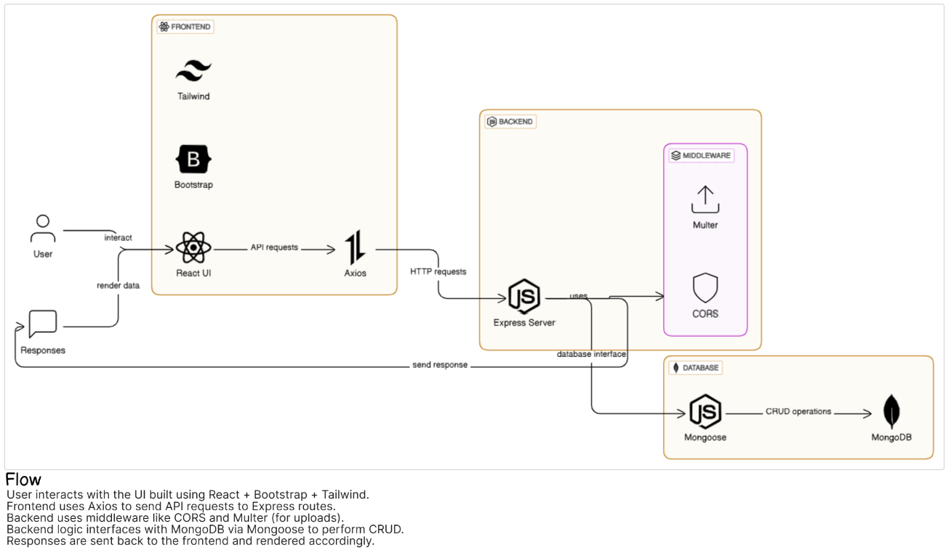

3.4 Technology Stack:  
Frontend: React (placeholder)  
Backend: Node.js + Express  
Database: MongoDB  
Authentication: JWT (assumed)

# 4. PROJECT DESIGN

4.1 Problem Solution Fit:  
This platform directly solves the need for an efficient online bookstore with role-based user access.

4.2 Proposed Solution:  
A responsive MERN-based system supporting sellers, users, and admin.

4.3 Solution Architecture:  
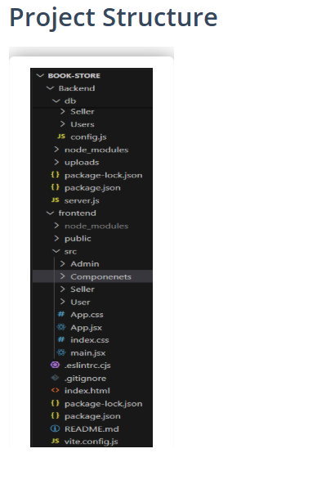

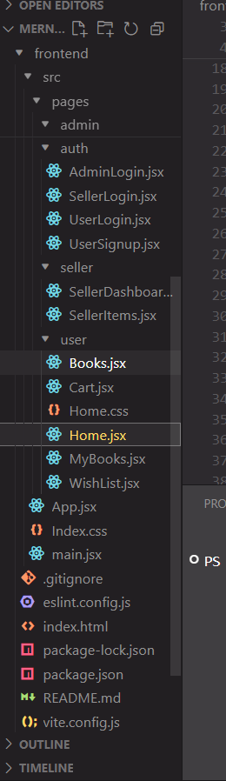

# 5. PROJECT PLANNING & SCHEDULING

5.1 Planning:  
The project was broken into sprints for designing database schema, backend APIs, frontend UI, integration, and testing.

# 6. FUNCTIONAL AND PERFORMANCE TESTING

6.1 Performance Testing:  
Postman was used for API testing, manual testing for UI flows, and browser developer tools for performance evaluation.

# 7. RESULTS

7.1 Output Screenshots:  


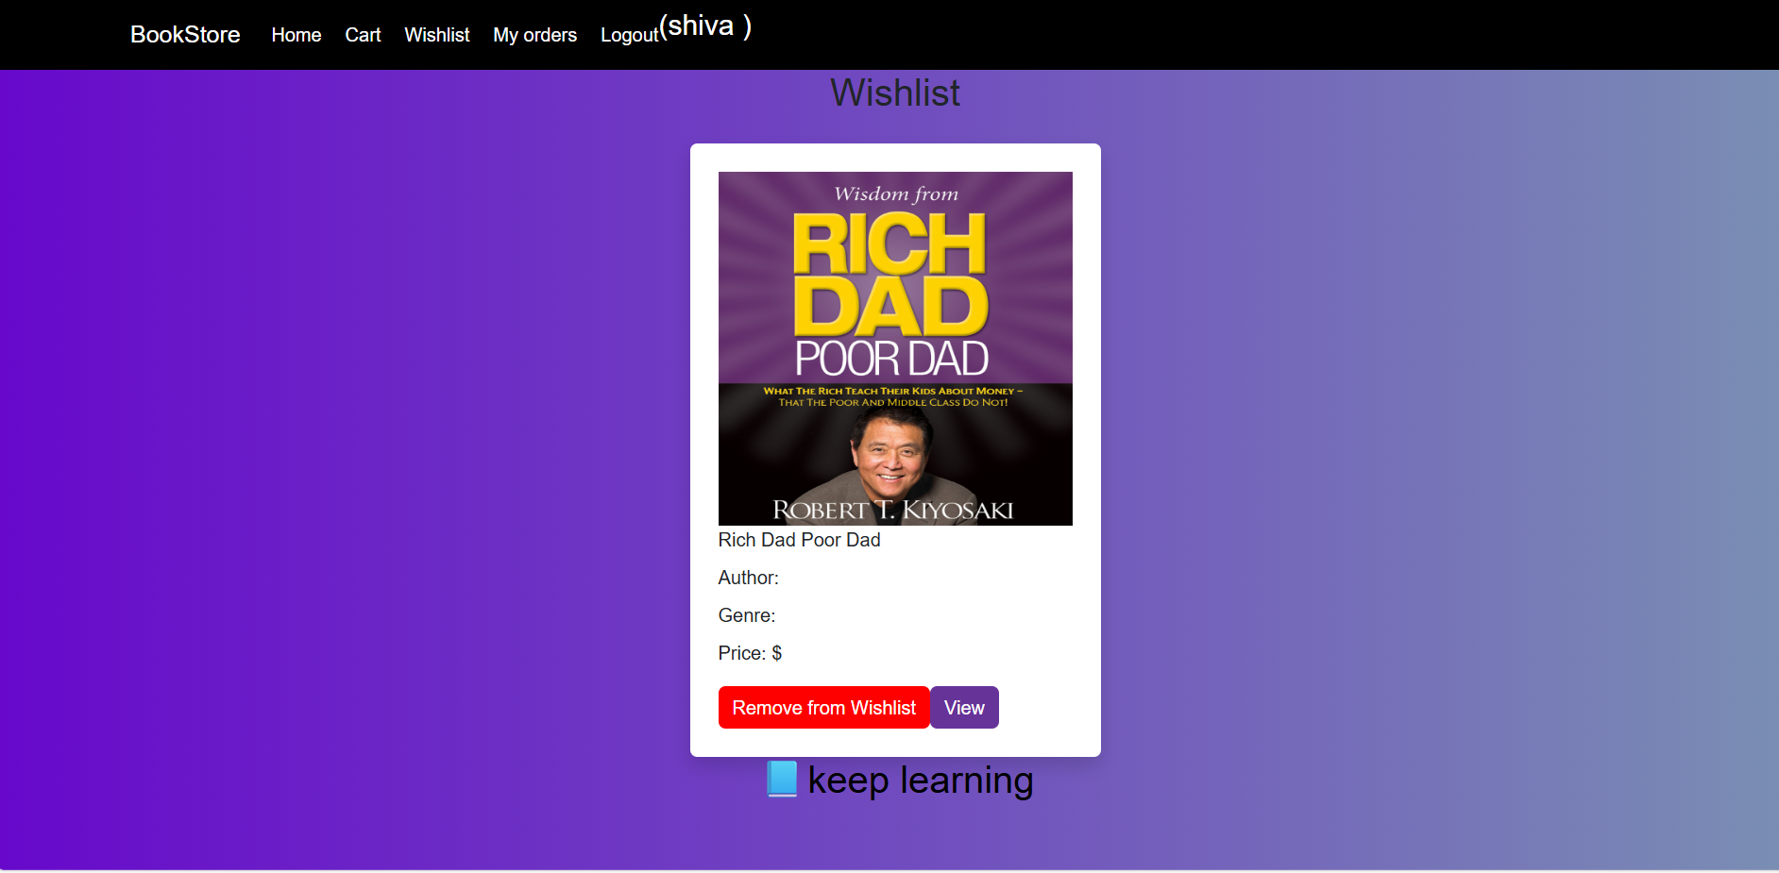



# 8. ADVANTAGES & DISADVANTAGES

Advantages:  
- Full stack skills demonstrated  
- Scalable architecture  
- User-friendly UI

Disadvantages:  
- Payment system not integrated  
- Limited book categorization

# 9. CONCLUSION

Booknest proves to be a viable and educational full stack development project that mimics a real-world e-commerce solution.

# 10. FUTURE SCOPE

- Add payment gateway integration  
- Enable user reviews  
- Improve search and filtering  
- Deploy on cloud (e.g., Render, Vercel)

# 11. APPENDIX

Source Code in github: <https://github.com/shivachandraganti/MernStack_project_booknest.git>

Video Demo Link in drive : <https://drive.google.com/drive/folders/1JM8P8KpDfOHBhEq4yOjD5Bj5eg_otPa?usp=sharing>