Ship Extraction using Post CNN from High Resolution Optical Remotely Sensed Images

In this paper author is describing concept to extract ships from sea satellite images using POST CNN (Convolution Neural Network). This paper consists of two parts where first part implement SVM algorithm to identify ship or water from images, if ship is there in image part then SVM class will be define as ‘SHIP’ and if ship is not there in image part then SVM class will be define as ‘WATER’ Here SVM algorithm is applied on satellite images to extract features with ‘SHIP’ and ‘WATER’ class.

Second consists of CNN algorithm which will take SVM train features and then build model, this model will be applied new images to detect ships from sea.

To implement this project KAGLE software already given SVM implemented dataset in JSON format which contains of three values location id, ship images in integer format RGB values, class (SHIP or WATER).

This dataset I kept inside ‘dataset' folder and all values in dataset are in integer format as they convert all satellite images in that dataset into integer RGB values. Application will convert that RGB values into images and then extract ships.

Test image with ships in sea I kept inside ‘testimage’ folder

CNN is a built in algorithm from KERAS which will build train models using features from images.

Screen shots

To run project double click on ‘run.bat’ file to get below screen

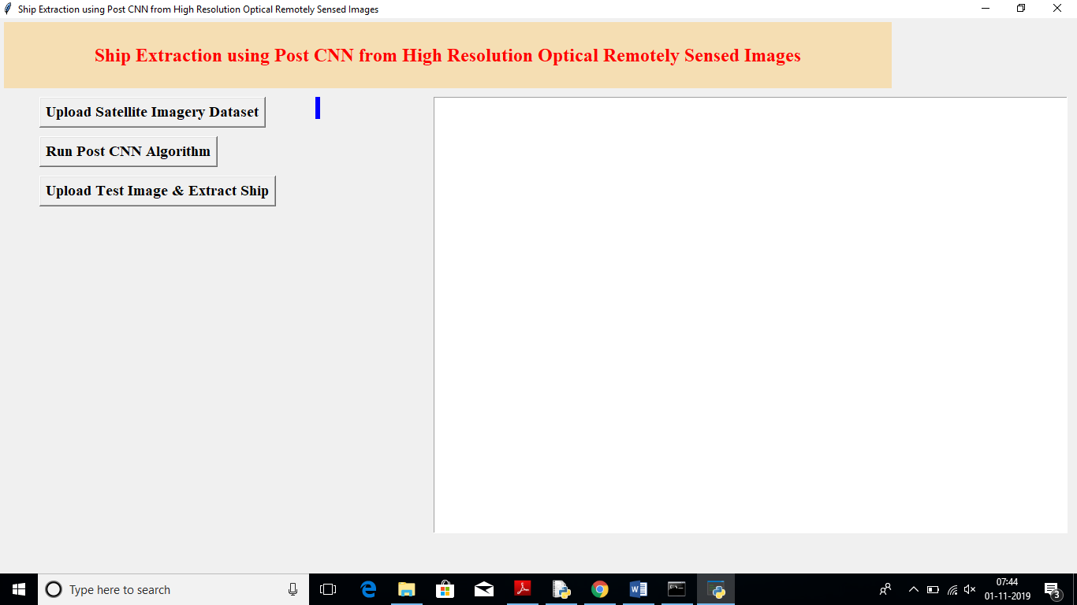

In above screen click on ‘Upload Satellite Imagery Dataset’ button to upload ship image dataset

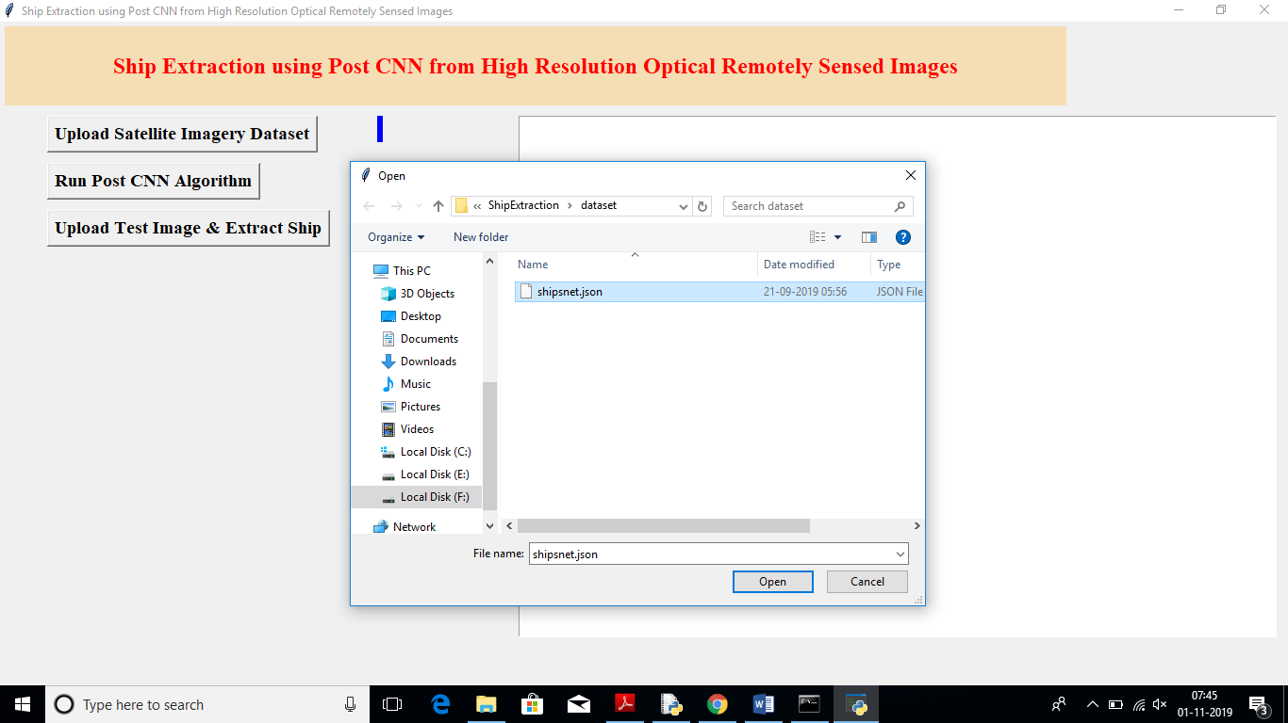

After uploading dataset will get below screen

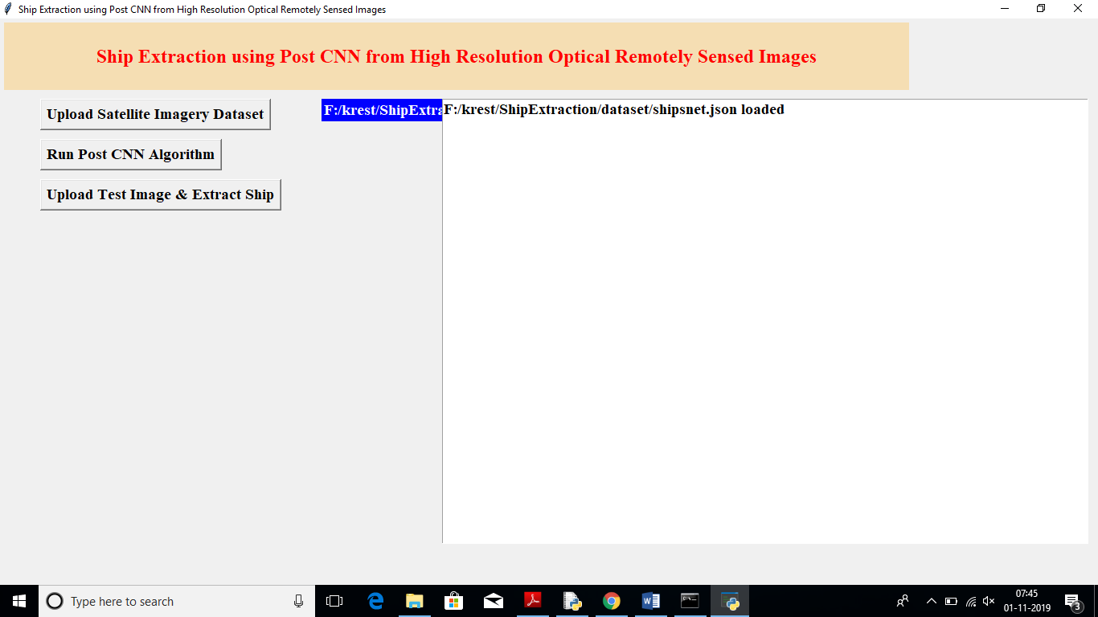

After uploading dataset click on ‘Run Post CNN Algorithm’ button to generate CNN model on uploaded images dataset

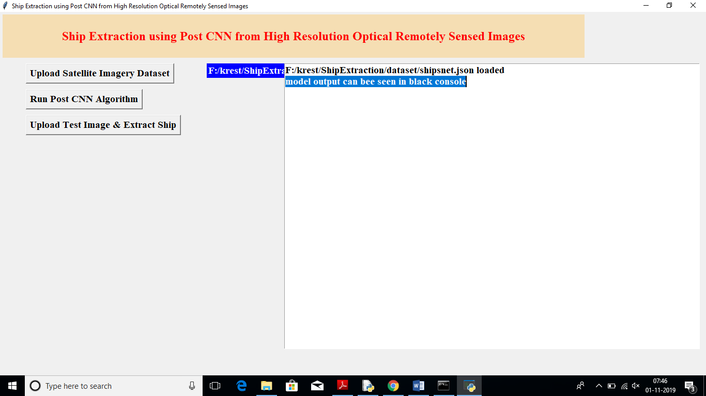

In above screen in selected text we can see model details are printed at black command prompt. So see black console to CNN model details

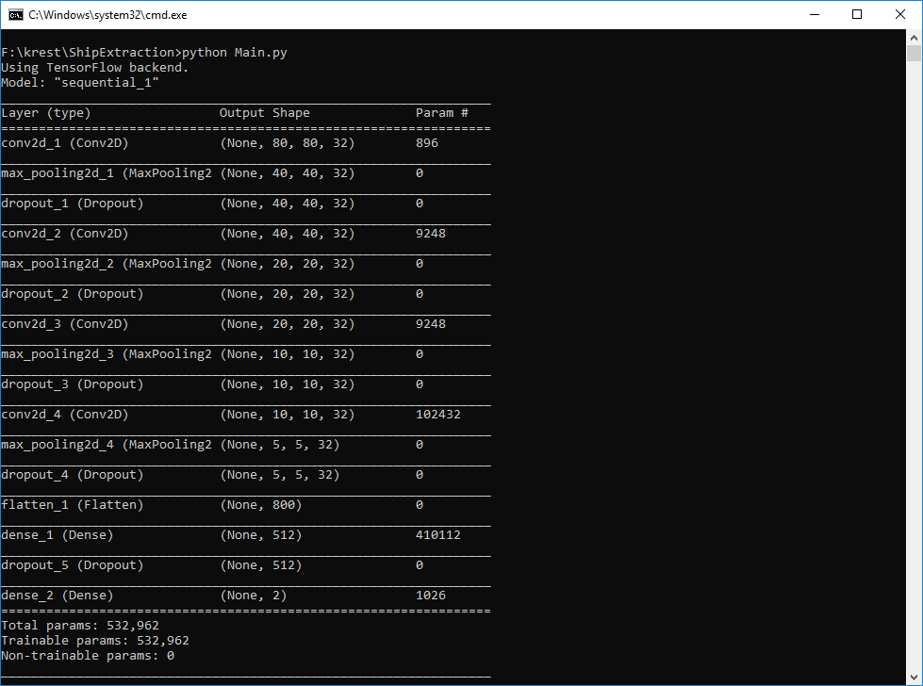

In above screen we can see CNN model is generated with images and for each image CNN generated multiple models with various sizes, in above screen we can see first CNN model generated on 80X80 image size then 40X40 then 20X20 etc. due to generating multiple models capability CNN can perform ship detection or extraction with high accuracy.

Now click on ‘Upload Test Image & Extract Ship’ button to upload test image and to extract ship

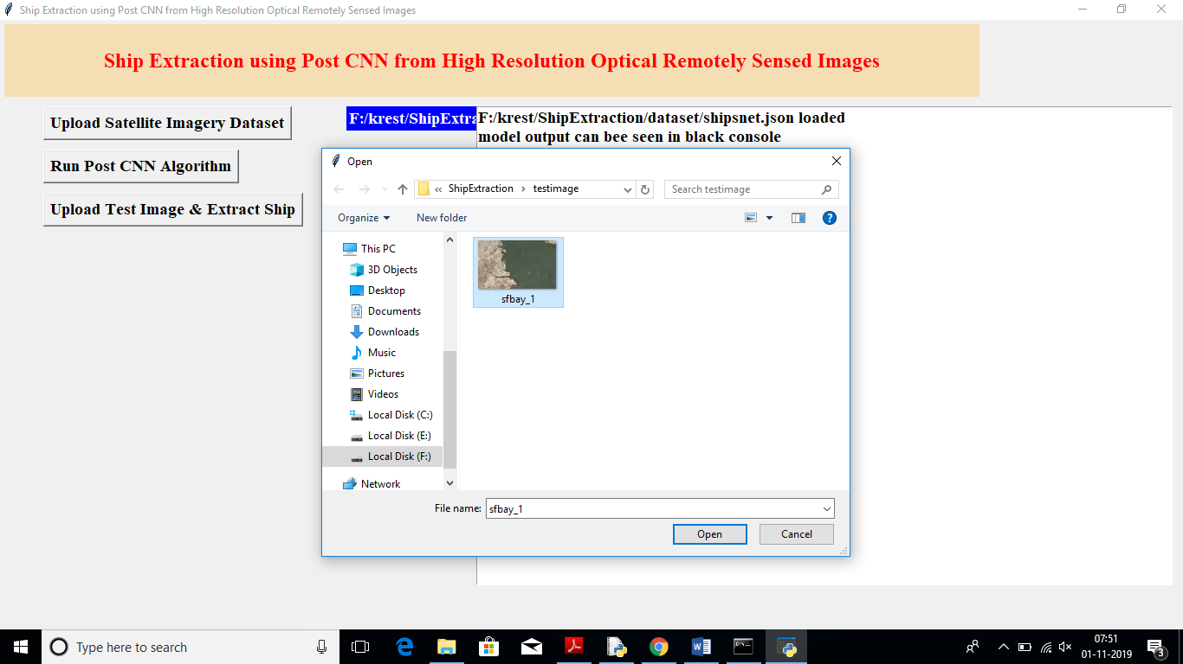

In above screen I am uploading image with sea and ships, now click on open button to view below screen with uploaded image

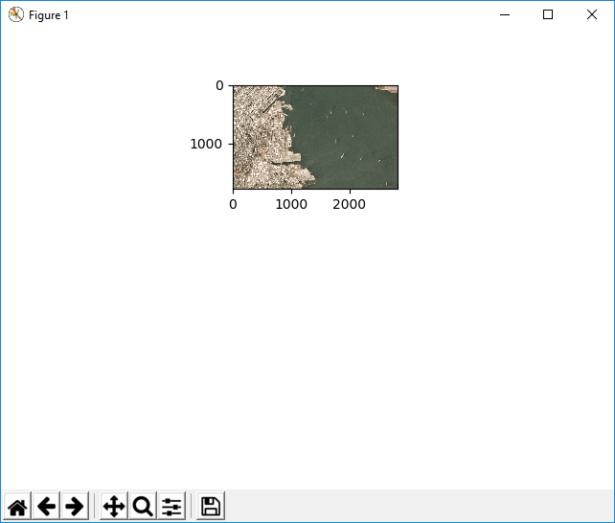

In above screen we can see uploaded image, now close this image screen and main screen to allow CNN to start ship extraction. Please close above image screen and main window and then see output from black console

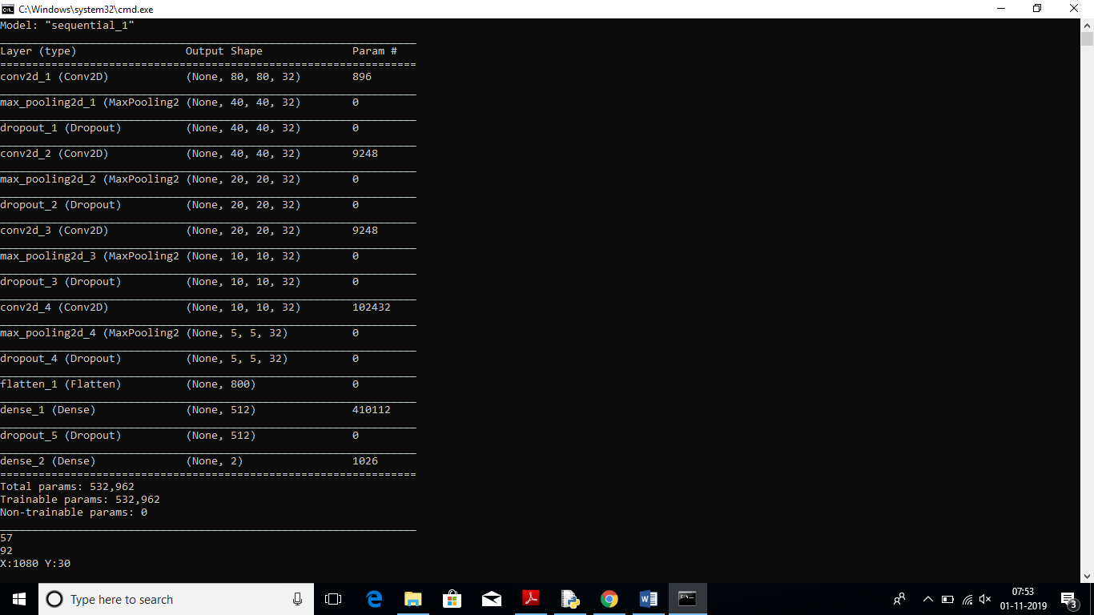

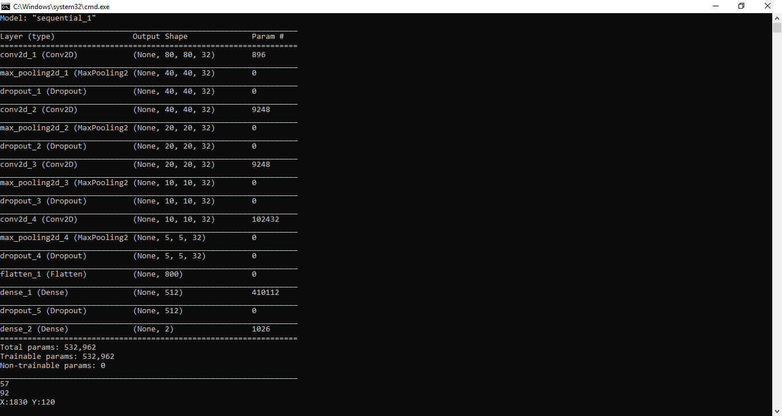

In above two black screen u can continuously see CNN is scanning pixel of uploaded image to extract ship and to extract all ships it may take hours of times as this images are huge and for each image extraction it has to take 2700 iterations, so I am extracting only one image from uploaded image. See Below extracted ship image screen

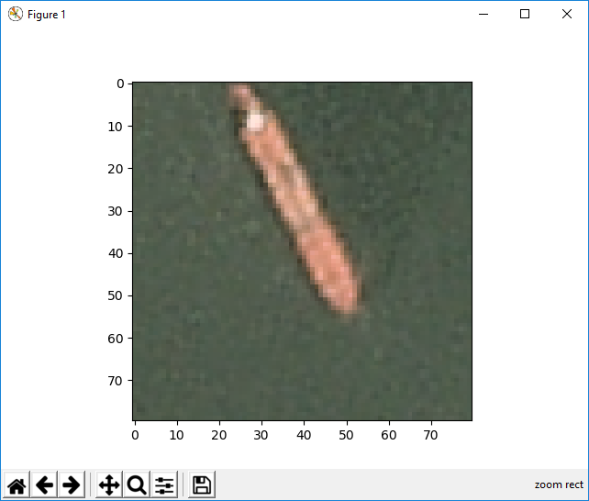

In above screen we can see one ship is extracted and now close this ship image to see uploaded image with extracted ship mark with bounding boxes

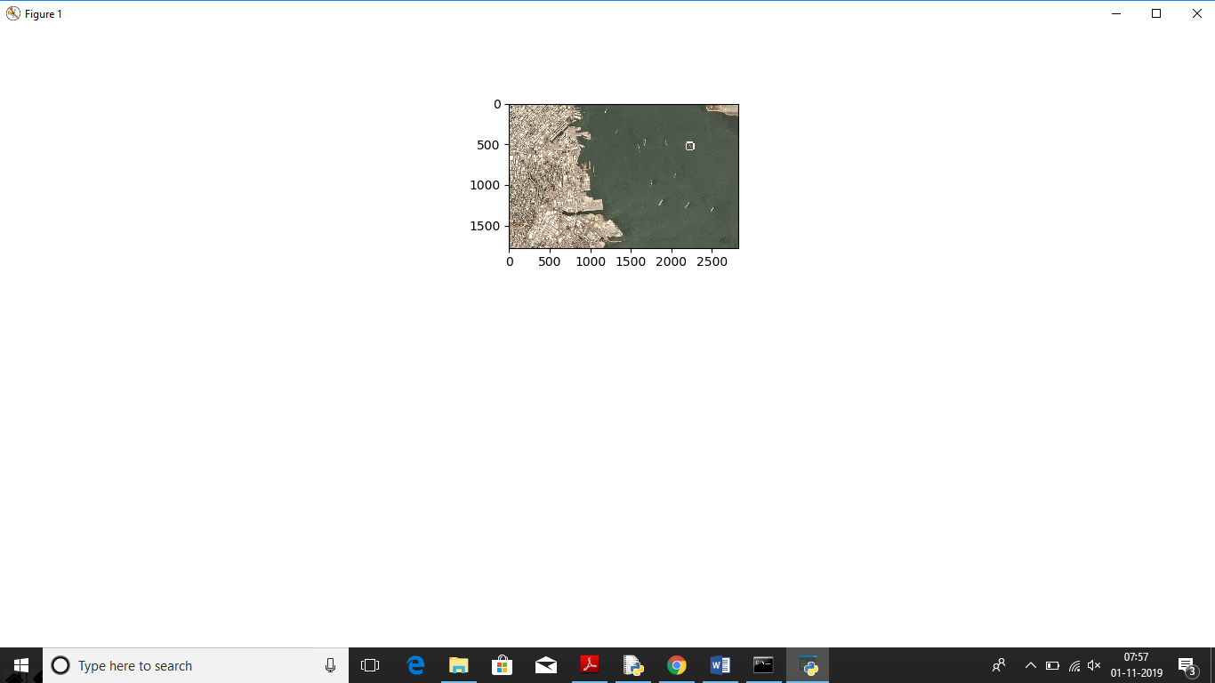

In above screen we can see one circle in centre of image around the extracted ship, in your pc you can see it clearly, now see below command prompt to see number of iterations it took to extract that single ship

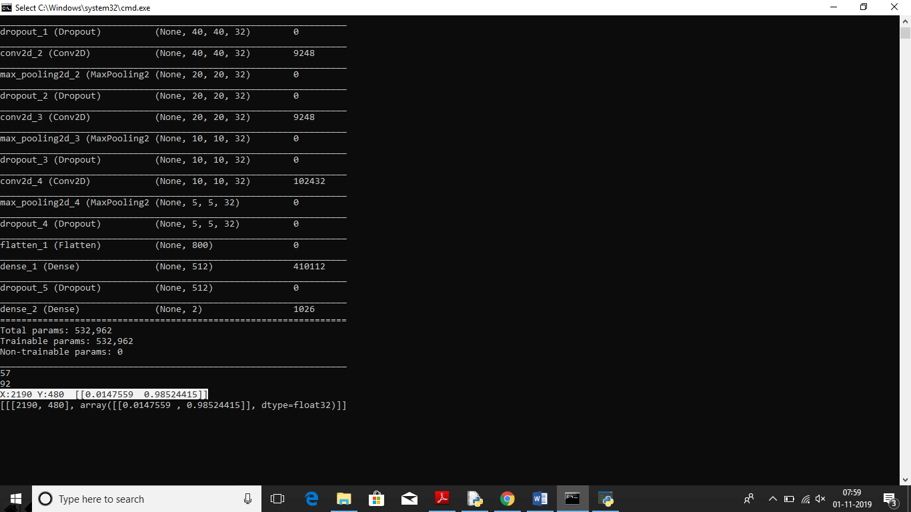

In above screen in selected text u can see X iteration it took 2190 and Y iteration 490 and in same line extraction accuracy is 0.98%. May be in your pc u can see clearly

Second line showing location of ship in X and Y location format

Install below packages if not there

pip install keras

pip install Pillow

pip install tensorflow