**MURANG’A UNIVERSITY OF TECHNOLOGY PROGRAMMING AND DATABASE PRACTICUM GORDON OTIENO**

**SC212/1269/2017**

**HOUSE RENTAL MANAGEMENT PORTAL REPORT**

### Abstract

We are stuck with technology when what we really want is just stuff that works. With the current paradigm shift in technological field, there is an urgent need to embrace and appreciate the power of technology. Housing sector remains vigilant to face the challenges of change by employing a new strategy that facilitates easy management of rental houses. Hence there is need to develop a rental house management system that can simplify work for the rental managers so that all their work can be efficient and effective. The Rental Management System is Searching in Based on the Apartment Paying Guest, Office, House in metropolitan cities. The Rental Management System is Based on the Owners and the Customers. The Owner is updated on the Apartment, Office details, House, Paying Guest details. The Customer is details about the Room space, Room rent and the Address Details also. The Rental Management System is best Suitable the owners because time save and the only contact and the eligible person and there is no need to explain the room details on the speak. The Rental Management System is best application in the city place The customer contact and the easily search and the suitable place of Apartment, Office, PG, House and based the Money, Limit Person is based on the suitable house. The Rental Management System is save the time also. The Rental Management System is used to easily identify the suitable place in Save time, cost also. The Rental Management System is best way to search the house, Apartment office, Paying Guest. Hence this system is best applicable for the above reasons making House rental an easy process through an online system

### Acknowledgement

At the beginning I am very much grateful to almighty God for giving me strength and opportunity and sound mind to complete the House Rental Management report. I want to bid my heartiest thanks to my Lecturer, Dr. Tirus, for guiding and giving me the opportunity to initiate this report. Then I want to thank Jionme Real Estate Ltd for giving me the opportunity to do my research in their organization. Thanks again to my colleagues Thomas, Joseph and Steve Amani without forgetting the 3 Idiots Team.I would also like to thank Murang’a University for their library and internet facilities from where I got enormous information.

### Table of Content

Abstract 1

CHAPTER ONE 5

Introduction 5

* 1. Problem Statement 5
  2. Background 5
     1. How House Rental Services Work 5
     2. Benefits of Online House Rental Services 5
  3. Aims & Objectives 6
  4. Purpose, Scope and Applicability 6
     1. Purpose 6
     2. Scope 7
     3. Applicability 7

CHAPTER TWO 7

SURVEY OF TECHNOLOGIES 7

2.1 About PHP 7

* 1. Connecting PHP Application to MySQL Database 9
  2. Introduction to MySQL 10

Basic administration (supervisory level) 11

General management (functional level) 11

Strategic management 12

CHAPTER THREE 12

REQUIREMENTS AND ANALYSIS 12

* 1. HARDWARE & SOFTWARE REQUIREMENT 12
     1. HARDWARE 12
     2. SOFTWARE 12
  2. Functional Requirements 13
  3. Non-Functional Requirements 13
  4. CONCEPTUAL MODELS 14

Data Flow Diagram (DFD) 14

Functions of Customer 15

Functions of System Administrator 15

Functions of Landlord: 15

USE-CASE DIAGRAMS 16

Actor and Use Case Description 16

Use Case Diagram 18

Use-Case Dependency Diagram 19

Class Diagram 19

CHAPTER FOUR 20

SYSTEM DESIGN 20

Tenant Registration Module 20

House Listing Module 21

LANDLORD REGISTRATION MODULE 23

SALE HOUSE MODULE 24

POST HOUSE 28

Book House 31

Contact and feedback 31

ADMIN LOGIN MODULE 35

Manage pages 36

Security 37

The system provides username and password to prevent the system from unauthorized access. The staffs’ password must be greater than eight characters 37

Test Cases Design 37

CHAPTER FIVE 40

IMPLEMENTATION AND TESTING 40

* 1. TESTING 40
  2. Installation and project description 41

CHAPTER 6 47

CONCLUSION 47

* 1. Limitation of the system 48
  2. REFERENCES 48

Books Used: 48

References Used: 48

GLOSSARY 48

Table of figures

ER diagram Figure 1 14

Level 0 DFD diagram for House Rental management system Figure 2 14

Figure 3Level 1 DFD of Online House Rental System 16

Figure 4: Use Case Diagram 18

Figure 5Dependency Use Case Diagram 19

Figure 6 Class Diagram 19

# CHAPTER ONE

# Introduction

## Problem Statement

House Rental is a house/Apartment/home that can be used temporarily for a fee during a specified period. The individual who needs a house must contact a rental car company and contract out for a room/home/apartment. This system increases customer retention and simplify House and staff management.

## Background

* + 1. **How House Rental Services Work**

A House rental is a house that can be used temporarily for a period of time with a fee. Renting a house assists people to live in a comfortable house when they do not have access to build their own personal homes/houses or. The individual who want to rent a house/room/apartment/home must first contact the House rental company for the desire House/Home/apartment. This can be done online. At this point, this person has to supply some information such as; dates of rental, and type of house. After these details are worked out, the individual renting the house must present a valid Identification Card.

Most companies throughout the industry make a profit based of the type of house that are rented. The rental houses are categorized into modern Homes, Colonial, apartment, Rentals etc. And customers are free to choose any house of their choice based on their purse and availability of such houses at the time of booking.

## Benefits of Online House Rental Services

* This online house rental solution is fully functional and flexible.
* It is very easy to use.
* This online House rental system helps in back office administration by streamlining and standardizing the procedures.
* It saves a lot of time, money and labor.
* Eco-friendly: The monitoring of the Housing activity and the overall business becomes easy and includes the least of paper work.
* The software acts as an office that is open 24/7.
* It increases the efficiency of the management at offering quality services to the customers.
* It provides custom features development and support with the software.

### Aims & Objectives

* To produce a web-based system that allow customer to register and reserve houses online and for the company to effectively manage their House rental business.
* To ease customer’s task whenever they need to rent a house.
* To Transform the manual process of renting a house to an online and computerized system
* To validate the house rental system using user feedback and testimonies
* To produce the documentation such as Software Requirement specification, Software Design Description and Software Development References

## Purpose, Scope and Applicability:

* + 1. **Purpose**

The advancement in Information Technology and internet penetration has greatly enhanced various business processes and communication between companies (services provider) and their customers of which Real Estate/House Rentals industry is not left out. This House Rental System is developed to provide the following services:

* Enhance Business Processes: To be able to use internet technology to project the rental company to the global world instead of limiting their services to their local domain alone, thus increase their return on investment.
* Online House/Room Booking: A tools through which customers can book available Rooms/House/Apartment online prior to their date of using the house instead of walking around and asking for a vacant house.
* Customer’s registration: A registration portal to hold customer’s details, monitor their transaction and used same to offer better and improve services to them and user account where he/she can view her/his details instead of the poor existing systems where only the administrators control their customer details.
* Rentals Notice and Blog: A tool where customers can see and view the details of nearby available House for rent/sale, and also view the current economic design of houses/apartments.

### Scope

This project traverses a lot of areas ranging from business concept to computing field, and required to perform several researches to be able to achieve the project objectives. The area covers include:

* Real Estate Company: This includes study on how the Real Estate business is being done, process involved and opportunity that exist for improvement.
* PHP Technology used for the development of the application.
* General customers as well as the company’s staff will be able to use the system effectively.
* Web-platform means that the system will be available for access 24/7 except when there is a temporary server issue which is expected to be minimal.
* Existing Systems: This involves studying the existing systems and learning their weakness hence developing a new system to cater for the challenges the local and world domains faces when dealing with house rental issues.

### Applicability

House Rental is a house/Apartment/home that can be used temporarily for a fee during a specified period. The individual who needs a house must contact a House Rental Owners Through House rental Online System by first checking the available Houses, booking it then The system will contact the house owners to check the House and contract out for a room/home/apartment. This system increases customer retention and simplify House and staff management. The System can be used by Real Estate Companies to increase the house rental market around the world. The system will also help people to rent apartments/houses easily instead of walking and manually renting houses. It is also applicable for landlords who wants to expand their house rental business.

# CHAPTER TWO

**SURVEY OF TECHNOLOGIES**

* 1. **About PHP**

**PHP: Hypertext Pre-processor** is a widely used, general-purpose scripting language that was originally designed for web development to produce dynamic web pages. For this purpose, PHP

code is embedded into the HTML source document and interpreted by a web server with a PHP processor module, which generates the web page document.

As a general-purpose programming language, PHP code is processed by an interpreter application in command-line mode performing desired operating system operations and producing program output on its standard output channel. It may also function as a graphical application. PHP is available as a processor for most modern web servers and as standalone interpreter on most operating systems and computing platforms.

PHP was originally created by Rasmus Lerdorf in 1995 and has been in continuous development ever since. The main implementation of PHP is now produced by the PHP Group and serves as the *de facto* standard for PHP as there is no formal specification. PHP is free software released under the PHP License.

PHP is a general-purpose scripting language that is especially suited to server-side web development where PHP generally runs on a web server. Any PHP code in a requested file is executed by the PHP runtime, usually to create dynamic web page content. It can also be used for command-line scripting and client-side GUI applications. PHP can be deployed on most web servers, many operating systems and platforms, and can be used with many relational database management systems. It is available free of charge, and the PHP Group provides the complete source code for users to build, customize and extend for their own use.

Originally designed to create dynamic web pages, PHP now focuses mainly on server side scripting, and it is similar to other server-side scripting languages that provide dynamic content from a web server to a client, such as Microsoft's Active Server Pages, Sun Microsystems’ Java Server Pages, and mod_perl. PHP has also attracted the development of many frameworks that provide building blocks and a design structure to promote rapid application development (RAD). Some of these include CakePHP, Symfony, Code Igniter and Zend Framework, offering features similar to other web application frameworks.

## PHP Syntax:

HTML and PHP code is written on the same page, and to distinguish PHP code from HTML, the PHP code is enclosed within <? php ?> Tags.

For example:

<html>

<head><title>php basics</title></head>

<body>

<h2>HELLO</h1> <?php echo "hello";

?>

</body>

</html>

In the above example PHP code is embedded within HTML. In this way PHP and HTML coding is combined on the same page.

Since PHP is a server side scripting language, the PHP coding cannot be seen by the end user through view source option, due to this feature PHP is very secure.

PHP is a parsed language; therefore PHP environment is necessary at the server for running PHP scripts.

### Working Of PHP:

When a client requests web page containing PHP code from the server, then the requested PHP pages are parsed under PHP environment and interaction with database is made if required.

After server side processing, the resulting HTML pages are passed to client and displayed on the browser.

In this way the working of php is complete.

## Connecting PHP Application to MySQL Database

Make a connection variable to the database:

$con= mysql_connect ("localhost","servername","password"); Here $con is a connection variable to database.

Select database over that connection variable

$db=mysql_select_db("databasename",$con); Prepare a sql query to execute:

$qry= Select * from abc; Run the sql query:

$result=mysql_query($qry); Iterate over the result:

while($row = mysql_fetch_array($result))

{

//some logic

}

## Introduction to MySQL:

**MySQL** is a relational database management system (RDBMS) that runs as a server providing multi-user access to a number of databases. MySQL is officially pronounced ("My S-Q-L"), but is often pronounced ("My Sequel"). It is named for original developer Michael Widenius's daughter My.

The MySQL development project has made its source code available under the terms of the GNU General Public License, as well as under a variety of proprietary agreements. MySQL is owned and sponsored by a single for-profit firm, the Swedish company MySQL AB, now owned by Sun Microsystems, a subsidiary of Oracle Corporation.

MySQL code uses C and C++. The SQL parser uses yacc and a home-brewed lexer, sql_lex.cc.

MySQL works on many different system platforms, including AIX, BSDi, FreeBSD, HPUX, i5/OS, Linux, Mac OS X, NetBSD, Novell NetWare, OpenBSD, OpenSolaris, eComStation, OS/2 Warp, QNX, IRIX, Solaris, Symbian, SunOS, SCO OpenServer, SCO UnixWare, Sanos, Tru64 and Microsoft Windows. A port of MySQL to OpenVMS also exists.

All major programming languages with language-specific APIs include Libraries for accessing MySQL database. In addition, an ODBC interface called MyODBC allows additional programming languages that support the ODBC interface to communicate with a MySQL database, such as ASP or ColdFusion. The HTSQL - URL based query method also ships with MySQL adapter allowing direct interaction with MySQL database from any web client via structured URLs. The MySQL server and official libraries are mostly implemented in ANSI C/ANSI C++.

## Introduction to APACHE SERVER:

In this project apache server is used to parse and execute PHP pages, before deploying websites on the server, the website should be tested at the developer side to get a feel of how the website will work on actual server.

Therefore apache server is like a local server on the developer side, apache server should be informed about the environment on which it should work.

In our project apache server is configured to work with PHP, in this way all the PHP pages are parsed and executed by the server.

When apache is installed on the system, then its services is controlled by apache service monitor. The following are the database entities used in this system;

**Houses**: House information, Rental or sale/Buy agreement administration, credit control, cash flow control, compatibility with accounting principles and practices and existing systems, accurate bookkeeping, owner reporting and identifying of key performance indicators.

**Tenant**: general tenant information (name and contact details), finding space for a tenant, accurate rent billing and collection, handling of payments, accounting and general ledger (GL) functions.

**Landlord, Client or Body Corporate:** general details (name and contact details), shareholding if applicable.

### Basic administration (supervisory level)

Repair and maintenance schedules are required by the House manager, as well as a diary to “flag” important dates for tenant’s works, rent review and lease renewal dates. A good software program should also provide for a forward planning facility.

### General management (functional level)

Aptly summarises the requirements at this level as follows:

“In terms of accounting procedures, the main property management related tasks will comprise

* Rent invoicing and income connection
* Recovery of expenditure
* Disbursements/outgoings
* Service charge costing and apportionment
* Client and tenant accounts
* Report production.

Any rent invoicing system should record amounts owing from tenants quickly and accurately and bill them accordingly. Receipts will need to be processed quickly and credit control systems maintained. Rent demands and accounts should be easily accessible as should rent apportioned over periods not concurrent with a normal rent review period. Interest on unpaid rent should be calculable and a stop on rent collection made if necessary. Full analysis of rents, classified by tenant, property or client should also be possible. Service charge accounting is often provided as a separate module. This will need to cater for multi tenanted buildings where perhaps some tenants do not contribute to some services. Separate schedules may well need to be set up in such cases. In addition, a full analysis of property expenditure, service suppliers, tenant expenditure, service charges, wages and salaries, and VAT on expenditure should be possible”.

Strategic management

Lastly, a software programme should provide the information necessary to make strategic decisions. Such decisions include the performance and valuation of individual properties and property portfolios, as well as development appraisals. Features that are required comprise, among other things, tenancy and tenure details, the calculation of yields and profitability, discounted cash flows, cost, financing, tax implications and the valuation of both freeholds and leaseholds. All these should be supported by good menu-driven features and help facilities.

Technical aspects and user interface requirements are discussed below.

# CHAPTER THREE REQUIREMENTS AND ANALYSIS

## HARDWARE & SOFTWARE REQUIREMENT

* + 1. **HARDWARE:**

Processor Pentium-II or higher

Processor Speed 533 MHZ

Hard Disk Space 20 GB (min.)

Ram Memory 32 MB (64 MB recommended)

## SOFTWARE:

Operating System Windows 95/98/NT/2000 /10/7/8

Database Server MySql /XAMP/WAMP

Front end PHP

Text Editor Notepad++

### Functional Requirements

Requirement analysis is a software engineering technique that is composed of the various tasks that determine the needs or conditions that are to be met for a new or altered product, taking into consideration the possible conflicting requirements of the various users.

Functional requirements are those requirements that are used to illustrate the internal working nature of the system, the description of the system, and explanation of each subsystem. It consists of what task the system should perform, the processes involved, which data should the system holds and the interfaces with the user. The functional requirements identified are:

* Customer’s registration: The system should allow new users to register online.
* Online reservation of House: Customers should be able to use the system to make booking and online reservation.
* Automatic update to database once reservation is made or new customer registered: Whenever there’s new reservation or new registration, the system should be able update the database without any additional efforts from the admin.
* Feedbacks to customers: It should provide means for customers to leave feedback.

### Non-Functional Requirements

It describes aspects of the system that are concerned with how the system provides the functional requirements. They are:

1. Security**:** The subsystem should provide a high level of security and integrity of the data held by the system, only authorized personnel of the company can gain access to the company’s secured page on the system; and only users with valid password and username can login to view user’s page.
2. Performance and Response time: The system should have high performance rate when executing user’s input and should be able to provide feedback or response within a short time span usually 50 seconds for highly complicated task and 20 to 25 seconds for less complicated task.
3. Error handling: Error should be considerably minimized and an appropriate error message that guides the user to recover from an error should be provided. Validation of user’s input is highly essential. Also the standard time taken to recover from an error should be 15 to 20 seconds.
4. Availability: This system should always be available for access at 24 hours, 7 days a week. Also in the occurrence of any major system malfunctioning, the system should be available in 1 to 2 working days, so that the business process is not severely affected

## CONCEPTUAL MODELS

ER diagram

ER diagram is a graphical representation of a system entities their attributes and the relationship between them as shown in the figure below

*ER diagram Figure 1*

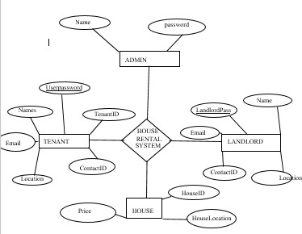

### Data Flow Diagram (DFD)

A Data Flow Diagram (DFD) is a graphical representation that depicts the information flow and the transforms that are applied as data moves from input to output.

*Level 0 DFD diagram for House Rental management system Figure 2*

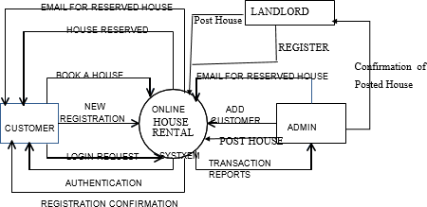

Level 0 DFD of Online House Rental System in this diagram, Customer, Landlords and System Administrator are entity sets.

## Functions of Customer:

* New Registration
* Login Request
* Registration Confirmation by the System
* Reserve House
* House Issued by the System
* Email received for Reserved House.

## Functions of System Administrator

* Add Customers/Tenants/landlords
* Send E-Mails for Reserved House
* View Transaction reports
* Post Vacant Houses

## Functions of Landlord:

* + Register in the system
  + Post a New house
  + Send House Confirmation to System Administrator

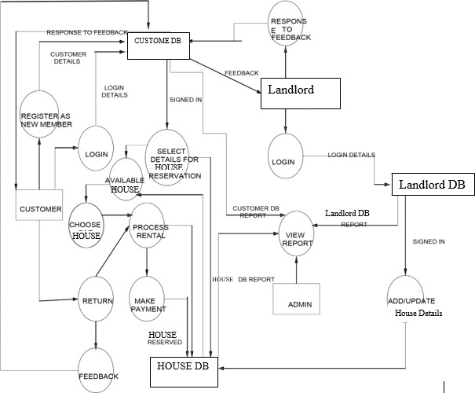

House Details

*Figure 3Level 1 DFD of Online House Rental System*

### USE-CASE DIAGRAMS

### Actor and Use Case Description

Actor and use case description shows the detail description of interaction between the actors and their use cases. The description enables to have a proper understanding of how actor interacts with the system through their use cases.

|  |  |  |  |
| --- | --- | --- | --- |
| **Actor** | **Use Case** | | **Use Case Description** |
| Customer | Register member | as | This use case describes the activities of the customer to register online and become a member. Customer's details are required as part of the registration. Customer chooses his login details by  entering user name and password registration. |

|  |  |  |
| --- | --- | --- |
|  | Make reservation | This use case enable customer to search and make reservation. Non-register customer will be directed to register before their reservation can be confirmed. Notification is automatically send to the customer after the task is completed. |
| Account management | This use case describes the event of customer setting his account and viewing his bookings. |
| Give feedback  And testimonies and subscription | This use case is used by the customer to provide feedbacks and Testimonies to the company; The user also subscribes to the news feeds to automatically get news on the available houses. a confirmation notification will be send to the customer once a  feedback has been submitted. |
| Landlord | Add new House | This use case is used by the landlords to add new and vacant house for rent or sale to the company's fleet database. Landlord will  needed to login to activate this use case. |
| Update House details | This use case is used by the Landlord to edit and modify House details whenever there is new renewal  (images, fees). It allows the company to keep up-to-date records  of their fleet |
|  |  |  |
| Reply to customer’s feedback | This use case describes the event by which Landlords sends reply to customer's earlier feedback. It depends on `give feedback' use case  from the customer. |
| Process rental | This use case described the event by which landlord updates the  system when customer take the house |
| Admin | Add new landlord | This use case describes the event by which Admin add new landlord detail to the company's landlord database.  It is invoke whenever a new landlord join the company. |
| View report | This use case is used by the Admin to view transaction report. |
|  | Post House | This use case is used by admin to add/edit new house |
| Manage pages | This use case allows admin to manage system pages by either adding,deleting or editing |
| Manage Testimonies | This use case allows admin to view and manage Customers  Testimonies |
|  | Manage Bookings | This use case describes the event by which admin views and confirm house bookings from the customer and the send the customer a  confirmation message |
|  |  |  |

|  |  |  |
| --- | --- | --- |
|  |  |  |
|  | Manage users | This use case allows admin to add, edit, delete new customer |
| Manage County/State/Area | This use case allows admin to add, delete or edit county, state, area of the properties |
| Manage listing Types | This use case describe how admin can add, delete or edit house listing  Types |
| Manage Subscribers | This use case allows admin to edit system subscribers. |

Table: Actors and Use Case Description

### Use Case Diagram

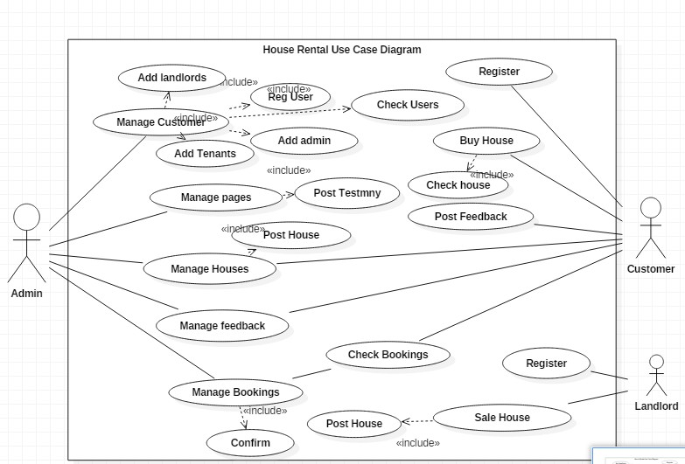

*Figure 4: Use Case Diagram*

### Use-Case Dependency Diagram

Add new

Register as Member

Depends on

Update House details

Make reservation

Contract

<<extend>>

Renew House contract

<<extend>>

Process rental

r

<<extend>> <<extend>>

From Date

To-Date

Reply to customer's feedback

Depends on

Give feedback/ comments

*Figure 5Dependency Use Case Diagram*

View customer’s

<<include>>

View report

details

<<include>>

View transaction report

## Class Diagram

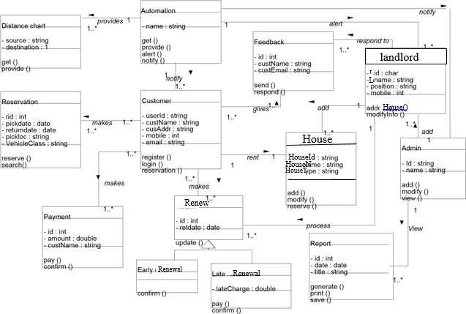

*Figure 6 Class Diagram*

# CHAPTER FOUR SYSTEM DESIGN

## Tenant Registration Module

This module allows Tenants or the system users to register and log in in case they want to make any inqueries in the system

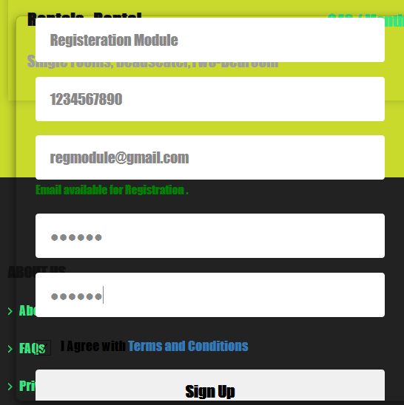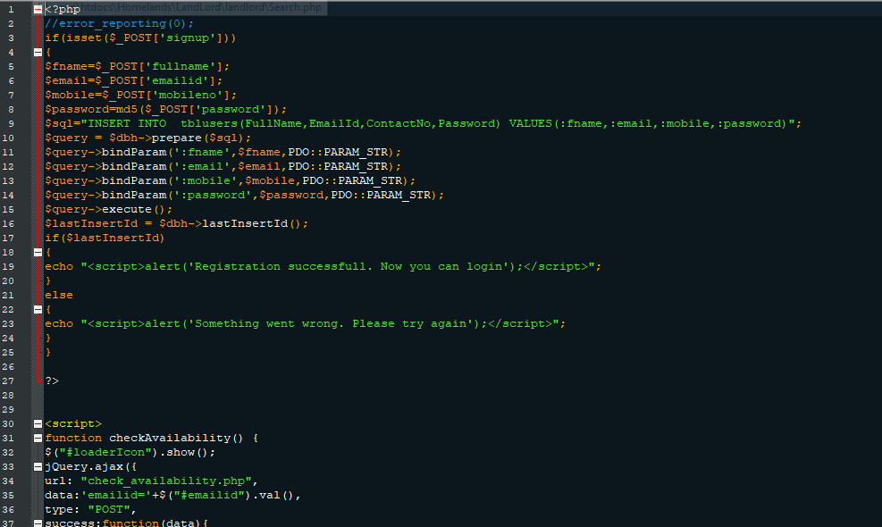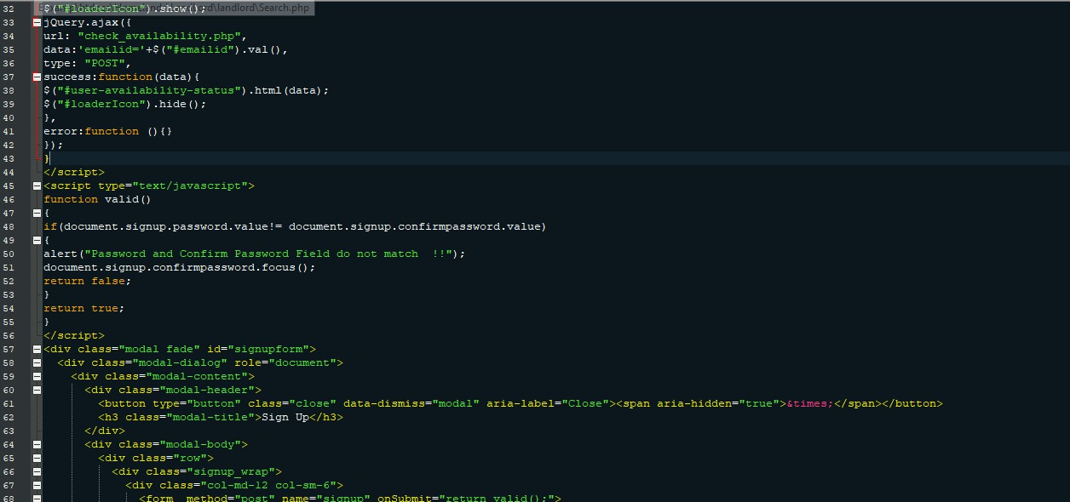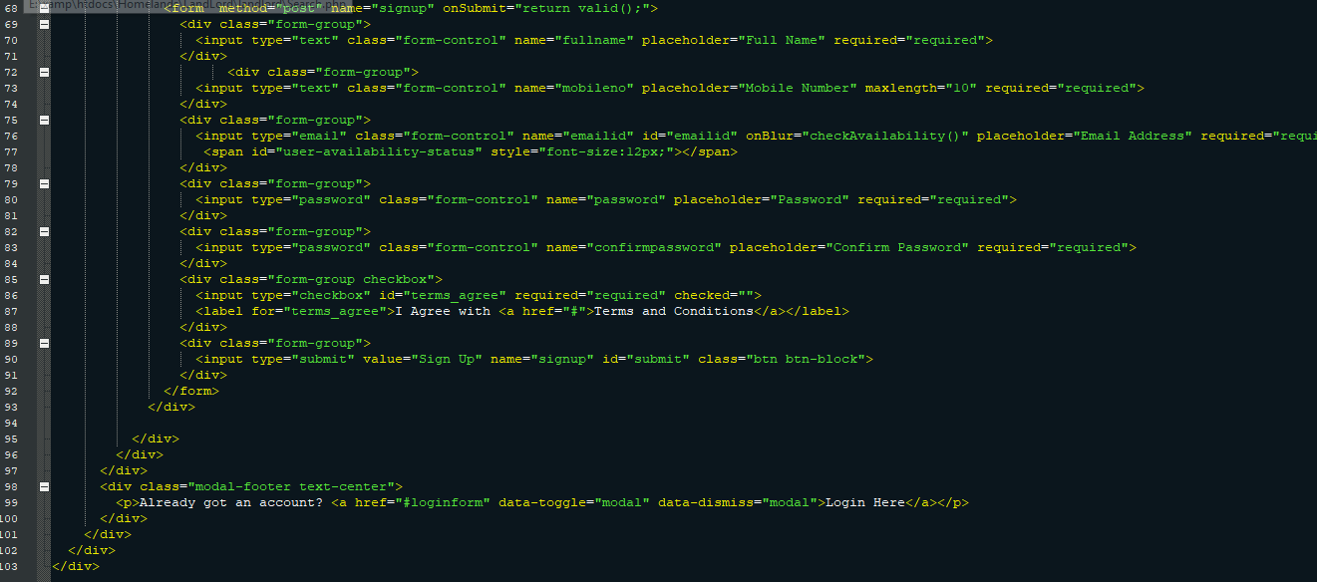

## House Listing Module

This module allows the system the system to query the uploaded Houses or property and display them in the web portal page called house listing

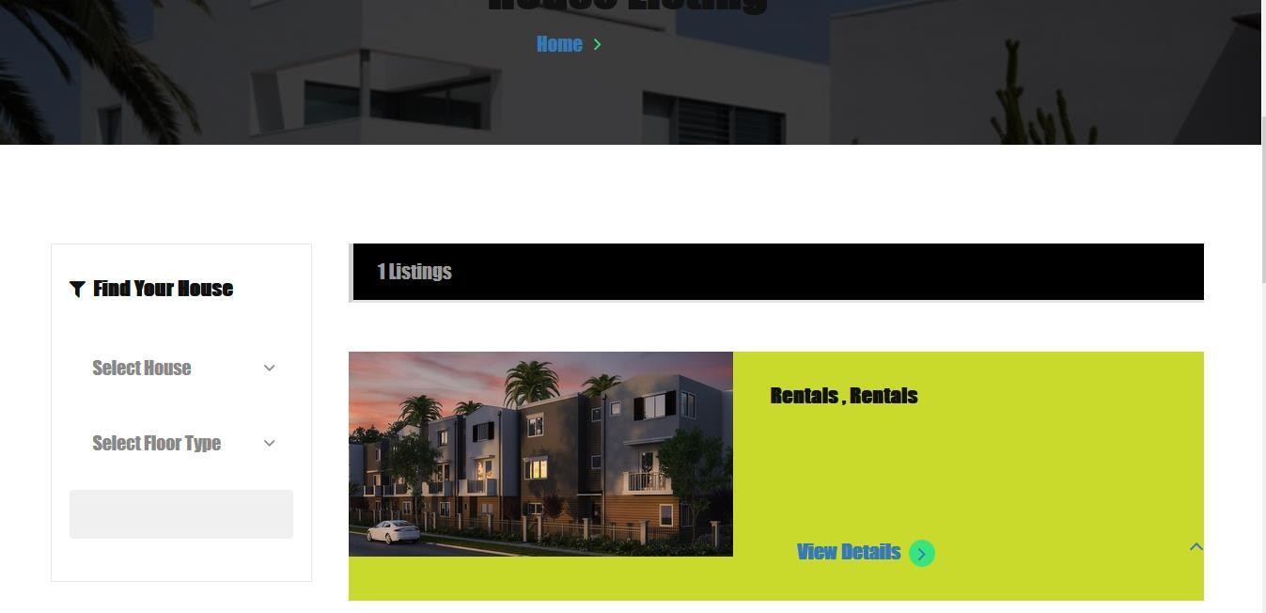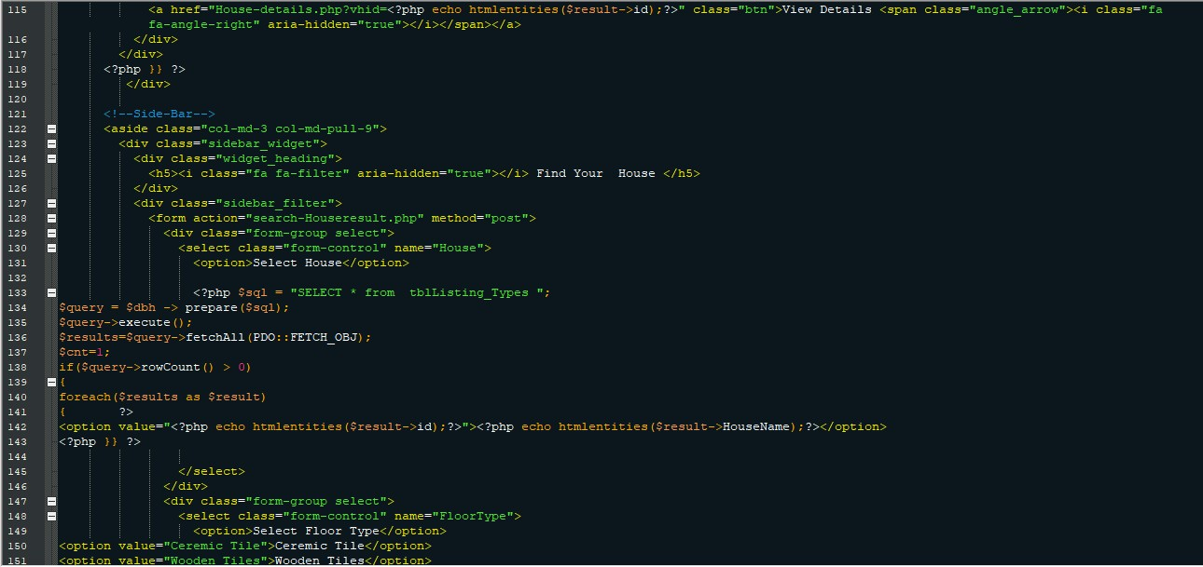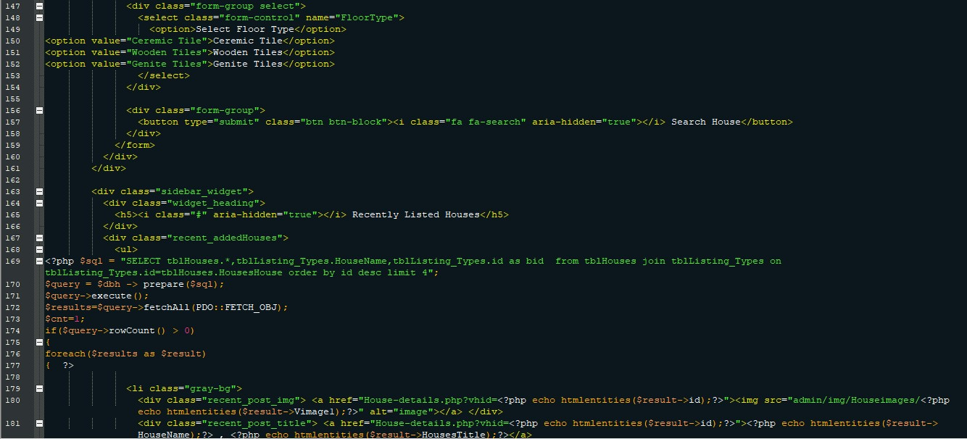

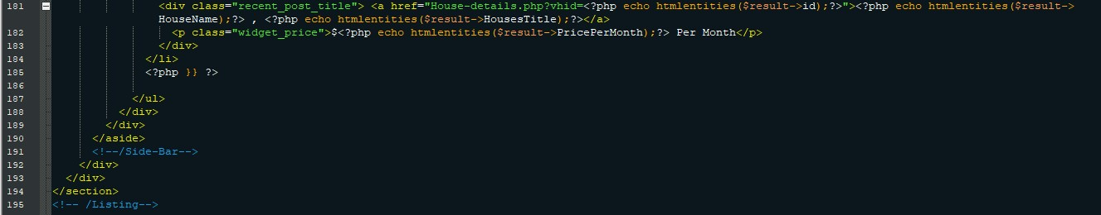

## LANDLORD REGISTRATION MODULE

This module allows property owners or landlords to register or log in incase the want to post their properties in the system without contacting system administrator to do it.

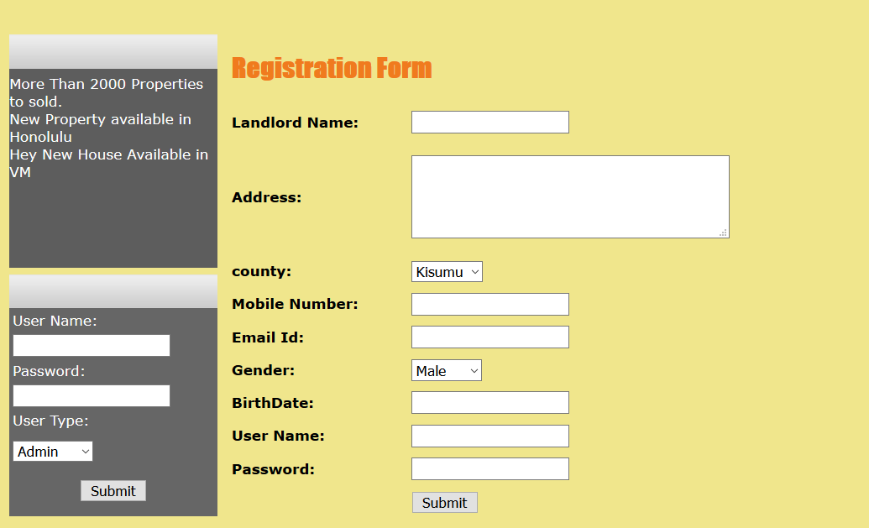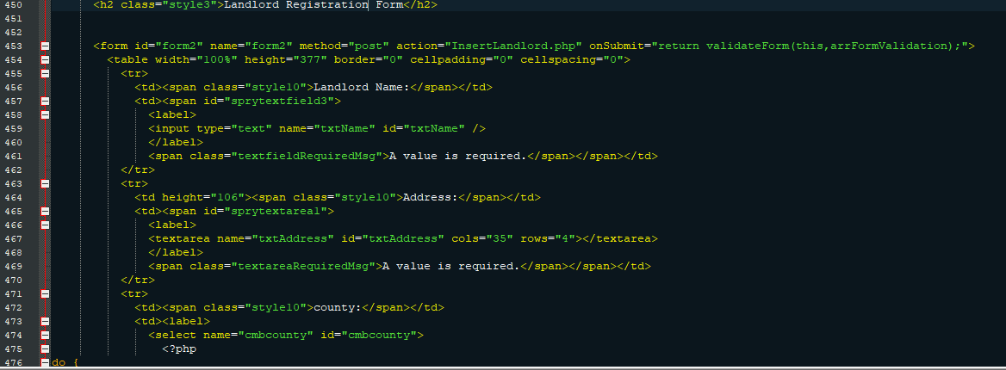

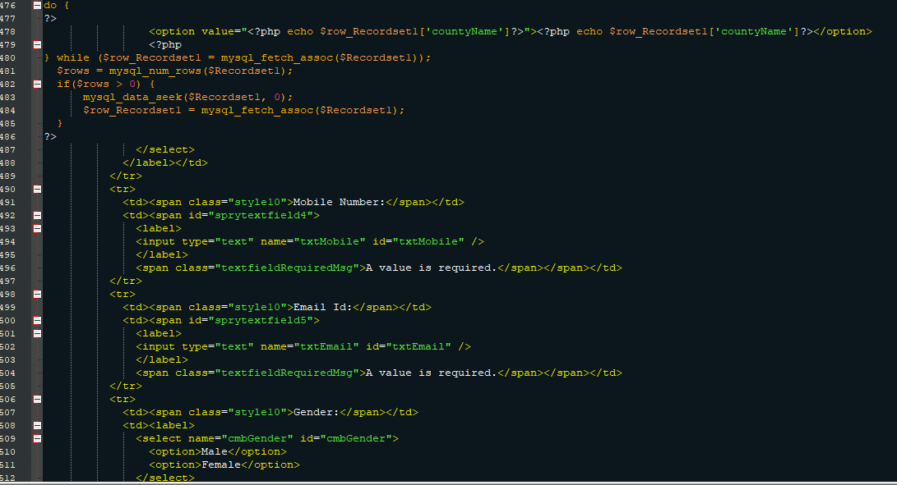

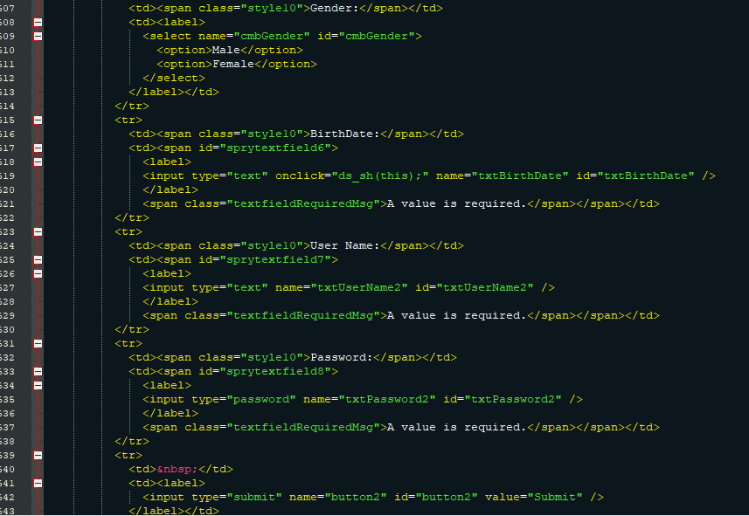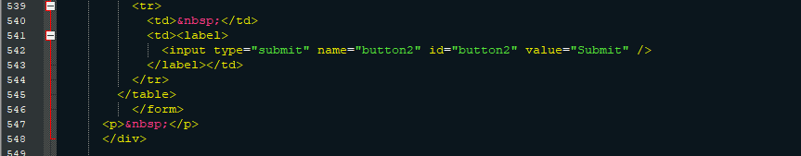

## SALE HOUSE MODULE

This module allows Landlord to post a property in the system after successful registration or login.



 

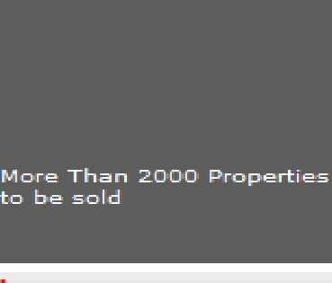Browse... No file selected.

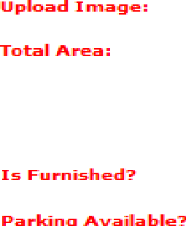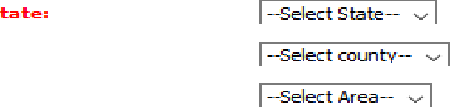





UpÌoad

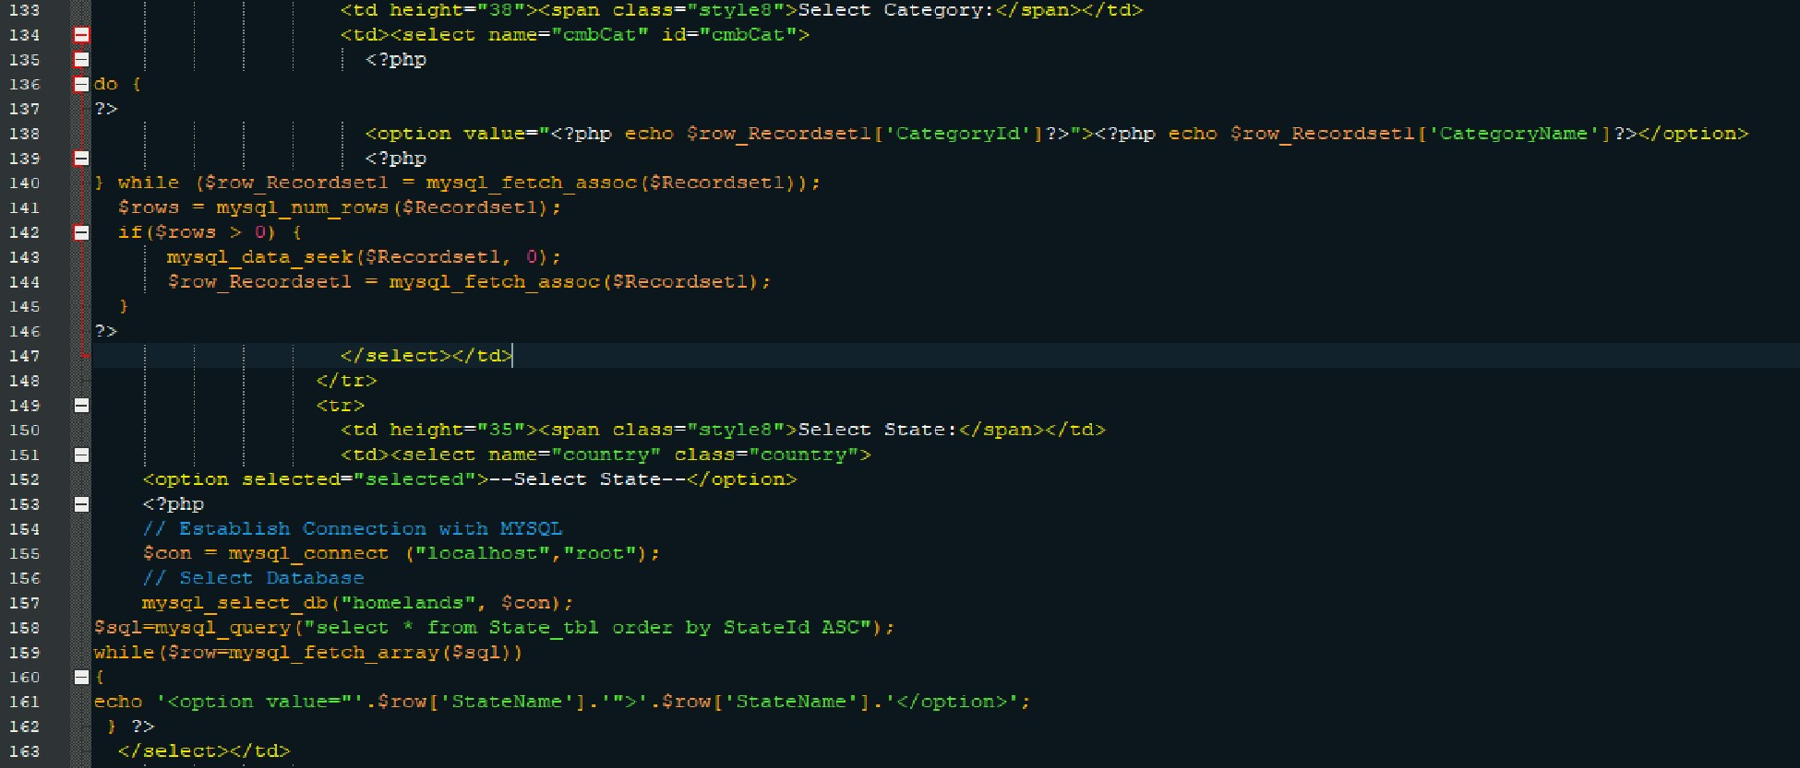

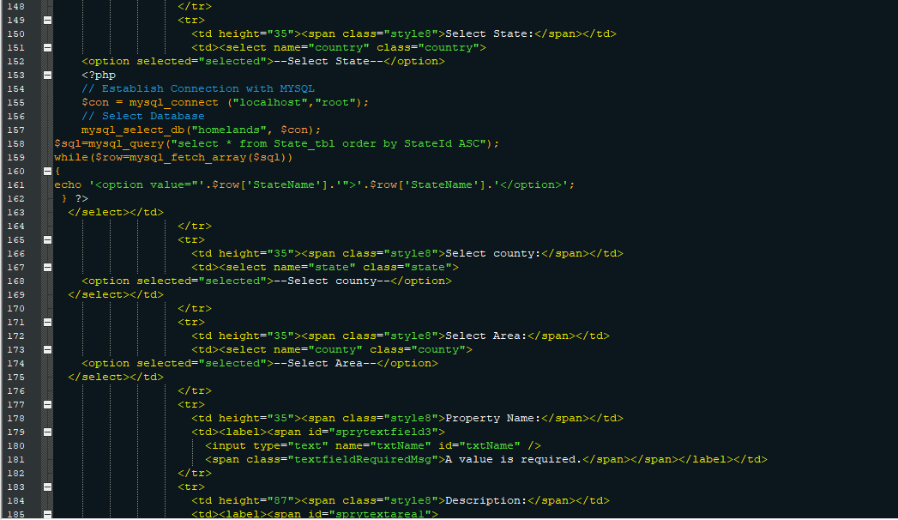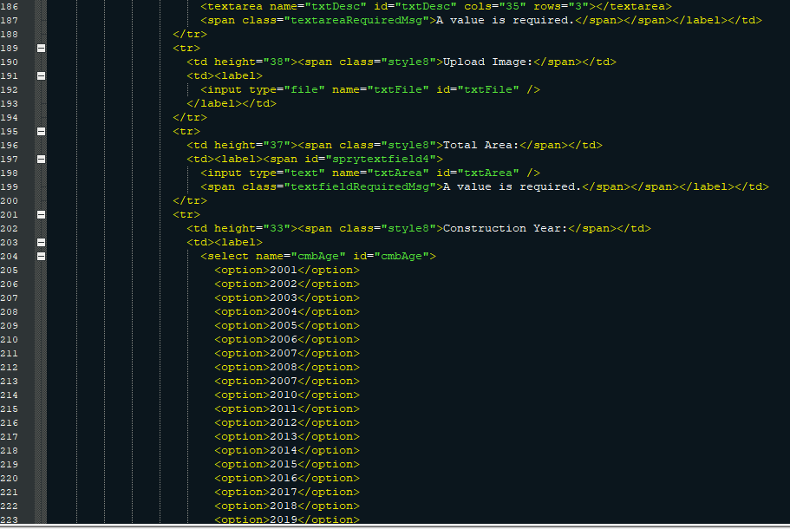

’TOtzl ROOi/s : :’’’’’aha’. ’’’zä

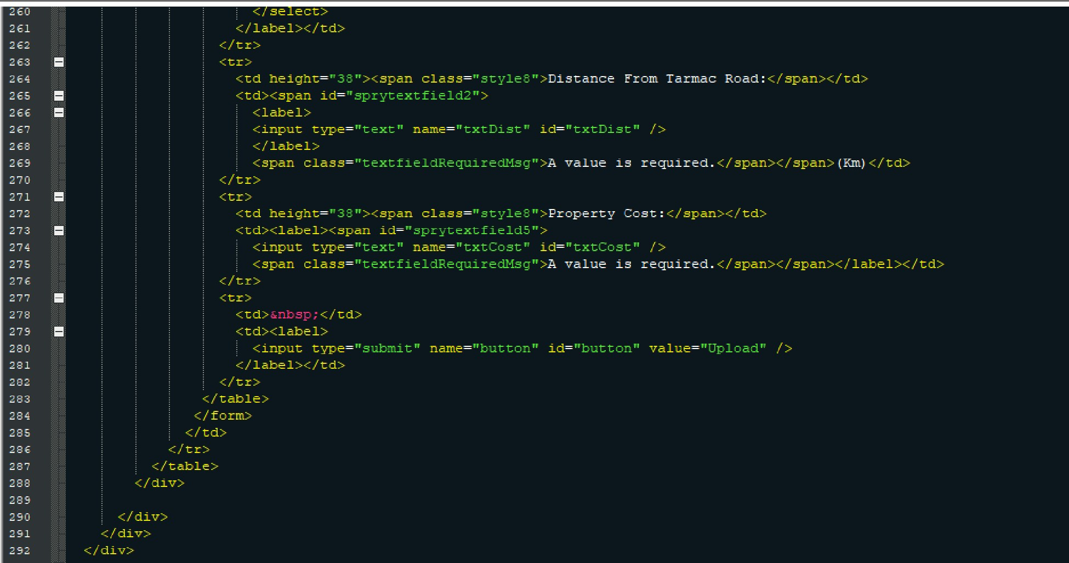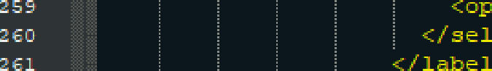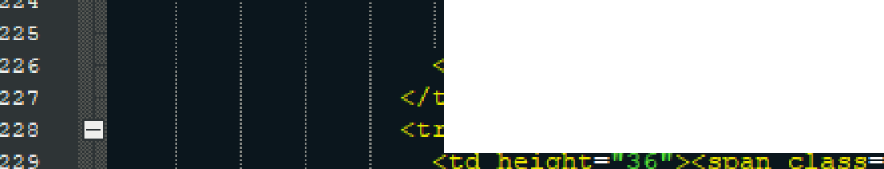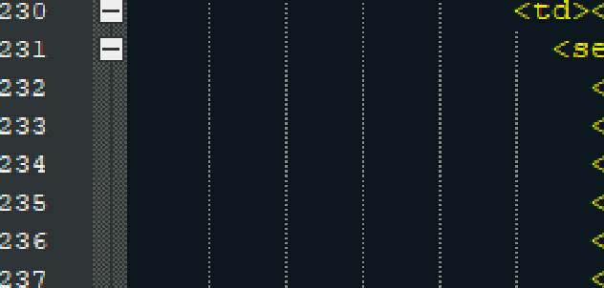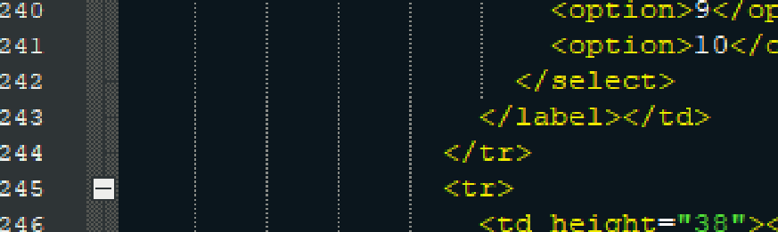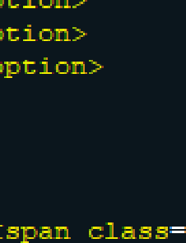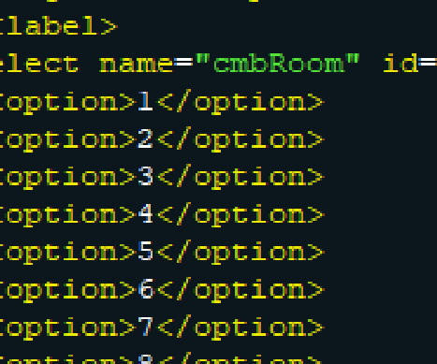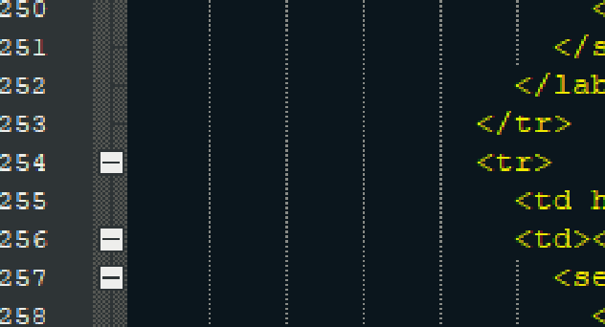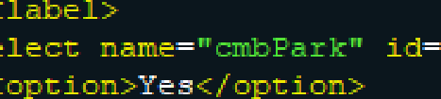

=4 .:

548 Æ

=4S

Is Farnîshed#’’:•_a’. :’:’’-:ì

Forking A=zailzkleï ’’u’.rr. ’:’:.i

## POST HOUSE

This module allows System administrator to mange by editing ,adding or posting a new house

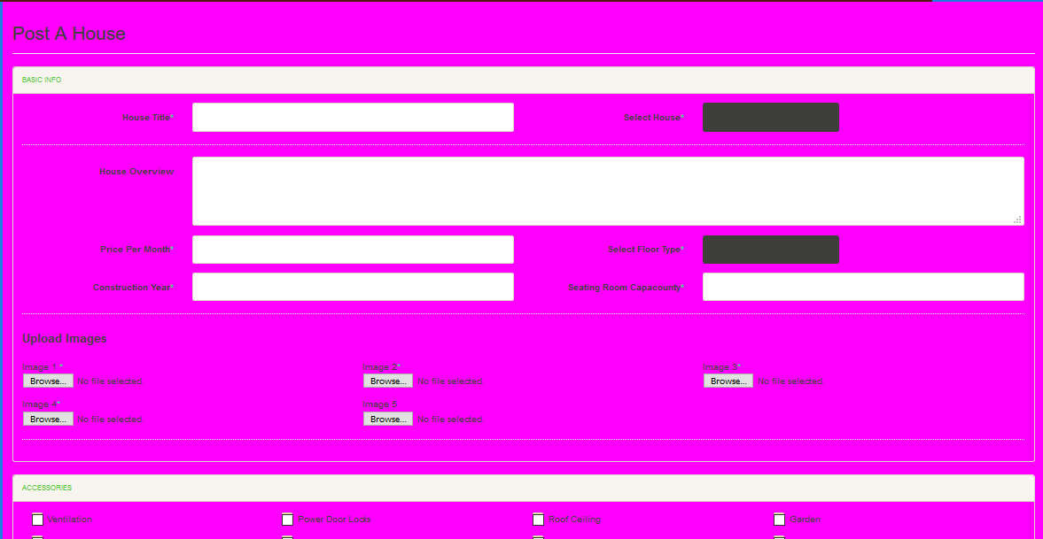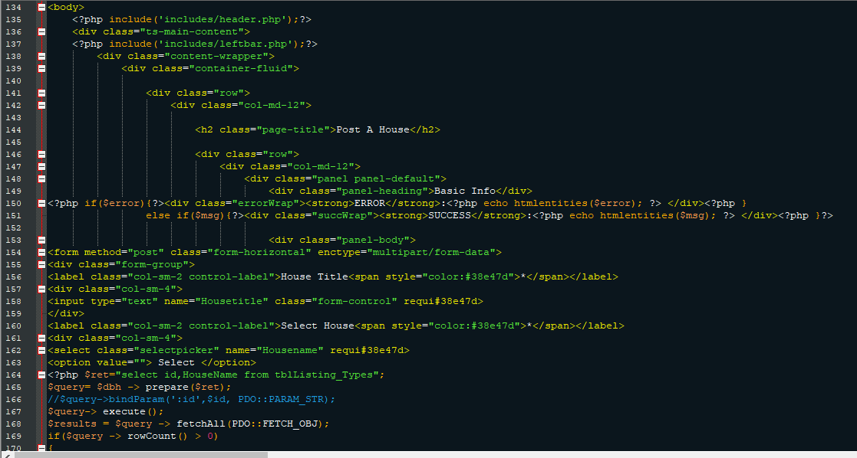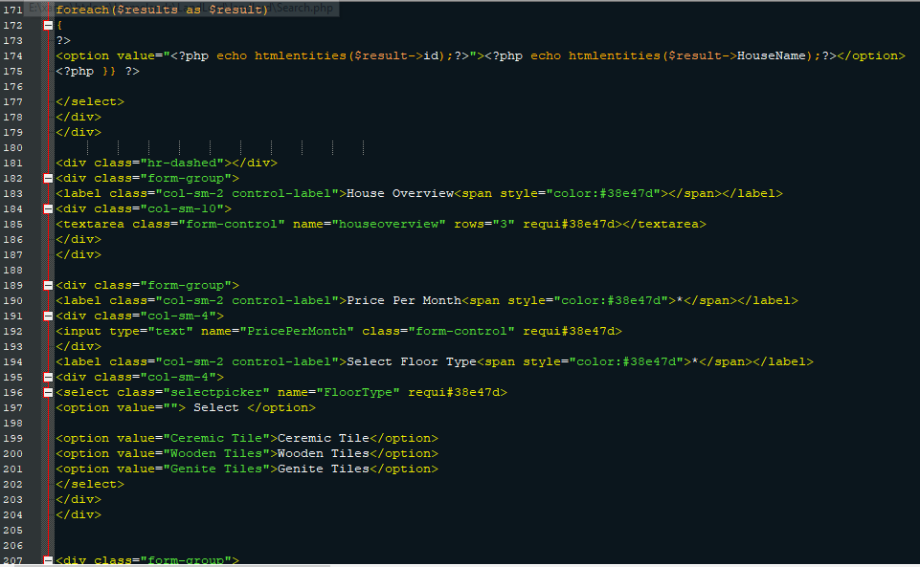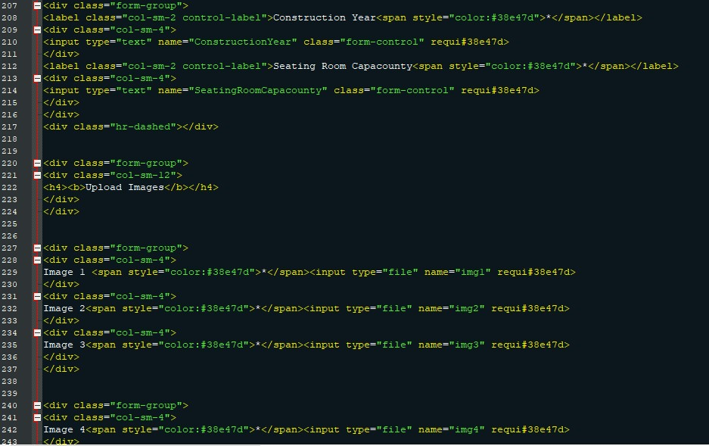

Accessories ’’l ”

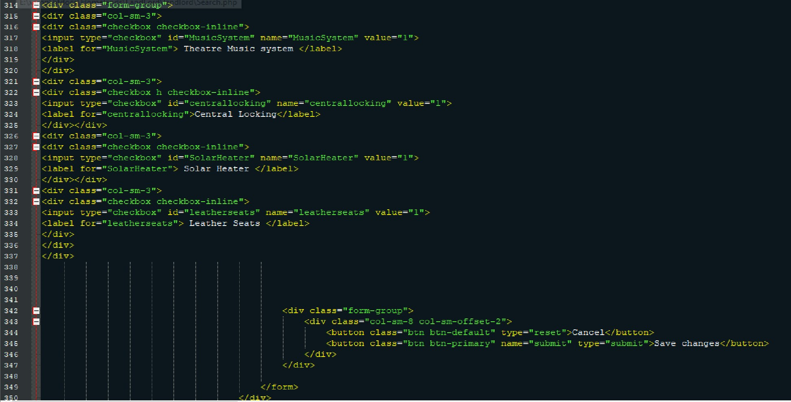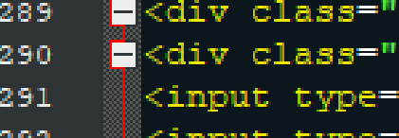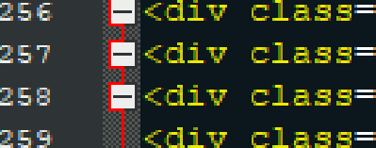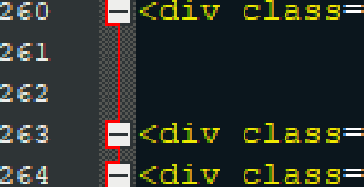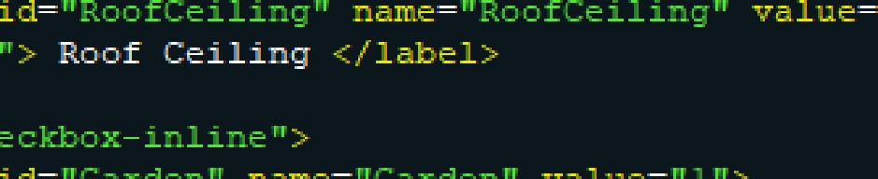

oc8

=4S

zTB

zBz

=84

-.*- .<r=- --,l =-

Ventllatlon ’’’ te

-.*- ..<.r=- --,l =-

Fower Door locks ’’’l=b:-

## Book House

This module allows Tenant/Customer to Book a house after selecting from available listed houses. In order to book a house, the customer/Tenant would be required by the system to log in or register to continue with the process.

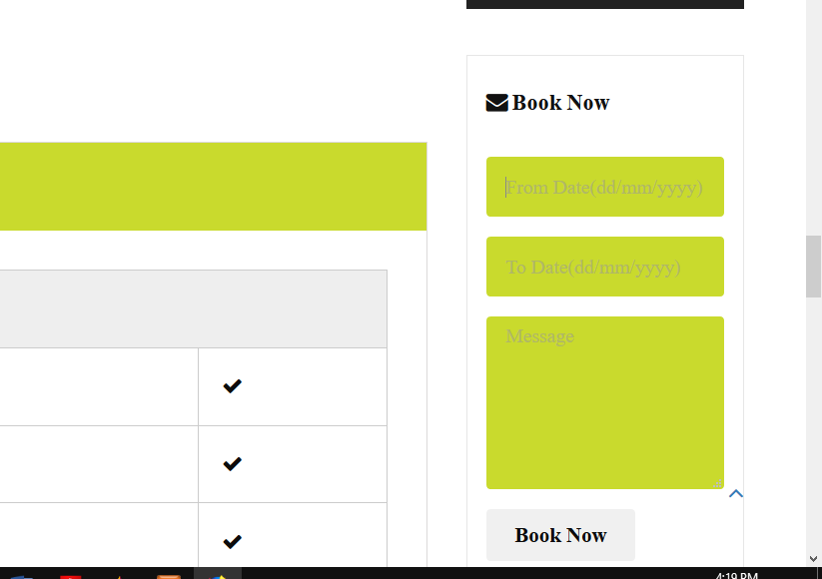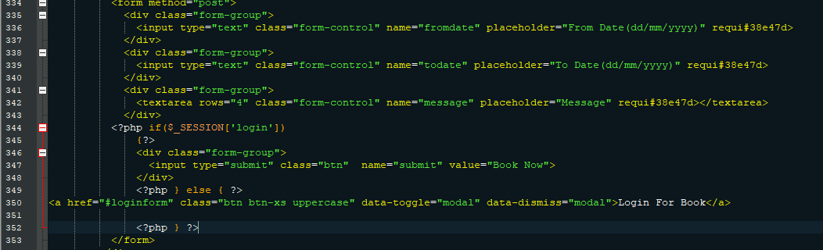

## Contact and feedback

This module allows Customers to send their queries and feedbacks about the system and services enquiries and their experience with the system services.

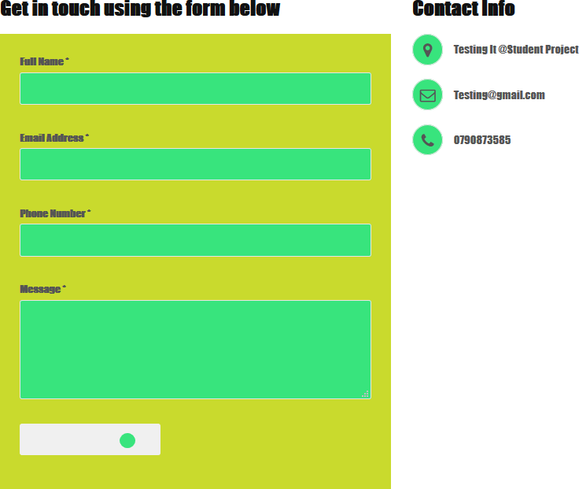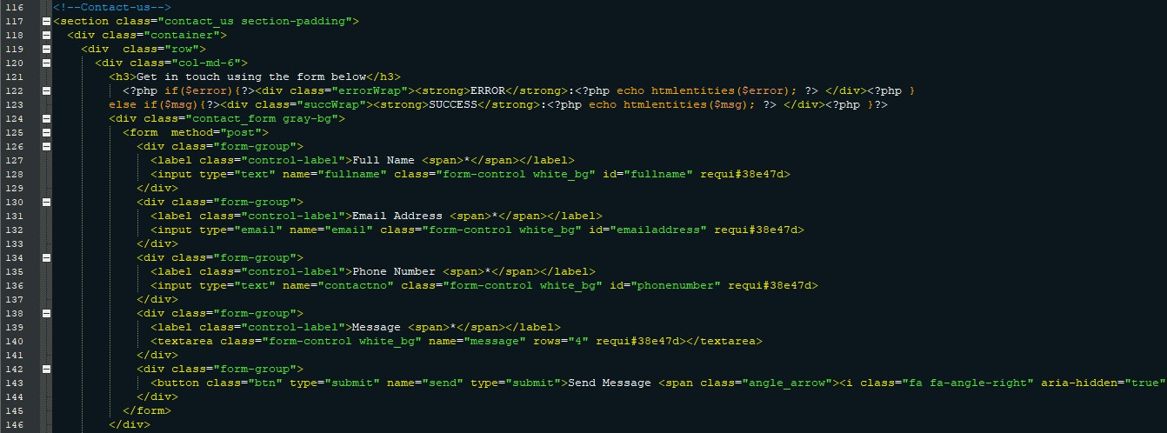

Buy House/Apartment

This module allows Customers to search for available houses, offices, shops, land, apartments in system following the search panel then make order

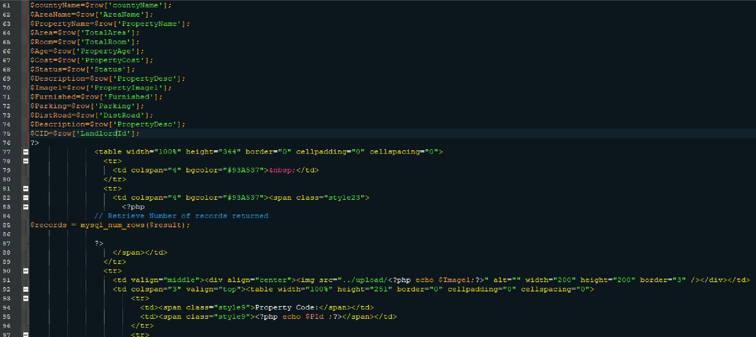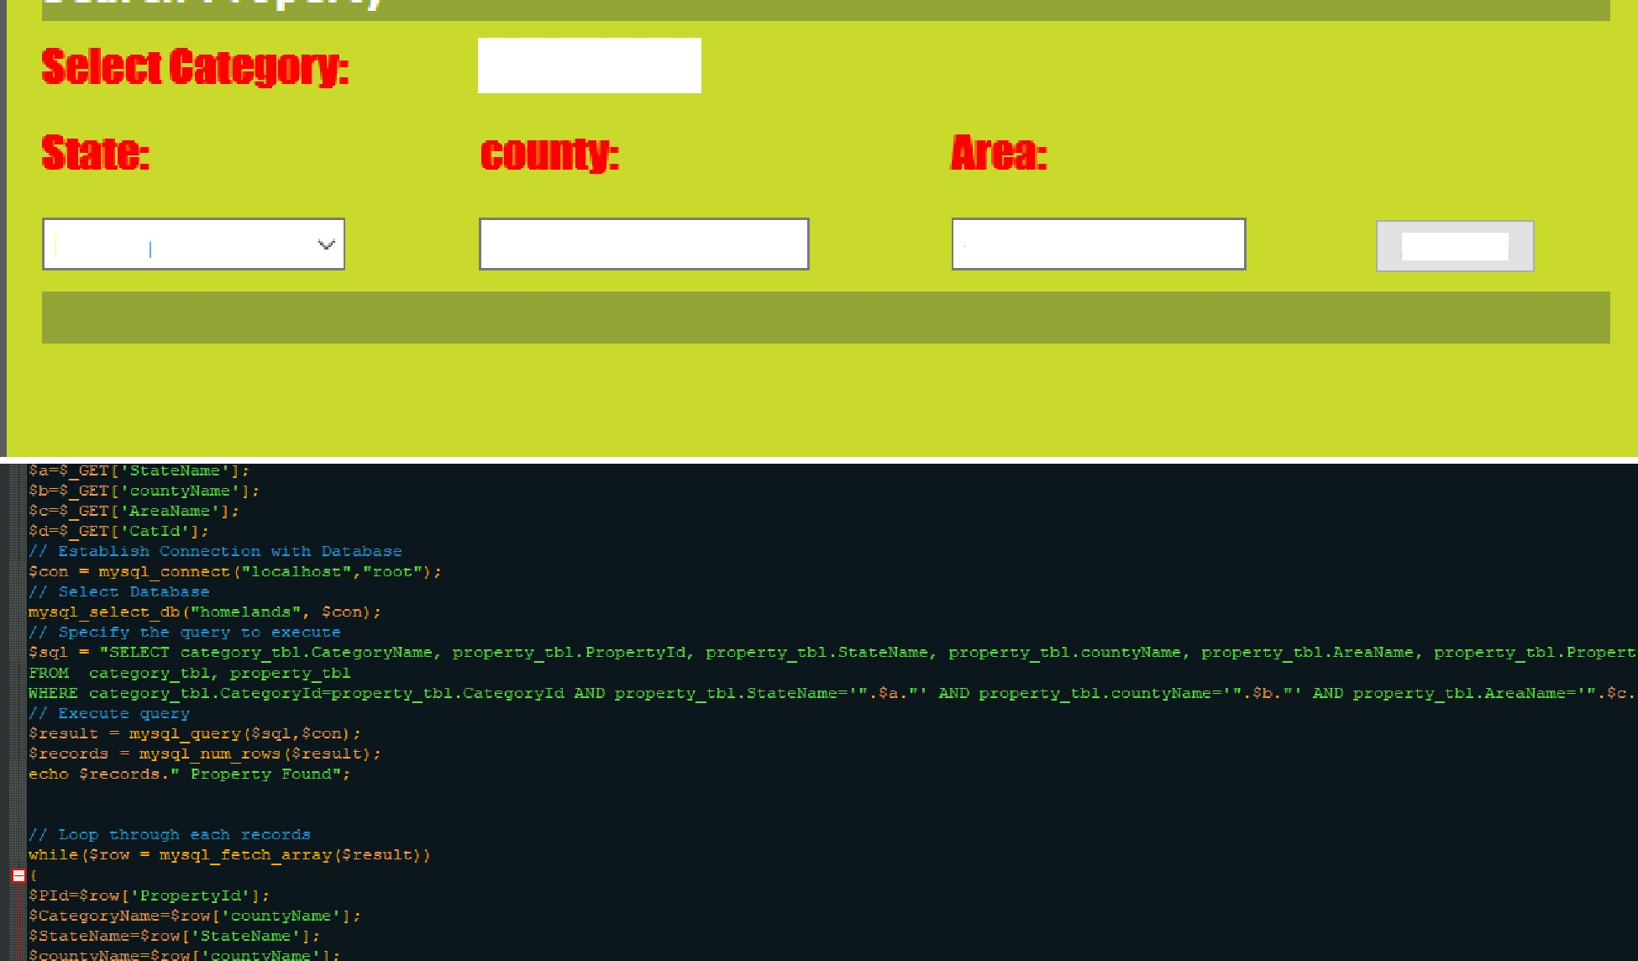

Rental

Kenya

--Select county-

-Select Area-

Search

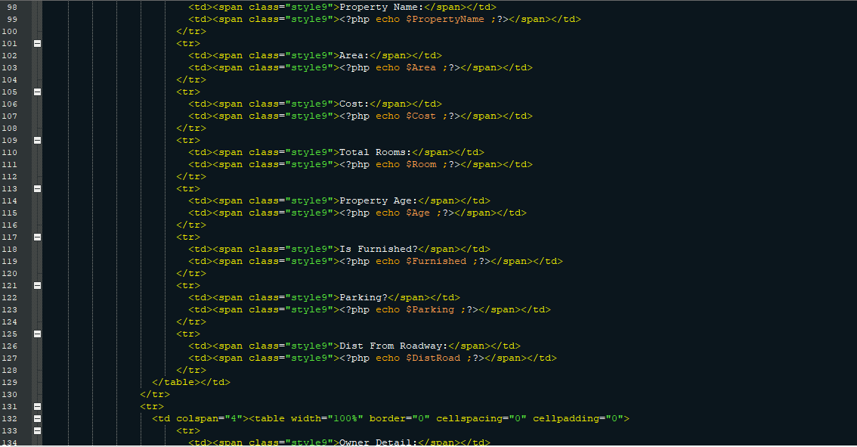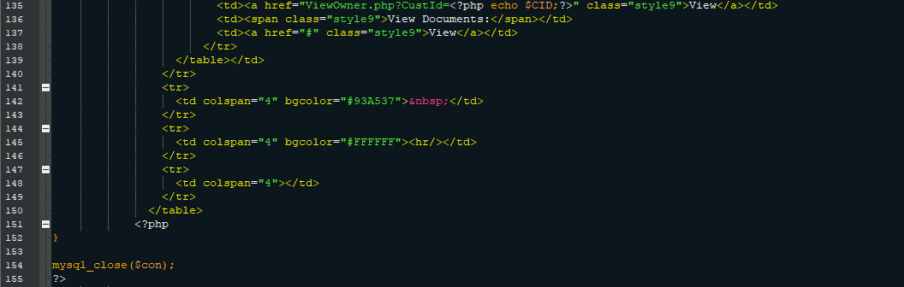

## ADMIN LOGIN MODULE

This module allows system administrator to log in to the admin panel

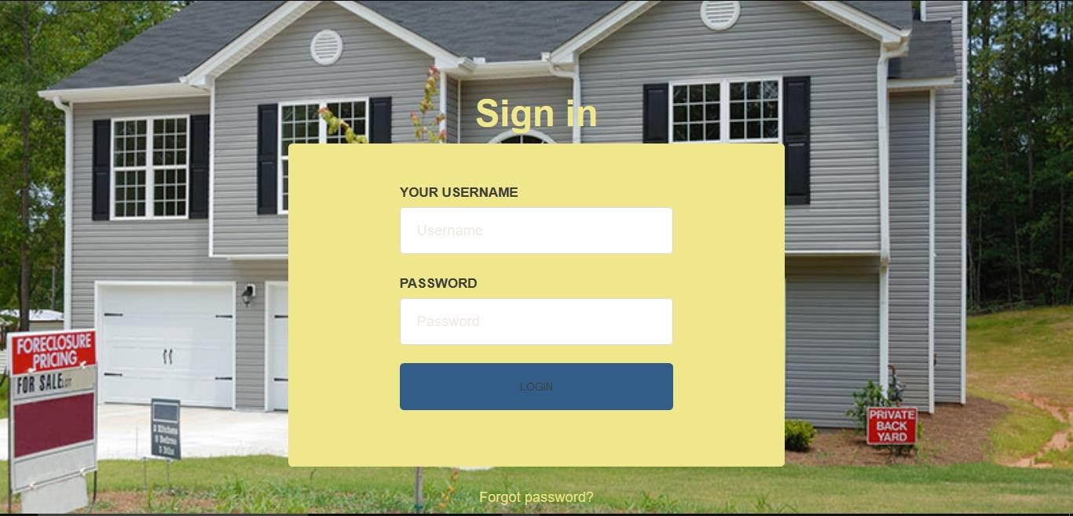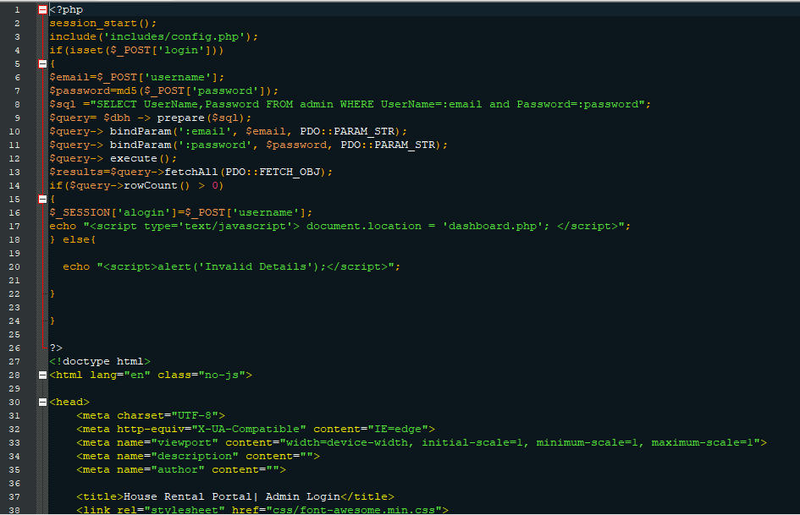

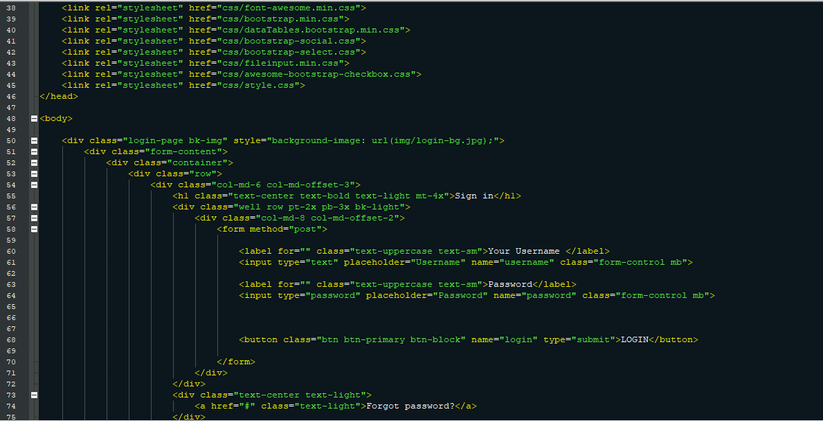

## Manage pages

This module allows system administrator to update the system pages without interfering with the source code

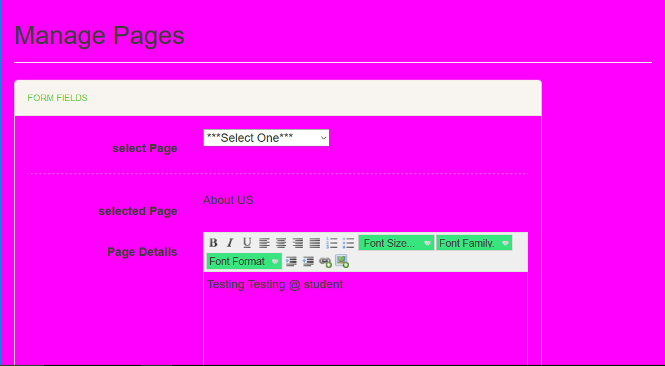

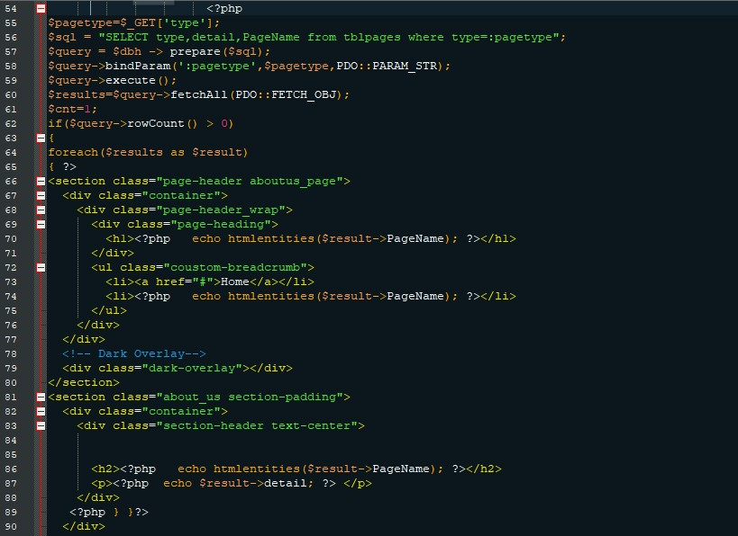

## Security

The system provides username and password to prevent the system from unauthorized access. The staffs’ password must be greater than eight characters.

**Test Cases Design**

|  |  |  |  |  |
| --- | --- | --- | --- | --- |
| **Test case Name** | **Purpose** | **Precondition** | **Test Steps** | **Expected Results** |

|  |  |  |  |  |
| --- | --- | --- | --- | --- |
| Register for House booking | Enable customer to register in the system before booking house | Customer has valid email id. | Click register button. Provide required information such as, name, email, phone no. | Customer will be registered in the system. |
| View House Details | Enable Customers/tenants to view the details of listed Vacant  houses | Customer is logged in the system | Click view Details to see the listed house details | Detailed description of The listed House in the system |

|  |  |  |  |  |
| --- | --- | --- | --- | --- |
| Admin/Landlord log in | Enable admin/Landlord to  log in to the system | Admin/Landlord has required credentials to log in | Input username Input password Select user type (Admin or Landlord) Verify username,  password and type | If verified, grant access to the system.  If not, show error message. |
| Create new Admin account | Enable new admin to use the system | Admin has valid email id | Log in as admin, click create new user Click submit | Another admin will be registered in the system. |
| User log out | Enable user to log out of the system | User is logged in | Click log out button. | User will be logged out |

|  |  |  |  |  |
| --- | --- | --- | --- | --- |
| Change password | Allow user to change password | User exists in the system | Click forgot password in log in page or change password in account settings. If forgot password, then recovery link will be sent to email. After clicking link, input new password, save password. | Log in credentials will be updated with new password. |

|  |  |  |  |  |
| --- | --- | --- | --- | --- |
| Post/Upload new house | Enable admin/landlord to upload a vacant house for rent or sale into the  system | Admin/Landlord has access to the system and authority to upload a new house for  sale | Input House details Upload picture.  Save | New house is uploaded in the system under new houses web page. |
| Update House details | Enable Admin/Landlord to update House details to current status | Admin/landlord is logged in and has clearance to update House details | Select House to edit Insert the new changes Save changes | Updated information will be saved and  displayed. |
| View House list | Enable Customers to view list of all vacant Houses | Customer/tenant is logged in to the system | Select House listing | List of available vacant Houses will be displayed |
| Search rent records by | Enable employee to search rent | Employee is logged in | Select search by category. | Search result matching input |
| Display Landlords report | Enable Admin to view the landlords report | Admin is logged in and has the clearance to view landlord report | Select view Landlords rent report | Landlord’s report will be displayed in a new window |

# CHAPTER FIVE IMPLEMENTATION AND TESTING

### Implementation:

The online House Rental management system in used in the following modules that can be implemented.

Modules Details:

The Implemented modules in given below 1.Registration/Login module 2.Booking Module

3 House Posting Module 4.Feedback and contact module

### Login modules:

Login modules is implemented in the online House Rental Management to only allowed a register person. we have to use this module in security purpose related on the detail.

### Registration modules:

The online House Rental management system in Registration modules is used to collect the user personal information. It has to collect the address, name, phone number also. The registration module details are stored in the database.

### Booking Modules

Online House Rental Management System has an implementation of House Booking where only registered members are allowed to view and book house/office/land/home for rental or lease

### Post House Module:

House Rental Management System has been implemented with House posting module where the seller/landlord or system administrator can upload house/property details for sale or rent

* 1. **TESTING**

Testing is the process of detecting errors. Testing performs a very critical role for quality assurance and for ensuring the reliability of software. The results of testing are used later on during maintenance also.

Psychology of Testing

The aim of testing is often to demonstrate that a program works by showing that it has no errors. The basic purpose of testing phase is to detect the errors that may be present in the

program. Hence one should not start testing with the intent of showing that a program works, but the intent should be to show that a program doesn’t work. Testing is the process of executing a program with the intent of finding errors.

Testing Objectives:

The main objective of testing is to uncover a host of errors, systematically and with minimum

effort and time. Stating formally, we can say

Testing is a process of executing a program with the intent of finding an error. A successful test is one that uncovers an as yet undiscovered error.

A good test case is one that has a high probability of finding error, if it exists. The tests are inadequate to detect possibly present errors.

The software more or less confirms to the quality and reliable standards.

### Levels of Testing:

In order to uncover the errors, present in different phases we have the concept of levels of testing. The basic levels of testing are as shown below…

Client Needs Requirements Design

Code

## Installation and project description

The database as it is developed by MySQL can be installed only by using the export and import concepts.

Using XAMP Server Upload the system files to the htdocs directory then open your server in the browser by typing <http://localhost/phpmyadmin>to import the database

The project can be described by the screenshots in the project as follows Home page

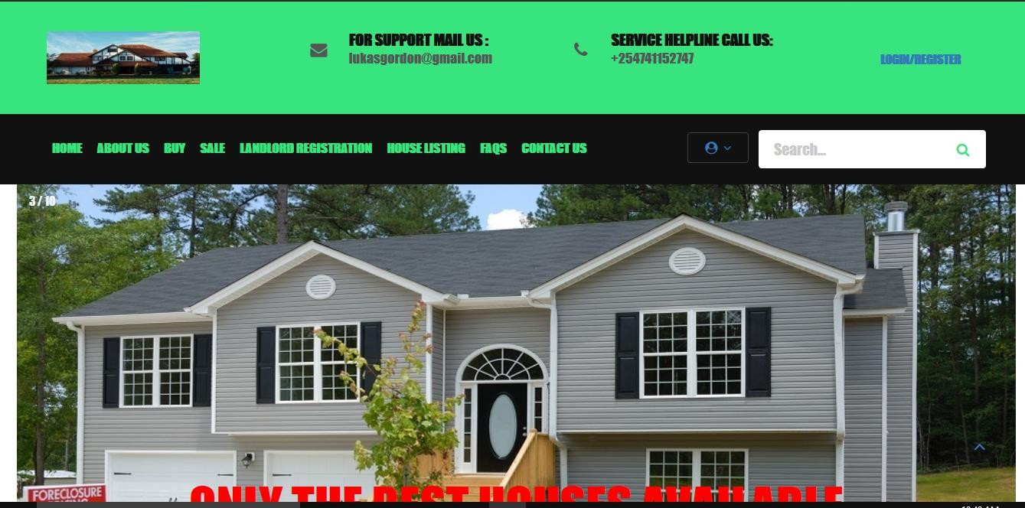

### House Listing

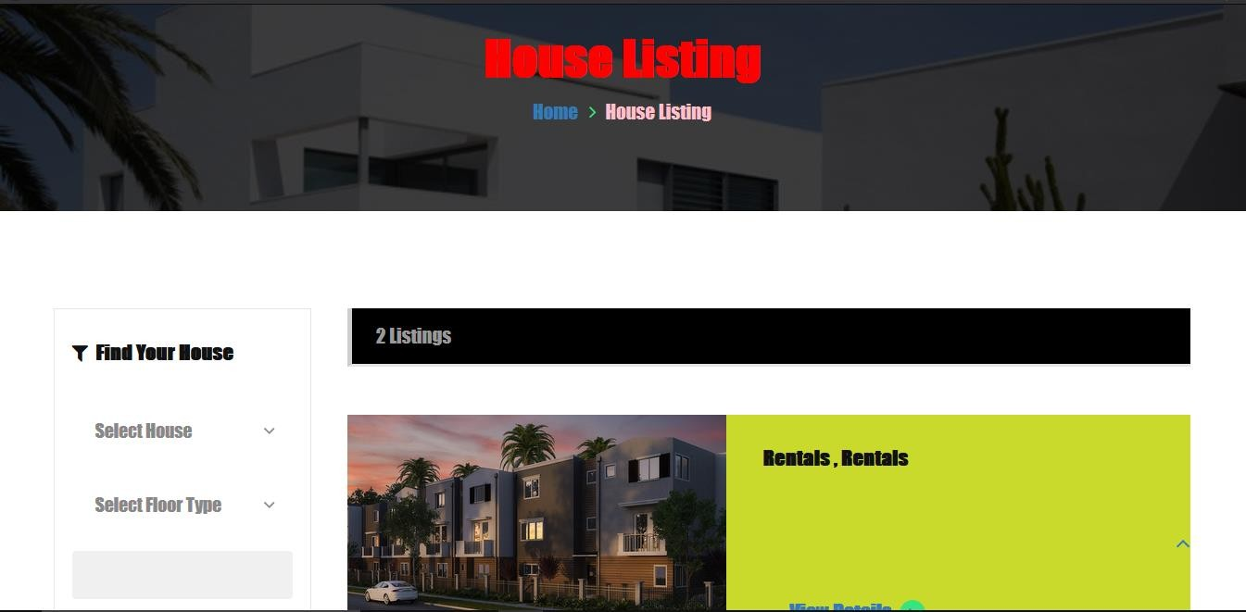

**Tenant Registration panel**



### Posting House

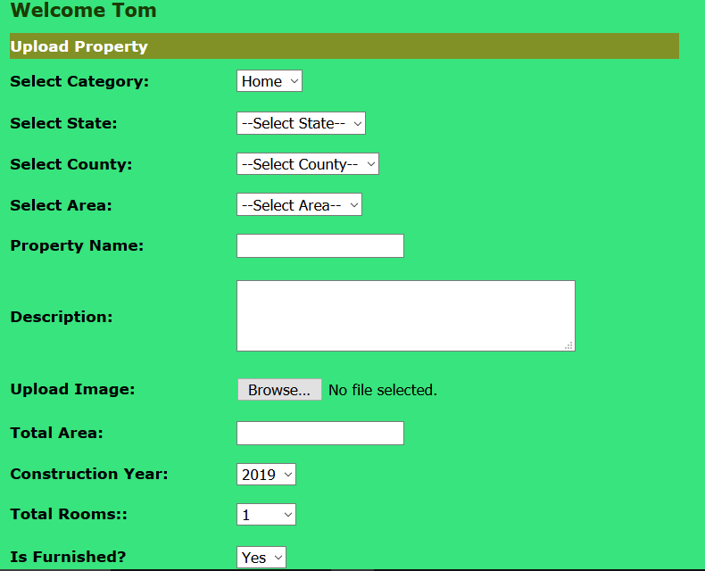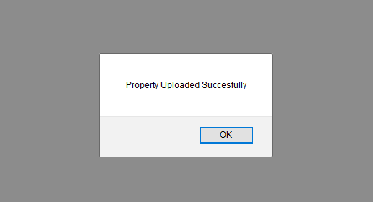

**Search Property**

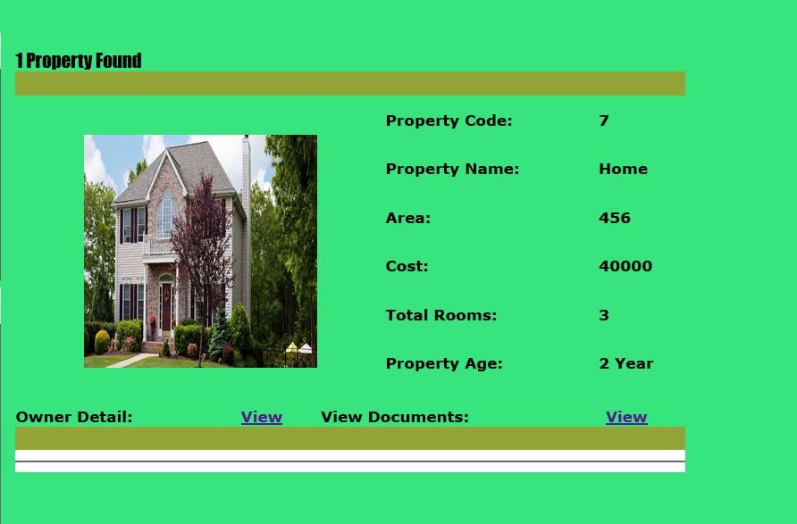

### Subscribe button

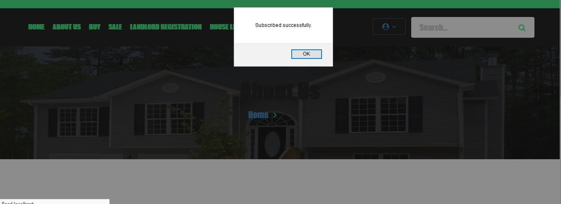

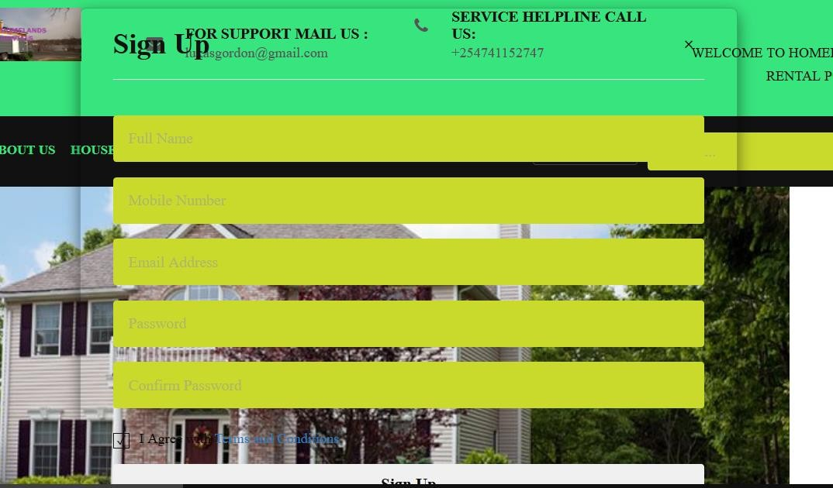**Sign Up form**

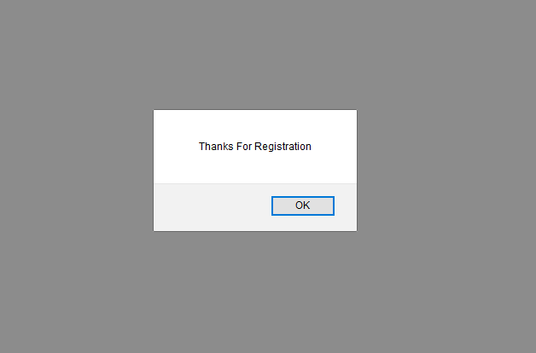

# CHAPTER 6 CONCLUSION

### Conclusion

House Rental business has emerged with a new goodies compared to the past experience where every activity concerning House rental business is limited to a physical location only. Even though the physical location has not been totally eradicated; the nature of functions and how these functions are achieved has been reshaped by the power of internet. Nowadays, customers can reserve book/buy/sale House online, rent House online, and have the house contracted successfully without any sweat once the customer is a registered member of the House Rental Management System.

The web based House rental system has offered an advantage to both Tenants as well as Landlords to efficiently and effectively manage the business and satisfies customers’ need at the click of a button.

* 1. **Limitation of the system**

The system at present does not take care of the money payment methods, as the

consolidated constructs need SSL standards and are critically to be initiated in the first face, the application of the credit card transactions is applied as a developmental phase in the coming days. The system needs more elaborative technicality for its inception and evolution.

## REFERENCES Books Used:

* Software Engineering - R.S. Pressman
* PHP for Dummies
* PHP Beginners Guide by McGraw-Hill Publication
* JavaScript by McGraw-Hill Publication

## References Used:

* <http://www.resgroup.net/>
* [http://www.a1realestate.solutions](http://www.a1realestate.solutions/)
* Wikipedia.org
* [www.w3schools.com](http://www.w3schools.com/)
* [www.webcampzg.org](http://www.webcampzg.org/)

## GLOSSARY

* + 1. MB Megabytes
    2. GB Gigabytes
    3. SQL Structural Query language
    4. Admin Administrator
    5. RAM Random Memory
    6. PHP Hypertext preprocessor
    7. HTML Hypertext Markup Language