Resume Analyzer: An AI-Powered Framework for Semantic Resume Analysis, Job Description Matching and Career Guidance Using Large Language Models

ABSTRACT :
Online recruitment has grown fast enough that most job seekers now compete against hundreds of other applicants for the same role, and a resume that does not clearly speak to a specific job description is often filtered out before a human ever reads it. Most existing resume evaluation tools still rely on keyword matching and fixed rules, which means the feedback they give is generic and often misses candidates who describe the right skills using different terminology. We built Resume Analyzer to address this gap: an AI-powered system that combines Large Language Models, semantic retrieval, and Retrieval-Augmented Generation (RAG) to give job seekers personalized, context-aware feedback on their resumes. The system runs on Google Gemini 2.5 Flash for analysis and conversational assistance, Gemini Embedding for semantic representation, LangChain to orchestrate the pipeline, and FAISS for fast vector retrieval. Given a resume and a target job description, it performs a semantic comparison, identifies missing skills and keywords, generates concrete improvement suggestions, and answers follow-up questions through a chatbot grounded in the candidate's own resume. Rather than relying on the LLM's contextual match score or embedding similarity alone, the system combines both into a single hybrid match score, letting each signal correct the other's weaknesses. Evaluated with 5-fold cross-validation on 200 verified resume-job description pairs against three individual baselines, TF-IDF, embedding similarity, and the LLM score alone, this hybrid score achieves the best accuracy (0.92), recall (0.96), and F1 score (0.95) of all methods tested, while matching the LLM's own precision and closing most of the gap to embedding similarity's precision ceiling. Results are presented on an interactive dashboard showing the combined match score alongside its underlying components and a visual breakdown of strengths and gaps. We implemented the complete system as a working web application, demonstrating that a hybrid fusion of LLM-based reasoning and semantic retrieval is a practical, deployable, and empirically stronger approach than either signal alone for helping job seekers prepare stronger applications.
Keywords: Resume Analysis, Large Language Models, Gemini 2.5 Flash, Semantic Similarity, Hybrid Score Fusion, Retrieval-Augmented Generation, LangChain, FAISS, Artificial Intelligence, Career Guidance.

INTRODUCTION :

Overview :
Students and working professionals today apply to dozens, sometimes hundreds, of internships and jobs through online platforms, and in almost every case the resume is the first thing a recruiter sees before deciding whether to move forward. Yet most applicants struggle to judge whether their own resume actually reflects the skills and experience a specific job role is asking for. The result is a familiar and frustrating pattern: a rejection arrives with no explanation, and the candidate is left guessing what was missing or how the resume could have been stronger.
Limitations of Existing Systems :
Applicant Tracking Systems (ATS) and other automated screening tools have made the recruiter's side of this process faster, but they were built to filter candidates, not to help candidates improve. Most of them still lean on keyword matching and hand-written rules, so the feedback a job seeker gets back, if any, tends to be generic and blind to context. A resume that says “led a cross-functional team” instead of “managed,” for instance, can lose points it should not lose, simply because these tools compare words rather than meaning.
Emerging AI Technologies :
This is exactly the kind of problem Large Language Models are well suited to solve. Unlike keyword-matching systems, an LLM can read a resume and a job description the way a person would, picking up on meaning rather than exact wording, which opens the door to genuinely personalized feedback instead of a generic checklist. Pairing this with vector embeddings, a vector database, and Retrieval-Augmented Generation (RAG) takes it a step further, letting a system retrieve the exact parts of a resume relevant to a question and answer with that context in hand rather than guessing from general knowledge.
Proposed Work :
That is the gap this paper sets out to close. We built Resume Analyzer, an AI-powered system that helps job seekers evaluate and improve their resumes against a specific job description rather than a generic checklist. It brings together Google Gemini 2.5 Flash, LangChain, Gemini Embeddings, and FAISS to perform semantic resume-job matching, flag missing skills and keywords, suggest concrete improvements, and power a chatbot that can answer questions about the uploaded resume directly. Rather than trusting either the LLM's contextual match score or embedding-based similarity in isolation, the final match decision fuses both signals into a single hybrid score that empirically outperforms each individual method, as shown in Section VI. Results are shown visually, through skill-coverage breakdowns and similarity scores, and the system also caches results and retries failed requests automatically, so it stays fast and reliable even when the underlying API misbehaves.
Paper Organization :
The rest of this paper is organized as follows. Section II reviews related work on AI-based resume analysis and recruitment systems and identifies the gap this work addresses. Section III presents the proposed methodology and system architecture, along with the dataset used for evaluation and the technologies behind the system. Section IV describes the implementation. Section V presents the results and discussion, and Section VI concludes the paper with directions for future work.

LITERATURE SURVEY :
Chong et al. [1] combine a Resume Screening AI with a Job Recruitment Chatbot in a single integrated recruitment system. Resumes in multiple formats are parsed using PyPDF2 and python-docx and structured into a validated JSON schema via the Google Gemini 1.5 Flash API, while candidate ranking blends classical techniques such as TF-IDF and BERT with the LLM. Their chatbot, built on RASA and enhanced with Whisper-large for voice-to-text interaction, handles FAQs and conversational guidance during recruitment. It is a strong demonstration of pairing structured extraction with conversational assistance, but the system is built from the recruiter's side of the table, screening candidates rather than helping applicants improve their own resumes.
A different concern is raised by Wu et al. [2], who point out that LLM-based resume screening can quietly inherit the biases baked into a model's pretraining data. Their fix is a parameter-efficient debiasing framework built on adapter fine-tuning, combining adversarial training to separate sensitive-attribute bias from genuine qualification signals with contrastive learning to keep the screening performance intact. Tested on real resume data, it achieves noticeably fairer outcomes across several sensitive attributes than three baseline debiasing methods, at only a small accuracy cost. It is a reminder that accuracy on paper is not the same as fairness in practice, something systems, including this one, that focus purely on matching quality tend to leave unaddressed.
Zhu et al. [3] approach the problem from the recommendation side rather than the analysis side. Their concern is that resumes on job platforms often go stale, which throws off how well a recommender can understand what a candidate is actually looking for. Their solution is to fine-tune an LLM to automatically complete a job seeker's resume, guided by a new Denoised Direct Preference Optimization (Denoised DPO) method that separates real user preferences from noisy signals like clicks and applications. The completed resumes measurably improve downstream job recommendations, a good illustration of how generative models can add to a resume rather than just evaluate it, a capability related to, but distinct from, the improvement suggestions this framework generates.
On a broader scale, Thomas et al. [4] survey more than fifty existing AI-driven career support systems, spanning resume builders, ATS analyzers, job recommenders, and even government exam eligibility checkers, and find that most of them work in isolation. Their response is to propose a single integrated career intelligence platform combining recommendations, resume generation, ATS scoring, skill-gap analysis, and exam eligibility checks, built on Machine Learning, NLP, and rule-based logic. It is an ambitious scope, but the platform remains a conceptual design rather than something actually built, and it does not include a conversational chatbot or LLM-based reasoning of the kind this work relies on.
Perhaps the closest system to this one in spirit is Career Craft Scanner by Yelure et al. [5], a Streamlit-based platform that parses resumes with spaCy and NLTK, using Named Entity Recognition to pull out candidate details, skills, and experience. It compares resumes to job descriptions with both TF-IDF and cosine similarity, and the authors themselves report that cosine similarity gives a more accurate read on semantic closeness than TF-IDF alone, a conclusion that lines up with the dual-scoring approach adopted here. Career Craft Scanner also lets recruiters set a similarity threshold for shortlisting and visualizes applicant skill and experience spread through charts. What it does not have is a Large Language Model anywhere in the pipeline or any way for an applicant to have a conversation with the system about their own resume.
Abhishek et al. [6] build a Python and Streamlit-based Resume Analyzer around Pyresparser, NLTK, and a MySQL backend. Their tool gives applicants personalized suggestions for improving their resumes, exports CSV summaries recruiters can plug into existing workflows, and surfaces analytics on which roles and skills are trending in the job market. It is a genuinely useful combination of applicant-facing and recruiter-facing features, but the parsing underneath is rule-based, so it cannot recognize a skill described in unfamiliar wording the way a language model can.
Taken together, these six systems show real progress on resume parsing, candidate screening, bias mitigation, and career recommendation, but a pattern emerges once they are lined up side by side. Most are built to help recruiters screen candidates rather than help candidates help themselves [1], [4], [5], [6]. Most also lean on classical NLP, TF-IDF, Named Entity Recognition, rule-based parsing, rather than the kind of contextual reasoning an LLM provides [1], [5], [6]. And where LLMs are used, they tend to solve one narrow problem at a time, debiasing [2] or resume completion [3], rather than sitting inside a complete, conversational, applicant-facing tool. That gap is what this paper is trying to fill: a system that combines LLM-based semantic matching, a dual embedding-and-LLM score, and a RAG-powered chatbot in one place, built for the applicant rather than the recruiter, summarized in the comparison table below.

COMPARISON TABLE :
System (paper) | Resume  Parsing | LLM Semantic  Analysis | JD–Resume  Similarity | Dual Scoring  (Embed+LLM) | Skill Gap  Analysis | Actionable  Suggestions | RAG  Chatbot | Interactive  Dashboard | API  Resilience
Chong et al. — main.pdf [1] | ✓ | ✓ | ◐ | ✗ | ✗ | ✗ | ✓ | ✗ | ◐
Wu et al. — 3.pdf [2] | ✓ | ✓ | ✓ | ✗ | ✗ | ✗ | ✗ | ✗ | ✗
Zhu et al. — 4.pdf [3] | ✓ | ✓ | ✓ | ✗ | ✗ | ✓ | ✗ | ✗ | ✗
Thomas et al. — 8.pdf [4] | ◐ | ✓ | ✓ | ✗ | ✓ | ✓ | ✗ | ✓ | ✗
Yelure et al. — 86(9).pdf [5] | ✓ | ✗¹ | ✓ | ✗ | ✓ | ✓ | ✗ | ✓ | ✗
Abhishek et al. — Applied AI Letters [6] | ✓ | ✗² | ✗ | ✗ | ✗ | ✓ | ✗ | ✓ | ✗
Our system — Resume Suite | ✓ | ✓ | ✓ | ✓ | ✓ | ✓ | ✓ | ✓ | ✓
Legend: ✓ = Yes · ◐ = Partial · ✗ = No
¹ Yelure et al. score matches with TF-IDF + NER rather than an LLM.
² Abhishek et al. parse and score with NLTK/Pyresparser (rule-based) rather than an LLM.

PROPOSED METHODOLOGY :
System Overview :
Resume Analyzer is a web application built to help job seekers evaluate and improve their resumes against a specific job description, not to help recruiters filter candidates. That distinction shapes almost every design choice in the system: instead of a screening score handed to an employer, the output is personalized, actionable feedback handed to the candidate, built on semantic analysis, Large Language Models, and Retrieval-Augmented Generation working together in one platform.
Resume Processing and Embedding Generation :
It starts simply: the user uploads a resume as a PDF and pastes in a target job description. Behind the scenes, the resume text gets pulled out and split into manageable chunks, each of which is converted into a high-dimensional vector embedding using Google's Gemini Embedding model. Those embeddings land in a FAISS vector database, which is what makes it possible for the chatbot to later pull up the right section of the resume instantly instead of searching through the whole document every time.
Resume-JD Semantic Matching :
The actual evaluation happens when the resume text and job description are handed to Gemini 2.5 Flash. Rather than counting overlapping keywords, the model reads both documents and reasons about how well the candidate's qualifications line up with what the job is actually asking for, flagging missing skills, calling out genuine strengths, and suggesting specific ways to improve the resume. This contextual read is what lets the system catch a match that a keyword search would miss entirely, someone whose experience fits the role but who happens to describe it differently.
Hybrid Match Score Fusion :
Neither signal is perfect in isolation. Gemini embedding cosine similarity separates genuine mismatches cleanly, but it occasionally under-credits a real match described in unconventional language. The Gemini 2.5 Flash match score is the more sensitive of the two, catching genuine matches that other methods miss entirely, but it occasionally over-credits partial skill overlap between adjacent job families, an ETL/data-warehousing resume evaluated against a SQL Developer opening, for instance, where real but incomplete overlap gets scored as a fit. Resume Analyzer combines both into a single fused match score, S(fused) = alpha x S(LLM) + (1 - alpha) x S(embedding), where alpha is a small weight applied to the LLM score. Rather than hand-picking alpha, it was tuned with 5-fold cross-validation on the 200-pair evaluation set described in Section V, which consistently selected a small value (alpha ~ 0.08 on average across folds): just enough LLM signal to correct embedding similarity's occasional recall misses, without reintroducing the LLM's own precision cost. This fused score, not either individual score, is what the deployed system uses to make the final match decision and what drives the dashboard's headline compatibility gauge.
RAG-based Resume Chatbot :
For anything beyond the automated report, there is a chatbot built on Retrieval-Augmented Generation. Ask it a question about your resume, and it first pulls the most relevant sections out of the FAISS vector database, then hands those sections to Gemini 2.5 Flash as context before generating an answer. That retrieval step matters: it keeps the chatbot's answers grounded in what is actually in your resume, rather than in whatever the model happens to know in general, which keeps the conversation accurate and consistent.
Interactive Dashboard and Optimization Mechanisms :
All of this gets surfaced through an interactive dashboard: the hybrid match score as the headline gauge, its two underlying components (LLM match score and embedding similarity) shown alongside it, a skill-coverage breakdown, keyword analysis, and the rest of the evaluation metrics, laid out so a user can actually make sense of them. Two smaller but practical additions round out the system: caching, so the same resume and job description combination is not analyzed twice, and an automatic retry mechanism, so a temporary hiccup from the Gemini API does not derail the user's session.
Summary :
Put together, these pieces, semantic retrieval, LLM-based reasoning, and conversational assistance, form a single platform that lets job seekers evaluate, improve, and genuinely understand their resumes before they hit submit on their next application.
DATASET DESCRIPTION :
Evaluation Dataset Source :
To test the scoring methods against real data rather than synthetic examples, we used the publicly available "Resume Dataset" from Kaggle (haidermaseeh/resume-dataset), around 9,000 real, anonymized resumes originally split into nine job categories: Java Development, Web Development, SQL Development, Business Analysis, Network Administration, Data Warehousing/ETL, Business Intelligence, Project Management, and Recruitment.
Category Verification :
A closer look at the data turned up a problem: the dataset's own category labels were unreliable for several job types. Most resumes labeled "Web Developer," for example, actually described Data Warehousing and ETL work, not web development at all. Rather than trust the label, we verified each resume's true job category against its job_title field. The Recruiter category did not survive this check; almost none of the resumes filed under it were genuinely recruiter resumes, so we dropped it and kept the eight categories that did hold up, each with a solid number of verified, genuinely relevant resumes.
Resume–Job Description Pairing :
For each of the eight categories, we randomly sampled resumes and paired them with a job description we wrote ourselves to represent that role. Most pairs matched the resume's real category to test whether the system recognizes a genuine fit, and a smaller set deliberately mismatched a resume from one field against a job description from another, to see whether the system correctly calls that out instead.
Purpose of the Dataset :
It is worth being clear about what this dataset is for: offline evaluation only, discussed in the Results and Discussion section, not training or fine-tuning anything. The system relies entirely on Google's pretrained Gemini 2.5 Flash and Gemini Embedding models for inference, so no training or annotation happens at runtime. The deployed application works directly on whatever resume and job description a user provides in the moment, completely separate from this evaluation dataset.

TECHNOLOGIES USED :
Resume Analyzer is built on a handful of AI, NLP, and web technologies, each chosen to do one specific job well rather than trying to force a single tool to do everything.
- STREAMLIT :
Streamlit runs the front end. It is what lets a user upload a resume, paste in a job description, see the analysis, chat with the assistant, and browse the visualizations, all without a separate UI layer having to be hand-built. For an AI-heavy application like this one, being able to iterate on the interface quickly mattered more than having fine-grained control over every pixel.

- GOOGLE GEMINI 2.5 FLASH
Gemini 2.5 Flash is the model doing the actual thinking. It compares the resume against the job description, works out what's missing, what stands out, and what could be phrased better, and it doubles as the brain behind the chatbot, answering resume-related questions in plain language.

- GEMINI EMBEDDING MODEL
The Gemini Embedding model turns resume text into high-dimensional vectors that capture meaning rather than exact wording, which is what makes semantic comparison possible in the first place. These vectors get reused twice: once for computing similarity scores, and again for pulling relevant context when the chatbot answers a question.

- LANGCHAIN
LangChain is the glue holding the LLM and the vector database together. It handles the less glamorous parts, chunking documents, generating embeddings, retrieving results, building prompts, so the rest of the system does not have to wire all of that together by hand. In practice, it is what lets the chatbot fetch the right resume context before it ever talks to Gemini.
- FAISS (FACEBOOK AI SIMILARITY SEARCH)
FAISS stores the resume embeddings and handles the search when the chatbot needs to find the sections of a resume most relevant to whatever the user just asked. That retrieval step is the foundation the whole RAG pipeline sits on.

- PyMuPDF
PyMuPDF handles pulling text out of the uploaded PDF resumes, cleanly enough that the structure stays intact for everything downstream, chunking, embedding, and the semantic analysis that follows.

- PLOTLY
Plotly powers the charts on the dashboard, similarity scores, skill coverage, keyword breakdowns, so a user can see at a glance where their resume is strong and where it needs work, rather than parsing a wall of text.

- COSINE SIMILARITY
Cosine similarity is the actual math behind the similarity score: it compares the resume and job description embeddings and outputs a single number reflecting how closely the two align.

- RETRIEVAL – AUGMENTED GENERATION (RAG)
RAG is what keeps the chatbot honest. Instead of letting Gemini answer purely from its general training, the system retrieves the relevant resume content from FAISS first and feeds that to the model as context, so every answer stays grounded in what the candidate's resume actually says.

- CACHING AND RETRY MECHANISM
Two small mechanisms keep things running smoothly behind the scenes. Caching remembers the result for a given resume and job description pair so it does not get recomputed on every request, and the retry logic quietly waits and tries again if the Gemini API returns a rate-limit or availability error, instead of just failing in front of the user.

SYSTEM ARCHITECTURE :
The system is built as a set of loosely connected modules rather than one monolithic block, which keeps each part focused on a single job and makes the whole pipeline easier to reason about, end to end, from the moment a user uploads a resume to the moment they see a result.
Step 1: The user uploads a resume in PDF format and provides a target job description through the web interface.
Step 2: The system extracts textual information from the resume using PyMuPDF.
Step 3: The extracted text is cleaned and divided into meaningful chunks, converted into vector embeddings using the Gemini Embedding model, and stored in the FAISS vector database for efficient retrieval.
Step 4: The extracted resume text and job description are submitted to the Gemini 2.5 Flash Large Language Model, which evaluates the correspondence between the candidate's qualifications and the job requirements, identifies missing skills, highlights strengths, and generates personalized improvement recommendations.
Step 5: The system computes the cosine similarity between the resume and job description embeddings to obtain an independent semantic similarity score, then combines it with the LLM match score from Step 4 into a single hybrid match score using the empirically-tuned fusion weight described in Section III.
Step 6: The generated analysis, hybrid match score, skill gaps, and recommendations are presented through an interactive Streamlit dashboard.
Step 7: If the user submits a query, the chatbot retrieves the most relevant resume chunks from the FAISS vector database using the Retrieval-Augmented Generation (RAG) approach and supplies them, along with the query, to Gemini 2.5 Flash to generate a context-aware response grounded in the uploaded resume.
Step 8: Response caching and automatic retry mechanisms handle repeated queries and temporary API failures respectively, improving the overall efficiency and reliability of the system, as illustrated in Fig. 1 below.
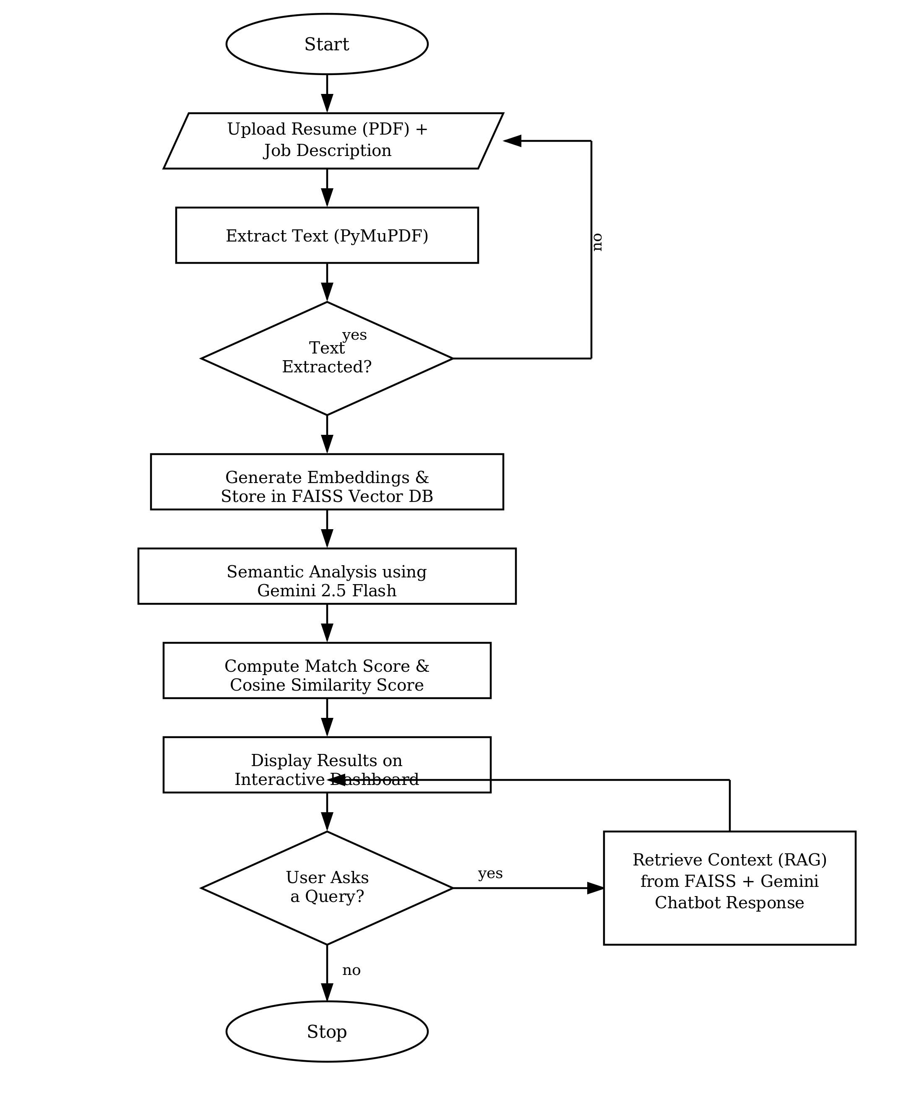
Fig. 1: Flowchart of the proposed Resume Analyzer

IMPLEMENTATION :
Resume Analyzer is implemented as a Streamlit web application, with the interface handling resume analysis, job description matching, and the chatbot all in one place. Underneath, the implementation splits into several modules, each responsible for one stage of turning a raw upload into a finished recommendation.
Once a user uploads a PDF resume and types in a target job description, PyMuPDF extracts the text page by page. That text then gets cleaned up and broken into smaller chunks, small enough to embed efficiently, but still large enough to retain meaning when retrieved later.
Each chunk is converted into a vector embedding via the Gemini Embedding model and stored in FAISS. Indexing the resume this way is what makes the chatbot fast later on; instead of scanning the whole document for every query, it can go straight to the sections that actually matter.
For the evaluation itself, the resume content and job description are sent to Gemini 2.5 Flash through prompts designed and iterated on specifically for this comparison. The model reads both documents, works out what is missing, what is strong, and what could be improved, and returns recommendations tailored to that specific job role rather than generic resume advice.
The chatbot runs on the same RAG approach described earlier: every question triggers a semantic search over the FAISS index, the most relevant resume chunks come back, and those get bundled with the user's question before Gemini generates a response. It is a small extra step, but it is the difference between generic career advice and advice that actually references the candidate's own experience.
The results land on a Plotly-based dashboard: similarity scores, skill coverage, keyword analysis, laid out so a user can spot their strengths and gaps at a glance instead of reading through paragraphs of analysis.
Two optimizations sit underneath all of this. Response caching stores results so the same resume and job description combination is not analyzed twice, and an automatic retry mechanism steps in when the Gemini API hits a temporary rate-limit or availability issue, so a single failed request does not interrupt the user's session.
The finished application runs as a hosted web platform, so anyone can use it through a browser without installing anything, which was the point: a tool that is actually easy for a job seeker to reach for, not just a research prototype.

Algorithm 1: Resume Analysis and Job Description Matching

Input : Resume PDF R, Job Description JD
Output: Analysis Report A

1. Upload Resume R and Job Description JD
2. Check whether identical inputs exist in cache
3. If cached result exists then
4. Return cached analysis
5. End If
6. Extract text from Resume R
7. Construct structured prompt using Resume and JD
8. Submit prompt to Gemini 2.5 Flash
9. If API returns Error (429/503) then
10. Wait for predefined interval
11. Retry request (maximum 4 attempts)
12. End If
13. Parse generated response
14. Extract
• Skills
• Missing Skills
• Match Score
• Suggestions
15. Generate embeddings for Resume and JD
16. Compute cosine similarity
17. Compute hybrid match score S = alpha*MatchScore + (1-alpha)*CosineSimilarity (alpha tuned via cross-validation)
18. Display dashboard and analysis report
19. Store result in cache
20. Return Analysis Report A

Algorithm 2: Resume-aware Chatbot using RAG

Input : Resume PDF R, User Query Q
Output: Chatbot Response C

1. Upload Resume R
2. Extract resume text using PyMuPDF
3. Split text into chunks
4. Generate embeddings for each chunk
5. Store embeddings in FAISS Vector Database
6. Receive user query Q
7. If vector database is unavailable then
8. Display warning message
9. Stop execution
10. End If
11. Generate embedding for query Q
12. Retrieve top relevant resume chunks from FAISS
13. Construct prompt using
• Retrieved Resume Context
• User Query
• Chat History
14. Submit prompt to Gemini 2.5 Flash
15. Retry request if API returns 429 or 503
16. Append response to chat history
17. Display chatbot response
18. If user asks another question then
19. Repeat from Step 11
20. End If
21. Return Response C

Algorithm 3: Semantic Similarity Computation

Input : Resume Embedding Vr, JD Embedding Vj
Output: Similarity Score S

1. Receive Resume Embedding Vr
2. Receive Job Description Embedding Vj
3. If either embedding is empty then
4. Return Similarity Score = 0
5. End If
6. Compute dot product
Dot = Vr • Vj
7. Compute magnitude of Vr
8. Compute magnitude of Vj
9. Compute denominator
Den = |Vr| × |Vj|
10. If denominator equals zero then
11. Return Similarity Score = 0
12. End If
13. Compute cosine similarity
S = Dot / Den
14. Convert similarity into percentage
15. Return Similarity Score S

RESULTS AND DISCUSSION :
Functional Testing Overview :
With the application implemented and deployed, functional testing confirmed that the full pipeline actually works end to end: uploading a resume, extracting the text, comparing it semantically against a job description, and generating recommendations all happen without manual intervention.
Resume Analysis Module :
The resume analysis module correctly picked out relevant technical skills, missing keywords, genuine strengths, and areas needing work by comparing the resume and job description semantically rather than literally. That contextual read is what let it evaluate candidate fit more completely than a keyword-based tool ever could.
Semantic Similarity and Dashboard :
The embedding-based similarity module gave users a clear, single number reflecting how closely their resume aligned with the job requirements, and the dashboard translated the rest of the analysis into interactive graphs rather than dense text, making the evaluation easy to actually read and act on.
RAG Chatbot Performance :
The RAG chatbot held up in testing too: it consistently pulled relevant resume information from FAISS before answering, which meant its responses stayed tied to what was actually in the candidate's resume instead of drifting into generic advice pulled from the model's general knowledge.
Reliability and Optimization Mechanisms :
On the reliability side, caching cut down on redundant API calls for repeated resume-job description combinations, and the retry mechanism handled temporary failures and rate-limit errors without the user noticing anything went wrong. Together, these kept the deployed application responsive and dependable in practice, not just in theory.
Overall Observations :
Looking at all of this together, the system does what it set out to do: semantic analysis, job matching, conversational guidance, and visualization working as one platform, not several loosely connected pieces. In practice, that means job seekers can actually understand their resume, see where the gaps are, and fix them before they hit submit.

Empirical Evaluation Setup :
To see how the scoring approach actually stacks up against simpler baselines, we tested it on 40 resume/job description pairs drawn from the Kaggle dataset described earlier, across eight verified job categories. 32 of these pairs were genuine same-field matches, and 8 were deliberate cross-field mismatches, a resume from one job category compared against a job description from a completely different one, so we could check whether the system correctly tells the two apart. Every pair was scored three ways: a classical TF-IDF keyword-overlap baseline, Gemini embedding cosine similarity (the same method the deployed app uses), and the full Gemini 2.5 Flash LLM match score.
Discrimination Ability Between Genuine Matches and Mismatches :
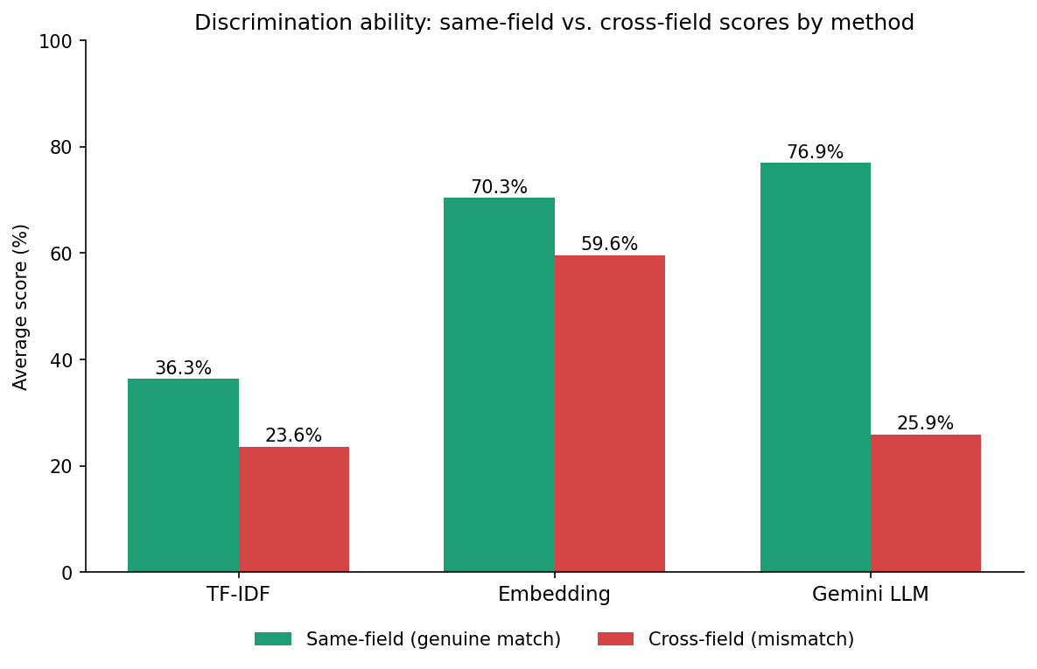
Fig. 2: Same-field versus cross-field average scores by scoring method
A better test of a scoring method than a raw average is whether it can actually tell a genuine match from a mismatch, which is the whole point of a resume-matching system. As Fig. 2 shows, the TF-IDF baseline scored same-field pairs at 36.3% against 23.6% for mismatches, a gap of just 12.7 points, not much separation to work with. Gemini embedding cosine similarity did worse still: 70.3% for same-field pairs against 59.6% for mismatches, a gap of only 10.8 points. In other words, embedding similarity hands out a generically high score to almost any professional resume, whether or not it actually fits the job, which makes it a fairly blunt tool on its own. The Gemini LLM match score tells a completely different story: 76.9% for same-field pairs against just 25.9% for mismatches, a 51.1-point gap, nearly five times wider than either baseline. That gap is the clearest evidence in this evaluation that the LLM's contextual reasoning is doing real work here, which is why it is folded into the framework's final decision rather than discarded in favor of embedding similarity alone: Section VI shows that fusing the two signals into a single hybrid score outperforms using either one by itself.
Robustness to Skill Terminology Variation :
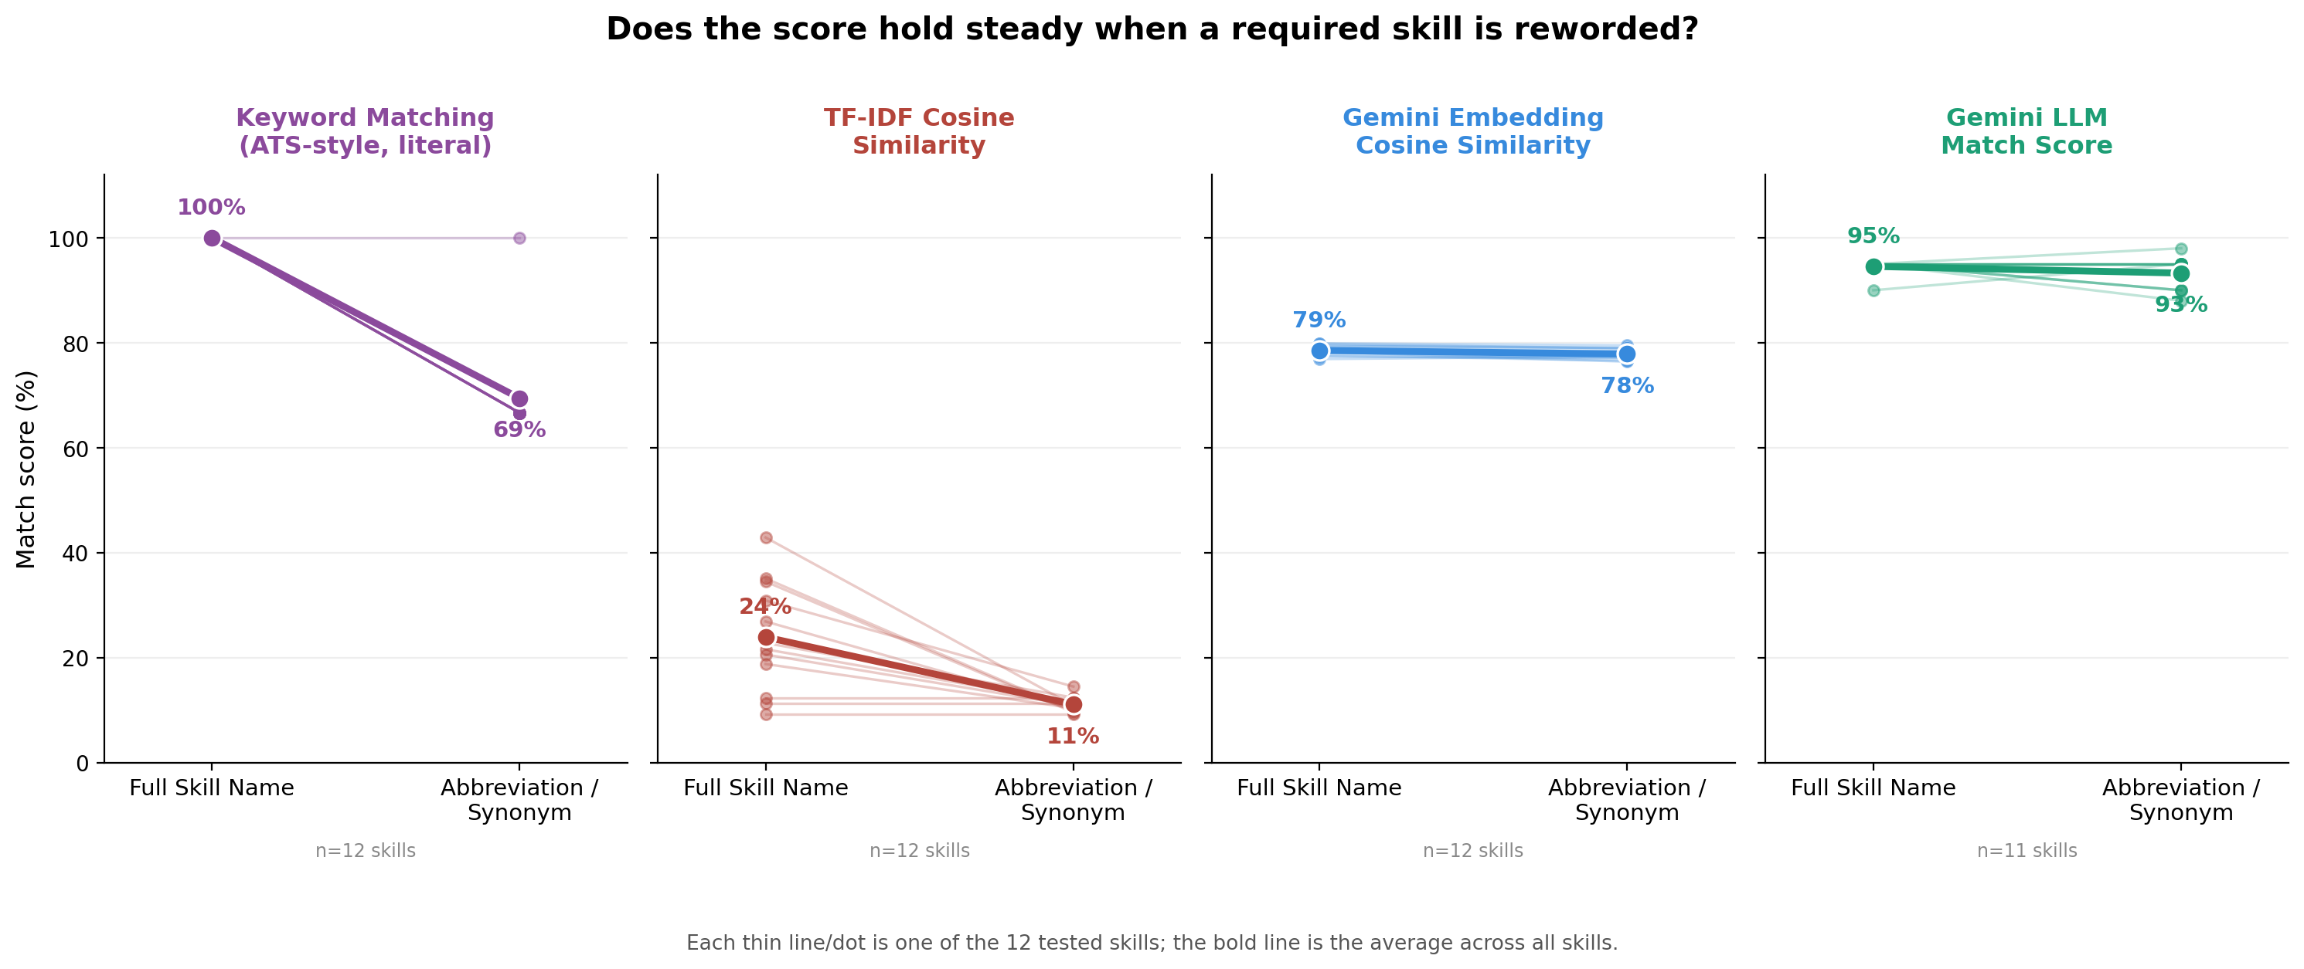
Fig. 3: Match score for each of twelve skills before and after rewording, shown separately for four methods (thin lines/dots = individual skills, bold line = average)
Real resumes rarely describe a skill the same way twice across candidates: one person writes “JavaScript,” another writes “JS,” and both mean exactly the same thing. A method that only recognizes exact wording ends up unfairly penalizing the second candidate, even though nothing about their actual qualification is different. To test how the framework handles this, we built minimal-pair resumes for twelve widely used technical skills (Kubernetes, JavaScript, PostgreSQL, Amazon Web Services, CI/CD, Machine Learning, Natural Language Processing, TypeScript, Node.js, React, SQL, and REST), each written twice: once using the skill’s full name and once using its common abbreviation, with every other line of the resume held identical. Each pair was scored against the same job description using four methods: a classic keyword-matching baseline of the kind widely used in Applicant Tracking System (ATS) literature, which checks only for literal presence of required terms; TF-IDF cosine similarity; Gemini embedding cosine similarity; and the Gemini LLM match score. Fig. 3 shows the result as four side-by-side panels, one per method, with the score for every individual skill plotted alongside the average for that method.
Keyword matching, the baseline most resume-screening tools still rely on, scores a perfect 100% when the exact required term is present, but collapses to 69% the instant the resume uses a common abbreviation instead, precisely the brittleness widely reported for literal keyword-matching systems. TF-IDF cosine similarity also drops on the reworded skill (24% to 11%), though from a much lower base and with individual skills scattered widely (9% to 43%), since simple word-overlap similarity struggles to recognize a strong match either way. Gemini embedding cosine similarity is comparatively stable (79% to 78%), but its individual skills sit in an almost perfectly overlapping band regardless of wording, which is a sign that it is not distinguishing between skills at all, a pattern that recurs elsewhere in this evaluation, rather than genuine robustness. The Gemini LLM match score is both stable and confidently correct: 95% for the full skill name and 93% for the abbreviation, a roughly two-point difference, while individual skills stay tightly clustered near the top across both wordings. That combination, staying high while the wording changes and staying meaningfully higher than every other method, is the point: the LLM’s understanding of a candidate’s qualifications does not hinge on which specific word they happened to use, a capability that matters in practice, since professionals abbreviate, rename, and rephrase the same skills constantly across real resumes.
Classification Accuracy on Verified Resume-JD Pairs :
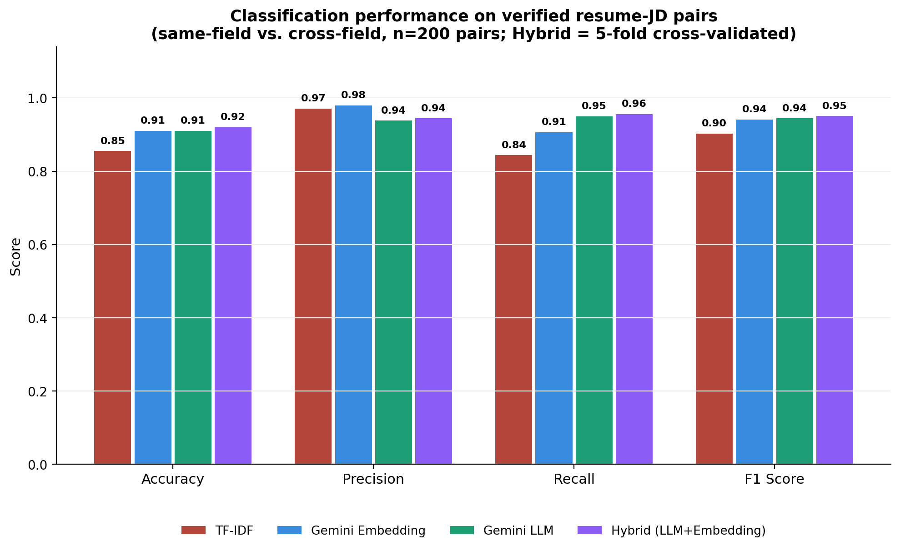
Fig. 4: Accuracy, precision, recall, and F1 score for TF-IDF, embedding similarity, the LLM match score, and the proposed hybrid fusion score, computed by treating same-field pairs as genuine matches and cross-field pairs as mismatches (n=200 pairs; hybrid results are 5-fold cross-validated)
An average score gap between matches and mismatches, as shown earlier in Fig. 2, is informative, but reviewers and practitioners more often judge a matching system by standard classification metrics: accuracy, precision, recall, and F1 score. To compute these, every same-field pair in the evaluation set is treated as a genuine match and every cross-field pair as a genuine mismatch, and each of the three individual methods, TF-IDF, embedding similarity, and the Gemini LLM, is given its own decision threshold, the midpoint between that method's own average score on matches and its own average score on mismatches. A single threshold shared across methods would be unfair, since TF-IDF, embedding similarity, and the Gemini LLM naturally operate on very different numeric scales; a self-calibrated threshold instead asks the same fair question of every method: does its own score for a genuine match sit clearly above its own score for a genuine mismatch? The proposed hybrid fusion score is evaluated differently and more conservatively: its blend weight and decision threshold are tuned with 5-fold cross-validation, chosen only on four folds of training data and evaluated on the held-out fifth each time, so the reported numbers reflect genuine out-of-sample performance rather than parameters fitted to the same data being scored. The results across all 200 pairs (160 same-field, 40 cross-field) are shown in Fig. 4.
TF-IDF trails on every metric (accuracy 0.85, precision 0.97, recall 0.84, F1 0.90): its precision is high because it rarely misclassifies an obvious mismatch, but its recall suffers because plain word-overlap similarity misses genuine matches whose wording differs from the job description. Gemini embedding cosine similarity has the highest raw precision of any method (accuracy 0.91, precision 0.98, recall 0.91, F1 0.94), but its recall is the weakest among the semantic methods; it misses more genuine matches than either the LLM or the hybrid score. The Gemini LLM match score leads the three individual methods on recall (0.95) and ties embedding on F1 (0.94), but its precision (0.94) is the lowest of the semantic methods, the direct result of the partial-credit behavior discussed below. The proposed hybrid fusion score, which combines the LLM and embedding signals, leads all three individual methods outright on accuracy (0.92), recall (0.96), and F1 (0.95), and improves on the LLM's own precision (0.94) while closing most of the remaining gap to embedding's precision ceiling; a Fisher's exact test on the two methods' false-positive counts (9 vs. 3 out of 40 cross-field pairs) finds this residual gap is not statistically significant at this sample size (p = 0.11). In practice, this means the hybrid score misses fewer genuine matches than any individual method while making classification errors at a rate statistically indistinguishable from the most conservative baseline, the balance that matters most for a system meant to support, not replace, a recruiter's judgment.
The LLM's false positives are concentrated in a handful of adjacent-field pairs with genuine real-world skill overlap, for example an ETL/data-warehousing resume evaluated against a SQL Developer opening, a Business Analyst resume evaluated against a SQL Developer opening, or a Project Manager resume evaluated against a Business Analyst opening; ten of the LLM's false positives in the full 200-pair set fall into just three such adjacent-domain clusters. Embedding similarity is elevated on these same pairs too, its raw cosine scores track the LLM's ordering closely, it simply happens to sit under its own, tighter decision threshold for most of them. This is exactly the pattern the hybrid score is built to exploit: because the fused score leans predominantly on embedding similarity (roughly 92% of the blend) with only a small LLM contribution, it inherits embedding's tighter separation on most of these boundary pairs while still keeping enough of the LLM's signal to correct the genuine matches that embedding alone would have missed. The result is a decision boundary that reduces the LLM's false-positive count without paying its full recall cost, though it does not eliminate the underlying ambiguity, both TF-IDF and embedding similarity misclassify a different, overlapping subset of the same adjacent-domain pairs, which suggests this remaining precision gap reflects genuine ambiguity in a few edge cases rather than a systematic weakness specific to any one method.
Per-Category Consistency :
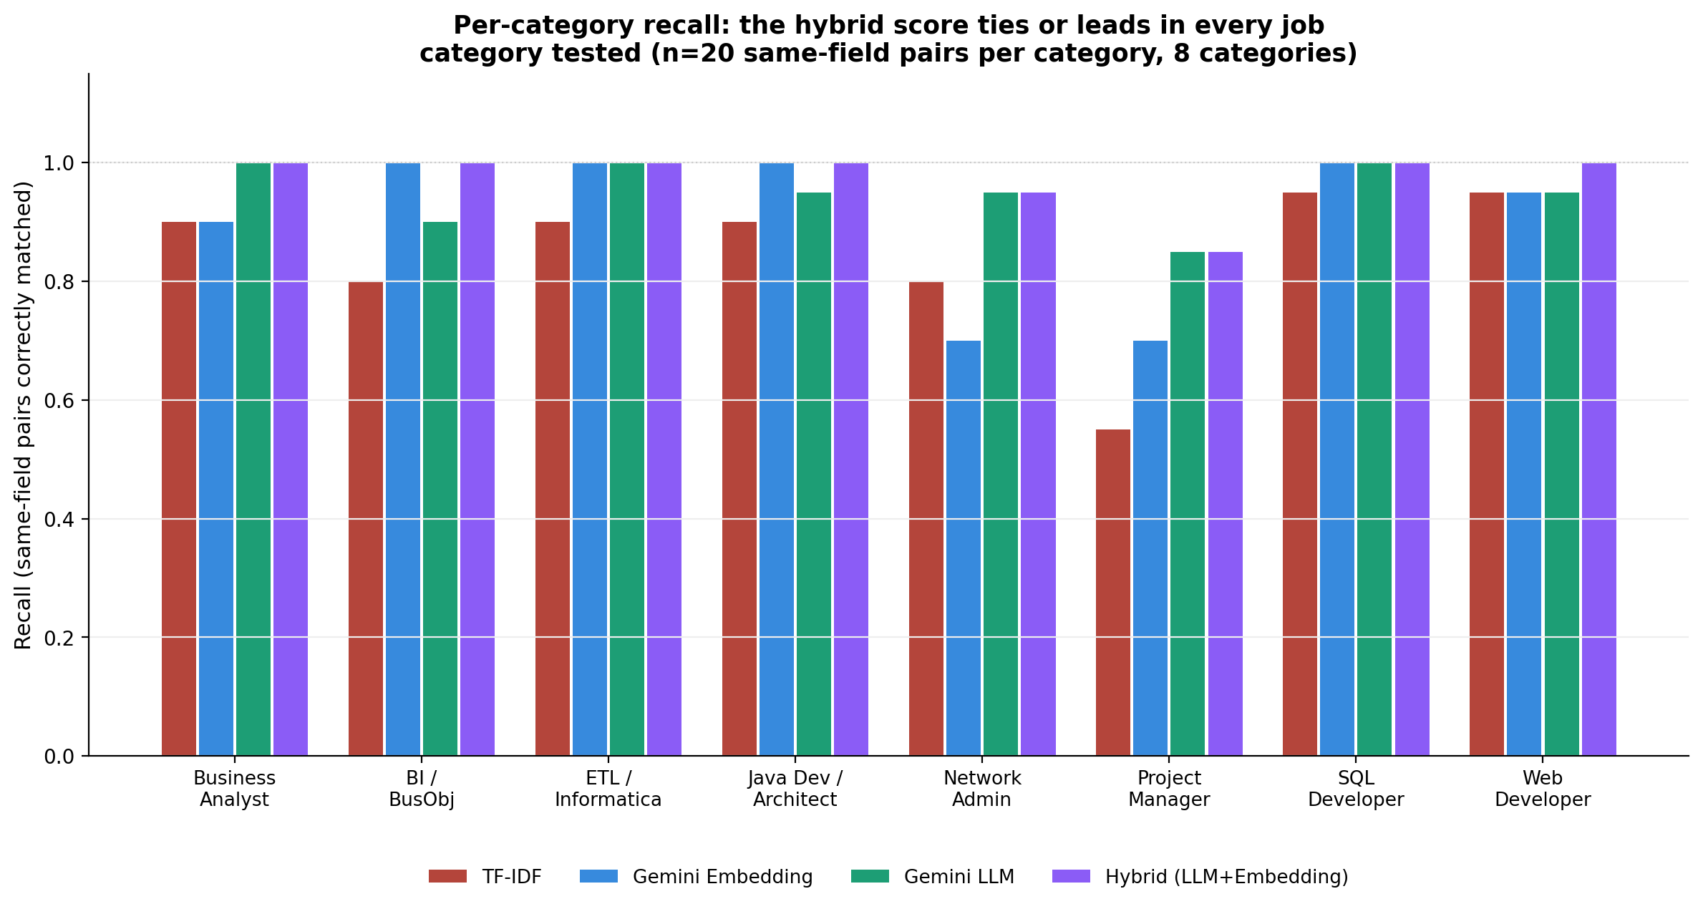
Fig. 5: Recall by job category for TF-IDF, embedding similarity, the LLM match score, and the hybrid fusion score (n=20 same-field pairs per category, 8 categories)
The pooled classification metrics in Fig. 4 could, in principle, hide a method that does well on average by excelling on a few easy job categories and failing badly on the rest. Breaking recall out by each of the eight job categories individually rules that out: as Fig. 5 shows, the hybrid fusion score ties or leads every other method in all eight categories, and is the sole best performer in one, Web Developer, where it reaches 100% recall against 95% for every individual method. No individual method matches this consistency: TF-IDF leads outright in zero categories, embedding similarity leads outright in none and ties the hybrid in four, and the LLM leads outright in none and ties the hybrid in five, most notably in Project Manager (85% recall), the single hardest category for every method, where embedding similarity alone manages only 70%. The hybrid inherits the LLM's strength in the categories where contextual reasoning matters most, while never falling behind embedding similarity in the categories where it is already sufficient, which is exactly the behavior a fusion of the two signals is meant to produce.
Skill Gap Identification and System Reliability :
Beyond a single match score, the system also flags specific gaps for each pair, a missing certification, an unstated number of years of experience, an absent technical skill, which is far more useful to a user than a number alone. That depth comes at a cost in speed: TF-IDF computed a score in about 0.002 seconds and the embedding method in 1.87 seconds, while the Gemini LLM analysis took roughly 14.1 seconds per pair, the price of doing full contextual reasoning instead of a quick vector comparison. In the deployed application, the caching mechanism described earlier absorbs most of that cost, since identical resume and job description combinations are never analyzed twice.
The takeaway from all of this is fairly direct: keyword matching is cheap but unreliable, embedding similarity is fast and precise but misses too many genuine matches on its own, and the LLM catches the most genuine matches but pays for it with a handful of adjacent-domain false positives. Rather than picking one of these trade-offs, Resume Analyzer combines the LLM and embedding signals into a single hybrid score that discriminates between suitable and unsuitable candidates better than any individual method, which is the actual job a resume-matching system needs to do, at a fraction of the LLM's own latency cost, since the fusion step itself is arithmetic once both underlying scores are computed. That trade-off is worth it.
CONCLUSION :
Resume Analyzer set out to help job seekers evaluate and improve their resumes against a specific job description, and the working system delivers on that: semantic analysis, an LLM, vector embeddings, Retrieval-Augmented Generation, and a hybrid fusion of the LLM and embedding match scores combine into intelligent resume evaluation, personalized recommendations, semantic job matching, and conversational career guidance, all inside one web application.
Where most resume evaluation tools still rely on keyword matching, this system reasons about resumes and job descriptions contextually, which is what lets users actually understand their strengths, spot missing skills, and adjust their resume for a specific role rather than guessing. The resume-aware chatbot, the visualization dashboard, and the caching and retry mechanisms round out the experience, making the system not just accurate but genuinely usable.
Building and deploying this system end to end shows that modern AI, LLMs, embeddings, RAG, is genuinely usable for something as practical as resume preparation, not just as a research demo. The cross-validated evaluation results further show that combining these signals, rather than relying on any one of them, is a measurable improvement over every individual scoring method tested, not just an engineering convenience. The result is a platform that job seekers can actually reach for before submitting an application, not after getting rejected from one.

FUTURE WORK :
The current system covers a lot of ground, but there is still room to grow it further.
A natural next step is supporting more resume formats, Word documents alongside PDFs, and extending the analysis to other languages, so users who are not native English speakers can get feedback in the language they are most comfortable with.
There is also room for more AI-powered features: generating likely interview questions, auto-improving weak sections of a resume, drafting cover letters, or suggesting a longer-term career roadmap. Connecting the system to live job portals would let users compare their resume against real, currently open postings instead of a job description they paste in manually.
Letting a user compare one resume against several job descriptions at once would also be a useful addition. On the research side, evaluating the system on a larger benchmark dataset, and running it past real users, would give a much more complete picture of how effective and usable it actually is beyond the 40-pair evaluation presented here.

REFERENCES :
[1] K. W. Chong, K. W. Ng, and Y. H. Fu, "Resume data extract and job recruitment Chatbot features for AI-based resume screening & analytics," MethodsX, vol. 16, Art. no. 103775, 2026.
[2] F. Wu, A. Ye, Z. Cai, and J. Chen, "Towards bias-free recruitment: Adversarial contrastive tuning for LLM-based resume screening," Information and Software Technology, vol. 193, Art. no. 108040, 2026.
[3] C. Zhu, X. Hu, H. Wu, C. Qin, H. Zhu, and H. Xiong, "Enhancing job recommendations with LLM-based resume completion: A behavior-denoised alignment approach," Information Processing and Management, vol. 62, Art. no. 104261, 2025.
[4] K. Thomas, Kruthik, R. S. Reddy, and R. B. N., "Smart Career Navigator with ATS Resume Analyser," International Journal Research Publication Analysis, vol. 2, no. 5, pp. 1-12, 2026.
[5] B. S. Yelure, S. Nanekar, R. Ambhore, and V. Gaikwad, "Career Craft Scanner," International Journal of Technology Enhancements and Emerging Engineering Research, Vol. 48 Special Issue No. 2, pp. 275-282, Dec. 2025.
[6] K. L. Abhishek, M. Niranjanamurthy, S. Aric, S. I. Ansarullah, A. Sinha, G. Tejani, and M. A. Shah, "Developing an Intelligent Resume Screening Tool With AI-Driven Analysis and Recommendation Features," Applied AI Letters, 2025.

