FML-Assignment-4

shiva gadila

2023-03-18

#Importing the Dataset

Pharmaceuticals <- read.csv("~/Downloads/Pharmaceuticals.csv")  
summary(Pharmaceuticals)

## Symbol Name Market_Cap Beta   
## Length:21 Length:21 Min. : 0.41 Min. :0.1800   
## Class :character Class :character 1st Qu.: 6.30 1st Qu.:0.3500   
## Mode :character Mode :character Median : 48.19 Median :0.4600   
## Mean : 57.65 Mean :0.5257   
## 3rd Qu.: 73.84 3rd Qu.:0.6500   
## Max. :199.47 Max. :1.1100   
## PE_Ratio ROE ROA Asset_Turnover Leverage   
## Min. : 3.60 Min. : 3.9 Min. : 1.40 Min. :0.3 Min. :0.0000   
## 1st Qu.:18.90 1st Qu.:14.9 1st Qu.: 5.70 1st Qu.:0.6 1st Qu.:0.1600   
## Median :21.50 Median :22.6 Median :11.20 Median :0.6 Median :0.3400   
## Mean :25.46 Mean :25.8 Mean :10.51 Mean :0.7 Mean :0.5857   
## 3rd Qu.:27.90 3rd Qu.:31.0 3rd Qu.:15.00 3rd Qu.:0.9 3rd Qu.:0.6000   
## Max. :82.50 Max. :62.9 Max. :20.30 Max. :1.1 Max. :3.5100   
## Rev_Growth Net_Profit_Margin Median_Recommendation Location   
## Min. :-3.17 Min. : 2.6 Length:21 Length:21   
## 1st Qu.: 6.38 1st Qu.:11.2 Class :character Class :character   
## Median : 9.37 Median :16.1 Mode :character Mode :character   
## Mean :13.37 Mean :15.7   
## 3rd Qu.:21.87 3rd Qu.:21.1   
## Max. :34.21 Max. :25.5   
## Exchange   
## Length:21   
## Class :character   
## Mode :character   
##   
##   
##

str(Pharmaceuticals)

## 'data.frame': 21 obs. of 14 variables:  
## $ Symbol : chr "ABT" "AGN" "AHM" "AZN" ...  
## $ Name : chr "Abbott Laboratories" "Allergan, Inc." "Amersham plc" "AstraZeneca PLC" ...  
## $ Market_Cap : num 68.44 7.58 6.3 67.63 47.16 ...  
## $ Beta : num 0.32 0.41 0.46 0.52 0.32 1.11 0.5 0.85 1.08 0.18 ...  
## $ PE_Ratio : num 24.7 82.5 20.7 21.5 20.1 27.9 13.9 26 3.6 27.9 ...  
## $ ROE : num 26.4 12.9 14.9 27.4 21.8 3.9 34.8 24.1 15.1 31 ...  
## $ ROA : num 11.8 5.5 7.8 15.4 7.5 1.4 15.1 4.3 5.1 13.5 ...  
## $ Asset_Turnover : num 0.7 0.9 0.9 0.9 0.6 0.6 0.9 0.6 0.3 0.6 ...  
## $ Leverage : num 0.42 0.6 0.27 0 0.34 0 0.57 3.51 1.07 0.53 ...  
## $ Rev_Growth : num 7.54 9.16 7.05 15 26.81 ...  
## $ Net_Profit_Margin : num 16.1 5.5 11.2 18 12.9 2.6 20.6 7.5 13.3 23.4 ...  
## $ Median_Recommendation: chr "Moderate Buy" "Moderate Buy" "Strong Buy" "Moderate Sell" ...  
## $ Location : chr "US" "CANADA" "UK" "UK" ...  
## $ Exchange : chr "NYSE" "NYSE" "NYSE" "NYSE" ...

#Loading the Packages

library(readr)  
library(dplyr)

##   
## Attaching package: 'dplyr'

## The following objects are masked from 'package:stats':  
##   
## filter, lag

## The following objects are masked from 'package:base':  
##   
## intersect, setdiff, setequal, union

library(caret)

## Loading required package: ggplot2

## Loading required package: lattice

library(tidyverse)

## ── Attaching core tidyverse packages ──────────────────────── tidyverse 2.0.0 ──  
## ✔ forcats 1.0.0 ✔ stringr 1.5.0  
## ✔ lubridate 1.9.2 ✔ tibble 3.1.8  
## ✔ purrr 1.0.1 ✔ tidyr 1.3.0

## ── Conflicts ────────────────────────────────────────── tidyverse_conflicts() ──  
## ✖ dplyr::filter() masks stats::filter()  
## ✖ dplyr::lag() masks stats::lag()  
## ✖ purrr::lift() masks caret::lift()  
## ℹ Use the ]8;;http://conflicted.r-lib.org/conflicted package]8;; to force all conflicts to become errors

library(cluster)  
library(gridExtra)

##   
## Attaching package: 'gridExtra'  
##   
## The following object is masked from 'package:dplyr':  
##   
## combine

library(ggrepel)  
library(factoextra)

## Welcome! Want to learn more? See two factoextra-related books at https://goo.gl/ve3WBa

library(flexclust)

## Loading required package: grid  
## Loading required package: modeltools  
## Loading required package: stats4

library(ggcorrplot)  
library(FactoMineR)

#(A)Use only the numerical variables (1 to 9) to cluster the 21 firms. Justify the various choices made in conducting the cluster analysis, such as weights for different variables, the specific clustering algorithm(s)used, the number of clusters formed, and so on

#Selecting the numerical variables and removing the dataset's null values.  
colSums(is.na(Pharmaceuticals))

## Symbol Name Market_Cap   
## 0 0 0   
## Beta PE_Ratio ROE   
## 0 0 0   
## ROA Asset_Turnover Leverage   
## 0 0 0   
## Rev_Growth Net_Profit_Margin Median_Recommendation   
## 0 0 0   
## Location Exchange   
## 0 0

row.names(Pharmaceuticals)<- Pharmaceuticals[,1]  
Pharmaceuticals_data_num<- Pharmaceuticals[, 3:11]  
head(Pharmaceuticals_data_num)

## Market_Cap Beta PE_Ratio ROE ROA Asset_Turnover Leverage Rev_Growth  
## ABT 68.44 0.32 24.7 26.4 11.8 0.7 0.42 7.54  
## AGN 7.58 0.41 82.5 12.9 5.5 0.9 0.60 9.16  
## AHM 6.30 0.46 20.7 14.9 7.8 0.9 0.27 7.05  
## AZN 67.63 0.52 21.5 27.4 15.4 0.9 0.00 15.00  
## AVE 47.16 0.32 20.1 21.8 7.5 0.6 0.34 26.81  
## BAY 16.90 1.11 27.9 3.9 1.4 0.6 0.00 -3.17  
## Net_Profit_Margin  
## ABT 16.1  
## AGN 5.5  
## AHM 11.2  
## AZN 18.0  
## AVE 12.9  
## BAY 2.6

# Normalizing and scaling the dataset.  
Pharmaceuticals_scale <- scale(Pharmaceuticals_data_num)  
head(Pharmaceuticals_scale)

## Market_Cap Beta PE_Ratio ROE ROA Asset_Turnover  
## ABT 0.1840960 -0.80125356 -0.04671323 0.04009035 0.2416121 -5.121077e-16  
## AGN -0.8544181 -0.45070513 3.49706911 -0.85483986 -0.9422871 9.225312e-01  
## AHM -0.8762600 -0.25595600 -0.29195768 -0.72225761 -0.5100700 9.225312e-01  
## AZN 0.1702742 -0.02225704 -0.24290879 0.10638147 0.9181259 9.225312e-01  
## AVE -0.1790256 -0.80125356 -0.32874435 -0.26484883 -0.5664461 -4.612656e-01  
## BAY -0.6953818 2.27578267 0.14948233 -1.45146000 -1.7127612 -4.612656e-01  
## Leverage Rev_Growth Net_Profit_Margin  
## ABT -0.2120979 -0.5277675 0.06168225  
## AGN 0.0182843 -0.3811391 -1.55366706  
## AHM -0.4040831 -0.5721181 -0.68503583  
## AZN -0.7496565 0.1474473 0.35122600  
## AVE -0.3144900 1.2163867 -0.42597037  
## BAY -0.7496565 -1.4971443 -1.99560225

normalization_data <- as.data.frame(scale(Pharmaceuticals_data_num))

# Using multiple K values, compute K-means clustering for various centers, and compare the results.  
kmeans_1 <- kmeans(Pharmaceuticals_scale, centers = 2, nstart = 30)  
kmeans_2<- kmeans(Pharmaceuticals_scale, centers = 5, nstart = 30)  
kmeans_3<- kmeans(Pharmaceuticals_scale, centers = 6, nstart = 30)  
Plot_1<-fviz_cluster(kmeans_1, data = Pharmaceuticals_scale)+ggtitle("k=2")  
plot_2<-fviz_cluster(kmeans_2, data = Pharmaceuticals_scale)+ggtitle("k=5")  
plot_3<-fviz_cluster(kmeans_3, data = Pharmaceuticals_scale)+ggtitle("k=6")  
grid.arrange(Plot_1,plot_2,plot_3, nrow = 3)

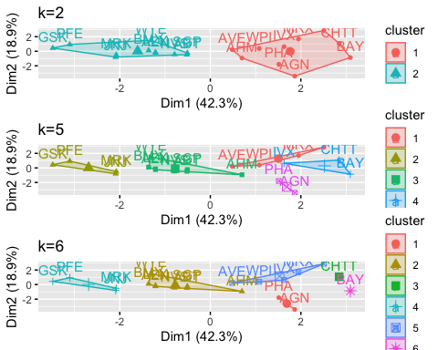 #so the recommanded number of clusters is k=2 i.e plot2

distance<- dist(Pharmaceuticals_scale, method = "euclidean")  
fviz_dist(distance)

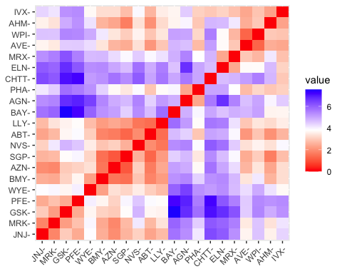

# Estimating the number of clusters   
# Scaling the data using the Elbow Method to determine k's value  
fviz_nbclust(normalization_data, FUNcluster = kmeans, method = "wss") + labs(subtitle = "Elbow Method")

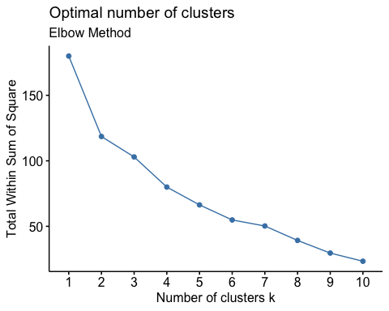

# The number of clusters is calculated by scaling the data using the Silhouette Method.  
fviz_nbclust(normalization_data,FUNcluster = kmeans,method = "silhouette")+labs(subtitle="Silhouette Method")

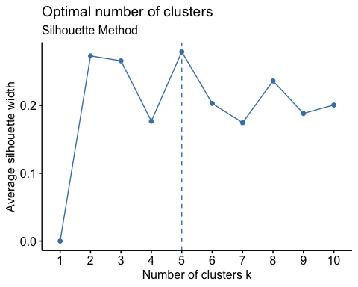

# Final analysis, extraction of data from five clusters, and presentation of the data  
set.seed(300)  
final_Cluster<- kmeans(Pharmaceuticals_scale, 5, nstart = 25)  
print(final_Cluster)

## K-means clustering with 5 clusters of sizes 8, 3, 4, 2, 4  
##   
## Cluster means:  
## Market_Cap Beta PE_Ratio ROE ROA Asset_Turnover  
## 1 -0.03142211 -0.4360989 -0.31724852 0.1950459 0.4083915 0.1729746  
## 2 -0.87051511 1.3409869 -0.05284434 -0.6184015 -1.1928478 -0.4612656  
## 3 -0.76022489 0.2796041 -0.47742380 -0.7438022 -0.8107428 -1.2684804  
## 4 -0.43925134 -0.4701800 2.70002464 -0.8349525 -0.9234951 0.2306328  
## 5 1.69558112 -0.1780563 -0.19845823 1.2349879 1.3503431 1.1531640  
## Leverage Rev_Growth Net_Profit_Margin  
## 1 -0.27449312 -0.7041516 0.556954446  
## 2 1.36644699 -0.6912914 -1.320000179  
## 3 0.06308085 1.5180158 -0.006893899  
## 4 -0.14170336 -0.1168459 -1.416514761  
## 5 -0.46807818 0.4671788 0.591242521  
##   
## Clustering vector:  
## ABT AGN AHM AZN AVE BAY BMY CHTT ELN LLY GSK IVX JNJ MRX MRK NVS   
## 1 4 1 1 3 2 1 2 3 1 5 2 5 3 5 1   
## PFE PHA SGP WPI WYE   
## 5 4 1 3 1   
##   
## Within cluster sum of squares by cluster:  
## [1] 21.879320 15.595925 12.791257 2.803505 9.284424  
## (between_SS / total_SS = 65.4 %)  
##   
## Available components:  
##   
## [1] "cluster" "centers" "totss" "withinss" "tot.withinss"  
## [6] "betweenss" "size" "iter" "ifault"

clusplot(Pharmaceuticals_scale,final_Cluster$cluster, color = TRUE, labels = 2,lines = 0)

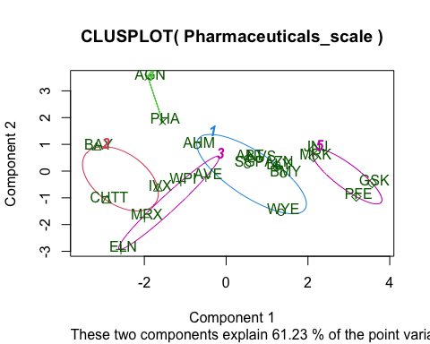 #b) Interpret the clusters with respect to the numerical variables used in forming the clusters.

#Cluster 1 - AHM,SGP,WYE,BMY,AZN, ABT, NVS, LLY ( lowest Market_Cap,lowest Beta,lowest PE_Ratio,highest Leverage,highest Rev_Growth.)  
#Cluster 2 - BAY, CHTT, IVX (lowest Rev_Growth,highest Beta and levearge,lowest Net_Profit_Margin)  
#Cluster 3 - WPI, MRX,ELN,AVE (lowest PE_Ratio,highest ROE,lowest ROA,lowest Net_Profit_Margin, highest Rev_Growth)  
#Cluster 4 - AGN, PHA (lowest Beta,lowest Asset_Turnover, Highest PE Ratio)  
#Cluster 5 - JNJ, MRK, PFE,GSK (Highest Market_Cap,ROE, ROA,Asset_Turnover Ratio and lowest Beta/PE Ratio)  
  
Pharmaceuticals_Cluster <- Pharmaceuticals[,c(12,13,14)]%>% mutate(clusters = final_Cluster$cluster)%>% arrange(clusters, ascending = TRUE)  
Pharmaceuticals_Cluster

## Median_Recommendation Location Exchange clusters  
## ABT Moderate Buy US NYSE 1  
## AHM Strong Buy UK NYSE 1  
## AZN Moderate Sell UK NYSE 1  
## BMY Moderate Sell US NYSE 1  
## LLY Hold US NYSE 1  
## NVS Hold SWITZERLAND NYSE 1  
## SGP Hold US NYSE 1  
## WYE Hold US NYSE 1  
## BAY Hold GERMANY NYSE 2  
## CHTT Moderate Buy US NASDAQ 2  
## IVX Hold US AMEX 2  
## AVE Moderate Buy FRANCE NYSE 3  
## ELN Moderate Sell IRELAND NYSE 3  
## MRX Moderate Buy US NYSE 3  
## WPI Moderate Sell US NYSE 3  
## AGN Moderate Buy CANADA NYSE 4  
## PHA Hold US NYSE 4  
## GSK Hold UK NYSE 5  
## JNJ Moderate Buy US NYSE 5  
## MRK Hold US NYSE 5  
## PFE Moderate Buy US NYSE 5

#(c)Is there a pattern in the clusters with respect to the numerical variables (10 to 12)?

plot1<-ggplot(Pharmaceuticals_Cluster, mapping = aes(factor(clusters), fill=Median_Recommendation))+geom_bar(position = 'dodge')+labs(x ='No of clusters')  
plot2<- ggplot(Pharmaceuticals_Cluster, mapping = aes(factor(clusters),fill = Location))+geom_bar(position = 'dodge')+labs(x ='No of clusters')  
plot3<- ggplot(Pharmaceuticals_Cluster, mapping = aes(factor(clusters),fill = Exchange))+geom_bar(position = 'dodge')+labs(x ='No of clusters')  
plot4 <- ggplot(Pharmaceuticals_Cluster, mapping = aes(factor(clusters), fill=Median_Recommendation)) + geom_bar(position = 'dodge') + labs(x='Clusters', y='Frequence')  
grid.arrange(plot1, plot2, plot3,plot4)

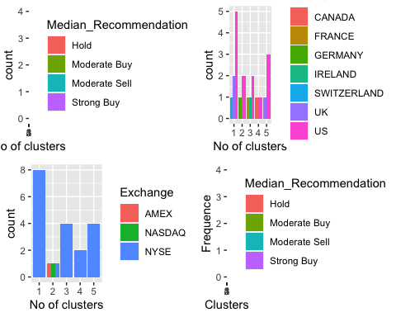

#1 Cluster: In this cluster, which also has medians for Hold, Moderate Buy, Moderate Sell, and Strong Buy, the Hold median is the highest. They hail from Switzerland, the United States, and are listed on the NYSE.  
  
#2 Cluster: Despite the fact that the companies are evenly distributed across the AMEX, NASDAQ, and NYSE, there is a distinct Hold and Moderate Buy median and a distinct count between the United States and Germany.  
  
#3 Cluster: listed on the NYSE, with separate counts for the United States, Ireland, and France, and moderate buy and sell medians that are equal.  
  
#4, Cluster: distributed throughout the United States and the United Kingdom and listed in, shares the same hold and moderate buy medians   
  
#Cluster 5: # only on the NYSE, equally distributed in the US and Canada, with medians of Hold and Moderate Buy  
  
#The clusters follow a particular pattern in relation to the media recommendation variable:  
  
#Hold Recommendation applies to Clusters 1 and 2.  
  
#The buy recommendation for Clusters 3, 4, and 5 is moderate.

#(D)Provide an appropriate name for each cluster using any or all of the variables in the dataset.

#Cluster 1 :-Buy Cluster  
#Cluster 2 :- Sceptical Cluster  
#Cluster 3 :- Moderate Buy Cluster   
#Cluster 4 :- Hold Cluster  
#Cluster 5 :- High Hold Cluster