|  |  |  |  |  |
| --- | --- | --- | --- | --- |
|  | Original Model | Original Model (with gains used in VI) | New Model (with gains used in VI) | Real Physical System |
| BW of Velocity Loop [Hz] | 6.52 | 6.52 | 2.8 | 2.9 |
| BW of Position Loop [Hz] | 11.4 | 11.8 | 5.1  (with I =1) | 5.27  (with I =10) |

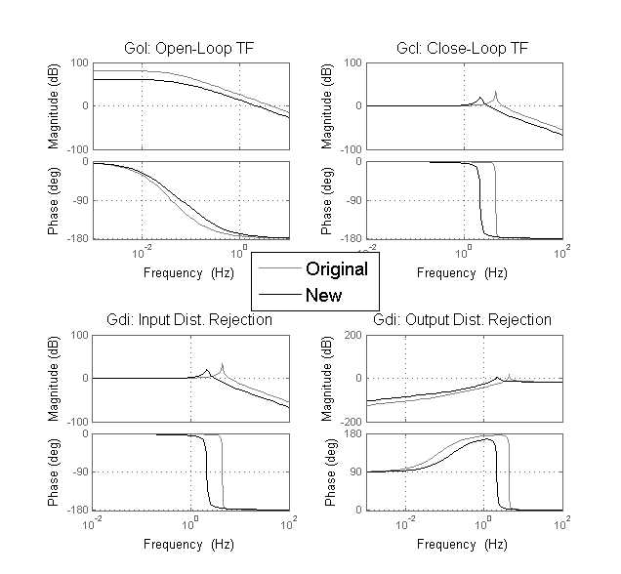

Q5b:

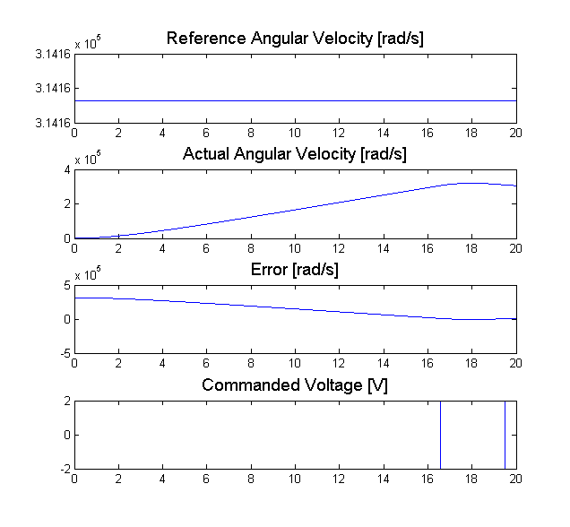

Figure 1: Tracking Ability for Extremely Large amplitude of step command

Q5c:

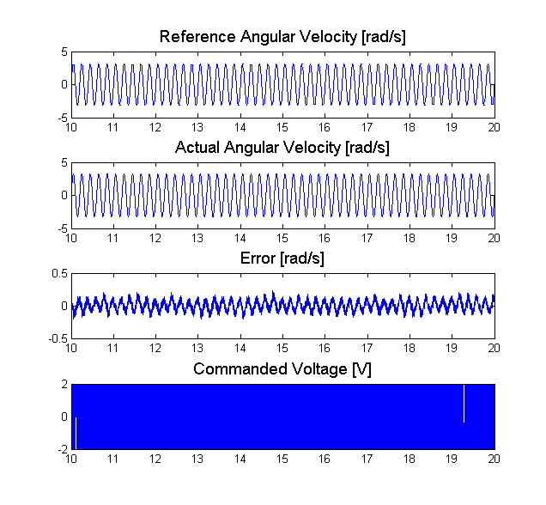

Figure 1: Sinusoidal Tracking Error > %5 when Resolution = 75 steps/rev

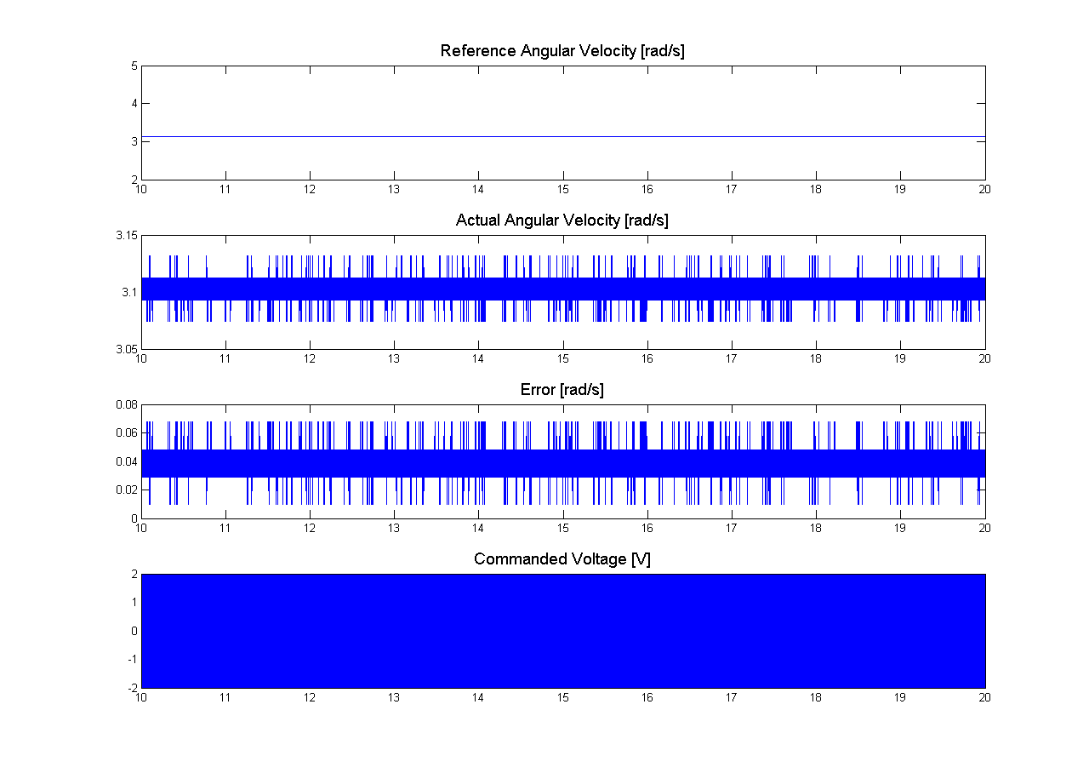

Figure 2: Step Tracking Error > %2 when Resolution = 325 steps/rev

|  |  |  |  |  |
| --- | --- | --- | --- | --- |
|  | Original Model | Original Model (With Real Gain) | Modified Model( new J B Tf) |  |
| Step |  | 0.01% |  |  |
| Sine 5Hz |  | 5.62% |  |  |
| Input Dist. 60Hz |  | 0.5% |  |  |
| Output Dist. 60Hz |  | 18% |  |  |