CLOSED LOOP GAIN(2,6.02db)

OPEN LOOP GAIN (3625,71.1db)

OPEN LOOP GAIN AT STAGE1(102.5)

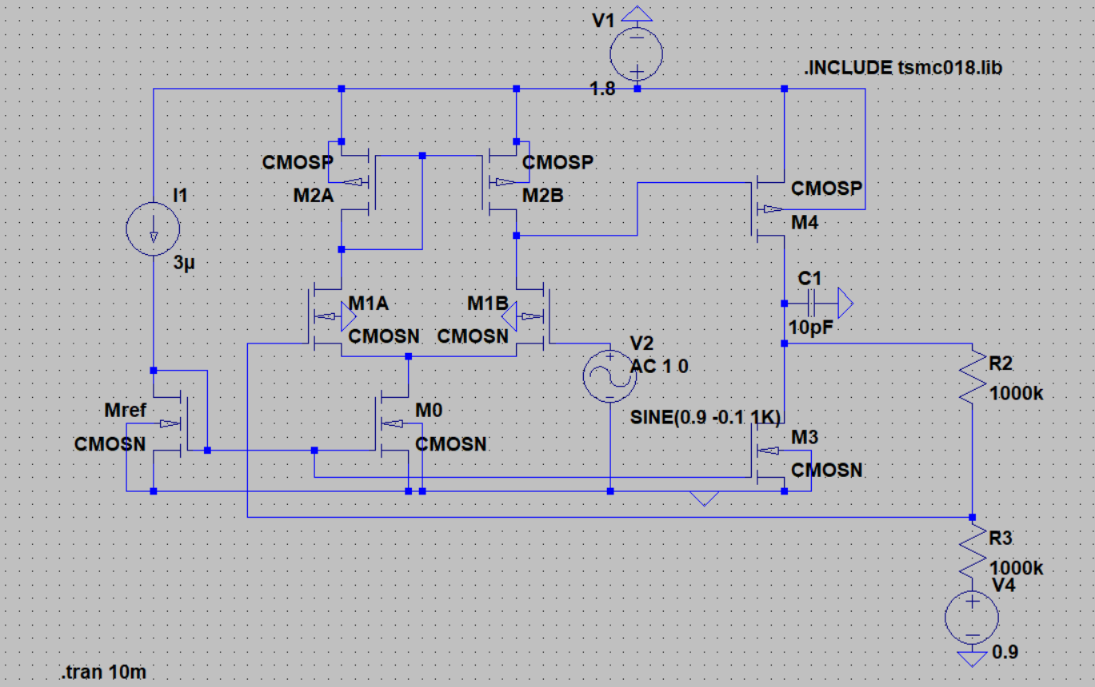

CIRCUIT AFTER NEGATIVE FEEDBACK